Contents

Abstract: 2

Introduction: 4

Advanced Prostate Cancer and Caveolin-1 4

Horizontal Transfer of MicroRNAs via Extracellular Vesicles: 5

Secreted MicroRNAs in Prostate Cancer: 6

Hypothesis and Aims: 7

Methods and Materials: 9

Reagents: 9

Cell culture: 9

Differential miRNA expression: 9

Extracellular Vesicle Extraction and RNA extraction: 10

Reverse Transcription quantitative Polymerase Chain Reaction (RT-qPCR) and preparation: 10

Motif Discovery and Assessment 11

Proteomic Analysis: 11

Co-localization by Immunofluorescence Confocal Microscopy: 11

MicroRNA *In situ* Hybridization: 12

Immunoprecipitation: 12

Western blotting: 13

Results 15

MicroRNAs are selectively exported from prostate cancer cells. 15

Distinct sequence motifs are overrepresented in differentially exported microRNAs. 17

Candidate proteins are present in EVs with RNA binding ability. 19

hnRNPK sub-cellular localization modified in cavin-1 PC3 line. 22

hnRNPK co-localizes with selectively exported microRNAs. 23

hnRNPK binds RNAs in the PC3 cell line. 26

Discussion: 28

# Abstract:

While primary prostate tumours are usually successfully treated, advanced prostate cancer patients are limited in treatment options, often resulting in mortalities. Hereby, efforts to investigate biomarkers or therapeutic targets is required to reduce the number of prostate cancer deaths. Caveolin-1 is a common marker in aggressive prostate cancer where its overexpression has been linked to increased proliferation, migration and differentiation. However, these phenotypes can be truncated by ectopic expression of caveolin binding partner and putative tumour suppressor, cavin-1, to these cells. Previous studies from our lab assessed the role of extracellular vesicles (EVs) in advanced prostate cancer by utilising this caveolin-1/cavin-1 switch in PC3 cells. This revealed that cavin-1 truncates the EV export of oncomiR miR-148a without corresponding cellular expression changes, indicating a novel microRNA (miRNA, miR) export mechanism that is modulated by cavin-1.

This project investigated the proposed microRNA export mechanism and miRNA targets by combining bioinformatics and wet lab techniques. Specifically, analysis of RNA-seq data revealed a subset of 19 miRNAs, including miR-148a, are selectively exported from PC3 cell lines, reduced by cavin-1 expression. Sequence similarities shared in these miRNA sequences were detected by motif discovery which may explain selectivity of these targets for export. In addition to reduced miRNAs in the EVs, proteomics data revealed differential export of 5 RNA-binding proteins upon cavin-1 expression, including heterogeneous nuclear ribonuclear protein K (hnRNPK). Motif scanning indicated that hnRNPK binds similar sequences to the shared miRNA motif thus hinting at an interaction between hnRNPK and exported miRNAs. Immunofluorescence and microRNA *in situ* hybridization confirmed that hnRNPK is compartmentalised with miR-148a in multivesicular bodies in pro-tumourigenic PC3 cell lines that is not occurring in PC3-cavin-1 cells. hnRNPK in PC3-cavin-1 cells localise to endoplasmic reticulum, which suggests a change in subcellular localisation may contribute to differential export of hnRNPK and its binding partners. While immunoprecipitation confirmed that hnRNPK binds RNA, identifying specific miRNA species requires further work.

Ultimately, these results suggest that many microRNAs are being modified by hnRNPK differential export in PC3 cells, where expression of cavin-1 reduces hnRNPK and miRNA export. hnRNPK is commonly detected in cancer derived EVs, however its role in EVs and result of secretion was previously unknown. While a previous study determined that hnRNPA2B1 mediates EV export of miRNAs in T-lymphocytes, this is the first study to identify a link between EV secreted hnRNPK and miRNA export in cancer.

# Introduction:

Advanced Prostate Cancer and Caveolin-1**:**

Prostate cancer is the second most commonly diagnosed cancer in men (Stewart & Wild 2014). While the primary tumour can be treated and removed efficiently resulting in almost 99% survival, patients inflicted with metastatic prostate cancer possess a reduced 5-year survival rate of 29.3% (SEER 2016). Bone metastasis is the most common complication of advanced prostate cancer which severely impacts survival (Bubendorf *et al.* 2000). This highlights the necessity to identify therapeutic targets and underlying biological phenomena that induce the metastatic phenotype.

Caveolin-1 has been linked to prostate cancer metastasis and has been a speculated biomarker for cancer progression (Gumulec *et al.* 2012; Moon *et al.* 2014; Hayashi *et al.* 2015). This protein binds cholesterol and serves as a structural protein for the formation of caveolae, a specialised lipid microdomain, through interaction with cytoplasmic proteins of the cavin family (Hill *et al.* 2008; Moon et al. 2014). Cavin-1 is required for caveolae formation while cavin-2 and cavin-3 modulate caveolae endocytosis and elongation (Hansen *et al.* 2009; McMahon *et al.* 2009). These proteins are co-expressed and co-localised in healthy human tissue, however in the case of many cancer types only caveolin-1 is expressed (Wu *et al.* 2011; Moumita *et al.* 2015). Increased proliferation, migration and differentiation are a result of the aberrant caveolin-1 expression, yet, the mechanism that links caveolin to these phenotypes is still actively being investigated (Grande-García *et al.* 2007; Chatterjee *et al.* 2015).

Recent studies have shown that cavin-1 is capable of reversing the pro-metastatic action of caveolin-1 in prostate cancer (Moon et al. 2014). Cavin-1 expression inhibited prostate cancer PC3 cell proliferation, migration and anchorage-independent growth *in vitro*, and tumour growth, metastasis and angiogenesis *in vivo* (Moon *et al.* 2014, Inder *et al.* 2012). Mechanistically, cavin-1 expression altered the tumour microenvironment, including reduction of stromal fibroblasts, secretion of matrix metalloprotein-9 and IL-6 (Aung *et al.* 2011; Moon et al. 2014). The reduced IL-6 secretion was determined to be through extracellular vesicle (EV) release (Inder *et al.* 2014). Intriguingly, cavin-1 expression also attenuated the EV-mediated release of microRNA-148a, which was previously reported to mediate bone metastasis through osteoclastogenesis (Cheng *et al.* 2013; Inder et al. 2014). These results suggest that one mechanism of cavin-1 tumour suppression in prostate cancer occurs partly by modulating EV microRNA content.

## Horizontal Transfer of MicroRNAs via Extracellular Vesicles:

Secreted membrane-bound vesicles, called extracellular vesicles, are important mediators of intercellular communication (Pegtel *et al.* 2014). EVs are comprised of vesicles predominately from two different sources, exosomes and microvesicles (Fig.1). Exosomes are defined as 40-100nm diameter extracellular vesicles which are released upon fusion of the multivesicular bodies with the plasma membrane (Gu *et al.* 2014). Whilst similar in function and biochemical markers, microvesicles (≥100nm) differ from exosomes by being released from budding of the plasma membrane (Minciacchi *et al.* 2015). This report focused on a mixed population of EVs as past research also utilized mixed populations when analysing EV content. EV cargo consists of cytoplasmic material, functional RNA and proteins where uptake of this content had been reported to influence a range of biological processes, such as the selective export of cytokines in immunological responses, mediating homeostasis and stress response (McKechnie *et al.* 2006; Wysoczynski *et al.* 2009; Hedlund *et al.* 2011). Recent studies have reported that cancer-derived EVs absorbed into recipient cells are able to induce the establishment of the pre-metastatic niche in cancer progression and tumour microenvironment modifications (Costa-Silva *et al.* 2015; Ramteke *et al.* 2015). Primarily

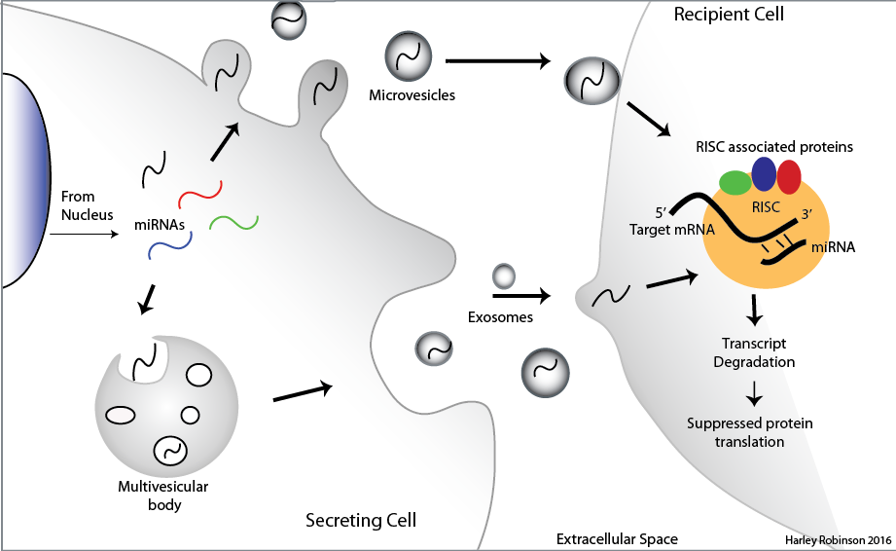

**Figure 1:** *Diagrammatic representation of microRNA extracellular vesicle transport.* EVs are formed in two different ways: from budding of the plasma membrane to form microvesicles and from fusion of the multivesicular bodies (MVBs) with the plasma membrane to release exosomes. EV contents includes miRNAs. Uptake of miRNAs to the recipient cell facilitates the recruitment of the RISC complex and associated proteins once bound to its target mRNA by complementary binding. This enables down regulation of proteins in the recipient cell by degradation of the transcript. (Illustration completed on Adobe Illustrator CC 2014)

this is attributed to the proteomic EV content being introduced into the endogenous population of the target cell, such as introduction of beta-catenin, epidermal growth factor receptor and major elements of the MAPK pathway (Dovrat *et al.* 2014; Kharmate *et al.* 2016; Song *et al.* 2016). Yet, more intriguing is the discovery that exported microRNAs may be associated with this function.

MicroRNAs (miRNAs, miRs) are small non-coding RNAs found to be involved in most developmental and pathological processes due to its ubiquitous gene regulatory function. The functional miRNA sequences (~19-24 nt) are derived from longer transcripts that undergo processing and shuttling events to give rise to functional mature sequences, known to induce RNA degradation (Ha *et al.* 2014). Typically, the mature miRNA sequence interact with the 3’ untranslated region (3’-UTR) of its target transcripts and guides the multi-protein RNA induced silencing complex (RISC) to destine these molecules for degradation or translational inhibition (Djuranovic *et al.* 2012). A 2009 estimate predicted that approximately 60% of the mammalian genome is able to be directly mediated by the miRNA RISC mechanism where a single miRNA can target hundreds of transcripts (Friedman *et al.* 2009). This indicates the necessity of tight temporal and spatial control over miRNAs to prevent dysregulation of vital pathways. MicroRNAs in the extracellular space was expected to be controlled by the high content of RNases in the extracellular space (Reddi *et al.* 1976; Tsui *et al.* 2002). However, recent studies show that EV-contained miRNAs are protected from this degradation and are absorbed into recipient cells, thus evoking their canonical function in a potentially diverse cell type (Kosaka *et al.* 2010; Montecalvo *et al.* 2012) (Fig.1).

## Secreted MicroRNAs in Prostate Cancer:

Earlier work from our lab utilizes the caveolin-1/cavin-1 system to investigate the role of caveolin-1 in prostate cancer (Inder *et al.* 2014). Interestingly, the addition of cavin-1 to PC3 cells modified extracellular vesicle (EV) content, a pathway unrelated to the canonical function of caveolin or cavin-1. In addition to limiting adhesion independent growth, hyper-proliferation and EV protein content of PC3 cells, the ectopic expression of putative tumour suppressor, cavin-1, modified miRNAs found within EVs; specifically miR-148a (Inder et al. 2014). Expression of miR-148a in bone marrow was reported to induce osteoclastogenesis by targeting an inhibitory transcription factor, MAFB, of the RANKL-induced osteoclastogenesis pathway, where the inverse was observed upon miR-148a inhibition (Cheng *et al.* 2013). Bone fracture, pain and fragility are common co-morbidities associated with the bone metastasis-mediated prostate cancer due to increased bone resorption (Luz *et al.* 2010). Therefore the export of miR-148a from pro-metastatic prostate cancer cell line is consistent with clinical findings and may be a regulator of metastatic progression. Interestingly, the expression of cavin-1 does not modify the cellular level of miR-148a, only the EV content (Inder et al 2014). This suggests that cavin-1 regulates the miRNA sorting to EVs and therefore export. Selective export of miRNAs in EVs had been observed in other studies, some of which links these miRNAs with disease states, particularly cancer metastasis (Palma *et al.* 2012; Zhou *et al.* 2014). Yet, the mechanism that governs this selectively is mostly unknown.

A recent clue was provided by Villarroya-Beltri *et at.*, who reported that sumoylated ribonucleoprotein, hnRNPA2B1 mediate the export and subcellular localization of particular miRNAs in T-lymphocytes (Villarroya-Beltri *et al.* 2013). Typically, the hnRNP family are involved in mRNA processing within the nucleus for translational control, mRNA stability and subcellular localisation. Yet, this is the first reported case of EV/multivesicular body localisation occurring from this mechanism and one of the first reports of its ability to bind to miRNAs (Mili *et al.* 2001; Dreyfuss *et al.* 2002). Further questions arise due to this finding, such as the use of other hnRNP proteins for miRNA subcellular localization, how hnRNPs are targeted to the EVs and whether this protein family could be responsible for miRNA EV export in other cell types and stimuli.

Hypothesis and Aims:

Based on the above, we hypothesised that cavin-1 expressed in PC3 cells attenuates the EV export of oncogenic miR-148a by modulating export of RNA-binding proteins (Fig.2), similar to the mechanism identified by Villarroya-Beltri *et al* (2014). Given that RNA-binding proteins select for targets by binding conserved RNA sequences, known as motifs, we further hypothesize that miR-148a and other RNA targets will share a motif that enable their selective export over other microRNAs. The following aims were devised to address these hypotheses:

1. Assess the EV microRNA species that are modified by the PC3/cavin-1 model.
2. Identify candidate export proteins that participate in microRNA EV export.
3. Verify the interaction between candidate protein and microRNA by *in situ* and *ex vivo* experimental methods.

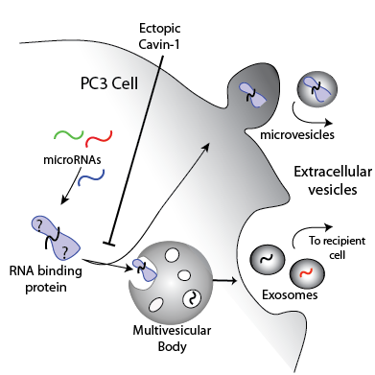

**Figure 2**: *Diagrammatic representation of the proposed miRNA export mechanism mediated by cavin-1 expression in PC3 cells.* It is hypothesised that RNA-binding proteins involved with the miRNA export mechanism are exported in the PC3-derived EVs. However, ectopic expression of cavin-1 to these cells will reduce the export of RNA-binding proteins and therefore miRNA export. All miRNAs manipulated by this mechanism and the proteins that mediate this process is currently unknown.

# Methods and Materials:

## Reagents:

Trypsin-EDTA (Gibco), Roswell Park Memorial Institute (RPMI) 1640 media (Sigma), Fetal Bovine Serum (FBS) (Bovogen), Phosphate Buffered Saline (PBS) (Amresco Inc), Geneticin G418 Antibiotic (Invitrogen). Antibodies used: rabbit anti-hnRNP K (CST), mouse anti-hnRNPK (Abcam), rabbit anti-CD9 (), rabbit anti-ERp44 (), normal rabbit IgG (CST), anti-mouse AlexaFluor568 and anti-rabbit AlexaFluor674 (ThermoFisher). All antibody dilutions used were per the manufactures’ suggestion.

## Cell culture:

Previously generated PC3 cell lines containing GFP or GFP tagged cavin-1 (referred to as PC3-cavin-1) were cultured in 5% FBS/RPMI1640 media in a 5% CO2 incubator set to 37°C. Ectopic gene expression levels were confirmed by immunoblotting for GFP (not shown). G418 antibiotic drug (0.1 mg/ml) was added to these cultured cells to select for GFP expressing cells.

## Differential miRNA expression:

The results from a previously conducted RNA-seq experiment, prepared by Jayde Ruelcke (Hill lab) and conducted by Nicole Cloonan (QIMR), were utilized for this analysis. Briefly, small RNAs were collected from EVs derived from PC3-GFP and PC3-cavin-1 cell lines and the cognate cells, resulting in 3 biological replicates. These RNAs were multiplexed, sequenced via Illumina sequencing, aligned and assessed for raw counts for miRNAs in cell and EVs (completed by Nicole). Analysis was performed using these raw counts. An R package, DESeq2, had normalized these counts to fit a negative binomial distribution and excluded microRNA data that possessed low to no counts (≤10 counts) for miRNA species across the triplicates and conditions (GFP and cavin-1), allowing for only relevant microRNAs to be assessed. Applying the function makes comparisons of expression or content between GFP and cavin-1 cell conditions and returns this in the form of log2 fold change (FC), Wald test p-value and a false discovery rate corrected p-value. This analysis was completed separately for cell and EV miRNA content. By using the log2FC values for each miR, comparisons were made between cell and EV expression by taking the difference in the form of FCEV-FCcell. Frequency disruption graphs were plotted by measuring the frequency of FC-FC in increments of 0.05. GraphPad Prism was used to generate this graph and line of best fit added by analysis of ‘Sum of two Gaussians’.

## Extracellular Vesicle Extraction and RNA extraction:

Cells were grown to 70% confluency prior to the addition of fresh serum free RPMI1640 media on 15cm Petri dishes. The conditioned media was collected after 24hrs of incubation and concentrated in a 10kDa ultracentrifugation filter tube (Sigma) until 1mL of concentrated media was achieved. This was processed through an exoRNeasy midi kit (Qiagen) to extract the total EV RNA as per manufacturer’s instruction. A sample of the cognate cells were also collected for comparison. The total cellular RNA was collected using the MiRvana kit as per manufactures’ instruction (Invitrogen). Nanodrop was used to assess to the purity and concentration of the RNA, where samples with an A260/280 approximating 1.8 were be used for further experimentation.

## Reverse Transcription quantitative Polymerase Chain Reaction (RT-qPCR) and preparation:

Poly-adenylation was completed using the E.coli polyadenylation enzyme and associated buffers (NEB) using a standard protocol (Balcells *et al.* 2011). This was immediately followed by cDNA conversion using the Superscript II Reverse Transcriptase and 0.1μg/μL oligo DT (Invitrogen) as per standard Invitrogen protocol. RT-qPCR was performed on the samples with primers specific to miR-363-3p, 148a-3p, 10b-5p, 200a-3p, 30a-3p and 574-5p (IDT). Mir-125a-3p was used as the reference gene due to producing the same level of expression in EVs derived from both GFP and cavin-1 PC3 cells based on the RNA-seq data. Delta delta CT statistics were completed by comparing between GFP and cavin-1 cell lines for the target and reference genes. Bar graphs generated by GraphPad Prism 6 and statistics calculated using a non-parametric two-sided T-test (Mann-Whitney U-test).

Motif Discovery and Assessment:

TAMO (Tools for Analysis of MOtifs) Unix package was used to determine shared RNA-motifs within the differentially exported miRNA data set. The MEME algorithm was used to find a motif 4 to 10 nucleotides in length mapped amongst the inputted miRNA sequences with at least 70% conservation. The resulting motif was compared to the sequences of all expressed miRNAs in the PC3 cells to determine specificity to the differentially exported miRNAs using the sitemap algorithm. Sequence logos were generated using WebLogo online logo generator. Comparing motifs to sequences to determine matches was performed using FIMO algorithm with default parameters.

## Proteomic Analysis:

Previously published proteomics data were retrieved from online supplementary data file (Inder *et al.* 2012). The RNA binding annotation for the significantly altered proteins, listed in the supplementary data file, were analyzed using the biomaRt R package for Gene Ontology (GO) annotation (GO:0003723). Venn diagram generated using an online graphing and diagram tool, Draw.IO.

## Co-localization by Immunofluorescence Confocal Microscopy:

Cells were grown to 70% confluency on coverslips prior to fixation with 4% PFA for 30 minutes at room temperature. All further incubations were performed at room temperature. After washing with PBS, 0.1% Triton-X100 in blocking solution (1% BSA/PBS) was added to the coverslips to block and permeabilize the cells. After 30 minutes of incubation, the coverslips were washed and primary antibodies in blocking solution were then incubated with the coverslips for 1 hour at room temperature. Coverslips were then washed 3 times with PBS prior to incubation with secondary antibodies in blocking buffer for 1 hour in the dark at room temperature. After washing 3 times in PBS, 1:1000 dilution of DAPI in blocking solution was incubated with coverslips for 10 minutes in the dark, followed by additional PBS and MilliQ water washing. Excess water was removed by Kimwipe prior to mounting on slides with 8μL Prolong Diamond (Invitrogen). Slides were dried for 24 hours at 37°C prior to imaging with the Olympus Confocal microscope. Pseudocolour and scale bar was added by the FluorView software for the Olympus microscope.

## MicroRNA *In situ* Hybridization:

Cells were grown to 70% confluency on coverslips prior to fixation with cold 100% methanol. Coverslips were then washed thrice with PBS and incubated in the dark overnight at room temperature in 50 pmole of Cy5 conjugated antimiR in oligo hybridization buffer; 50mM NaCl, 1mM Tris-Cl (pH 8.0), 0.1mM EDTA (pH 8). Cy5-scrambled-miR-148a oligo (5’-Cy5-GAUUCAUAGCGAUCCUUACAUG-3’) was used as a negative control and anti-miR-589 was used as a biological control as this miR should not bind or co-localize with hnRNPK. Excess antimiR was removed by washing thrice in PBS before 4% PFA fixation for 30minutes. Subsequent steps were performed as per immunofluorescence protocol for hnRNPK localisation with Alexa Fluor 568 secondary antibody. Spectral bleed through of Cy5 and Alexa Fluor was checked prior to data collection by individually staining a sample with antibody or hybridizing fluorophore-antimiR and visualizing neighbouring channels (data not shown).

Immunoprecipitation:

Protein G DynaBeads were washed thrice in washing and antibody binding (W&B) buffer to remove storage reagents using the DynaMag2 magnet to separate and fix beads. W&B contains XXX. 1μL of rabbit anti-hnRNPK were added to 200uL of W&B buffer, added to the beads and incubated on a rotating wheel for 40 minutes. 1μL of normal rabbit IgG were also prepared separately as a negative control. Excess antibody were removed by washing with W&B buffer thrice.

Cellular components were cross-linked by adding 1% formaldehyde/PBS for 8 minutes at room temperature. After washing with room temperature PBS, cells were scraped into tubes. Cell pellets were lysed by 20 minute incubation, on ice, with modified lysis buffer; 1% Triton-X, 20mM Tris (pH7.5), 150mM NaCl, 1x Protein Inhibitors (1mg/ml of Aprotinin, Antipain, Pepstain A, Leupetin and 500mM Benzamidine), 0.5mM MAEBSF, 0.5mM Na3VO4, 10mM NaF and 0.1mM sodium pyrophosphate. After incubation, lysates were centrifuged at 14,000g, for 5 minutes at 4°C and supernatant transferred to a new tube. Cell lysate were diluted 1:5 in lysis buffer and added to antibody-bead tube. This was incubated for 45minutes at 4°C on a rotating wheel prior to washing 5 times with lysis buffer. Protein-RNA crosslinked sample were eluted by incubation with SDS-PAGE buffer for 5 minutes at 95°C. This were then analyzed with western blot for protein level, or Trizol extraction for RNA level. TRIzol (500µL) was added to the beads and incubated at 95°C for 5 minutes to reverse the crosslink. Subsequent steps were performed as per standard TRIzol extraction protocol (Lee *et al.* 2011). Quantification of RNA was performed by Nanodrop analysis.

## Western blotting:

Sample buffer were added to whole cell lysate or EV lysate sample to reach a final 1X concentration and protein denatured by incubation at 95° C for 5minutes if denaturation was not already performed. BioRad Precession Plus protein ladder were loaded into a 12.5% SDS-PAGE gel with 4% stacking gel. Blanks (10uL of SDS-PAGE buffer) were placed in wells either side of the ladder. Samples were added in equal amounts to the wells. SDS-PAGE buffer were added to any unfilled wells to maintain consistent salt concentrations across the gel. Gels were ran at 80V until sample stacked, then increased to 100V until the dye front reached the end of the gel. Wet transfer was completed following a standard procedure and reagents to transfer protein to a fluorescent PVDF membrane (Towbin *et al.* 1979). Membrane was subsequently blocked in 3% BSA/PBS with 0.1% Triton-X for 30minutes to prevent non-specific antibody binding. hnRNPK antibody was diluted 1:1000 in blocking buffer in a 50mL falcon tube. Membrane was added face up into the tube, avoiding air bubbles and incubated for 1.5hrs at room temperature on a roller. This was followed by washing thrice in TBS-Tween-20 (0.1%). IRdye800W anti-mouse (Li-Cor) was added to blocking solution to a final concentration of 1:7,500, kept in the dark and incubated with the membrane for 1hr. After subsequent washing thrice with TBS-tween, membrane was washed again with PBS and dried in the dark. Odyssey (Li-Cor) imaging system visualized the bands in two channels (700 and 800nm) with the ImageStudio software.

Results:

## MicroRNAs are selectively exported from prostate cancer cells.

MicroRNA-148a was previously found to be selectively exported from the PC3 cell line where this export was truncated by ectopic expression of cavin-1 (Inder et al. 2014). However, this analysis had not considered other miRNAs that may also be regulated by cavin-1. To determine all PC3-EV miRNAs that are modified by cavin-1 expression, our lab conducted a comprehensive RNA-seq analysis to quantify the miRNAs in EVs and cognate cells. From 3 biological replicates, a total of 95 miRNAs were detected in EVs from PC3 cell lines. Comparison between GFP and cavin-1 cell lines through differential expression analysis (DESeq2) revealed a total of 12 significantly (p ≤ 0.05) modified miRNAs in the EVs (fig. 3a), including miR-148a.The previous study revealed that reduction of EV-contained miR-148a was not simply due to a reduction of its cellular expression level. Here, I wanted to determine if this trend persists with additional miRNAs. Comparison between cellular and EV modifications induced by cavin-1 reveals a subset of 5 miRs that are dramatically reduced in the EVs with little change in total cellular expression. These are the miRNAs likely to be acted upon by the proposed protein mediated export, attenuated by cavin-1 expression. In contrast, 6 of these miRNAs (miR-19a-3p, 10b-5p, 146a-5p, 363-3p, 149-5p and 222-3p) present with proportionate cellular expression change that could explain the decrease or increase in EV miRNA content. This process is known as sampling, where miRNAs in the cytoplasm are taken into the forming EVs due to proximity as opposed to protein mediated export that would confer some selectivity. These results suggest that both sampling and selective export of miRNAs can occur in this system.

A subset of significantly modified miRNAs across the sampling and selective export groups were selected for RT-qPCR validation; Selective export reduced by cavin-1; miR-30a-5p, miR-148a-3p, miR-200a-3p, miR-10b-5p, selective export induced by cavin-1; miR-574-5p

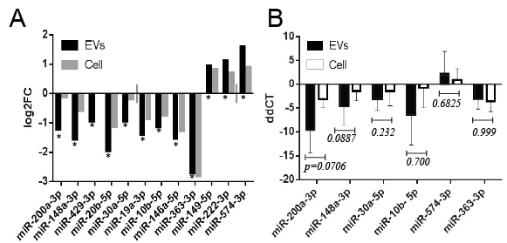

**Figure 3**: *Addition of cavin-1 to PC3 cells modifies EV microRNAs.* **A**) RNA-seq was performed previously on microRNAs contained in the EV and cellular content of PC3-GFP and PC3-cavin-1 cells. DESeq2 analysis compared PC3-GFP to PC3-cavin-1 EV content (black), expressed as log2FC, to determine the effect of cavin-1 on EV miR content. miRs that were significantly modified (* p ≤ 0.05) in the EVs were plotted. Analysis was repeated on cellular content (grey) for each of the miRs significantly modified in the EV. This reveals that cavin-1 has an effect of miR EVs where some effected miRs are not modified in the cell. **B**) RT-qPCR was performed to validate the RNA-seq data. This was performed on EV and cellular RNA content extracted from GFP and cavin-1 PC3 cells to determine relative amount of miR-200a-3p, 148a-3p, 30a-5p, 10b-5p, 574-3p and 363-3p (n > 3). Delta-delta CT (ddCT) was calculated and plotted (ddCT + SEM) by comparing expression of targets to miR-125a-3p. This miR was unchanged in the EV and cell by cavin-1 expression. A Mann-Whitney U test compared EV change to the cellular change for each of the miRs. This analysis confirms the trends found from the RNA-seq data.

and sampling; miR-363-3p. Independent biological replicates of EV and cellular small RNAs were prepared and used for RT-qPCR. As shown in Figure 3B, the trend first displayed by the RNA-seq data (Fig. 3a) is maintained. Consistent with the RNA-seq data, cavin-1 expression led to higher magnitude of reduction of miR-30a-5p, 148a-3p, 10b-5p and 200a-3p in EVs compared to the reduction of their cellular levels. Inversely, miR-574-3p was increased due to the presence of cavin-1 in the EVs, and miR-363-3p is confirmed to be not selectively exported by cavin-1. This result establishes that some miRNAs are indeed selectively exported from PC3 cells, where cavin-1 modulated this export.

## Distinct sequence motifs are overrepresented in differentially exported microRNAs.

Protein-RNA interactions are dictated by specific nucleic acid sequences, or motifs, that are conserved across the targeted RNAs. Here, we attempted to assess whether the selectively exported miRNAs share a sequence motif to explain their selective export. Based on statistical criteria, only 5 miRNAs were selectively exported (fig.3a). However, motif discovery with only 5 miRNAs was not adequate to establish a significant motif (data not shown), so additional miRNAs were selected for this analysis based on their relative levels of change between EV and cell. All 95 miRNAs recorded in the EVs from the RNA-seq data were compared to their cellular change in the form of log2FCEV- log2FCcell (Fig.4a). This provides a single value that reflects how different the EV modifications are from the cell, where selective export results in a large negative (cavin-1 reduces export) or positive (cavin-1 enhances export) value and sampling approximates 0. Expressing these values as a frequency distribution plot reveals how prevalent each form of export is (Fig.4b). This yielded a large population of miRNAs that undergo sampling, around 0.1, but also a small peak at -0.45. The miRNAs that were validated in RT-qPCR were noted on the graph to demonstrate where they fit into this distribution. This shows the selectively exported 200a-3p, 148a-3p and 30a-5p to the far left of the graph, with 363-3p in the sampling population (FC-FC≈0.1) and 574-3p to

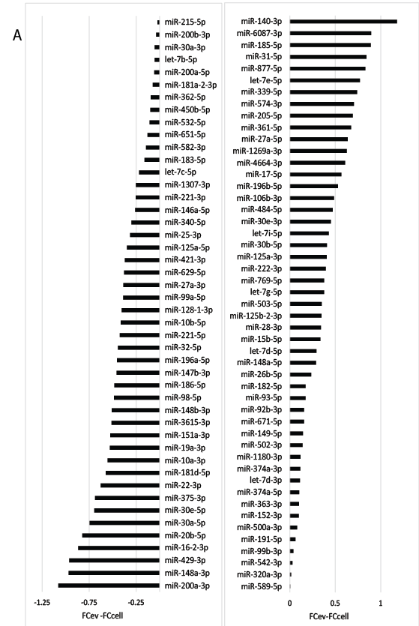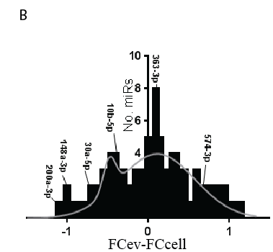

**Figure 4**. *Comparison of microRNA EV and cellular changes inflicted by cavin-1 expression.* **A**) All 95 miRs detected in the EVs were analysed to determine selective or sampling mediated export. Bar graph displays the difference between FCev and FCcell for each miR. **B**) Frequency distribution graph of the FC-FC value, by increments of 0.05, and experimentally validated microRNAs. Line of best fit modelled by sum of two Gaussians. Two major populations are present: sampling peak at 0.1 and selective export at -0.45.

the right of the graph. This corresponds to the groupings established previously (Fig.3a). Hereby, miRNAs that correspond to a FC-FC of -0.45 or lower are considered selectively exported for this motif discovery. 19 miRNAs fulfill this criteria.

Motif discovery, using the MEME algorithm, was used to define stretches of RNA that are shared amongst the differentially exported miRNAs which would be targeted by the miRNA export protein. This analysis returned two distinct motifs that are enriched in the miRNA group that possess reduced export upon cavin-1 expression (Fig.5). These motifs are present within 14 of the 19 miRNAs within this group. Individually, the first motif matches to 12 of the 19 miRNAs and the second correlated to 8 of the 19. As the miRNAs found in the sampling group should not bind to the export protein, it is likely that sampled miRNAs would not contain these motifs if this motif does indeed represent the binding site. Using the sitemap algorithm on all of the 95 miRNAs determines all matches of the motif to the EV contained miRNAs. This returned no significant matches between the motifs and the sampled miRNAs. This reveals potential binding sites the export protein may be able to bind to evoke specificity and selectivity of the targets.

## Candidate proteins are present in EVs with RNA binding ability.

To identify candidate proteins that could mediate this selective miRNA export, EV protein content was assessed for (1) differential export upon cavin-1 expression and (2) RNA-binding ability. The analysis used a previously published quantitative proteomic dataset (Inder et al. 2012). A total of 120 EV proteins were differentially exported upon cavin-1 expression (Fig.6). Since miRNAs of interest were down-regulated by cavin-1, the 109 down-regulated proteins were selected for further GO analysis to determine whether these proteins had previously reported RNA-binding capacities. Together, this yields a total of 5 differentially exported RNA-binding proteins: FUS, hnRNPK, snRPD3, HSP90B1 and ILF2. As members

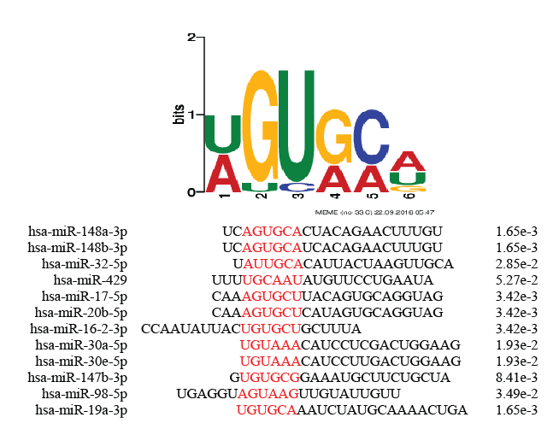

**Figure 5**. *Shared motif contained within a subset of the selectively exported microRNAs.*

Motif discovery using the MEME algorithm revealed a motif from the exported miR

group. Table shows the miRs containing the motif, position of motif (red) and p-value

calculated from the sitemap algorithm. Motif matches to 12 of the 19 miRs in this group.

## Havent put in the second motif yet, need to redo its mapping to miRs so I can get similar table to that shown for the first motif.

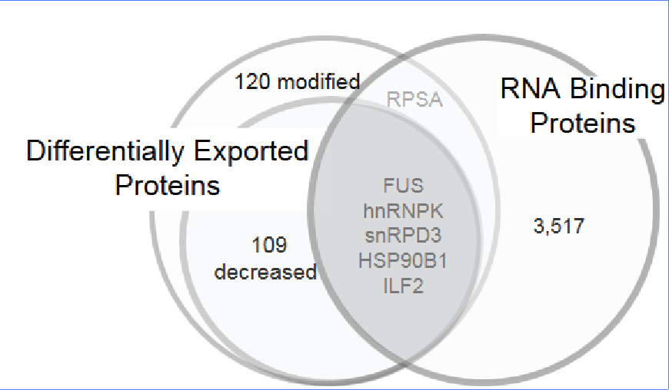

**Figure 6**: *Cavin-1 attenuates the export of RNA binding proteins*. MS/MS data compared the protein content of EVs between PC3 and PC3-cavin-1 cells to determine significantly (p≤0.05) differentially exported proteins. This is divided into proteins modified and proteins reduced in the EVs upon cavin-1 expression. Gene Ontology analysis revealed whether these exported proteins bind RNAs. Number of total RNA binding proteins reflects all human proteins with GO term, GO:0003723. 5 RNA binding proteins had reduced exported upon cavin-1 expression, shown by the shaded region.

of the hnRNP protein family had previously been implemented in miRNA export, focus was shifted to hnRNPK and FUS (also known as hnRNPP2). Interestingly, further investigation into the RNA binding specificity of hnRNPK revealed, through mutagenesis assays, its affinity to bind to sequence AGUGUG in miR-122 (Fan *et al.* 2015). Upon comparison to the known motif, using the FIMO algorithm, hnRNPK matches adequately to the predicted binding motif (p=0.0435). Hereby, hnRNPK was considered a viable candidate protein to mediate the selective export of miRNAs.

## hnRNPK sub-cellular localization modified in cavin-1 PC3 line.

Heterogeneous Nuclear Ribonucleoprotein K (hnRNPK) is primarily a nuclear protein which is known to shuttle to the cytoplasm, where several reports had detected hnRNPK in exosomes. However, the subcellular localization of hnRNPK in PC3 cells, and the effect of cavin-1 on subcellular localization, is unknown. Understanding hnRNPK activity may assist in understanding the differential export of hnRNPK and therefore its effect on miRNA export. Immunofluorescence was performed using hnRNPK specific antibodies to determine cellular localization changed between GFP and cavin-1 cell lines. An initial observation of hnRNPK localization revealed a distinct change between cell lines, from punctate-like structures in PC3-GFP to a perinuclear focus in cavin-1 positive cell lines (Fig.7a). Further co-localization studies were performed to determine what these structures were. CD9 is a commonly used marker for multivesicular bodies and exosome formation. hnRNPK appears to co-localize somewhat with the CD9 protein in GFP PC3 cells, which suggests potential presence in the multivesicular bodies (Fig.7b). However, the hnRNPK in PC3-cavin-1 cells was found present in endoplasmic reticulum, shown by strong overlap with ER resident protein, ERp44 (Fig.7c). No co-localization of hnRNPK with CD9 was observed in PC3-cavin-1 cells. Therefore, change in hnRNPK subcellular localization modified by cavin-1 expression could explain the differential export of hnRNPK and miRNAs.

## hnRNPK co-localizes with selectively exported microRNAs.

hnRNPK has been reported to bind and interact with RNA, but so far there has been only one report of hnRNPK binding miRNA (Fan et al. 2015). The interaction between the selectively exported miRNAs and hnRNPK was assessed in two separate ways: by assessing co-localization by microRNA *in situ* hybridization with immunofluorescence (miR-ISH IF) and binding ability by RNA immunoprecipitation (RIP). miR-ISH IF methodology was established by modifying the existing Fluorescence *In Situ* Hybridization (FISH) methods and IF. The anti-miR probe highlights the target miRNAs based on RNA-RNA hybridization. Here, I assessed the subcellular co-localization of miR-148a-3p, 589-5p, a scrambled form of miR-148a (control) and hnRNPK (Fig.8). miR-148a was assessed as it contains the motif that hnRNPK was predicted to bind and possesses decreased export upon cavin-1 expression. In contrast, miR-589 was seen to be unaffected by expression of cavin-1 in cell and EVs in RNA-seq analysis. This establishes a negative biological control that determines natural miRNA localization when not affected by any export mechanism or expression variation between cell lines. Copies of pri-miR (primary microRNA transcript) for miR-148 and 589 are believed to be present in the nucleolus (Ritland Politz *et al.* 2009). Therefore the nucleolar localization of the Cy5 probes (excluding scrambled) confirms that the ISH was successful and that these miRNAs are expressed in these cells. MiR-148a does seem to localize to punctate structures in the cytoplasm of PC3-GFP cell lines, presumably indicating presence in the multivesicular bodies that is not occurring in the PC3-cavin-1 cell lines. Interestingly, miR-148a co-localized with hnRNPK in PC3-GFP cells, shown by overlap towards the cells periphery (Fig.8). However no evidence of hnRNPK-miR-148 co-localization was observed in the PC3-cavin-1 cells (Fig. 8). Conversely, miR-589 displayed a non-specific localization in both cell lines, despite varying cell lines and hnRNPK

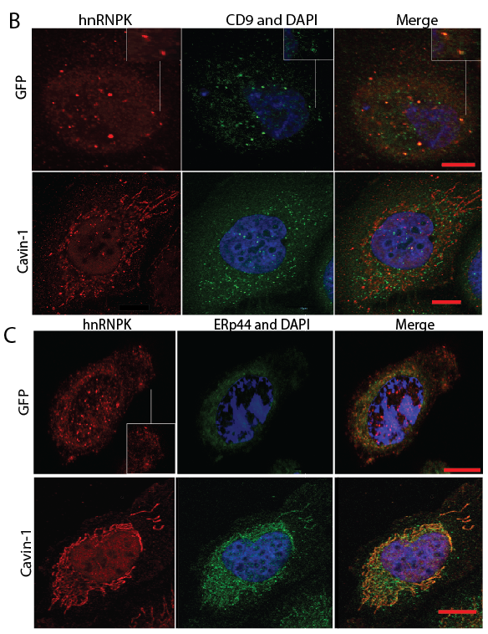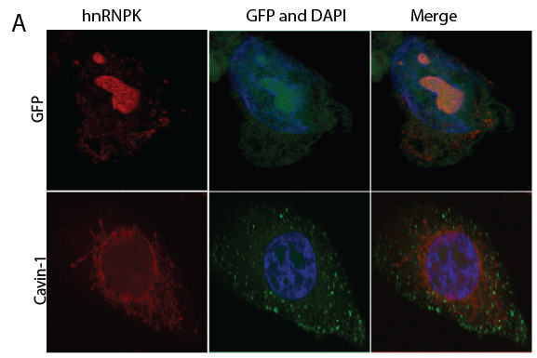

**Figure 7**: *hnRNPK changes subcellular localization between PC3 GFP and PC3-cavin-1 cell lines*. Immunofluorescence completed on PC3 GFP or cavin-1 cell lines was used to assess changes in hnRNPK activity, particularly localization. **A**) hnRNPK (red) was detected in punctate cytoplasmic structures and nucleolus of GFP PC3 cells and in perinuclear structures in cavin-1 PC3 cells. Green channel shows position of GFP or GFP tagged cavin-1 **B**) Confocal images display hnRNPK (red) and CD9 (green) co-localization to assess the identity of the punctate structures. Inset highlights co-localization. **C**) ERp44 (green) and hnRNPK (red) visualised by fluorescence microscopy in PC3-GFP and PC3-cavin-1 cell lines. Scale bar represents 10μm. DAPI stain (blue) present in each sample. Images are representative of at least 3 replicate experiments.

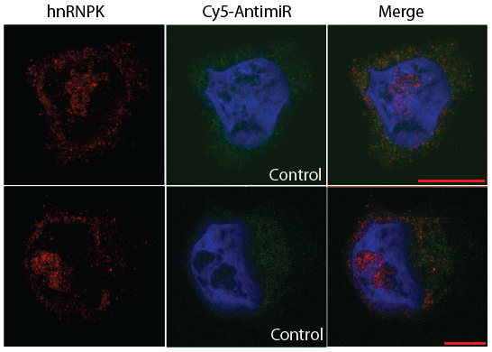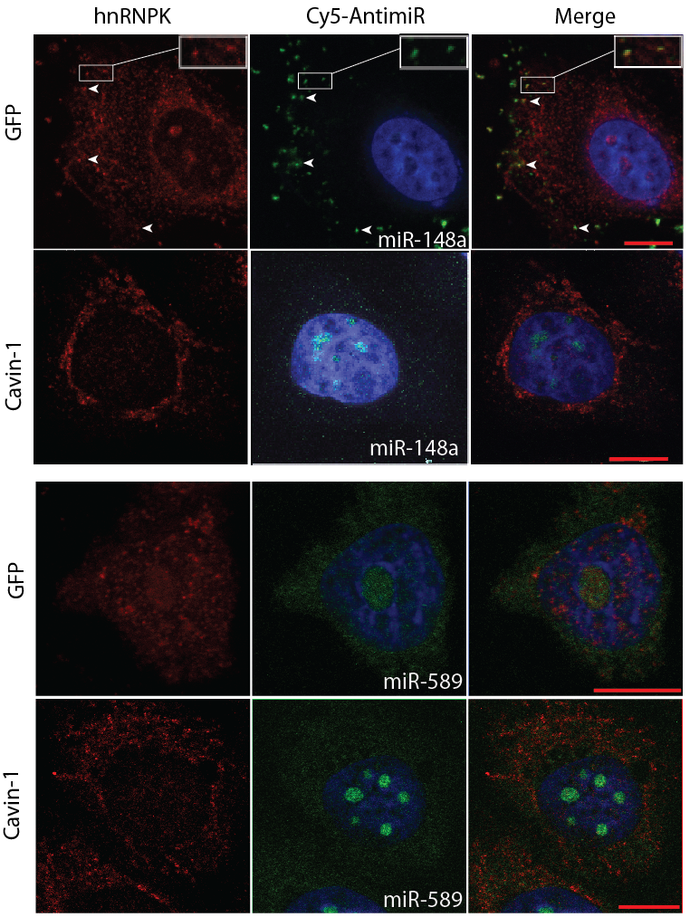

**Figure 8***. miR-148a co-localizes with hnRNPK in situ*. Representative images show localization of hnRNPK (red) and fluorophore tagged (Cy5) anti-miR (pseudocoloured green) in PC3-GFP and PC3-cavin-1 cell lines, with DAPI stain (blue). MicroRNA targets include selectively exported 148a-3p (top left), miR-589-3p biological control (bottom left) and technical control; scrambled-148a oligo (top right). Yellow overlap between red hnRNPK and green anti-miR and boxed areas indicate examples of co-localization. Scale bar represents 10μm. Images are representative of at least 2 replicate experiments.

localization. Lastly, control condition showed that the Cy5-scrambled miR did not localize to the nucleolus or to any structures in particular. Therefore, the concentrated fluorescent signal in punctate structures containing hnRNPK confirms co-localization of miR-148a and hnRNPK in GFP cells that is lacking in the PC3-cavin-1 cell line.

## hnRNPK binds RNAs in the PC3 cell line.

Having demonstrated co-localization between hnRNPK with miR148a in PC3 cells, and the loss of this co-localization upon cavin-1 expression, next I attempted to demonstrate their direct interaction using immunoprecipitation (IP). Initial experiments were performed to confirm the specificity of the hnRNPK antibody by immunoblotting (not shown) and to optimize hnRNPK antibody coupling to protein G DynaBead, as well as using these beads for IP (not shown). As the RNA-protein interaction can be fairly transient, cellular material was crosslinked by formaldehyde prior to the co-IP. After elution from the IP beads, a western blot was performed to determine if IP conditions were suitable to pull down the targets of hnRNPK antibody (Fig.9a). This is observed as a band approximating 58-62kDa that reflects the native weight of hnRNPK. Additional bands at 70, 100, 125 and approximately 140kDa presumably reflect hnRNPK bound to various partners in this IP, including proteins, RNAs and miRNAs. Next, I attempted to purify the RNAs that hnRNPK binds. After purification by TRIzol extraction (which also reverses formaldehyde crosslinks), the RNA was quantified using Nanodrop. This yielded a consistent increase of RNA identified from the hnRNPK pull down compared to the IgG control (Fig.9b). This is consistent with past research that shows hnRNPK binding to RNAs and reports of it binding miRNAs (Klimek-Tomczak *et al.* 2004; Fan et al. 2015). While this is instrumental in determining whether hnRNPK binds to miRNAs, the low yield indicates the need to scale up the experiments. Further assessment is needed to determine whether this population of RNA contains microRNAs and whether these miRs are the ones also predicted.

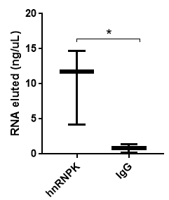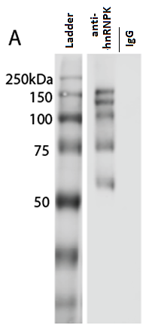

B

**Figure 9**: *hnRNPK binds RNA in PC3 cells.* **A)** Western blotting of elutant from anti-hnRNPK and anti-IgG immunoprecipitation experiment. Crosslinked protein from PC3 whole cell lysates was applied to rabbit hnRNPK or IgG antibody conjugated Dynabeads, eluted in SDS-page buffer, and blotted with mouse hnRNPK antibody to detect hnRNPK and its binding partners. Lane 2 (anti-hnRNPK) bands reflect the native weight of hnRNPK (≈60kDa) and hnRNPK bound material (≥75kDa) whereas lane 3 (control IgG) reveals no bands. **B)** Box and whisker plot displaying the nanodrop RNA quantification of RNA eluted from hnRNPK IP experiment. Each point summarises the mean, minimum and maximum RNA concentration (ng/μL) eluted from three IP experiments for anti-hnRNPK and IgG control. A two-sided Mann Whitney U-test revealed a significant (* p=0.0402) difference between test and control.

# Discussion:

This study determined that a subset of microRNAs are selectively exported from the PC3 cell line, where addition of cavin-1 attenuated this export. Furthermore, a protein predicted to mediate this export proved to be a viable candidate due to being selectively exported, predicted to bind to many of those exported miRs and co-localizing to miR-148a.

Points to discuss:

* RNA-seq data: microRNAs aren’t so dramatically modified by the proteins. System is definitely a gradient rather than a switch. ~~May suggest synergy of proteins working together,~~ differences between EV types being modified by cavin-1 eg mechanism in exosomes but not microvesicles, maybe?. Additionally there is nothing to prevent sampling from occurring, where if the export protein isn’t there there still isn’t anything preventing miRs going into forming EVs.
* Validation with rt-qpcr, while confirms trends, the analysis struggles to yield significant results; discuss why and use of ddPCR.
  + Relevance with the field: IE relation of these microRNAs to disease and what that means for this system. Eg. What does export of miR-429 even mean for the recipient cell? How does past data fit in with this?
  + ~~Do these differentially exported miRs relate to clinical findings? Eg. Exported miR-148a from prostate cancer makes sense as its role with oestoclastogensis is consistent with advanced prostate cancer.~~
* ~~Motifs: discuss that some do not contain the motif but seem to be differentially exported. Ie. This would come back to the multiple proteins involved with same process.~~
* ~~hnRNPK information: family members associated with the function, ability to bind to the motif/miRs. Role in cancer on its own, usually related to increase or decrease in cytoplasm/nucleus (Helpful paper: Emerging roles of heterogeneous nuclear ribonucleoprotein K (hnRNP K) in cancer progression)~~
* hnRNPK localization to cd9 positive MVB and whether that’s been detected before. What it could mean (duh, export) etc. Any issues with this analysis? Why isn’t every MVB hnRNPK positive, and why isn’t every hnRNPK dot co-localizing with CD9?
* Discus co-localization miRISH results and how that help the hypothesis. Discus concerns with methodology set up: eg unlikely for the probe to be binding the target miR if in active site so maybe we aren’t visualizing miRs actively being bound, but rather, together in lipid bound vesicles but not necessarily bound. Then suggest alternative methods.
* microRNA localization discussion: What is currently known about microrna localization in genrereal and how that might relate to this data. Seeing as mir-148a is no longer in the cytoplasm in cavin-1 is this indicative of some mechanism helping the phenotype/ binding affinity/effect of hnrnpk.
* Discuss binding of hnRNPK to RNA. This is consistent with previous results however doesn’t establish anything new. Need to scale up, rethink approach, and try specific techniques. Limitation in this method, IE. Binding is probably only transient to the protein, hence the low pull down amounts. Additionally, it gives all information about hnRNPK binding partners but nothing of the microRNA ability to bind. Ideally, fixing microRNA to beads (eg streptavidin-biotin system) and pulling down its binding partners would provide more information about the system.
* Significance: what does this mean for microRNA research? What does this mean for EV research? How does this link back to the original issue of caveolin-1 in prostate cancer?
* Future directions.

Aung, C. S., et al. (2011). "PTRF-cavin-1 expression decreases the migration of PC3 prostate cancer cells: role of matrix metalloprotease 9." Eur J Cell Biol **90**(2-3): 136-142.

Balcells, I., et al. (2011). "Specific and sensitive quantitative RT-PCR of miRNAs with DNA primers." BMC Biotechnology **11**(1): 1-11.

Bubendorf, L., et al. (2000). "Metastatic patterns of prostate cancer: An autopsy study of 1,589 patients." Human Pathology **31**(5): 578-583.

Chatterjee, M., et al. (2015). "Caveolin-1 is Associated with Tumor Progression and Confers a Multi-Modality Resistance Phenotype in Pancreatic Cancer." Scientific Reports **5**: 10867.

Cheng, P., et al. (2013). "miR-148a regulates osteoclastogenesis by targeting V-maf musculoaponeurotic fibrosarcoma oncogene homolog B." J Bone Miner Res **28**(5): 1180-1190.

Costa-Silva, B., et al. (2015). "Pancreatic cancer exosomes initiate pre-metastatic niche formation in the liver." Nat Cell Biol **17**(6): 816-826.

Djuranovic, S., et al. (2012). "miRNA-Mediated Gene Silencing by Translational Repression Followed by mRNA Deadenylation and Decay." Science **336**(6078): 237-240.

Dovrat, S., et al. (2014). "14-3-3 and β-catenin are secreted on extracellular vesicles to activate the oncogenic Wnt pathway." Molecular Oncology **8**(5): 894-911.

Dreyfuss, G., et al. (2002). "Messenger-RNA-binding proteins and the messages they carry." Nat Rev Mol Cell Biol **3**(3): 195-205.

Fan, B., et al. (2015). "Heterogeneous Ribonucleoprotein K (hnRNP K) Binds miR-122, a Mature Liver-Specific MicroRNA Required for Hepatitis C Virus Replication." Mol Cell Proteomics **14**(11): 2878-2886.

Friedman, R. C., et al. (2009). "Most mammalian mRNAs are conserved targets of microRNAs." Genome Res **19**(1): 92-105.

Grande-García, A., et al. (2007). "Caveolin-1 regulates cell polarization and directional migration through Src kinase and Rho GTPases." The Journal of Cell Biology **177**(4): 683-694.

Gumulec, J., et al. (2012). "Caveolin-1 as a potential high-risk prostate cancer biomarker." Oncology Reports **27**(3): 831-841.

Ha, M. and V. N. Kim (2014). "Regulation of microRNA biogenesis." Nat Rev Mol Cell Biol **15**(8): 509-524.

Hansen, C. G., et al. (2009). "SDPR induces membrane curvature and functions in the formation of caveolae." Nature Cell Biology **11**(7): 807-814.

Hayashi, T., et al. (2015). "Expression of CAVEOLIN 1 in uterine mesenchymal tumors: No relationship between malignancy and CAVEOLIN 1 expression." Biochemical and Biophysical Research Communications **463**(4): 982-987.

Hedlund, M., et al. (2011). "Thermal- and Oxidative Stress Causes Enhanced Release of NKG2D Ligand-Bearing Immunosuppressive Exosomes in Leukemia/Lymphoma T and B Cells." PLoS ONE **6**(2): e16899.

Hill, M. M., et al. (2008). "PTRF-Cavin, a Conserved Cytoplasmic Protein Required for Caveola Formation and Function." Cell **132**(1): 113-124.

Inder, K. L., et al. (2014). "Cavin-1/PTRF alters prostate cancer cell-derived extracellular vesicle content and internalization to attenuate extracellular vesicle-mediated osteoclastogenesis and osteoblast proliferation." J Extracell Vesicles **3**.

Inder, K. L., et al. (2012). "Expression of PTRF in PC-3 Cells modulates cholesterol dynamics and the actin cytoskeleton impacting secretion pathways." Mol Cell Proteomics **11**(2): M111.012245.

Kharmate, G., et al. (2016). "Epidermal Growth Factor Receptor in Prostate Cancer Derived Exosomes." PLoS ONE **11**(5): e0154967.

Klimek-Tomczak, K., et al. (2004). "Characterization of hnRNP K protein-RNA interactions." J Mol Biol **342**(4): 1131-1141.

Kosaka, N., et al. (2010). "Secretory mechanisms and intercellular transfer of microRNAs in living cells." J Biol Chem **285**(23): 17442-17452.

Lee, J. T. Y., et al. (2011). "Simple Modifications to Standard TRIzol® Protocol Allow High-Yield RNA Extraction from Cells on Resorbable Materials." Journal of Biomaterials and Nanobiotechnology **02**(01): 41-48.

Luz, M. A. and A. G. Aprikian (2010). "Preventing bone complications in advanced prostate cancer." Current Oncology **17**(Suppl 2): S65-S71.

McKechnie, N. M., et al. (2006). "Fas-ligand is stored in secretory lysosomes of ocular barrier epithelia and released with microvesicles." Experimental Eye Research **83**(2): 304-314.

McMahon, K.-A., et al. (2009). "SRBC/cavin-3 is a caveolin adapter protein that regulates caveolae function." The EMBO Journal **28**(8): 1001-1015.

Mili, S., et al. (2001). "Distinct RNP complexes of shuttling hnRNP proteins with pre-mRNA and mRNA: candidate intermediates in formation and export of mRNA." Mol Cell Biol **21**(21): 7307-7319.

Montecalvo, A., et al. (2012). "Mechanism of transfer of functional microRNAs between mouse dendritic cells via exosomes." Blood **119**(3): 756-766.

Moon, H., et al. (2014). "PTRF/cavin-1 neutralizes non-caveolar caveolin-1 microdomains in prostate cancer." Oncogene **33**(27): 3561-3570.

Moumita, C., et al. (2015). "Caveolin-1 is Associated with Tumor Progression and Confers a Multi-Modality Resistance Phenotype in Pancreatic Cancer." Scientific Reports **5**.

Palma, J., et al. (2012). "MicroRNAs are exported from malignant cells in customized particles." Nucleic Acids Research **40**(18): 9125-9138.

Pegtel, D. M., et al. (2014). "Extracellular vesicles as modulators of cell-to-cell communication in the healthy and diseased brain." Philosophical Transactions of the Royal Society B: Biological Sciences **369**(1652): 20130516.

Ramteke, A., et al. (2015). "Exosomes secreted under hypoxia enhance invasiveness and stemness of prostate cancer cells by targeting adherens junction molecules." Mol Carcinog **54**(7): 554-565.

Reddi, K. K. and J. F. Holland (1976). "Elevated serum ribonuclease in patients with pancreatic cancer." Proceedings of the National Academy of Sciences **73**(7): 2308-2310.

Ritland Politz, J. C., et al. (2009). "MicroRNAs with a nucleolar location." RNA **15**(9): 1705-1715.

Song, X., et al. (2016). "Cancer Cell-Derived Exosomes Induce Mitogen-Activated Protein Kinase-Dependent Monocyte Survival by Transport of Functional Receptor Tyrosine Kinases." Journal of Biological Chemistry.

Towbin, H., et al. (1979). "Electrophoretic transfer of proteins from polyacrylamide gels to nitrocellulose sheets: procedure and some applications." Proc Natl Acad Sci U S A **76**(9): 4350-4354.

Tsui, N. B., et al. (2002). "Stability of endogenous and added RNA in blood specimens, serum, and plasma." Clin Chem **48**(10): 1647-1653.

Villarroya-Beltri, C., et al. (2013). "Sumoylated hnRNPA2B1 controls the sorting of miRNAs into exosomes through binding to specific motifs." Nat Commun **4**.

Wu, H.-C., et al. (2011). "Significant Association of Caveolin-1 (CAV1) Genotypes with Prostate Cancer Susceptibility in Taiwan." Anticancer Research **31**(2): 745-749.

Wysoczynski, M. and M. Z. Ratajczak (2009). "LUNG CANCER SECRETED MICROVESCILES: UNDERAPPRECIATED MODULATORS OF MICROENVIRONMENT IN EXPANDING TUMORS." International journal of cancer. Journal international du cancer **125**(7): 1595-1603.

Zhou, W., et al. (2014). "Cancer-secreted miR-105 destroys vascular endothelial barriers to promote metastasis." Cancer Cell **25**(4): 501-515.