Photo one

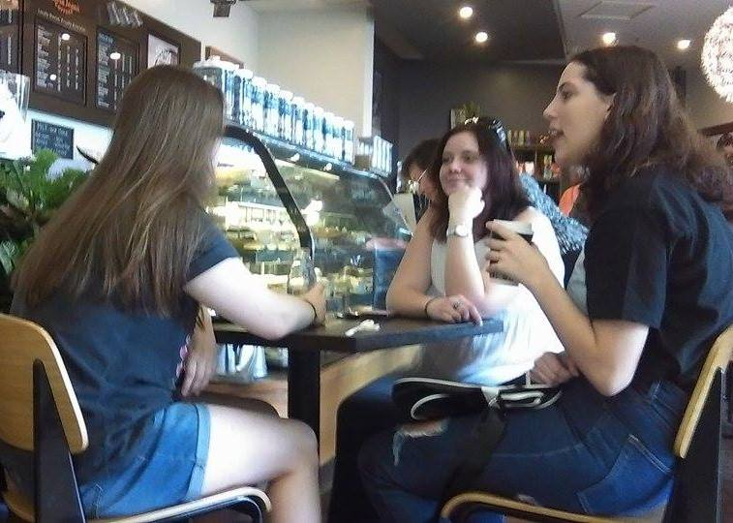

**Sunshine journey**

Gympie Centro 2 September, 2016.

Jenna Erickson, 18, Rachel Benstead, 18 and Kate Stonier, 18 prepare for sun, surf and sand as they head to the Sunshine Coast for a relaxing weekend. Miss Erickson, originally from Perth, and her friends enjoy heading to the Coast during the weekend as the environment is friendly and the beaches are beautiful. “The coast is the place to be really. It’s such an amazing place it has great places to shop and yet is doesn’t have the big city feel to it.” Miss Erickson said.

For this photo I utilized the rule of thirds specifically, to centre the focus on the ladies discussing plans for their coastal trip. Here, the focal points lie on the ladies face in the back, where the other two ladies align with the outer two thirds (Left and right). This technique is well known to improve balance of the photo, making it feel more natural and relaxed. The natural lighting also accompanies the relaxed feel. I added to this by angling the capture at medium high and almost eye level to the subjects as to draw the viewer into the photo and make it look like the plans may include them. By keeping the subjects level like this, it gives the photo a much less professional and laid back feel to convey relaxation, as if on a holiday.

Photo two

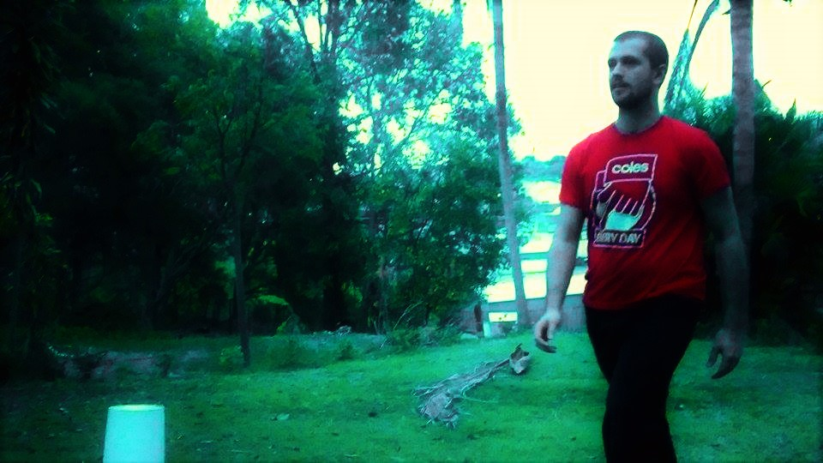

**Daylight affects**

Gympie, 9 September, 2016.

Coles employee and university student Brady McGregor, 24, walks to work for his shift as a night fill worker at dusk. Mr McGregor is quite happy to make the change to day light savings in Queensland. “I feel that daylight savings would really benefit me as I can enjoy more sunlight between coming home from university and starting night shift. I might not have to walk [to work] in the dark so much.” He said.

The photo above depicts a man in a Coles uniform walking against setting sunlight. I used contrasting lighting, shown by the darken trees but bright sky, to convey changing daylight. This relates to the story brief about daylights savings and how many businesses are willing to take on these new changes. My subject is happy about the story content and is illuminated by the natural but dwindling light. Additionally, this use of the sunset allows viewers to roughly see the lighting conditions my subject usually walks to work in but also conveys a walk into darkness as he approaches the dark trees. There is a sight tilt to the photo that I used to show movement. Rule of thirds was also used here to focus on the man. This causes the man to be off centre which can give a sense of direction; from light to the dark.

Photo three

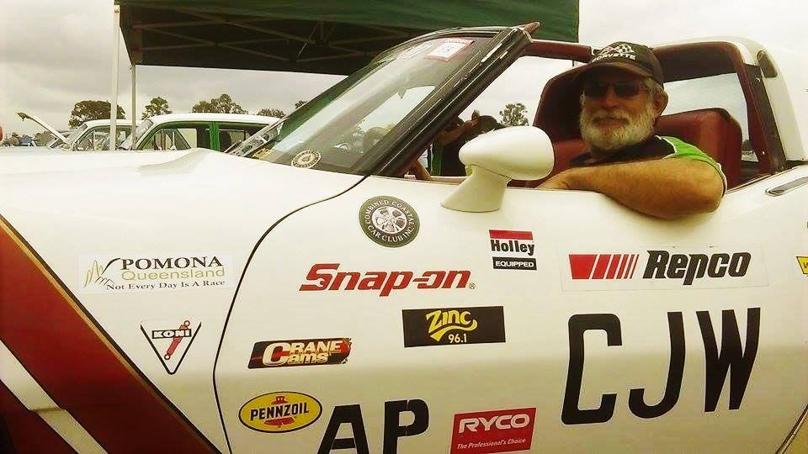

**Hobby car**

Gympie showgrounds**,** 10 September, 2016.

Combined Coastal Car Club Inc. member Cliff Watson, 56, placed a great deal of pride in his 1969 Corvette Stingray while driving around Gympie on Saturday. Mr Watson and his club head out every weekend to car shows to show off their variety of rare cars; his favourite being the Stingray. “I bought this beauty five years ago, best investment I ever made. I love driving it. My wife loves driving it. It’s why I’m in this club. Cars are my life” he said.

Thisenvironmental portraiture shows the subject doing what he loves; driving around in his car. It is important in environmental portraits to equally depict the subject and the environment they are in which is why I chose to use the techniques the way I did. I selected a low angle shot to include the stickers and the subject at the wheel of the car to make the car look big and powerful. I had to alter the lighting setting as the weather conditions were not ideal. However, the change to the lighting adds a brighter element to the photo as it was something the subject was extremely proud of and wanted to convey. The glasses he had on could not have been removed as they were corrective lenses. This shot also adheres to the rule of thirds, where the focal point is centred on the subjects face. This can make the driver seem like they are about to drive away and I wanted that effect to this photograph.

Photo four

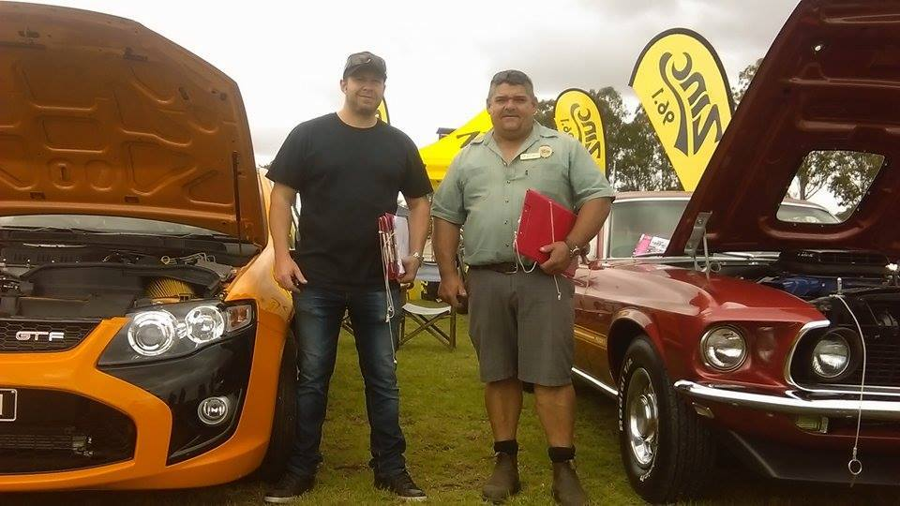

**Dyno day**

Gympie showgrounds**,** 10 September, 2016.

Dyno show founder Barry Mclean, 50, and dating officer Ivor Kempson, 39, judging cars at the 4th annual Dyno Show day and swap meet. President of the show for the past 3 years, Mr Mclean and his assistant officer, Mr Kempson are amazed at how many people showed up to the annual car show which battled unfortunate the weather conditions over the weekend. “The Dyno day has been running for the past 4 years and the swap meet has been running for the past 48 years. But I’m still surprised to see how many people show up even in weather conditions such as this.” Mr Mclean said.

With my final photo I decided to use many techniques. I went with an environmental portraiture of the subjects in their element, being the car show, where you can see clipboard props and cars to establish their environment. I used framing around the subjects by getting the subjects to stand between two brightly coloured cars which they were judging at the time. This focuses in on the subjects. I chose natural light in this photo as I felt it illuminated the subjects in the most perfect way; not to dark but bright and warm thus establishing a friendly vibe. I took a low angle shot to make the subjects seem larger to depict how important the subjects are to the story about the Dyno Day show.