Photo one



**Sunshine journey**

Gympie Centro 2 September, 2016.

Jenna Erickson, 18, Rachel Benstead, 18 and Kate Stonier, 18 prepare for sun, surf and sand as they head to the Sunshine Coast for a relaxing weekend. Miss Erickson, originally from Perth, and her friends enjoy heading to the Coast during the weekend as the environment is friendly and the beaches are beautiful. “The coast is the place to be really. It’s such an amazing place it has great places to shop and yet is doesn’t have the big city feel to it.” Miss Erickson said.

Used: rule of thirds, eye level, medium shot.

Photo two

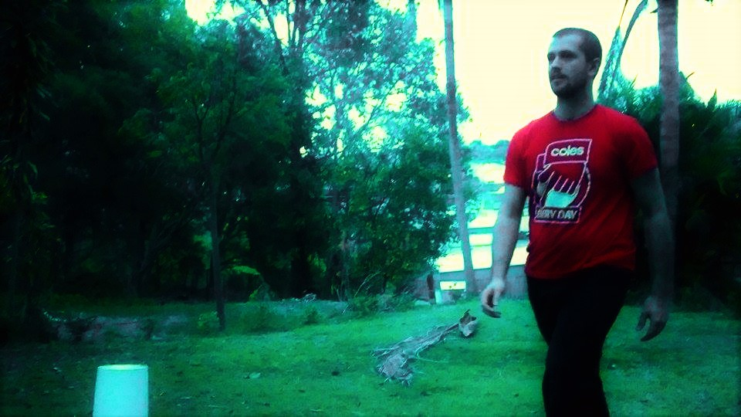

**Daylight affects**

Gympie, 9 September, 2016.

Coles employee and university student Brady McGregor, 24, walks to work for his shift as a night fill worker at dusk. Mr McGregor is quite happy to make the change to day light savings in Queensland. “I feel that daylight savings would really benefit me as I can enjoy more sunlight between coming home from uni and starting night shift. I might not have to walk [to work] in the dark so much.” He said.

Used: contrasting lighting, by using the sunset, it can establish a contrast in light to represent the main theme, daylight savings.

Photo three

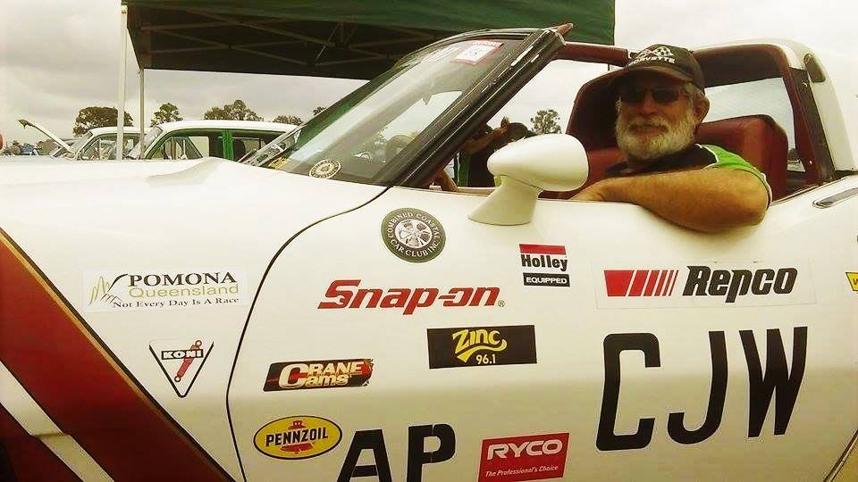

**Hobby car**

Gympie showgrounds**,** 10 September, 2016.

Combined Coastal Car Club Inc. member Cliff Watson, 56, placed a great deal of pride in his 1969 Corvette Stingray while driving around Gympie on Saturday. Mr Watson and his club head out every weekend to car shows to show off their variety of rare cars; his favourite being the Stingray. “I bought this beauty five years ago, best investment I ever made. I love driving it. My wife loves driving it. It’s why I’m in this club. Cars are my life” he said.

**Used: portraiture. Rule of thirds, low angle?**

Photo four

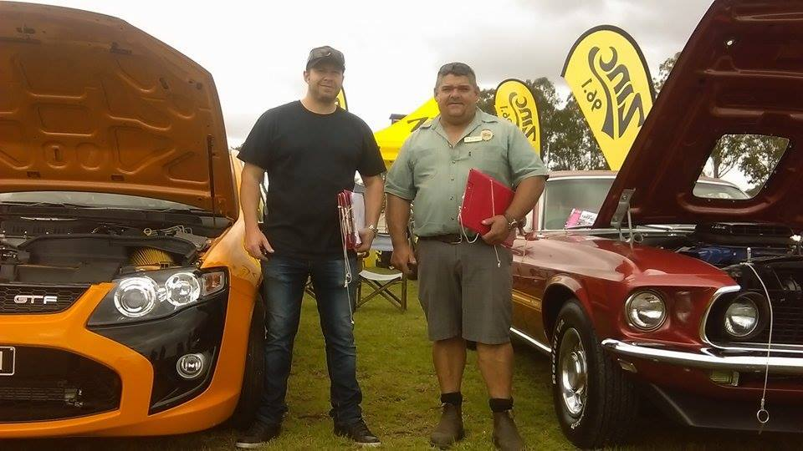

**Dyno day**

Gympie showgrounds**,** 10 September, 2016.

Dyno show founder Barry Mclean, 50, and dating officer Ivor Kempson, 39, judging cars at the 4th annual Dyno Show day and swap meet. President of the show for the past 3 years, Mr Mclean and his assistant officer, Mr Kempson are amazed at how many people showed up to the annual car show which battled unfortunate the weather conditions over the weekend. “The Dyno day has been running for the past 4 years and the swap meet has been running for the past 48 years. But I’m still surprised to see how many people show up even in weather conditions such as this.” Mr Mclean said.

Used: framing, low angle, natural lighting, environmental portraiture.