Supplemental Figure S1 - Cell growth properties of SW480 and SW620. The proliferation rate of SW480 and SW620 was demonstrated using the MTT assay. SW620 were shown to have a higher rate of proliferation than SW480 from 4 day cell culture (A). For migration, SW620 cells showed a decreased migration using the wound-healing assay in comparison to SW480 (B). Magnification 200×. For cell adhesion, SW480 were shown to have a greater cell-matrix adhesion capacity to collagen in comparison to SW620 (C). Magnification 200×. Student’s paired t-test (p < 0.05). Error bars, ± 1 standard deviation for three replicate experiments. The colony formation assay demonstrated increased colony size and frequency for SW620 in comparison with SW480 (D), demonstrating increased anchorage-independent growth. Magnification 20×. For cell invasiveness, SW620 showed a higher penetrance through the collagen-matrigel than SW480, with increased cell branching in SW620 which were not present in SW480 (E). Magnification 40×.

Supplemental Figure S2 - MASCOT search results of the peptide sequence LIEDNEYTAR from Src. The peptide was manually validated and the MASCOT MS/MS profile for the peptide “LIEDNEYTAR” shown (m/z 612.29, ions score 46, only y and b series shown).

Supplemental Figure S3 - Subcellular localization of SW480 and SW620 exosome and soluble-secreted datasets based on UniProt protein annotation. SW480-Exos (A), SW620-Exos (B), SW480-SS (C), and SW620-SS (D).

Supplemental Figure S4 - Functional classification of SW480 and SW620 exosome and soluble-secreted datasets based on UniProt protein annotation. SW480-Exos (A), SW620-Exos (B), SW480-SS (C), and SW620-SS (D).

Supplemental Figure S1

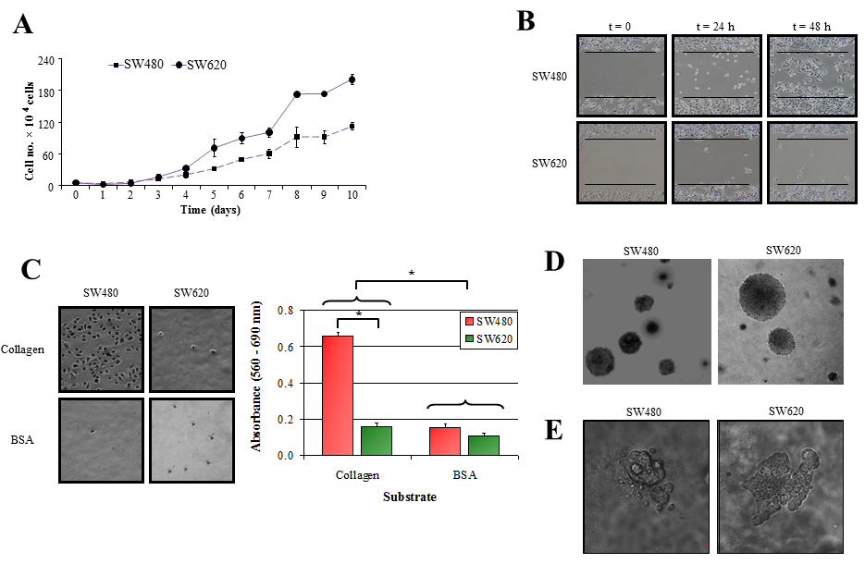

Supplemental Figure S2

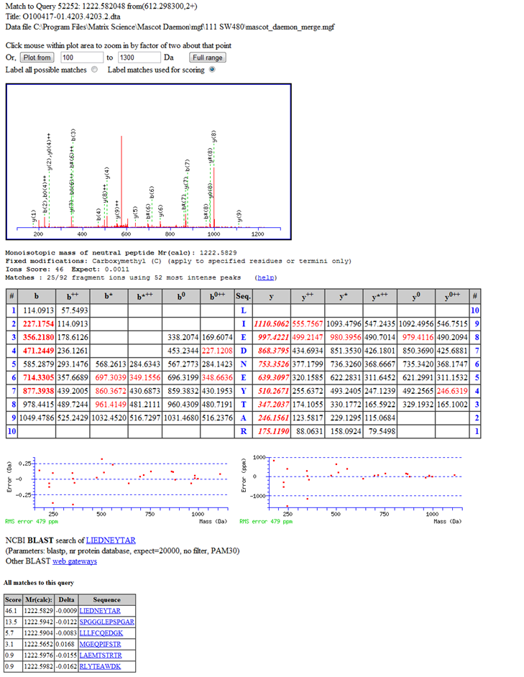

Supplemental Figure S3

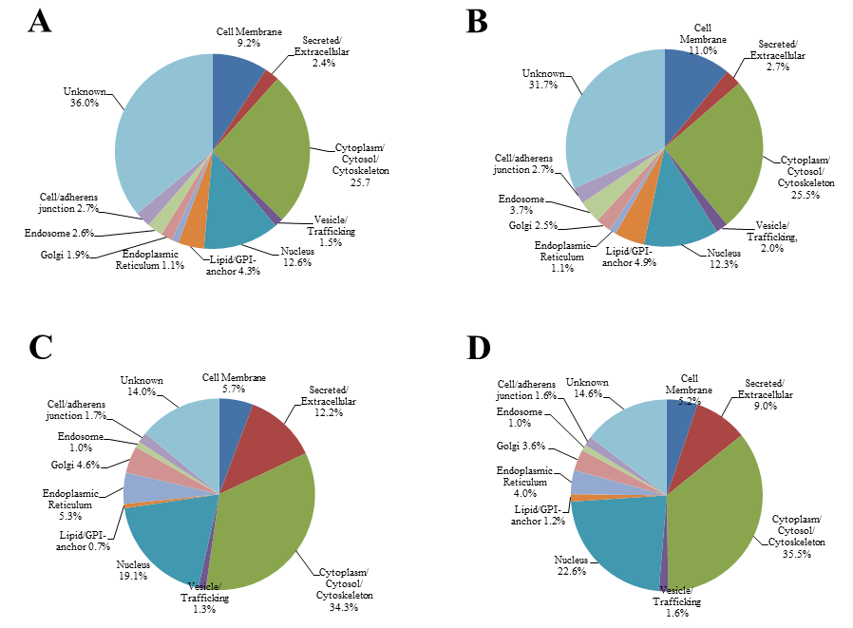

Supplemental Figure S4

