PROJECT – 1

Baby Name Popularity Ranking

PROG8580 - Computer Programming
Professor Srdjan Toholj

GROUP 2
Jinu John – 8932097
Deepthi Dineshan – 8943346
Nguyen Hai Anh Tran – 9013769
Anjali Sharma – 9005370

Table of Contents
1. Analysis: 3
a. Problem description 3
b. Input 3
c. Output 3
d. Implementation 3
2. Design 5
a. Pseudo Code 5
b. Flowchart 9
3. Coding 12
a. Source Code 12
b. Program 17
4. Testing 22
a. Testcase 1: all input values are valid and the name is ranked 22
b. Testcase 2: all input values are valid and the name is not ranked 23
c. Testcase 3: year input is less than minimum of year range 24
d. Testcase 4: year input is valid and gender input is invalid 25
e. Testcase 5: year input is greater than maximum of year range 26
f. Testcase 6: continue searching for next input values 27
g. Testcase 7: stop searching after getting result 28

Analysis:

Problem description
The program is developed to allow users to search for baby name rankings based on a specific year, gender, and name. The program retrieves data from pre-existing text files containing baby name rankings from 2001 to 2010. The application should allow the user to input a year, gender, and name. It will then provide the rank of the specified name for the given year. If the name is not ranked, an appropriate message should be displayed.

Input
- Year (datatype is integer): The program accepts a year from the user, which must be between 2001 and 2010 (inclusive).
- Gender (datatype is string): The user must specify the gender of the name they want to look up, using "M" for male or "F" for female, lower case and upper case are accepted.
- Name (datatype is string): The user provides the baby name to be checked in the ranking list for the specified year, no case sensitive.
- The popularity ranking of baby names from years 2001 to 2010 are downloaded from www.ssa.gov/oact/babynames (stored in files named babynameranking2001.txt, babynameranking2002.txt, …, babynameranking2010.txt in the zip file). Files contain one thousand lines, each line contains a ranking, a boy’s name, number for the boy’s name, a girl’s name, and number for the girl’s name.
- Continue checking (datatype is string): After receiving the result of the most recent search, the user is prompted to decide whether to check another case. “Y” indicates that the program should continue (no case sensitive), and other input should cease.

Output
- Ranking: The program returns the rank of the given name for the selected year and gender.
Example: If the name is "Jacob" and the user inputs 2001 and "M", the program should return "Jacob is ranked #1 in 2001."
- Not Ranked: If the name does not appear in the top 1000 names for that year, a message should indicate that the name is not ranked.
Example: "The name Liam is not ranked in 2001."
- Error Messages: The program should provide error messages for the following situations:
If the input year is out of range (not between 2001 and 2010).
If the gender input is not valid (neither "M" nor "F").
If there's an issue reading the data file (handled via a try-catch for file handling).

Implementation
- Process
- Data Loading
- The program reads from a series of files (babynameranking2001.txt, babynameranking2002.txt, etc.) that contain the rankings of baby names for each year. The files are assumed to be formatted in a specific way, with ranks, boy names, and girl names in each line.
- The names for boys and girls should be stored in two separate 2D arrays (boyNames and girlNames), where each row corresponds to a year, and each column represents the rank (up to 1000 entries per year).
- Input Validation
- The year must be validated to ensure it's between 2001 and 2010.
- The gender input must be validated to ensure it is either "M" or "F".
- Name Lookup
- Based on the user's inputs (year and gender), the program searches the appropriate array (boyNames for male, girlNames for female) to find the rank of the specified name.
- If the name is found, the program returns the rank.
- If the name is not found within the top 1000 names, the program returns a message indicating that the name is not ranked.
- Continuation
- The program should prompt the user whether they want to continue searching for other names.
- The user can input "Y" or "y" to continue or "N" or "n" or anything except “y” and “Y” to end the program.
- Exception Handling
- File handling: The program should handle errors that might occur during file reading (e.g., missing files or file read errors) using a try-catch block.
- User Input Errors:
- If the year is outside the valid range, the user should be prompted to re-enter a valid year.
- If the gender input is invalid, the user should be prompted to input either "M" or "F".
- Flow
- The program first loads the data from the files into two arrays (boyNames and girlNames).
- It then prompts the user for inputs: year, gender, and name.
- Based on these inputs, the program looks up the name’s ranking from the corresponding array.
- The result is displayed, and the user is asked if they want to continue with another name lookup.
- Assumption
- The program only supports ranking data from 2001 to 2010.
- It can only search names in the top 1000 rankings for each year

Design

Pseudo Code
//Main Method
BEGIN
// Initialize arrays to store boy and girl name (10 years and 1000 names)
DECLARE boyNames as 2D array [10][1000]
DECLARE girlNames as 2D array [10][1000]

// Start main function
// Call method to read name ranking data from files
CALL readFiles()

//Create Scanner object to get user input
DECLARE input as Scanner

// Initialize continuation variable
SET continueProgram to “Y”

DO
// Get year input from user
PRINT “Enter the year: ”
READ year
// Ensure the year is between 2001 and 2010
WHILE year is not between 2001 - 2010
PRINT “The year is out of range! Please choose a year from 2001 to 2010: ”
READ year
END WHILE

// Get gender input from user
PRINT “Enter the gender: ”
READ gender
//Ensure gender is either "M", “m” or "F", “f”
WHILE gender is not “M” and “m” and not “F” and “f”
PRINT “Please type M for male or F for female: ”
READ gender
END WHILE

// Get name input from user
PRINT “Enter the name: ”
READ name

// Get ranking for the input name
CALL getRanking(year, gender, name) RETURN ranking

// If ranking is 0, name not found
IF ranking is 0 THEN
PRINT "The name " + name + " is not ranked in year " + year
ELSE
PRINT name + " is ranked #" + ranking + " in year " + year
END IF

// Ask user if they want to check another name
PRINT "Do you want to continue with another name (Y/N)? "
READ continueProgram
WHILE continueProgram is “Y” or “y”

PRINT "*****Thank you*****"
END

//Method to read files into arrays boyNames and girlNames
METHOD readFiles()
FOR each year from 2001 to 2010
SET FILENAME_PREFIX to "babynameranking"
SET file to "src\\Data\\babynameranking" + year + ".txt" //filename path
TRY
OPEN files with file
SET ranking to 0

// Read each line in from the file
WHILE file has more lines
SPLIT line into words
ADD second word as boyName to boyNames array for this year
ADD fourth word as girlName to girlNames array for this year
INCREMENT ranking by 1
END WHILE
CATCH Exception
PRINT error message
END TRY
END FOR
END METHOD

// Method to get ranking for a given year, gender, name
METHOD getRanking(year, gender, name) RETURNS int
// Check the gender and search for the ranking of the input name
IF gender is “M” or “m” THEN
// Search for the boy's name in the input year
FOR each nameRanking from 0 to 999
IF boyNames [year – 2001][nameRanking] equals name THEN
RETURN ranking + 1
END IF
END FOR
ELSE IF gender is “F” or “f” THEN
// Search for the girl's name in the input year
FOR each nameRanking from 0 to 999
IF girlNames [year – 2001][nameRanking] equals name THEN
RETURN ranking + 1
END IF
END FOR
END IF

RETURN 0 //Name not found
END METHOD

Flowchart
- Main method

- readFiles method
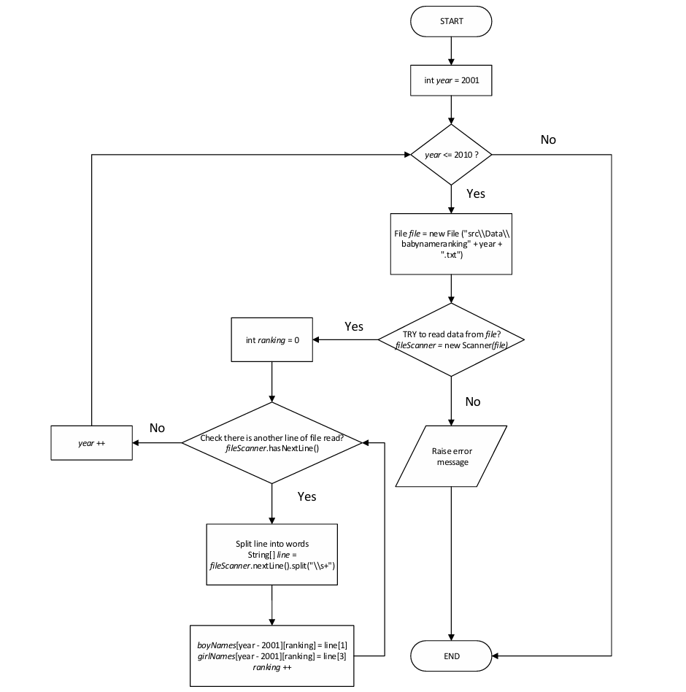

- getRanking method
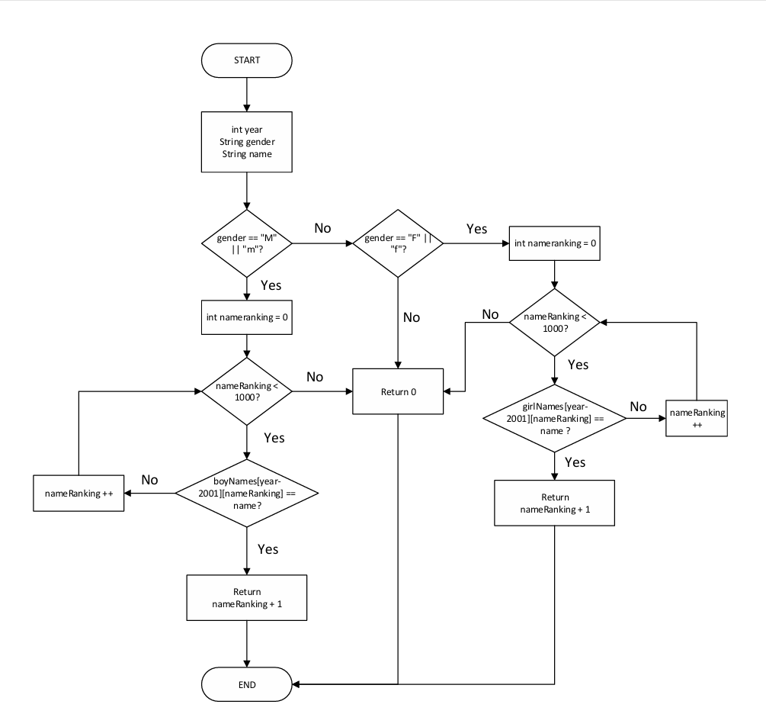

Coding

Source Code
package Project1;

import java.io.File;
import java.io.IOException;
import java.util.Scanner;

public class BabyNameRankings {

//Initialize two dimensional arrays to store boy and girl names
static String[][] boyNames = new String[10][1000];
static String[][] girlNames = new String[10][1000];

public static void main(String[] args) {

//Call method to read data from files to arrays
readFiles();

//Create Scanner object to get user input
Scanner input = new Scanner(System.in);

//Initialize continue program variable
String continueProgram = "Y";

//Start main program loop
do {

//Get year input from user
System.out.print("Enter the year: ");
int year = input.nextInt();
while (year > 2010 || year < 2001) // Ensure the year is within the range 2001-2010
{
System.out.print("The year is out of range! Please choose a year from 2001 to 2010: ");
year = input.nextInt();
}

//Get gender input from user
System.out.print("Enter the gender: ");
String gender = input.next();
while (!gender.equalsIgnoreCase("M") && !gender.equalsIgnoreCase("F")) //Ensure gender is either "M" or "F"
{
System.out.print("Please type M for male or F for female: ");
gender = input.next();
}

//Get name from user input
System.out.print("Enter the name: ");
String name = input.next();

//Initial ranking variable
int ranking = getRanking(year, gender, name); //Call method

//Check the ranking of the input name
if (ranking == 0)
System.out.println("The name " + name +" is not ranked in year " + year);
else
System.out.println(name + " is ranked #" + ranking + " in year " + year);

//Promp whether user want to check another name
System.out.print("Do you want to continue with another name (Y/N)? ");
continueProgram = input.next();

} while (continueProgram.equalsIgnoreCase("Y")); //Continue when user type y or Y

System.out.print("*****Thank you*****"); //End of program

}

//Method to load data from files to boy name and girl name arrays
public static void readFiles() {

for (int year = 2001; year <= 2010; year++)
{
//Initial filename prefix
final String FILENAME_PREFIX = "babynameranking";

File file = new File("src\\Data\\babynameranking" + year + ".txt"); //filename path

try (Scanner fileScanner = new Scanner(file))
{
int ranking = 0; //Initial column for ranking

while (fileScanner.hasNextLine()) //Check value at next line
{
String[] line = fileScanner.nextLine().split("\\s+"); //Slip the line

boyNames[year - 2001][ranking] = line[1]; //Get boy name to array
girlNames[year - 2001][ranking] = line[3]; //Get the girl name to array

ranking++; //Increase ranking for next loop
}

} catch (IOException ioException)
{
ioException.printStackTrace();;
}
}
}

//Method to get ranking from input values: year, gender and name
public static int getRanking (int year, String gender, String name) {

if (gender.equalsIgnoreCase("M")) //Search for boy name
{
for (int nameRanking = 0; nameRanking < 1000; nameRanking++) //Search ranking of the input name
{
if (boyNames[year - 2001][nameRanking].equalsIgnoreCase(name))
return nameRanking + 1;
}
}
else if (gender.equalsIgnoreCase("F")) //Search for girl name
{
for (int nameRanking = 0; nameRanking < 1000; nameRanking++) //Search ranking of the input name
{
if (girlNames[year - 2001][nameRanking].equalsIgnoreCase(name))
return nameRanking + 1;
}
}
return 0; //Name not found
}
}

Program
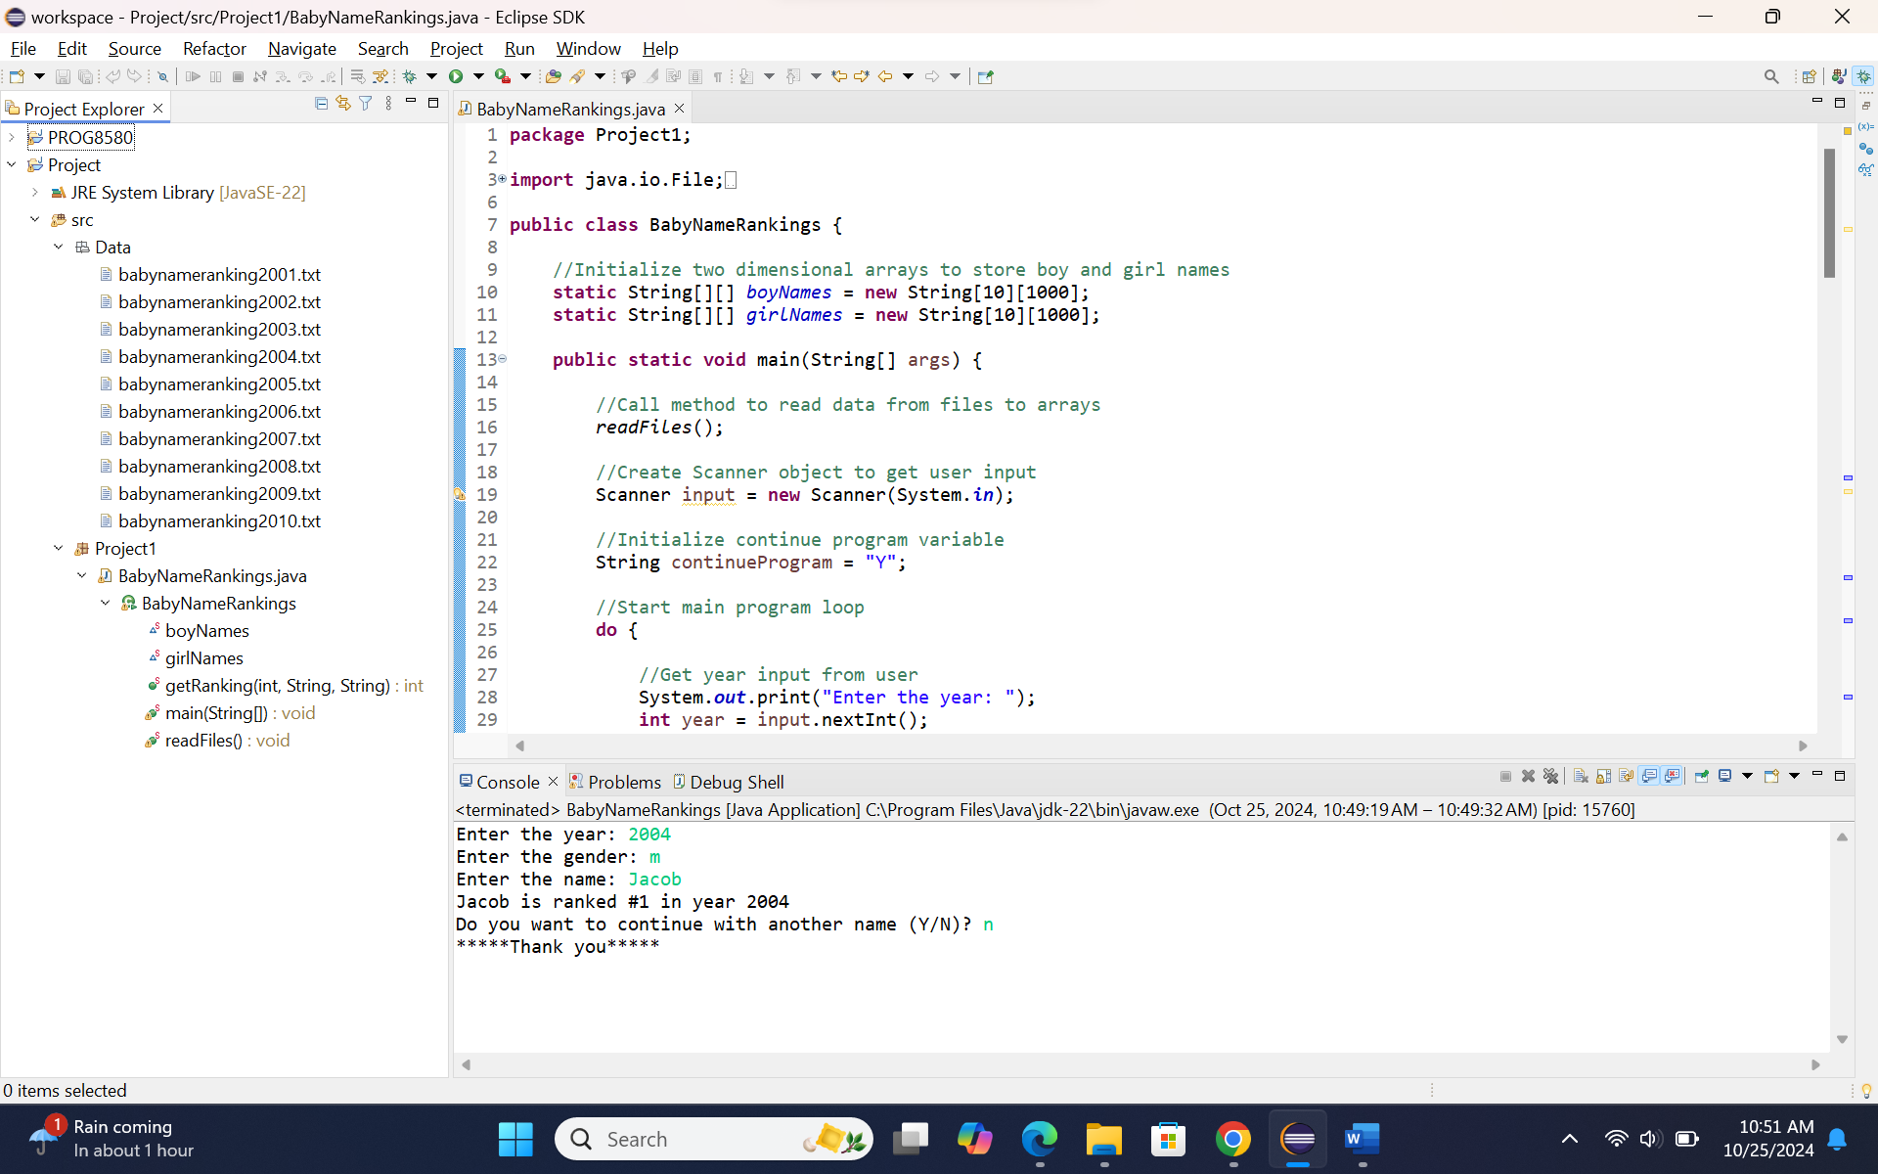
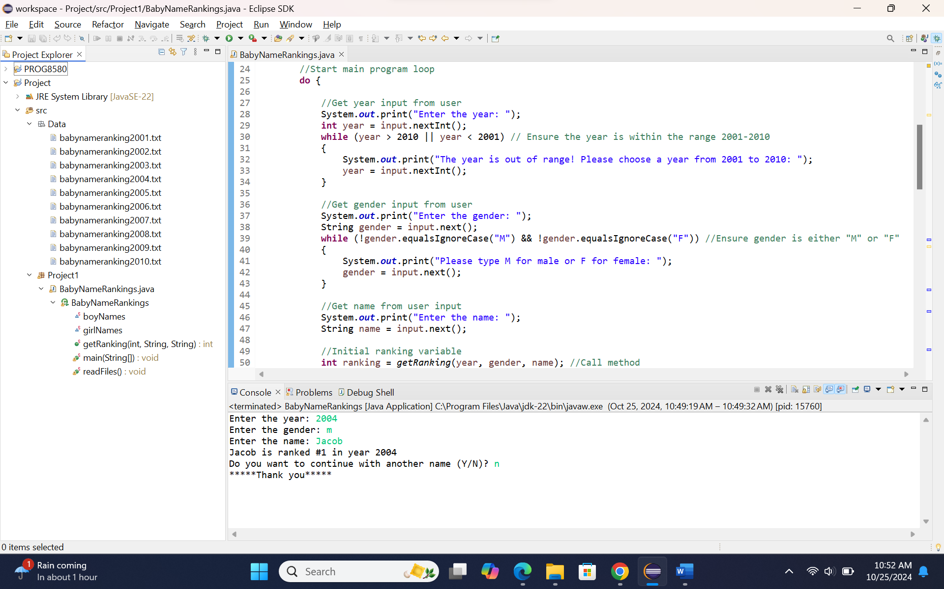
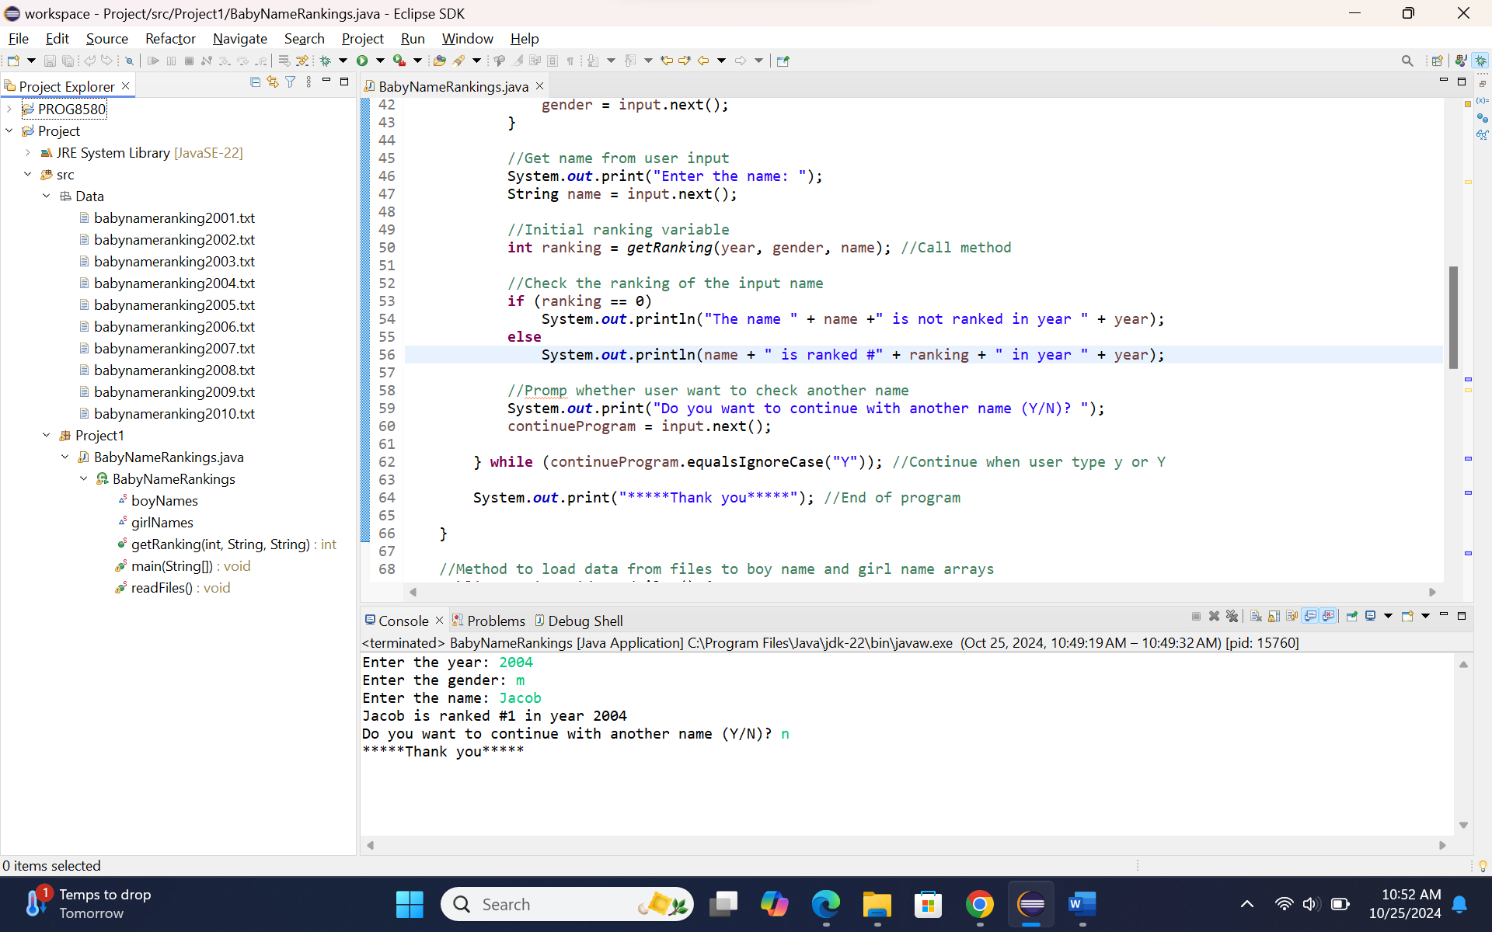
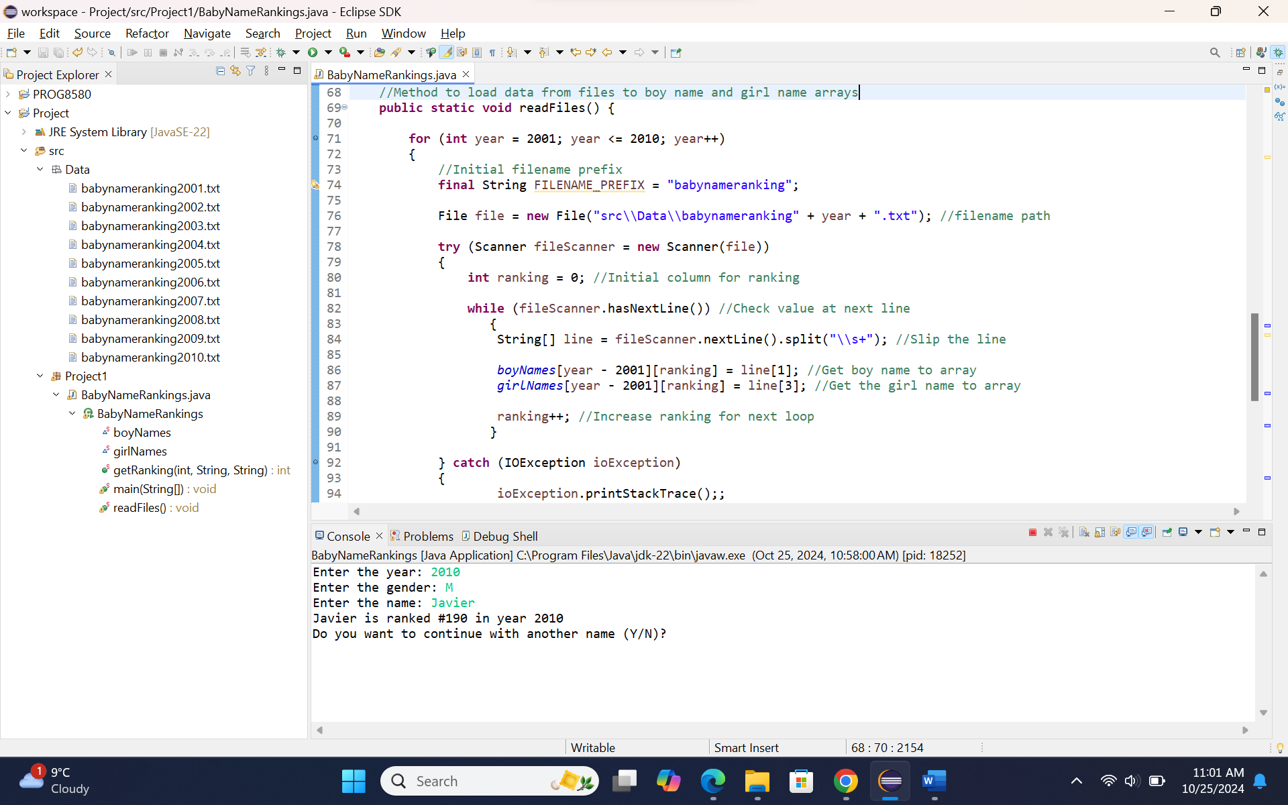
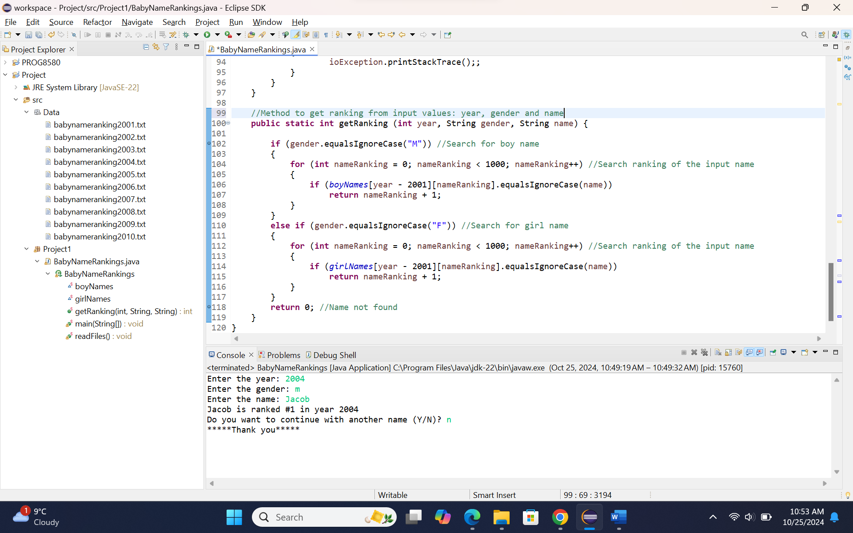

Testing

Testcase 1: all input values are valid and the name is ranked
Input: year 2010, gender M, name Javier
Output: Javier is ranked #190 in year 2010
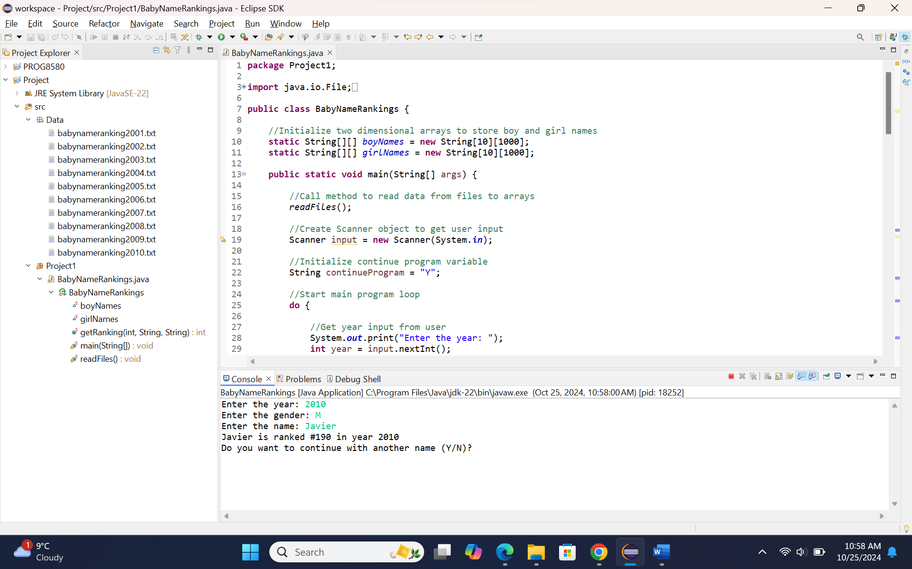

Testcase 2: all input values are valid and the name is not ranked
Input: year 2010, gender F, name ABC
Output: The name ABC is not ranked in year 2010
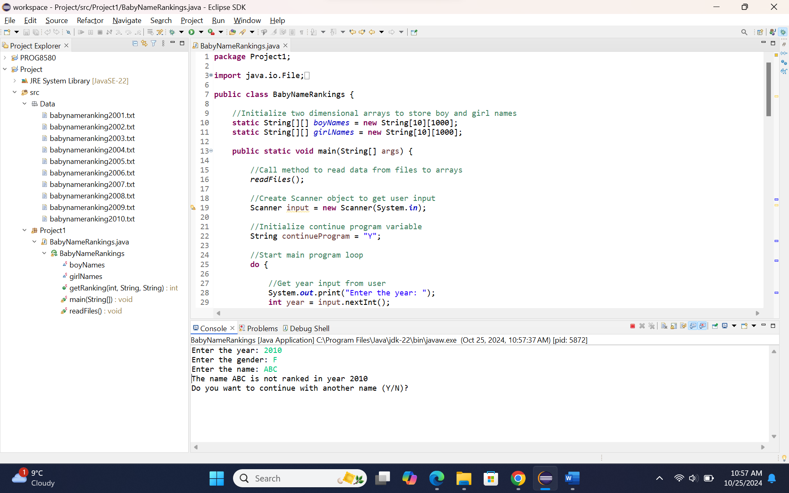

Testcase 3: year input is less than minimum of year range
Input: year 2000
Output: The year is out of range! Please choose a year from 2001 to 2010:
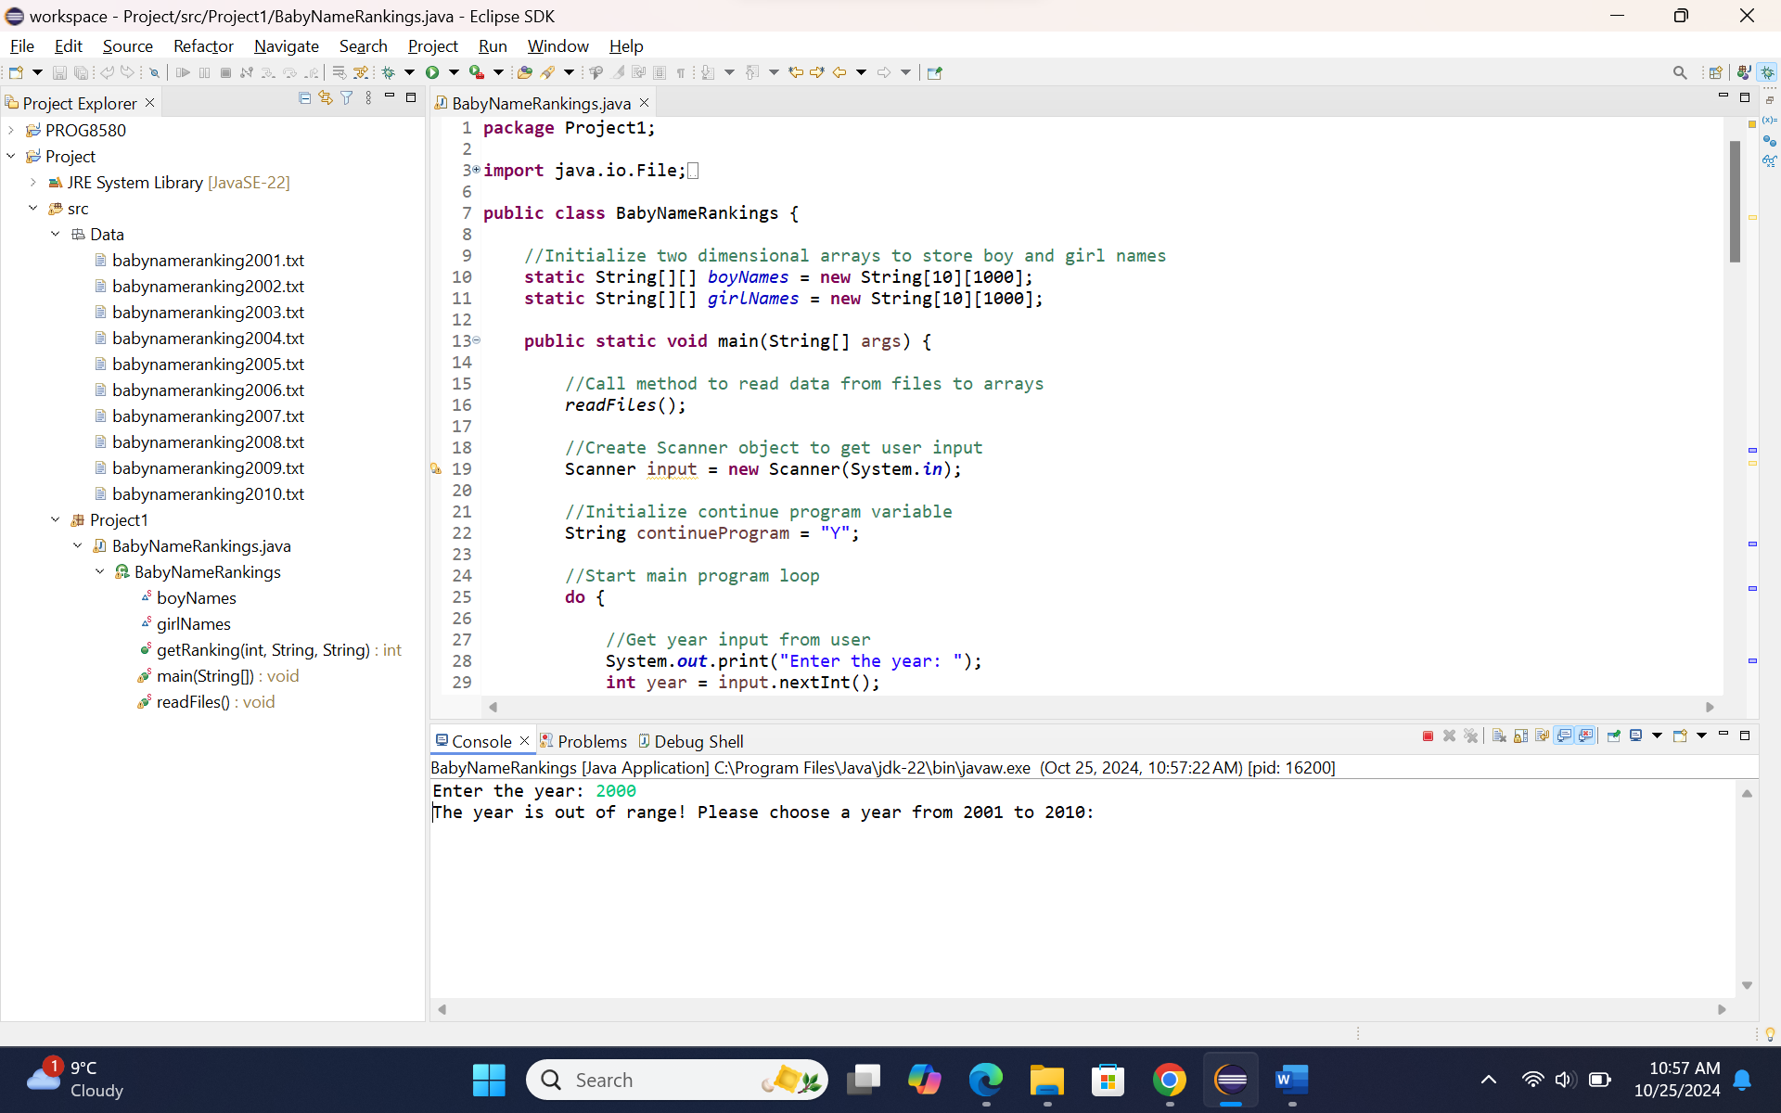

Testcase 4: year input is valid and gender input is invalid
Input: year 2008, gender k
Output: Please type M for male or F for female:
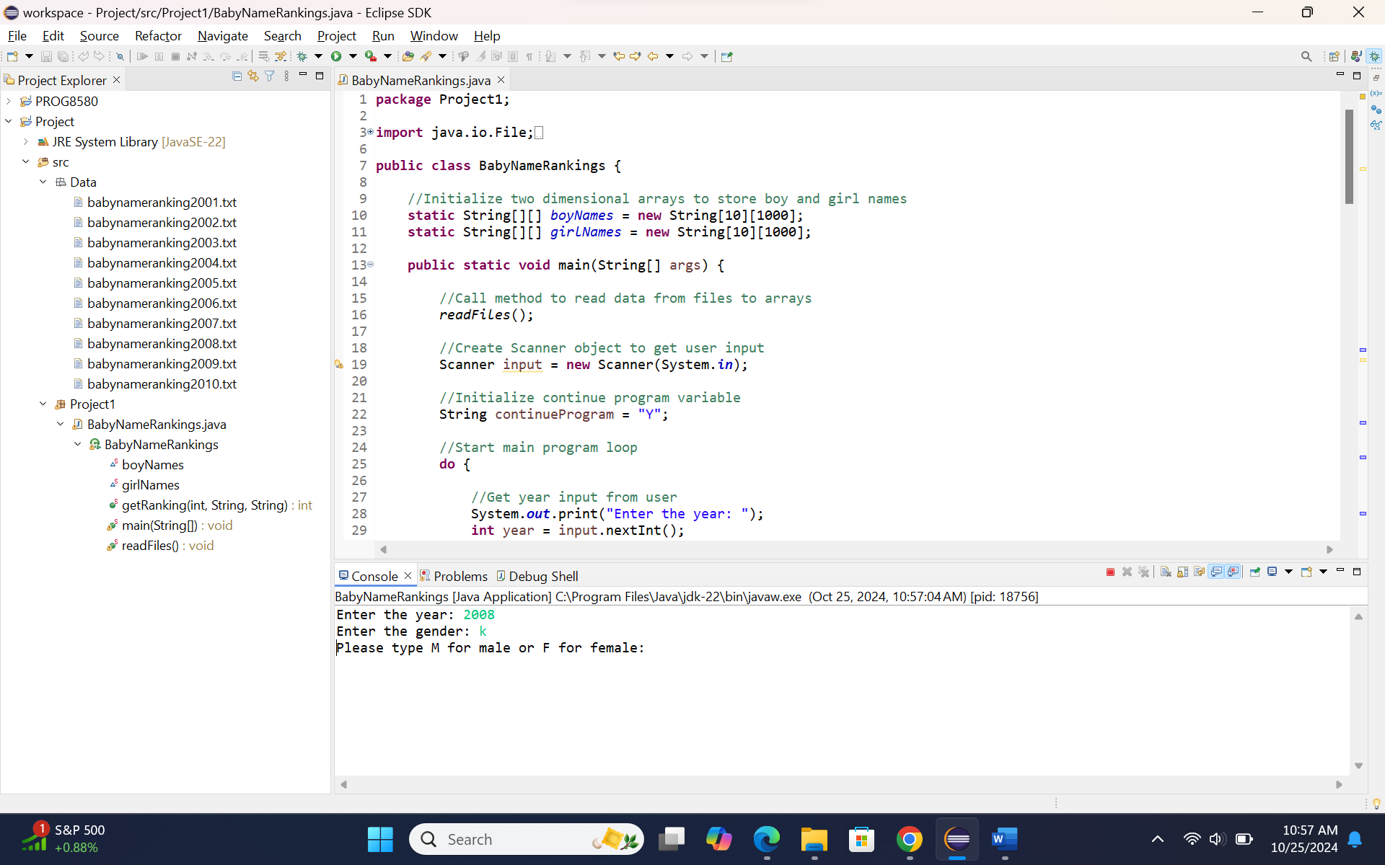

Testcase 5: year input is greater than maximum of year range
Input: year 2011
Output: The year is out of range! Please choose a year from 2001 to 2010:
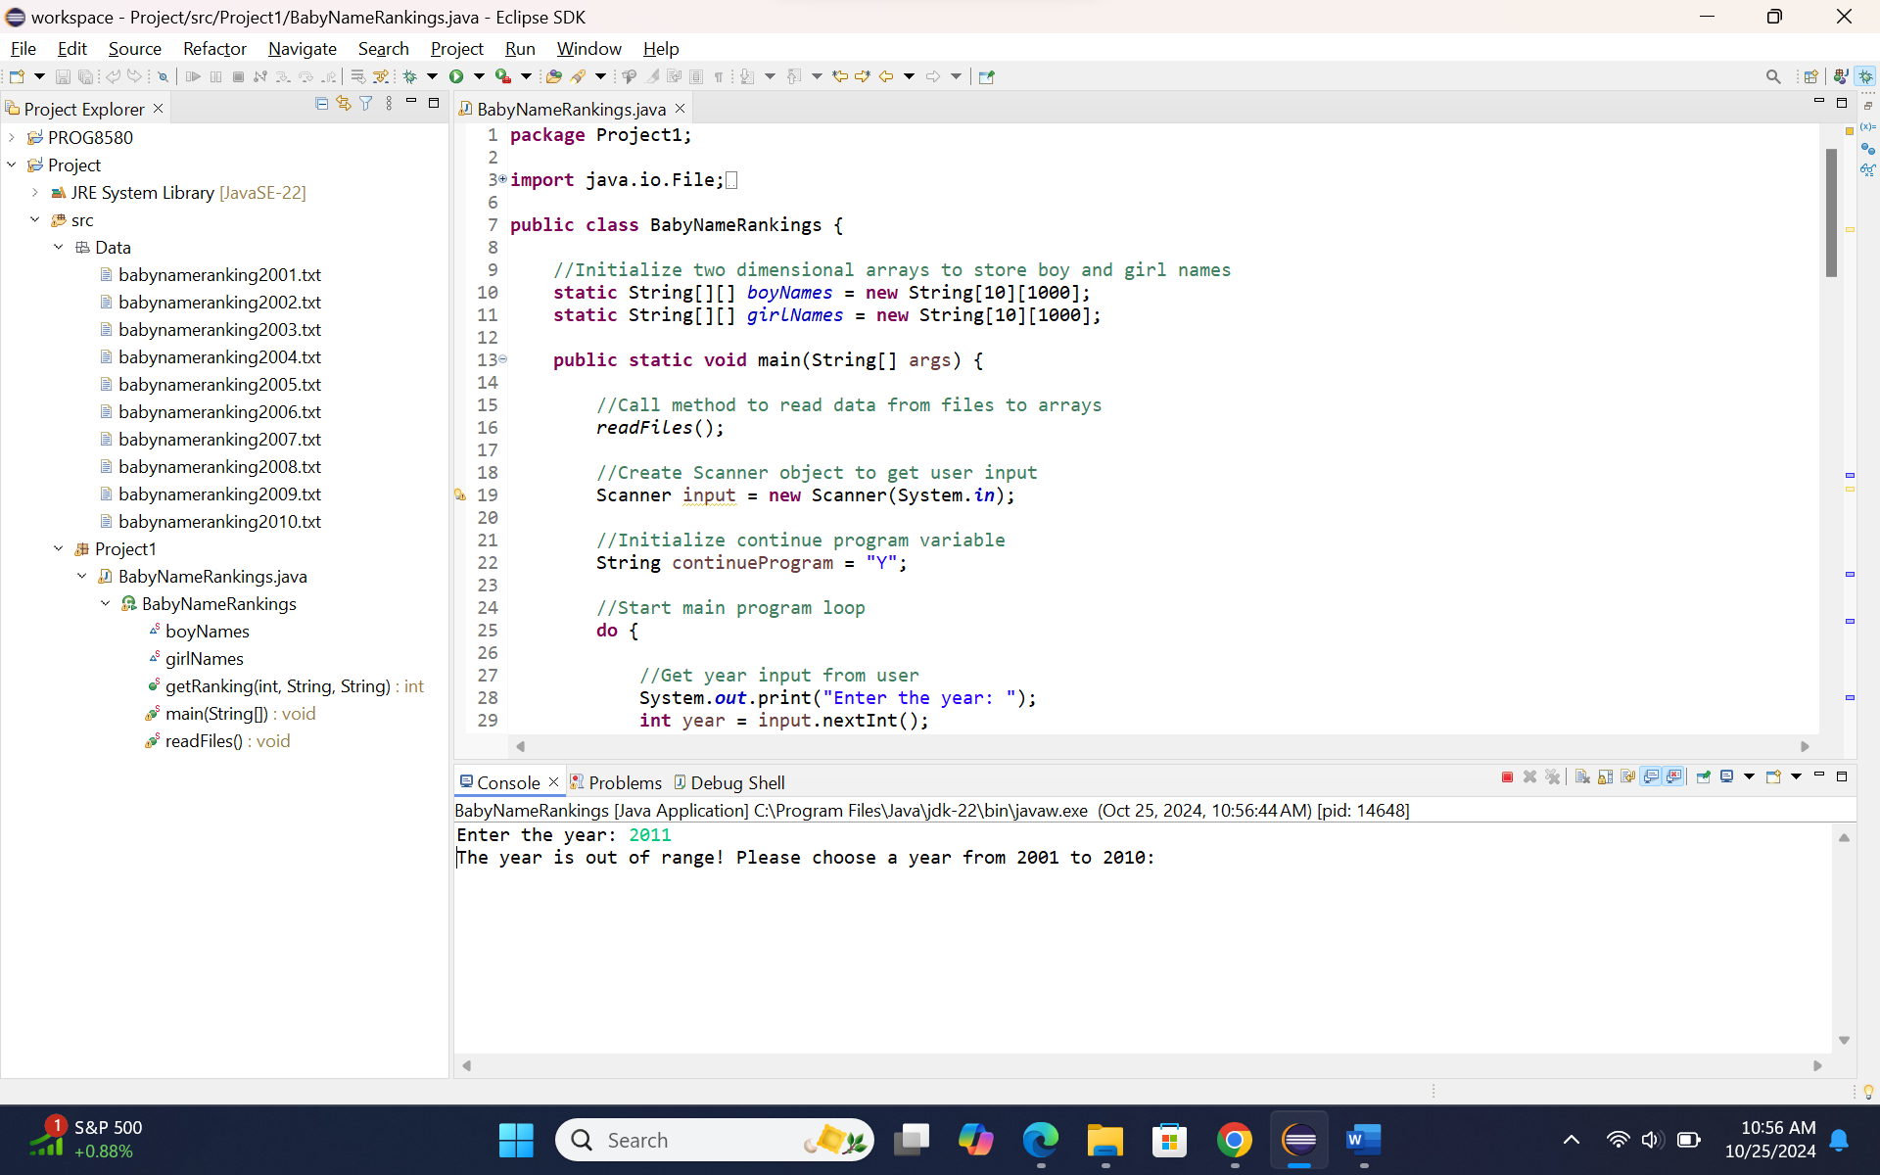

Testcase 6: continue searching for next input values
Input: year 2008, gender f, name sophia, continue Y – year 2008, gender M, name Ryan
Output: sophia is ranked #7 in year 2008 and Ryan is ranked #18 in year 2008
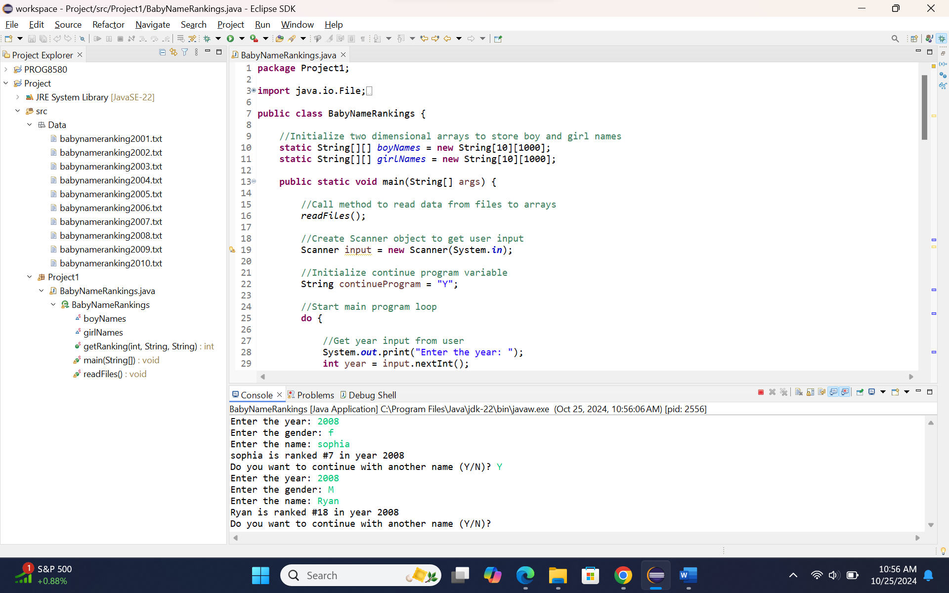

Testcase 7: stop searching after getting result
Input: year 2004, gender m, name Jacob, continue n
Output: Jacob is ranked #1 in year 2004 and *****Thank you*****
