PROJECT – 1

Baby Name Popularity Ranking

PROG8580 - Computer Programming
Professor Srdjan Toholj

GROUP 2
Jinu John – 8932097
Deepthi Dineshan – 8943346
Nguyen Hai Anh Tran – 9013769
Anjali Sharma – 9005370

Table of Contents
1. Analysis: 3
a. Problem description 3
b. Input 3
c. Output 3
d. Implementation 3
2. Design 5
a. Pseudo Code 5
b. Flowchart 9
3. Coding 12
a. Source Code 12
b. Program 17
4. Testing 22
a. Testcase 1: all input values are valid and the name is ranked 22
b. Testcase 2: all input values are valid and the name is not ranked 23
c. Testcase 3: year input is less than minimum of year range 24
d. Testcase 4: year input is valid and gender input is invalid 25
e. Testcase 5: year input is greater than maximum of year range 26
f. Testcase 6: continue searching for next input values 27
g. Testcase 7: stop searching after getting result 28

Analysis:

Problem description
You need a system to manage the information of staff members. This includes the ability to view all staff, retrieve details of a specific staff member, update their information, remove a staff member, and add new staff.

Input
The information you need includes:
- The action the user wishes to perform (view all staff, get details, update, delete, or add staff).
- For each staff member:
ID: A unique identifier, 9 characters long.
First Name: Between 2 and 15 characters.
Last Name: Between 2 and 15 characters.
Date of Birth: In the format yyyy-MM-dd.
Address: Between 5 and 20 characters.
City: Between 2 and 20 characters.
State: Exactly 2 characters.
Telephone: Exactly 10 digits.
Email: Between 5 and 50 characters.

Output
What you expect to get after performing each action:
- A list of all current staff members.
- Details of a specific staff member.
- Confirmation that a staff member's information was updated.
- Confirmation that a staff member was removed.
- Confirmation that a new staff member was added successfully.

Validation
To make sure the solution works as expected, you will:
- Check that the chosen action (such as viewing the list or updating information) performs correctly.
- Ensure that the system accurately retrieves and displays the staff information.
- Confirm that updates, deletions, and additions of staff members are recorded correctly and that the information shown reflects these changes.
- Validate inputs to ensure they meet the specified criteria (like length and format requirements for each field).

Design

Pseudo Code

Flowchart

UML Digram

Coding

Source Code

Program

Testing

Testcase 1: all input values are valid and the name is ranked
Input: year 2010, gender M, name Javier
Output: Javier is ranked #190 in year 2010
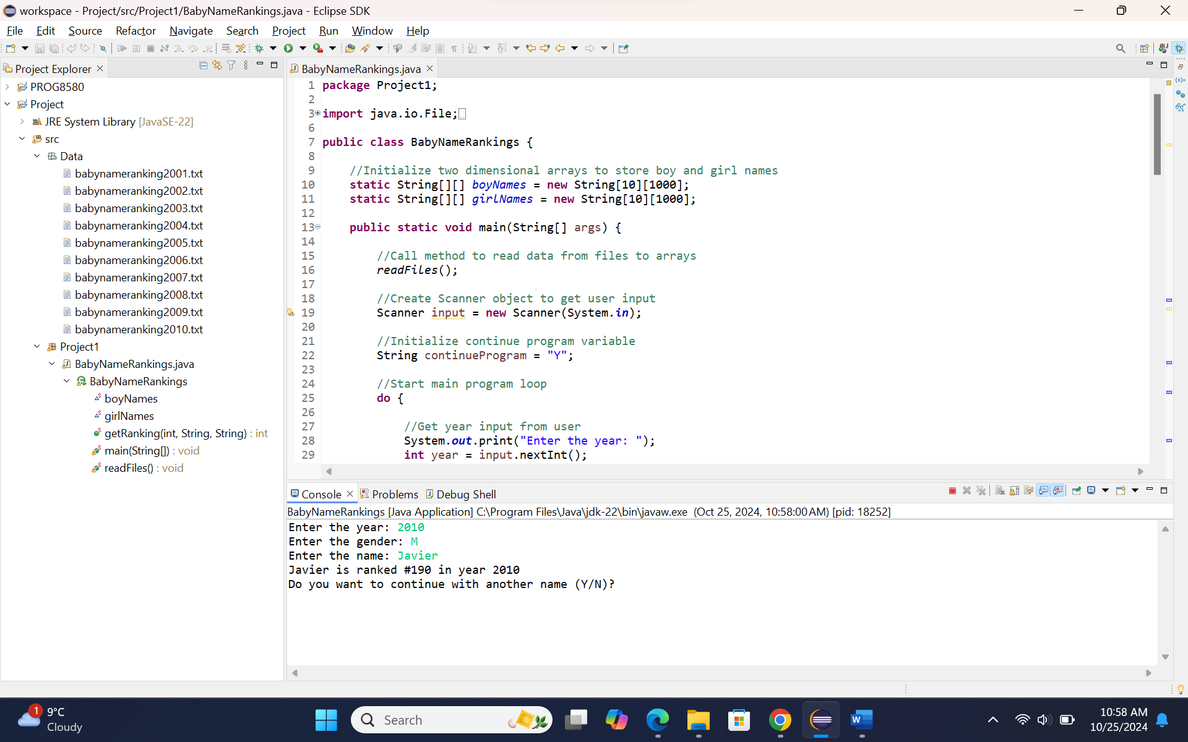

Testcase 2: all input values are valid and the name is not ranked
Input: year 2010, gender F, name ABC
Output: The name ABC is not ranked in year 2010
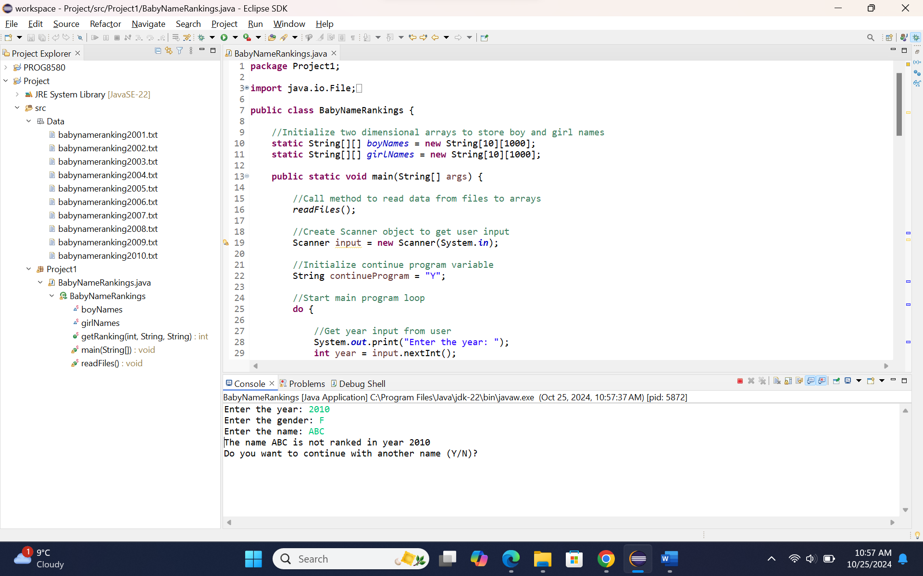

Testcase 3: year input is less than minimum of year range
Input: year 2000
Output: The year is out of range! Please choose a year from 2001 to 2010:
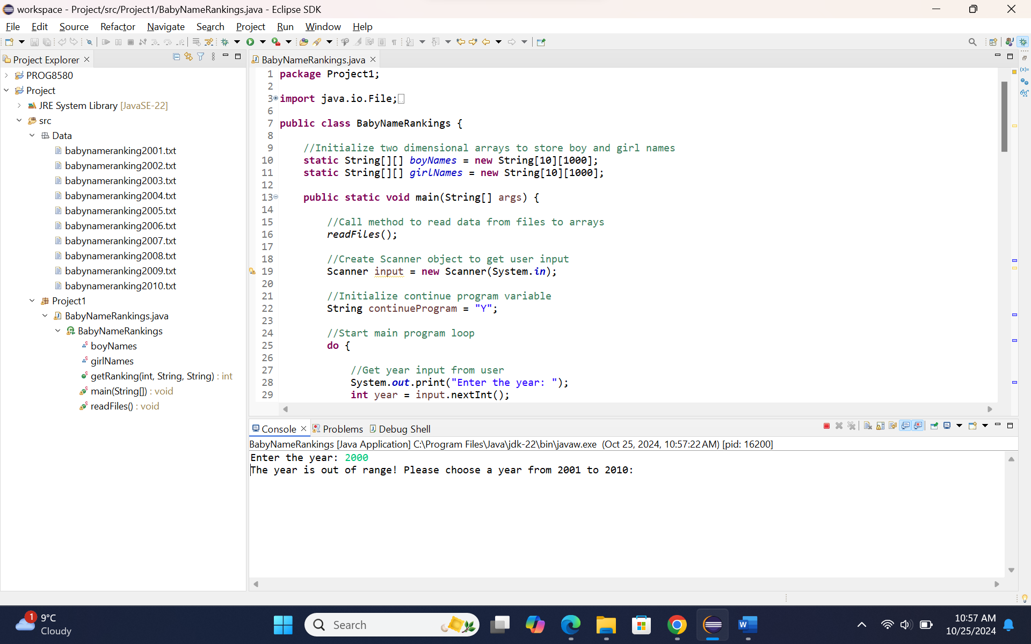

Testcase 4: year input is valid and gender input is invalid
Input: year 2008, gender k
Output: Please type M for male or F for female:
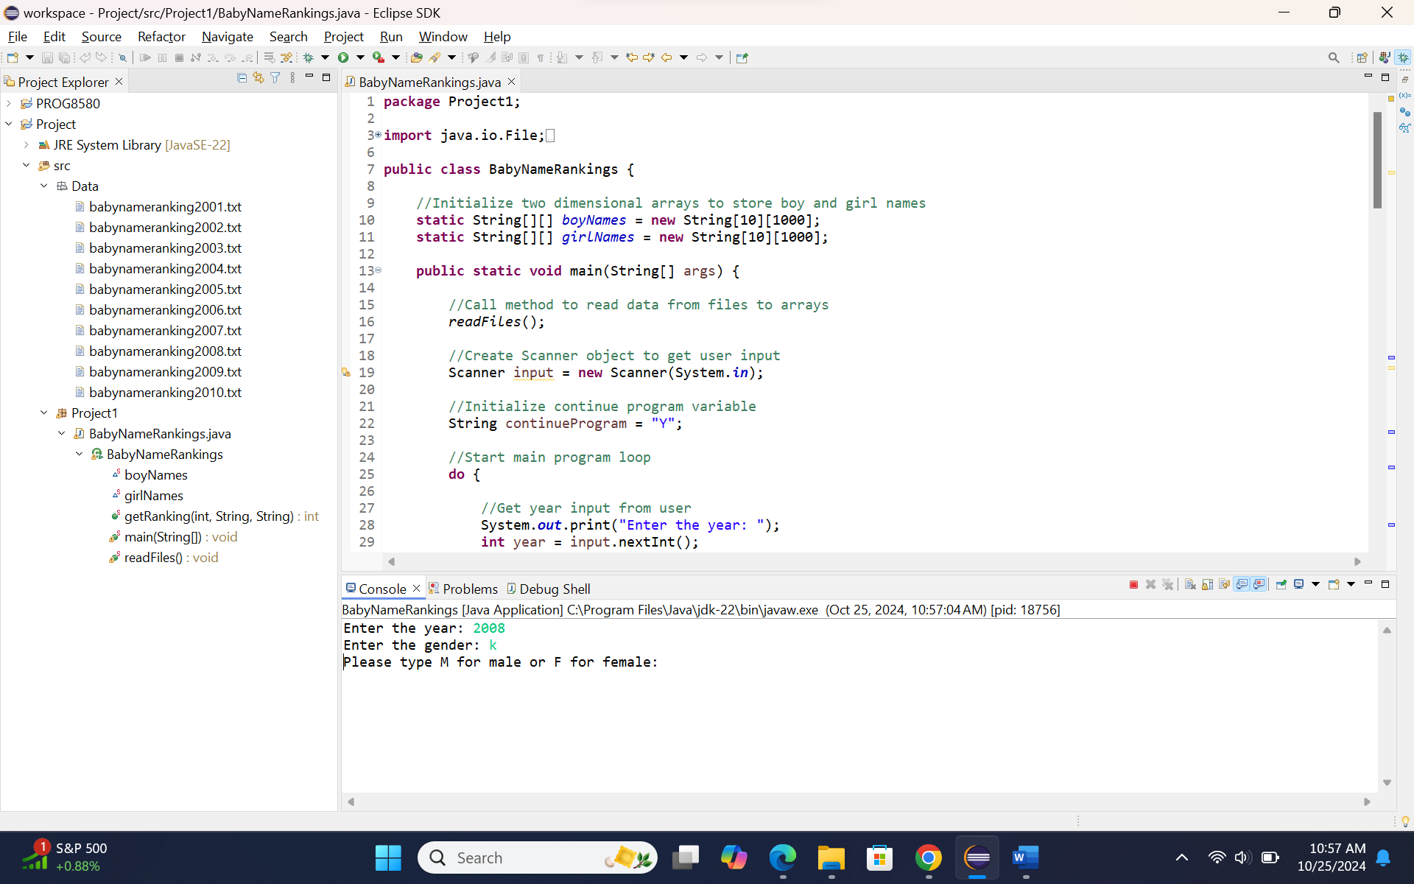

Testcase 5: year input is greater than maximum of year range
Input: year 2011
Output: The year is out of range! Please choose a year from 2001 to 2010:
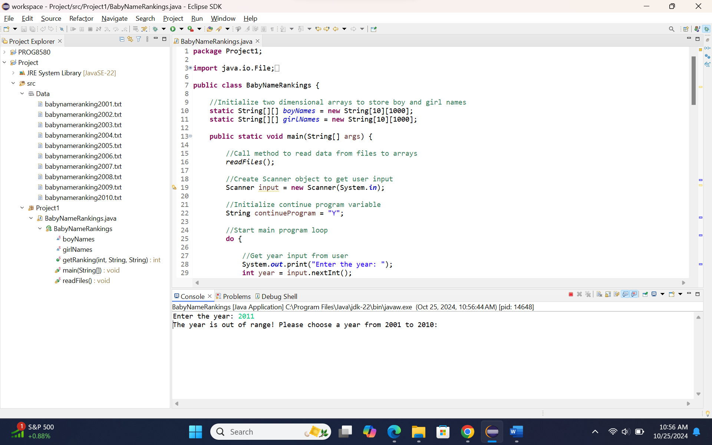

Testcase 6: continue searching for next input values
Input: year 2008, gender f, name sophia, continue Y – year 2008, gender M, name Ryan
Output: sophia is ranked #7 in year 2008 and Ryan is ranked #18 in year 2008
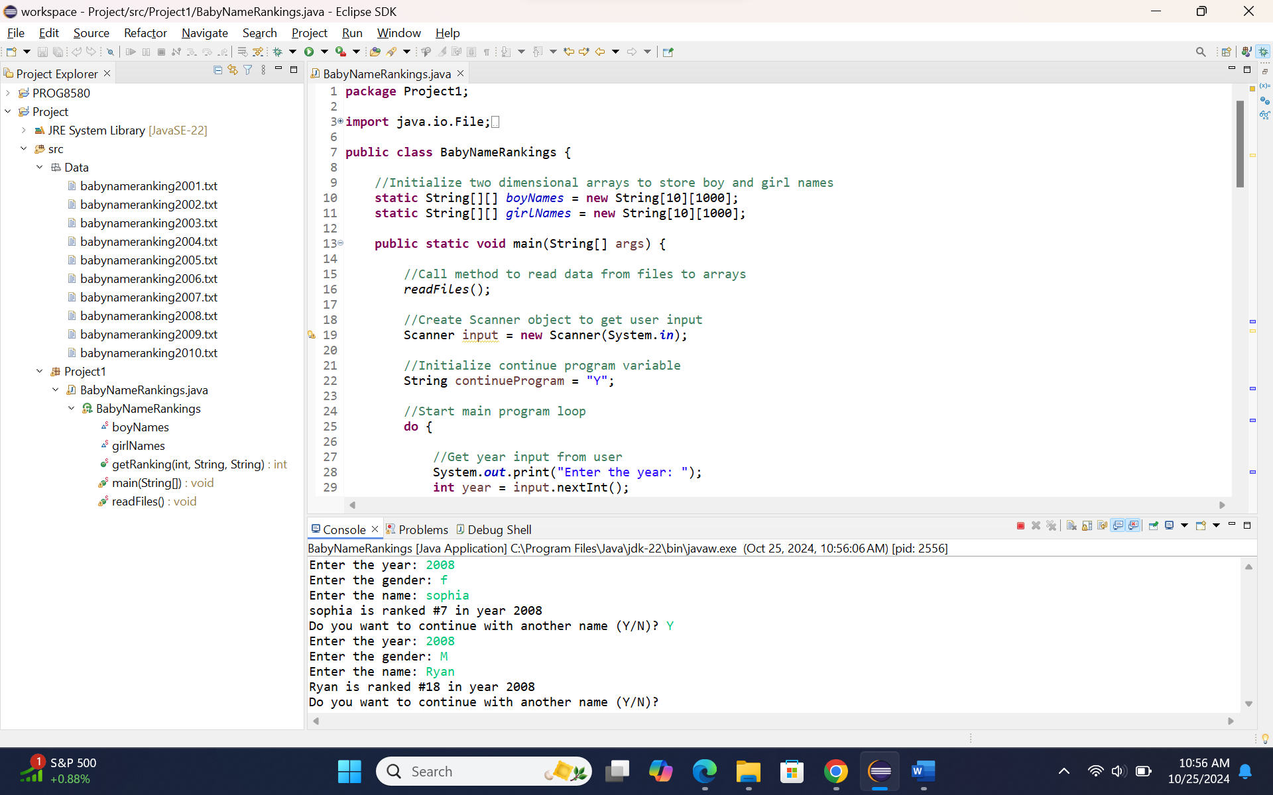

Testcase 7: stop searching after getting result
Input: year 2004, gender m, name Jacob, continue n
Output: Jacob is ranked #1 in year 2004 and *****Thank you*****
