ASSIGNMENT 3
Week #10 – Individual Assignment

PROG8580 - Computer Programming
Professor Srdj Toholj
Use classes, exception handling, abstract class.
NGUYEN HAI ANH TRAN
Student ID 9013769

Table of Contents
1. Problem analysis 4
a. Problem statement 4
b. Input 4
c. Output 4
d. Validation 5
2. Design 7
a. Pseudo Code 7
b. Flowchart 10
3. Coding 14
a. Source code 14
b. Program 23
4. Testing 35
a. Testcase 1: Create checking account with a balance of $20,000 and then withdraw 2,500 from this account 35
b. Testcase 2: Create checking account with a balance of $20,000 and then deposit 3,000 from this account 36
c. Testcase 3: Create saving account with a balance of $100,000 and then withdraw 2,500 from this account 37
d. Testcase 4: Create saving account with a balance of $100,000 and then deposit 3,000 to this account 38
e. Testcase 5: Invalid account ID 39
f. Testcase 6: Invalid first name 40
g. Testcase 7: Invalid last name 41
h. Testcase 8: Invalid balance 42
i. Testcase 9: Annual interest rate is greater than 100 43
j. Testcase 10: Annual interest rate is less than 0 44
k. Testcase 11: Withdraw amount is less than 0 45
l. Testcase 11: Withdraw amount is greater than sum of balance and overdraft limit for checking account 46
m. Testcase 12: Deposit amount is less than 0 47
n. Testcase 13: Sum of withdraw amount and transaction fee is greater than balance for saving account 48
o. Testcase 14: Deposit amount is less than transaction fee for saving account 49

Problem analysis

Problem statement
The program is designed to manage different types of bank accounts. This system should capture essential information about the account holders and provide functionalities like depositing, withdrawing, and calculating monthly interest. In addition to that, it should accommodate unique behaviors specific to checking and saving accounts.

Input
The system will gather the following information
- Account ID: the unique identifier for the account. It will be in integer format and not a negative number. Default value is 0.
- First name: the first name of the customer (account holder). It will be in string format and has a length between 2 and 100.
- Last name: the last name of the customer (account holder). It will be in string format and has a length between 2 and 100.
- Initial balance: the original balance of the account. It will be in decimal format and not a negative number. Default value is 0.
- Annual interest rate: the current annual interest rate of the account. It will be in percentage format and between 0 and 100. Default value is 0.
- Monthly interest rate: calculated by dividing the annual interest rate by 12, since there are 12 months in a year.
- Account’s created date: the date when the account was created.
- Overdraft limit: The predefined amount by which an account holder is allowed to exceed their balance, only for checking account. It will be in decimal format and is 10% of the balance.
- Transaction fee: the fee that applied for each transaction (withdraw/deposit), only for saving account. It will be in decimal format and is fixed $8/transaction.
- Withdraw amount: the amount that customer wants to withdraw, and it cannot be negative number.
For checking account, this amount cannot be greater than sum of balance and overdraft limit.
For saving account, sum of this amount and transaction fee cannot be greater than balance.
- Deposit amount: the amount that customer wants to deposit, and it cannot be negative number.
For saving account, this amount must be greater than transaction fee.

Output
The system will produce
- When creating an account, the output should display all relevant account information, including the account ID, customer names, balance, monthly interest rate, the date when the account was created, and overdraft limit if this account is checking account or transaction fee if this account is saving account.
- When withdrawing a valid amount, the balance should be updated accordingly, considering the overdraft limit for checking account and the transaction fee for savings accounts.
- When depositing a valid amount, the balance should be updated accordingly, considering the transaction fee for savings accounts.
- When attempting invalid operations, such as creating an account with a negative ID or withdrawing more than the available balance, appropriate error messages should be displayed.

Validation
To ensure the system functions correctly, the program will:
- Verify Account Details: Ensure that all input information is accurately captured and valid. Validation rules are mentioned in b. Input section.
The appropriate error message will be displayed when there is any invalid input value.
For example:
Input:
Enter Account ID: -1234
Enter customer's first name: Alex
Enter customer's last name: Smith
Enter initial balance: 3000
Enter annual interest rate: 4.5
Output:
“Invalid input! Id cannot be negative: -1234”
- Transaction Validation: Confirm that deposits and withdrawals are properly processed, adhering to account-specific rules that mentioned in b. Input section.
For example, deposit amount is less than transaction fee for saving account with details information as below:
Input:
Enter Account ID: 1125
Enter customer's first name: Emma
Enter customer's last name: Stone
Enter initial balance: 0
Enter annual interest rate: 4.5
Deposit amount $: 5
Output:
“Deposit must be greater than transaction fee! Current balance: 0.0 Deposit: 5.0 Transaction fee: 8.0”
For example, withdraw amount is negative number.
Input:
Enter Account ID: 1122
Enter customer's first name: Alex
Enter customer's last name: Smith
Enter initial balance: 20000
Enter annual interest rate: 4.5
Withdraw amount $: -2345
Output:
“Withdraw amount cannot be negative!”
For example: Withdraw amount is greater than sum of balance and overdraft limit for checking account
Input:
Enter Account ID: 1122
Enter customer's first name: Alex
Enter customer's last name: Smith
Enter initial balance: 20000
Enter annual interest rate: 4.5
Withdraw amount $: 23000
Output:
“Withdrawal denied. Exceeds overdraft limit! Balance: 20,000.00, Overdraft limit: 2,000.00 and withdraw: 23000.0”
For example: Sum of withdraw amount and transaction fee is greater than balance for saving account
Input:
Enter Account ID: 1134
Enter customer's first name: Alex
Enter customer's last name: Smith
Enter initial balance: 2000
Enter annual interest rate: 4.5
Withdraw amount $: 2000
Output:
“Cannot withdraw greater than balance: 2000.0 , withdraw: 2000.0 and transaction fee: 8.0”

Design

Pseudo Code
- Main method:
BEGIN
DECLARE accountType, action AS STRING, DEFAULT “”
DECLARE amount AS DOUBLE, DEFAULT 0.0

TRY
PRINT "Enter Account ID: "
READ accountId

PRINT "Enter customer's first name: "
READ firstName

PRINT "Enter customer's last name: "
READ lastName

PRINT "Enter initial balance: "
READ initialBalance

PRINT "Enter annual interest rate: "
READ annualInterestRate

PRINT "Which account would you like to create, Checking (type C) or Saving (type S)? "
READ accountType

WHILE accountType is not ('C' or ‘c’) and accountType is not ('S' or ‘s’)
PRINT "Please type C for Checking or type S for Saving? "
READ accountType
END WHILE

IF accountType is 'C' or ‘c’
CREATE CheckingAccount with accountId, firstName, lastName, initialBalance, annualInterestRate
PRINT "Account Created"
PRINT checkingAccount details

PRINT "Which action would you like to do, Withdrawal (type W) or Deposit (type D)? "
READ action

WHILE action is not ('W' or ‘w’) and action is not ('D' or ‘d’)
PRINT "Please type W for Withdrawal or type D for Deposit? "
READ action
END WHILE

PRINT "How much money would you like to do? "
READ amount

CALL actionPerform with checkingAccount, action, amount
ELSE IF accountType is 'S' or ‘s’
CREATE SavingAccount with accountId, firstName, lastName, initialBalance, annualInterestRate
PRINT "Account Created"
PRINT savingAccount details

PRINT "Which action would you like to do, Withdrawal (type W) or Deposit (type D)? "
READ action

WHILE action is not ('W' or ‘w’) and action is not ('D' or ‘d’)
PRINT "Please type W for Withdrawal or type D for Deposit? "
READ action
END WHILE

PRINT "How much money would you like to do? "
READ amount

CALL actionPerform with savingAccount, action, amount
END IF

CATCH IllegalArgumentException
PRINT exception message
END TRY
END
- actionPerform method
METHOD actionPerform (acc, action, amount)
IF action is 'W' or ‘w’
CALL acc.withdraw(amount)
PRINT "Withdraw Successfully"
PRINT "After Withdrawal" + amount
PRINT acc details
ELSE IF action is 'D' or ‘d’
CALL acc.deposit(amount)
PRINT "Deposit Successfully"
PRINT "After Deposit" + amount
PRINT acc details
END IF
END METHOD

Flowchart
- Main method
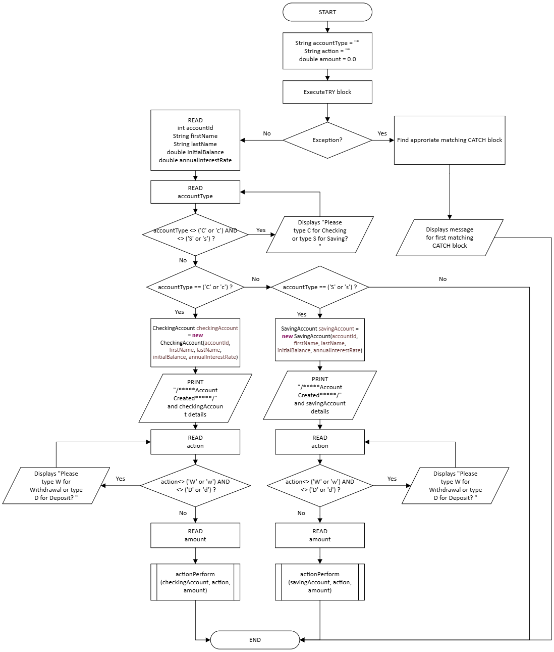
- actionPerform method
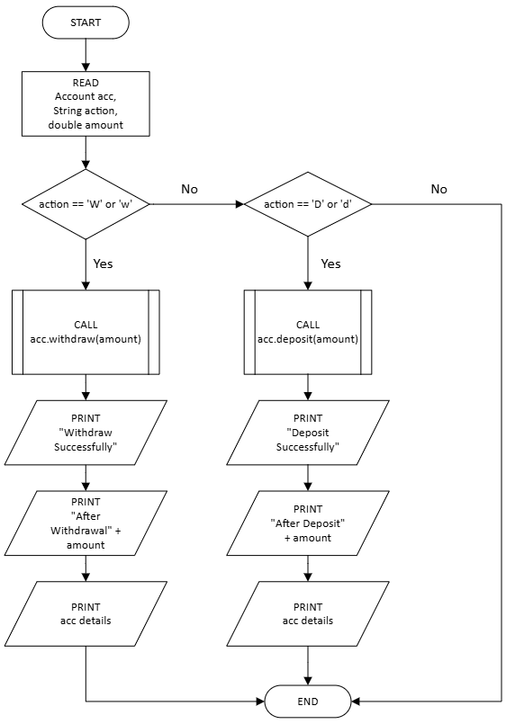

- UML Diagram
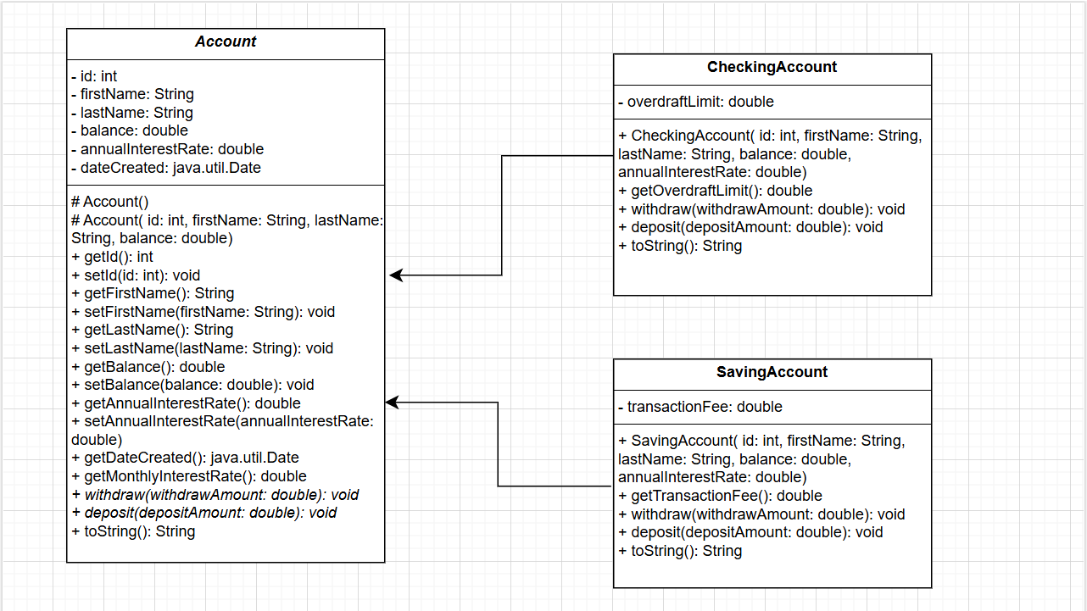

Coding

Source code
- Account Class
package Assignment;

import java.util.Date;

public abstract class Account {

//Initialize private parameters
private int id;
private String firstName;
private String lastName;
private double balance;
private double annualInterestRate;
private java.util.Date dateCreated;

//Create default account
public Account() {
this.id = 0;
this.firstName = "Unknown";
this.lastName = "Unknown";
this.balance = 0;
this.annualInterestRate = 0;
dateCreated = new java.util.Date();
}

//Creates an account with the specified id, first name, last name and initial balance
public Account(int id, String firstName, String lastName, double balance) {
try {
setId(id);
setFirstName(firstName);
setLastName(lastName);
setBalance(balance);
dateCreated = new java.util.Date();
} catch (IllegalArgumentException ex) {
System.out.println(ex.getMessage());
}

}

//Accessor method for id
public int getId() {
return id;
}

//Mutator method for id
public void setId(int id) throws IllegalArgumentException {
if (id < 0) //Ensure Id is positive number
throw new IllegalArgumentException ("Invalid input! Id cannot be negative: " + id);

this.id = id;
}

//Accessor method for first name
public String getFirstName() {
return firstName;
}

//Mutator method for first name
public void setFirstName(String firstName) throws IllegalArgumentException {
if (firstName.isEmpty() || firstName.length() < 2 || firstName.length() > 100) //Ensure number of characters is from 2 to 100
throw new IllegalArgumentException ("Invalid input! First name cannot be: " + firstName);

this.firstName = firstName;
}

//Accessor method for last name
public String getLastName() {
return lastName;
}

//Mutator method for last name
public void setLastName(String lastName) throws IllegalArgumentException {
if (lastName.isEmpty() || lastName.length() < 2 || lastName.length() > 100) //Ensure number of characters is from 2 to 100
throw new IllegalArgumentException ("Invalid input! Last name cannot be: " + lastName);

this.lastName = lastName;
}

//Accessor method for balance
public double getBalance() {
return balance;
}

//Mutator method for balance
public void setBalance(double balance) throws IllegalArgumentException {
if (balance < 0 ) //Ensure balance is greater than or equal to 0
throw new IllegalArgumentException ("Invalid input! Balance cannot be negative: " + balance);

this.balance = balance;
}

//Accessor method for annualInterestRate
public double getAnnualInterestRate() {
return annualInterestRate;
}

//Mutator method for annualInterestRate
public void setAnnualInterestRate(double annualInterestRate) throws IllegalArgumentException {
if (annualInterestRate < 0 || annualInterestRate > 100) //Ensure rate is between 0 and 100.
throw new IllegalArgumentException ("Invalid input! Annual InterestRate cannot be: " + annualInterestRate);

this.annualInterestRate = annualInterestRate;
}

//Accessor method for date created
public java.util.Date getDateCreated() {
return dateCreated;
}

//Method returns the monthly interest rate.
public double getMonthlyInterestRate() {
return annualInterestRate / 12;
}

//Abstract method deposit
public abstract void deposit(double depositAmount);

//Abstract method withdraws
public abstract void withdraw(double withdrawAmount);

//toString method
public String toString() {
return "Account ID: " + getId()
+ "\nCreated on: " + getDateCreated()
+ "\nFull name: " + getFirstName() + " " + getLastName()
+ "\nBalance ($): " + String.format("%,.2f", getBalance())
+ "\nMonthly Interest Rate: " + getMonthlyInterestRate() + "%";
}

}

- CheckingAccount class
package Assignment;

public class CheckingAccount extends Account {
private double overdraftLimit;

//Creates an account with the specified id, first name, last name, initial balance and annual interest rate
public CheckingAccount (int id, String firstName, String lastName, double balance, double annualInterestRate) {

super(id, firstName, lastName, balance);

try{
setAnnualInterestRate(annualInterestRate);
} catch (IllegalArgumentException ex) {
System.out.println(ex.getMessage());
}
}

//Accessor method for overdraft limit
public double getOverdraftLimit() {
return getBalance() * 0.1; //Default overdraft limit is 10% of balance;
}

//Withdraw method
public void withdraw(double withdrawAmount) throws IllegalArgumentException {
//Ensure withdraw amount is positive and less than or equal to sum of balance and overdraft limit
if (withdrawAmount < 0 )
{
throw new IllegalArgumentException ("Withdraw amount cannot be negative!");
}

else if(withdrawAmount > getBalance() + getOverdraftLimit())
{
throw new IllegalArgumentException ("Withdrawal denied. Exceeds overdraft limit!"
+ " Balance: " + String.format("%,.2f", getBalance())
+ ", Overdraft limit: " + String.format("%,.2f", getOverdraftLimit())
+ " and withdraw: " + withdrawAmount);
}

setBalance(getBalance() - withdrawAmount);
}

//Deposit method
public void deposit(double depositAmount) throws IllegalArgumentException {
//
if(depositAmount < 0)
throw new IllegalArgumentException ("Deposit amount cannot be negative!");

setBalance(getBalance() + depositAmount);
}

//toString method
public String toString() {
return "Checking Account:\n"+ super.toString() +
"\nOverdraft limit ($): " + String.format("%,.2f", getOverdraftLimit());
}

}

- SavingAccount class
package Assignment;

public class SavingAccount extends Account {

//Default $8/transaction
private double transactionFee = 8.0;

//Creates an account with the specified id, first name, last name, initial balance and annual interest rate
public SavingAccount(int id, String firstName, String lastName, double balance, double annualInterestRate) {

super(id, firstName, lastName, balance);

try {
setAnnualInterestRate(annualInterestRate);
} catch (IllegalArgumentException ex) {
System.out.println(ex.getMessage());
}

}

//Accessor method for transaction fee
public double getTransactionFee() {
return transactionFee ;
}

//Withdraw method
public void withdraw(double withdrawAmount) throws IllegalArgumentException {
//Ensure withdraw amount is positive number
//and sum of withdraw amount and transaction fee is less than or equal to balance
if (withdrawAmount < 0 )
throw new IllegalArgumentException ("Withdraw amount cannot be negative!");
else if (withdrawAmount + getTransactionFee() > getBalance())
throw new IllegalArgumentException ("Cannot withdraw greater than balance: " + getBalance()
+ " , withdraw: " + withdrawAmount
+ " and transaction fee: " + getTransactionFee());

setBalance(getBalance() - withdrawAmount - getTransactionFee());
}

//Deposit method
public void deposit(double depositAmount) throws IllegalArgumentException {
//Ensure deposit amount is greater than 0
if (depositAmount < 0)
throw new IllegalArgumentException ("Deposit cannot be negative: " + depositAmount);
else if (depositAmount < getTransactionFee())
throw new IllegalArgumentException ("Deposit must be greater than transaction fee!"
+ " Current balance: " + getBalance()
+ " Deposit: " + depositAmount
+ " Transaction fee: " + getTransactionFee());

setBalance(getBalance() + depositAmount - getTransactionFee());
}

//Override to String
public String toString() {
return "Saving Account:\n" + super.toString()
+ "\nTransaction fee ($): " + transactionFee +"/transaction";
}
}

- TestCheckingAndSavingAccount class
package Assignment;

import java.util.Scanner;

public class TestCheckingAndSavingAccount {

public static void main(String[] args) {
String accountType = "";
String action = "";
double amount = 0.0;
try {
Scanner input = new Scanner(System.in);

//Get account ID from user input
System.out.print("Enter Account ID: ");
int accountId = input.nextInt();

//Get customer's first name from user input
System.out.print("Enter customer's first name: ");
String firstName = input.next();

//Get customer's last name from user input
System.out.print("Enter customer's last name: ");
String lastName = input.next();

//Get initial balance from user input
System.out.print("Enter initial balance: ");
double initialBalance = input.nextDouble();

//Get annual interest rate from user input
System.out.print("Enter annual interest rate: ");
double annualInterestRate = input.nextDouble();

//Select account type
System.out.print("Which account would you like to create, Checking (type C) or Saving (type S)? ");
accountType = input.next();
//Check input value
while (!accountType.equalsIgnoreCase("C") && !accountType.equalsIgnoreCase("S"))
{
System.out.print("Please type C for Checking or type S for Saving? ");
accountType = input.next();
}

//Create account
if (accountType.equalsIgnoreCase("C"))
{
CheckingAccount checkingAccount = new CheckingAccount(accountId, firstName, lastName, initialBalance, annualInterestRate);
System.out.println("\n/*****Account Created*****/");
System.out.println(checkingAccount); //Display account detail info

//Select action
System.out.print("Which action would you like to do, Withdrawal (type W) or Deposit (type D)? ");
action = input.next();
//Check valid action input
while (!action.equalsIgnoreCase("W") && !action.equalsIgnoreCase("D"))
{
System.out.print("Please type W for Withdrawal or type D for Deposit? ");
action = input.next();
}

System.out.print("How much money would you like to do? ");
amount = input.nextDouble();

//Call method
actionPerform(checkingAccount, action, amount);
}
else if (accountType.equalsIgnoreCase("S"))
{
SavingAccount savingAccount = new SavingAccount(accountId, firstName, lastName, initialBalance, annualInterestRate);
System.out.println("\n/*****Account Created*****/");
System.out.println(savingAccount); //Display account detail info

//Select action
System.out.print("Which action would you like to do, Withdrawal (type W) or Deposit (type D)? ");
action = input.next();
//Check valid action input
while (!action.equalsIgnoreCase("W") && !action.equalsIgnoreCase("D"))
{
System.out.print("Please type W for Withdrawal or type D for Deposit? ");
action = input.next();
}

System.out.print("How much money would you like to do? ");
amount = input.nextDouble();

//Call method
actionPerform(savingAccount, action, amount);
}

} catch (IllegalArgumentException ex) {
System.out.println(ex.getMessage());
}
}

public static void actionPerform(Account acc, String action, double amount) {
if (action.equalsIgnoreCase("W")) //For withdrawal
{
acc.withdraw(amount);
System.out.println("\n/*****Withdraw Successfully*****/");
System.out.println("\n/*****After Withdrawal $" + String.format("%,.2f", amount) +"*****/");
System.out.println(acc);
}
else if (action.equalsIgnoreCase("D")) //For deposit
{
acc.deposit(amount);
System.out.println("\n/*****Deposit Successfully*****/");
System.out.println("/*****After Deposit $"+ String.format("%,.2f", amount) +"*****/");
System.out.println(acc);
}
}

}

Program
- Account class
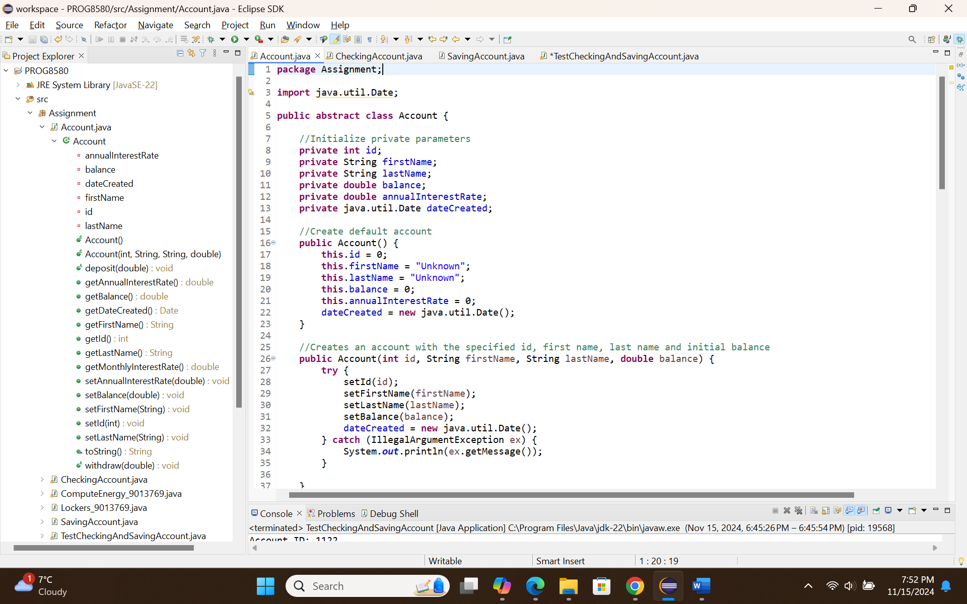
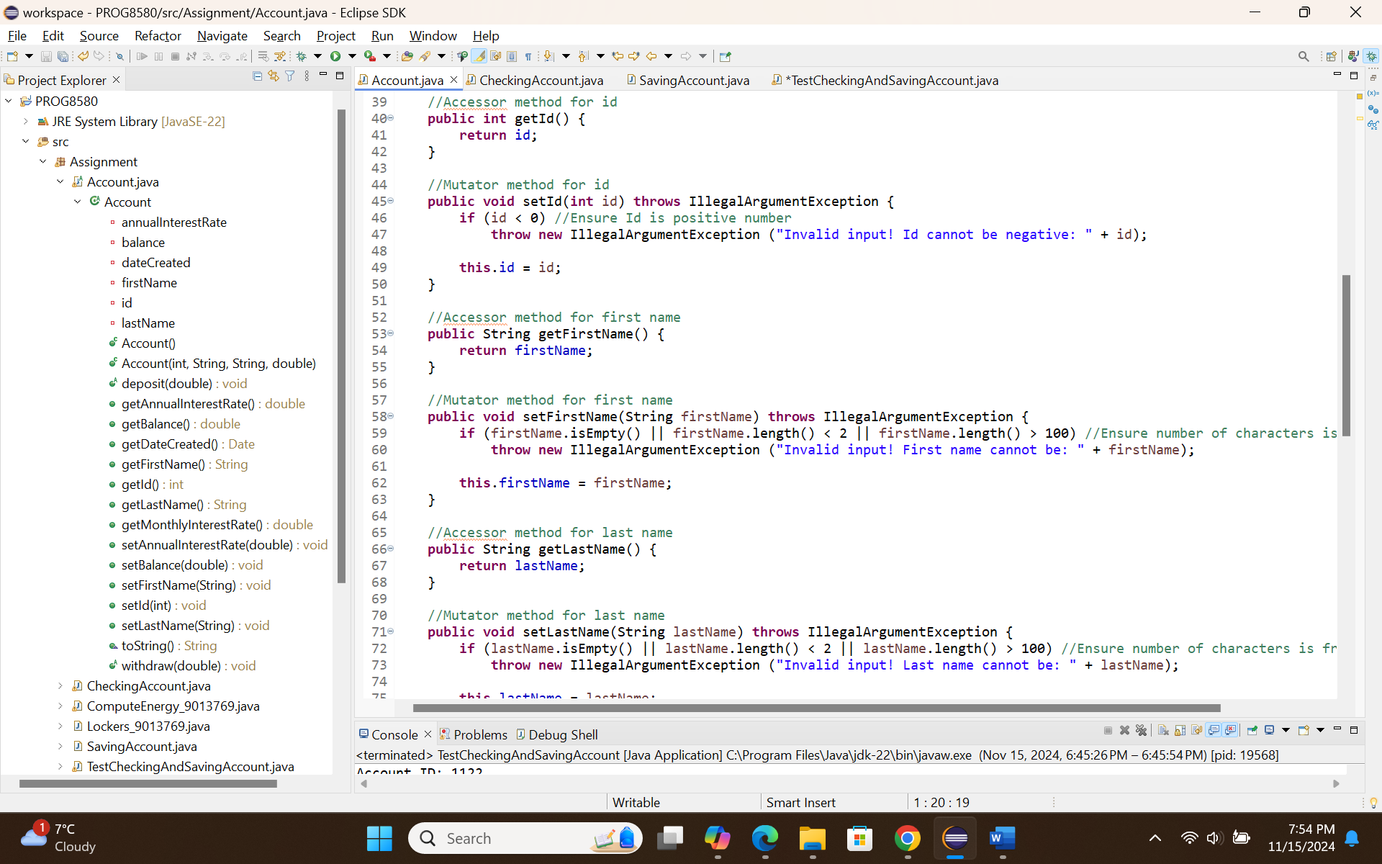
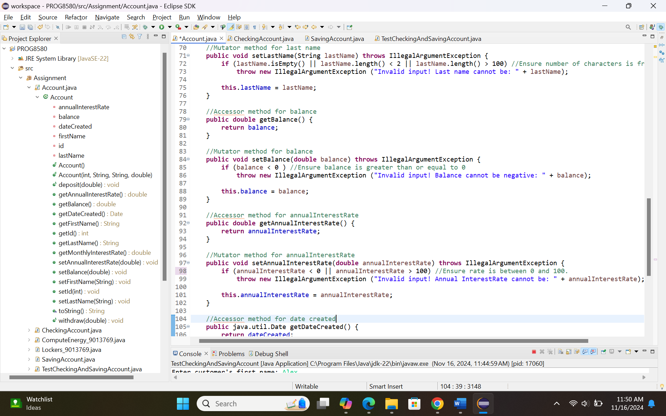
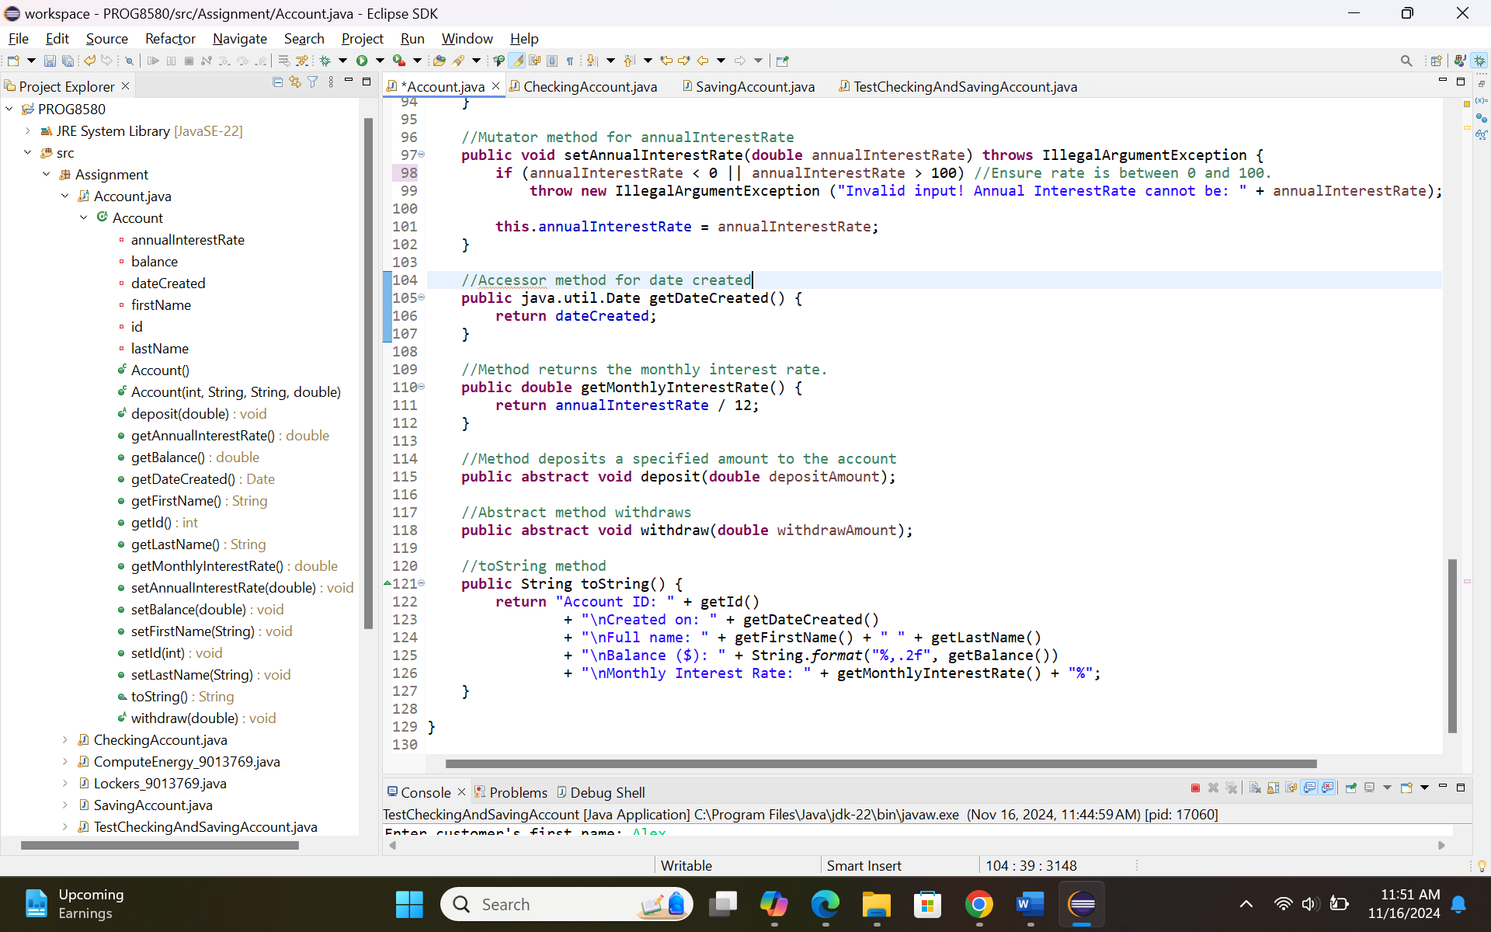

- CheckingAccount Class
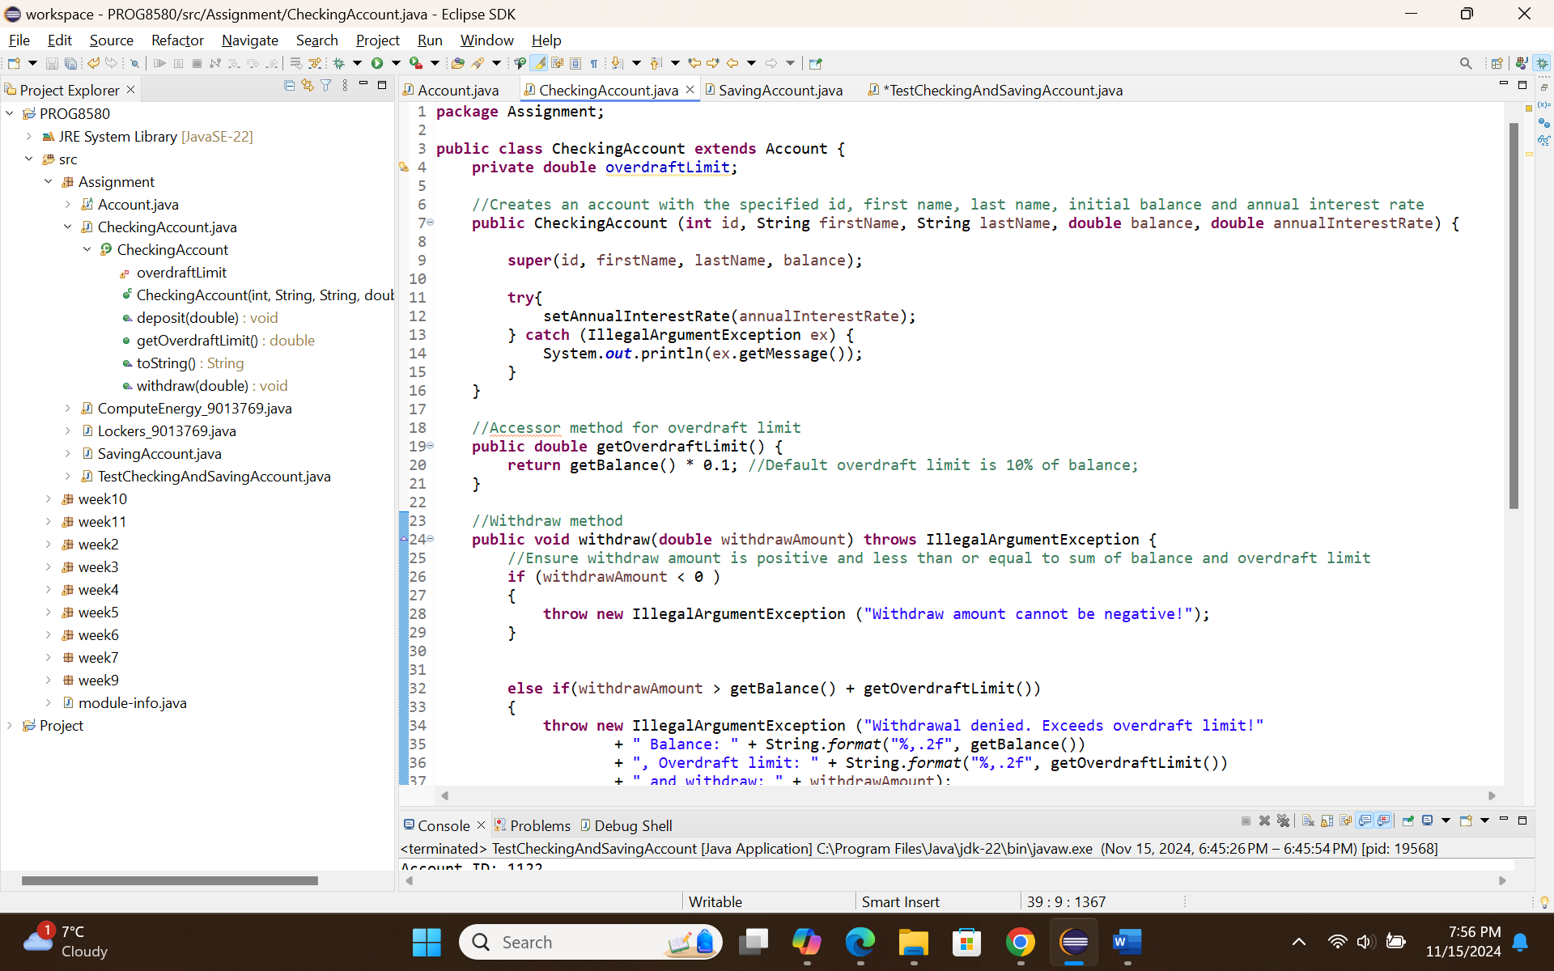
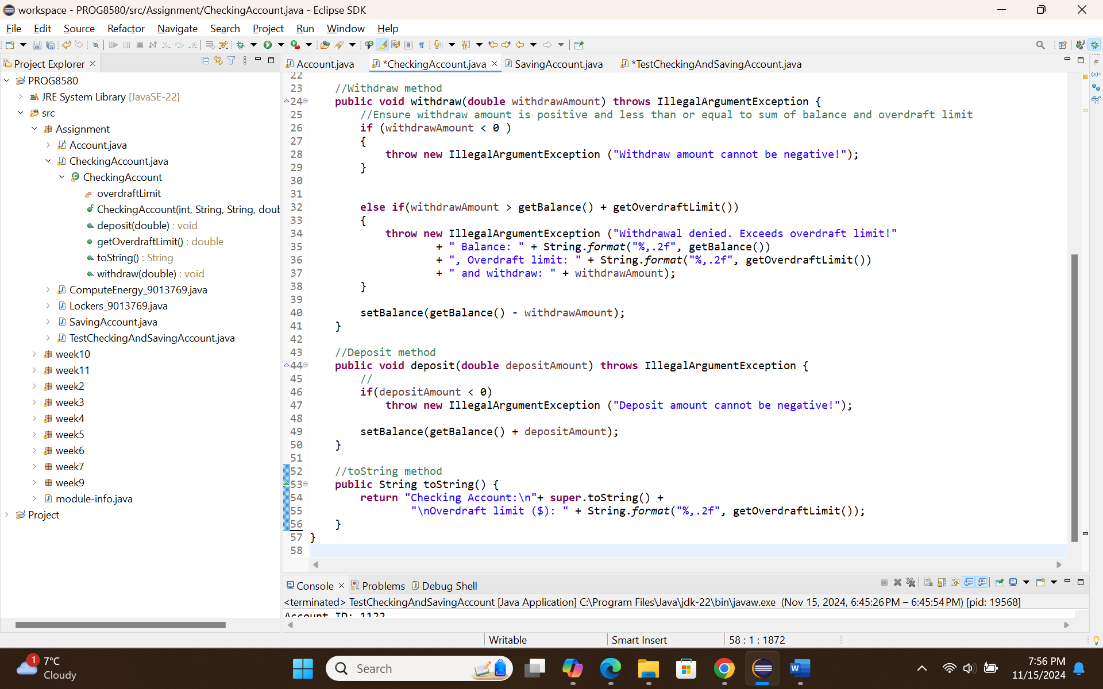

- SavingAccount Class
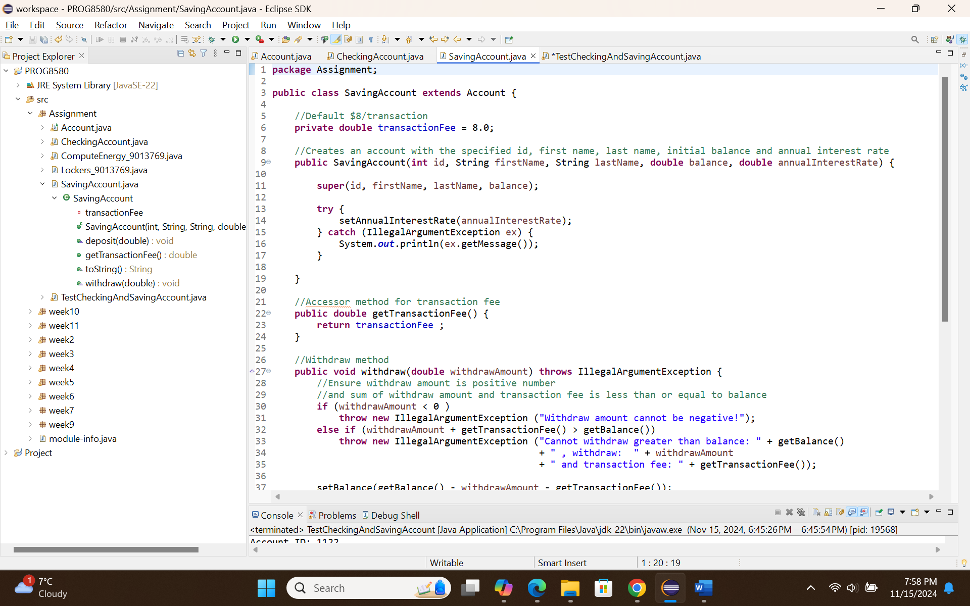
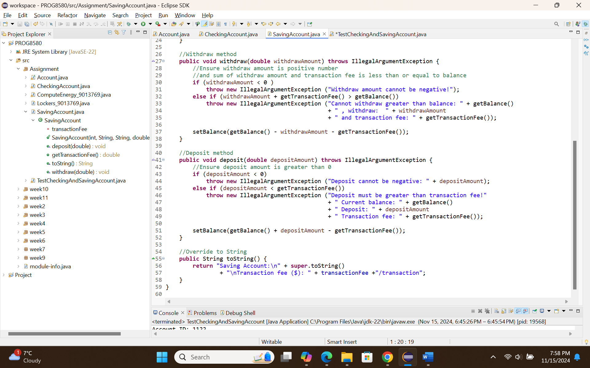

- TestCheckingAndSavingAccount
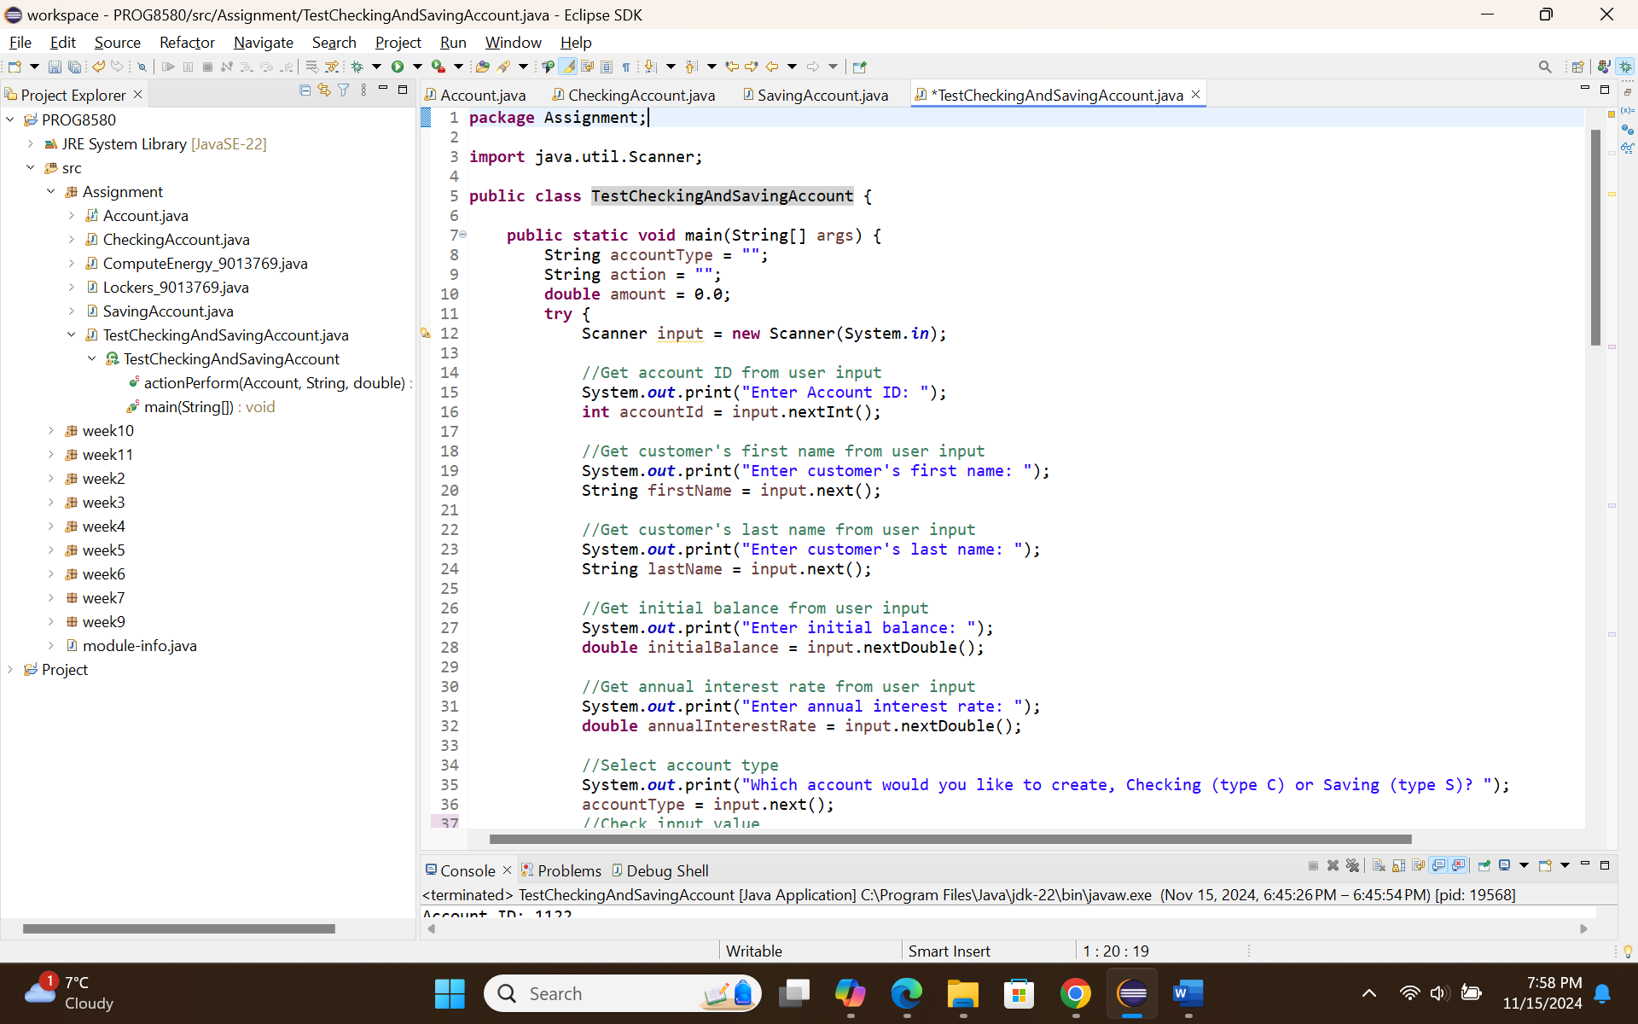
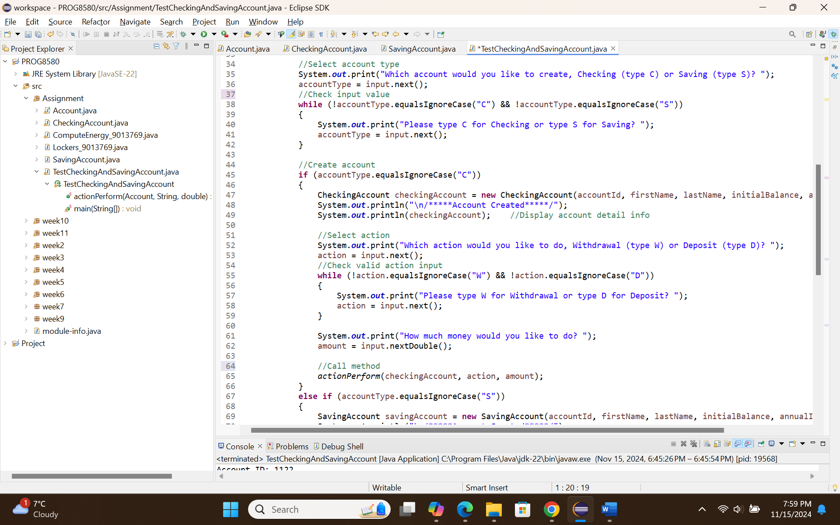
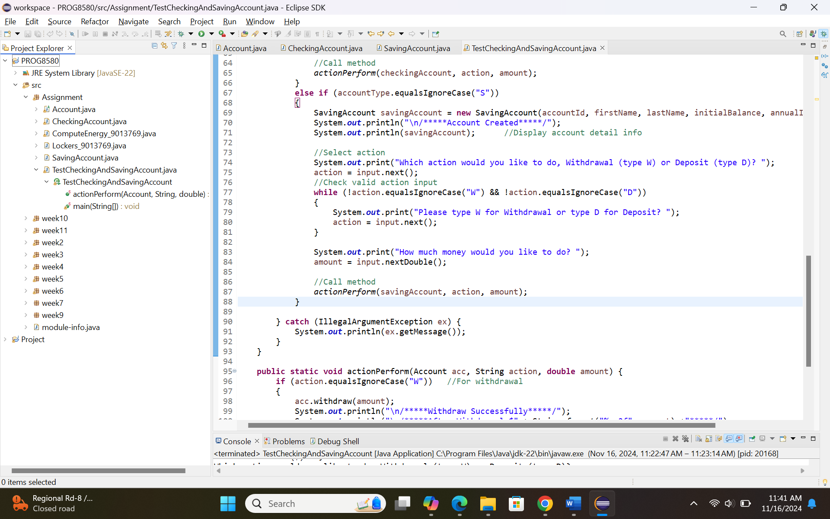
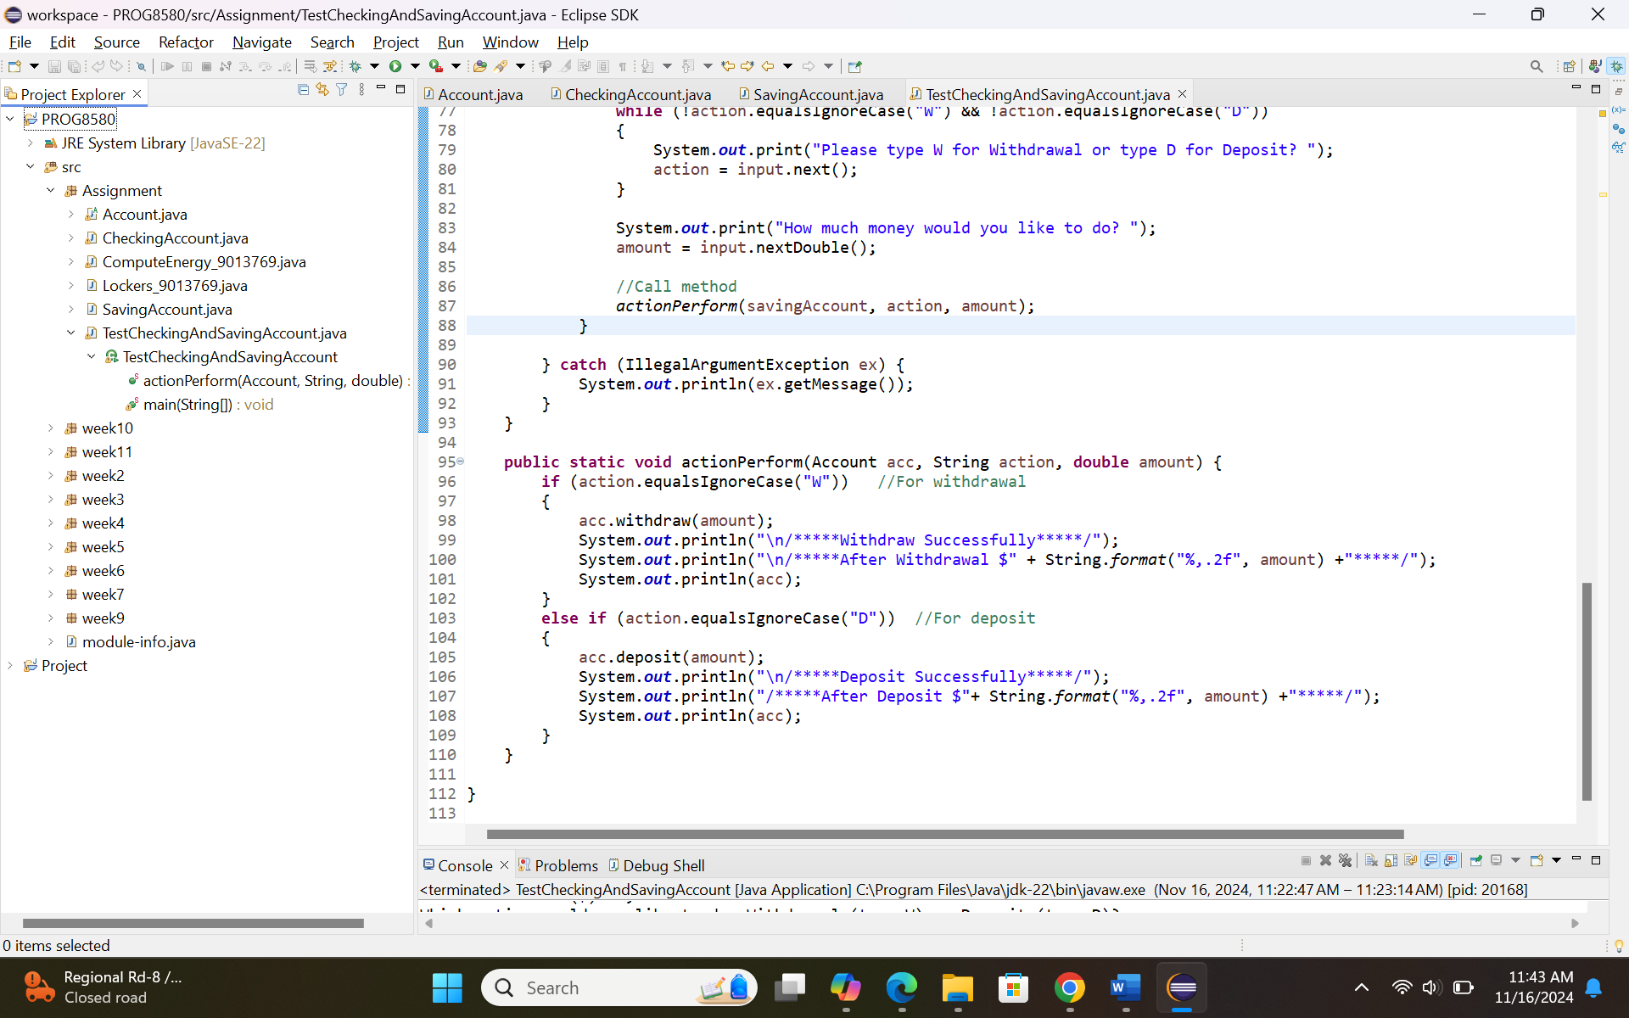

Testing

Testcase 1: Create checking account with a balance of $20,000 and then withdraw 2,500 from this account
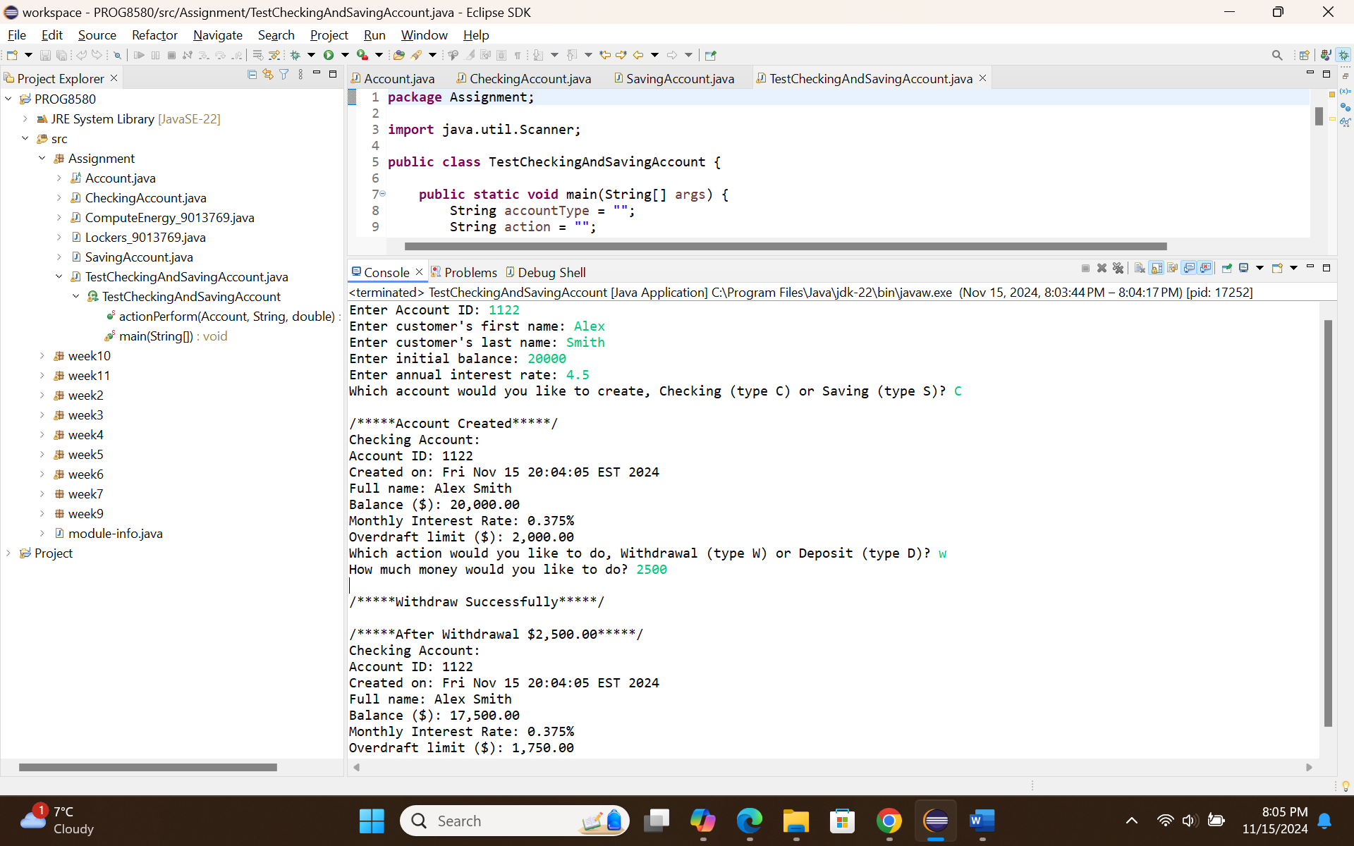

Testcase 2: Create checking account with a balance of $20,000 and then deposit 3,000 from this account
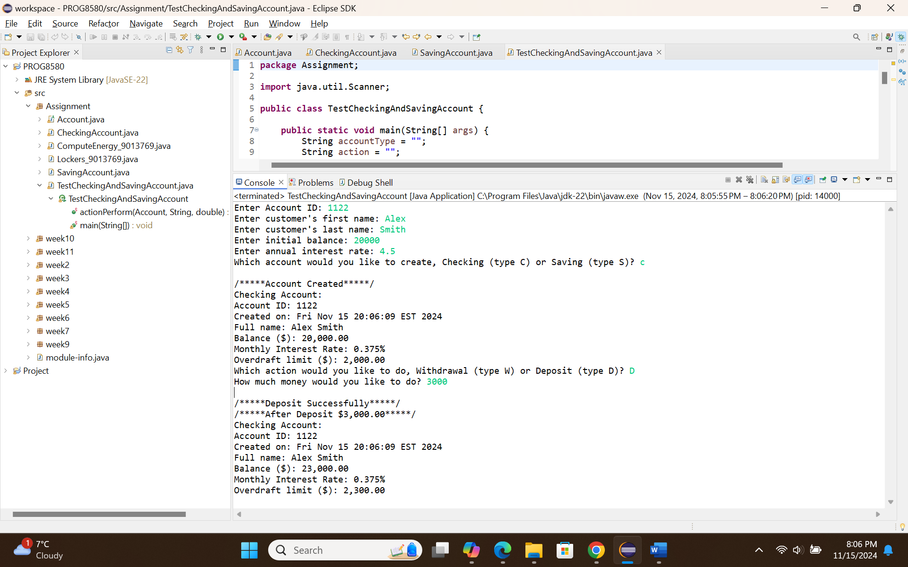

Testcase 3: Create saving account with a balance of $100,000 and then withdraw 2,500 from this account
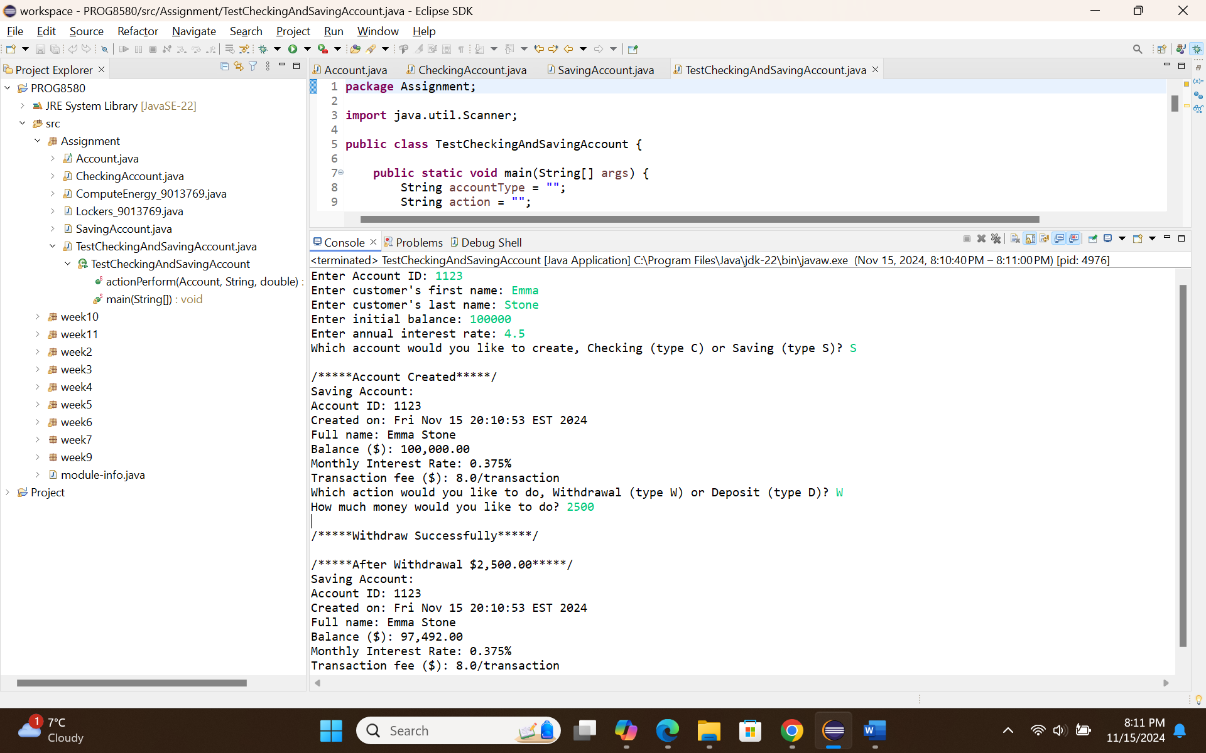

Testcase 4: Create saving account with a balance of $100,000 and then deposit 3,000 to this account
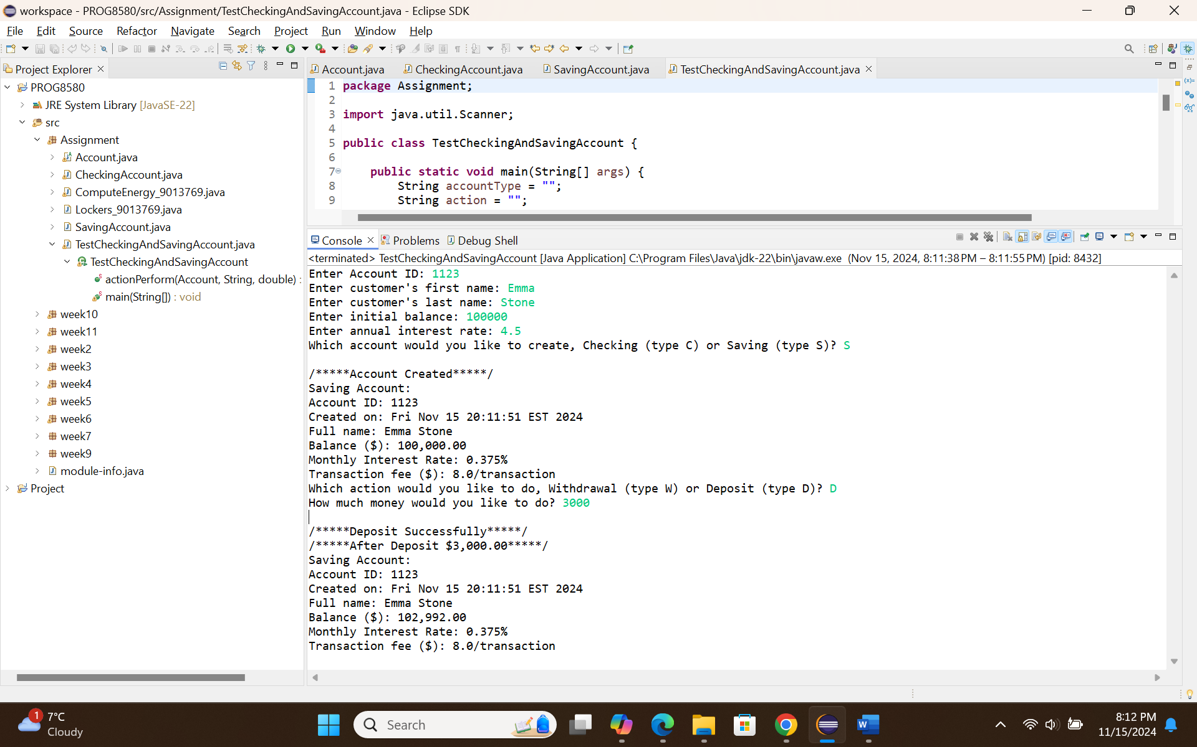

Testcase 5: Invalid account ID
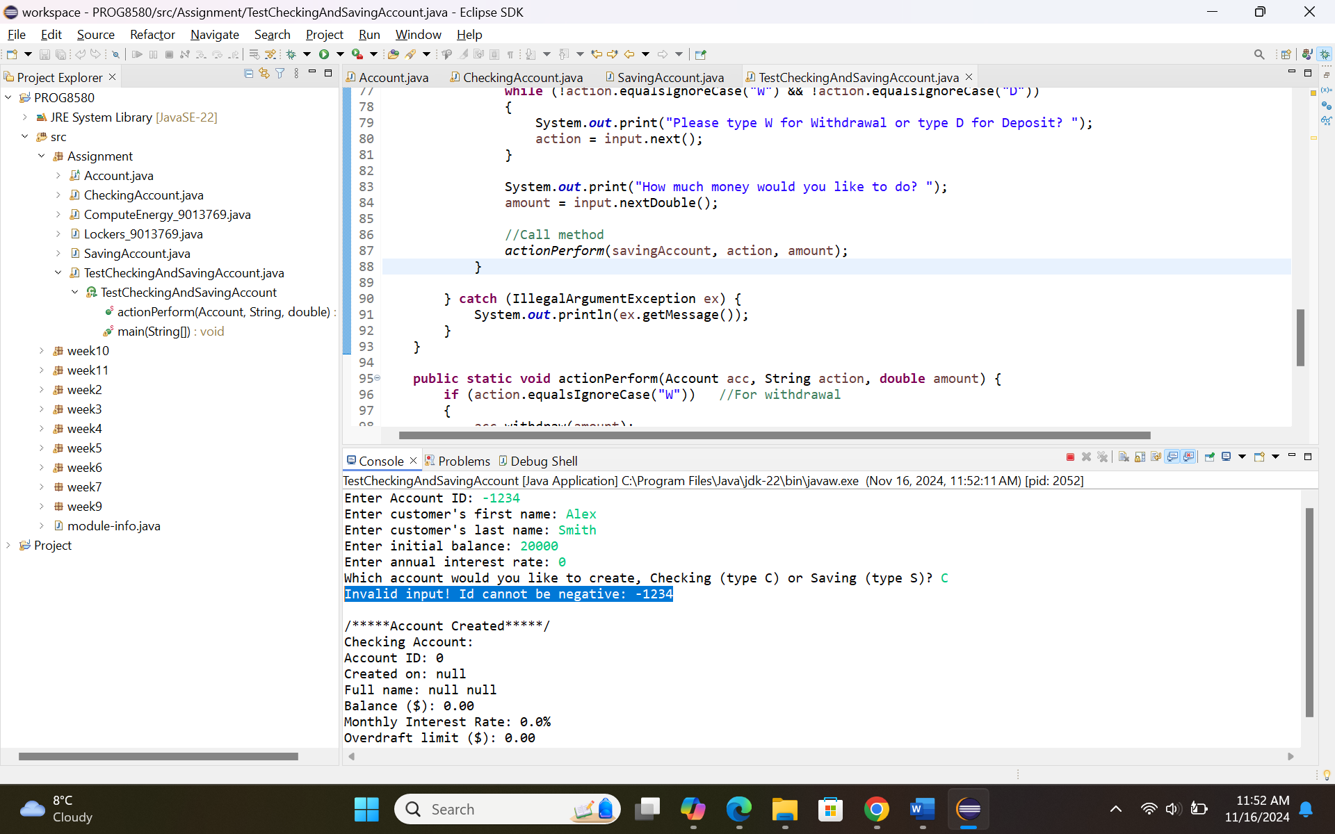

Testcase 6: Invalid first name
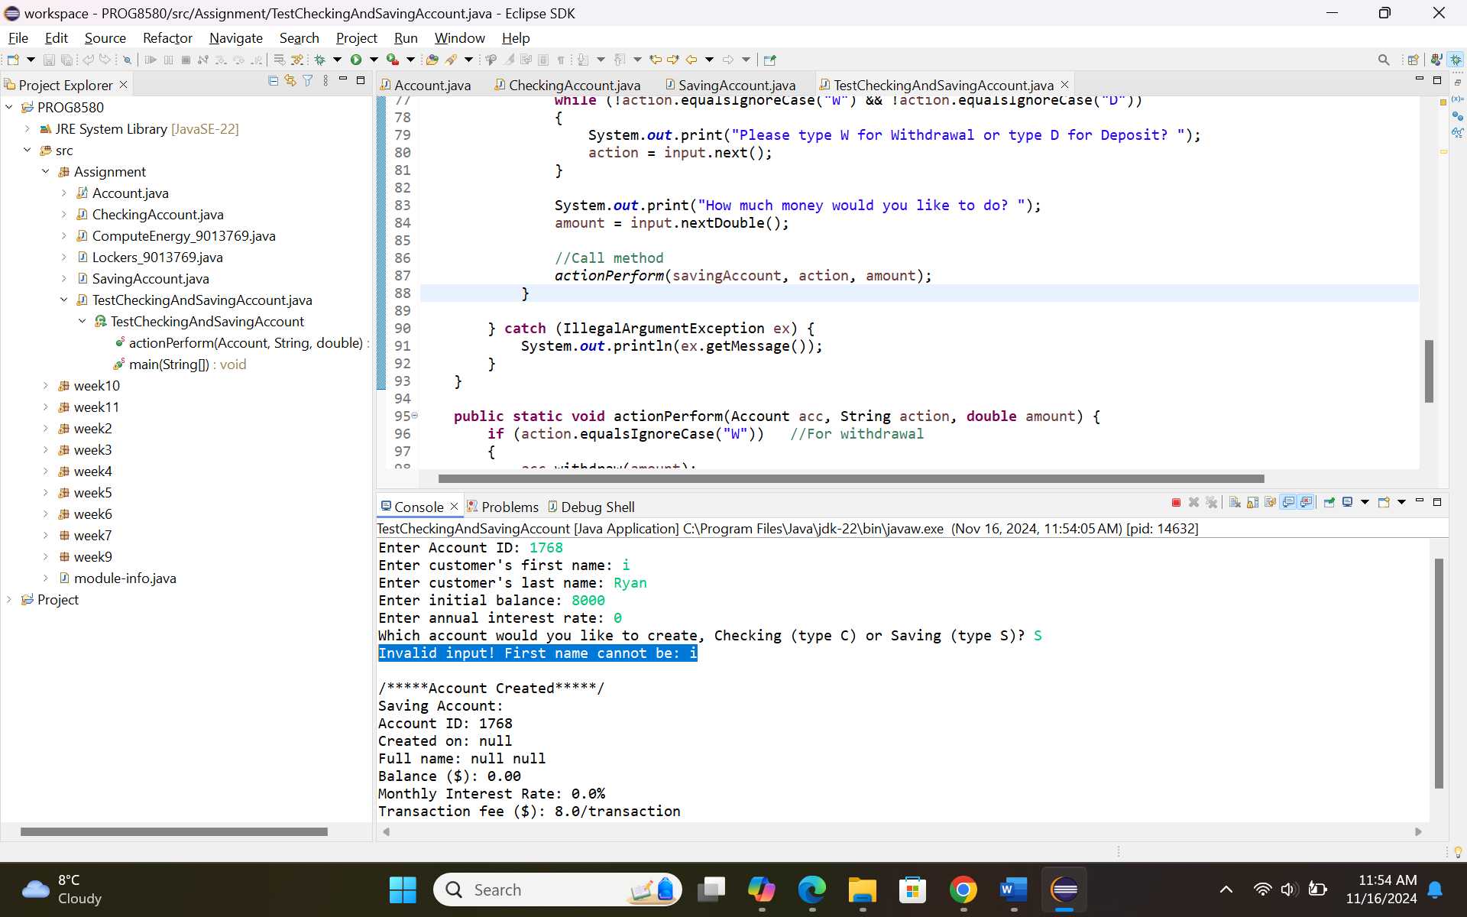

Testcase 7: Invalid last name
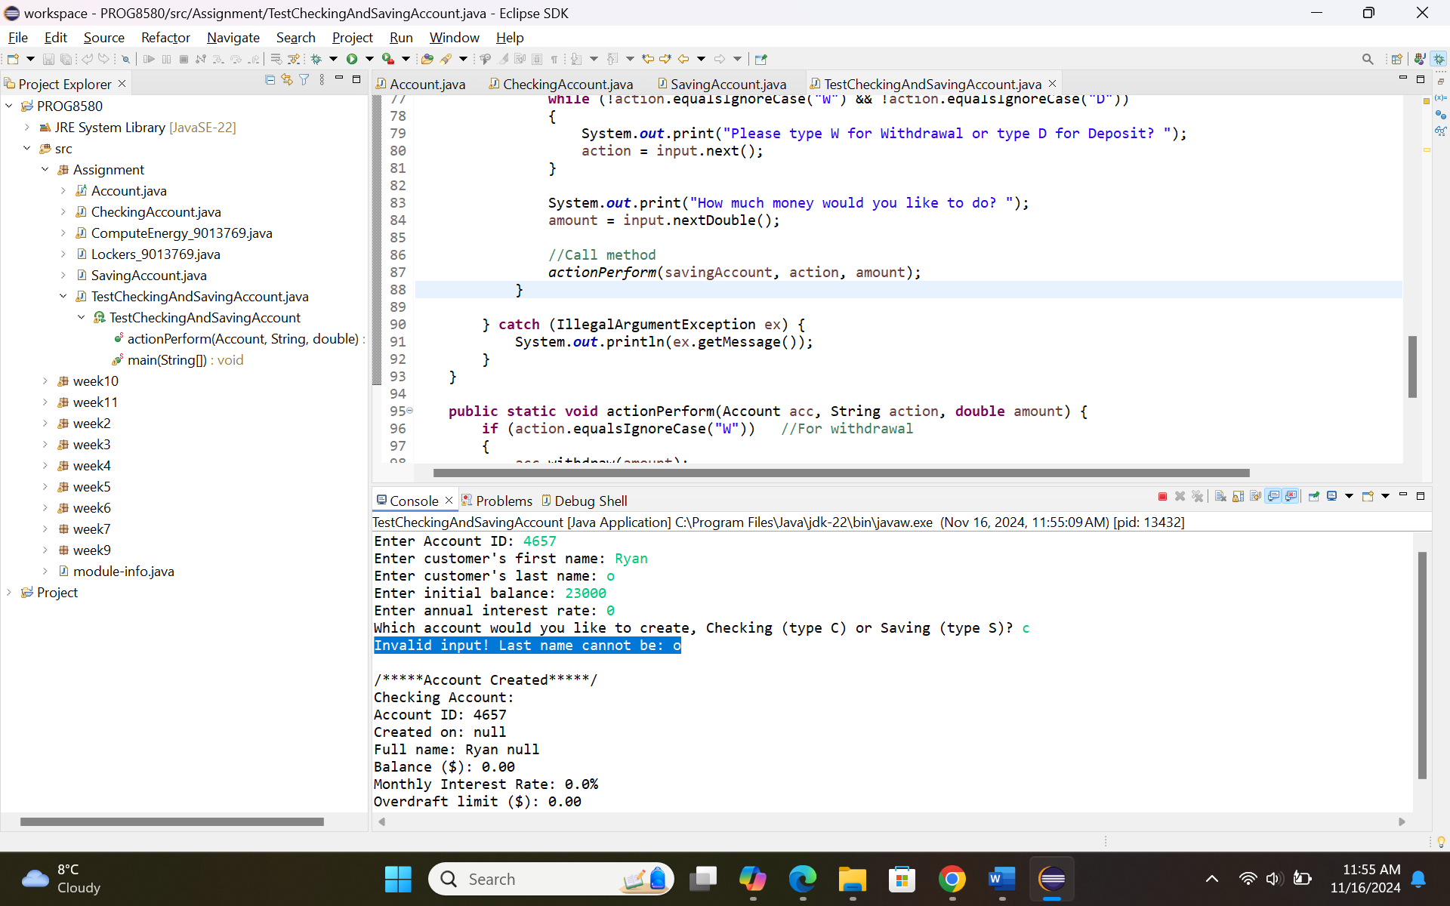

Testcase 8: Invalid balance
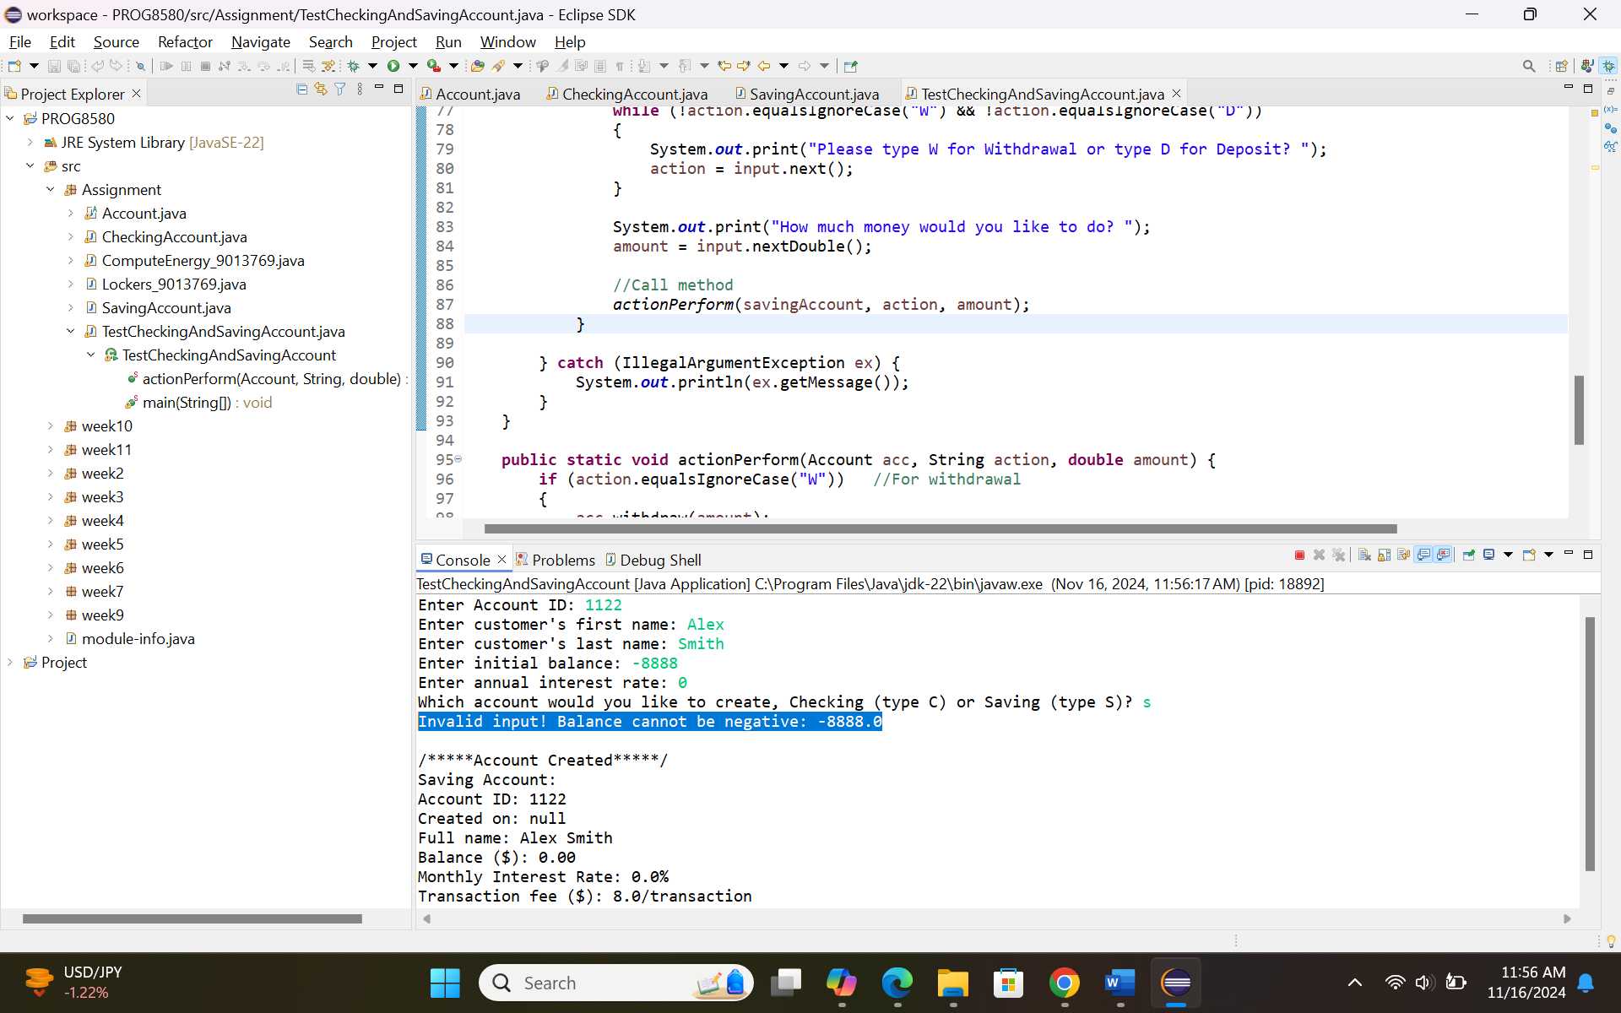

Testcase 9: Annual interest rate is greater than 100
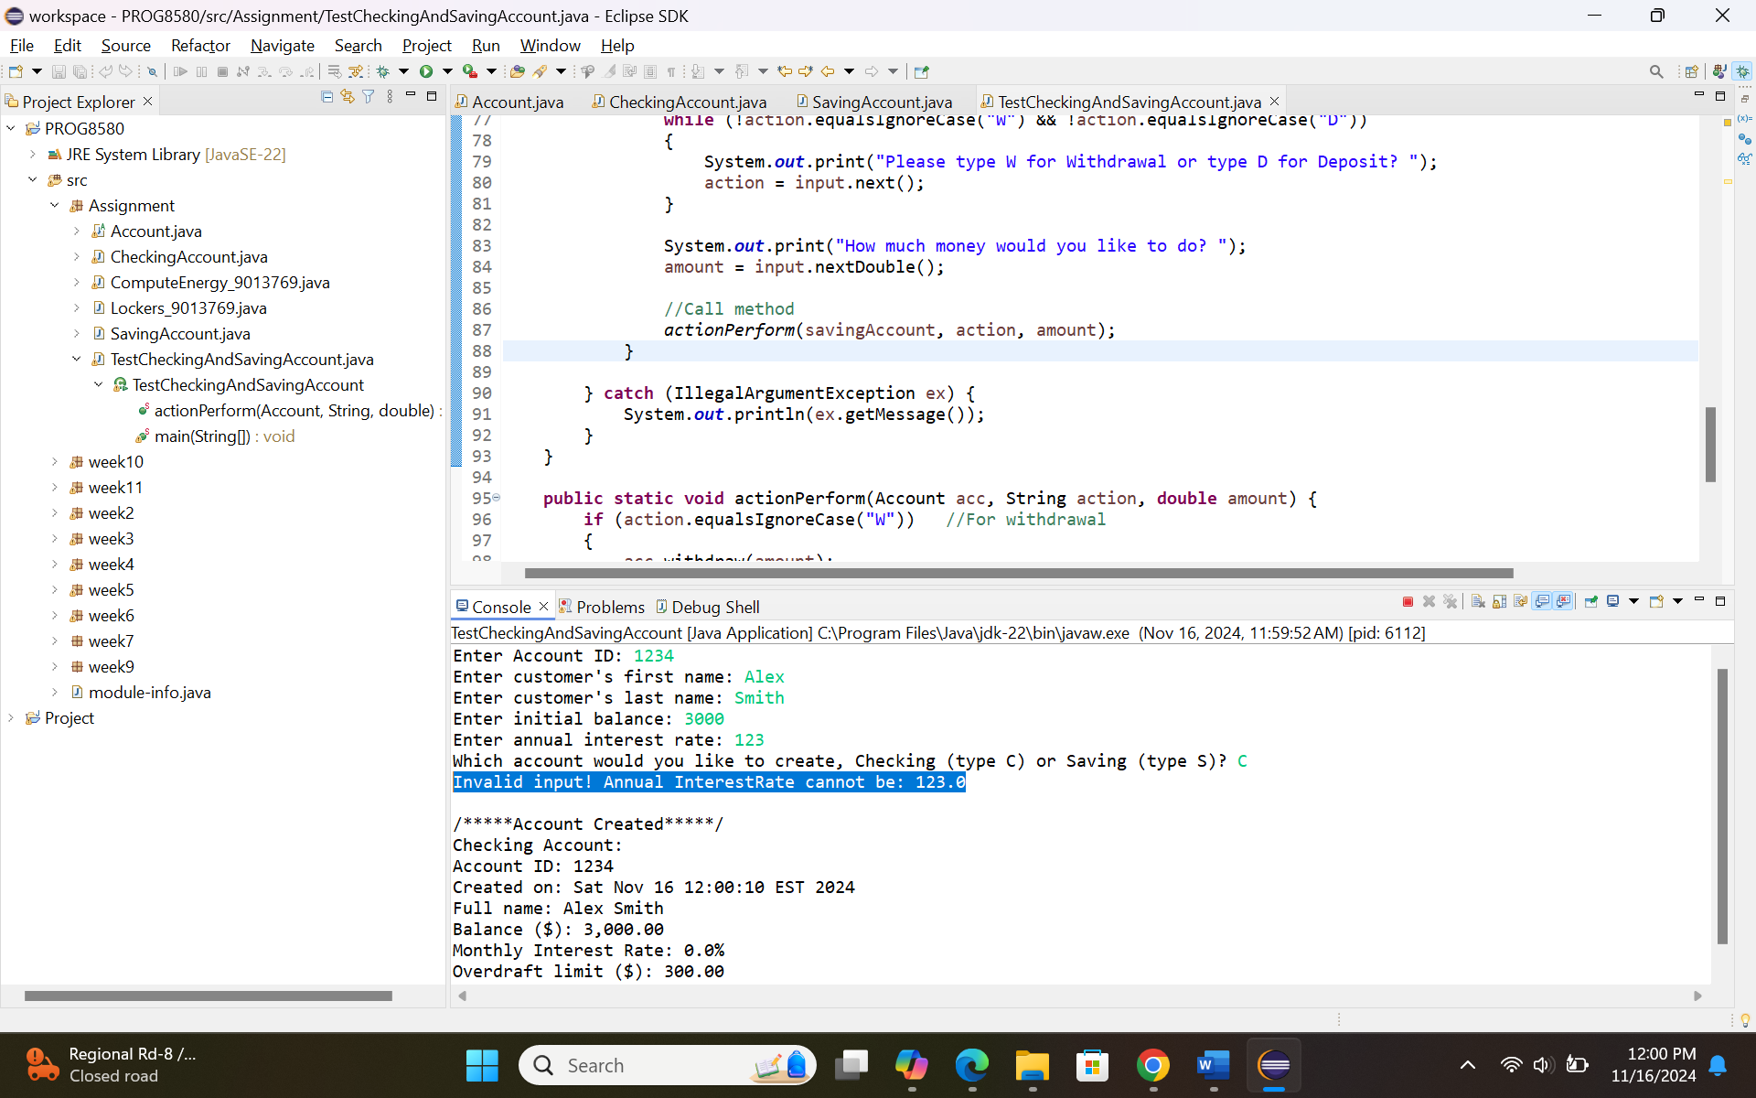

Testcase 10: Annual interest rate is less than 0
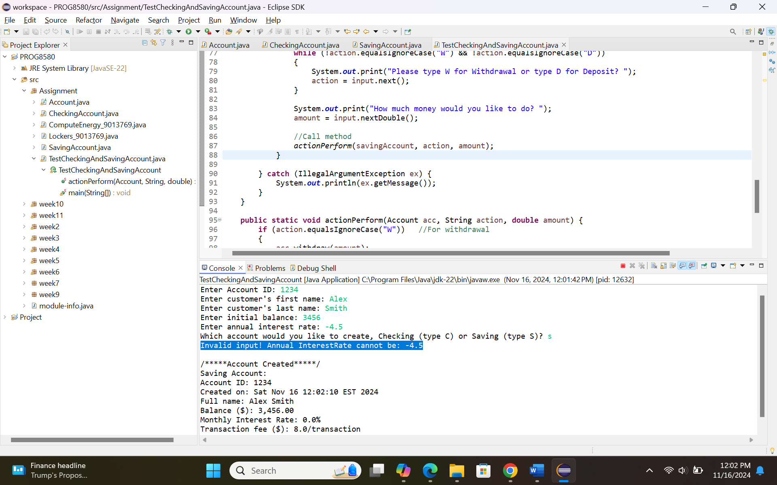

Testcase 11: Withdraw amount is less than 0
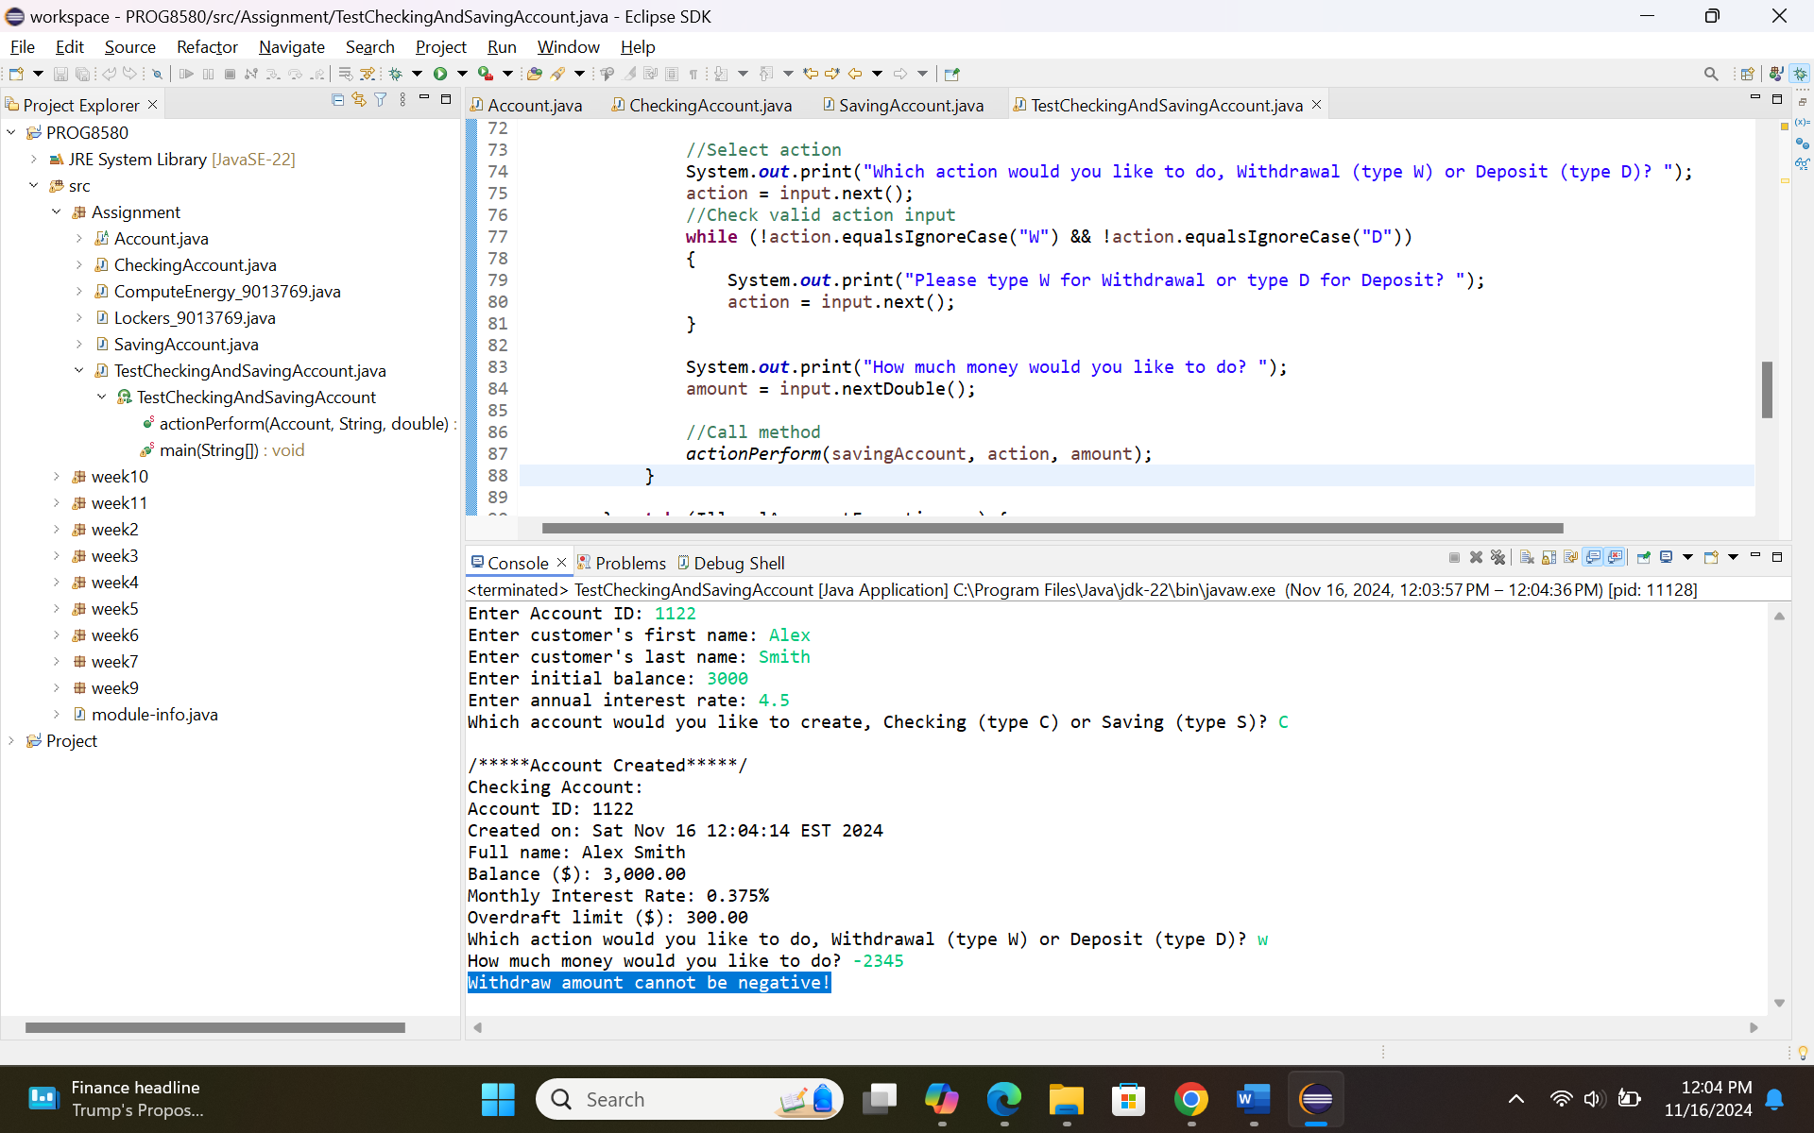

Testcase 11: Withdraw amount is greater than sum of balance and overdraft limit for checking account
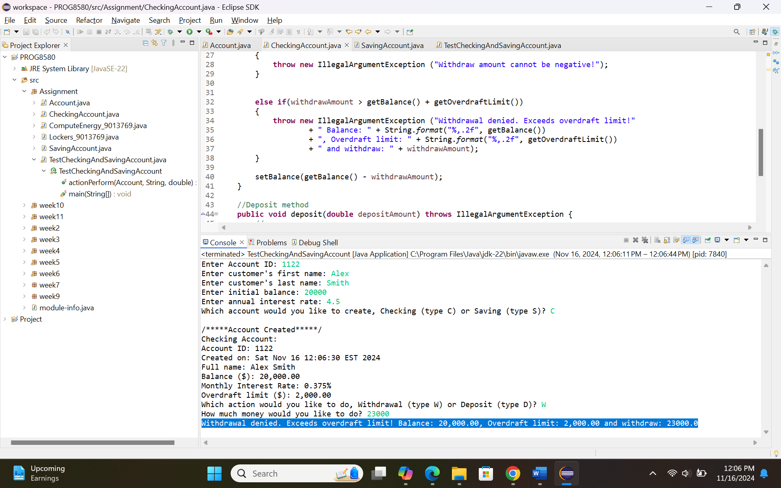

Testcase 12: Deposit amount is less than 0
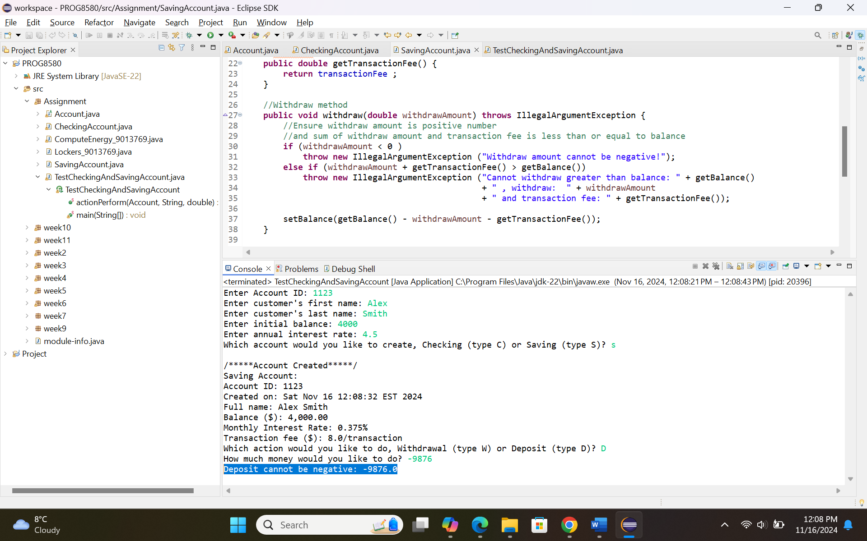

Testcase 13: Sum of withdraw amount and transaction fee is greater than balance for saving account
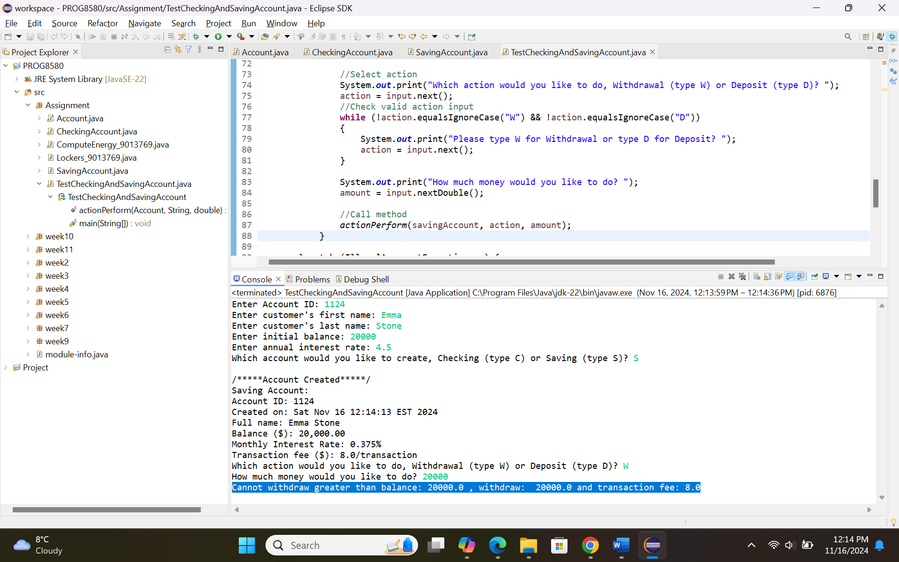

Testcase 14: Deposit amount is less than transaction fee for saving account
