座號： 01 姓名： 林秋輝

階段性作業五

ASP.net WebForm - Validation Controls綜合應用

* 承作業四，請利用各控制項與驗證器，完成以下要求之功能。
  1. 請利用合適的控制項，驗證帳號、密碼、身分證字號、姓名、生日、學歷等欄位是否有填，若未填須提示錯誤。
  2. 請利用合適的控制項，驗證身分證字號、E-Mail、生日等欄位之格式是否正確，若不正確須提示錯誤。
  3. 請利用合適的控制項，驗證生日欄位之輸入區間是否介於1912/1/1至填表單當日之間，若不正確須提示錯誤。
  4. 請利用合適的控制項，驗證兩個密碼欄位是否輸入相同的值，若值不相同須提示錯誤。
  5. 請利用合適的控制項，驗證興趣欄位是否選擇三個(含)以上，若不足三個須提示錯誤。
  6. 請利用合適的控制項，驗證身分證字號是否合法，若不合法須提示錯誤。
  7. 上述所有欄位必須全部通過驗證，才能將表單資料送至(Post)伺服器端，反之不得送出資料。

結果畫面截圖：

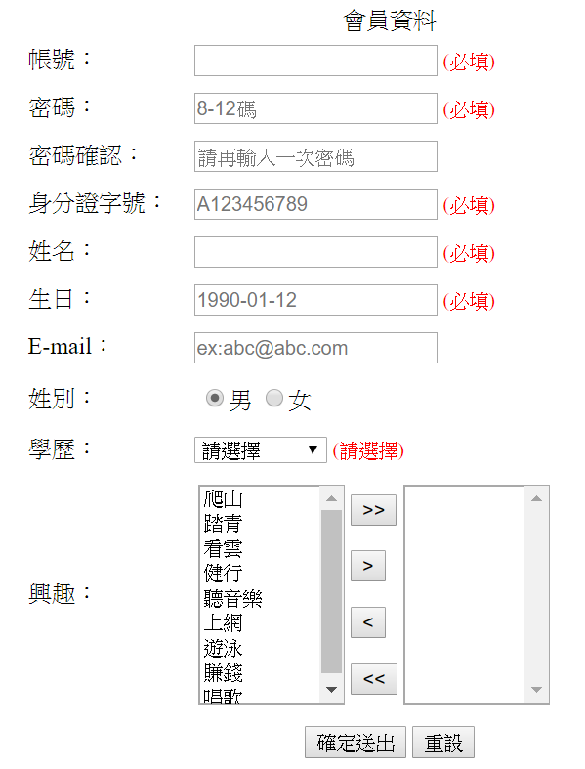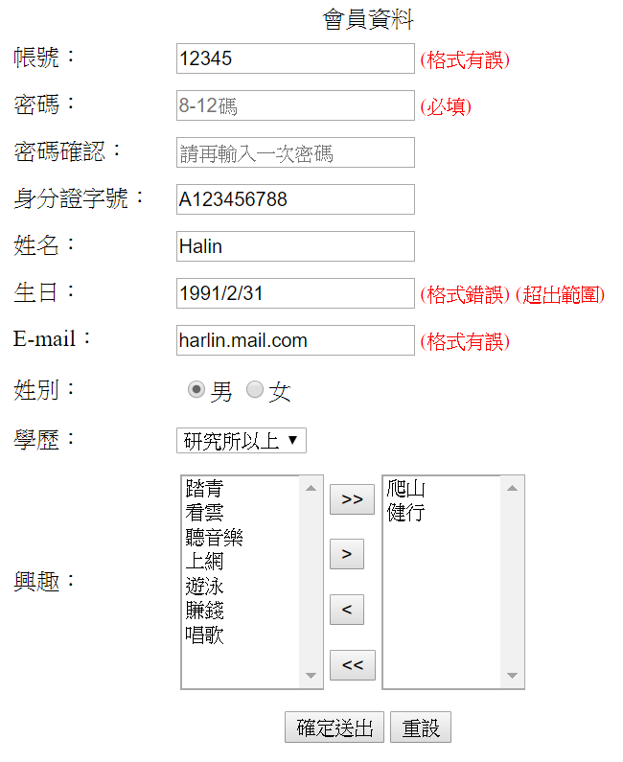

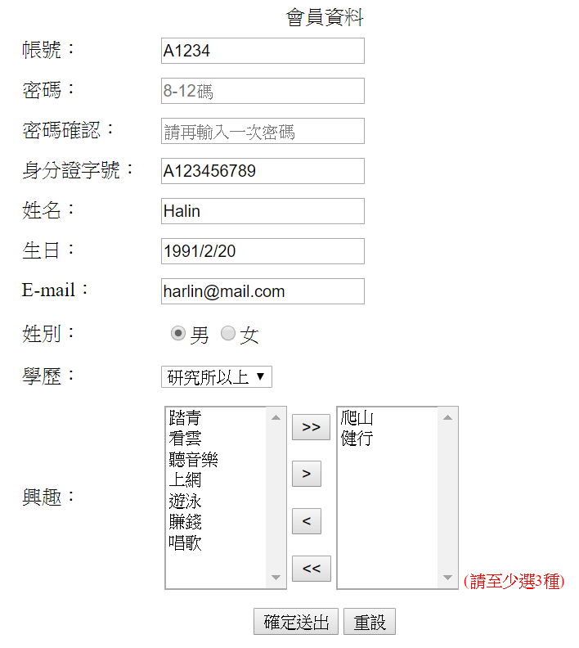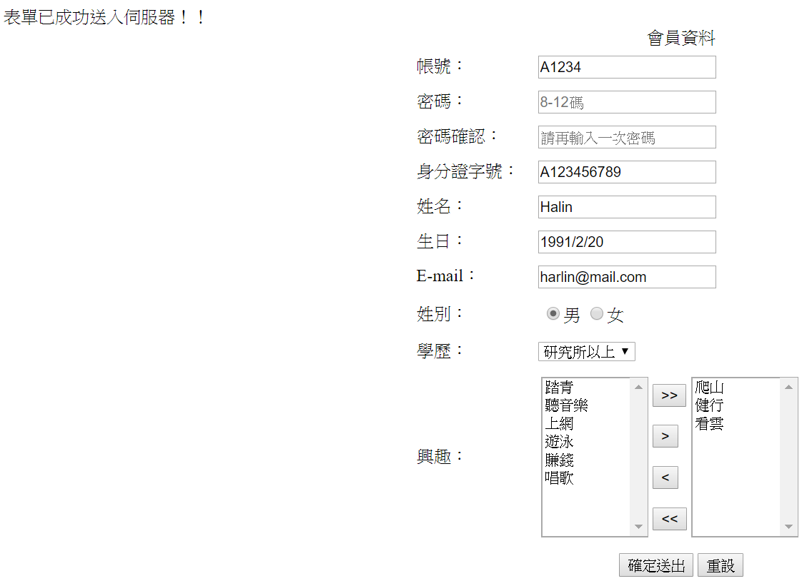

程式碼：

<%@ Page Language="C#" AutoEventWireup="true" CodeBehind="CSHW5_01林秋輝.aspx.cs" Inherits="ASPnet.後端作業五._01林秋輝.CSHW5_01林秋輝" %>

<!DOCTYPE html>

<html xmlns="http://www.w3.org/1999/xhtml">

<head runat="server">

<meta http-equiv="Content-Type" content="text/html; charset=utf-8"/>

<title>CSHW5_01林秋輝</title>

</head>

<style>

#tbMember{

width:500px;

height:500px;

margin:auto;

}

#tbMember tr:last-child>td{

text-align:center;

}

</style>

<body>

<form id="form1" runat="server">

<div>

<table id="tbMember">

<caption>會員資料</caption>

<tr>

<td>帳號：</td>

<td>

<asp:TextBox ID="txtAccount" runat="server"></asp:TextBox>

<asp:RequiredFieldValidator ID="RequiredFieldValidator1" ControlToValidate="txtAccount" Display="Dynamic" runat="server" ErrorMessage="姓名為必填欄位" Text="(必填)" ForeColor="Red" Font-Size="10pt"></asp:RequiredFieldValidator>

<asp:RegularExpressionValidator ID="RegularExpressionValidator1" ControlToValidate="txtAccount" ValidationExpression="[ABC][A-Za-z0-9]{4}" runat="server" ErrorMessage="(格式有誤)" ForeColor="Red" Font-Size="10pt"></asp:RegularExpressionValidator>

</td>

</tr>

<tr>

<td>密碼：</td>

<td>

<asp:TextBox ID="txtPwd" runat="server" TextMode="Password" placeholder="8-12碼" MaxLength="12"></asp:TextBox>

<asp:RequiredFieldValidator ID="RequiredFieldValidator2" Display="Dynamic" ControlToValidate="txtPwd" runat="server" ErrorMessage="密碼為必填欄位" Text="(必填)" ForeColor="Red" Font-Size="10pt"></asp:RequiredFieldValidator>

<asp:RegularExpressionValidator ID="RegularExpressionValidator3" ControlToValidate="txtPwd" ValidationExpression="\S{8,12}" runat="server" ErrorMessage="(密碼不可含有空白)" ForeColor="Red" Font-Size="10pt"></asp:RegularExpressionValidator>

</td>

</tr>

<tr>

<td>密碼確認：</td>

<td>

<asp:TextBox ID="txtPwd2" runat="server" TextMode="Password" placeholder="請再輸入一次密碼"></asp:TextBox>

<asp:CompareValidator ID="CompareValidator3" runat="server" Operator="Equal" ControlToCompare="txtPwd2" ControlToValidate="txtPwd" ErrorMessage="(兩次密碼輸入不相同)" ForeColor="Red" Font-Size="10pt"></asp:CompareValidator>

</td>

</tr>

<tr>

<td>身分證字號：</td>

<td>

<asp:TextBox ID="txtID" runat="server" placeholder="A123456789" MaxLength="10"></asp:TextBox>

<asp:RequiredFieldValidator ID="RequiredFieldValidator3" Display="Dynamic" ControlToValidate="txtID" runat="server" ErrorMessage="身分證為必填欄位" Text="(必填)" ForeColor="Red" Font-Size="10pt"></asp:RequiredFieldValidator>

<asp:RegularExpressionValidator ID="RegularExpressionValidator2" Display="Dynamic" ControlToValidate="txtID" ValidationExpression="[A-Za-z](1|2)\d{8}" runat="server" ErrorMessage="(格式有誤)" ForeColor="Red" Font-Size="10pt"></asp:RegularExpressionValidator>

<asp:CustomValidator ID="CustomValidator1" runat="server" ErrorMessage="(不合法)" ForeColor="Red" Font-Size="10pt" OnServerValidate="CustomValidator1_ServerValidate"></asp:CustomValidator>

</td>

</tr> <tr>

<td>姓名：</td>

<td>

<asp:TextBox ID="txtName" runat="server"></asp:TextBox>

<asp:RequiredFieldValidator ID="RequiredFieldValidator4" ControlToValidate="txtName" runat="server" ErrorMessage="(必填)" ForeColor="Red" Font-Size="10pt"></asp:RequiredFieldValidator>

</td>

</tr>

<tr>

<td>生日：</td>

<td>

<asp:TextBox ID="txtBirthday" runat="server" placeholder="1990-01-12"></asp:TextBox>

<asp:RequiredFieldValidator ID="RequiredFieldValidator5" ControlToValidate="txtBirthday" Display="Dynamic" runat="server" ErrorMessage="(必填)" ForeColor="Red" Font-Size="10pt"></asp:RequiredFieldValidator>

<asp:CompareValidator ID="CompareValidator1" Display="Dynamic" runat="server" Operator="DataTypeCheck" Type="Date" ControlToValidate="txtBirthday" ErrorMessage="(格式錯誤)" ForeColor="Red" Font-Size="10pt"></asp:CompareValidator>

<asp:RangeValidator ID="ranForBirthday" runat="server" Type="Date" MinimumValue="1912/1/1" ControlToValidate="txtBirthday" ErrorMessage="(超出範圍)" ForeColor="Red" Font-Size="10pt"></asp:RangeValidator>

</td>

</tr>

<tr>

<td>E-mail：</td>

<td>

<asp:TextBox ID="txtEmail" runat="server" TextMode="Email" placeholder="ex:abc@abc.com"></asp:TextBox>

<asp:RegularExpressionValidator ID="RegularExpressionValidator4" ControlToValidate="txtEmail" ValidationExpression="([\w-\.]+)@((\[[0-9]{1,3}\.[0-9]{1,3}\.[0-9]{1,3}\.)|(([\w-]+\.)+))([a-zA-Z]{2,4}|[0-9]{1,3})(\]?)" runat="server" ErrorMessage="(格式有誤)" ForeColor="Red" Font-Size="10pt"></asp:RegularExpressionValidator>

</td>

</tr>

<tr>

<td>姓別：</td>

<td>

<asp:RadioButtonList ID="rblGender" runat="server" RepeatDirection="Horizontal">

<asp:ListItem Text="男" Selected="True"></asp:ListItem>

<asp:ListItem Text="女"></asp:ListItem>

</asp:RadioButtonList>

</td>

</tr>

<tr>

<td>學歷：</td>

<td>

<asp:DropDownList ID="ddlEduLevel" runat="server">

<asp:ListItem Text="請選擇"></asp:ListItem>

<asp:ListItem Text="國小"></asp:ListItem>

<asp:ListItem Text="國中"></asp:ListItem>

<asp:ListItem Text="高中"></asp:ListItem>

<asp:ListItem Text="大學"></asp:ListItem>

<asp:ListItem Text="研究所以上"></asp:ListItem>

</asp:DropDownList>

<asp:CompareValidator ID="CompareValidator2" runat="server" Operator="NotEqual" ValueToCompare="請選擇" ControlToValidate="ddlEduLevel" ErrorMessage="(請選擇)" ForeColor="Red" Font-Size="10pt"></asp:CompareValidator>

</td>

</tr>

<tr>

<td>興趣：</td>

<td>

<table>

<tr>

<td rowspan="4">

<asp:ListBox ID="ltbInterest" runat="server" Width="100" Height="150">

<asp:ListItem Text="爬山"></asp:ListItem>

<asp:ListItem Text="踏青"></asp:ListItem>

<asp:ListItem Text="看雲"></asp:ListItem>

<asp:ListItem Text="健行"></asp:ListItem>

<asp:ListItem Text="聽音樂"></asp:ListItem>

<asp:ListItem Text="上網"></asp:ListItem>

<asp:ListItem Text="遊泳"></asp:ListItem>

<asp:ListItem Text="賺錢"></asp:ListItem>

<asp:ListItem Text="唱歌"></asp:ListItem>

</asp:ListBox>

</td>

<td>

<asp:Button ID="btnAll" runat="server" Text=">>" OnClick="btnAll_Click" CausesValidation="false" />

</td>

<td rowspan="4">

<asp:ListBox ID="ltbInterest2" runat="server" Width="100" Height="150">

</asp:ListBox>

<asp:CustomValidator ID="CustomValidator2" runat="server" ErrorMessage="(請至少選3種)" ForeColor="Red" Font-Size="10pt" OnServerValidate="CustomValidator2_ServerValidate"></asp:CustomValidator>

</td>

</tr>

<tr>

<td>

<asp:Button ID="btnYes" runat="server" Text=">" OnClick="btnYes_Click" CausesValidation="false" />

</td>

</tr>

<tr>

<td>

<asp:Button ID="btnNo" runat="server" Text="<" OnClick="btnNo_Click" CausesValidation="false" />

</td>

</tr>

<tr>

<td >

<asp:Button ID="btnCancel" runat="server" Text="<<" OnClick="btnCancel_Click" CausesValidation="false" />

</td>

</tr>

</table>

</td>

</tr>

<tr>

<td colspan="2">

<asp:Button ID="Button1" runat="server" Text="確定送出" OnClick="Button1_Click"/>

<input id="Reset1" type="reset" value="重設" />

</td>

</tr>

</table>

</div>

</form>

</body>

</html>

using System;

using System.Collections.Generic;

using System.Linq;

using System.Web;

using System.Web.UI;

using System.Web.UI.WebControls;

namespace ASPnet.後端作業五._01林秋輝

{

public partial class CSHW5_01林秋輝 : System.Web.UI.Page

{

protected void Page_Load(object sender, EventArgs e)

{

ranForBirthday.MaximumValue = DateTime.Now.ToString("d");

}

protected void btnAll_Click(object sender, EventArgs e)

{

for (int i = 0; i < ltbInterest.Items.Count; i++)

{

ltbInterest2.Items.Add(ltbInterest.Items[i].Text);

}

ltbInterest.Items.Clear();

}

protected void btnCancel_Click(object sender, EventArgs e)

{

for (int i = 0; i < ltbInterest2.Items.Count; i++)

{

ltbInterest.Items.Add(ltbInterest2.Items[i].Text);

}

ltbInterest2.Items.Clear();

}

protected void btnYes_Click(object sender, EventArgs e)

{

for (int i = 0; i < ltbInterest.Items.Count; i++)

{

if (ltbInterest.Items[i].Selected)

{

ltbInterest2.Items.Add(ltbInterest.Items[i].Text);

ltbInterest.Items.RemoveAt(i);

}

}

}

protected void btnNo_Click(object sender, EventArgs e)

{

for (int i = 0; i < ltbInterest2.Items.Count; i++)

{

if (ltbInterest2.Items[i].Selected)

{

ltbInterest.Items.Add(ltbInterest2.Items[i].Text);

ltbInterest2.Items.RemoveAt(i);

}

}

}

protected void CustomValidator1_ServerValidate(object source, ServerValidateEventArgs args)

{

string id = txtID.Text;

string[] eng = {"A", "B", "C", "D", "E", "F", "G", "H", "J", "K",

"L", "M", "N", "P", "Q", "R", "S", "T", "U", "V", "X", "Y", "W",

"Z", "I", "O" };

int intEng = 0;

for (int i = 0; i < eng.Length; i++)

{

if (eng[i] == id.Substring(0, 1).ToUpper())

{

intEng = i + 10;

break;

}

}

//假設n=17

int n1 = intEng / 10; //n1=1

int n2 = intEng % 10; //n2=7

int[] a = new int[9];

for (int i = 0; i < a.Length; i++)

{

a[i] = Convert.ToInt16(id.Substring(i + 1, 1));

}

int sum = 0;

for (int i = 0; i < 8; i++)

{

sum += a[i] * (8 - i);

}

int n = 0;

n = n1 + n2 * 9 + sum + a[8];

//n1 +n2*9+a[0]*8+a[1]*7*a[2]*6+a[3]*5

if (n % 10 == 0)

args.IsValid = true;

else

args.IsValid = false;

}

protected void Button1_Click(object sender, EventArgs e)

{

if (IsValid)

{

Response.Write("表單已成功送入伺服器！！");

}

}

protected void CustomValidator2_ServerValidate(object source, ServerValidateEventArgs args)

{

if (ltbInterest2.Items.Count < 3)

{

args.IsValid = false; //驗證器不通過；顯示錯誤訊息

}

else

args.IsValid = true; //驗證器會通過

}

}

}

**繳交作業時，請以FTP上傳程式原始檔與本文件檔各一份，原始程式碼請另放置在「完成結果檔」資料夾內。**

※以上各項均須完成始得通過※