Using BlazorCodeTools to help scaffold your Blazor Application development.

BlazorCodeTools was written with a few of things in Mind.
- It assumes that the application being worked on is in the shape of the default Blazor Project template, in that their exists a Shared component and a Server component at minimum. There may also be the Client component if the Webassembly form of the template was used in setting up the project.
- It assumes that the Shared component is where common class definitions will get placed.
- The controller creation logic is assumed to be going into the Server component

Running the tool presents you with the following interface initially

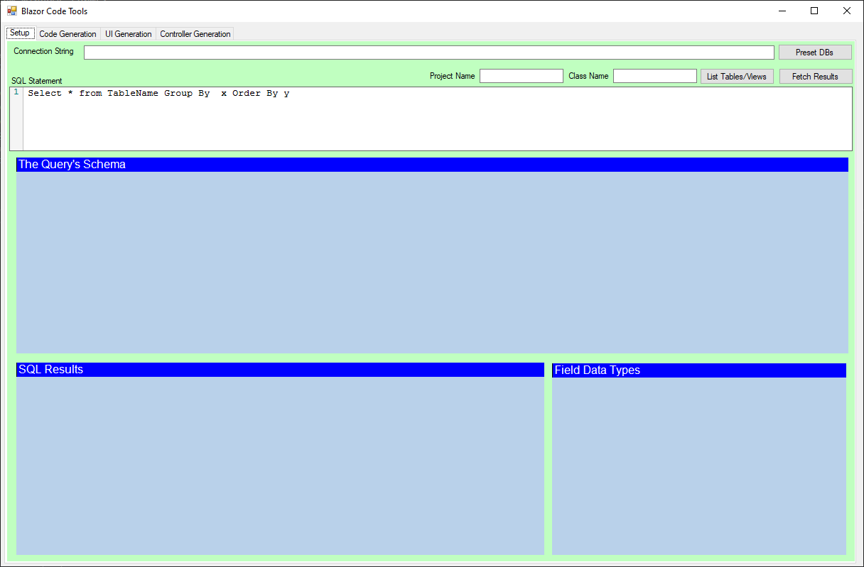
The SQL connection string connects you your database from which the data is gathered to generate the code from. Normally this is a test system and the hard-coded connection parameters as shown by default are what I as the developer need to connect to my local SQL server instance. You will surely have to adjust this point at whatever database you are using to do your code generation from. On Launch the software will look for a BlazorCodeTools.ini file. In that file it will look for one or more DBASE={Some SQL Connection String} lines to present as database connection presets. If you click on the Preset DBs button you will get this list allowing you to chose one to configure the tool for. Otherwise you can type it into the Connection string box manually, or copy and past the connection string from elsewhere.

Clicking the LIST TABLES/VIEWS button will present you with a Dialog like the one shown below.

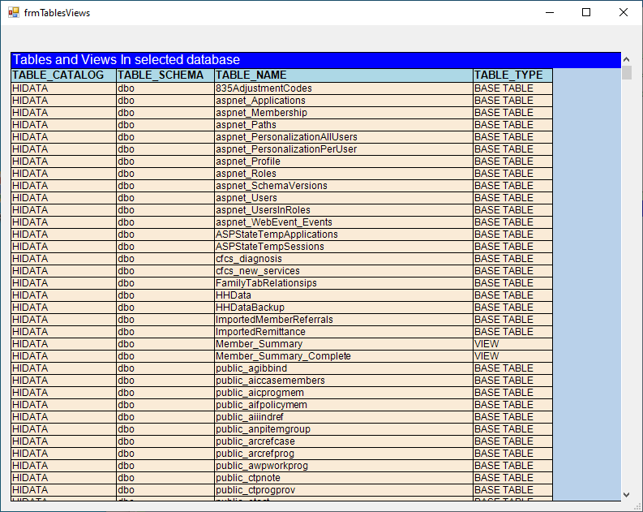
You can scroll through this list that shows all the Tables and Views contained in the target database pointed at by the Connection String. Double click on a desired base table to select it for coding against..

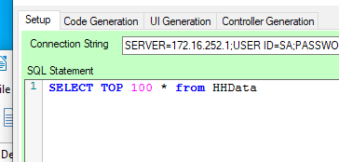
The resulting query inserted into the SQL Statement box will select the top 100 records from the selected base table or View.

Alternately you can just paste a desired query to execute into the SQL Statement box to generate your code against. This is useful when your are running code and have a break-point as some internal SQL query that you want to generate further code against. Just copy that query from the running code and paste it into this interface to work with it.

The Project Name and Class Name boxes are where you can enter your desired Class name (Auto entered if you selected a table from the List Tables/Views dialog). The Project name will be used in the coded USING statements and NAMESPACE declarations…

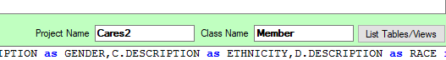

Using a simple table as the source for the code generation process is more than likely not useful in a real work coding example. More often than not the base data for use in LOB applications is the result of a significantly complex query that joins data from numerous places in the underlying database backend. (JOINS and Sub Selects for example). Other times the data being orchestrated is the result of an execution of a stored procedure and not a simple SELECT X,Y,Z from Table A. BlazorCodeTools can accommodate simple selects or very complex queries to generate code against.

On clicking Fetch Results, the query supplied is executed and its resulting schema enumerated in the Query Schema Grid, The actual field contents in the SQL Results Grid, As well as an interpretation of the fields in the results datatypes used for internal code generation work Field Data Types grid. Example shown below

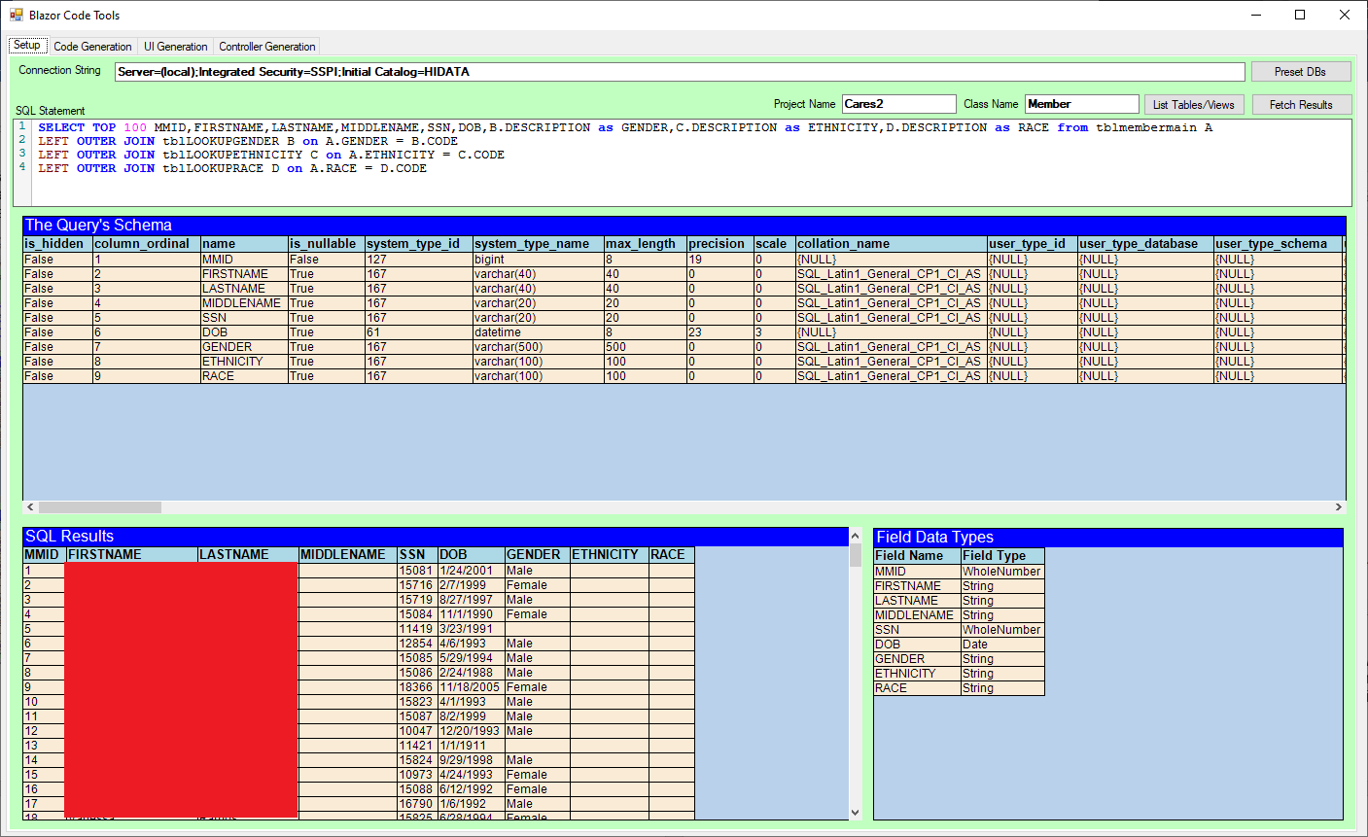

Now the tool can create code for you on Three fronts

The Backing Class that will encapsulate each instance of record returned by the query supplied. By convention this would be named as the singular form of the object that the results are for. So for this screenshot example we might call the class MEMBER because each record indicates a member in the system.

Using the schema of the resulting table and interpreting the results of that schema the software can generate a class for this with a number of important characteristics

- Data Annotations for REQUIRED fields
- Data Annotations for Strings Maximum length
- Data Types in code that are appropriate for the underlying database storage, IE Dates are Dates, Numbers are Numbers, Strings are Strings, bits are Booleans, and so on
- If fields are Required (IE are not NULLABLE in the database, Appropriate default values are assigned to those fields on instantiation of the class in code.

This Class can be Generated and Viewed on the Code Generation Tab, just click on the Generate Object Button.

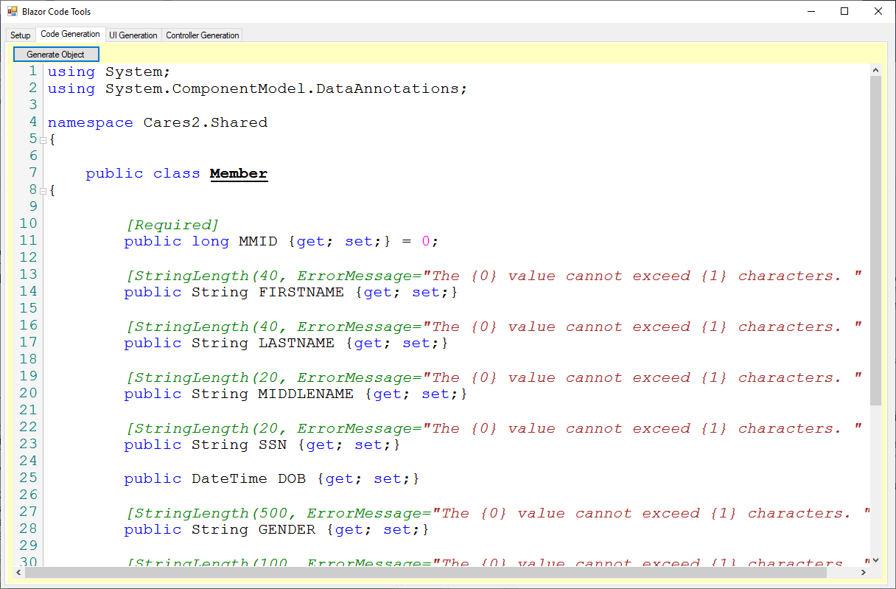

Note how the generated code contains the necessary USING STATEMENTS to accommodate the needs of the rest of the code generated, Certain fields are decorated with appropriate data annotations. (This will satisfy the Veracode scanning requirements for any public facing applications as well as is just good coding practice. Fields have the appropriate type for the underlying data backend, as well as certain field types contain feather validations for maximum length allowed with a formatted message on failing those validations. As a coder, you no longer have to write all this stuff by hand, or take a copy of something similar from some other code and copy and paste it with modifications. The results can instead be selected from this tool and copied and pasted directly into the IDE of your choice (I use Visual Studio and Visual Studio Code) and compiled without further modifications. Because this tool is meant for working with Blazor projects where a Shared component is normally containing these sorts of classes that gets used both on the webservice side as well as the User Interface side of things, the code supplied PROJECTNAME.Shared namespace further enhancing its plug and play usability in those scenarios.

If this was all the tool did, it would still be work using for that single use case but there are two other coding tasks that the tool is adept at assisting with. The first of these we will examine is the generation of WebService REST API endpoints to return these items from the data via Representational State Transfer services (REST API’s using WEB API in .Net and .NetCore). All the code to return a LIST of the generated classes shown above via a REST API GET call can be built with a single button click on the Controller Generation Tab.

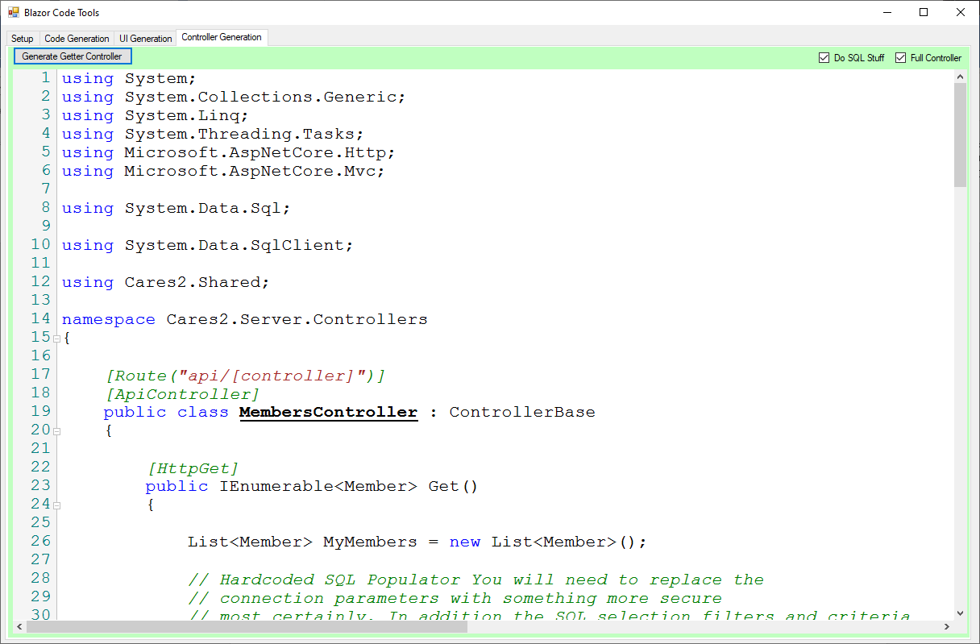

The code generated in this portion of BlazorCodeTools can scaffold the selection statement supplied at the outset to return a LIST of the classes generated containing the actual data gathered if the DO SQL STUFF if checked (It’s on by default). The entirety of the controller can get built of the Full Controller checkbox is checked (Its also on my default). This code generated exposes itself via the accepted standards of Routing (and is in fact annotated. appropriately with the necessary ROUTE, APICONTROLLER, and HTTPVERB data annotations. The resulting code, (Shown in its entirety below for this example, contains code to create the SQL call to the database pointed at by the supplied connection string. (The developer will need to adjust this section to fetch those connection parameters in alternate ways usually from the configuration of the web server environment where this webservice is going to run from. (I can’t do everything for you now can I?)
The generated code will also employ the SQL code that was supplied in the beginning to generated the data that gets returned. Normal use cases would have the developer adjusting this based on supplied filtering criteria and other environmental characteristics to adjust this in some way. The generated code takes the repetitive grunt work away but the job is not done in most cases.

Sample WEBAPI endpoint code below in its entirety.
using System;
using System.Collections.Generic;
using System.Linq;
using System.Threading.Tasks;
using Microsoft.AspNetCore.Http;
using Microsoft.AspNetCore.Mvc;

using System.Data.Sql;

using System.Data.SqlClient;

using Cares2.Shared;

namespace Cares2.Server.Controllers
{

[Route("api/[controller]")]
[ApiController]
public class MembersController : ControllerBase
{

[HttpGet]
public IEnumerable<Member> Get()
{

List<Member> MyMembers = new List<Member>();

// Hardcoded SQL Populator You will need to replace the
// connection parameters with something more secure
// most certainly. In addition the SQL selection filters and criteria
// will likely need to be adjusted to accomodate actual use cases

string sql ="SELECT TOP 100 MMID,FIRSTNAME,LASTNAME,MIDDLENAME,SSN,DOB,B.DESCRIPTION as GENDER,C.DESCRIPTION as ETHNICITY,D.DESCRIPTION as RACE from tblmembermain A " +
"LEFT OUTER JOIN tblLOOKUPGENDER B on A.GENDER = B.CODE " +
"LEFT OUTER JOIN tblLOOKUPETHNICITY C on A.ETHNICITY = C.CODE " +
"LEFT OUTER JOIN tblLOOKUPRACE D on A.RACE = D.CODE";

SqlConnection cn = new SqlConnection("Server=(local);Integrated Security=SSPI;Initial Catalog=HIDATA");

cn.Open();

SqlCommand cmd = new SqlCommand(sql,cn);

SqlDataReader r = cmd.ExecuteReader();

while (r.Read())
{
// Do the read and class stuffage here
Member TheClass = new Member();

// TODO: Implement the field reader
Copyfields(r,TheClass);

MyMembers.Add(TheClass);

}

r.Close();
cmd.Cancel();
cmd.Dispose();
cn.Close();
cn.Dispose();
return MyMembers;

}

[HttpGet("{id}")]
public Member Get(long id)
{

// Return a specific instance of Member

return new Member();

}

[HttpPost]
public void Post([FromBody] Member value )
{

}

[HttpPut("{id}")]
public void Put(long id, [FromBody] Member value )
{

}

[HttpDelete("{id}")]
public void Delete(long id )
{

}

private void Copyfields(SqlDataReader r, Member TheClass)
{

if (!Convert.IsDBNull(r["MMID"]))
{
TheClass.MMID = Convert.ToInt64(r["MMID"]);
}

if (!Convert.IsDBNull(r["FIRSTNAME"]))
{
TheClass.FIRSTNAME = r["FIRSTNAME"] + "";
}

if (!Convert.IsDBNull(r["LASTNAME"]))
{
TheClass.LASTNAME = r["LASTNAME"] + "";
}

if (!Convert.IsDBNull(r["MIDDLENAME"]))
{
TheClass.MIDDLENAME = r["MIDDLENAME"] + "";
}

if (!Convert.IsDBNull(r["SSN"]))
{
TheClass.SSN = r["SSN"] + "";
}

if (!Convert.IsDBNull(r["DOB"]))
{
TheClass.DOB = Convert.ToDateTime(r["DOB"]);
}

if (!Convert.IsDBNull(r["GENDER"]))
{
TheClass.GENDER = r["GENDER"] + "";
}

if (!Convert.IsDBNull(r["ETHNICITY"]))
{
TheClass.ETHNICITY = r["ETHNICITY"] + "";
}

if (!Convert.IsDBNull(r["RACE"]))
{
TheClass.RACE = r["RACE"] + "";
}

}

}

}

The next bit of cod generated assistance that BlazorCodeTools provides for you is Scaffolding for UI. Specifically the single most common presentation mechanism for lists of related records in LOB applications is the ubiquitous GRID. BlazorCodeTools currently supports the syntactic sugar to create user interface grids employing the very popular Radzen Data Grid component. (This component exists both as a Blazor Component and as an Angular component) With the syntactic differences being minor is both cases. Access to this code generation assistance is found on the UI Generation Tab and like the other code generation tabs is executed by clicking on the Generate UI button on this tab.

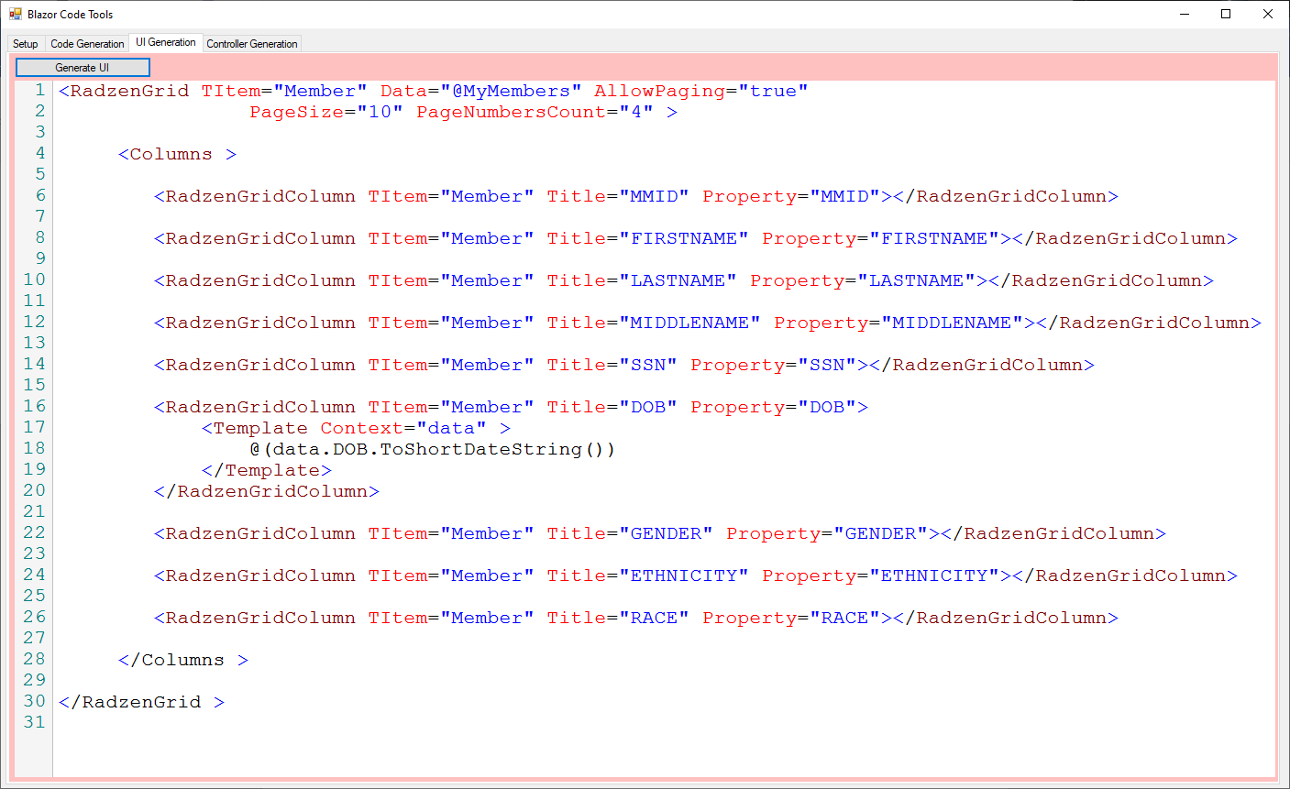

In this example shown a relative simple grid local list of objects (returned by the rest API endpoint scaffolded in the previous section, of objects scaffolded in the first section is bound to a grid component setup to allow paging, with each column bound to a specific element in each record. Certain columns are formatted in specifically common ways Dates in this example…

Copying and pasting this code verbatim yields a good starting point on UI development that contains these other bits of data coded with the tool in your application.

So now with this tool and a few lines of user generated code we can have an application that employs 95% generated code from the tool to read data from an actual database backend and stream that data to a web application in a browser using a REST API endpoint. That gets placed in a more than serviceable user interface… As shown below

