Putting AI Agents to Work in Our Clients' Software
What modern tooling makes possible today, how to do it with PHI and PII in the room, and where we can start
Lonnie Watson, Software Architect · November 2026 · harlock123.com
The short version
- AI models can now operate real business software through an open standard, the Model Context Protocol (MCP), doing the steps a user would do, with every step visible, checked and reversible.
- I have built this into three of my own applications, one of them a HIPAA X12 viewer. Adding it to the tools we build for clients is a well-understood piece of engineering, not a research project.
- Our healthcare and public-sector clients assume their data rules shut them out. They don't: the same tools can be driven by a model running on hardware they control, with a modest loss of capability.
What MCP is, in one paragraph
MCP is an open standard, now supported across the major AI vendors and developer tools, for letting an AI model use an application. The application publishes a menu of operations (add a part, run a query, open a claim), each with a plain-language description. The model reads the menu, decides which operations to call, and sees the results. The application stays in charge: it validates every call, enforces permissions and records what was done. The MCP layer sits on top of commands the application already has, so its screens, business rules and database don't change.
Proof: three applications I've built
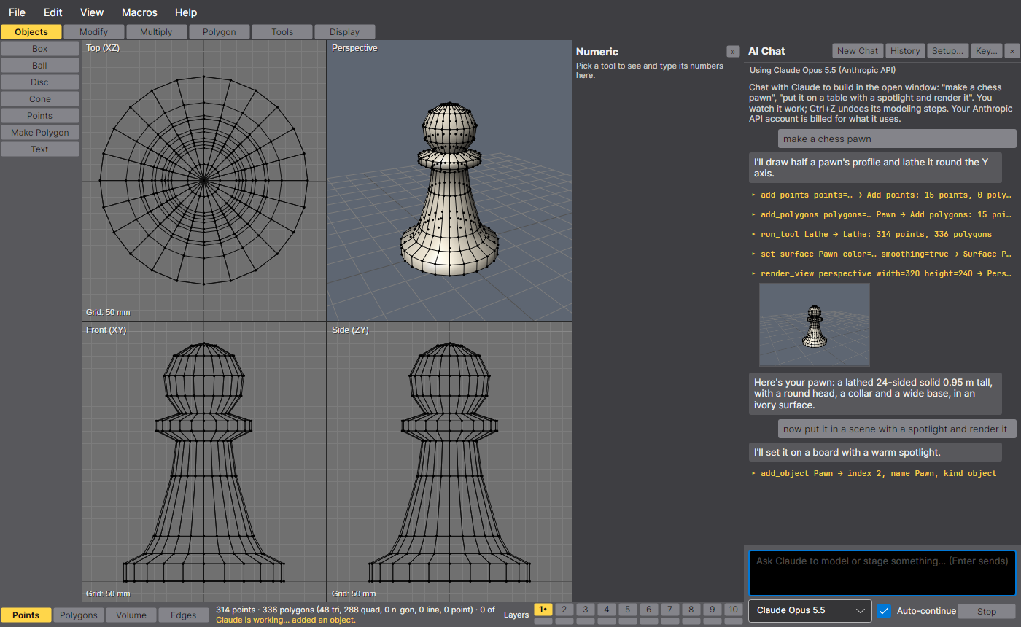  AVA Modeler  A 3D modeling and animation tool with 85 MCP tools and 15 saved recipes. Ask its chat to "make a chess pawn, put it on a table with a spotlight and render it", and Claude, or a local model, builds it in the open window, then checks the mesh is closed. Its companion, [AVALightWave](https://github.com/Harlock123/AVALightWave), a standalone Layout with a render farm, adds 60 scene tools. | 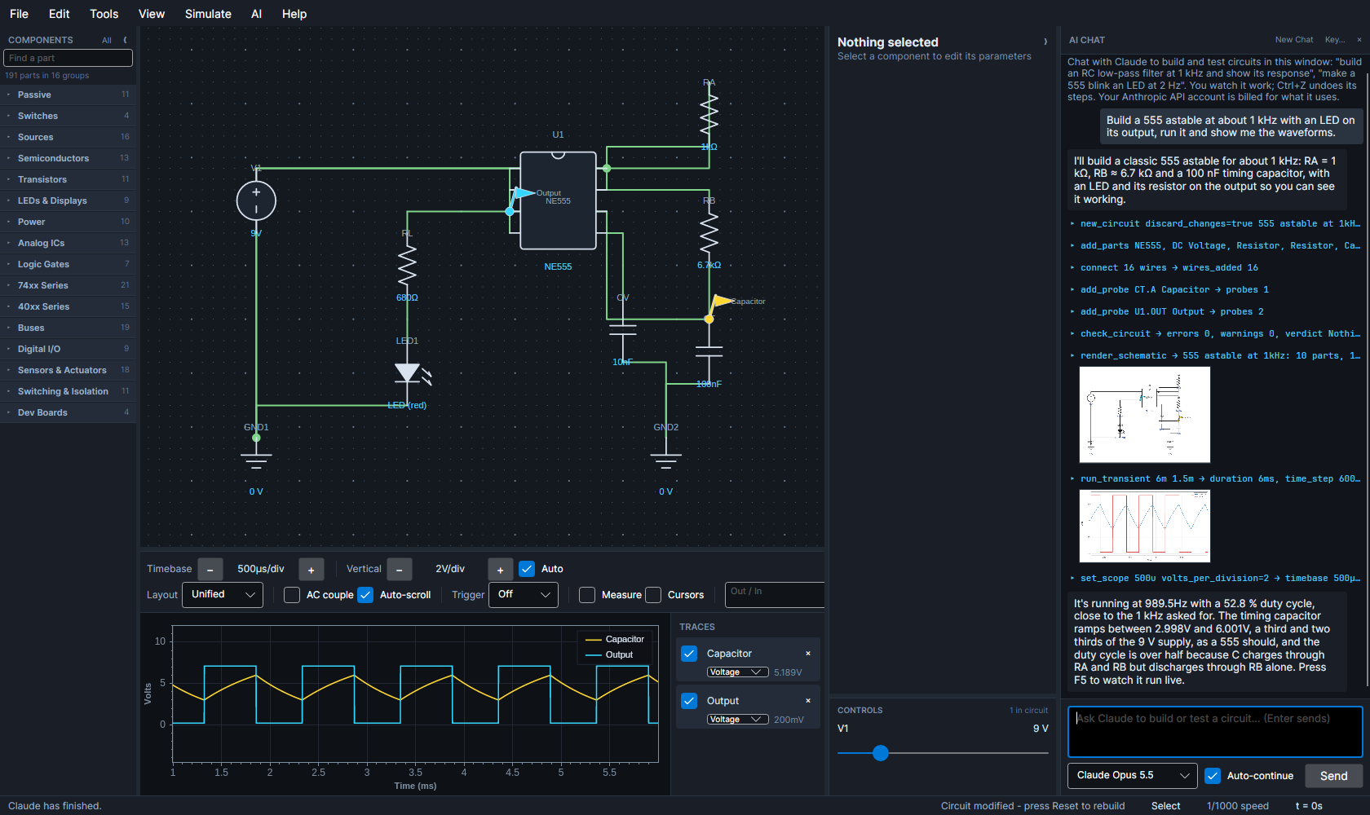  CirqAvalonia  A circuit simulator with 337 parts, working 6502, 6510, 6809, Z80, 8085 and 68000 computers among them. It exposes 41 MCP tools and twelve recipes. Claude places and wires the parts, runs the simulation, and reads back measured results and plots (a 555 timer at a measured 989.5 Hz), so it checks its own work.
[X12 Explorer](https://github.com/Harlock123/X12_820Explorer), a HIPAA X12 viewer, is the healthcare case: seven read-only MCP tools that balance an 835, find every denied claim and trace a 999 rejection to the bad element, reading one folder and writing nothing. The shape a first PHI pilot should take.
The pattern, and how it carries over to client tools
- One set of tools for people and agents. The agent uses the same commands, checks and business rules as a user, so nothing about the application's behaviour is duplicated or bypassed.
- Three ways in. A chat panel inside the application; an outside agent (Claude Code, Claude Desktop or any MCP client) attached to the open window; or headless, for batch work and automated testing.
- Safe by construction. Every agent action is one undo step and shows on screen as it happens. The connection is a local channel only the user's own account can open, and file access is fenced to one folder.
Where our clients are missing the boat
- Their software is built for clicking, not delegating. Staff read raw claim rejections line by line, wait days for a report request, re-read a chart before every visit, and hand-match records across systems. Each of these is a few well-defined operations an agent could chain together in seconds, with a person approving the result.
- They think AI means a chatbot on the side, or a vendor product they must send their data to. They don't see that their own systems, including ones we built, can be made agent-ready.
- The platforms around them are moving. Commercial EHR, CRM and ERP vendors are shipping agent interfaces now. The custom systems we build risk becoming the part of the estate that can't take part.
PHI and PII: run the model where the data lives
- The objection is real. HIPAA, business associate agreements, state privacy law and, for behavioral health, 42 CFR Part 2 all limit where client data can go. Sending it to a public AI service is often off the table.
- MCP doesn't care where the model runs. The same tool layer can be driven by an open-weight model on a workstation GPU, an on-premises server, or a private endpoint in the client's own cloud tenancy. The data never leaves the client's boundary. AVA Modeler's chat already switches between Claude and a local model (Ollama, LM Studio).
- The trade-off is modest. Today's open-weight models call tools reliably for well-defined tasks; they trail the frontier models on long, open-ended reasoning. MCP plays to their strengths: the application does the precise work and the model chooses the steps. Narrow tools, saved recipes and human approval of changes close most of the gap.
- Or take the identifiers out first. X12 Explorer's de-identifier swaps names, IDs, addresses and dates for consistent stand-ins, so totals still balance; with it switched on, its MCP tools never return PHI.
- Use both, by data class. A frontier model where no protected data is involved; a local one for PHI or PII.
Where this applies in work we've already delivered
Tool | What an agent could do | Data | Model
CARES (behavioral health EHR) | Summarize a client's last 90 days before a visit; draft progress notes from structured data for clinician sign-off | PHI, Part 2 | Local
Cares Query Reporter, AVA Query Builder | Turn "active clients with no contact in 60 days, by county" into a visible query the analyst checks and runs | PHI / PII | Local
X12 Explorer (MCP built) | Explain why claims were rejected (999, 277) or paid short (835 adjustments), across a whole batch | PHI | Local
Vector Match Engine | Review borderline matches between two member lists and explain each decision | PII | Local
TSTimeLine (claims and eligibility timelines) | Narrate a member's claims, eligibility and authorization history, and point out gaps and overlaps | PHI | Local
SSHRtm, Log Visualizer (servers) | Read a whole fleet's combined log and say which server spiked, when, and what moved with it | Operational | Either
CODE Complete, Code Generation API | Generate data-access layers and screens from a schema description | Schema only | Either
What it takes
- Inventory what the tool already does. Most of our applications already have a command or service layer; the MCP layer describes a focused set of those operations, with their units, rules and limits, in plain language.
- Start read-only, as X12 Explorer does. Searching, summarizing and explaining carry little risk and pay off quickly. Add changes later, each one shown to a person for approval, logged, and reversible.
- Decide where the model runs by data class, with the client's security team, before any data moves.
- Test it like any other feature. All three applications test every tool automatically, like the rest of the code.
A proposed next step
Pick one client tool and one painful, repetitive task. Add an MCP layer over the tool's existing commands (a focused set of operations, not the whole application), run it against an open-weight model on client-approved hardware, and measure time per task, accuracy against a person doing the same work, and whether users would keep it. I'd welcome 30 minutes to demonstrate these applications live and to talk through which client and which tool would make the best pilot.
Links
Portfolio harlock123.com | CODE Complete reimagined github.com/Harlock123/CCReimagined
AVA Modeler github.com/Harlock123/AVAModeler | TSTimeLine github.com/Harlock123/TSTimeLine
CirqAvalonia github.com/Harlock123/CIRQAvalonia | SSHRtm github.com/Harlock123/SSHRtm
X12 Explorer github.com/Harlock123/X12_820Explorer | SSHRtm Visualizer github.com/Harlock123/SSHRtmLogVisualizer
AVA Query Builder github.com/Harlock123/AVAQueryBuilder | CARES overview (PDF) harlock123.com/docs/CARES V2.pdf
Vector Match Engine github.com/Harlock123/VectorMatchEngine

