SSHRTM Log Visualizer
Table of Contents

A cross-platform desktop app that turns an SSHRTM CSV metric dump into a multi-series line chart. Point it at a dump, pick the measures you care about, and plot them against the sample timeline.
Built with Avalonia 12 on .NET 9, charting with ScottPlot 5.
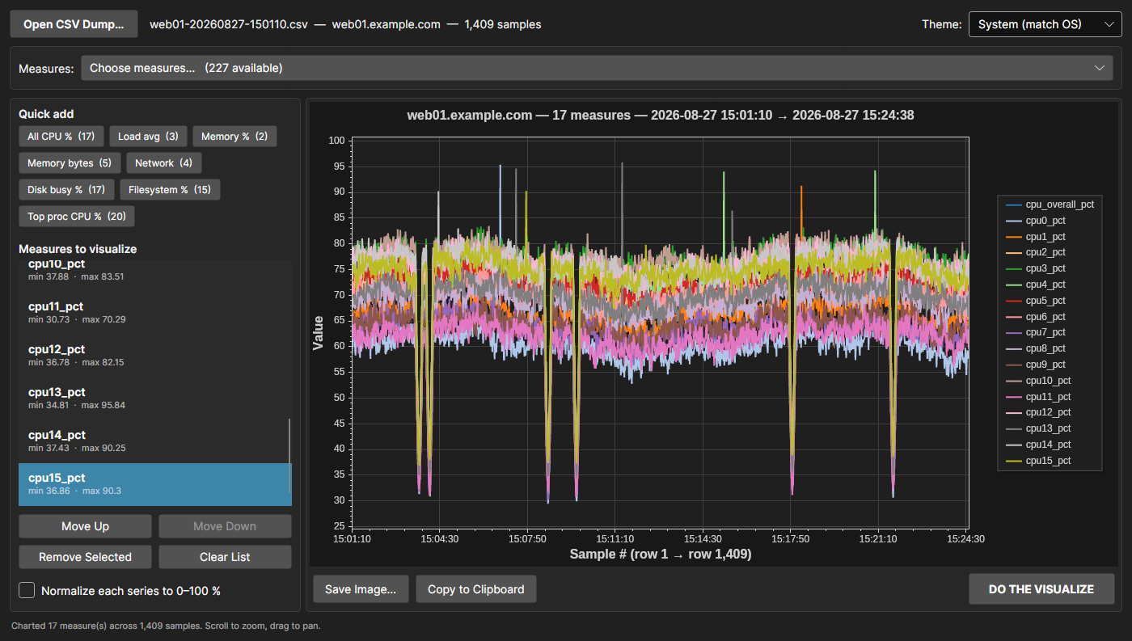
The app with all 17 CPU utilisation measures charted

What it’s for
SSHRTM writes a wide CSV: one row per sample, one column per metric, a trailing timestamp. A real dump is ~260 columns across a few thousand rows — far too wide to read in a spreadsheet and awkward to chart ad hoc. This app reads that shape directly and lets you pull any combination of measures onto one time axis.
Everything it knows about the format is derived from the file itself, so it works on a dump from any host without configuration.

Requirements
- .NET 9 SDK (or newer) to build; the built app needs only the .NET 9 runtime
- Windows, macOS or Linux

Build and run
dotnet build SSHRtmLogVisualizer.sln
dotnet run --project SSHRtmLogVisualizer
Optionally pass a dump path to open it at startup — this also lets you drop a .csv onto the built executable:
dotnet run --project SSHRtmLogVisualizer -- web01-20260827-150110.csv

Publishing a single executable
Publish profiles produce one self-contained file — no .NET runtime needed on the target machine, no support DLLs to ship alongside it.
dotnet publish SSHRtmLogVisualizer -c Release -p:PublishProfile=win-x64
dotnet publish SSHRtmLogVisualizer -c Release -p:PublishProfile=linux-x64
Output lands in publish/<rid>/ and is a single ~47 MB executable. Copy it anywhere and run it; that is the whole deployment.
Profile | Output
win-x64 | publish/win-x64/SSHRtmLogVisualizer.exe
linux-x64 | publish/linux-x64/SSHRtmLogVisualizer
For another target, pass the RID directly:
dotnet publish SSHRtmLogVisualizer -c Release -r osx-arm64 --self-contained \
-p:PublishSingleFile=true
Notes on the size and the settings behind it:
- The ~47 MB is mostly the bundled .NET runtime plus SkiaSharp’s native rendering library. Compression is on, so the file is roughly a third of its uncompressed footprint.
- Native libraries are bundled with IncludeNativeLibrariesForSelfExtract, which means the first launch extracts them to a temp directory — expect a couple of seconds on first run and a fast start after that.
- Trimming is deliberately off. Avalonia resolves controls and XAML through reflection, and a trimmed build risks failing at runtime in ways a successful build won’t reveal. Turn it on in the profile only if you are willing to retest the whole UI.
- If every target machine already has the .NET 9 runtime, a framework-dependent single file is far smaller — add --no-self-contained to the command above.

Using it

1. Open a dump
Open CSV Dump… picks a file. The header bar then shows the file name, the host it came from, and the sample count; the status bar reports how many measures are chartable.

2. Choose measures
Choose measures… opens a multi-select picker over every numeric column in the dump. Click entries to tick them — no Ctrl needed — Shift+click for a run, Ctrl+A for everything currently shown. The filter box at the top narrows a long list; a typical dump offers well over two hundred measures.
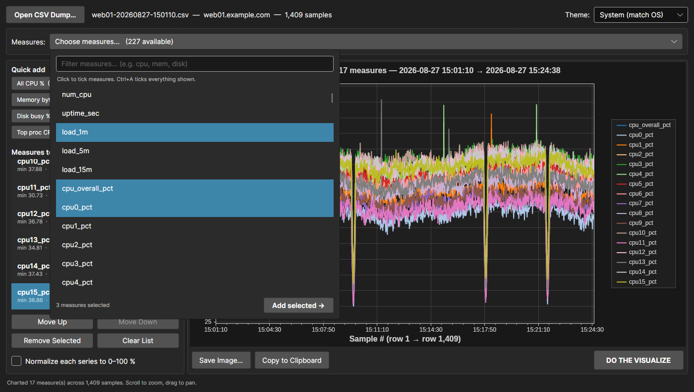
The measure picker with three measures ticked
Add selected → appends every ticked measure to the visualize list at once, skipping any already there. The picker stays open so you can filter again and add another batch. Changing the filter clears the current ticks, so a tick never refers to a measure you can no longer see.

3. Or use a quick-add preset
The Quick add buttons pull in a whole related group in one click. Each button shows how many measures it will add, and presets are built from the dump you opened — one that matches nothing simply doesn’t appear.
Preset | Matches
All CPU % | cpu_overall_pct and every cpuN_pct
Load avg | load_1m, load_5m, load_15m
Memory % | mem_used_pct, swap_used_pct
Memory bytes | every mem_*_bytes
Network | per-interface rx/tx bit rates
Disk busy % | per-device busy_pct
Filesystem % | per-mount used_pct
Top proc CPU % | procN_cpu_pct for the top processes
Presets append rather than replace, so you can stack Memory % on top of All CPU %.

4. Edit the list
Move Up / Move Down reorder (which sets the series colour order), Remove Selected drops one, and Clear List empties it. Whenever the list becomes empty the chart is cleared too, so what’s on screen always matches what’s in the list.

5. Visualize
DO THE VISUALIZE draws the chart. The first data row sits at the left edge, the last at the right, and both axes auto-scale to the data. X ticks are labelled with the timestamp of the row they fall on.
On the chart: scroll to zoom, drag to pan, right-click for ScottPlot’s own menu.

Mixed units and the normalize option
A dump mixes units freely. Plot mem_*_bytes (tens of billions) next to load averages (around 12) on a shared axis and the load lines collapse onto zero:
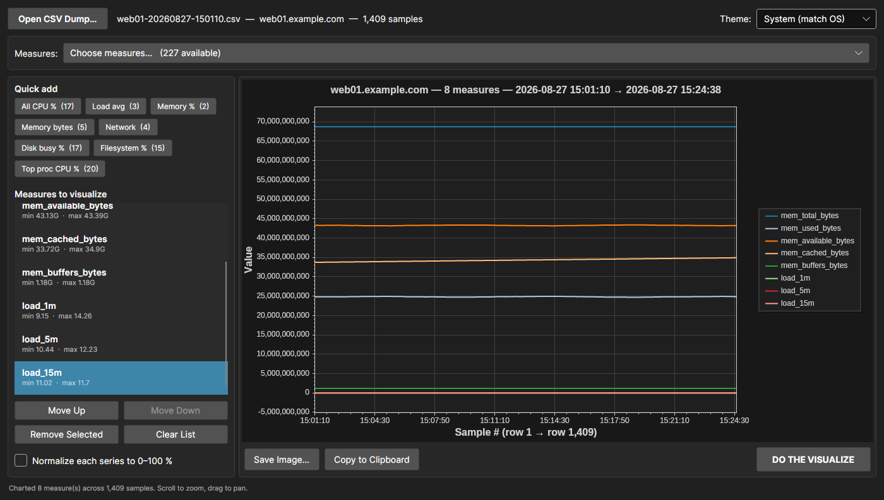
Memory bytes and load averages on one absolute axis
Tick Normalize each series to 0–100 % and every series is rescaled onto its own min–max range, so the shapes become comparable. The legend then reports the real range each series was squashed from:
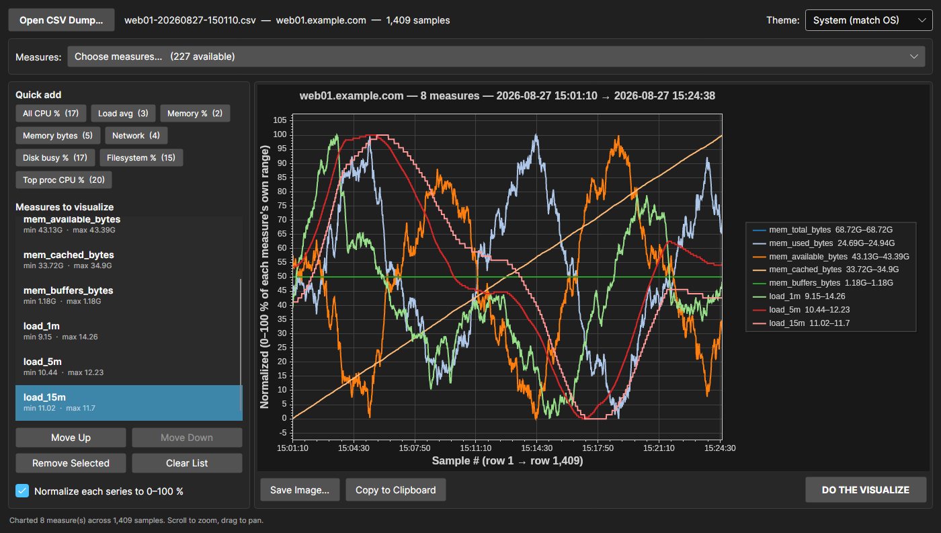
The same measures normalised to 0-100 %
Leave it off when your measures already share units — all the CPU percentages, say.

Themes
The theme dropdown sits in the top-right corner. It defaults to System (match OS), which follows the operating system’s light/dark setting and re-resolves live if that flips.
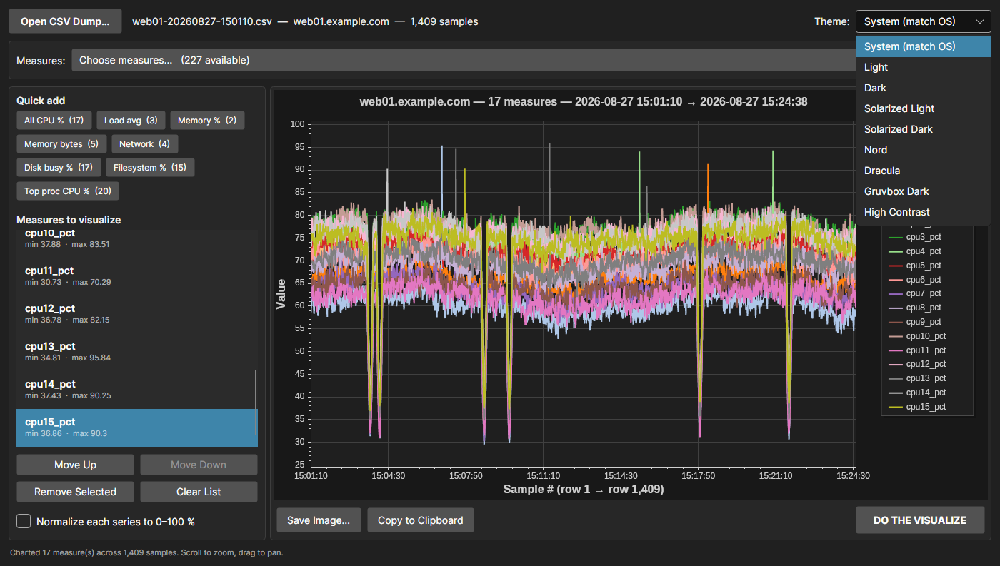
The theme dropdown listing all nine themes
Selecting a theme repaints the window chrome, the control accent, and the chart together.
Solarized Light | Nord
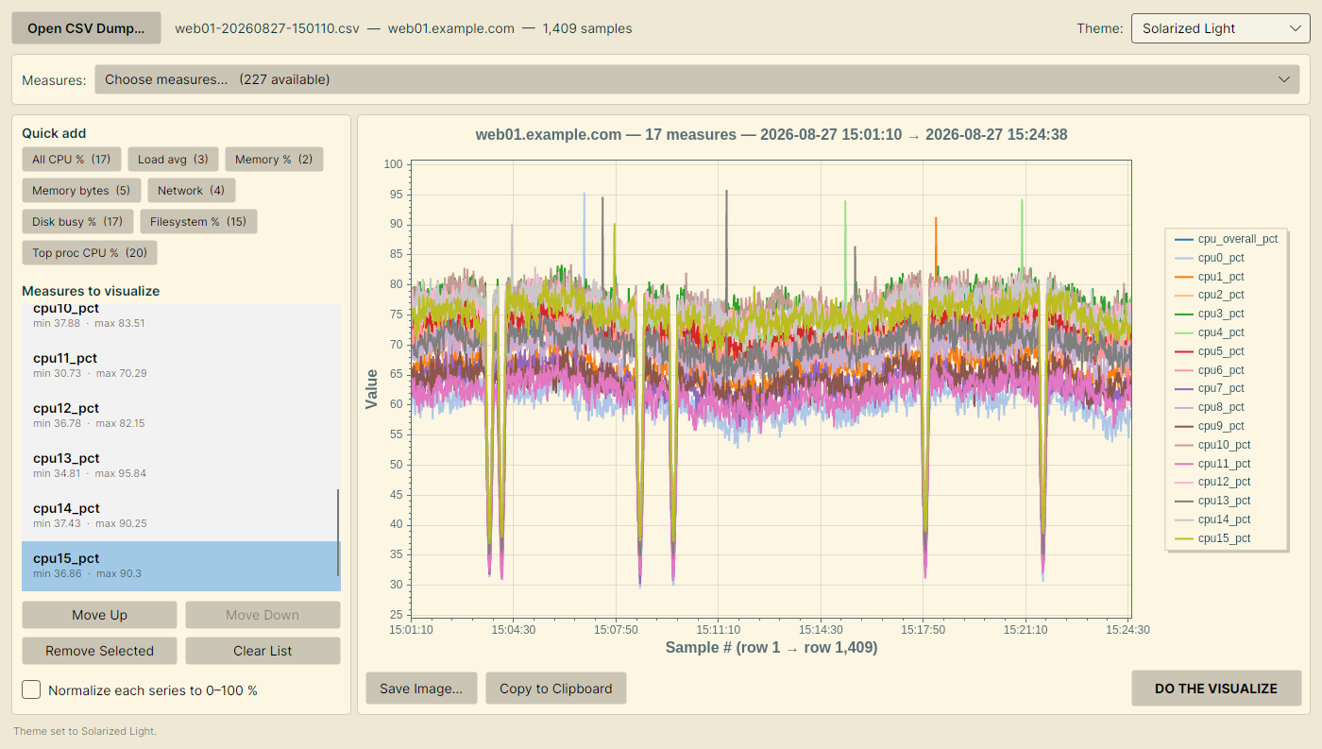 | 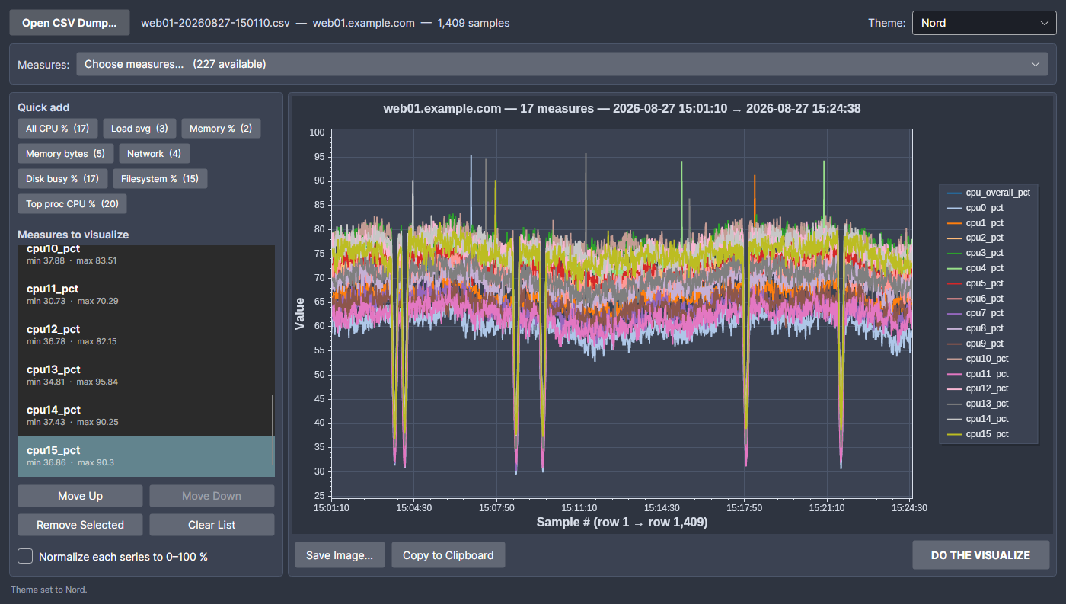
The full list: System, Light, Dark, Solarized Light, Solarized Dark, Nord, Dracula, Gruvbox Dark, High Contrast.

Exporting the chart
- Save Image… writes the chart to a PNG, JPEG or BMP through a save dialog. The file name is suggested from the dump’s own name, and the correct extension is appended if the dialog doesn’t add one.
- Copy to Clipboard puts the chart on the clipboard as a PNG, ready to paste into a ticket or an email.
Both export at the on-screen size (with a 1000 × 560 floor), so the image matches what you see.

How a dump is read
Row 1 holds the measure names. The last column is the sample timestamp — it is never offered as a measure, and is used instead to label the X axis. yyyyMMdd-HHmmss is the expected layout, with several other common forms accepted as a fallback.
Columns whose samples are text rather than numbers cannot be plotted, so they are left out of the picker: hostname, the fs_*_type filesystem types, the procN_command process names. The status bar reports how many were skipped. Blank or n/a samples become gaps in the line rather than zeroes.
Values are parsed with the invariant culture — a dot decimal separator, matching what SSHRTM writes — so the app reads a dump identically regardless of the machine’s regional settings. The CSV parser handles quoted fields, including embedded commas, quotes and newlines.
The dump is opened with FileShare.ReadWrite, so you can chart a file that SSHRTM is still appending to.

Project layout
Path | Purpose
Models/MetricColumn.cs | One numeric measure: name, per-row values, min/max
Models/RtmLogFile.cs | A parsed dump: timestamps plus chartable measures
Models/MetricPreset.cs | A quick-add group resolved against the loaded dump
Models/AppTheme.cs | Theme definition — window palette and chart palette
Services/RtmCsvReader.cs | CSV parsing, timestamp parsing, numeric-column detection
Services/ChartRenderer.cs | Builds the ScottPlot line chart
Services/ChartExporter.cs | Save-to-file and copy-to-clipboard
Services/ThemeManager.cs | Theme catalogue and application
ViewModels/MainWindowViewModel.cs | Picker state, visualize list, edit commands
MainWindow.axaml(.cs) | Window layout, dialogs, chart hosting
Properties/PublishProfiles/ | Single-file publish profiles per runtime

Dependencies
- Avalonia 12.1.1 (Avalonia.Desktop, Avalonia.Themes.Fluent, Avalonia.Fonts.Inter)
- ScottPlot.Avalonia 5.1.59 — charting
- CommunityToolkit.Mvvm 8.4.2 — observable properties and commands

Notes and limits
- Every series shares one Y axis; there is no secondary axis. Normalize is the answer for mixed magnitudes.
- The X axis is the row index, not elapsed time. Rows are evenly spaced even if the sampling interval varies — the tick labels still show each row’s real timestamp.
- Series colours cycle through a 20-colour palette, so charting more than 20 measures at once will repeat colours.

