SqlScripter
Usage Guide
A cross-platform MSSQL “drop & recreate” scripting tool
Windows · macOS · Linux — Intel/AMD (x64) and ARM64

1. Overview
SqlScripter connects to a Microsoft SQL Server database, enumerates its tables, views and stored procedures, and lets you select any combination of them to generate a single T-SQL script that drops (if present) and recreates each object. The generated script appears in a built-in, SQL-syntax-highlighted editor where it can be reviewed, copied or saved.

Key features
- Connect to any reachable MSSQL instance with a standard connection string.
- Browse Tables, Views and Stored Procedures in a categorized tree.
- Multi-select objects with checkboxes; select whole categories at once.
- Filter the object list by a “contains” or “does not contain” pattern.
- Toggle existence checks & DROP statements on or off.
- Optionally script table data as INSERT statements, with a per-table row cap.
- Syntax-highlighted T-SQL output with line numbers.
- Copy the script to the clipboard, save it to a .sql file, or clear the output.
- Runs natively on Windows, macOS and Linux (x64 and ARM64).

2. Launching the Application
On start-up the window is divided into three areas: the connection bar across the top, the object tree and scripting options on the left, and the generated-SQL editor on the right. A status bar along the bottom reports progress and results.
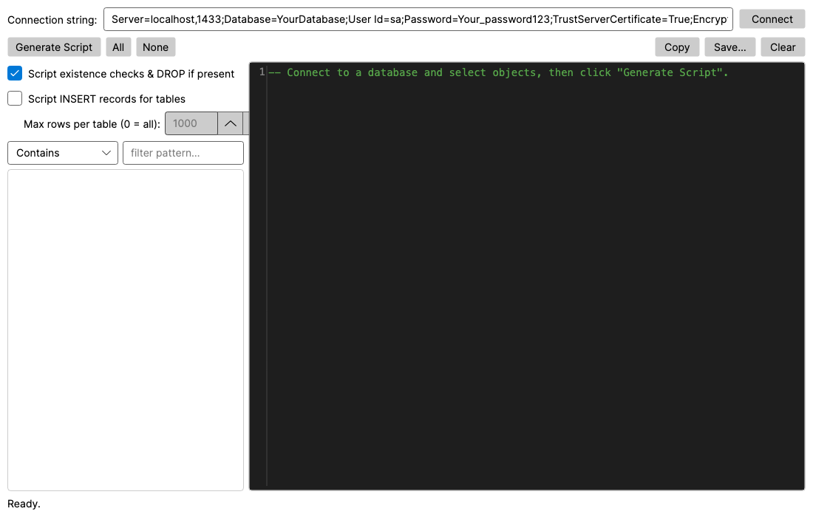
Figure 1 — SqlScripter immediately after launch.

3. Connecting to a Database
Enter a connection string in the box at the top of the window and click Connect. A typical SQL-authentication connection string looks like:
Server=localhost,1433;Database=MyDb;User Id=sa;Password=Pass123;TrustServerCertificate=True;Encrypt=True;
When the connection succeeds, the tree is populated and the status bar reports how many tables, views and stored procedures were found. Integrated/Windows and Azure AD authentication are also supported — the tool simply passes the connection string through to the SQL client.

4. Browsing Database Objects
Discovered objects are grouped under three categories — Tables, Views and Stored Procedures — each showing a count. Expand a category to see its members, listed as schema-qualified names (for example, dbo.Customer).
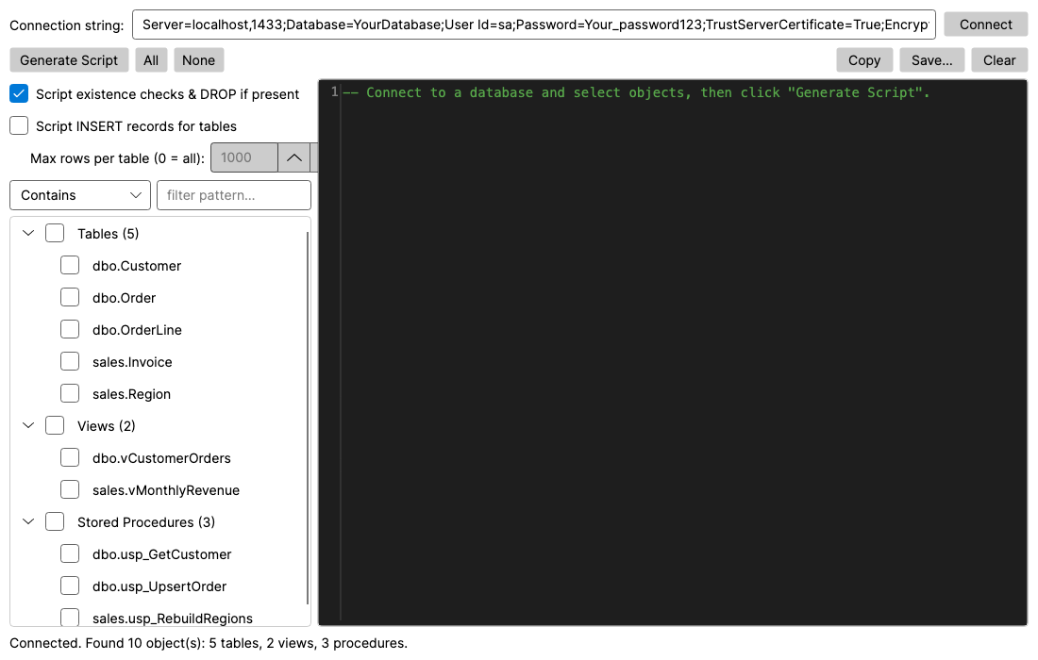
Figure 2 — The object tree populated after a successful connection.

5. Selecting Objects to Script
Tick the checkbox next to any object to include it. Ticking a category checkbox selects all of its children at once. Use the All and None buttons to select or clear everything quickly.
Selections are remembered independently of the filter: you can tick some objects, change the filter, tick more, and the Generate Script command will include everything you ticked — even rows currently hidden by the filter. The None button clears the entire selection.

6. Filtering the Object List
Above the tree, a filter lets you narrow what is shown. Choose Contains or Does not contain from the drop-down and type a pattern; matching is case-insensitive and applied to each object’s schema.name. In the example below, the pattern “usp_” with Contains reduces the list to just the stored procedures.
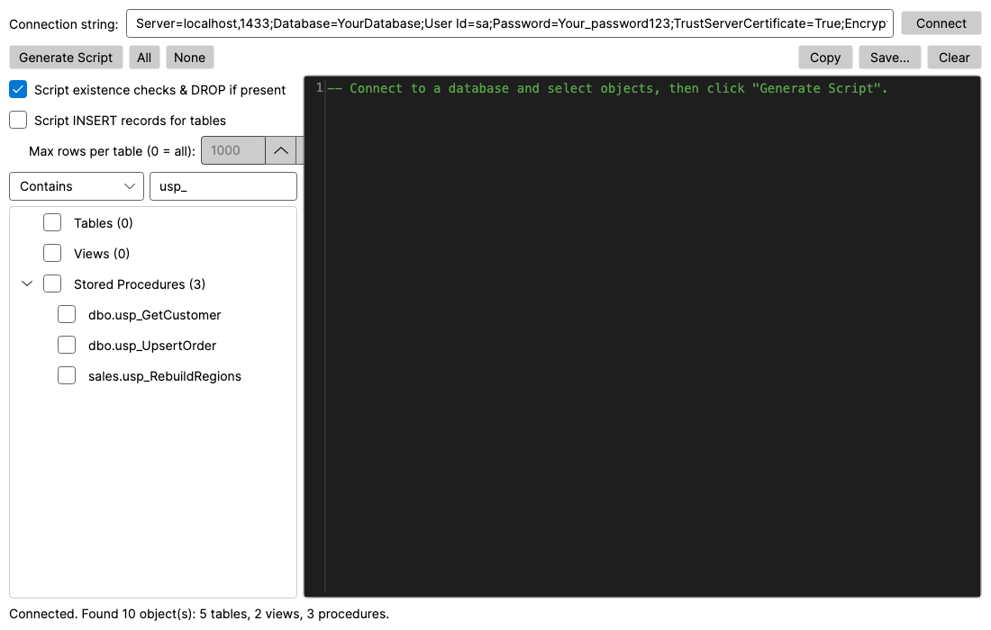
Figure 3 — Filtering with “Contains usp_” narrows the tree to stored procedures.

7. Scripting Options
Three options on the left panel control what the generated script contains:
- Script existence checks & DROP if present — emits an IF OBJECT_ID(...) guard that drops each object before it is recreated. Turn this off to produce CREATE-only scripts.
- Script INSERT records for tables — also reproduces table data as INSERT statements (identity columns are handled with SET IDENTITY_INSERT).
- Max rows per table (0 = all) — caps how many rows are scripted per table. This field is enabled only when INSERT scripting is turned on.
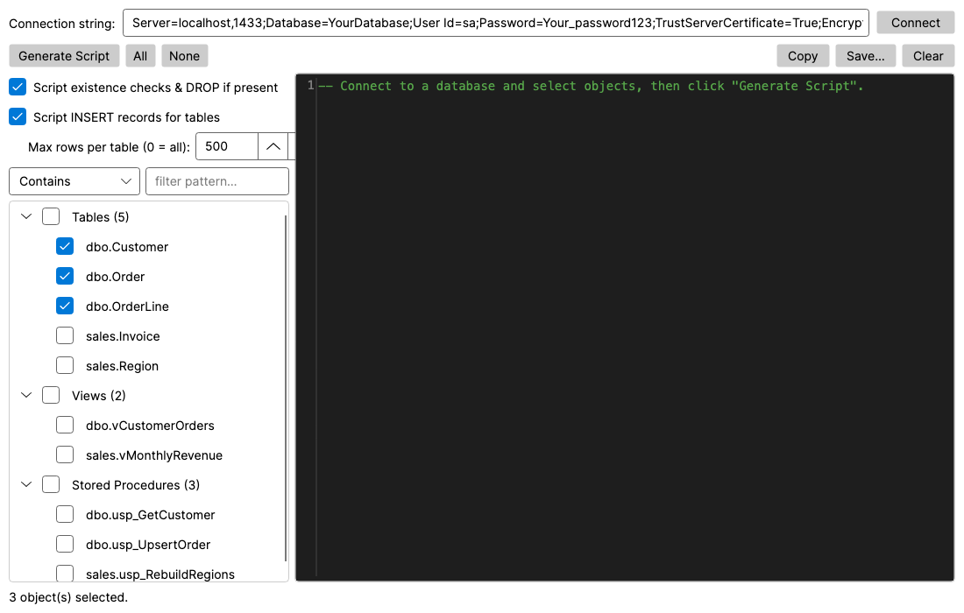
Figure 4 — Drops and INSERT scripting enabled with a 500-row cap, three tables selected.

8. Generating and Reviewing the Script
Click Generate Script to build the T-SQL for every selected object. The result is shown in the editor on the right, syntax-highlighted as MSSQL with line numbers. For each object the script contains an optional existence check and DROP followed by a full recreation:
- Tables — CREATE TABLE with current data types, identity, computed columns and defaults, then PRIMARY KEY / UNIQUE / FOREIGN KEY / CHECK constraints and secondary indexes (plus optional INSERT data).
- Views — the stored CREATE VIEW definition.
- Stored procedures — the stored CREATE PROCEDURE definition.
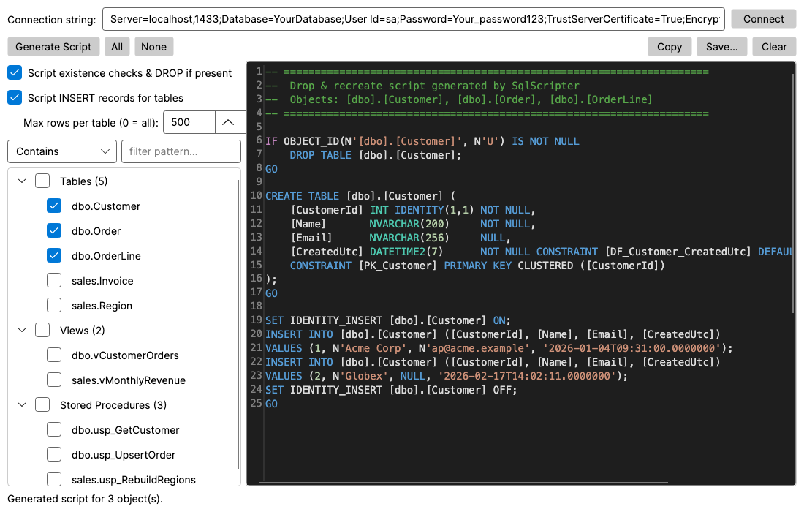
Figure 5 — A generated drop & recreate script in the syntax-highlighted editor.

9. Copying, Saving and Clearing Output
The toolbar above the editor provides three actions for the generated script:
- Copy — copies the entire script to the system clipboard.
- Save… — opens a file dialog to write the script to a .sql file.
- Clear — empties the output pane.

10. Supported Platforms & Building
SqlScripter is built with .NET 9 and Avalonia and runs on Windows, macOS and Linux on both Intel/AMD (x64) and ARM64. Self-contained, single-file executables can be produced for every target — no .NET install is required on the destination machine.
- macOS / Linux: run ./publish-all.sh (bash, no PowerShell required).
- Windows: run ./publish-all.ps1 (PowerShell).
- Runtime identifiers: win-x64, win-arm64, osx-x64, osx-arm64, linux-x64, linux-arm64.
Note: because it uses Microsoft.Data.SqlClient, the application requires ICU globalization data; minimal Linux containers may need the libicu package installed.

