Expert Data Mining:

Correction of Functions

Contents

1. Introduction 3

2. Input 3

3. Violation of the Monotonicity Assumption of the Domain Expert 3

3.1 One Below Upper Zero 4

3.2 Zero Above Upper One 4

3.3 Both 5

4. Fixing Violations 5

4.1 Changing Class 5

4.1.1 Monotonicity Preservation 6

4.1.2 Monotonicity Reaffirmation 6

4.1.3 Examples of Fixing Violations 7

4.2 Fix by Adding Attributes 8

4.2.1 Example of Adding Attributes 9

4.3 Non-Monotonic Function 10

4.4 Fixing Violations in Real Data 10

5. Violation of Monotonicity in Real Data 11

6. Output 11

7. Examples 11

# 1. Introduction

This document will describe how the Expert Data Mining program works with violations of monotonicity. Note: due to the complexity of the program, the previous README is also attached.

# 2. Input

The input of the program is the same as its previous iteration. However, once all questions are asked, the program will ask the user to specify where any violations of monotonicity in the outputted dataset should be. Before going forward, it is important to note that the expert dataset does not contain violations of monotonicity due to the user assumption that the data should be monotonic for the given attributes. The user was asked some questions, but the remaining questions were answered through an expansion of monotonicity. However, a user can review these expanded values to find some expansion that does not correspond to his/her knowledge of the domain or on real experimental data. Once reviewed, the user may change the answer from one to zero or zero to one so that the answer corresponds to his/her knowledge or real data. Therefore, the user is essentially indicating where violations of monotonicity *should* occur in the expert dataset.

However, where the description above is about the user's intention to change values of monotonically expanded values of cases, it is also possible that the user, after reviewing all the cases, would like to change his/ her answers to some of the cases on the assumption that monotonicity not violated at all. In this scenario, the values of the cases are updated. The user may need to answer some additional questions about any cases that were expanded by the case whose value was changed. This is because those other cases will no longer be monotonically related to the changed case.

Those changes which do not create violations are called updates of monotonicity. Function-changes, or *f*-changes is a generic term used to describe both violations of monotonicity and updates of monotonicity. The term *f*-change is used in this document when it is unknown if an *f*-change is a violation or an update. If it is known, then the more specific term should be used.

Furthermore, there are two forms of violations of monotonicity: violation of **the monotonicity assumption of the expert**, and violation of **monotonicity in real data**. First, we will consider the former.

# 3. Violation of the Monotonicity Assumption of the Domain Expert

A violation of the monotonicity assumption is a violation that occurs in the expert data set. This violation occurs because the data were assumed to be monotone, but there are case(s) where it is not. For example, if the expert answered that F(100) = 1, the monotonicity will require having F(101) = 1 by monotonicity expansion. In fact, a user can say that despite F(100) = 1 there is F(101) = 0.

Once the expert dataset has been created and all classes are assigned, the user can select a case or cases where the values need to be changed. The *f*-change can be a misassigned class or a violation of monotonicity. For example, an upper zero can be changed to a one and a lower one can be changed to a zero without a violation of monotonicity occurring. Let’s look at the two cases:

101 = 1

100 = 0

The user can change (101), the lower one to have a value of 0. This case is simply called an update of monotonicity instead of a violation of monotonicity because the monotone Boolean function is simply updated.

Furthermore, there are two types of violation of the monotonicity assumptions: “one below upper zero” and “zero above upper one.”

## 3.1 One Below Upper Zero

For this type of violation, the source of the violation causes a violation between itself and the case above it. For example, we have the three cases:

1110 = 1

1010 = 0

1000 = 1

The violation of monotonicity is the two highlighted cases. However, we can say that the source of the violation is due to the case (1000) because it is the reason why the case above it breaks the property of monotonicity. The upper two cases, which are adjacent, do not form a violation of monotonicity. For that reason, this situation is called a “one below upper zero.”

## 3.2 Zero Above Lower One

For this type of violation, the source of the violation causes a violation between itself and the case below it. For example, we have the three cases:

1110 = 0

1010 = 1

1000 = 1

The violation of monotonicity is the two highlighted cases. We can say that the source of the violation is (1110) because it breaks the property of monotonicity. The two other cases, which are adjacent to each other, are monotonically in order.

## 3.3 Both Types

The above situations are not mutually exclusive. For example:

1111 = 1

1110 = 0

1010 = 1

1000 = 1

It is unclear which case is the source of the violation. The zero is not above the lower one. The one is below the upper zero, but since there are more ones below it, it is hard to say if that upper zero should be there or not.

# 4. Fixing Violations

To fix violations of monotonicity, the user will be asked to either to use the changing class method, or to add a new attribute to the dataset.

## 4.1 Changing Class

When a user chooses to change the class of the case, then the class will be changed to the opposite of what it was originally given. This is an *f*-change. At this stage, in the expert dataset, it is important to note that a violation of monotonicity has possiblybeenmade. First, it is checked if the *f*­-change creates a violation. Remember that there are no violations in the expert dataset in the first place. If there is no violation, then an update of monotonicity has been made. If there is a violation, then monotonicity has to be reinstated to fix the violation. There are two methods of doing this. First, the user is asked if they would like to preserve monotonicity. If the answer is yes, then monotonicity preservation occurs, which is simply expanding from the case whose class was changed. If the answer is no, then the monotonicity reaffirmation occurs, where additional questions must be asked about other cases or where new attributes are added in order to try to preserve monotonicity. If reaffirmation is not possible, then a non-monotonic function will be used. Both of these methods of changing class are described below.

### 4.1.1 Monotonicity Preservation

The first method is monotonicity preservation (a user said yes to preserving monotonicity). Due to the assumption of monotonic dependencies between *n*-D points, the change of the class in the specified case will change the classes of some other *n*-D points which are monotonically related to it: children, parents, grandparents, grandchildren and so on. This means that cases will have to be re-asked if they were expanded and were monotonically related to the case whose class has been changed. This is due to the change of class in the specified case: the source of expansion does not exist anymore for those expanded cases. Some questions may not have to be re-asked if a true attribute was given and the related case does not contain that true attribute, so the related case would be false.

### 4.1.2 Monotonicity Reaffirmation

The second method is monotonicity reaffirmation (a user said no to preserving monotonicity). An adjacent case to the source of the violation of monotonicity will need to be checked if it was asked before. For a source of a violation of monotonicity that has a class of zero, then the adjacent case is the case below it. For a source of a violation of monotonicity that has a class of one, then the adjacent case is the case above it. Monotonicity must be reaffirmed in the direction of possible expansion. This is because the values of the case in the opposite direction, no matter if the value is one or zero, will not cause a violation of monotonicity. For example, let’s look at two cases:

101 = 0

100 = 0 (original); 1 (*f*-change/violation)

000 = 0

If the user specifies that there is an *f­*-change in (100), then F(100) = 1. The adjacent case that needs to be checked is the case above it, (101), because the case below the violation, (000), can be of any value and not cause a violation. However, the case above it must be checked because if the user changes the case above it to one as well, then there was simply an update of monotonicity. Otherwise, a violation truly occurred and either attributes must be added or a non-monotonic function must be used.

Furthermore, if the adjacent case was asked before, the user must be asked if they are confident in their prior answers. If they are confident, then the user will be asked to add a new attribute(s), or else the restored function will be a non-monotonic function (more on these in subsequent sections). If the user is not confident on their answer or if the case was expanded, the user is asked to give the class to this adjacent case. If the new class solves the violation of monotonicity, then monotonicity preservation will be used (expanding to other cases). If the new class reaffirms the violation of monotonicity, the user will be asked to add a new attribute(s), or else the restored function will be a non-monotonic function (more on these in subsequent sections).

### 4.1.3 Examples of Fixing Violations

For the subsequent examples, the “Given” column are the cases as they originally were in the expert dataset. The red cases are cases which were specified to have f-changes. The “Situation” columns are the results of attempting to fix the monotonicity by using the Changing Class method.

#### Example 1

|  |  |  |  |
| --- | --- | --- | --- |
| Given | Situation 1 | Situation 2 | Situation 3 |
| F(110) = 1 | F(110) = 0 | F(110) = 0 | F(110) = 1 |
| F(100) = 1 | F(100) = 1 | F(100) = 0 | F(100) = 0 |

In the first situation, the *f­*-change was specified in the first case of the chain. The user did not preserve monotonicity, change the class of the adjacent case and did not add new attributes, so a non-monotonic function must be used due to the violation of monotonicity. In the second situation, the *f­*-change was also specified in the first case of the chain, which is a violation of monotonicity. The user preserved monotonicity, so the adjacent case’s class was changed. In the third situation, the *f­*-change was specified in the last case of the chain. This is simply an update of monotonicity, so nothing else is done.

#### Example 2

|  |  |  |  |  |
| --- | --- | --- | --- | --- |
| Given | Situation 1 | Situation 2 | Situation 3 | Situation 4 |
| F(110) = 1 | F(110) = 0 | F(110) = 0 | F(110) = 1 | F(110) = 0 |
| F(100) = 0 | F(100) = 1 | F(100) = 0 | F(100) = 1 | F(100) = 1 |

In the first situation, the *f­*-change was specified in the first case of the chain. The user did not preserve monotonicity, changed the class of the adjacent case, and did not add new attributes, so a non-monotonic function must be used due to the violation of monotonicity. In the second situation, the *f­*-change was also specified in the first case of the chain, which is a violation of monotonicity. The user preserved monotonicity, so the adjacent case’s class was kept the same, so it ended up being an update of monotonicity. In the third situation, the *f­*-change was specified in the last case of the chain. The user preserved monotonicity, so the adjacent case’s class was kept the same, so it ended up being an update of monotonicity, just like the previous situation. In the last situation, the user specified that the *f­*-change was in the second case of the chain. The user did not preserve monotonicity and did not change the answer to the case above it, so a non-monotonic function must be used due to the violation of monotonicity.

#### Example 3

|  |  |  |  |
| --- | --- | --- | --- |
| Given | Situation 1 | Situation 2 | Situation 3 |
| F(110) = 0 | F(110) = 1 | F(110) = 1 | F(110) = 0 |
| F(100) = 0 | F(100) = 0 | F(100) = 1 | F(100) = 1 |

In the first situation, the *f­*-change was specified in the first case of the chain. There was no violation. In the second situation, the *f­*-change was specified in the second case of the chain. The user preserved monotonicity or answered “1” to the question about the case above it, so this ended up being an update of monotonicity. In the third situation, the *f­*-change was specified in the second case of the chain. The user did not preserve monotonicity and did not change the answer to the case above the violation, so a non-monotonic function must be used due to the violation of monotonicity.

## 4.2 Fix by Adding Attributes

In the case that the user decides to add a new attribute, then new Hansel Chains must be generated. Before asking any new questions about the new chains, it is possible to expand some of the new n-D points with the old **n-D points**.

Here we have can have two situations:

**Situation 1**: Let F(**a**) = 1 and F(**b**) = 1, where **b** is the next n-D point greater than **a**. Assume there is a user told us that the F(**a**) = 1 is incorrect and change it to F(**a`**) = 0 with adding a new attribute xn+1. For example, an old **a** = (101) and F(**a**) = 1 with a new class of 0 will expand to a new n-D point **a**` = (1010) and F(**a**`) = 0. This change of value does not create a violation of monotonicity but still changes the function, which needs to be adjusted for all *n*-D points that are monotonically related to this point.

**Situation 2:** Let F(**a**) = 0 and F(**b**) = 0, where **b** is the next n-D point greater than **a**. Assume the user told us that the F(**a**) = 0 is incorrect, changing it to F(**a`**) = 1 by adding a new attribute xn+1. For example, an old **a** = (101) and F(**a**) = 0 with a new class of 1 will expand to a new n-D point **a**` = (1011) and F(**a**`) = 1. This creates a violation of monotonicity. To remove a violation of monotonicity the algorithm will assign F(**b**) = 1. It will be conducted not only for this **b** but for all n-D points, which are greater than **a**, meaning for all n-D points that are monotonically related to **a.**

The two situations are also used to expand from old cases to the new cases in the new expert dataset by using the same process.

Furthermore, real data can be input as well. The “filename” variable at line 81 of the header file gives the name of the required dataset file, which is assumed to be a CSV. The first line of the CSV gives the name of the attributes, and it is assumed that the last column is the class column (otherwise, there is no point in including real data). Each case will have a 1 appended to it, as well as a duplicate with a 0 appended to it, and this repeats for however many new attributes there are. The real data is doubled in count for each new attribute added.

### 4.2.1 Example of Adding Attributes

Let’s look at a dataset with a small dimension of just two.

11 = 1

10 = 1

01 = 0

00 = 0

Now we will add an attribute, so

111 = 1

110 = ?

101 = 1

100 = ?

011 = ?

010 = 0

001 = ?

000 = 0

Notice that the attribute that was added corresponds to the class of the case. In the situation that there is no correspondence between the attribute that was added and the class, we cannot expand by monotonicity, so the user must be asked questions about those cases which have a question mark for its class.

Furthermore, if the user decided to add attributes to fix the monotonicity, then they will be done after finding the other violations. Multiple attributes can be added by using this method. The only caveat with this method is that the “Order of Questions” and “Total Questions” columns will be for the questions asked about the new cases in the new dataset. Order of Questions” will show the sequence for asking the questions that determine if there is a violation of monotonicity, and “Total Questions” will be the number of questions in that sequence.

## 4.3 Non-Monotonic Function

If the user does not add new attributes and the changing class method did not work, then there is no possibility of having a monotone function. Therefore, an “AND NOT” clause must be added to the function, where the “NOT” represents a violation of monotonicity. For example, we have two lower ones:

100 = 1

010 = 1

The monotone Boolean function that corresponds to these two lower ones is “x1 v x2.” However, let’s say that there was an unresolved violation of monotonicity in the chain that corresponds to the second case. The violation was a “zero above a lower one” and it was F(110) = 0. Since the previous function does not apply to the violation (and the violation is the only case where the function does not work, the function can be modified to account for the violation. The new function is “x1 v (x2 & !x1x2).” The “x1x2” corresponds to the case (110), and there is a not symbol before “x1x2” because the function is only true for “x2” when “x1” is not true. In the NOT clause, the “x2” is not necessary, but it is included for clarity of what the violation stands for.

## 4.4 Fixing Violations in Real Data

A violation of monotonicity in real data occurs when a case in the real dataset does not match the class of the corresponding case in the expert dataset. The methods described above can also be used to fix violations in the real data. Of course, this also does not strictly have to be a violation. For example, in the real dataset, the upper zero could actually be the lower one. This case is simply called a mismatch.

There are two additional options presented to the user to fix violations of monotonicity in the real data: to apply the monotone Boolean function that was restored from the expert dataset, or to indicate that the case itself is wrong.

The first option is quite simple: the function is applied to the real data, and the value returned is the class. The second option is a bit more complicated: the user must be asked if the case is wrong because there was either a recording error in the class of the case or the attribute(s) of the case. Changing the class is quite simple; however, changing the attribute itself can also occur. For example, a patient was recorded with a blood pressure of (140, 80). Let’s say that 150 is the threshold for high blood pressure (a value of 1), and that low blood pressure is equal to or below 150 (a value of 0). Therefore, the Boolean version of this case would be (1, 0). Now, the user decides that the threshold of 150 is wrong. The threshold is changed to 140, so the case is now (0, 0).

In terms of how the program operates, if the user needs to change an attribute of a case to fix it, then the user must be asked about which attribute to change.

# 5. Violation of Monotonicity in Real Data

Moreover, for violations of monotonicity that the user wants to rectify with the latest class that was assigned, these can be immediately fixed. However, should the user want to add a new attribute, we cannot do this immediately because there may be more violations of monotonicity that would be “lost” due to creating a new data set. They would be lost because those cases would not exist anymore.

# 6. Output

The output of the program is very similar to its previous iteration, except there are two tables.

The first table is the same as before, but the second table is a trimmed down table that shows the results of rectifying violations of monotonicity. Several irrelevant columns were taken out (such as the columns for ordering because the ordering for the rectification is the same every time). An additional column was added, “Monotonicity Fixed,” which signifies if a case had a violation of monotonicity that was fixed. This also applies even when a new attribute was added because case **a** goes to **a`** as showed in situation 1 and 2.

Also, a new version of the real dataset, if applicable will be printed to a different file. The name is simply a concatenation of “new_” and the given filename variable.

# 7. Examples

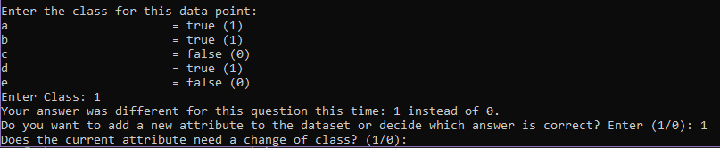

When checking a violation of monotonicity, this is the dialogue that will occur. If a violation is detected, then the program will prompt the user to enter “1” to add a new attribute or “0” to use the value which they last entered as the new class. If the user adds a new attribute, then the program will ask questions on the new cases of the new dataset in the same format that has always been done. This interaction is the only new interaction in the program.

Here is an example of the secondary table:

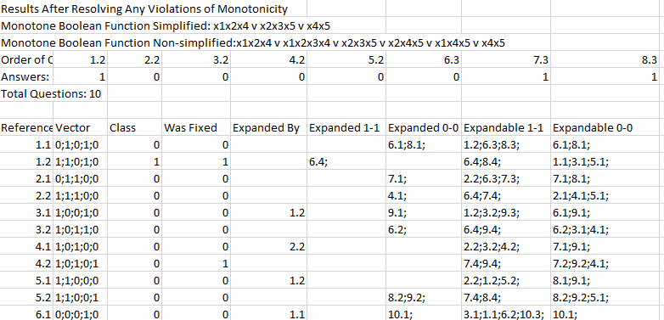

Needless to say, the “Class,” “Expanded By,” “Expanded 1-1,” and “Expanded 0-0” columns will be different than the table above if there were any violations of monotonicity.

Finally, there are several results files that are attached. “results_resolved.csv” is fixing a violation of monotonicity without adding any new attributes, “results_resolved_add_1.csv” is fixing a violation of monotonicity by adding one attribute, and “results_resolved_add_2.csv” is fixing two violations of monotonicity by adding two attributes. These files were included in the last iteration of this README as well. Additional files are a sample dataset with just two cases and its modified version after being fixed.

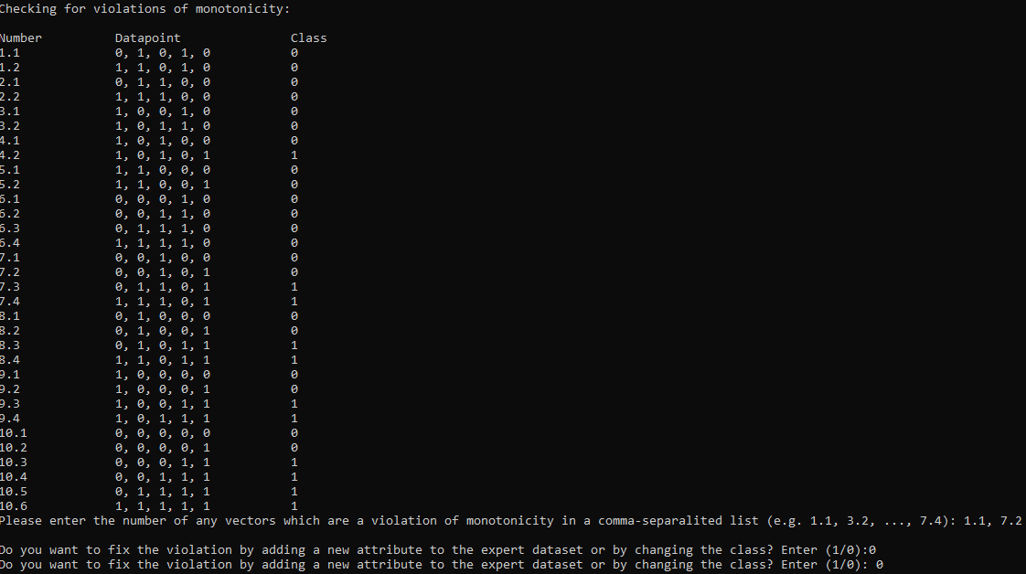

In the above photo, the user specified two violations of monotonicity, 1.1 and 7.2. The user decided to change the class of the two cases as shown in the bottom two lines.

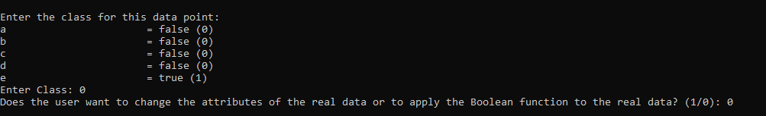

In this photo, the last few lines of console print-outs are given. There was one last question that was asked due to it being expanded, but its parent’s class was changed. Then, the user specifies that they want to apply the Boolean function to the real data instead of changing the attributes of the real data.

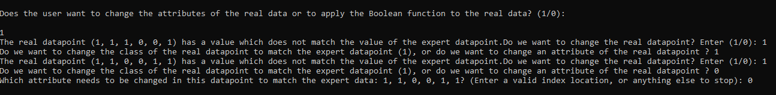



TODO

~~In code, check if f-change is violation~~

~~Non-monotonic function -> reaffirm~~

~~When changing attributes of real data, always ask~~

~~Monotonicity preservation~~

~~Monotonicity reaffirmation~~

~~Check f-change if there is no violation~~

~~Check monotonicity preservation~~

~~Check real data changing attributes or class~~

~~Check monotonicity reaffirmation~~

~~Check non-monotonic function printing~~