**q1 Brief summary of how your site satisfies the requirements -**

My project uses the following technologies - jquery,vanilla js,css,html,sql,php

All pages have the same look/feel consistency

my site provides users with books they are able to search for books based on author,title or category as well as view the number of

books available per category , they are also able to see the info on the book by clicking on the TITLE or link below the description of

the book, if they click on the author name they can see a different page with books written by that author. They can also contact me by

filling the contact form .

**q2 What features did you implement?**

following is a list of features implemented in my project as per the rubric -

1. 2 column layout with masthead and footer

(although footer isnt there on product and contact pages cause there is no need to add the search functionality there,all the pages still mantain a similar look/feel consistency)

2 responsive design (works and resizes appropriately for mobile devices) proof -

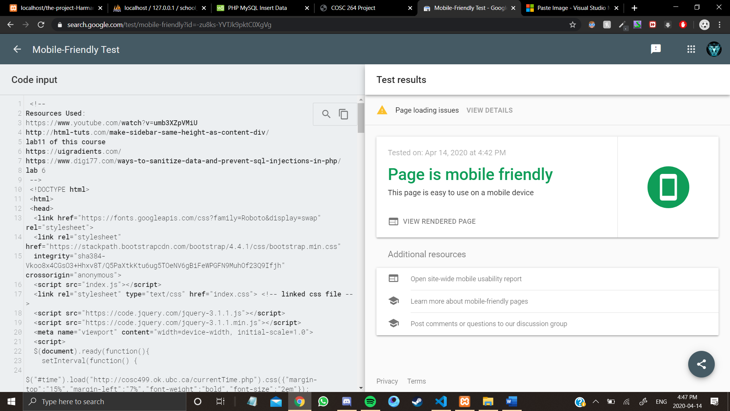

3 Search functionality for items (title, author, category)

4 User input is sanitized against SQL injection attack

5 **Search results (contains the following):**

* book title, author, short description
* displays thumbnail image for book on search (from img folder)
* hyperlink on book title to product page for product details (product.php)
* hyperlink on another to a different page showing all other books author has written
* more link at end of description that will link to product page for product details (product.php)

6 **Product page (Product page displaying information (all details) for book (redirects here when user clicks on title of book on home page or on link below the description in search results):**

* product details
* product image (from img folder)

7 **Side bar:**

* general search input field and button
* search by categories , author , title or none
* Pages show time using asynchronous updates (page doesn’t reload but time updated using cosc499.ok.ubc.ca/currentTime.php)
* Number of books according to category

8 **Contact :**

* Required fields and posts to processContact.php
* validation (client side)

9 **ProcessContact:**

* confirmation page that displays the information POSTed from contact.php and a thank you message
* send data to my database in contact table
* validation(server side) before writing results to the database

10 **Masthead (on all pages):**

* Create logo for masthead (SVG/other for logo + branding)
* Nav links for main page and contact page

11 **Footer (on all page)**

* copyright information (/1)

***Essential Features :***

* *All except ajax update search results without refreshing*
* *Author link click should display all books written by the author on index.php(mine displays on a separate pages)*

***Bonus Features :***

* *Send data filled by user in contact form to a database*
* *Display number of books by category*
* *Validate the search field(it cannot be empty)*

**Summary of php and js files-**

1. **Index.php ->**

**Features -** Home page of the site , provides clean design , search functionality , live time display , navbar, footer ,display number of books per category , search field cannot be empty (js validation)

1. **Authorlink.php ->**

**Features –** display all books written by the author the user clicked on in the index.php page

1. **Contact.js**

**Features –** perform client side validation on data in the contact.php form

1. **Contact.php –**

**Features –** form to contact the owner of the site , server side validation

1. **Processcontact.php**

**Features –** process data received from contact.php including sanitizing the data and sending it to the database, and display thankyou message

**\*some pages have javascript code within them**

**Q3 Website performance at high level ?**

The website was built in 3 days(50 hours) considering that it has pretty good functionality at high level however many websites can easily outperform it in terms of features and functionality.

**Q4. Limitation of the site ?**

1. **Doesn’t update search results asynchronously**
2. **Doesn’t provide links to search by name of category(user has to enter the category)**
3. **Doesn’t provide books written by author on link click on the same page**
4. **Displays some duplicates in search results**