BUSINESS INSIGHTS REPORT –
MARKETING CAMPAIGN PERFORMANCE
Task 04 | Exploratory Data Analysis | 88 Campaigns

EXECUTIVE SUMMARY:
This analysis evaluates the performance of marketing campaigns across different channels using spend, revenue, clicks, ROI, revenue per click, and revenue contribution. Across 88 campaigns, total marketing spend was ₹217,355.59 and total revenue was ₹873,498.63, resulting in an overall ROI of 301.88%. The analysis compares channel performance to identify patterns that can support data-driven marketing budget decisions.

KEY FINDINGS:
- Social Media recorded the highest ROI among the named channels at 379.01% and the highest revenue per click at ₹10.53.
- PPC recorded 352.75% ROI and generated the largest share of total revenue at 27.02%, compared with 23.99% of total spend.
- Email recorded 313.40% ROI, with its revenue share (11.26%) slightly above its spend share (10.95%).
- Referral recorded 294.63% ROI, with its revenue share (17.02%) close to its spend share (17.33%).
- Paid Search recorded the lowest ROI among the named channels at 228.07%, while its revenue share (19.29%) was below its spend share (23.62%).

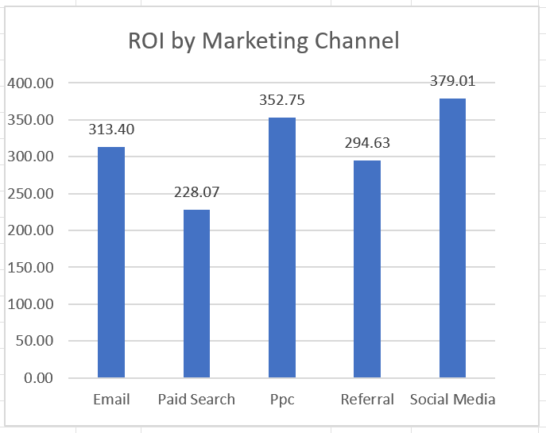

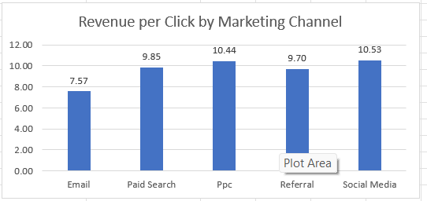

BUDGET RECOMMENDATION:
Based on the historical results in this dataset, Social Media and PPC showed the strongest combination of ROI and revenue contribution. The company could consider allocating a greater share of future test budget toward these channels while continuing to monitor performance. Paid Search could be reviewed before increasing its allocation because its spend share exceeded its revenue share and it had the lowest ROI among the named channels. These observations are based on historical campaign performance and do not guarantee future results.

MARKETING FUNNEL/PERFORMANCE OVERVIEW:
The available campaign metrics form a high-level sequence of Marketing Spend → Clicks → Revenue. Across the dataset, campaigns used ₹217,355.59 in marketing spend, generated 90,689 clicks, and produced ₹873,498.63 in revenue. Because the dataset does not contain explicit lead or conversion stages, this visualization should be interpreted as a performance overview rather than a traditional conversion funnel.

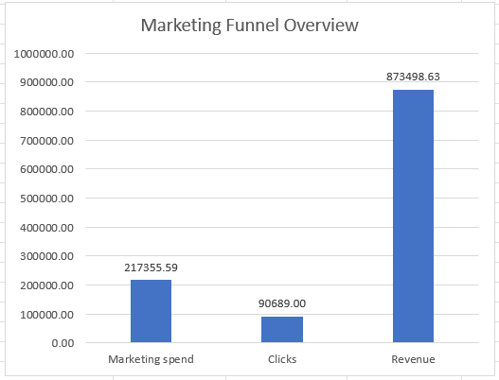

DATA NOTE:
The dataset contained 5 campaign records with missing Marketing_channel values. These records were retained in the overall dataset totals but excluded from named-channel comparisons and budget recommendations. No marketing-channel values were invented or assigned.

CONCLUSION:
The analysis shows that marketing channel performance varied across ROI, revenue contribution, and revenue per click. Social Media and PPC demonstrated strong historical performance, while Paid Search showed comparatively lower ROI among the named channels. These findings can help guide future marketing budget testing and channel monitoring. Overall, the results highlight the value of using multiple performance metrics rather than relying on ROI alone when evaluating marketing campaigns.

