**POST addToInventory :** which will add product to Inventory , a message will be produced in kafka topic and consumer will consume that msg and get list of customer using productId from Notify_customer CB bucket and acc send notification to customer how clicked on notify Me option

**POST notifyMe/{productId} :** when customer will click on NotifyMe option in that case this API will be triggered and help to add customer email address to the notify_Customer couchbase bucket

**Couchbase Bucket:** Notify_customer , ProductInventory

**Kafka Topic:** notify_Customer

**Kafka**

{"id":"Product_1834821000","update_time":"2024-05-07T18:01:47.423160600+05:30","price":"80000","title":"Samsung","quantity":"200","productType":{"productType":"Electronics","productCategory":"Mobile"},"specification":"128GB RAM , White Color","tags":["Electronics","Mobile","Smartphone","Android"],"active":false}

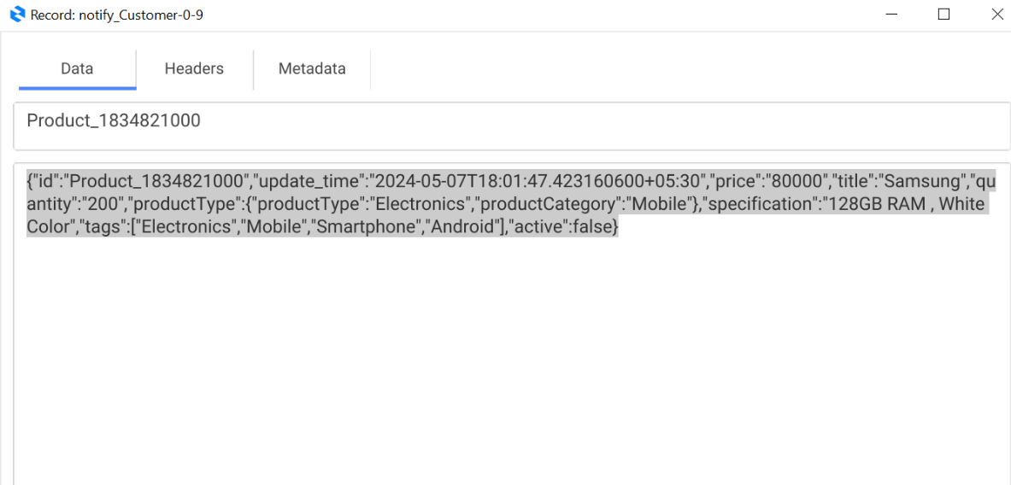

**Couchbase**

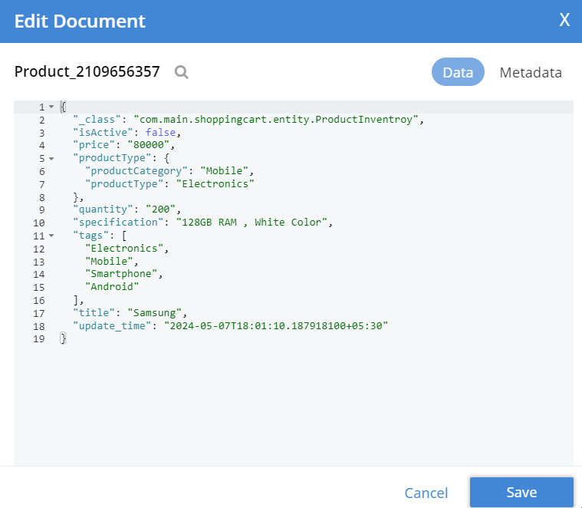

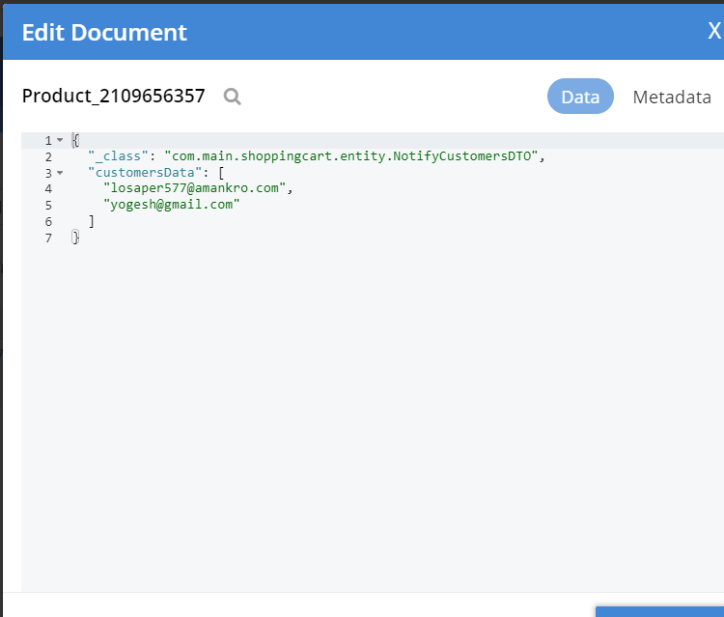

**Postman Request Body**

{

    "price": "80000",

    "title": "Samsung",

    "specification": "128GB RAM , White Color",

    "quantity": "200",

    "productType": {

        "productType": "Electronics",

        "productCategory": "Mobile"

    },

    "tags": ["Electronics", "Mobile", "Smartphone", "Android"],

    "isActive": **true**

}

