A Two-Regime Lognormal Model for Fund X Monthly Returns
Working note — regime-switching analysis, September 2026

1. Data
The series consists of 115 monthly returns for Fund X (LSQ), January 2017 to July 2026, taken from the COMBined3b.xlsx workbook (Sheet1). Only 5 of the 115 months are negative (4.3%). The unconditional sample mean is 3.52% per month with a standard deviation of 3.98%, consistent with the strong positive skew and excess kurtosis reported previously for this series (Boyle and Peng, working paper).

2. Model
Let r_t denote the monthly return and y_t = ln(1+r_t) the corresponding log return. A two-state Markov regime-switching lognormal model (Hamilton, 1989; Hardy, 2001) assumes that, conditional on an unobserved state S_t in {1,2}:
y_t | S_t = i ~ Normal(mu_i, sigma_i^2),
with S_t following a first-order Markov chain with transition matrix P = [p_ij], p_ij = Pr(S_t = j | S_t-1 = i). This is the RSLN-2 specification used by Hardy (2001) for long-term equity returns; it is applied here to Fund X's own return history rather than an equity index.
Parameters (mu_1, sigma_1, mu_2, sigma_2, P) were estimated by maximum likelihood via the Baum-Welch (EM) algorithm, using 300 random initialisations to guard against local optima. The reported fit converged (log-likelihood 255.75) and was the best of all initialisations tried.

3. Fitted parameters
Parameter | Regime 1 (normal) | Regime 2 (high) | Notes
mu_i (log scale) | 0.0237 | 0.0895 | mean of ln(1+r)
sigma_i (log scale) | 0.0211 | 0.0606 | s.d. of ln(1+r)
Implied mean return | 2.42% / month | 9.57% / month | exp(mu+sigma^2/2)-1
Implied s.d. of return | 2.16% / month | 6.64% / month
p_ii (stay probability) | 0.9119 | 0.5289 | diagonal of P
Expected duration | 11.3 months | 2.1 months | 1/(1-p_ii)
Stationary probability | 0.842 | 0.158 | long-run time share

Regimes are labelled by mean: regime 1 is the prevailing, lower-return state (84.2% of the time, expected duration 11.3 months); regime 2 is a shorter-lived, high-return state (15.8% of the time, expected duration 2.1 months). Both regimes have a positive mean and there is no separate crash/loss regime, which fits the near-absence of negative months in the raw data.

3.1 Transition matrix
From \ To | Regime 1 | Regime 2
Regime 1 | 0.9119 | 0.0881
Regime 2 | 0.4711 | 0.5289

4. Model comparison
A one-regime lognormal fit (a single Normal distribution for y_t) is nested inside the two-regime model when the two components coincide. The table below compares the two.
 | Log-likelihood | AIC | BIC
One-regime lognormal | 217.17 | -430.34 | -424.85
Two-regime lognormal | 255.75 | -499.50 | -483.03

The two-regime model raises the log-likelihood by 38.6 and both AIC and BIC favour it by a wide margin. The likelihood-ratio statistic is 77.2 on 3 extra parameters; this is not chi-square under standard regularity conditions because the mixing weights sit on a boundary under the null (Hartigan, 1985), but a difference of this size, together with the AIC/BIC gap, is strong evidence for regime switching in this series.

5. Regime classification
Using the Viterbi algorithm to assign the single most likely path, 12 of 115 months (10.4%) fall in the high regime: August-October 2018, March-July 2020, January-February 2021, and September-October 2025. These correspond to the largest positive outliers in the series (21.46%, 21.97%, 18.18%, 16.44%, 13.90%, 11.38%, and similar), which the single-regime model could only accommodate through heavy right skew and excess kurtosis rather than a distinct state.
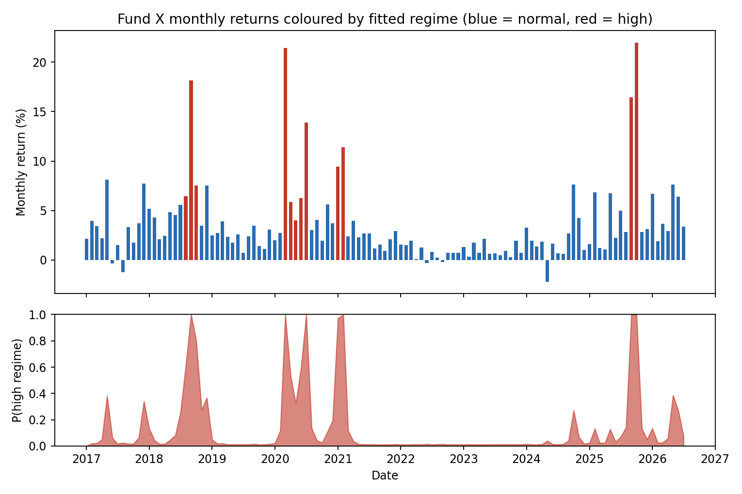
Figure 1. Monthly returns coloured by fitted regime (top) and smoothed probability of the high regime (bottom).
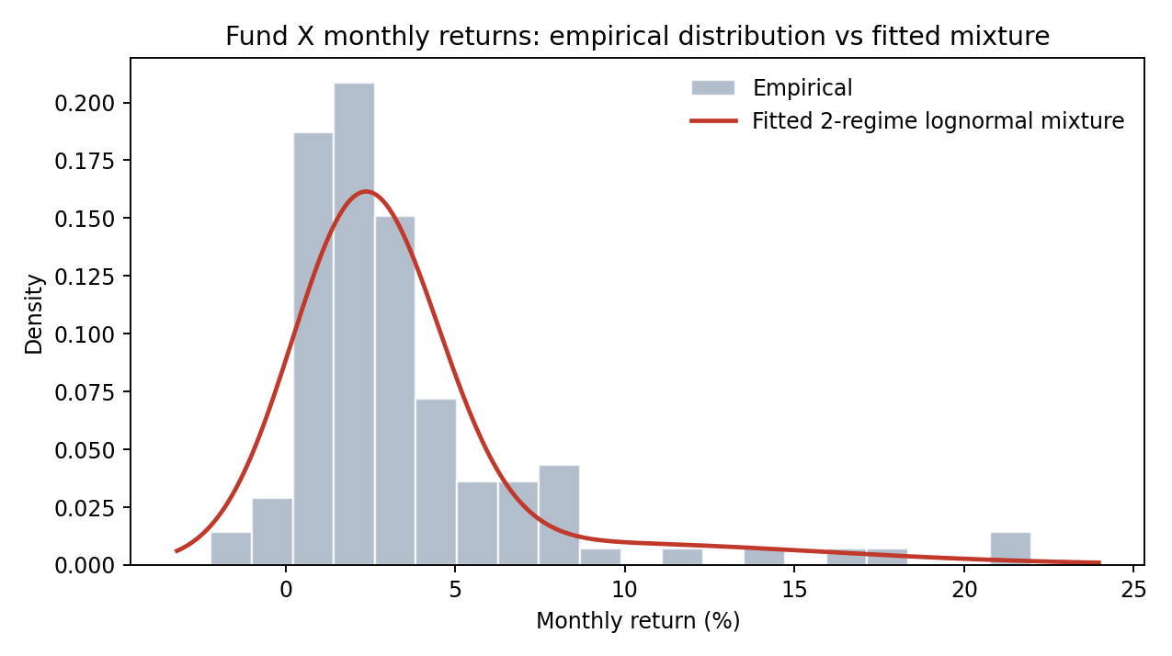
Figure 2. Empirical distribution of monthly returns against the fitted two-component lognormal mixture density.

6. Autocorrelation function
The sample ACF of the raw returns shows significant positive autocorrelation at short lags, most notably lag 1 (0.352), consistent with a Ljung-Box test (Q(1) = 14.6, p < 0.001; Q(12) = 40.3, p < 0.001).
Lag | 1 | 2 | 3 | 4 | 5 | 6 | 7 | 8 | 9 | 10 | 11 | 12
ACF(r) | 0.352 | 0.155 | 0.222 | 0.205 | 0.059 | 0.048 | 0.167 | 0.170 | 0.066 | 0.091 | 0.129 | 0.043
ACF(resid.) | 0.157 | 0.108 | 0.183 | 0.179 | 0.135 | 0.092 | 0.218 | - | - | - | - | -

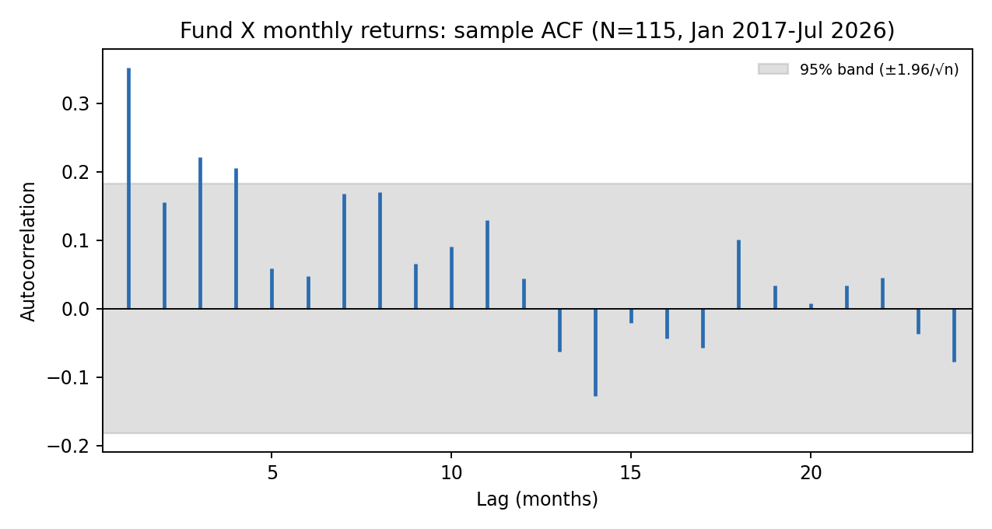
Figure 3. Sample ACF of Fund X monthly returns, lags 1-24, with 95% band.
Demeaning each observation by its Viterbi-classified regime mean (i.e. computing the ACF of y_t - mu_hat(S_t)) reduces the lag-1 autocorrelation from 0.352 to 0.157 and the lag-1 Ljung-Box test is no longer significant at 5% (p = 0.087). This indicates that persistence within the high-return regime (average duration 2.1 months) accounts for a substantial part of the raw autocorrelation. Some autocorrelation remains at lags 3-4 and 6-8 after regime-demeaning (Ljung-Box Q(6) p = 0.017, Q(12) p < 0.001), so regime switching alone does not fully explain the dependence structure; a next step would be to allow within-regime AR(1) dynamics or regime-dependent autocorrelation.

7. Summary
- A two-regime lognormal (RSLN-2 style) model fits Fund X's monthly returns markedly better than a single lognormal, by both AIC and BIC.
- Regime 1 (84% of months): mean 2.4% per month, s.d. 2.2%, average duration 11.3 months.
- Regime 2 (16% of months): mean 9.6% per month, s.d. 6.6%, average duration 2.1 months.
- The high regime contains the large positive outliers that drive the series' skewness and kurtosis; there is no separate loss regime, unlike typical equity-index applications of RSLN-2.
- Regime switching explains part, but not all, of the positive autocorrelation in raw returns; residual dependence remains at several lags.

Appendix A. Intuition and formulae for the two-regime lognormal model

A.1 Intuition
A single lognormal distribution has one mean and one variance. Fund X's returns are almost always modest and positive, but occasionally jump to 15-22% in a month, then revert. A single lognormal can only fit this by stretching its variance and skewness parameters to cover both the ordinary months and the rare jumps at once; the fitted curve then sits too low over the bulk of the data and too flat over the tail, as in Figure 2's implicit one-regime alternative.
A two-regime model instead allows two separate lognormal distributions, a quiet one and a fast one, and lets the data decide, month by month, which one was probably in force. This alone is just a mixture. The Markov switching adds memory: the state is not redrawn independently each month but tends to persist, because the fast regime has its own probability of continuing (p_22 = 0.529) versus reverting to the quiet regime (p_21 = 0.471, via the row-sum-to-one constraint). This is what lets the model reproduce the observed clustering of big months, for example August-October 2018 or March-July 2020, rather than treating each outlier as an isolated, independent draw.
The two-regime lognormal used here is the RSLN-2 specification introduced by Hardy (2001) for actuarial applications (segregated fund and variable annuity guarantee valuation), building on the general Markov-switching framework of Hamilton (1989). Hardy's application to equity indices typically finds a low-volatility bull regime and a high-volatility bear regime with a negative mean. The fitted model for Fund X differs in one respect: both regimes have a positive mean, and the second regime is a high-return rather than a loss regime, reflecting that only 5 of 115 months in this series are negative.

A.2 State space and observation equation
Let R_t be the return in month t and Y_t = ln(1+R_t) the log return. Let S_t in {1,2} be an unobserved (latent) state, evolving as a first-order, time-homogeneous Markov chain:
Pr(S_t = j | S_1,...,S_t-1) = Pr(S_t = j | S_t-1) = p_{S_t-1, j}.
Conditional on the state, the log return is Normal and independent of the past given S_t:
Y_t | S_t = i ~ N(mu_i, sigma_i^2), i = 1, 2,
equivalently 1 + R_t = exp(mu_i + sigma_i Z_t) with Z_t ~ N(0,1) i.i.d., so 1+R_t is lognormal within each regime, which is the sense in which the model is a “two-regime lognormal” model. The full parameter vector is theta = (mu_1, sigma_1, mu_2, sigma_2, p_11, p_22), since each row of the 2x2 transition matrix P sums to one (p_12 = 1-p_11, p_21 = 1-p_22).

A.3 Likelihood via the forward algorithm
Direct evaluation of the likelihood would require summing over all 2^T possible state paths. The forward algorithm avoids this by recursion. Let phi(y; mu, sigma) denote the Normal density and pi_i the initial-state probability. Define the forward variable
alpha_t(i) = Pr(Y_1=y_1,...,Y_t=y_t, S_t=i).
Then, with alpha_1(i) = pi_i * phi(y_1; mu_i, sigma_i), the recursion for t = 2,...,T is
alpha_t(j) = [ sum_i alpha_t-1(i) p_ij ] * phi(y_t; mu_j, sigma_j),
and the sample log-likelihood is ln L(theta) = ln[ sum_i alpha_T(i) ]. This is the quantity maximised numerically to obtain the fitted parameters in Section 3 (log-likelihood 255.75 at the optimum).

A.4 Estimation by the EM (Baum-Welch) algorithm
Because the states are unobserved, direct maximisation is replaced by the EM algorithm, whose use here goes by the name Baum-Welch. Given current parameter values, the E-step uses the forward variable together with an analogous backward variable beta_t(i) = Pr(Y_t+1,...,Y_T | S_t=i) to compute, for every t, the smoothed state probability
gamma_t(i) = Pr(S_t=i | Y_1,...,Y_T) = alpha_t(i) beta_t(i) / sum_k alpha_t(k) beta_t(k),
and the smoothed transition probability xi_t(i,j) = Pr(S_t=i, S_t+1=j | Y_1,...,Y_T), obtained similarly from alpha_t(i), p_ij, phi(y_t+1; mu_j,sigma_j) and beta_t+1(j). The M-step then updates each parameter in closed form as a gamma-weighted average:
mu_i = [ sum_t gamma_t(i) y_t ] / [ sum_t gamma_t(i) ],
sigma_i^2 = [ sum_t gamma_t(i) (y_t - mu_i)^2 ] / [ sum_t gamma_t(i) ],
p_ij = [ sum_t=1^T-1 xi_t(i,j) ] / [ sum_t=1^T-1 gamma_t(i) ].
E- and M-steps alternate until the log-likelihood stops increasing; the fit reported here converged after 10 iterations from the best of 300 random starting points, chosen because this class of mixture likelihood is known to have multiple local optima.

A.5 Stationary distribution, regime duration and implied moments
The long-run (stationary) probability of each state solves pi P = pi with pi_1+pi_2=1, which for a 2-state chain gives the closed form
pi_1 = p_21 / (p_12 + p_21), pi_2 = p_12 / (p_12 + p_21).
Because the chain tends to stay in whichever state it is in, the expected number of consecutive months in state i, once entered, is a geometric mean duration:
E[duration in state i] = 1 / (1 - p_ii).
Finally, since 1+R_t is lognormal within a regime, the regime-conditional mean and variance of the arithmetic return follow the standard lognormal moment formulae:
E[1+R_t | S_t=i] = exp(mu_i + sigma_i^2/2), Var(1+R_t | S_t=i) = [exp(sigma_i^2) - 1] * exp(2 mu_i + sigma_i^2).
These are the formulae used to convert the fitted log-scale parameters (mu_i, sigma_i) into the implied monthly arithmetic mean and standard deviation reported in the parameter table of Section 3.

A.6 Most likely regime path (Viterbi)
The regime classification in Section 5 (Figure 1) uses the Viterbi algorithm, which replaces the sum in the forward recursion with a maximum to find the single most probable state sequence given the whole sample, rather than the smoothed marginal probability gamma_t(i) at each t taken in isolation:
delta_t(j) = max_i [ delta_t-1(i) p_ij ] * phi(y_t; mu_j, sigma_j),
with the maximising state stored at each step and the full path recovered by backtracking from arg max_i delta_T(i). This is the path plotted in the top panel of Figure 1; the bottom panel instead shows the smoothed probability gamma_t(2) from Section A.4, which is why a given month can show, for example, a 60% posterior probability of the high regime without being classified into it by Viterbi.

References
Hamilton, J. D. (1989). A new approach to the economic analysis of nonstationary time series and the business cycle. Econometrica, 57(2), 357-384.
Hardy, M. R. (2001). A regime-switching model of long-term stock returns. North American Actuarial Journal, 5(2), 41-53.
Hartigan, J. A. (1985). A failure of likelihood asymptotics for normal mixtures. In Proceedings of the Berkeley Conference in Honor of Jerzy Neyman and Jack Kiefer, Vol. 2, 807-810.
Boyle, P. and Peng, Z. (Judy). High Returns, Low Risk: The Case of Fund X. Working paper.

