**Face emotion recognition and Classification**

Harman Bhutani

**Methodology**

General process for emotion recognition and Classification :-

1. **Pre-Processing –**

In pre-processing, firstly input image is obtained from digital camera, then use histogram equalization which enhances the image quality. After this process, to find the probability of the largest connected region this is related to face. If the largest connected regions height & width is larger or equal than 50 and the ratio of height/width is between 1 and 2, then it may be face. For face boundary detection, first convert RBG image in to binary image. For this conversion, calculate the average value of RGB for each pixel and if the average value is below the predefined threshold, replace it by black pixel and otherwise replace it by white pixel. Then, this binary image may be used to isolate the forehead from the face in the binary image . The steps for this isolation would be Scanning from the mid- point of the image horizontally and vertically. Then, find the maximum width of the white pixel on both left and right side. If find the new width is half of previous maximum width, then we reach the eyebrow region. At this stage, cut the face from the starting position of the forehead and its height will be 1.5 multiply of its width**.**

1. **Boundary detection of eye and lip regions:-**

For detecting the boundary of eye region, consider the face width by W, and starts scan from the W/4 to (W-W/4) for to find the middle position of the two eyes. Then find the upper position and lower position of the two eyebrows. For left eye, scan from w/8 to mid and for right eye scan from mid to w – w/8. Here w is the width of the image and mid is the middle position of the two eyes .Some white pixels present between eyebrow and eye, to make connection between eyebrow and eye some black pixels are placed from eyebrow to eye. Also, scan the black pixels vertically and horizontally for lower and upper position of two eyebrows . For detecting the boundary of the lip region, first consider the lip box and calculate the distance between the forehead and eyes. Then determine the lower height of eyes and upper height of the box which will contain the lip . Therefore, this box will contain lip and some part of nose. Then, cut the RGB image according the box. Finally, sobel edge detector is applied to the eyes and lip image for edge detection . The sobel edge detected image of lip and eyes shown in following figures:-



(The Neutral Emotion)

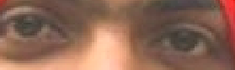

(Sobel Edge detected eyes region)



(Sobel Edge detected lips region)

1. **Image processing and Feature Extraction:-**

Now, a feature extraction method is applied to sobel edge detected image. This feature extraction method is associated with the row-sum and column-sum of white pixels of edge detected image. For this purpose, projection profile method is used because of high speed. In this method, let f (m, n) represents a binary image with m rows and n columns. This projection profile is divided into 2 types such as horizontal and vertical profile. The vertical profile is defined as sum of white pixels of each column perpendicular to X-axis which is represented by,

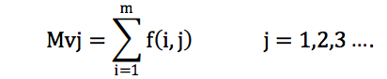

The horizontal profile is defined as sum of white pixels of each row perpendicular to Y-axis which is represented by,

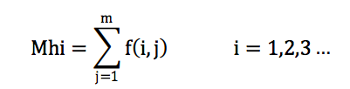

The human eye is like an ellipse so; it is called as regular ellipse. The length of minor axis of eye is varies for each emotions and the length of major axis of eye is fixed.. The major and minor axis of eye is defined by following equation,

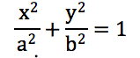

Where, a - major axis, b – minor axis

The human lip is a combination of two ellipses which is called as irregular ellipse. Irregular means it has two minor axes wherein major axis remains same .For each emotion, the lengths of minor axes are computed and major axes are fixed.. Emotions totally depend on facial expression of lip is represented as b1, b2 and expression of eye is represented as b.

1. **Emotion recognition using Genetic Algorithm:-**

Genetic Algorithm is an iterative process in which each iteration is called generation. In each generation, the fitness of each individual is calculated and to form new population, GA algorithm is used to calculate the optimized value of eye and lip features. For this purpose, length of chromosome is 7 bits and size of population is 20 used. In our approach, first select a pair of eye and lip region.

The GA process is described in the following steps:-

* First, represent the fixed length of chromosomes and initial population with cross-over and mutation probability.
* Define fitness functions of individual chromosomes.
* Randomly, generate an initial population of chromosomes.
* Calculate the fitness of each individual chromosome
* Select a pair of high fitness chromosomes for matting from initial population.
* By applying genetic operators such as crossover and mutation - to create a pair of offspring
* Created a new pair of offspring placed in new population.
* Repeat from step 5 until the size of initial population becomes equal to the size of the new population
* Replace the initial population with the new population
* Go to step 4, and repeat the process until the criteria is satisfied.

**Fitness Function:-**

A fitness function gives optimality of a solution which is the type of objective function. Using fitness function to obtain lip and eye features. Equation (3) is derived from fitness function. Equation (4) (5) are fitness functions for ‘b’, ‘b2’ to obtain optimized value of lip features. Equation (6) is fitness function for ‘b’ to obtain optimized value of eye feature.

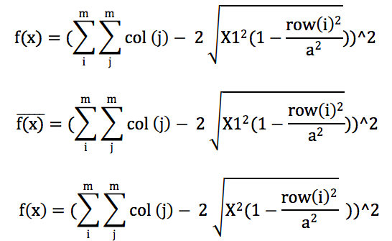

Where, col (j) is sum of white pixels in jth column, row (i) is the sum of white pixels in ith row. Table I. shows the manually computed mean value of ( b, b1, b2) and optimized mean value by GA (X, X1, X2).

1. **Emotion classification using neural network:-**

An artificial neural network is a non- linear network which is working like a human brain. This network consists of neurons which is working in parallel and communicating with each other through weighted interconnection.

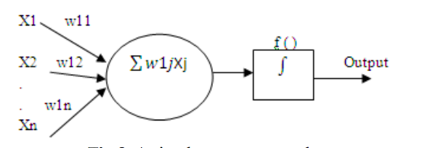

The ANN is used for database in which optimized values (X, X1 and X2) are used as a input to train the network. These inputs are trained using back propagation training algorithm. For this purpose, 3 inputs, 20 neurons and 7 0utputs are used.

|  |  |  |  |  |  |  |
| --- | --- | --- | --- | --- | --- | --- |
| Emotions | b | b1 | b2 | X | X1 | X2 |
| Neutral | 9.961 | 9.542 | 19.3 7392 | 12.1875 | 8.9375 | 18.4375 |
| Fear | 6.8582 | 10.1474 | 15.1063 | 7.0625 | 6.0625 | 13.3125 |
| Happy | 15.0087 | 13.8983 | 10.7356 | 13.8125 | 9.9375 | 9.8125 |
| Sad | 10.7820 | 9.9412 | 11.6803 | 13.0625 | 9.9375 | 10 |
| Angry | 13.1848 | 11.6735 | 9.91540 | 16.56 | 5.125 | 8.0025 |
| Dislike | 14.106 | 9.29956 | 16.8334 | 18.062 5 | 8.375 | 15.062 5 |
| Surprise | 19.1441 | 6.54390 | 6.69801 | 21.625 | 5 | 6.3125 |

Table II. Neural network classification of emotions

|  |  |  |  |  |  |
| --- | --- | --- | --- | --- | --- |
| NN  Structure | Epoch(in 10 Trials) | | | Classifica  tion % | |
|  | Min | Max | Mean | Range | Mean |
| 3*20*7 | 19 | 320 | 147 | 90-96 | 94 |

**Conclusion**

A method of classification and detection of emotions (Happy, sad, fear, angry, dislike, and surprise, neutral) based on a genetic optimization algorithm and neural network is used. Then, % accuracy is obtained in the NN model of (3*20*7) structure. Finally, the result of ANN is used for optimization and the ANN provides the best accuracy of classification.