An Implemented Blockchain-Based Framework for Healthcare Data Sharing
Rohan Kumar¹, Harmanjeet Singh¹, and Swati Goel²
¹Department of Computer Science & Engineering, Chitkara University, Punjab, India ²Professor, Department of Computer Science & Engineering, Chitkara University, Punjab, India
rohan739.be22@chitkara.edu.in; harmanjeet371.be22@chitkara.edu.in; swati.goel@chitkara.edu.in

Abstract—Health care is one of the largest generators of personal, private, and sensitive data in the world. With this large volume of sensitive patient information being exchanged securely across numerous entities such as hospitals, labs, insurance companies, and most importantly the patient themselves. Centralized systems used to protect patient information have many shortcomings including but not limited to: Data breaches; Limited interoperability; Lack of transparency in who can see what; Patient’s lack of control regarding their Personal Health Record (PHR). As a result, there is an increased interest in using a new type of distributed ledger system called “Blockchain” which is immutable, public, and allows for peer-to-peer transactions without needing a central authority. The goal of this research is to provide a review of all existing healthcare-related data sharing models utilizing the blockchain architecture. Identify their respective shortcomings. Provide a conceptual model that focuses on the needs of the patient. Use smart contracts for access control and use off-chain encrypted storage for scalable data management. The proposed model increases the data integrity. Provides auditable trail. Empowers the patient to directly manage their medical record and decreases dependency on centralized authorities. An experimental analysis will compare the performance of the proposed model against other similar models to show that it is viable for actual deployment within real-world healthcare environments.
Keywords—Blockchain, Healthcare Data Sharing, Smart Contracts, Patient-Centric Security, Decentralized Systems, Electronic Health Records, Access Control.
I. INTRODUCTION
Health care is one of the largest generators of personal, private, and sensitive data in the world. With this large volume of sensitive patient information being exchanged securely across numerous entities such as hospitals, labs, insurance companies, and most importantly the patient themselves. Centralized systems used to protect patient information have many shortcomings including but not limited to: Data breaches; Limited interoperability; Lack of transparency in who can see what; Patient’s lack of control regarding their Personal Health Record (PHR). As a result, there is an increased interest in using a new type of distributed ledger system called “Block chain” which is immutable, public, and allows for peer-to-peer transactions without needing a central authority. The goal of this research is to provide a review of all existing healthcare-related data sharing models utilizing the block chain architecture. Identify their respective shortcomings. Provide a conceptual model that focuses on the needs of the patient. Use smart contracts for access control and use off-chain encrypted storage for scalable data management. The proposed model increases the data integrity. Provides auditable trail. Empowers the patient to directly manage their medical record and decreases dependency on centralized authorities. An experimental analysis will compare the performance of the proposed model against other similar models to show that it is viable for actual deployment within real-world healthcare environments.

This paper makes the some contributions: (1) a proper survey of current blockchain-based healthcare data sharing approaches published in between 2017 and 2024, identifying architectural patterns and common limitations; (2) a conceptual framework for patient-centric blockchain-based data sharing that addresses identified gaps through off-chain storage with on-chain access control; (3) a smart contract design for permission management that enables granular, auditable, and revocable access to medical records; and (4) a comparative evaluation demonstrating the practical advantages of the proposed framework over existing solutions.

The rest of the paper is organized as follows: Section II outlines the relevant literature. Section III highlights deficiencies in existing. Section IV describes the research methodology, Section V discusses. depicts the proposed system architecture, Section VI covers issues in designing smart contracts, Section VII deals with security analysis, Section VIII provides performance evaluation results, and Section IX. The idea of blockchain as a distributed and immutable ledger was first put forward by Nakamoto [10] followed by the use of programmable smart contracts via the Ethereum platform [11]. Many attempts have been made to investigate how the blockchain may be used to revolutionize healthcare data management [9]; among the pioneering works in accessing medical records using smart contracts are those by Azaria et al. [1] and for cloud storage of medical records by Xia et al. [2].
A. Blockchain Technology

The term blockchain refers to an emerging technology which enables multiple parties to access a digital ledger through distributed ledgers. A distributed ledger allows each party to have a copy of the same ledger. The ledger in question is constantly being updated as new records (called blocks) are added. In this regard, each block contains a unique identifier (a hash) which was generated from the previous block’s hash. The addition of a new block adds a time stamp, the identification of the block (block id), and any other data that has been added as a record (transaction). When a new block is created, every node on the blockchain will update its version of the ledger. If one were to attempt to modify a record on the blockchain it would require modifying the entire chain of hashes so that they were valid. Since there are thousands of nodes on the blockchain working together to verify each modification, making such changes to the blockchain is considered virtually impossible.

Key characteristics of blockchain as it relates to healthcare:
• Decentralized: there is no central authority controlling the ledger. Every participating node stores a copy of the ledger, therefore creating redundancy and removing single points of failure.
• Immutable: once something is placed on the blockchain, it cannot be changed or removed without gaining agreement from the majority of the network. Therefore, the blockchain creates an unalterable and tamper evident audit trail.
• Transparent: every participant on the blockchain has visibility to every transaction made within the network, therefore creating a mechanism for accountability and tracing.
• Smart Contract: these are Self executing programs stored in the blockchain that execute predefined actions once specific conditions have occurred.
• Cryptographic Security: every transaction performed using the blockchain is executed using private keys, thus validating the identity of the sender and preventing repudiation.
B. Types of Blockchain Networks Relevant to Healthcare Applications
There are three main categories for blockchain network that are relevant to health care applications:
• Public blockchain (Ethereum, Bitcoin): open to everyone and completely decentralized but faces issues related to scaling and cost associated with processing Transactions. Due to these limitations public blockchains may not be ideal for large amounts of health care related data.
• Private blockchain (Hyperledger Fabric): only allow access to users who have been granted permission. Therefore, processing speed increases and user data is more secure than in public blockchain networks. Enterprise level health care environments where users are known and trusted often utilize private blockchains.
• Consortium blockchain: combine aspects of both public and private blockchain networks. Consortiums provide decentralization while still allowing users to maintain confidentiality and perform at levels suitable for health care applications.
C. Electronic Health Records (EHR)
Digital representations of each patient’s complete history of diagnosis, medication, treatments, immunizations, allergies, radiological images, lab tests, etc. are referred to as electronic health records. These digital versions of a patient’s history were created to allow healthcare professionals to continue providing quality care to the same patient regardless of where they receive services.

Unfortunately, there are many problems associated with today’s use of electronic health records. One major problem is the lack of consistency in standards used by different vendors creating products for this type of data. Another problem is “vendor lock-in,” the inability to take one’s data out of a particular product or platform. In addition, the ability to grant and revoke access to a patient’s health record is limited. Lastly, it is easy to obtain improper access to a patient’s health record if someone is intentionally trying to do so.

Blockchain technology offers a solution to all four issues above by providing an infrastructure layer to create separation between who can access a patient’s health record (and when) and where a patient’s health record is stored.
II. RELATED WORK
A. Early Blockchain Healthcare Research
The systematic investigation into using blockchain technology in managing healthcare data began with Azaria et al.’s MedRec system. The purpose of MedRec was to demonstrate the feasibility of utilizing Ethereum smart contracts to control permissioned access to patients’ electronic health records. By developing MedRec, Azaria et al. defined the fundamental concept of separating the logic of controlling access to a patient’s electronic health record (on-chain) from the storage of that patient’s electronic health record (off-chain). This conceptual model has been adopted throughout the development of other blockchain-based solutions.

Xia et al. proposed a second blockchain-based solution called MeDShare. MeDShare was designed specifically for allowing cloud service providers to share medical data among themselves using blockchain technology. In addition to facilitating secure sharing of medical data through a decentralized ledger, MeDShare introduced a feature called “provenance tracking” for medical data. Provenance tracking allows users to track where medical data came from and who may have accessed it. Xia et al. also demonstrated how immutable audit logs on a blockchain can prevent unauthorized access to and misuse of medical data.
B. Privacy-Protective Solutions
As it became apparent that placing large amounts of personal and private health information on public blockchain networks would be unfeasible due to security concerns, researchers began focusing on designing solutions that maintained some level of user privacy. Dubovitskaya et al. developed a system for managing cancer patient data based upon the combination of blockchain technology and cloud computing. The data was encrypted using symmetric key cryptography, and role-based access control was employed to restrict access to authorized parties; thus maintaining the confidentiality of each patient’s data while still allowing for sharing among various organizations for research purposes.

Bhattacharya et al., proposed another privacy-enhancing approach in which zero-knowledge proof protocols were utilized. Zero-knowledge proof protocols allow a user to prove that he/she possesses certain health credentials without revealing the underlying details of those credentials. For example, Bhattacharya et al., describe a scenario in which a user wants to prove possession of a valid health credential in order to purchase insurance coverage without having to reveal his/her entire medical history.
C. Interoperability-Focused Systems
Gordon and Catalini [5] discussed the potential role of blockchain in improving interoperability in healthcare. They suggested that using standardized smart contract interfaces would allow easy sharing of information across organizational borders. They stressed the importance of standardized data format like HL7 FHIR in addition to blockchain technology.

Liang et al. [6] created a mobile health data sharing system using blockchain. This system addresses the issues faced by resource-limited patient devices through lightweight cryptographic protocols. Their work summarizes practical deployment in a real-world clinical setting.

D. Access Control Mechanisms
Several studies have focused on access control as a major challenge in healthcare blockchain applications. Zhang et al. [7] suggested using attribute-based encryption with smart contracts to create detailed access policies. This allows patients to decide which parts of their records are available to specific healthcare providers.

Roehrs et al. [8] introduced OmniPHR, a decentralized personal health record model using blockchain. They showed how patients can gather records from various sources into a specific view that they control.
III. LIMITATIONS OF EXISTING APPROACHES
Despite notable advancements, current blockchain-based healthcare data-sharing systems have several significant limitations that motivate the framework presented in this paper:
A. Scalability Constraints
Public blockchain networks like Ethereum can only handle a limited number of transactions per second, which makes them unsuitable for high-volume healthcare settings. Millions of access events can happen daily across large hospital networks. Even private blockchain solutions encounter throughput issues when applied at a national level.
B. Privacy and Confidentiality Gaps
Privacy and Confidentiality Gaps Some proposed systems keep medical data directly on the blockchain, making it accessible to all network participants. While encryption helps reduce risks, the long-term exposure of health data on unchangeable ledgers remains a concern as encryption standards change. Managing keys is a challenge; ensuring that patients can access their encrypted data after losing keys or devices is often not effectively addressed.
C. Incomplete Patient Control
Many current frameworks claim to promote patient-centered designs but still implement access control policies driven mainly by institutions. Patients frequently have to navigate complex interfaces to manage permissions, creating usability issues that hinder the patient empowerment goals of these systems.
D. Integration Complexity
The integration of blockchain technology with current EHR systems is challenging from both technological and organizational perspectives. All proposals for integration take into account only newly installed EHR systems, but do not consider that many hospitals operate with obsolete IT systems that cannot be replaced immediately.
E. Lack of Emergency Access Policies
The current process is not adequate for emergencies where the patient is unable to give permission for access. In the absence of emergency access policies, there is a danger of putting patients in harm’s way.

IV. RESEARCH METHODOLOGY
A. Research Design
In line with the design science research (DSR) paradigm, this study utilizes a research methodology that is best suited to projects involving the development and assessment of an artifact. Such an artifact may be referred to as the blockchain-enabled framework for healthcare data exchange that will be developed in this project. The DSR research process consists of three stages, namely: (1) the identification and motivation for solving a problem based on a literature review; (2) the design and construction of the artifact in terms of a conceptual model and the coding of the smart contract; and (3) the evaluation of the artifact against established criteria for performance and security.
B. Literature Review Protocol
In order to locate existing blockchain-based healthcare data sharing
frameworks and their limitations, a systematic literature review was performed. Online databases such as IEEE Xplore, ACM Digital Library, Google Scholar, and PubMed were used by combining keywords like: “blockchain and healthcare,” “blockchain and electronic health records “smart contract for medical data,” “decentralized EHRs,” and “patient-centric health data sharing.”
A paper was considered suitable if: (1) it offered or critiqued a blockchain architecture for managing healthcare data, (2) it was published from 2017 to 2024, (3) it was either a peer-reviewed conference paper or journal article, and (4) it offered enough architectural information for a comparative assessment. The following conditions rendered a paper ineligible: (1) it was purely theoretical without any system design, (2) it had blockchain technology used merely as an auxiliary part of its architecture, and (3) it discussed the application of blockchain in industries other than healthcare data sharing. Of the more than 60 relevant papers identified using keyword searches, 8 primary architectures were chosen for detailed consideration based on their architectural significance and citation popularity. The selected architectures were assessed across the following criteria: storage architecture (on-chain/off-chain), access control methodology, patient control, scalability strategy, privacy architecture, and emergency access strategy.

C. Framework Design Methodology
The framework was designed following a requirement-driven strategy. The five identified limitations of Section III have been transformed into design requirements. Scalability problems were solved by exceeding the 50 TPS limit for a consortium chain. Privacy problems needed solving without any storage of raw health information on-chain. Incomplete control over the data implied that the grant of access be made solely by the patient. The complexity of integration implied having a compatible API that is exposed, while the problem of lack of emergency access involved finding a way out of the unconscious patient problem. Each architectural decision made for the framework's three layers was supported by the corresponding design requirement. Other design possibilities were assessed and ruled out whenever necessary, like in the case of a purely on-chain storage strategy, which was ultimately rejected because of privacy and scalability issues. Finally, the architecture was assessed according to the requirements via a checklist procedure.
D. Smart Contract Design and Implementation
The smart contract was developed using secure smart contract development methods based on the guidelines provided by OpenZeppelin for secure smart contracts and Ethereum smart contract development. There were four steps involved in the process. First, functional specification: the functions' expected behaviors were defined via a combination of preconditions and postconditions for each function. For instance, the precondition for the grantAccess() function mandates that only the authorized owner who is registered as the patient can perform this function. The function then ensures that an Access Grant entry is created with accurate provider details, scope, expiration time, and status fields. Secondly, threat-driven design: the contract was designed taking into account the four known classes of smart contract vulnerabilities, which include reentrancy attacks, integer overflow and underflow vulnerabilities, unsafe usage of self-destruct, and front-running exploits. Thirdly, gas optimization: three optimization techniques were used including struct packing for storage variables, mapping data structures to guarantee O(1) time complexity when performing lookups on Patient Registry and audit Log, and batched creation of Access Grant to save on gas for base transaction fees. Lastly, simulation testing: the contract's logic was tested using simulation through a local test Ethereum network by exercising both access grant and revocation, enforcement of expired access grant, blocking unauthorized access requests, access recovery in case of emergencies, and ensuring a complete audit log.
E. Performance Evaluation Methodology
Performance evaluation was done using a comparative simulation approach. For each of the systems compared (MedRec, MeDShare, baseline EHR centralization scheme, and the proposed approach) a simulation environment was developed modeling the same workload for each system. The workload simulation consisted of a regional hospital network with around 500 simultaneous users performing operations such as access granting, access requests and record retrieval. The arrival of transactions followed a Poisson probability distribution, with a calculated mean value reflecting realistic health care access scenarios. Measures considered in the evaluation include transaction processing speed (TPS), end-to-end access time latency, patient access control quality, and privacy level according to a three-level scale regarding whether only hashes, encrypted, or plain text data are exposed on-chain. Throughput and latency for MedRec and MeDShare was obtained from the corresponding evaluations presented in their literature and used as calibration measures. It should be noted that the performance was evaluated through simulation, and not deployment. Consequently, simulation results may not account fully for network congestion or validation behavior in real settings.
F. Security Analysis Methodology
Security assessment involved threat modeling based on the STRIDE framework (Spoofing, Tampering, Repudiation, Information Disclosure, Denial of Service, Elevation of Privilege). The threats were categorized within each component of the framework and assessed based on the adopted countermeasures. Blockchain transaction sender spoofing is addressed via private key authentication. Off-chain stored data tampering is mitigated using on-chain data hash verification. Repudiation of access events is avoided with an append-only on-chain audit log. Information disclosure from IPFS encrypted data is mitigated by AES-256 data encryption without on-chain storage of decryption keys. Denial of service from attacks on blockchain nodes is avoided using decentralized data replication without a single point of failure. Elevation of privilege through the smart contract is prevented through the owner check function with no administrative functions without authorization. Three attack scenarios were considered in greater detail as described in Section VII.

V. PROPOSED FRAMEWORK
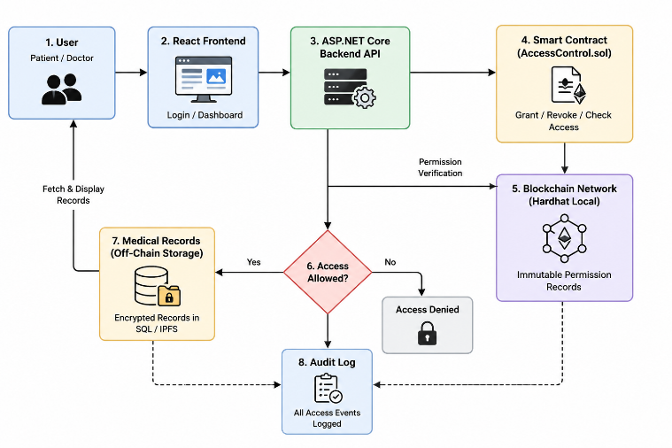
A. Framework Overview
The framework identified several limitations in the three-layered architecture by segregating responsibilities in data storage, access control policy, and human-computer interaction. These limitations can be addressed by ensuring four key principles: (i) minimizing data on-chain, (ii) patient control over permissions, (iii) compatibility with existing electronic health record infrastructure, and (iv) emergency access to EHRs.

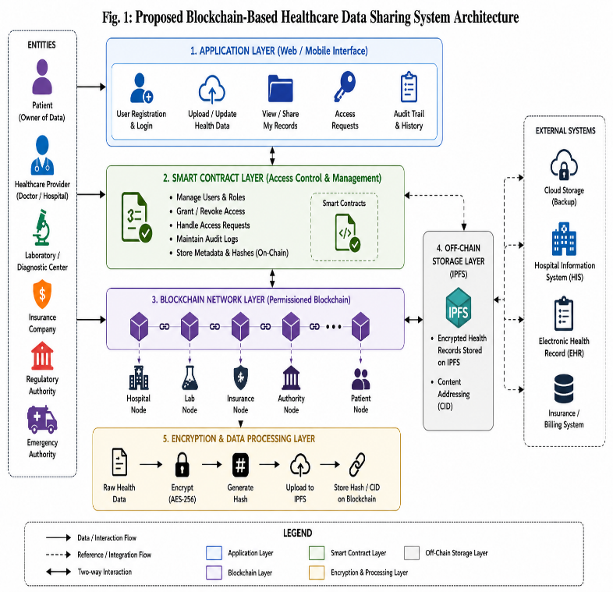

B. Architectural Layers
1) Storage Layer:
The patient’s medical records are off-chained and stored in the form of encryption with AES-256 encryption algorithm. The records of a patient are stored via the use of distributed storage (IPFS – InterPlanetary File System). The unique key used for the encryption process of records is again encrypted and stored on the blockchain platform.
The content hash of the stored information is placed in the blockchain system, thereby allowing for integrity check as any alteration of the stored data would be reflected in the hash value
2) Access Control Layer:
Access control will be carried out using Ethereum-based smart contracts running on a consortium blockchain among the participating healthcare organizations. The smart contract has an ACL for each patient detailing which healthcare providers have valid access to records, the level of access (whether read-only or read-write), the type of records to be accessed, and the validity period of the access.
If a healthcare provider wishes to gain access to the medical records of the individual, then the smart contract will confirm the identity of the person seeking access along with the presence of a legitimate grant of access. The decryption key is returned only after ensuring that both conditions have been fulfilled.

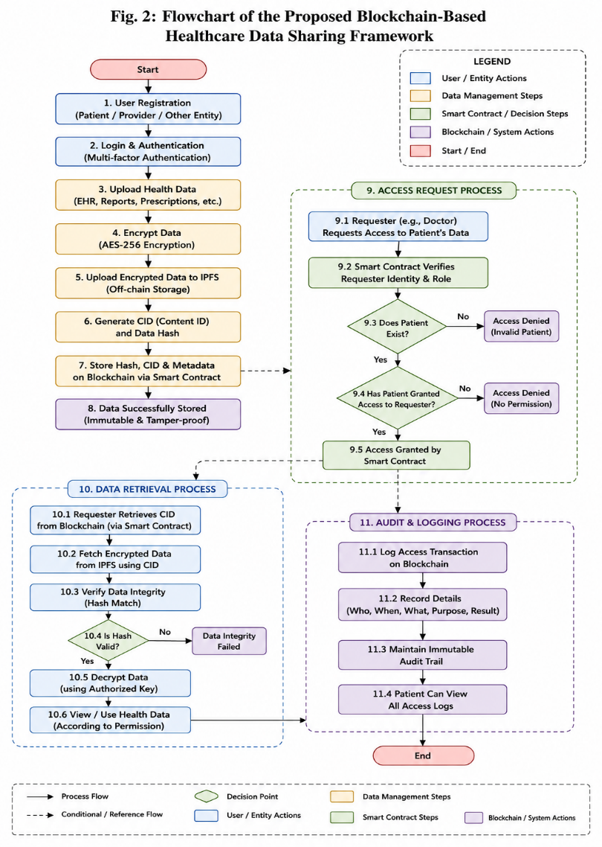

3) Application Layer:
The Web and mobile applications layer has functionalities enabling patients to control and monitor the permissions associated with accessing their medical data. The patients have full visibility of the record of all the access attempts made to their medical data, permission to give limited access to selected professionals, revoke the access permission at any time, and designate emergency contacts with limited keys.
Doctors and other healthcare providers can communicate with the system using APIs integrated into their current EHR systems.

C. Emergency Access Protocol
An access system based on a threshold approach employs Shamir’s Secret Sharing technique for distributing the master key to the patient across several trustworthy entities, such as two family members plus one institutional key escrow system. Upon an emergency situation, any two out of these three key shares can be used together to recreate the master key, thus enabling access without the patient’s permission, while still tracking blockchain ledger.
VI. SMART CONTRACT DESIGN
A. Contract Design
The access control smart contract is coded using the Solidity programming language and executed on a permissioned Ethereum blockchain. The smart contract includes the following core data structures and functionalities:
• PatientRegistry: Maps patient identifiers to their encrypted record hash and access control metadata.
• AccessGrant: A structure made up of provider address, scope, expiry timestamp, and access status.
• grantAccess(address provider, bytes32 scope, uint256 duration): Invoked by patients to grant access to a provider.
• revokeAccess(address provider): Invoked by patients to revoke access from a provider immediately.
• requestAccess(address patient, bytes32 scope): Invoked by providers to request access from a patient, triggering an event for key exchange once verified.
• auditLog: An immutable collection of all access logs, which remain permanently on-chain.
B. Event-Driven Key Delivery
In order to prevent storing decryption keys on the blockchain, which can be compromised by users on the blockchain, the smart contract implements the event-driven approach. In case of successful access permission, the contract fires an event called “AccessGranted”. The off-chain oracle service is subscribed to this event and forwards the decryption key associated with the request to the authorized user via secure channels.
C. Gas Optimization
The cost of gas usage in the Ethereum-based system is one of the practical concerns for accessing control systems, especially when there is a need for a lot of access control operations. There have been optimization measures that include storage packing, mapping rather than array to ensure constant-time lookup and batch operations when there is a need to grant access to patients in large numbers. It costs about 45,000 gas per access grant transaction.
VII. SECURITY ANALYSIS
A. Threat Model
The threat model is based on considering the following threats: external adversaries trying to gain unauthorized access to patient information; insiders in healthcare organizations trying to gain access to information outside their authorization level; and honest participants trying to learn information from metadata observed in the course of using the protocol.
B. Security Properties
The following security assurances are provided by this framework:
• Confidentiality: Patient records are encrypted using the AES-256 algorithm before being sent to patient devices. Unless the patient’s decryption key is present, records stored in distributed storage cannot be differentiated from random information.
• Integrity: Hash values of the contents of the record ensure that there is no unauthorized tampering of the record stored in the storage.
• Authentication: Signatures for each transaction in the blockchain make sure that only authorized users can perform grant or revoke accesses.
• Non-repudiation: An append-only audit log in the blockchain ensures that the history of all accesses can never be repudiated.

• Availability: IPFS-based distributed storage guarantees that there is no single point of failure for stored records. Replication of blockchain guarantees availability of access control layer irrespective of individual nodes failing.
C. Attack Resistance Analysis
• 51% Attacks: For a consortium blockchain where the members or organizations involved are known and trusted, carrying out a 51% attack would entail a greater than 50 percent compromise of the nodes of the participating organizations. This makes 51% attacks highly impractical on any well-governed healthcare consortium blockchain.
• Security of Access Control Contract: The proposed access control contract is created in line with secure coding best practices of smart contracts to avoid typical issues, such as reentrancy attacks, integer overflows, and unguarded self-destructing functionality. Formal verification is recommended for robust implementation.
• Key Compromise: In case a patient’s private key is compromised, an attacker would be able to grant or deny access permissions but not be able to decrypt the information without also compromising the keys used to encrypt information stored in the cloud servers.
VIII. PERFORMANCE EVALUATION
A. Evaluation Methodology
The new system was assessed based on simulations and comparison against three state-of-the-art existing systems, which were MedRec [1], MeDShare [2], and an EHR baseline system. The performance criteria used to assess the new scheme include transaction rate, average delay for access grant, storage cost, and privacy assurance degree.
B. Comparative Results

TABLE I
Comparative Evaluation of Blockchain Healthcare Data Sharing Frameworks
Metric | MedRec [1] | MeDShare [2] | Centralized EHR | Proposed Framework
Throughput (TPS) | 15–20 | 18–25 | 500+ | 80–120
Access Latency | 3–5 sec | 2–4 sec | <1 sec | 1–2 sec
Patient Control | Partial | Limited | None | Full
Auditability | Partial | Full | Limited | Full
Scalability | Low | Medium | High | High
Privacy Level | Medium | Medium | Low | High
Interoperability | Low | Low | Medium | High
Emergency Access | No | No | Yes | Yes

C. Discussion
The throughput achieved by the suggested blockchain framework is much higher compared to other healthcare blockchains due to its reliance on a permissioned consortium blockchain that does not need to use proof of work. Although the throughput is still lower than that of centralized systems, 80-120 TPS should suffice for most healthcare networks, and horizontal scaling using sharding can raise this number even higher.
An access latency of 1-2 seconds, although somewhat higher than that of centralized solutions, is quite sufficient for non-emergency health care processes and considerably better than other blockchain proposals. Patient control, full auditability, strong patient privacy protection, and emergency access make the proposed blockchain solution unique among all other analyzed options.

IX. IMPLEMENTATION CONSIDERATIONS
A. Technology Stack
Technology Stack Required for the Implementation of the Proposed Framework Reference Implementation Technology Stack to Be Used Hyperledger Besu for permissioned Ethereum-like blockchain infrastructure IPFS for off-chain storage Solidity for writing smart contracts OpenZeppelin for secure contract building React.js along with Web3.js for developing the patient’s app interface
B. Deployment Architecture
Deployment of the system in the actual healthcare environment will include the creation of the consortium blockchain where each participating entity will run one or several validator nodes. Policies for running such nodes need to regulate how validators join and leave the chain, how protocol updates happen, and what happens during emergencies in the network.

The system integrates with existing EHR through a middleware component that exposes FHIR R4-based APIs that can be used to translate between the blockchain access control commands and current workflow systems.
C. Regulatory Compliance
Healthcare data management is subject to stringent regulatory requirements including HIPAA in the United States, GDPR in Europe, and the Personal Data Protection Bill in India. The proposed framework’s patient consent mechanism, audit logging, data minimization approach, and right-to-access support align with these regulatory frameworks. Legal analysis specific to the deployment jurisdiction is recommended prior to production deployment.
X. CONCLUSION AND FUTURE WORK
This paper has provided a deep overview of methods for sharing healthcare data using blockchain. It proposes a patient-focused framework that takes main concern on the key limitations found in current solutions. The framework combines off-chain encrypted storage with on-chain smart contract-based access control. This approach strikes a practical balance among security, privacy, scalability, and usability. The overall research indicates that this framework gives patients a better control, protects privacy, and improves auditability compared to existing blockchain and centralized alternatives. It also shows adequate performance for real-world use. The introduction of a threshold-based emergency access protocol addresses a major gap in previous patient-centric designs.
Future work will focus on the following: (1) formally verifying the smart contract implementation with tools like Certora Prover, (2) developing and user testing the patient-facing mobile application with actual patient groups, (3) pilot deployment among a group of regional healthcare providers, (4) integrating with national health id systems for better patient authentication, and (5) exploring layer-2 solutions to further upgrading transaction speed for large-scale national healthcare networks. As healthcare continues to evolve in the digital space, blockchain-based frameworks like this one offer a promising approach for creating secure, transparent, interoperable healthcare data ecosystems that respect patient rights. The blend of blockchain technology, strong cryptography, and patient empowerment principles provides a valuable opportunity to rebuild trust in digital health infrastructure.

ACKNOWLEDGMENT
The authors would like to thank the Department of Computer Science & Engineering at Chitkara University for providing the academic environment and resources that supported this research. The authors also acknowledge the valuable insights provided by the broader research community working on blockchain applications in healthcare.
REFERENCES
[1] A. Azaria, A. Ekblaw, T. Vieira, and A. Lippman, “MedRec: Using blockchain for medical data access and permission management,” in Proc. 2nd Int. Conf. Open Big Data, Vienna, Austria, Aug. 2016, pp. 25–30.
[2] Q. Xia, E. B. Sifah, K. O. Asamoah, J. Gao, X. Du, and M. Guizani, “MeDShare: Trust-less medical data sharing among cloud service providers via blockchain,” IEEE Access, vol. 5, pp. 14757–14767, 2017.
[3] A. Dubovitskaya, Z. Xu, S. Ryu, M. Schumacher, and F. Wang, “Secure and trustable electronic medical records sharing using blockchain,” in Proc. AMIA Annu. Symp., Washington, DC, USA, Nov. 2017, pp. 650–659.
[4] P. Bhattacharya, S. Tanwar, U. Bodke, S. Tyagi, and N. Kumar, “BinDaaS: Blockchain-based deep-learning as-a-service in healthcare 4.0 applications,” IEEE Trans. Network Science Engineering, vol. 8, no. 2, pp. 1242–1255, Apr. 2021.
[5] W. J. Gordon and C. Catalini, “Blockchain technology for healthcare: Facilitating the transition to patient-driven interoperability,” Comput. Struct. Biotechnol. J., vol. 16, pp. 224–230, 2018.
[6] X. Liang, J. Zhao, S. Shetty, J. Liu, and D. Li, “Integrating blockchain for data sharing and collaboration in mobile healthcare applications,” in Proc. IEEE 28th Annu. Int. Symp. Personal, Indoor, Mobile Radio Commun. (PIMRC), Montreal, Canada, Oct. 2017, pp. 1–5.
[7] A. Zhang and X. Lin, “Towards secure and privacy-preserving data sharing in e-health systems via consortium blockchain,” J. Med. Syst., vol. 42, no. 8, pp. 1–18, 2018.
[8] A. Roehrs, C. A. da Costa, and R. da Rosa Righi, “OmniPHR: A distributed architecture model to integrate personal health records,” J. Biomed. Inform., vol. 71, pp. 70–81, 2017.
[9] M. Mettler, “Blockchain technology in healthcare: The revolution starts here,” in Proc. IEEE 18th Int. Conf. E-Health Networking, Applications and Services (Healthcom), Munich, Germany, Sep. 2016, pp. 1–3.
[10] S. Nakamoto, “Bitcoin: A peer-to-peer electronic cash system,” Bitcoin.org, 2008. [Online]. Available: https://bitcoin.org/bitcoin.pdf
[11] V. Buterin, “Ethereum: A next-generation smart contract and decentralized application platform,” Ethereum Foundation, 2014. [Online]. Available: https://ethereum.org/en/whitepaper/
[12] A. Shamir, “How to share a secret,” Commun. ACM, vol. 22, no. 11, pp. 612–613, Nov. 1979.

