


Technological, Social, and Sustainable Systems (24CST0209)
(BE computer Science & Technology)
Report on
Effective Energy for Sustainability: The Catalyst
Semester/Year: 3rd/2nd
Date of Submission : 11-12-2025

Submitted To: Submitted By:
Dr. Pooja Mahajan Shikhardeep Singh Saini (2410998014)
Harmanjeet Singh Dhillon (2410998018)

Abstract

This project examines how future societies may address the growing challenge of clean, accessible, and reliable energy by integrating principles of sustainable engineering and systems thinking. As global pressures on energy resources increase, there is a rising need for decentralized and adaptive systems that can withstand technological, ecological, and social uncertainties. Through a hybrid academic approach, the project combines research on emerging clean-energy frameworks with a fictional narrative titled The Catalyst. The narrative illustrates a conceptual decentralized energy system that adapts to environmental conditions and demonstrates the potential of system-level innovation in addressing future energy crises. This approach helps connect theoretical insights with practical imagination, offering a deeper understanding of how sustainable engineering concepts may guide long-term energy resilience. The project aims to contribute to academic discussions by highlighting the importance of responsible design, ecological awareness, and ethical decision-making in future energy transitions.

Table of context

Section | Page No.
Abstract | i
Introduction | 1
Literature Review | 2
Methodology | 4
Results and Analysis | 4
Discussion | 5
Conclusion | 5
Declaration | 6
Acknowledgment | 6
References | 6
Appendix A: Story Website Link | 7

Table of figures

Figure No. | Title | Page No.
Figure 1 | Fossil-fuel carbon emissions and carbon-free primary power requirements under stabilization scenarios (Schneider, 2001) https://www.nature.com/articles/35053203/figures/2 | 3

Introduction

The global energy landscape is rapidly shifting as societies confront increasing demand, resource limitations, and environmental degradation. Current centralized power systems, although effective in the past, have become more vulnerable to climate pressures, infrastructural failures, and inequitable access. Research shows that distributed and decentralized energy networks are emerging as key alternatives that can enhance reliability and community participation (Gui and MacGill, 2018, https://www.sciencedirect.com/science/article/abs/pii/S221462961730347X). At the same time, sustainability scholars argue that engineering systems must be understood in relation to planetary processes, long-term risks, and ethical responsibilities, a perspective emphasized within Earth Systems Engineering and Management (Schneider, 2001, https://www.nature.com/articles/35053203). These shifts reflect a broader global need for solutions that integrate technology with ecological balance rather than treating them as separate concerns.

Against this backdrop, the present study explores how future energy systems might embody cleaner, more resilient, and more adaptive characteristics. The aim is to understand how sustainable engineering principles, emerging clean-energy technologies, and systems thinking can contribute to better decision-making. The study also uses a narrative case study to illustrate these ideas in a human-centered and accessible format. Objectives of the project include examining clean energy research, identifying key sustainability frameworks, and interpreting a fictional future scenario as an applied example of sustainable engineering principles.

In addition to the research component, the project incorporates an original narrative titled The Catalyst, which serves as a conceptual case study demonstrating the practical meaning of sustainable engineering ideas. The story follows a future society where overdependence on centralized energy systems results in widespread collapse, leading an engineer to design an adaptive, decentralized energy lattice modeled on natural ecological feedback. This fictional scenario is used not as entertainment, but as an illustrative tool that helps translate theoretical principles—such as systems thinking, ethical decision-making, and Earth Systems Engineering—into a relatable, human-centered context.

To support the narrative component, the full story The Catalyst has been published on a dedicated project website. This digital version provides readers with the complete narrative, additional concept explanations, and an accessible presentation of the themes explored in this report. The story is available at: https://thecatalysttsass.vercel.app/

Objectives
• To review research on decentralized and clean-energy systems
• To examine sustainability frameworks relevant to future energy design
• To integrate these insights with a narrative case study
• To interpret the narrative as an applied example of sustainable engineering

Literature Review

Existing studies highlight the transformation of energy systems from centralized infrastructures toward more distributed and community-oriented models. Research indicates that decentralized systems—including microgrids, virtual power plants, and community energy networks—offer potential improvements in resilience, flexibility, and local empowerment (Gui and MacGill, 2018). Sustainability theory further emphasizes that long-term energy decisions must incorporate environmental thresholds, ethical considerations, and system-level interactions. Earth Systems Engineering and Management proposes that technological choices must be evaluated in relation to their ecological and societal consequences (Schneider, 2001).

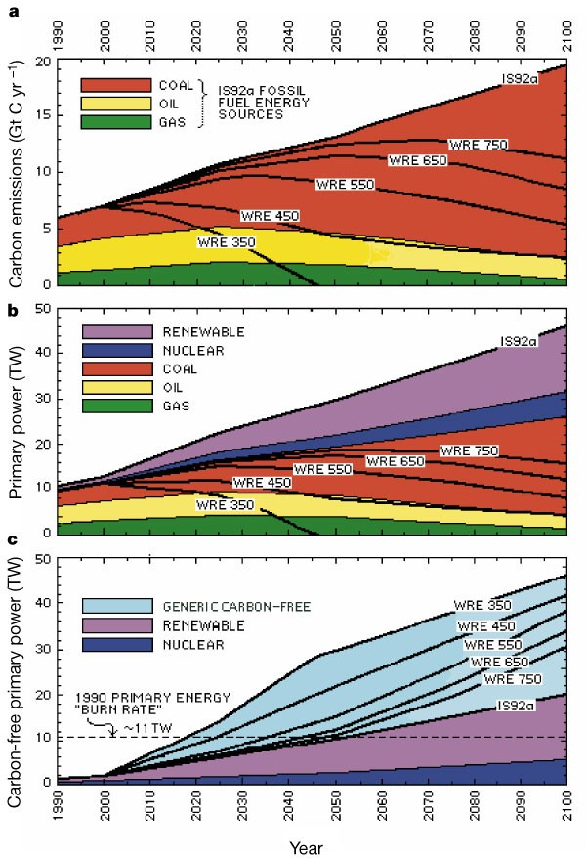

Figure 1. Fossil-fuel carbon emissions and carbon-free primary power requirements under multiple stabilization scenarios. Source: Schneider (2001). Available at: https://www.nature.com/articles/35053203/figures/2

Sustainable engineering education also plays a critical role, as future engineers must be equipped to handle constraints on energy, materials, and waste systems (Davidson et al., 2010, https://www.sciencedirect.com/science/article/abs/pii/S0959652609004156). Reviews of clean-energy options show varying performance across solar, geothermal, hydrogen, nuclear, and biomass systems, demonstrating the need for integrated multi-output systems to enhance overall efficiency (Dincer and Acar, 2015, https://onlinelibrary.wiley.com/doi/abs/10.1002/er.3329). In addition, energy engineering principles identify methods for optimization, auditing, and management systems that support efficient long-term energy performance (Thumann and Mehta, 2020, https://www.taylorfrancis.com/books/mono/10.1201/9781003151715).

Methodology

The project follows a hybrid methodology combining a conceptual literature review with a narrative case study approach. Academic sources are analyzed to identify themes related to clean energy, decentralized systems, and sustainable engineering frameworks. The narrative The Catalyst serves as an illustrative example, demonstrating how these concepts may operate within a future scenario. The process included reviewing peer-reviewed articles, identifying sustainability frameworks, constructing the narrative, and interpreting its outcomes in relation to research findings. The narrative used in this project was also published online to enhance accessibility and to present the story in a clear digital format. The website serves as a supplementary resource supporting the narrative component of the study.

Results and Analysis

The narrative case study presents a future society facing severe ecological and infrastructural challenges due to overdependence on centralized energy grids. The protagonist develops an adaptive decentralized energy lattice inspired by natural systems and systems thinking principles. When global grids fail, this system restores energy through autonomous, environmentally responsive processes. The narrative demonstrates concepts such as resilience, system adaptation, and ecological integration. The outcome shows that decentralized systems may provide greater stability and sustainability than traditional centralized structures. A conceptual figure could illustrate the energy lattice, although it is optional. Schneider’s emission stabilization figure is also relevant, as it highlights the scale of change required for future energy systems.
The digital version of the narrative further helps visualize the conceptual energy lattice and contextual themes explored in this study. Readers can access the complete narrative online for a deeper understanding of the scenario presented.

Discussion

The findings indicate that the ideas illustrated in the narrative align strongly with existing research on decentralized clean-energy futures. The narrative demonstrates how sustainable engineering principles can be applied to complex societal challenges by integrating ecological thinking with technical innovation. It also reinforces the importance of ethical awareness and systems thinking in future engineering practice. One challenge encountered was that the narrative method is conceptual and interpretive rather than empirical, which may limit quantitative analysis.
The narrative contributes additional insight by presenting these principles within a lived, personal context. Joseph Joestar’s creation of the adaptive lattice demonstrates how engineering innovation can shift from control-oriented designs to ecologically integrated solutions. His journey symbolizes the transformation required in real-world engineering practice, where resilience, decentralization, and long-term thinking replace short-term efficiency. The story helps highlight the practical significance of sustainable engineering frameworks by showing how they might operate within future societal and environmental pressures.

Conclusion

This study explored future clean-energy challenges by combining academic literature with a narrative case study. The work highlights the importance of decentralized systems, sustainability frameworks, and ethical engineering practices in shaping future energy solutions. The narrative, when analyzed in context, provides a conceptual demonstration of how resilient and adaptive systems may support long-term sustainability. Future research could include technical modeling, scenario simulations, or prototype system designs inspired by the narrative. The Catalyst narrative ultimately reinforces the study’s conclusions by illustrating how sustainable energy concepts may guide future solutions through innovation that is both technically adaptive and ecologically responsible.

Declaration

I declare that this report is my original work and has been completed using properly acknowledged sources. It has not been submitted elsewhere.

Acknowledgment

I thank my instructor and institution for their guidance and support throughout this project.

References (APA)

Gui, E. M., & MacGill, I. (2018). Typology of future clean energy communities: An exploratory structure, opportunities, and challenges. Energy Research & Social Science. https://www.sciencedirect.com/science/article/abs/pii/S221462961730347X

Schneider, S. H. (2001). Earth systems engineering and management. Nature. https://www.nature.com/articles/35053203

Davidson, C. I., Hendrickson, C. T., Matthews, H. S., et al. (2010). Preparing future engineers for challenges of the 21st century: Sustainable engineering. Journal of Cleaner Production. https://www.sciencedirect.com/science/article/abs/pii/S0959652609004156

Dincer, I., & Acar, C. (2015). A review on clean energy solutions for better sustainability. International Journal of Energy Research. https://onlinelibrary.wiley.com/doi/abs/10.1002/er.3329

Thumann, A., & Mehta, D. P. (2020). Handbook of energy engineering. Taylor & Francis. https://www.taylorfrancis.com/books/mono/10.1201/9781003151715

Appendix A: Story Website Link

The complete narrative The Catalyst is published online as part of the project’s digital component.
Dhillon, H. S., & Saini, S. S. (2025). The Catalyst: A narrative case study on sustainable energy
https://thecatalysttsass.vercel.app/

