Game Design Document
Fill up the Following document

- Write the title of your project.
The Space Complication

- What is the goal of the game?
Goal For Crewmate – Complete All The tasks

- Write a brief story of your game?
Some people who were going to a mystery planet but in between they met with an accident because of 1 or 2 or maybe 3 persons who are the impostors and they have sabotaged (Synonym for doing something Deliberately) the spaceship's parts and now the Crewmates have to fix the destroyed parts and also there can be a voting out of the impostor.

- Which are the playing characters of this game?
- Playing characters are the ones which respond to the user based on the input from the user
- Cars, monkeys, dinos, wizards etc, are the playing characters in the game.
Number | Character Name | What can this character do?
1 | The Crewmates | Move Around The Spaceship and do their tasks
2 | Task – Navigate - Spaceship | Move around rocks
3 | Task – Shield – Gun | Can shoot bullets at the aliens.
4 | The impostor | Can kill the Crewmate and destruct things inside the spaceship.

- Which are the Non Playing Characters of this game?
- Non Playing characters are the ones which don't have an action or a behaviour when the user interacts with the game.
- Hurdles, stones, bananas, coins, etc are non playing characters in the game.
Number | Character Name | What can this character do?
1 | The Spaceship | It is the main Setting of the game.
2 | Task – Navigate - Rocks | They are hurdles for the spaceship
3 | Task – Shield – Aliens | They are Hurdles for the People on spaceship

Draw your imagination of this game. What does this game look like?
- Draw the game either on your computer or on paper,
- Add images of scenes of the game to show each of the playing and non-playing characters at least once.
- 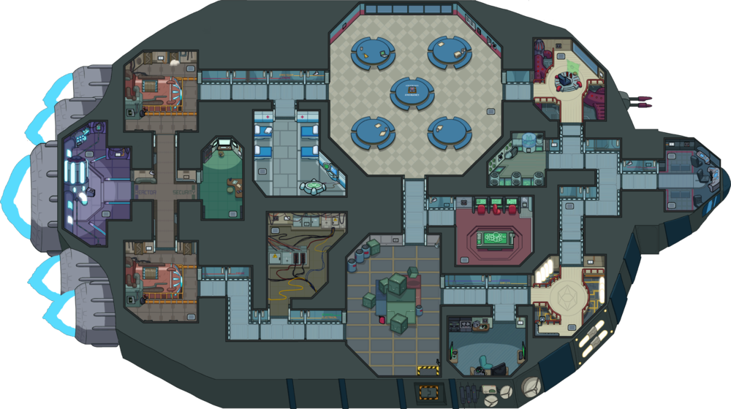

How do you plan to make your game engaging?
If I Make This game further, I am planning to:
  - To make It more efficient
  - Add some more maps and tasks
  - Remake some of the Things like the spaceship etc.
  - Make it a bit difficult by adding the impostor who can kill the crewmates and destruct things inside the spaceship.

