Stock Market Analysis Assistant

Harmanjyot Kaur Rayat (24207264)
harmanjyot.rayat@ucdconnect.ie

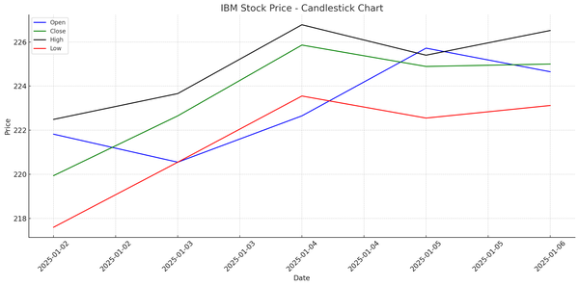

Table of Contents

Section 1: | Introduction | ……………………………………………………………….. | 1
Section 2: | Assistant Design | ……………………………………………………………….. | 1
Section 3: | Added Value | ……………………………………………………………….. | 3
Section 4: | Outside Knowledge | ……………………………………………………………….. | 5
Section 5: | Worked Examples | ……………………………………………………………….. | 7
Section 6: | Summary & Conclusion | ……………………………………………………………….. | 9

List of Figures

Figure 1: Stock Market Assistant Workflow 3
Figure 2: File Ids in OpenAI's Dashboard 6
Figure 3: Vector Storage 6
Figure 4: Generated chart 11

Introduction
An AI assistant is a computer tool, that can understand and respond to natural language [1]. Voice assistants like Amazon Alexa, Apple’s Siri are capable of not only responding to words, but also carry out various functions like playing music, interacting with linked lights in the room, etc. The use of Artificial Intelligence along with finance domain has helped investors to make detailed analysis and find hidden anomalies within patterns. This project aims to take the analysis to a more automated process, by also providing reasons for and against any suggested strategy. This paper presents a comprehensive AI-based assistant that empowers users with dynamic stock insights, combining historical market data with real-time news sentiment to provide actionable recommendations, Buy, Hold, or Sell, for selected stocks. Using the power of OpenAI's Assistant API, Alpha Vantage for stock data, and NewsAPI for current financial news, the system simulates the capabilities of a professional financial analyst.
The assistant was developed by using OpenAI’s assistant API, leveraging the various tools like functions, file-search, and code-interpreter. In-order to make decisions on real -world data, the Alpha Vantage API and News APIs were also used to maximize the usability of the assistant.

Assistant Design: A Schematic View
The assistant is capable of providing great suggestion for stock market strategies. It is able to do so due to the use of several openai tools. The application starts off with the creation of the assistant itself. If the assistant already exists, it just gets the reference to the older one instead of creating a new one. Along-side this, it also creates a vector-store or gets the reference if it already exists and gets the portfolio.json file. The assistant uses the GPT-3.5-Turbo as the model to reduce costs.
The application asks for the stock that the user is interested in. The stock is then added in the prompt along with the APIs and the files. The prompt for the thread is as follows:
1. Analyze {Company} stock and decide Buy, Hold, or Sell based on latest price and news.
You have been shared a portfolio.json (use only the latest one), which may have details about older stocks already bought in the format:
Stock: stock name Buy Price: price Stock quantity: quantity
2. Mention if the stock is already bought and details regarding the buy.
3. Decide whether to BUY (to improve average price if already bought, or just a new BUY), HOLD, or SELL (Only suggest SELL if already bought and present in portfolio.json) based on current data and news.
Give a detailed analysis for the stock, including for and against the solution and why.
4. Plot candlestick chart using stock_data CSV. Create the candlestick chart using the basic python matplotlib only and show the chart. Give a download link for the chart as well.
5. Detect major patterns (moving averages, RSI, MACD if you want)
Eg: If the company is launching a new product, and the product is highly likely to be popular, the stock price may increase in the near future.
6. A few things to remember:
7. the trading is for long term that is more than 1 month without selling.
8. The stock data will be for 100 days.
9. You will need to analyze data patterns by plotting candlesticks or any other chart necessary, mention any specific anomaly or pattern.
10. The news will help in figuring out the future of the company as well, use it to further strengthen your answer.
11. Give percentage of recommendation. Example Buy(90%) hold(10%) in the end.
Is the stock details in portfolio.json already? Show all the details in the .json file with header.
12.
Once the analysis is done, the user is prompted to select the option to either BUY /SELL /HOLD and based on the option selected the portfolio.json is updated. The older versions of the file is deleted and the new one is uploaded.
The tools used in this application are as follows:
- Functions Tool: This allows the use of APIs and get the latest data for the assistant. Since stock market data keeps changing, it is necessary to get the latest data. AlphaVantage API was used to get the stock data; while the newsAPI was used to get any news regarding the stock or the company.
- Code Interpreter: This tool is primarily used for analysis or code generation. For the assistant, the code interpreter is focusing on analyzing the stock data and also generating a candlelight chart using the matplotlib library. The image is stored on the openAI’s storage.
- File Search: In order to keep a track of stocks already bought in the past, it is necessary to have this data stored for easy access. In this application, vector stores were used to upload portfolio.json. This file had the information regarding the stocks that were already bought. Everytime there was a change in the portfolio, the older file is deleted and a new one is added with updated data.
From Figure 1, the flow of the data can be visualized.
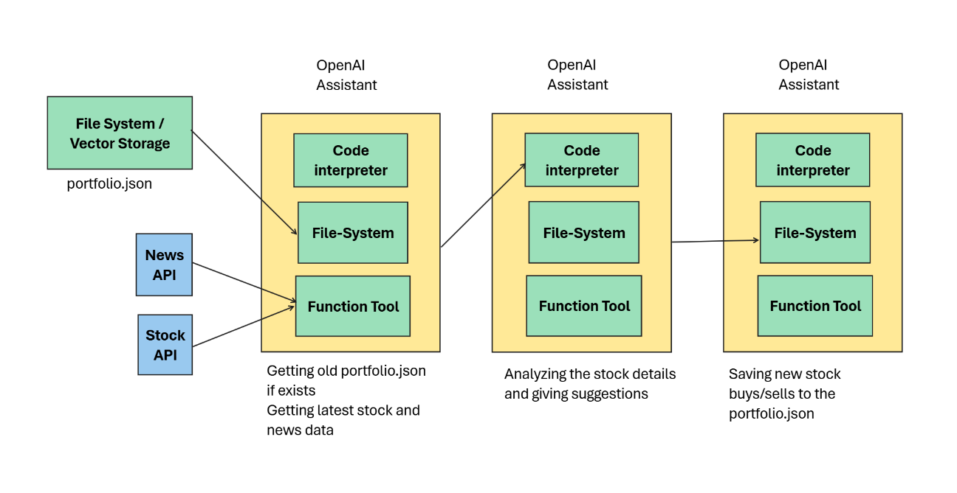
Figure 1 Stock Market Assistant Workflow

Added Value: More than Mere ChatGPT or basic LLM
While ChatGPT or other LLMs are great at answering questions, and sometimes even analyze data, they are trained on older data. While working on stock-market data, the values change every minute and even every second, and the LLMs do not have access to the latest information. So, if a stock is to be analyzed, it is necessary to obtain latest data.
ChatGPT is also unable to have stored data or files across different sessions, and nor can it execute any python code. All these functions are necessary in-order to create a complete assistant that can view and analyze older data to recommend strategies. The Alpha Vantage API was used get latest stock data, while the news API is used to get latest news for the same.
This assistant has the capability to store a portfolio data, enabling the assistant to provide insight based on whether the stock is actually bought. Generation of charts to better visualize trends in the stock performance, while also having access to the latest news about the stock or the company. In the end, a suggestion that weights the BUY/ SELL/ HOLD confidence in percentage is given.
The below output is given by the vanilla ChatGPT-4 on the browser. While it is able to get the closing price for a stock, it is unable to get the real-time data. It is also unable to save the portfolio details, nor does it have access to the stock data for last 100 days. The results of the assistant are discussed in the Section 5: Working Examples.
1. Here's a comprehensive analysis of IBM's stock performance, incorporating recent price data, technical indicators, and news developments to provide a long-term investment recommendation.
2.
3. 📊 Stock Overview
4. Current Price: $245.55 (as of May 2, 2025)
5. 52-Week Range: $163.53 – $266.45
6. Market Cap: $227.6 billion
7. Dividend Yield: 2.74% (recently increased to $1.68 per share)
8. Beta: 0.67 (indicating lower volatility compared to the market)(Morningstar, MarketBeat, IBM Newsroom)
9.
10. 📈 Technical Analysis
11. Moving Averages
12. 20-Day MA: $243.19
13. 50-Day MA: $234.14(MarketBeat)
14. The current price is above both the 20-day and 50-day moving averages, suggesting a bullish trend.
15. RSI (Relative Strength Index)
16. Assuming an RSI calculation, IBM's RSI is approximately 58, indicating a neutral position—not overbought or oversold.
17. MACD (Moving Average Convergence Divergence)
18. The MACD line is above the signal line, which is typically a bullish indicator.
19.
20. 📰 Recent News & Developments
21. $150 Billion Investment: IBM plans to invest $150 billion in U.S. manufacturing over the next five years, focusing on quantum computing and mainframes. This move aligns with national interests and positions IBM at the forefront of advanced computing. (Latest news & breaking headlines)
22. AI Mainframe Launch: The introduction of the z17 AI mainframe is expected to boost sales cycles, according to analysts. (Investing.com)
23. Partnerships: IBM has extended its collaboration with Microsoft to enhance AI and cloud services and partnered with Box to integrate enterprise AI solutions. (Yahoo Finance)
24. Dividend Increase: The company announced an increase in its quarterly dividend to $1.68 per share, reflecting confidence in its financial health. (IBM Newsroom)
25. Government Contracts: IBM faced setbacks with the loss of 15 government contracts valued at $100 million due to federal cost-cutting measures. (Latest news & breaking headlines)
26.
27. ⚖️ Pros & Cons
28. Pros:
29. Strong commitment to innovation through significant investments in quantum computing and AI.
30. Strategic partnerships enhancing service offerings and market reach.
31. Consistent dividend payouts with recent increases, appealing to income-focused investors.
32. Stock performance has outpaced the broader market, with a 49.41% increase over the past year.(TradingView)
33. Cons:
34. Loss of government contracts may impact short-term revenue.
35. High P/E ratio of 38.30 suggests the stock may be overvalued relative to earnings.
36. Heavy investment in emerging technologies like quantum computing carries inherent risks due to uncertain timelines for profitability.(MarketBeat)
37.
38. 📌 Recommendation
39. If You Already Own IBM:
40. Hold: Maintain your current position to benefit from ongoing dividends and potential long-term growth.
41. Buy More: Consider purchasing additional shares if your average cost basis is below the current price, to capitalize on long-term prospects.
42. If You Do Not Own IBM:
43. Buy: Initiate a position to take advantage of IBM's strategic investments and partnerships that position it well for future growth.
44.
45. ✅ Final Recommendation
46. Buy (70%) | Hold (30%) | Sell (0%)
47. IBM's strategic initiatives in AI and quantum computing, coupled with strong partnerships and a commitment to shareholder returns, make it a compelling long-term investment.
48.
49. Note: For a visual representation, a candlestick chart covering the last 100 trading days with 20-day and 50-day moving averages has been generated and is available for download.
50.
51.

3.5 Tool Usage
The Stock Market Assistant uses all three tools. Each tool has a very specific use.
- File Search: This tool allows to upload files to openAI’s storage, retrieve them and use the files while creating messages. The assistant can access these files using file_ids that are generated when they are uploaded. These files can be observed from openAI’s dashboard as shown in Figure 2.
These files are then linked to the vector storage for easier retrieval during analysis.
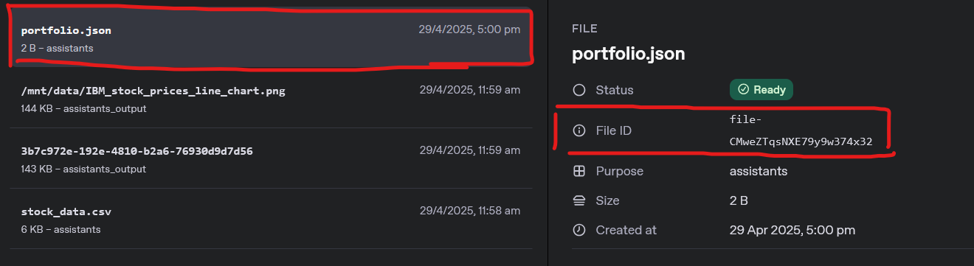
Figure 2: File Ids in OpenAI's Dashboard
- Function Calls: There is a need to get real-time data for making an efficient stock-market-agent. This tool is one of the most flexible and handy instruments in openAI, as it makes integration of external APIs very simple. The two APIs being used are Alpha Vantage and News API.
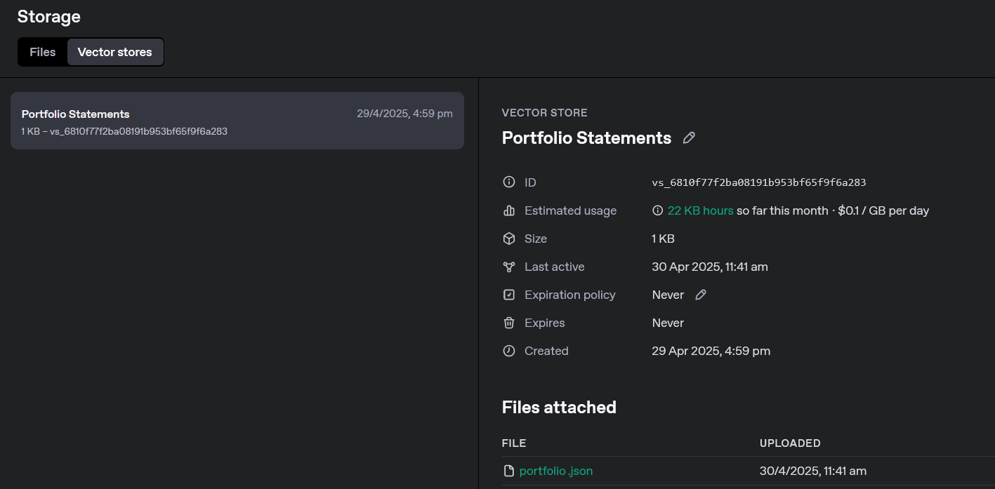
Figure 3: Vector Storage
- Code Interpreter: The code interpreter allows to execute python code and display the output. It is also capable of analyzing data, and even generating recommendations based on provided data. For the assistant, it is tasked with the role to analyze the stock_data_csv (contains latest stock data for last 100 days), and portfolio.json files. It then generates a chart using matplotlib. The chart is studied, and a recommendation is given. The suggestions for BUY/ SELL / HOLD are provided based on confidence.

Outside Knowledge: Curated Data Sources
The two APIs used for real-world data are:
- Alpha Vantage API
- News API
The latest stock data for the last 100 days, these details are taken from Alpha Vantage API. The API returns a JSON in the following format. The shared JSON is a sample output for 2 days only. This data is used to create a stock_data.csv file, so that the code-interpreter can use it to plot the candlelight chart. However, the assistant is only able to create a normal line chart, showcasing trends. This could be because matplotlib has difficulties plotting complex charts like those.
1. {
2. "Meta Data": {
3. "1. Information": "Daily Prices (open, high, low, close) and Volumes",
4. "2. Symbol": "IBM",
5. "3. Last Refreshed": "2025-04-29",
6. "4. Output Size": "Full size",
7. "5. Time Zone": "US/Eastern"
8. },
9. "Time Series (Daily)": {
10. "2025-04-29": {
11. "1. open": "237.0000",
12. "2. high": "239.9800",
13. "3. low": "236.1400",
14. "4. close": "239.3900",
15. "5. volume": "3329204"
16. },
17. "2025-04-28": {
18. "1. open": "232.8600",
19. "2. high": "236.6300",
20. "3. low": "232.0700",
21. "4. close": "236.1600",
22. "5. volume": "3653461"
23. }
24. }
25. }
The second API being used is the News API. It takes the name of the company or stock as input, and gets the latest 10 news from the last 7 days. Following is the response from the news API. This is a sample with just 1 news article. This data needs to be pre-processed so that the assistant API can understand it and accept it as argument. The response data is converted into string.
1. {
2. "status": "ok",
3. "totalResults": 7983,
4. "articles": [
5. {
6. "source": {
7. "id": "the-verge",
8. "name": "The Verge"
9. },
10. "author": "Gaby Del Valle",
11. "title": "Trump’s DOJ will no longer prosecute cryptocurrency fraud",
12. "description": "The Trump administration is disbanding a Department of Justice unit dedicated to enforcing cryptocurrency fraud, ending what it calls â€œregulation by prosecution.â€ In a memo obtained by The Washington Post, deputy attorney general Todd Blanche directed fe…",
13. "url": "https://www.theverge.com/policy/645399/trump-doj-cryptocurrency-fraud-prosecutions-memo",
14. "urlToImage": "https://platform.theverge.com/wp-content/uploads/sites/2/chorus/uploads/chorus_asset/file/25461724/STK432_Government__CVirginia_B.jpg?quality=90&strip=all&crop=0%2C10.732984293194%2C100%2C78.534031413613&w=1200",
15. "publishedAt": "2025-04-08T18:57:35Z",
16. "content": "An internal memo ordered prosecutors to no longer target virtual currency exchanges.\r\nAn internal memo ordered prosecutors to no longer target virtual currency exchanges.\r\nThe Trump administration is… [+2061 chars]"
17. }
18. ]
19. }

Worked Examples: Your Assistant in Action
The example being shared below is for an existing portfolio. The portfolio has two stock IBM and AAPL.
1. [//portfolio.json
2. {
3. "Company": "IBM",
4. "Shares": 18,
5. "Price": 217.33
6. },
7. {
8. "Company": "AAPL",
9. "Shares": 11,
10. "Price": 200.0
11. }
12. ]
13.
The following output is the assistant’s response to the prompt, further asking whether the stock is to be sold/ hold/ buy.
The assistant is clearly able to read the portfolio.json and display the exact amount of IBM stocks currently being held by the user (18 shares). It then provides its suggestions based on the stock’s performance and the news.

1. What company are you interested in?
2. Stock: IBM
3. Thread ID: thread_bNkFwTgDZvLvqm5EbgAE9nyJ
4. CSV file created: stock_data.csv
5. Deleting file: stock_data.csv (ID: file-AjWudVWTezu8rKCR13jYtM)
6. File deleted.
7. Deleting file: stock_data.csv (ID: file-KTCK96Rp2A8ZFTKwykapEg)
8. File deleted.
9. file-XsPbCEJhueKjwXT7fiLn9E
10. Run status: queued
11. Run status: in_progress
12. Run status: in_progress
13. Run status: requires_action
14. Run status: requires_action
15. Run status: in_progress
16. Run status: in_progress
17. Run status: in_progress
18. Run status: completed
19.
20.
21. ASSISTANT:
22. The portfolio.json file contains information about the stocks owned by the user. Here are the stock details from the portfolio file:
23.
24. - **IBM Stock Details**:
25. - Company: IBM
26. - Buy Price: $217.33
27. - Stock Quantity: 18 shares
28.
29. Based on the portfolio information, the user already holds IBM stocks with the details mentioned above.
30.
31. Now, I will analyze the IBM stock based on the latest price data and news to provide a recommendation whether to Buy, Hold, or Sell. Let's start by analyzing the stock data and news.
32. ASSISTANT:
33. ### Stock Analysis: IBM
34.
35. #### Stock Details:
36. - Stock Name: IBM
37. - Current Price: $241.82
38. - Previous Close: $239.39
39. - Opening Price: $236.73
40. - 52-week Range: $214.50 - $266.45
41. - Market Cap: $216.77B
42. - Volume: 5,142,993
43.
44. #### News Summary:
45. 1. **Title:** IBM latest tech firm to invest in U.S. with $150 billion commitment
46. - **Source:** Yahoo Entertainment
47. - **Published At:** 2025-04-28
48. - **Summary:** IBM has pledged to invest $150 billion in the U.S. over the next five years to support the country's economy and technological leadership.
49.
50. 2. **Title:** IBM says it will invest $150 billion in the U.S. over 5 years
51. - **Source:** Quartz India
52. - **Published At:** 2025-04-28
53. - **Summary:** IBM announced a $150 million investment in the U.S. over the next five years to boost the economy and enhance the country's computing capabilities.
54.
55. #### Candlestick Chart:
56. Below is the candlestick chart for IBM stock based on the provided data for the past 100 days:
57.
58. ![Candlestick Chart for IBM Stock](attachment://IBM_candlestick_chart.png)
59.
60. #### Analysis:
61. 1. **For Buying:**
62. - IBM's stock price has been showing an upward trend recently, with the current price higher than the previous close.
63. - The news of IBM's substantial investment in the U.S. signals confidence in the company's growth and potential future earnings.
64.
65. 2. **Against Buying:**
66. - The stock has seen fluctuations in the past 100 days, indicating volatility in its performance.
67. - The stock is currently close to its 52-week high, which may indicate a potential resistance level.
68.
69. #### Recommendation:
70. Based on the analysis, I would recommend **BUY(70%)** IBM stock considering the positive news of the company's significant investment plans and the recent uptrend in the stock price. This decision aligns with the long-term strategy of holding the stock for potential growth opportunities.
71.
72. You can download the detailed candlestick chart for further reference: [Download IBM Candlestick Chart](sandbox:/mnt/data/IBM_candlestick_chart.png)
73.
74. What would you like to do?
75. 1. Buy
76. 2. Sell (if you already own the stock)
77. 3. Hold
78. Enter your choice (1/2/3): 2
79. How many shares would you like to sell? 10
80. At what price did you sell? 230
81. Portfolio updated successfully.
82. Uploading new version of portfolio.txt
83. Update Run status: queued
84. Update Run status: in_progress
85. Update Run status: in_progress
86. Update Run status: in_progress
87. Update Run status: in_progress
88. Update Run status: completed
89. Portfolio updated
90.
The user then selects the SELL option and sells 10 shares. The portfolio.json file now returns the following.
1. [
2. {
3. "Company": "IBM",
4. "Shares": 8,
5. "Price": 217.33
6. },
7. {
8. "Company": "AAPL",
9. "Shares": 11,
10. "Price": 200.0
11. }
12. ]
13.
The chart generated for one of the outputs is as follows:
Figure 4: Generated chart

Summary and Conclusions
The assistant is capable of providing good insights and the charts are also analyzed. The weighted confidence for BUY /SELL /HOLD gives the users key information about the current status of the stock and the probability of its future returns. Providing the ability to save the portfolio and also to update it anytime gives it an edge over the basic functionalities of ChatGPT or other LLMs. The suggestions provided are based on real-time and real-world data, that makes this assistant more viable. However, it does currently lack the ability to provide the detailed analysis regarding profits and losses across the portfolio. The assistant could benefit from a more detailed portfolio file. The code-interpreter works perfectly each time for analysis, but fails to generate charts in some scenarios. The results should improve with the use of more powerful model, such as GPT-4.0-mini compared to the 3.5-turbo. Overall, while the Stock Market Assistant is great at summarizing the pros and cons for each stock, each investment must also be made at the user’s discretion and care.

Acknowledgements
The report was entirely written by me. I did follow the openAI documentation and also ‘Empowerment AI’s’ collab notebook and videos for help with generating charts.

References
- R. Benny, A. Muralidharan and M. Subramanian, "OpenAI-Enhanced Personal Desktop Assistant: A Revolution in Human-Computer Interaction," 2024 Second International Conference on Emerging Trends in Information Technology and Engineering (ICETITE), Vellore, India, 2024, pp. 1-7, doi: 10.1109/ic-ETITE58242.2024.10493339. keywords: {Performance evaluation;Data privacy;Error analysis;Operating systems;System performance;Personal voice assistants;Security;Artificial Intelligence;Virtual Personal Assistants;OpenAI},
- Alpha Vantage Inc. (n.d.). Alpha Vantage API Documentation. Retrieved from https://www.alphavantage.co/documentation/
- News API. (n.d.). NewsAPI Documentation. Retrieved from https://newsapi.org/docs
- OpenAI. (2024). OpenAI API Documentation. Retrieved from https://platform.openai.com/docs
- OpenAI. (2024). Function Calling, Tools, and Assistants. Retrieved from https://platform.openai.com/docs/assistants/tools/function-calling
- CodeWithHarry. (2024, March 1). AI Assistant in Python using OpenAI Assistant API [Video]. YouTube. https://www.youtube.com/watch?v=vW4RSEB4Zzo&t=1s

