#### **INTRODUCTION TO DEVOPS II (**Networking)

1. Describe Hub, Switch and Router

* A hub is a common connection point for devices in a network. It contains multiple ports so when a packet arrives at one port, it is copied to the other ports and all segments of the LAN can see all packets.
* A switch is more advanced than the hub in that it filters and forwards packets between ports.
* A router forwards [data packets](https://www.webopedia.com/definitions/packet/) across networks. It is connected to at least two networks. It uses headers and forwarding tables to determine the best path for forwarding the packets, and they use protocols to communicate with each other and configure the best route between any two hosts.

1. What is the OSI model?

The OSI model characterises and standardises the communication functions of a computing system without regard to its underlying internal structure and technology. Simply put, it describes seven layers that computer systems use to communicate over a network. It was the first standard model for network communications, adopted by all major computer and telecommunication companies in the early 1980s. The modern Internet is not based on OSI, but on the simpler TCP/IP model. However, the OSI 7-layer model is still widely used, as it helps visualize and communicate how networks operate and helps isolate and troubleshoot networking problems.

1. Explain the different layers of the OSI model[Top down].

* Application Layer: It is used by end-user software such as web browsers and email clients. Here, applications can access network services. Few examples of application layer protocols are the HTTP, FTP, DNS, etc.
* Presentation Layer: It prepares data for the application layer. It defines how two devices should encode, encrypt, and compress data so it is received correctly on the other end. The presentation layer takes any data transmitted by the application layer and prepares it for transmission over the session layer.
* Session layer: It creates communication channels, called sessions, between devices. It is responsible for opening sessions, ensuring they remain open and functional while data is being transferred, and closing them when communication ends.
* Transport layer: It data transferred in the session layer and breaks it into “segments” on the transmitting end. It is responsible for reassembling the segments on the receiving end, turning it back into data that can be used by the session layer. The transport layer carries outflow control, sending data at a rate that matches the connection speed of the receiving device, and error control, checking if data was received incorrectly and if not, request it again
* Network layer: It has two main functions. One is breaking up segments into network packets, and reassembling the packets on the receiving end. The other is routing packets by discovering the best path across a physical network. The network layer uses network addresses (typically Internet Protocol addresses) to route packets to a destination node.
* DataLink Layer: It establishes and terminates a connection between two physically-connected nodes on a network. It breaks up packets into frames and sends them from source to destination. This layer is composed of two parts—Logical Link Control (LLC), which identifies network protocols, performs error checking and synchronizes frames and Media Access Control (MAC) which uses MAC addresses to connect devices and define permissions to transmit and receive data.
* Physical Layer: It is responsible for the physical cable or wireless connection between network nodes. It defines the connector, the electrical cable or wireless technology connecting the devices, and is responsible for the transmission of the raw data, which is simply a series of 0s and 1s while taking care of bit rate control.

1. What do you mean by the TCP/IP Model?

It stands for Transmission Control Protocol/Internet Protocol. It is a concise version of the OSI model and contains four layers, unlike the OSI model. The diagram below highlights the differences between TCP/IP and OSI model The layers are:

* Process/Application Layer
* Host-to-Host/Transport Layer
* Internet Layer
* Network Access/Link Layer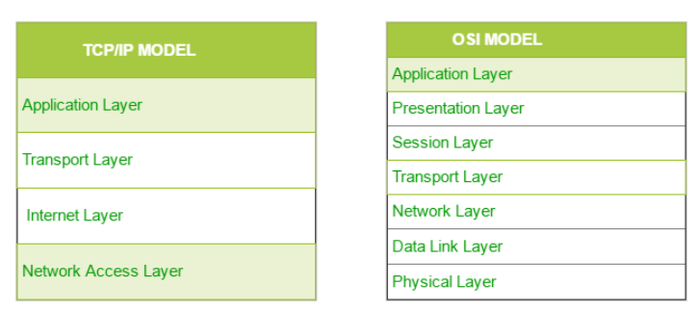

1. What do you mean by HTTP, TCP and UDP

* HTTP: HyperText Transfer Protocol (HTTP) is the underlying protocol used by the world wide web to define how messages are formatted and transmitted and what actions web servers and browsers should take in response to various commands. It is a request-response protocol in the client-server computing model. Clients and servers communicate by exchanging individual messages.
* TCP: Transmission Control Protocol (TCP) is one of the main protocols in TCP/IP transport layer. TCP enables two hosts to establish a connection then exchange streams of data. TCP guarantees delivery of data and also guarantees that packets will be delivered in the same order in which they were sent.
* UDP: User Datagram Protocol (UDP) is the other main protocol on the TCP/IP. However, UDP is a connectionless protocol since it does not determine the connection before sending data. It just sends data to the destination without checking whether the system is ready to receive or not. It is faster but very unreliable compared with the TCP.

1. What is a Firewall?

A firewall is a network security device that monitors incoming and outgoing network traffic and decides whether to allow or block specific traffic based on a defined set of security rules. It can be hardware, software or both.

1. Explain DNS

Domain Name System(DNS) is an Internet service that connects URLs with their IP address. With DNS, it’s possible to type words instead of a string of numbers into a browser, allowing people to search for websites and send emails using familiar names. Every time you use a domain name, the DNS service locates the website and translates the name into its corresponding IP address. Alphabetic domain names are easier to remember than IP address numbers, so when you type www.google.com into a web browser, you only have to remember the URL.

1. Define Latency

According to Tech Target, network latency is an expression of how much time it takes for a packet of data to get from one designated point to another. Latency is about the speed of the internet. It is a big determinant of application/web performance which largely affects the customer experience. Low latency means good web or application performance, and high latency means poor web or application performance.

1. Define caching

The cache is an area of a computer’s memory devoted to temporarily storing recently used information. The content, which includes HTML pages, images, files and Web objects, is stored on the local hard drive in order to make it faster for the user to access it, which helps improve the efficiency of the computer and its overall performance. What caching does is provide content in a more local area, for faster viewing. It provides the user with a faster recall of content, resulting in better user experience.

1. Explain Wireless Access point

Wireless Access Point (WAP) is what we commonly call hotspot. It is a hardware device or configured node on a local area network (LAN) that allows wireless capable devices and wired networks to connect through a wireless standard, including Wi-Fi or Bluetooth. WAPs provide wireless Internet in both private and public places, like homes, offices, coffee shops, airports and train stations.