**AWS CloudTrail**

Comprehensive Implementation & Security Analysis Documentation

**Executive Summary**

Successfully implemented AWS CloudTrail as the foundational audit logging service for Week 2 AWS Security Services training. Established secure, enterprise-grade monitoring capability that captures comprehensive API activity across all AWS regions with cryptographic integrity protection. Overcame multiple technical challenges to achieve MFA-enforced administrative access and complete audit trail functionality, including practical log analysis and security event investigation.

**CloudTrail Theory Foundation**

**What is AWS CloudTrail?**

**Definition:** CloudTrail is AWS's comprehensive API logging service that records every action taken in your AWS account, providing a complete audit trail for security monitoring, compliance, and forensic analysis.

**Core Function:** Captures WHO did WHAT, WHEN, WHERE, and HOW for every AWS API call, creating an immutable record of account activity.

**CloudTrail Architecture**

AWS API Calls → CloudTrail Service → S3 Bucket Storage → Security Analysis  
     ↓              ↓                      ↓                    ↓  
- IAM actions    - Event capture      - Encrypted logs      - SIEM tools  
 - S3 operations  - JSON formatting    - Access controls     - Compliance reports  
 - EC2 changes    - Integrity hashing  - Lifecycle policies  - Incident response

**Event Types Explained**

#### 1. Management Events (What We Implemented)

* **Definition:** Control plane activities that modify AWS resources
* **Examples:** CreateBucket, DeleteBucket, StartLogging, CreateTrail
* **Security Value:** Shows infrastructure changes and configuration modifications
* **Cost:** First copy FREE per region

#### 2. Data Events (Not Implemented - Cost Consideration)

* **Definition:** Data plane activities within resources
* **Examples:** S3 object access, Lambda function executions
* **Security Value:** Shows data access patterns and potential data exfiltration
* **Cost:** Charged per event (can be expensive)

#### 3. Insight Events (Not Implemented - Advanced Feature)

* **Definition:** ML-detected unusual activity patterns
* **Examples:** Spike in API calls, unusual access patterns
* **Security Value:** Automated anomaly detection
* **Cost:** Additional charges apply

**Day 1 Implementation Journey**

**Phase 1: Secure CLI Access Foundation**

#### Challenge: Establishing MFA-Enforced Access

**Problem:** Need secure administrative access without permanent access keys

**Solution:** Implemented assume role pattern with MFA enforcement

**Technical Achievement:**  
IAM User (admin) → MFA Verification → AssumeRole → AdminRole-MFA → Secure CLI Access

#### Detailed Implementation Steps:

**1. Initial Identity Verification**

aws sts get-caller-identity

✅ Achievement: Verified CLI authentication as IAM user admin in account 733366527973

**2. MFA Session Token Request**

aws sts get-session-token --serial-number arn:aws:iam::733366527973:mfa/device-1 --token-code 138559 --duration-seconds 43200

✅ Achievement: Received temporary credentials valid for 12 hours

**3. Permission Testing**

aws s3 ls

❌ Result: Access denied due to missing s3:ListAllMyBuckets permission  
🔍 Learning: Demonstrated principle of least privilege with base IAM user

**4. Profile Configuration**

aws configure --profile admin-mfa

notepad %USERPROFILE%\.aws\config

notepad %USERPROFILE%\.aws\credentials

✅ Achievement: Set up secure profile structure for role assumption

**5. Role Assumption Success**

aws --profile admin-mfa sts get-caller-identity

Result: Successfully transitioned to assumed-role/AdminRole-MFA

Figure 1.1: Successful MFA-enforced role assumption showing transition from IAM user to AdminRole-MFA.

Validates secure administrative access implementation.

**Phase 2: Secure S3 Storage Implementation**

#### Challenge: Balancing Security and Functionality

**Problem:** CloudTrail needs S3 access, but security requires blocking public access

**Error Encountered:** InsufficientS3BucketPolicyException

**Solution:** Explicit service permissions through manually configured bucket policies

**S3 Bucket Creation**

aws s3 mb s3://cloudtrail-logs-733366527973-training --region us-east-1

✅ Achievement: Created dedicated bucket for CloudTrail logs

**Security Controls Application (with error resolution)**

# Initial attempt (FAILED due to case sensitivity)

aws s3api put-public-access-block --bucket cloudtrail-logs-733366527973-training --public-access-block-configuration "BlockPublicACLs=true,IgnorePublicAcls=true,BlockPublicPolicy=true,RestrictPublicBuckets=true"

# Corrected command

aws s3api put-public-access-block --bucket cloudtrail-logs-733366527973-training --public-access-block-configuration "BlockPublicAcls=true,IgnorePublicAcls=true,BlockPublicPolicy=true,RestrictPublicBuckets=true"

🔍 Learning: AWS CLI parameters are case-sensitive (BlockPublicAcls not BlockPublicACLs)

Figure 1.2: CloudTrail S3 bucket with comprehensive public access blocking and service-specific permissions

Demonstrates enterprise-grade S3 security controls.

**CloudTrail S3 Bucket Policy Applied:**

{

"Version": "2012-10-17",

"Statement": [

{

"Sid": "AWSCloudTrailAclCheck",

"Effect": "Allow",

"Principal": {"Service": "cloudtrail.amazonaws.com"},

"Action": "s3:GetBucketAcl",

"Resource": "arn:aws:s3:::cloudtrail-logs-733366527973-training",

"Condition": {

"StringEquals": {

"AWS:SourceArn": "arn:aws:cloudtrail:us-east-1:733366527973:trail/SecurityAuditTrail"

}

}

},

{

"Sid": "AWSCloudTrailWrite",

"Effect": "Allow",

"Principal": {"Service": "cloudtrail.amazonaws.com"},

"Action": "s3:PutObject",

"Resource": "arn:aws:s3:::cloudtrail-logs-733366527973-training/AWSLogs/733366527973/*",

"Condition": {

"StringEquals": {

"s3:x-amz-acl": "bucket-owner-full-control",

"AWS:SourceArn": "arn:aws:cloudtrail:us-east-1:733366527973:trail/SecurityAuditTrail"

}

}

}

]

}

**Phase 3: CloudTrail Service Configuration**

#### Day 1 Status: **COMPLETE**

**CloudTrail implementation complete with comprehensive analysis capabilities and ready for Week 2 service integration with Config, GuardDuty, Security Hub, and Macie.**

Figure 1.3: SecurityAuditTrail active configuration with multi-region coverage and cryptographic validation.

Confirms operational CloudTrail implementation.

**Security Analysis and Risk Assessment**

**Security Strengths Achieved**

* **Complete API Coverage:** No blind spots in account activity monitoring
* **Cryptographic Integrity:** Tamper-evident audit logs for forensic analysis
* **Access Control:** Multi-layered protection for audit log storage
* **MFA Enforcement:** Multi-factor authentication required for all administrative actions
* **Centralized Logging:** Single location for comprehensive security analysis
* **Windows Workflow:** Practical log analysis capabilities on Windows platform

**Potential Security Considerations**

* **Log Delivery Delay:** 5-15 minute delay between events and log availability
* **Console Filtering:** Built-in console views hide reconnaissance activities
* **Storage Costs:** Long-term retention requires lifecycle management
* **Access Pattern Analysis:** Raw logs require additional tools for effective analysis
* **File Permissions:** Local config files readable by user account
* **Session Caching:** Temporary credentials cached for ~1 hour

**Risk Mitigation Strategies**

* **Real-Time Monitoring:** Integrate with CloudWatch for immediate alerting
* **SIEM Integration:** Use raw logs with security information management tools
* **Automated Analysis:** Implement GuardDuty for ML-based threat detection
* **Compliance Automation:** Use Config for continuous compliance monitoring
* **File Security:** Implement proper file permissions for config files
* **Session Management:** Regular credential rotation and monitoring

**Compliance Framework Mapping**

|  |  |  |
| --- | --- | --- |
| **Framework** | **Requirement** | **CloudTrail Value** |
| **SOX** (Sarbanes-Oxley) | Section 404 - Internal controls over financial reporting | * Provides audit trail of access to financial systems * Documents who made changes to critical infrastructure * Enables auditor verification of control effectiveness |
| **PCI DSS** (Payment Card Industry) | Requirement 10 - Monitor and regularly test networks | * Logs all access to cardholder data environment * Tracks privileged user activities * Supports forensic analysis for security incidents |
| **HIPAA** (Health Insurance Portability) | Administrative safeguards for PHI protection | * Documents access to systems containing PHI * Tracks user authentication and authorization events * Provides audit trail for breach investigations |

**CLI Commands Reference Summary**

**Environment Setup Commands**

# Identity verification and MFA setup

aws sts get-caller-identity aws sts get-session-token --serial-number arn:aws:iam::733366527973:mfa/device-1 --token-code [MFA_CODE] --duration-seconds 43200

aws configure --profile admin-mfa set AWS_PROFILE=admin-mfa

**CloudTrail Management Commands**

# S3 bucket setup

aws s3 mb s3://cloudtrail-logs-733366527973-training --region us-east-1

aws s3api put-public-access-block --bucket cloudtrail-logs-733366527973-training --public-access-block-configuration "BlockPublicAcls=true,IgnorePublicAcls=true,BlockPublicPolicy=true,RestrictPublicBuckets=true"

aws s3api put-bucket-policy --bucket cloudtrail-logs-733366527973-training --policy <file://cloudtrail-bucket-policy.json>

# CloudTrail configuration

aws cloudtrail create-trail --name SecurityAuditTrail --s3-bucket-name cloudtrail-logs-733366527973-training --include-global-service-events --is-multi-region-trail --enable-log-file-validation

aws cloudtrail start-logging --name SecurityAuditTrail aws cloudtrail get-trail-status --name SecurityAuditTrail

**Security Event Generation Commands**

# Identity and authentication events

aws sts get-caller-identity

aws iam list-users

aws iam list-roles

aws iam get-account-summary

aws iam get-user --user-name admin

# S3 service interactions

aws s3 ls aws s3api list-buckets

# Resource lifecycle events

aws s3 mb s3://test-event-bucket-733366527973 --region us-east-1

aws s3 rb s3://test-event-bucket-733366527973 --region us-east-1

# Configuration queries

aws cloudtrail describe-trails

aws configservice describe-configuration-recorders

aws guardduty list-detectors

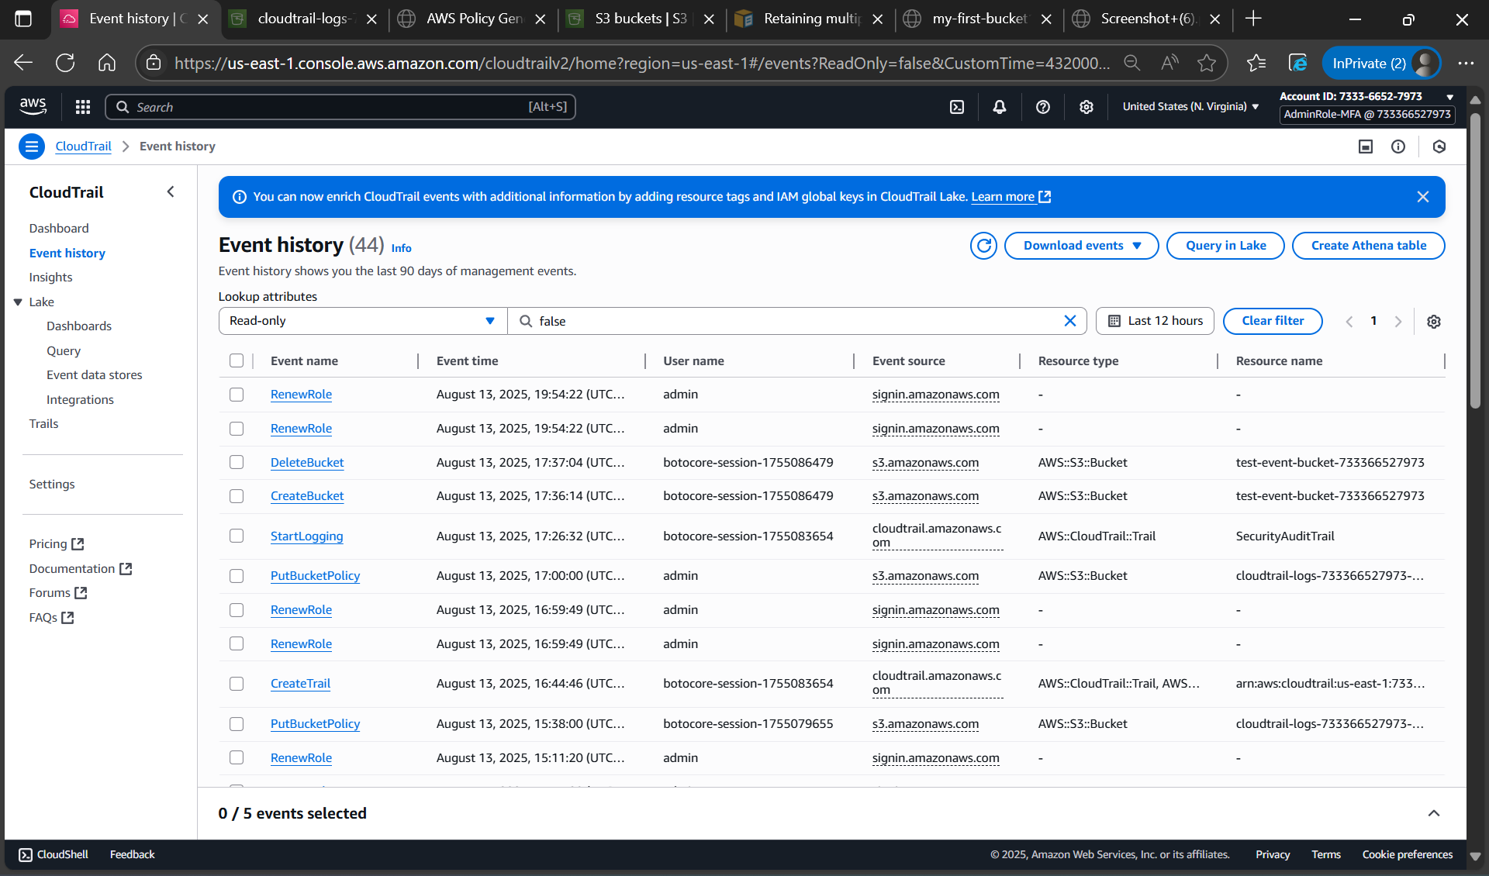

Figure 1.4: CloudTrail Event History showing comprehensive API activity capture with detailed event information.

Demonstrates audit trail functionality.

**Log Analysis Commands**

# Log download and analysis

aws s3 ls s3://cloudtrail-logs-733366527973-training/ --recursive mkdir cloudtrail-logs

aws s3 sync s3://cloudtrail-logs-733366527973-training/AWSLogs/733366527973/CloudTrail/us-east-1/2025/08/13/ ./cloudtrail-logs/

# Security event searches (Windows)

findstr /i "test-event-bucket" *.json findstr /i "AssumeRole" *.json findstr /i "CreateBucket" *.json findstr /i "GetCallerIdentity" *.json findstr /i "s3.amazonaws.com" *.json

**Important:** Keep CloudTrail logging active throughout Week 2 for complete service integration demonstration and comprehensive security monitoring.

**Business Value and ROI**

**Immediate Security Benefits**

* **Incident Response Capability:** Complete audit trail for security investigations
* **Compliance Evidence:** Automated collection of regulatory audit requirements
* **Threat Detection Foundation:** Data source for advanced security analytics
* **Risk Visibility:** Comprehensive view of account activity and access patterns

**Long-Term Strategic Value**

* **Security Operations Center (SOC) Foundation:** Essential data source for security monitoring
* **Compliance Automation:** Reduced manual effort for audit preparations
* **Forensic Readiness:** Legal-grade evidence collection for security incidents
* **Risk Management:** Data-driven security decision making

**Conclusion**

Day 1 successfully established AWS CloudTrail as the comprehensive audit logging foundation for Week 2 security services training. Overcame technical challenges including MFA implementation, S3 security configuration, service permission management, and Windows-based log analysis to achieve enterprise-grade security monitoring capability.

Key achievements include complete API activity coverage, cryptographic log integrity, secure storage implementation, practical log analysis workflows, and hands-on experience with real-world security configuration challenges. The implementation provides essential foundation for remaining Week 2 services and demonstrates practical security skills valuable for cybersecurity consulting roles.

**Status:** CloudTrail implementation complete and ready for Week 2 service integration with Config, GuardDuty, Security Hub, and Macie.

Day 1: AWS CloudTrail Implementation & Analysis Documentation

**Week 2 AWS Security Services Training**