# CE Experiment 5

**Generation of FM Roll No: 121A7044, Date: 09/08/2023**

**Aim:** To generate FM signal and plot its frequency spectrum using SCILAB



**Simulation Tool:** Scilab

**Theory:** Frequency modulation is the process of changing the frequency of a relatively high frequency carrier signal in accordance with the amplitude of the modulating signal.

The instantaneous frequency of the modulated signal is fi = fc + kf x(t).

Where fc is the carrier frequency, kf is the frequency sensitivity of the modulator in hz/volt and x(t) is the modulating signal.

The maximum frequency of the modulated signal is fH and the minimum frequency is fL.

The maximum frequency deviation ∆f = (fH - fL) / 2

The modulation index m = ∆f / fm, where fm is the modulating frequency. Deviation Ratio DR = ∆f / maximum fm

Bandwidth of FM using Carson’s rule = 2(fm + ∆f)

FM power = Ac2 /2R, where Ac is the peak amplitude of the carrier and R is the load resistance

# Program Code executed :

# Image preview

**Simulation Results and graphs :**

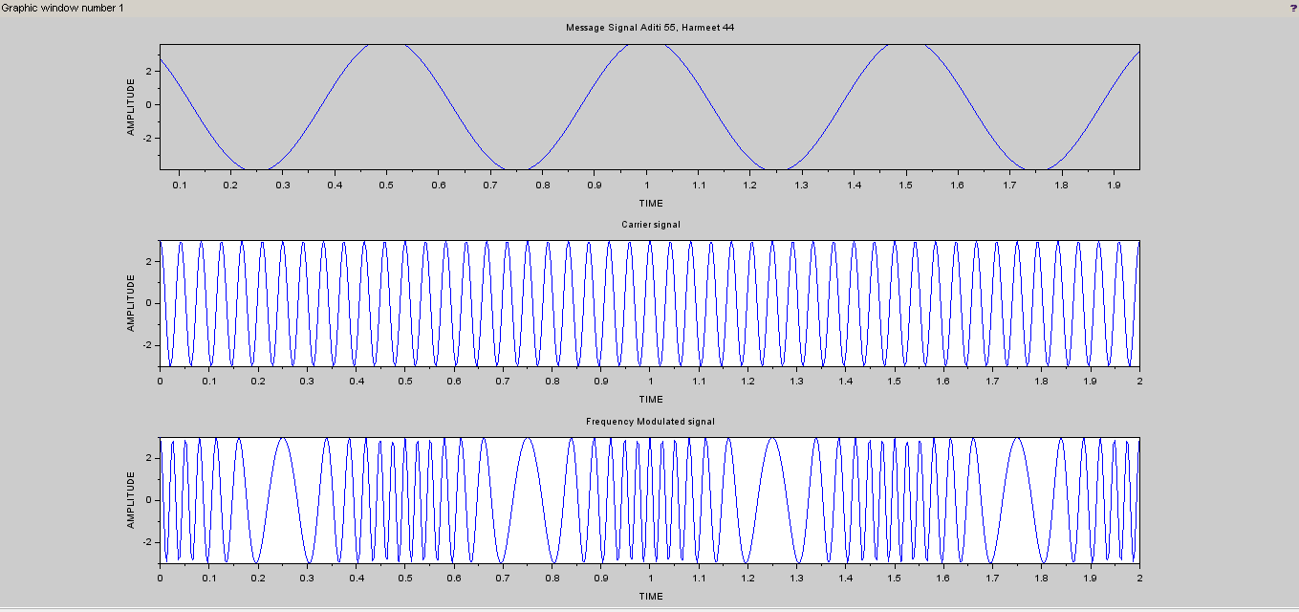

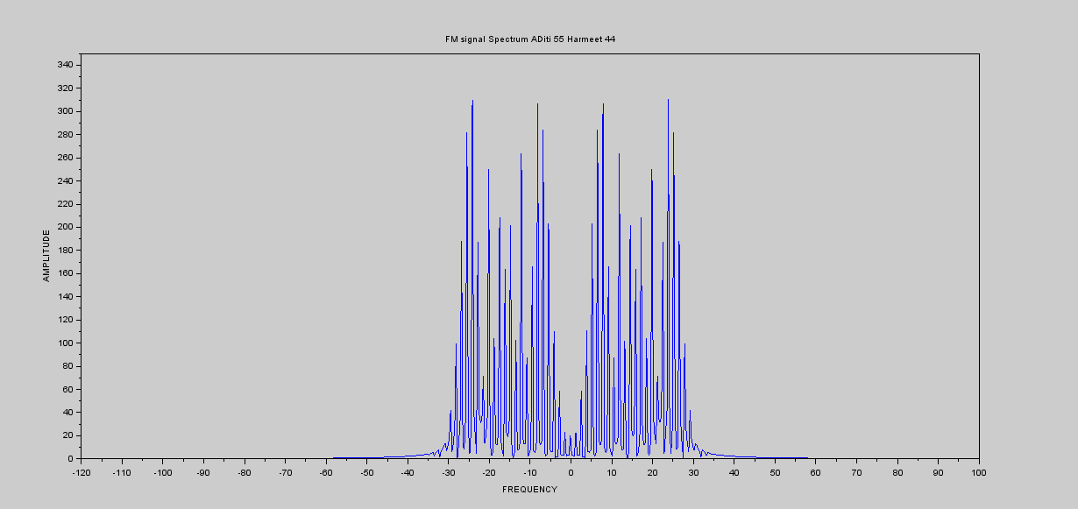

# Conclusion: Throughout the experiment, we have gained a deeper appreciation for the role of the modulation index in controlling the frequency deviation of the carrier signal in response to changes in the information signal. By adjusting this key parameter, we can precisely encode information onto the carrier signal by varying its frequency over time.