**CE Experiment 1**

**Generation and Envelope Detection of AM-DSBFC**

**Name: Harmeet Kaur Saini**

**Roll No: 121A7044**

**Batch: B1**

**Aim:** To generate AM-DSBFC signal using trainer kit and envelope detection using trainer kit and sketch the modulating, carrier, and modulated and detected signals in graph sheets.

**Hardware:** AMDSBFC modulation and demodulation trainer kits: Falcon ACL- 01 and ACL-02

**Theory:** Amplitude modulation is the process of changing the amplitude of a relatively high frequency carrier signal in accordance with the amplitude of the modulating signal. The basic version of AM is also known as Amplitude Modulation Double Side Band Full Carrier (AMDSBFC).

VAM(t) = Ac cosωct + Am cosωct cosωmt

Where Ac cosωct is the carrier signal, Am cosωmt is the modulating signal and Ac cosωct + Am cosωct cosωmt is the modulated signal.

Modulation index = Am / Ac

% modulation = modulation index x 100%

AMDSBFC signal can be detected using envelop detector. This is non-coherent detection technique and is less complex compared to coherent detection like product detector.

**Trainer kit Block diagram:**

Audio Generator for modulating

signal

Modulator 1

Envelope

Detector

Output

VCO for carrier

signal

**Images of trainer kits:**

**Fig.2.1 Modulating Signal**

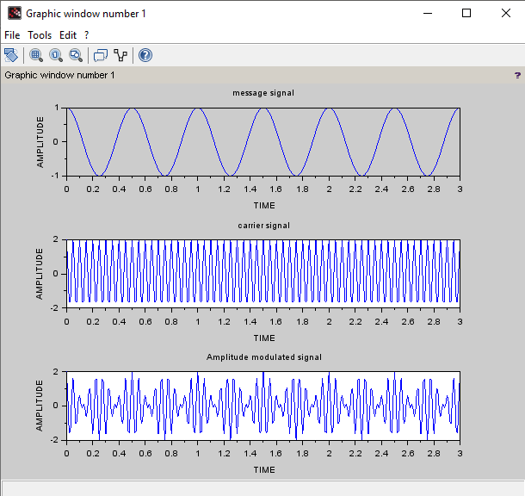

**Fig.2.2 Carrier Signal**

**Fig.2.3 Modulated Signal**

**Fig.2.4 Envelope Detector Output**

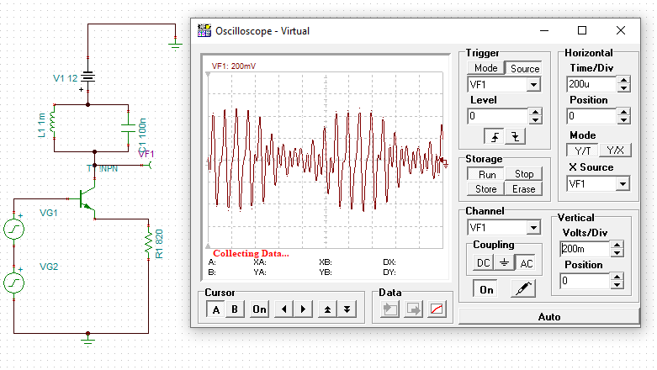

**Conclusion and application: (5-6 sentences)**

**•** The trainer kit was successfully used to produce an AM-DSBFC signal during the experiment.

• Utilizing the same equipment, the experiment showcased the envelope detection process.

• By applying these concepts practically, we acquired valuable insights into amplitude modulation and demodulation techniques.

• Visual representations of modulating, carrier, modulated, and detected signals were presented on graph sheets.

• This hands-on experience deepened our comprehension of analog communication systems.

• The acquired knowledge will prove advantageous for upcoming engineering and technological endeavors.