 ***SIES Graduate school of Technology***

Department of Electronics & Computer Science

Name: Harmeet Kaur Saini

Prn: 121A7044

Batch: B1

# EXPERIMENT NO. 7

**Aim:** Design Form using javascript/HTML/JQuery with client-side validations on the selected problem statement.

1. Registration form validation
2. Greeting card generation

# Theory:

Designing registration form using HTML5 elements The Input Element

The most important form element is the input element. The input element is used to select user information.

An input element can vary in many ways, depending on the type attribute. An input element can be of type text field, checkbox, password, radio button, submit button, and more.

Text Fields

<input type="text" /> defines a one-line input field that a user can enter text into. Password Field

<input type="password" /> defines a password field. Radio Buttons

<input type="radio" /> defines a radio button. Radio buttons let a user select ONLY ONE one of a limited number of choices.

Checkboxes

<input type="checkbox" /> defines a checkbox. Checkboxes let a user select ONE or MORE options of a limited number of choices.

Submit Button

<input type="submit" /> defines a submit button.

A submit button is used to send form data to a server. The data is sent to the page specified in the form's action attribute. The file defined in the action attribute usually does something with the received input.

HTML Form Tags Tag Description

<form> Defines an HTML form for user input

<input /> Defines an input control

<textarea> Defines a multi-line text input control

<label> Defines a label for an input element

<fieldset> Defines a border around elements in a form

<legend> Defines a caption for a fieldset element

<select> Defines a select list (drop-down list)

<optgroup> Defines a group of related options in a select list

<option> Defines an option in a select list

<button> Defines a push button Source code example

<html><body>

<form name="input" action="html_form_action.asp" method="get">

First name: <input type="text" name="FirstName" value="Mickey" /><br /> Last name: <input type="text" name="LastName" value="Mouse" /><br /> <input type="submit" value="Submit" />

</form> <p>If you click the "Submit" button, the form-data will be sent to a page called "html_form_action.asp".</p></body>

</html>

Client-side Validation

* Document Object Model - Event Handling Controlling Windows & Frames and Documents Form handling and validations
* Advanced JavaScript - Browser Management and Media Management – Classes – Constructors – Object-Oriented Techniques in JavaScript
* Object constructor and Prototyping - Sub classes and Super classes – JSON - jQuery and AJAX., Rich Internet Application with AJAX, jQuery Framework

Event Handling :Controlling Windows & Frames

* What is an Event:
* JS interactions with HTML are handled through events that occur when user or browser manipulates the page.

Events:

o Loading a page

o clicking a button

o pressing a key

o resizing frame window

o closing a window

Developers can use these events to execute JS coded responses.

* When a user visit your website, they do things like click on text and images and given links, hover over things etc. These are examples of what JavaScript calls events.
* We can write our event handlers in JavaScript or VbScript and can specify these event handlers as a value of event tag attribute. The HTML 4.01 specification defines 19 event attributes as listed below –
* onclick Event Type

This is the most frequently used event type which occurs when a user clicks the left button of his mouse. You can put your validation, warning etc., against this event type.

* onsubmit Event Type
* onsubmit is an event that occurs when you try to submit a form. You can put your form validation against this event type.

.

# PROGRAM 1 CODE



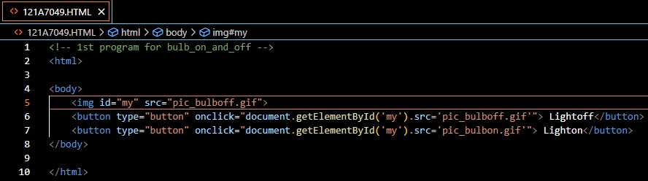

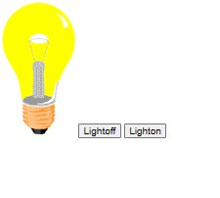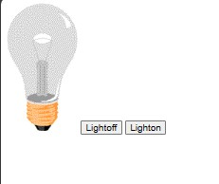**OUTPUT**



**CONCLUSION**: In conclusion, designing a form using JavaScript, HTML, and jQuery with client-side validations is a crucial and effective approach to enhance the user experience and ensure data accuracy. By addressing a specific problem statement through this process, we have learned several key takeaways.