**ITC Experiment 1**

Name: Harmeet Kaur

Roll No: 121A7044

Date: 31/8/23

**Calculation of Joint, Total, Likelihood and Channel error probabilities for a binary communication channel-Python program**

**Aim:** Write a program for the calculation of Joint, Total, Likelihood and Channel error probabilities for a binary communication channel using Python.

**Language**: Python

**Theory:**

Let the input random variables are X0 and X1 and the output random variables are Y0 and Y1

P(X0 transmission) = PX0 and P(X1 transmission) = PX1

P(Y0 reception given that X0 was transmitted) = P(Y0 / X0)

P(Y0 reception given that X1 was transmitted) = P(Y0 / X1)

P(Y1 reception given that X1 was transmitted) = P(Y1 / X1)

P(Y1 reception given that X0 was transmitted) = P(Y1 / X0)

Joint Probabilities:

P(X0 Y0) = PX0 P(Y0 / X0)

P(X0 Y1) = PX0 P(Y1 / X0)

P(X1 Y1) = PX1 P(Y1 / X1)

P(X1 Y0) = PX1 P(Y0 / X1)

Total Probabilities:

PY0 = P(X0 Y0) + P(X1 Y0)

PY1 = P(X1 Y1) + P(X0 Y1)

Likelihood Probabilities:

P(X0 / Y0) = P(X0 Y0) / PY0

P(X1 / Y0) = P(X1 Y0) / PY0

P(X1 / Y1) = P(X1 Y1) / PY1

P(X0 / Y1) = P(X0 Y1) / PY1

Channel error probability = P(X0 Y1) + P(X1 Y0)

**Program Code:**

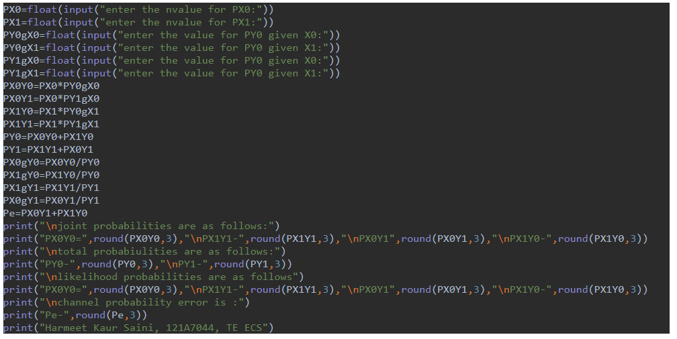

**Simulation Results:**

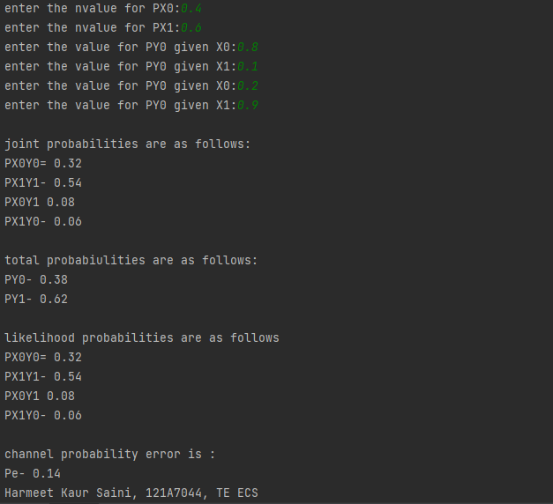

**Conclusion:**

For a given binary communication channel , using python code , the following probability are calculated: Joint Probability , Total probability , Likelihood probability and Channel error probability.