Project Proposal: RAG-LLM for Network Configuration & Evaluation

1. Introduction:
As network infrastructures become increasingly complex, managing and configuring networks manually presents significant challenges, particularly when dealing with similar but distinct topological setups. This project proposes the development of a Retrieval-Augmented Generation (RAG) system integrated with Large Language Models (LLMs) for automated network configuration and validation, specifically using Llama3 fine-tuned on routing configuration codes. The goal is to streamline the generation of network configuration code for similar topologies, allowing for faster and more reliable network management and evaluation.

2. Research Problem:
In modern networking, routing configurations need to be customized for various topologies. Current manual processes for creating network configurations are labor-intensive, prone to human error, and difficult to scale. While there are automated approaches for network configuration, they often lack flexibility in handling topologically similar yet unique configurations.
The research aims to:
- 1. Automate network configuration generation based on historical configuration data.
- 2. Use an LLM fine-tuned on a dataset of routing configuration codes to generate code modifications tailored to specific topologies.
- 3. Implement automated validation inspired by SwitchV techniques to ensure the correctness of the generated code.
- 4. Develop a feedback mechanism to handle errors and reverse failures in generated code, enabling continuous improvement of the model.

3. Related Work:
NetConfEval demonstrates how LLMs can be applied in network configuration by translating high-level requirements into low-level configurations. This research will build on this approach by expanding LLM's ability to generate configurations for topologically similar networks.
SwitchV focuses on the validation of SDN switches using fuzzing and symbolic execution to identify bugs. The methodology will be adapted in this project to provide quick feedback on generated network configuration code, ensuring robustness and reliability.

4. Proposed Methodology:

4.1 Data Collection and Preprocessing:
Routing Configuration Codes: Gather 100-200 network routing configuration codes as the training dataset. These codes will vary in network topologies and will form the basis for background knowledge in the LLM.
Data Annotation: Label the dataset with the topological information (such as the type of network, number of nodes, type of routing protocol used). This labeling will allow the LLM to learn the relationships between network structure and configuration requirements.
Data Preprocessing: Format the routing codes into training-ready input-output pairs, ensuring that similar topological configurations are grouped.

4.2 Fine-Tuning Llama3:
Fine-Tuning Strategy: Utilize Llama3 to fine-tune the model on the network configuration dataset. The goal of fine-tuning is to teach the model the structure of routing configuration codes and their relationship with network topologies.
Task Representation: The LLM will be tasked with generating modified or new routing configurations for given network topologies based on the training set. It will also learn how to integrate routing rules and apply correct modifications for specific topologies.

4.3 Task Generation with Topological Similarity:
Topology-Aware Generation: After training, the LLM will be able to generate routing configuration codes for new networks based on similar topologies it has encountered in the dataset. The model will learn from the history of configurations and suggest the appropriate modifications for similar topologies.
RAG Framework: A retrieval module will be developed to pull similar topological configuration examples from the history dataset, which will be used as background knowledge by the LLM for generating or modifying code. This retrieval-augmented approach will ensure that the generated configurations remain relevant to the task.

4.4 Validation and Error Handling:
Inspired by SwitchV: Borrowing from the methodologies in SwitchV, an automated validation system will be incorporated to check the generated routing codes. This system will use symbolic execution and fuzzing-like techniques to ensure the generated code adheres to the required configuration semantics.
Control Plane Validation: Ensure that control plane commands (like routing table updates) generated by the LLM are valid and aligned with protocol constraints.
Data Plane Validation: Ensure the forwarding behavior of the generated configurations is correct, using test packets to simulate real traffic scenarios.
Error Feedback and Reverse Mechanism: If the validation system detects a failure or invalid code, it will generate detailed error reports that the LLM can use to reverse its steps. This feedback loop will allow the model to learn from failures and improve over time.

4.5 Evaluation:
Benchmarking: The system’s performance will be evaluated using both functional correctness (does the generated code correctly configure the network?) and efficiency (how quickly can the system generate correct configurations for new topologies?).
Accuracy Metrics: Success rates for configuration generation, error correction cycles, and overall network performance improvements post-configuration will be tracked.

5. Project Milestones:
- 1. Data Collection: Gather and preprocess 100-200 configuration codes (1 month).
- 2. Fine-Tuning Llama3: Fine-tune Llama3 with routing configuration codes (2 months).
- 3. Task Generation: Implement topology-aware generation module (1 month).
- 4. Validation System: Develop and integrate validation techniques (based on SwitchV) (1.5 months).
- 5. Testing & Feedback: Test and refine error feedback and reverse mechanism (1 month).
- 6. Evaluation & Tuning: Benchmark system performance and optimize (1 month).
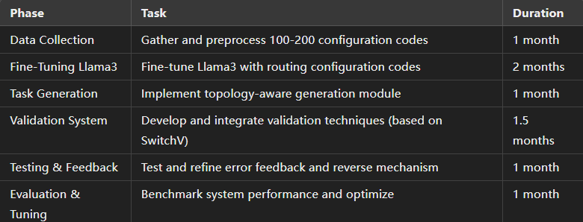

6. Expected Outcomes:
A fine-tuned Llama3 model capable of generating network configuration code based on topological similarity.
A retrieval-augmented generation system that can leverage historical configuration knowledge to improve network configuration generation.
An automated validation framework inspired by SwitchV that ensures the correctness of generated network configurations.
A feedback loop allowing the model to handle errors and continuously improve.

7. Conclusion:
This project combines state-of-the-art LLM techniques with rigorous validation methods to solve a critical problem in network configuration. By borrowing methods from existing works such as NetConfEval and SwitchV, this research aims to create a robust, scalable, and intelligent system that not only automates the configuration process but also ensures the generated configurations are reliable, significantly reducing human intervention in network management.

