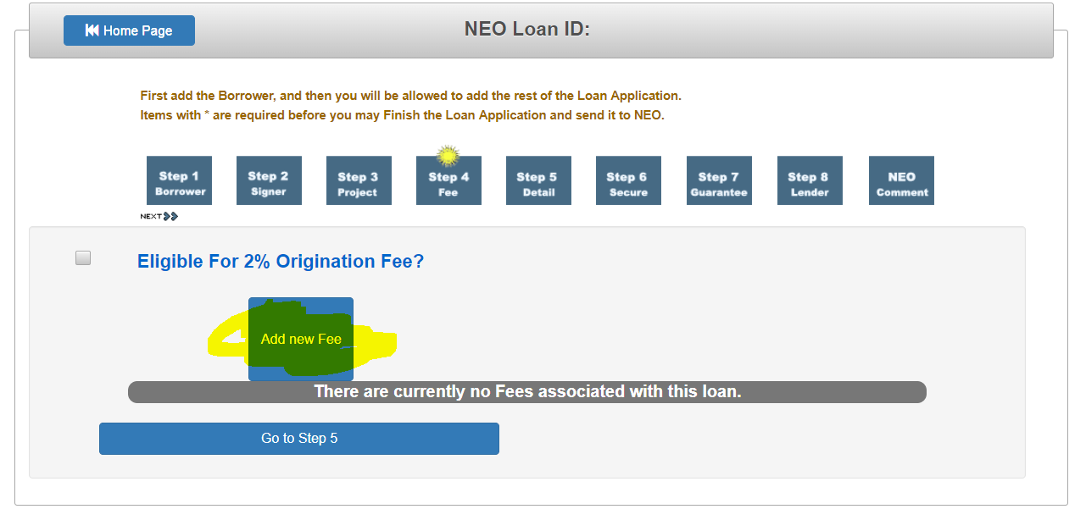

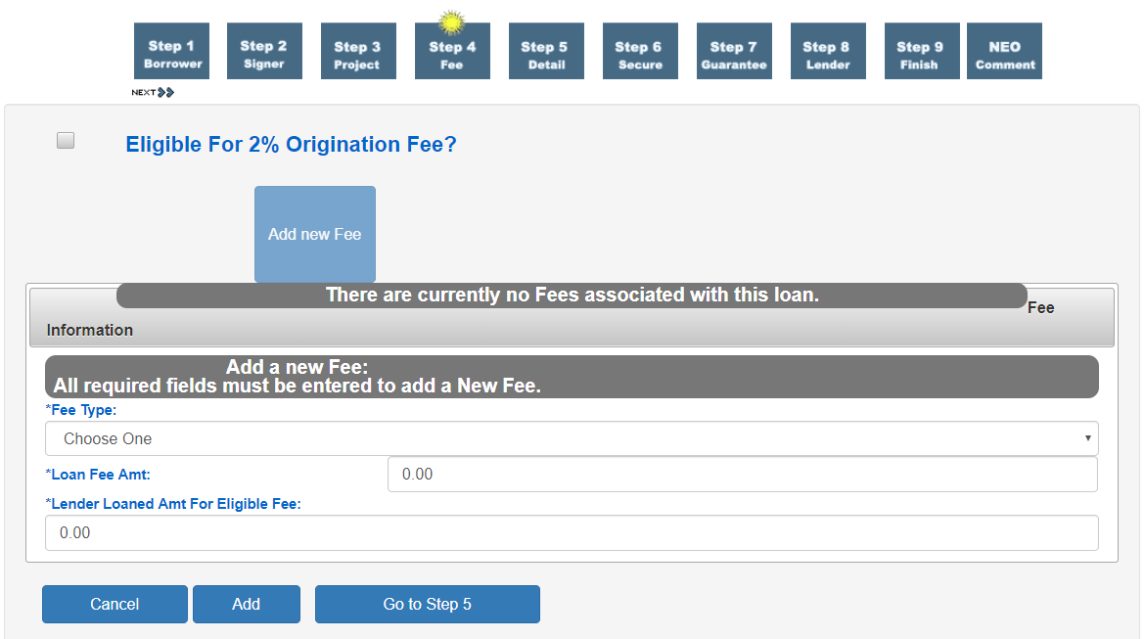

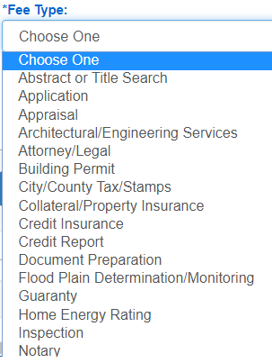

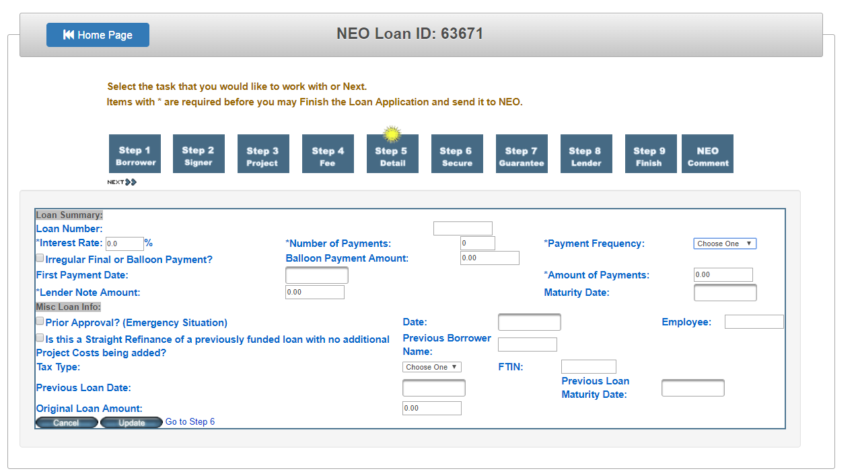

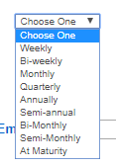

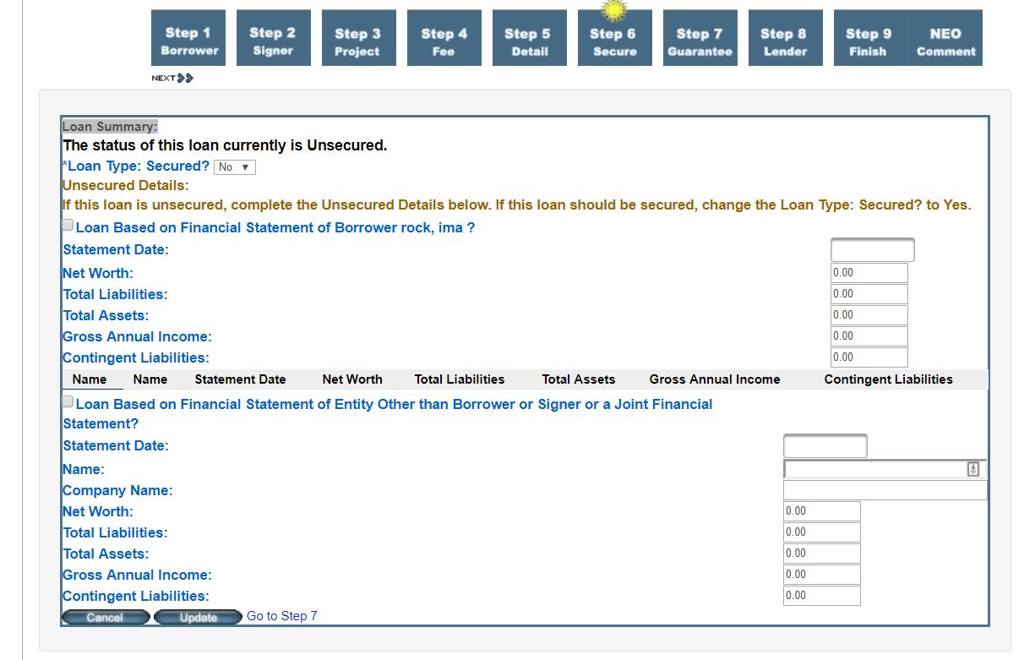

On “Go to Step 7”

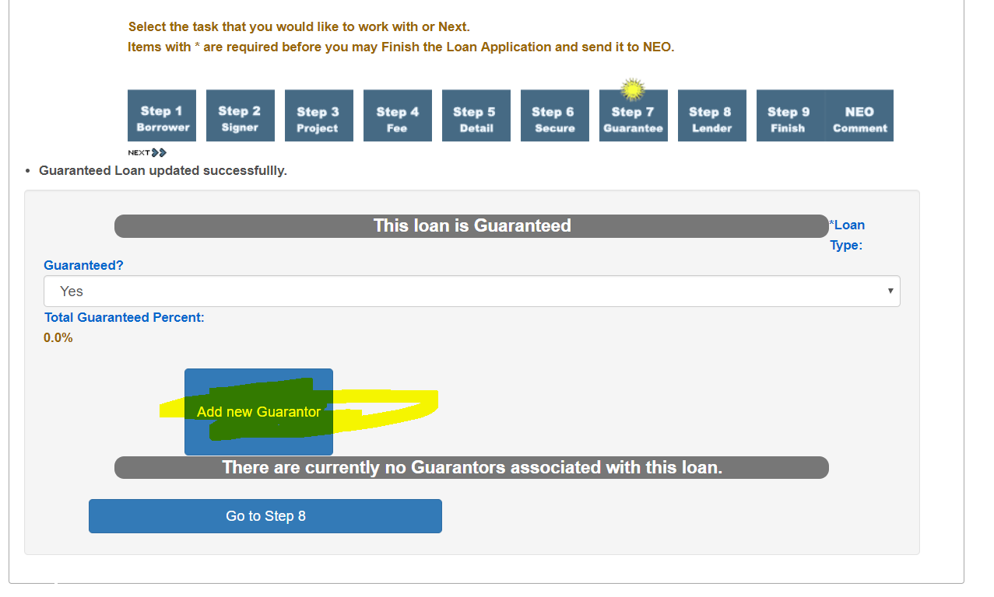

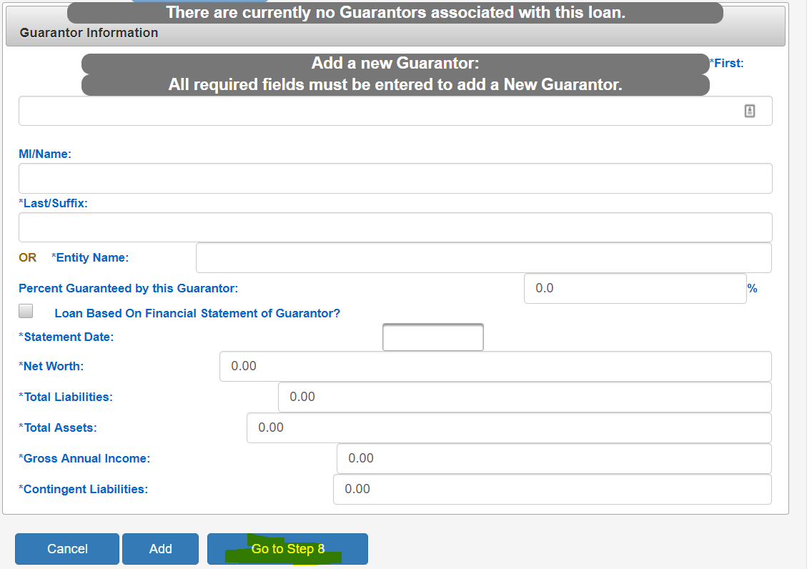

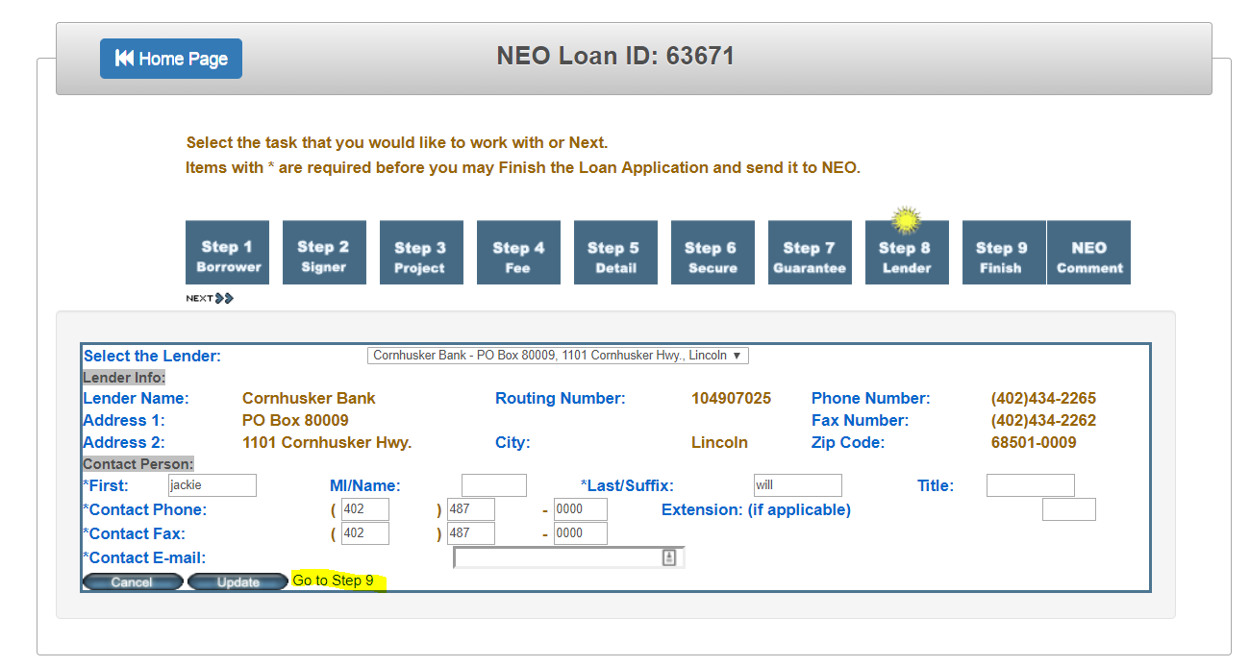

Not sure yet what screen for step 9

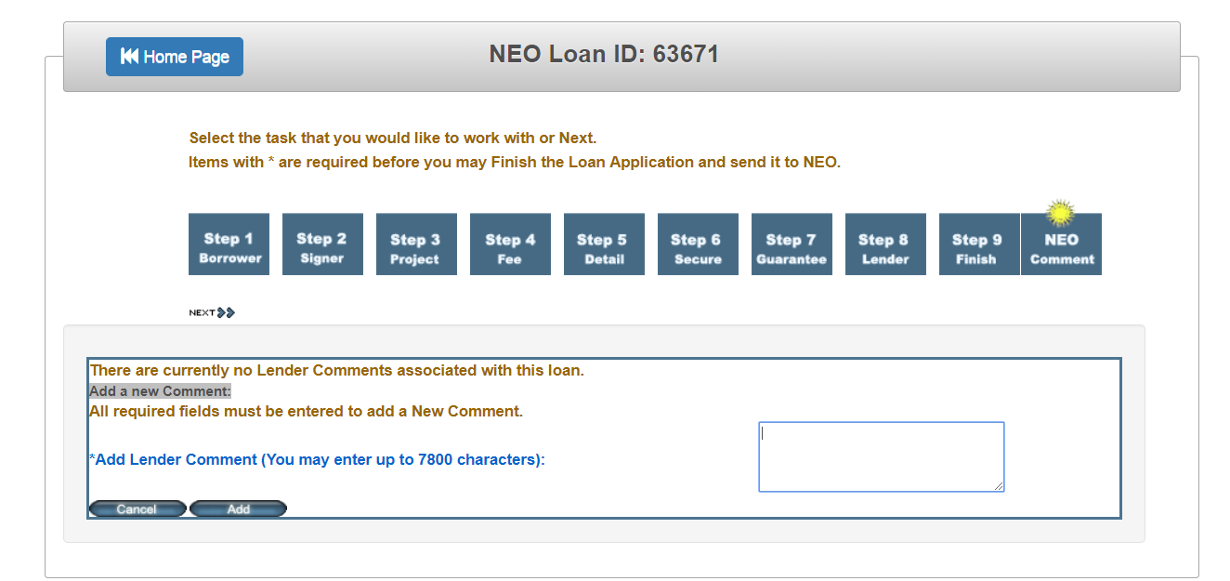

All tabs models are below, if you are confused then make your own or attach the input field to the closest you feel good

**public** **class** Signer **extends** Person

{

**private** **int** signerId;

**private** CodeItem relationshipToProperty;

**private** Signer shadow;

**private** String ftin;

**private** **boolean** added;

**private** **boolean** deleted;

**private** **int** loanId;

**private** CodeItem taxNumberCode;

//UnSecured Loan

**private** **double** netWorth;

**private** **double** annualIncome;

**private** **double** contingentLiabilities;

**private** GregorianCalendar statementDate;

**private** **boolean** loanBasedOnFinancialStatement;

**private** **double** totalAsset;

**private** **double** totalLiabilities;

**public** **class** Guarantor **extends** Person

{

**private** **int** guarantorId;

**private** **boolean** loanBasedOnFinancialStatement;

**private** **double** netWorth;

**private** **double** totalAsset;

**private** **double** totalLiabilities;

**private** **double** annualIncome;

**private** **double** contingentLiabilities;

**private** String CompanyName;

**private** GregorianCalendar statementDate;

**private** String ftin;

**private** **double** percentGuarantor;

**private** Guarantor shadow;

**public** **abstract** **class** Person **extends** NeoBaseObject

{

**private** **int** personId;

**private** Name name;

**private** Address address;

**private** PhoneNumber homePhone;

**private** PhoneNumber workPhone;

**private** PhoneNumber cellPhone;

**private** PhoneNumber faxPhone;

**private** String email;

**public** **class** Borrower **extends** Person

{

**private** **int** borrowerId;

**private** String ftin;

**private** CodeItem ftinCode;

**private** String companyName; //If it is a company.

**private** CodeItem borrowerType;

**private** CodeItem borrowerRel2Property;

**private** Borrower shadow;

**private** **int** loanId;

**public** **class** Project **extends** NeoBaseObject

{

**private** **int** projectId = -1;

**private** Address address; //Address for this project/

**private** Vector ecms = **new** Vector();

//Financial info related to the project.

**private** **double** totalProjectAmount;

**private** **double** neoShare;

**private** **double** currentFinancedAmt;

**private** **double** eligibleProjectAmt;

**private** **double** bankLoanedProjectAmt;

**private** GregorianCalendar inspectedDate;

**private** CodeItem inspectionStatusCode;

**private** GregorianCalendar inspectionFollowUpDate;

**private** GregorianCalendar fileInspectedDate;

**private** CodeItem fileInspectionStatusCode;

**private** GregorianCalendar fileInspectionFollowUpDate;

**private** **int** nbrDwellings;

**private** **float** building_Square_Feet;//jTrac-62 => HIDE from 08/29/2014

**private** **boolean** multiFamily;

**private** Project shadow;

**private** CodeItem sectorCode = **null**;

**private** **boolean** allElectric;

**private** **int** currentLoanId;

**private** **boolean** projectShared;

**private** Vector fuelSuppliers;

**private** String utilityName;

**private** String utilityRepresentative;

**private** String utilityRepresentativeTitle;

**private** String installerName;

**private** String installerRepresentative;

**private** String installerRepresentativeTitle;

**private** **boolean** loanLeaseFlag;

//This class items are used for Secure, Detail, Fee

**public** **class** Loan **extends** NeoBaseObject {

**private** **boolean** securedLoan; //Secured Loan

**protected** CodeItem loanPerformanceCode;

**protected** GregorianCalendar loanPerformanceEnteredDate;

**protected** String loanPerformanceEntryPerson;

// Loan Details

**private** String loanNbr;

**private** **int** nbrPayments;

**private** **double** intRate;

**private** **double** paymentAmt;

**private** GregorianCalendar firstPaymentDate;

**private** GregorianCalendar maturityDate;

//Secured Loan

**private** **boolean** collateralInsurance;

**private** **double** collateralInsuranceAmt;

**private** **double** collateralValue;

**private** **boolean** balloonPayment;

**private** **double** balloonPaymentAmt;

**private** String collateralDescription;

//UnSecured Loan

**private** **double** netWorth;

**private** **double** annualIncome;

**private** **double** contingentLiabilities;

**private** GregorianCalendar statementDate;

**private** **boolean** loanBasedOnFinancialStatement;

**private** **double** totalAsset;

**private** **double** totalLiabilities;

//UnSecured Loan - Other

**private** String otherName;

**private** String otherCompanyName;

**private** **double** otherNetWorth;

**private** **double** otherAnnualIncome;

**private** **double** otherContingentLiabilities;

**private** GregorianCalendar otherStatementDate;

**private** **boolean** otherLoanBasedOnFinancialStatement;

**private** **double** otherTotalAsset;

**private** **double** otherTotalLiabilities;

//Misc Loan Info

**private** GregorianCalendar originalLoanDate;

**private** CodeItem paymentFrequency;

**private** **double** previousLoanAmt;

//Guaranteed

**private** Vector guarantor;

**private** **double** guarantorPercentage;

**private** **boolean** guaranteedFlag;

//Misc Loan Info

**private** **boolean** priorApproval;

// Related Objects

**private** **int** loanId;

**private** **int** lenderId;

**private** **int** borrowerId;

**private** GregorianCalendar emergencyApprovalDate;

**private** GregorianCalendar entryDateTimeStamp;

**private** String StorageLocation;

//Refinance fields

**private** **int** originalLoanId;

**private** String originalBorrower;

**private** String originalBorrowerFtin;

**private** CodeItem originalBorrowerFtinCode;

**private** **boolean** refinanceOfPreviousLoan;

**private** **double** originalLoanAmount;

**private** GregorianCalendar originalLoanMaturityDate;

//For loans that are refinanced, this is their amount.

**private** **double** refinancedAmount;

// id is 0 if this loan as never been refinanced. other wise it will contain the loan id of the new loan

**private** **int** loanRefinanceID;

**private** String approvedBy;

**private** String enterBy;

//code Table Items

**private** CodeItem paymentStatus;

//lender contact

**private** LenderLoanContact contact;

**private** GregorianCalendar dateReceivedAtNEO;

**private** GregorianCalendar commitmentExtensionDate;

**private** GregorianCalendar dateParticipationReceived;

**private** **boolean** eligibleForOriginationFee; //Loan Details

//Lender Authorization Fields

**private** String lenderAuthorizedCommitmentSigner;

**private** String lenderAuthorizedParticipationSigner;

**private** GregorianCalendar lenderCommitmentDateSigned;

**private** String lenderCommitmentSignerTitle;

**private** GregorianCalendar lenderParticipationDateSigned;

**private** String lenderParticipationSignerTitle;

**private** Vector remittances;

**private** Vector fundingSourceTransactions;

**private** Vector statusHistory;

**private** Vector projects;

**private** Vector signer;

**private** Vector loanFees;

**private** Vector disbursements;

// Dollar Amount Fields

**private** **double** bankLoanedAmount;

// kcueto's sum fields for displaying in workflow page without actually loading

// all the projects from the database

**private** **double** sumCurrentFeeFinancedAmount;

**private** **double** sumCurrentProjectFinancedAmount;

**private** **double** sumNeoShareOfProjectAmount;

**private** **double** sumOriginalFeeAmount;

// Shadow

**private** Loan shadow;

//Added for Lender Interface

**private** Borrower borrowerLI;

**private** Lender lenderLI;

**private** String loanTypeLender;

**private** String guaranteedLender;

**private** String collateralInsuranceLender;

**private** **double** neoBalanceAmountOUTPUT;

**protected** Remittance remDetail;

**public** **class** LenderComment **extends** NeoBaseObject {

**private** **int** commentId;

**private** **int** loanId;

**private** String author;

**private** String comment;

**private** GregorianCalendar date;

**private** **boolean** emailSentFlag;

**private** **boolean** fromLenderFlag;