**Instruction of Quality Assurance Protocol On Siemens Scanners**

**Qingping Chen / Martin Büchert, 2024.11.22**

Inhalt

Foreword 2

1. QA Instruction 2

1.1 Coil and Phantom Placement 2

1.2 Patient Registration 3

1.3 Imaging Procedure 5

1.4 Data Transfer 7



# Foreword

Neuroimaging research requires consistent image quality and signal stability, particularly for functional magnetic resonance imaging (fMRI) studies that rely on detecting small blood oxygen level-dependent signal changes. Regular MR system performance monitoring is essential, especially for longitudinal and multi-site studies.

In light of the above, we implemented an open-source, vendor-independent quality assurance (QA) protocol for standardized data acquisition using Pulseq and harmonized image reconstruction using ISMRMRD and Gadgetron, accompanied by an automated post-processing pipeline to evaluate structural and temporal image quality.

This instruction aims to establish a robust quality assurance (QA) protocol to enhance data comparability across scanner versions, vendors, and sites, as well as over prolonged periods of time.

# QA Instruction

## Coil and Phantom Placement

Coil: 20-channel head coil

Phantom: “EZ *f*MRI” gel phantom

The phantom is positioned in the coil as shown in Figure 1.

Make the laser marker centered on the phantom. Put the phantom into the scanner hole.

Note: The phantom should be placed in the scanner room for a couple of hours to reach the room temperature.

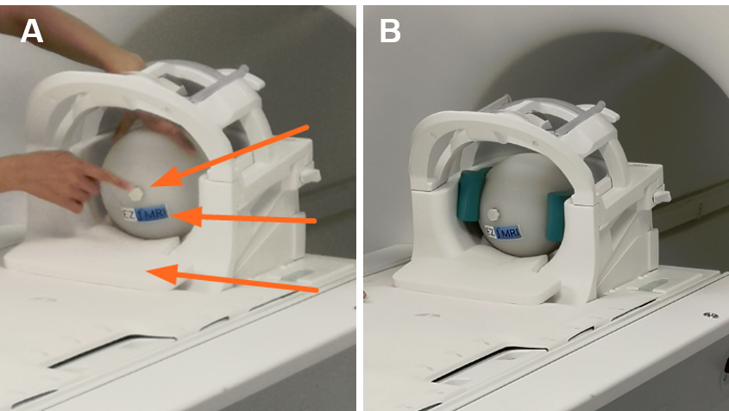

**FIGURE 1** Phantom positioning in the coil. Put a foam layer at the bottom of the coil. **(A)** Place the phantom on the foam with the lid facing out, centered in the coil. The “EZ fMRI” label is under the lid. **(B)** Fix the phantom well with small foam pieces at the back, right, and left sides. For Cima.X only: Since the angle of inclination of the coil can be adjusted, minimize this (=flat).

## Patient Registration

The patient registration page is shown in Figure 2, with information listed below. Usually the patient *QA* should already be registered. This can be checked under ‘Local Data’ (on the bottom of FIGURE 2) and a new examination may be added to the existing patient.

Last name: *QA*

Date of Birth: *01.01.2000*

Sex: *Other*

Height: *190 cm*

Weight: *91 kg*

Program selection, for example:

On Prisma: *MedPhys >> MRDAC_Studies >> QA_prisma >> QA_prisma_procotol*

On Cima.X: *MedPhys >> RSZ/MRDAC_Studies >> QA_cimax >> QA_cimax_protocol*

Body Part and Laterality: *Head*

Patient Orientation: *Head First Supine*

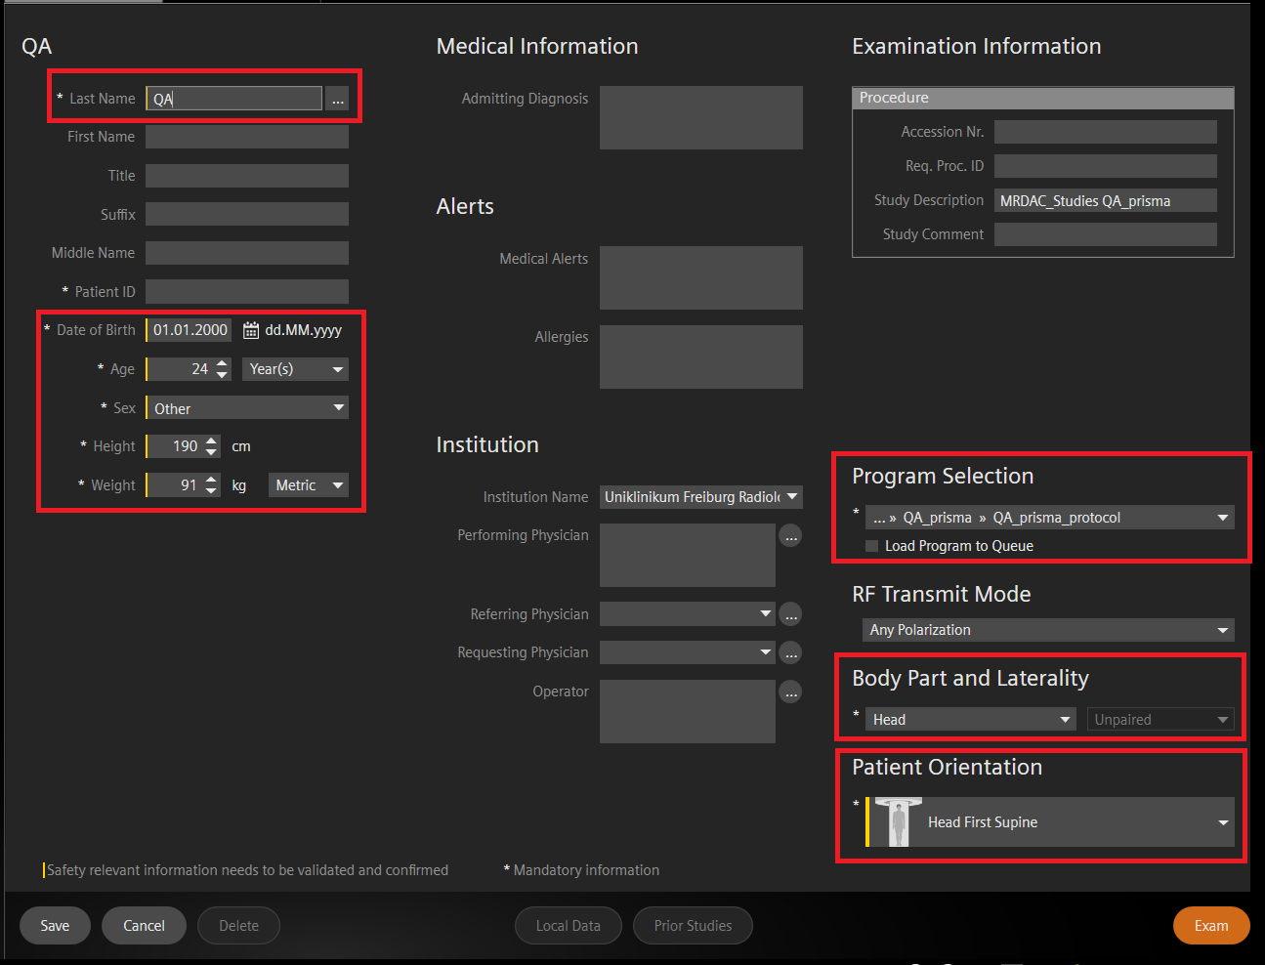

**FIGURE 2** Patient registration on Prisma.

The QA protocol is shown in Figure 3, including:

* Localizer (00:19 min)
* The SE scan (4:21 min) (not shown on FIGURE 3)
* The first fMRI scan (6:44 min)
* The second fMRI scan (6:44 min)
* The third fMRI scan (6:44 min) (not shown on FIGURE 3)

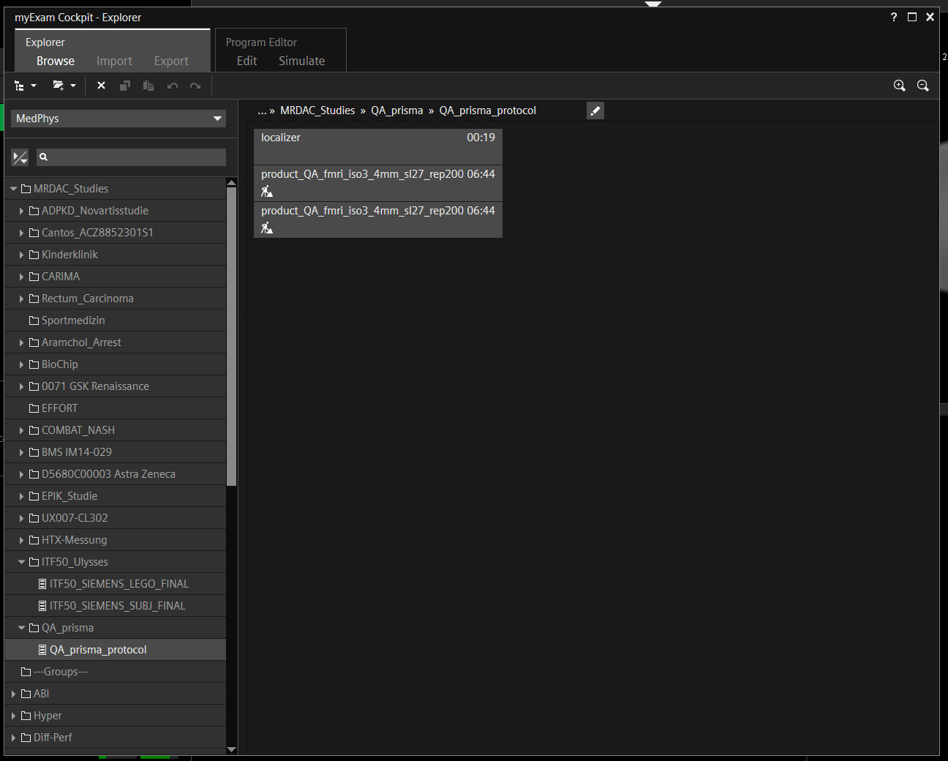

**FIGURE 3** QA protocol on Prisma.

## Imaging Procedure

**Step 1:** Turn of all lights in the scanner room. Close the door of the scanner room securely.

**Step2:** Set in-room Settings to turn off ventilation and lights, as shown in Figure 4.

**Step 3:** Run the Localizer.

**Step 4:** Open the SE sequence, adjust the FOV (yellow box) to make the phantom to be located at the center of the yellow box, as shown in Figure 5. Navigator to “Special Card” and select “ICE STD” (for NUMARIS/X) or “ICE 2D” (for NUMARIS/4) for ICE online reconstruction, as shown in FIGURE 6. Then, run the SE scan.

**Step 5:** Adjust the FOV (yellow box) to make the phantom to be located at the center of the yellow box, as shown in Figure 5. Navigator to “Special Card” and select “ICE STD” (for NUMARIS/X) or “ICE 2D” (for NUMARIS/4) for ICE online reconstruction, as shown in FIGURE 6. Then, run the first fMRI scan.

**Step 6:** Copy parameters, including the *Center of slice groups and saturation regions* and *Adjustment volume*, from the first fMRI scan to the second fMRI scan, as shown in Figure 7. Then, run the second fMRI scan.

**Step 7:** Repeat the last scan.

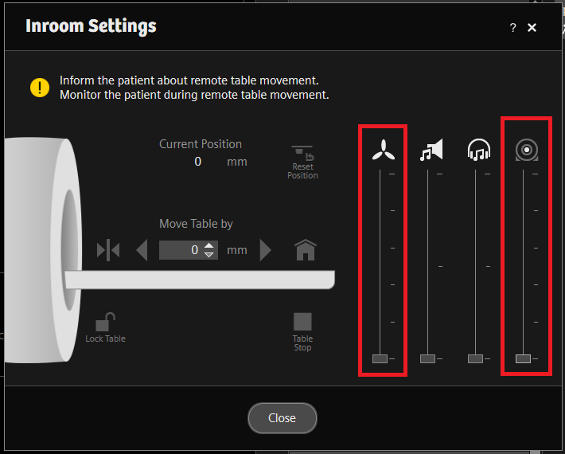

**FIGURE 4** In-room settings.

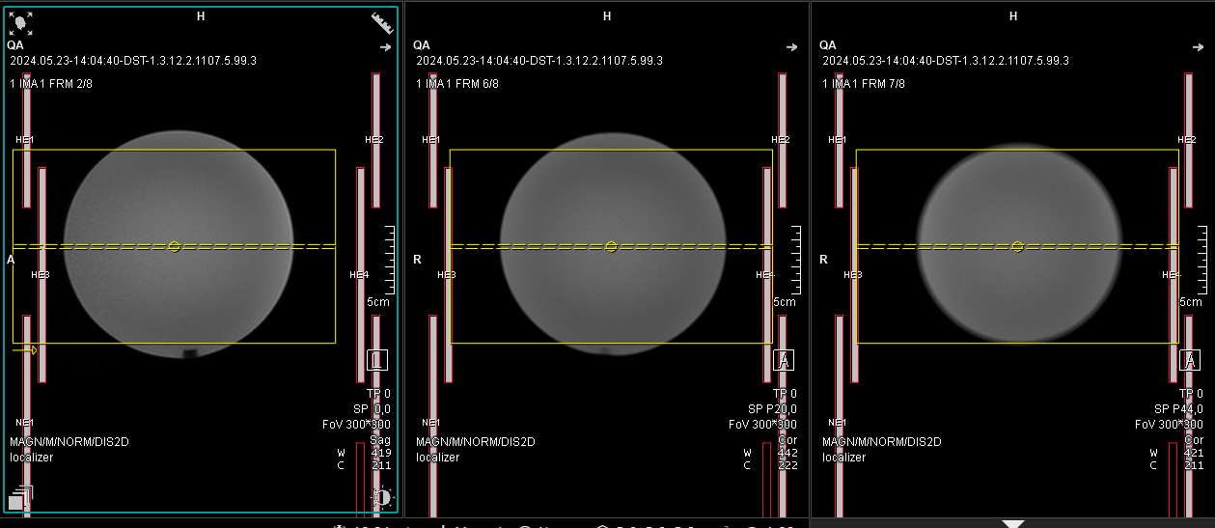

**Figure 5** FOV positioning. The yellow box is the FOV.

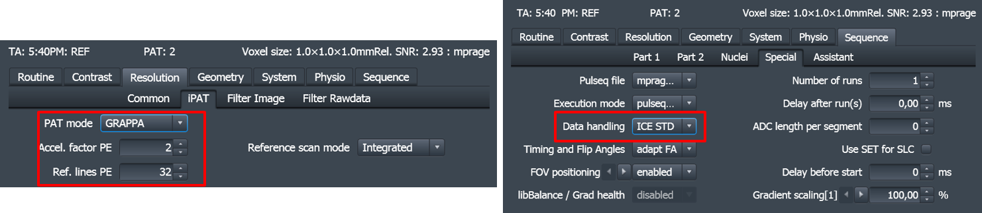

**FIGURE 6** Enable ICE online Reconstruction. “ICE STD” for NUMARIS/X (e.g. XA60A, XA61A), and “ICE 2D” for NUMARIS/4 (e.g. VB, VD, VE). Select “Sum-of-Square” for coil combination. Be sure that the maximum pixel intensity does not violate the intensity threshold of 4096.

**FIGURE 7** Copy parameters from the first fMRI scan to the second fMRI scan.

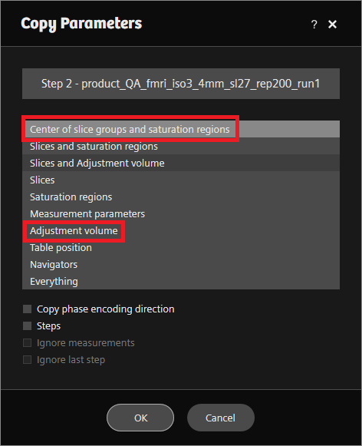

## Data Transfer

After data acquisition, transfer the raw data and the DICOM images of the SE sequence and the last fMRI scan to a proper storage place.

After data transfer, record the experiment in the Excel sheet: *QA_record*.