11 таблиц

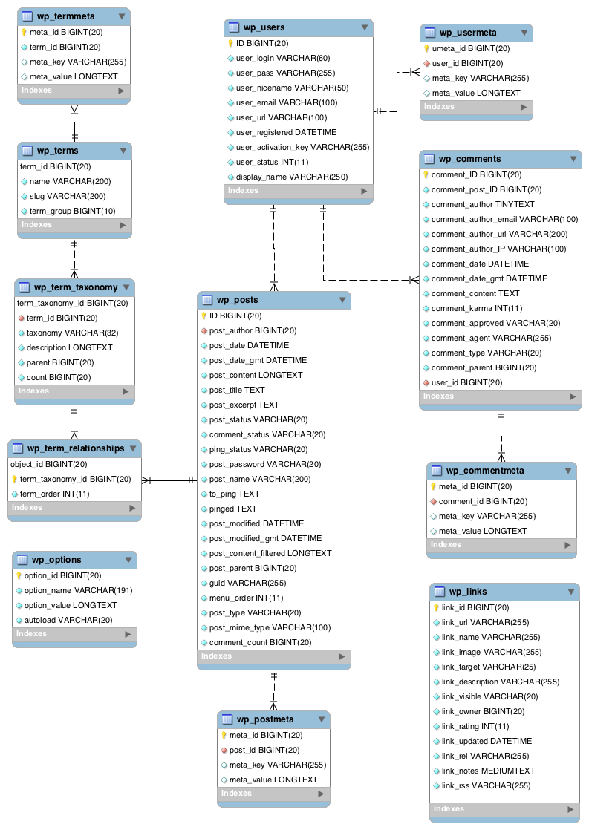
описание в https://codex.wordpress.org/%D0%9E%D0%BF%D0%B8%D1%81%D0%B0%D0%BD%D0%B8%D0%B5_%D1%81%D1%82%D1%80%D1%83%D0%BA%D1%82%D1%83%D1%80%D1%8B_%D0%B1%D0%B0%D0%B7%D1%8B_%D0%B4%D0%B0%D0%BD%D0%BD%D1%8B%D1%85#Table:_wp_users

