Enterprise Description
- Background Information: Our enterprise is a student event management system. It operates within a university campus environment and focuses specifically on managing the extracurricular activities of student life. While colleges already have a system for academic records for course enrollment and grades, there remains a significant need for a professional system to manage student bodies’ extracurricular activities. Our system mainly serves student bodies including student organizations, student membership, faculty oversight, and the planning and execution of events held across the campus.
- Operation of the Enterprise:
- Club Governance: Each club is required to appoint a faculty advisor who is responsible for providing oversight, approving planned activities, and ensuring that the organization operates in accordance with university policies.
- Student Advising: The faculty assist students in exploring different organizations and identifying groups that align with their interests. Through this advisory relationship, students receive personalized support as they engage in campus life.
- Club Membership Management: The system records and maintains information on students who join clubs. When a student becomes a member, a corresponding membership record is created, linking the student to the organization and assigning them a specific role.
- Event Management: (1) Member Events: Internal events intended exclusively for club members, including meetings, workshops, and planning sessions. (2) Public Events: Campus activities open to all students, such as fairs, cultural programs, or guest speaker sessions. The system supports event scheduling, room reservations, participant tracking, and enforcement of specific event access rules.
- The Need for the Database: A database is essential for managing campus organizations and events. For instance, LSU admitted 8,153 freshmen in Fall 2025, which is 3.8% higher from the previous year, bringing the total student population to 37,354. As enrollment continues to rise, the scale of student involvement increases proportionally. Relying on paper-based methods to manually track every detail becomes impractical and prone to mistakes. Manual systems can’t prevent duplicated records, scheduling conflicts, lost information, or inconsistencies across student organizations. Using a database is a necessary step to maintain operational efficiency, accountability, and improve the overall quality of student engagement services.
E-R Diagram
Sub-diagram:
(1) Club Governance
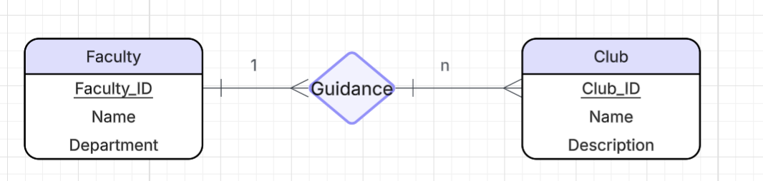
(2) Student and Faculty Advising
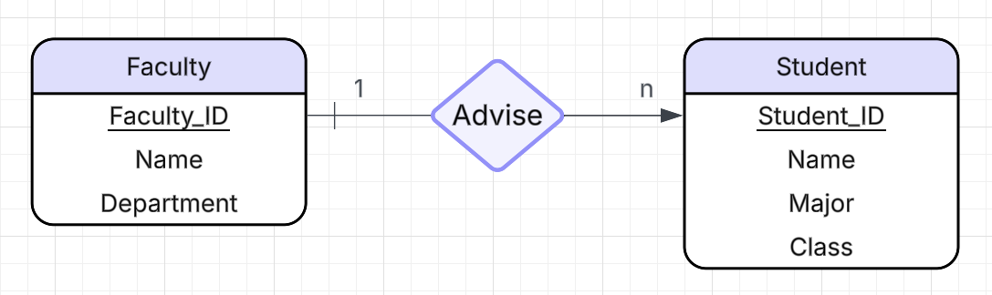
(3) Club Membership
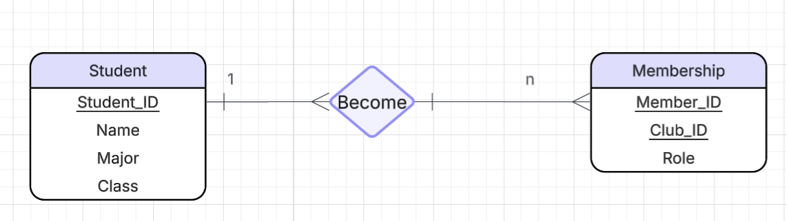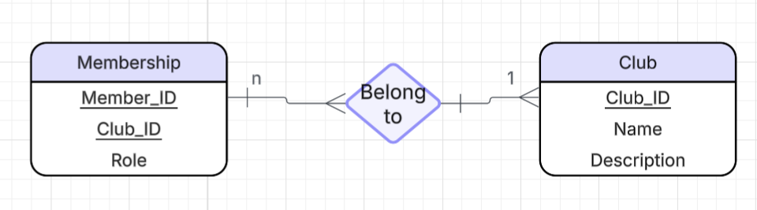
(4) Event Schedule
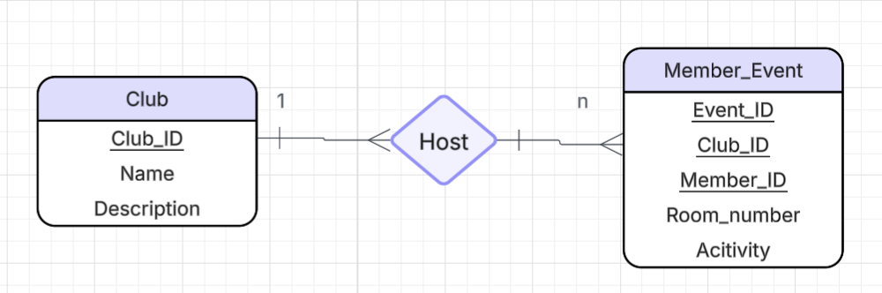
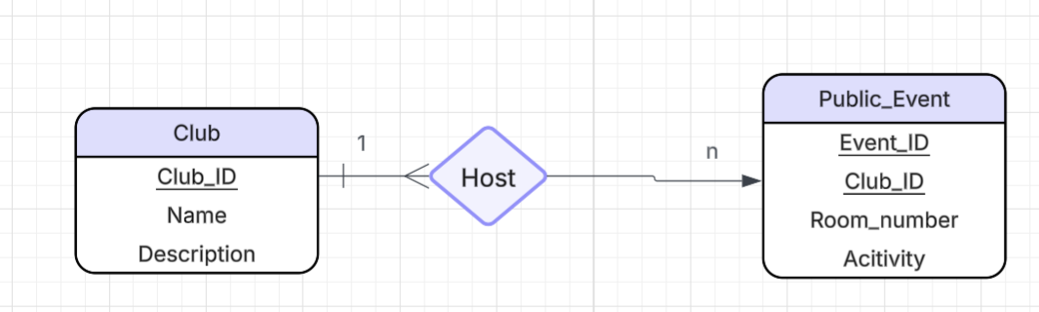
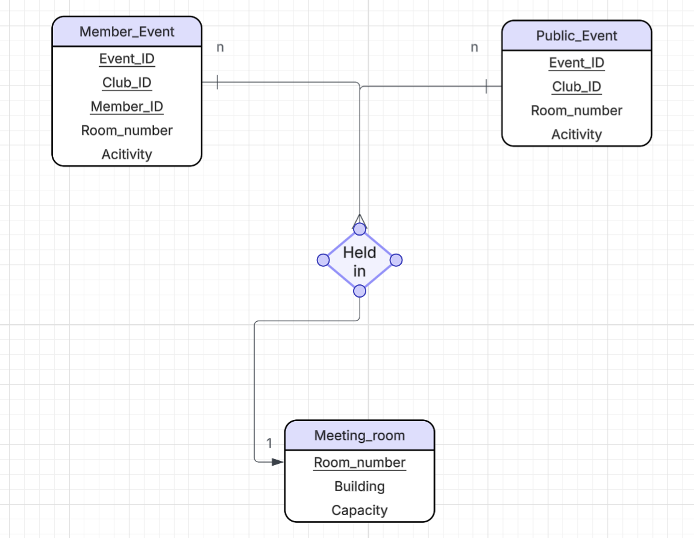
Master-Diagram:
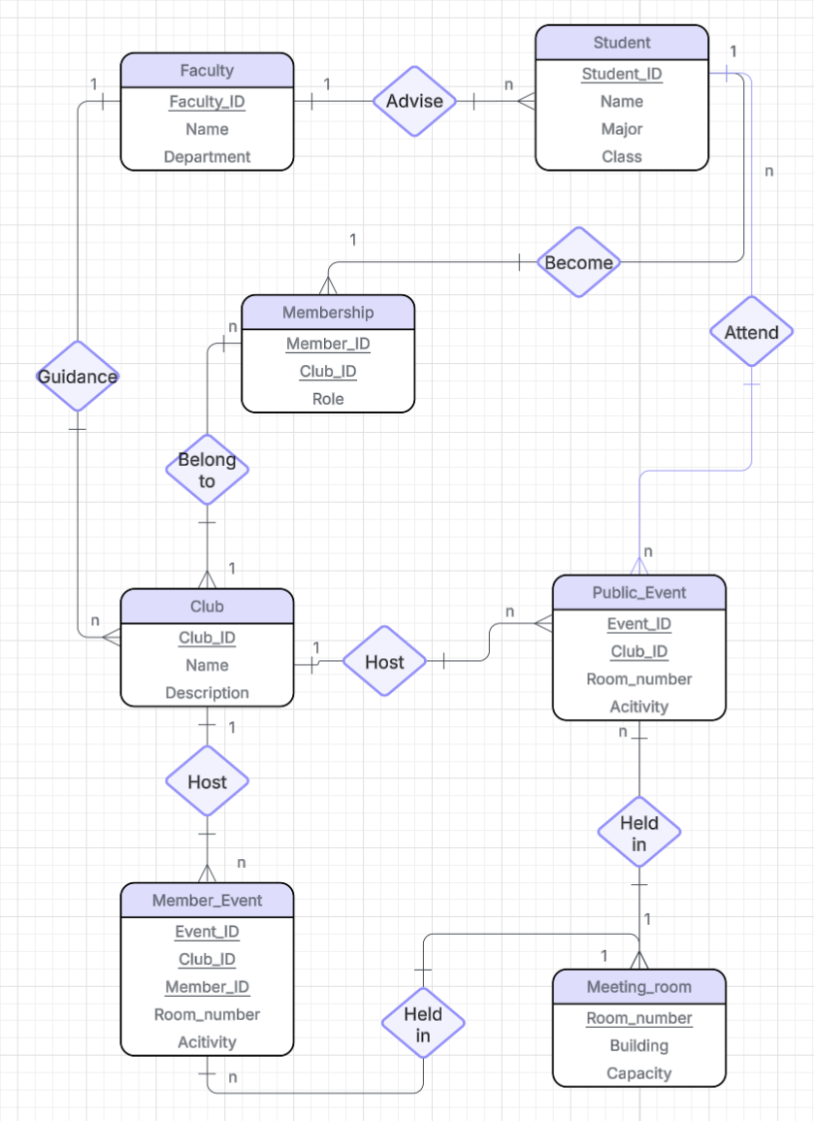
Relationship Schema
Student (Student_ID, Name, Major, Class)
- Student Entity keeps track of the students primarily through their Student_ID (sort of like a TigerID)
Faculty (Faulty_ID, Name, Department)
- Faculty Entity is primarily identifiable through their Faculty_ID, they will also be an advisor role for the different clubs
Club (Club_ID, Club Name, Description)
- Clubs will be primarily identifiable through their Club ID which can also be used to distinguish the different students, rooms and events via the clubs
Membership (Student_ID, Member_ID, Club_ID, Role)
- Membership will be an entity that shows which students are a part of which clubs on campus
Member_Event (Event_ID, Club_ID, Member_ID, Room_Number, Activity)
- Member Event will be differentiated by the public events via their Member IDs which are assigned to students via the Member IDs in the Membership Entity
Public_Event (Event_ID, Club_ID, Room_Number, Activity)
- These public events will be public and “open to all” meaning there is no requirement for membership in order for people to participate in these club events
Meeting_Room (Room_Number, Building, Capacity
- Meeting Rooms will be identifiable through their room numbers and buildings, this helps prevent overlapping in clubs hosting club events (whether public or members only) on the same rooms
Data Generation
- Drops tables if they already exist due to a prior run through
- Creates Student table
- Creates Faculty table
- Creates Club table
- Creates Membership table
- Creates Member_Event table
- Creates Public_Event table
- Creates Meeting_Room table
- Inserts values into Student
- Inserts values into Faculty
- Inserts values into Club
- Inserts values into Membership
- Inserts values into Member_Event
- Inserts values into Public_Event
- Inserts values into Meeting_Room
Test Queries
Below are five test queries that were chosen to test different parts of the database. Each query has a short explanation of what it verifies, the SQL code for the query itself, and a small example of query output from our data.
- Query 1
  - Checks that Student, Membership, and Club all join correctly, and that the role stored in Membership shows up with the correct student and club.
  - SQL:
    - SELECT
s.Student_ID,
s.Name AS StudentName,
c.Club_ID,
c.Club_Name AS ClubName,
m.Role
FROM Membership AS m
JOIN Student AS s ON m.Student_ID = s.Student_ID
JOIN Club AS c ON m.Club_ID = c.Club_ID
ORDER BY s.Student_ID, c.Club_ID;
  - Sample output:
Student_ID | StudentName | Club_ID | ClubName | Role
89450 | Jordan | 2 | Board Game Club | Member
89555 | Robert | 3 | SASE | President
89460 | Shaquille | 4 | ClubA | Vice President
89775 | Alice | 1 | Robotics | Treasurer
89651 | Cassandra | 5 | ClubB | Member
- Query 2
  - Tests the Membership to Club connection and makes sure aggregation works correctly
  - SQL:
    - SELECT
c.Club_ID,
c.Club_Name,
COUNT(m.Member_ID) AS MemberCount
FROM Club AS c
LEFT JOIN Membership AS m
ON c.Club_ID = m.Club_ID
GROUP BY c.Club_ID, c.Club_Name
ORDER BY c.Club_ID;
  - Sample output:
Club_ID | Club_Name | MemberCount
1 | Robotics | 1
2 | Board Game Club | 1
3 | SASE | 1
4 | ClubA | 1
5 | ClubB | 1
- Query 3
  - Checks the long join chain: Member_Event to Membership to Student to Club to Room. If it runs without issues, the schema is behaving as expected.
  - SQL:
    - SELECT
me.Event_ID,
c.Club_Name,
s.Student_ID,
s.Name AS StudentName,
me.Activity,
me.Room_Number
FROM Member_Event AS me
JOIN Membership AS m ON me.Member_ID = m.Member_ID
JOIN Student AS s ON m.Student_ID = s.Student_ID
JOIN Club AS c ON me.Club_ID = c.Club_ID
ORDER BY me.Event_ID;
  - Sample output:
Event_ID | Club_Name | Student_ID | StudentName | Activity | Room_Number
44000 | SASE | 89555 | Robert | Feeding other ducks | 43
45000 | Robotics | 89775 | Alice | Something important | 55
46000 | Board Game Club | 89450 | Jordan | Feeding ducks | 25
47000 | ClubA | 89460 | Shaquille | Feeding geese | 44
48000 | ClubB | 89651 | Cassandra | Feeding geese to ducks | 87
- Query 4
  - Checks filtering and the join between Public_Event and Club.
  - SQL:
    - SELECT
pe.Event_ID,
c.Club_Name,
pe.Activity,
pe.Room_Number
FROM Public_Event AS pe
JOIN Club AS c ON pe.Club_ID = c.Club_ID
WHERE pe.Activity LIKE '%duck%'
ORDER BY pe.Event_ID;
  - Sample output:
Event_ID | Club_Name | Activity | Room_Number
41000 | SASE | Something with ducks | 43
- Query 5
  - Tests both event tables are connected to Club correctly. Also shows the database can aggregate over multiple joined tables.
  - SQL:
    - SELECT
c.Club_ID,
c.Club_Name,
COUNT(DISTINCT me.Event_ID) AS MemberEvents,
COUNT(DISTINCT pe.Event_ID) AS PublicEvents,
COUNT(DISTINCT me.Event_ID) + COUNT(DISTINCT pe.Event_ID) AS TotalEvents
FROM Club AS c
LEFT JOIN Member_Event AS me ON c.Club_ID = me.Club_ID
LEFT JOIN Public_Event AS pe ON c.Club_ID = pe.Club_ID
GROUP BY c.Club_ID, c.Club_Name
ORDER BY c.Club_ID;
  - Sample output:
Club_ID | Club_Name | MemberEvents | PublicEvents | TotalEvents
1 | Robotics | 1 | 1 | 2
2 | Board Game Club | 1 | 1 | 2
3 | SASE | 1 | 1 | 2
4 | ClubA | 1 | 1 | 2
5 | ClubB | 1 | 1 | 2
Application User Interfaces
For the Application UI, we went with a simple CLI that allows the user to perform 4 commands to add, edit, delete, and view. The add command will essentially be like using INSERT INTO, the edit command will use UPDATE, SET, and WHERE in sequence, delete will use DELETE FROM, and WHERE in sequence, and view will SELECT all items from a table and display them. All CLI command prompts were illustrated on word docs to get an idea of what text prompts we wanted.
Example of add:
This example would be the equivalent of running
INSERT INTO Club (Club_ID, Club_Name, Description) VALUES
(6, ‘ClubC’, ‘description C’)
Example of add when trying to add an item with a duplicate super key:
Example of View:
This example would the SQL equivalent to SELECT * Student

Example of delete:
Participation Details
- Jordan Berger: (1) SQL code for generating test data (2) feedback for vital decisions
- Colton Elliott: (1) Five SQL test queries (2) “Test Queries” section of project report
- Huarong Teng: (1) E-R Diagram (2) Enterprise Description
- Hope McMillen: (1) Relation Schema (2) Enterprise Description
- Konor Trosclair: (1) Worked on Illustrating CLI (2) Programmed prompts for add and view commands of the CLI
- Justin Ramirez: (1) Worked on CLI illustrations (2) Programmed prompts for delete and edit commands of the CLI

