A simple Command Example

==> HELLOCMD (F4 key)

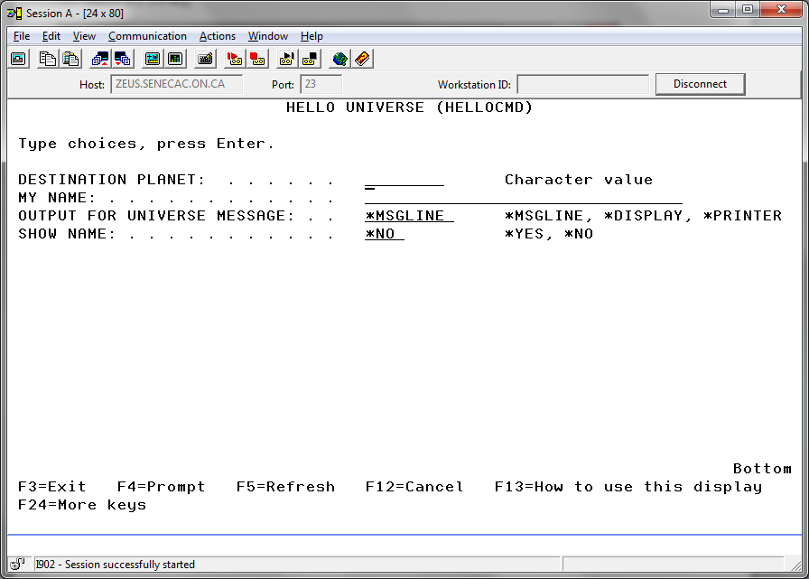

Two required parameters and two default parameters above.

Entries made on the two required parameters below:

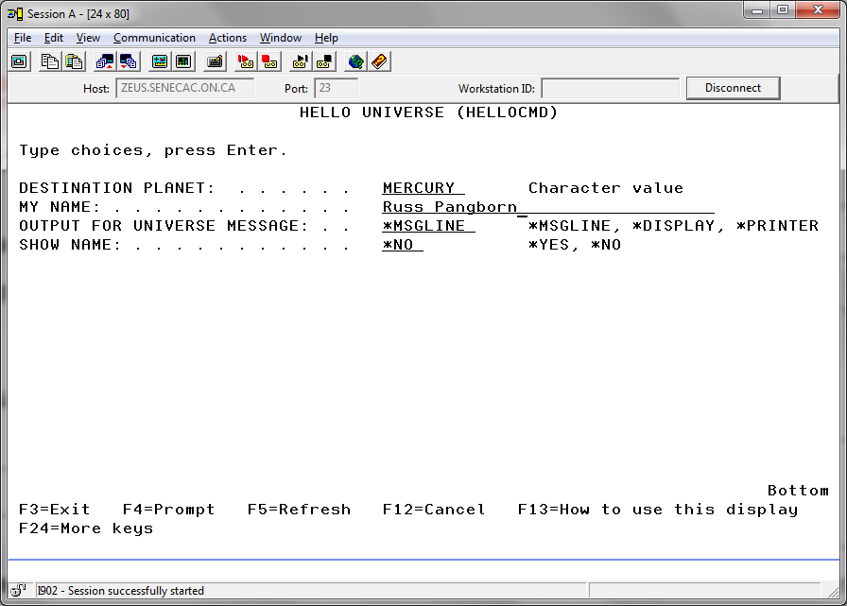

The Command Processing program being used without the help of a supporting command:

CALL HELLOCPP PARM( 'MERCURY' 'RUSS PANGBORN' '*MSGLINE' '*NO')

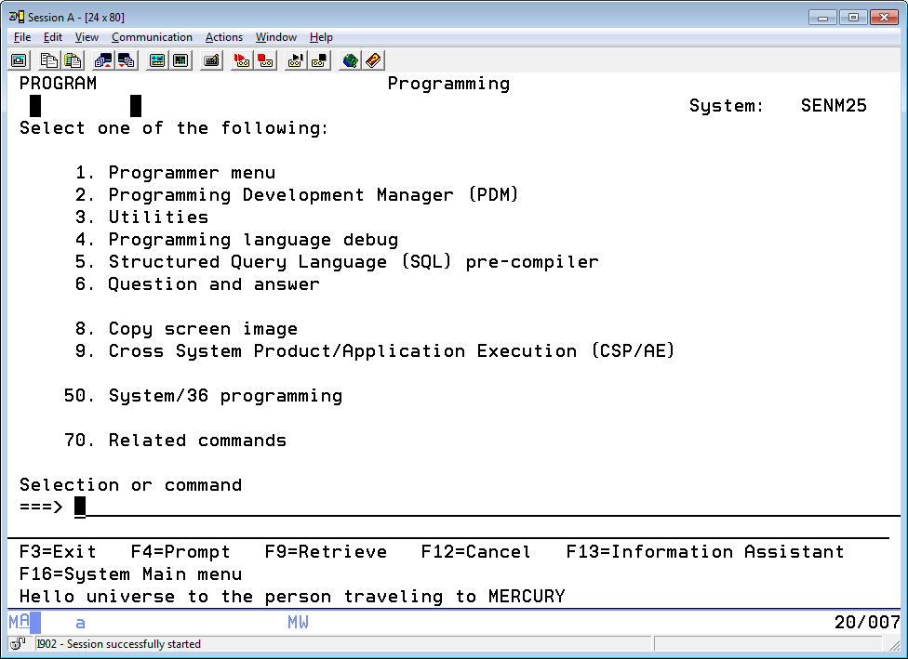

CALL HELLOCPP PARM( 'MERCURY' 'RUSS PANGBORN' '*MSGLINE' '*YES')

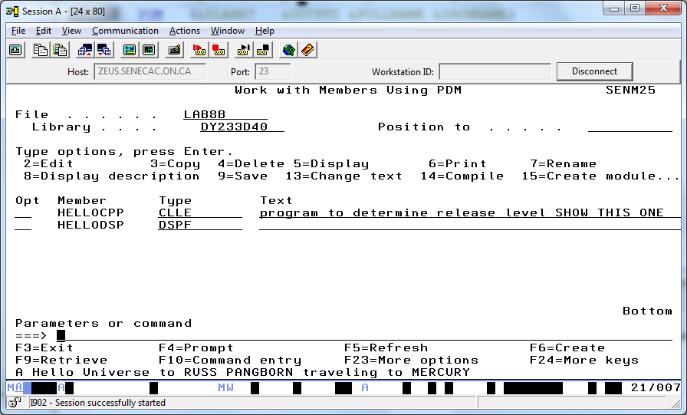

CALL HELLOCPP PARM('MERCURY' 'RUSS PANGBORN' '*DISPLAY' '*NO')

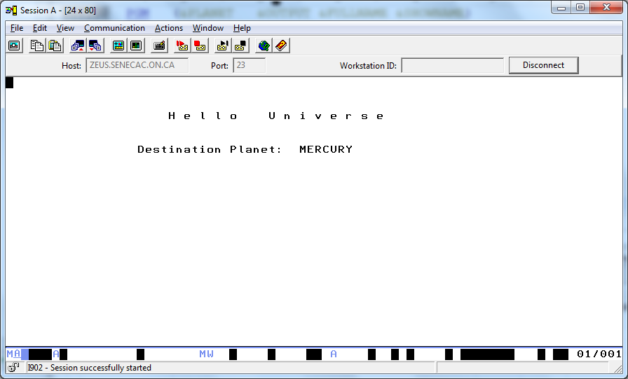

CALL HELLOCPP PARM('MERCURY' 'RUSS PANGBORN' '*DISPLAY' '*YES')

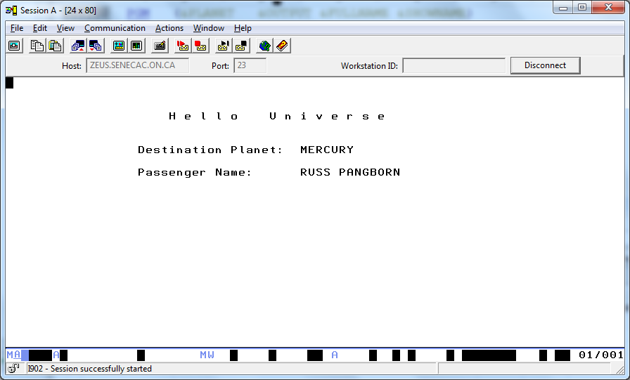

When you run the program it requires that you remember what the parameters are and the order they need to be stated.

Passed parameters to this program determine the names of the destination planet and the passenger; where to show the resulting output, and if the name will be hidden.

That is a lot to remember when running the program. With a supporting command setup we could:

allow the parameters to show with some helpful keywords or helpful text,

make it easy for the correct order of parameters to be presented to the program,

make a decision on default parameters where the user does not always need to enter information

decide what parameters are essential for this program.

Here is our silly little program:

PGM (&PLANET &FULLNAME &OUTPUT &SHOWNAME)

DCLF HELLODSP

DCL &SHOWNAME *CHAR 4

DCL &OUTPUT *CHAR 8

SELECT

WHEN (&OUTPUT = '*MSGLINE') DO

IF (&SHOWNAME = '*YES') DO

SNDPGMMSG MSG('A Hello Universe to' *BCAT +

&FULLNAME *BCAT +

'traveling to' *BCAT +

&PLANET ) MSGTYPE(*COMP)

ENDDO

ELSE DO

SNDPGMMSG MSG('Hello universe to the person' *BCAT +

'traveling to' *BCAT +

&PLANET ) MSGTYPE(*COMP)

ENDDO

ENDDO

WHEN (&OUTPUT = '*DISPLAY') DO

IF (&SHOWNAME = '*YES') CHGVAR &IN99 '1'

ELSE CHGVAR &IN99 '0'

SNDRCVF RCDFMT(RECORD1)

ENDDO

ENDSELECT

ENDPGM

Objects:

HELLOCPP – A simple CLLE program that says hello universe on a display screen or the message line.

Four parameters are passed to this program. A destination planet, your name, a choice of either the message line or a display file screen for output and a decision on whether the name you pass is shown.

A command processing program may accept one or more parameters to produce results.

HELLOCMD – The actual command that can run at the command line prompt without using “CALL” that supports easy entry of all the parameters for the HELLOCPP program.

HELLODSP – Display file used by the HELLOCPP program.

HELLOCMD stored in LAB8B

This is the code for the command:

CMD 'HELLO UNIVERSE'

PARM KWD(PLANET) +

MIN(1) +

TYPE(*CHAR) LEN(8) +

PROMPT('DESTINATION PLANET:')

PARM KWD(MYNAME) +

MIN(1) +

TYPE(*CHAR) LEN(31) +

PROMPT('MY NAME:')

PARM KWD(OUTPUT) +

TYPE(*CHAR) LEN(9) +

RSTD(*YES) +

VALUES(*MSGLINE *DISPLAY *PRINTER) +

DFT(*MSGLINE) +

PROMPT('OUTPUT FOR UNIVERSE MESSAGE:')

PARM KWD(SHOWNME) +

TYPE(*CHAR) LEN(4) +

RSTD(*YES) +

VALUES(*YES *NO) +

DFT(*NO) +

PROMPT('SHOW NAME:')

1. Keywords for each parameter are established with KWD.

HELLOCMD **PLANET**(MERCURY) **MYNAME**('RUSS PANGBORN'**) OUTPUT**(*DISPLAY) **SHOWNME**(*YES)

2. MIN(1) denotes a parameter as a required parameter. You cannot run the command at the command line without including a value for these parameters.

===> HELLOCMD MERCURY

(causes the following screen to display informing the user that a required parameter was not included)

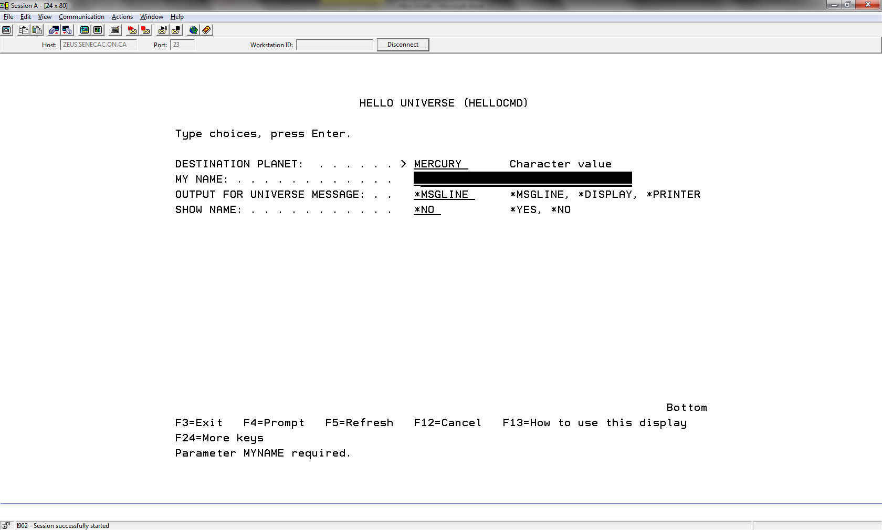

TYPE and LEN determine what is allowed

*3. TYPE can be:*

*Simple name*, *DEC, *LGL, *CHAR, *INT2, *INT4, *NAME, *GENERIC, *VARNAME, *DATE, *TIME, *CMD, *X, *HEX, *ZEROELEM, *NULL, *CMDSTR, *PNAME, *UINT2, *UINT4, *SNAME, *CNAME

4. LEN can be:

Values that use three integers. 012 would be a length of twelve so ‘XXXXXXXXXXXX’ can be entered with the *CHAR type. If it was a *DEC type then one digit would be the number of digits and one digit would be the decimal portion.

5. PROMPT:

The informative text that shows beside the area where a parameter value is to be entered.

6. RSTD

Specifies whether the value entered for the parameter (specified in the PARM statement) is restricted to only one of the values given in the **Valid values (VALUES)** parameter.

7. VALUES

The list of values allowed for a parameter.

8. DFT

Specifies the default value that is assigned to the parameter if a value is not specified by the user.

In order to create the command, the CRTCMD command requires a command processing program (we have HELOCPP) the command source (we have HELLOCMD) and the location of the command source (we are using a source physical file called LAB8B)

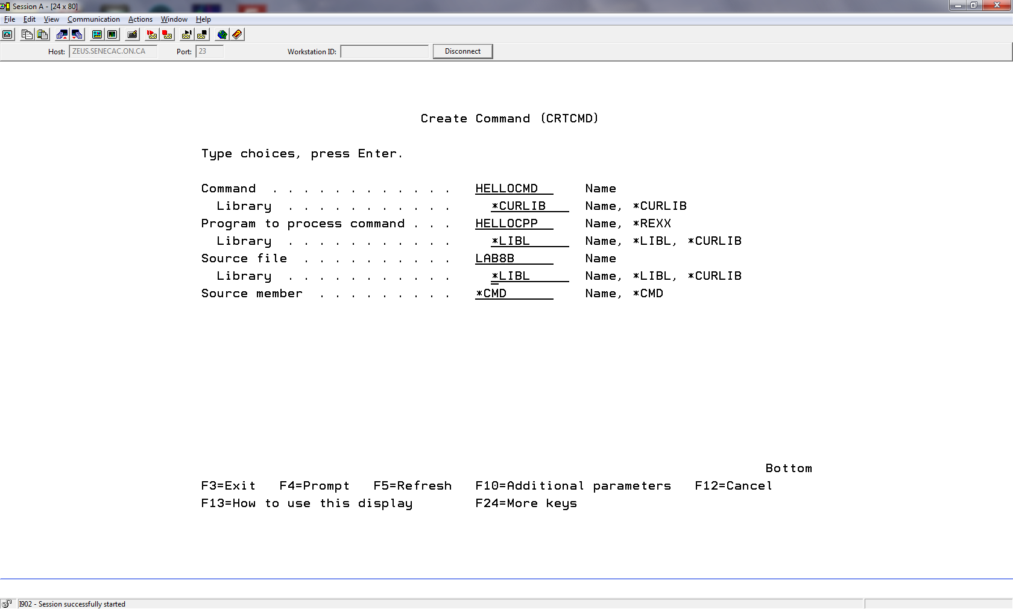

If there are no errors a command is created. If we press F9 we see:

CRTCMD CMD(*CURLIB/HELLOCMD) PGM(HELLOCPP) SRCFILE(LAB8B)

