Lab 8 Additional Help

Lab8Demo is in IBC233LIB

Create a Lab8demo source physical file in your library and copy all the members in IBC233LIB/LAB8DEMO

All the code is supplied allowing you to just practice how to put together the parts for a CLLE command that uses a display file and a CLLE program.

Compile

HELLODSP – used by HELLOCMD

HELLOCPP – CLLE program that does the command work

Use the CRTCMD command to tie in the source describing HELLOCMD to the CLLE command processing program

HELLOCPP.

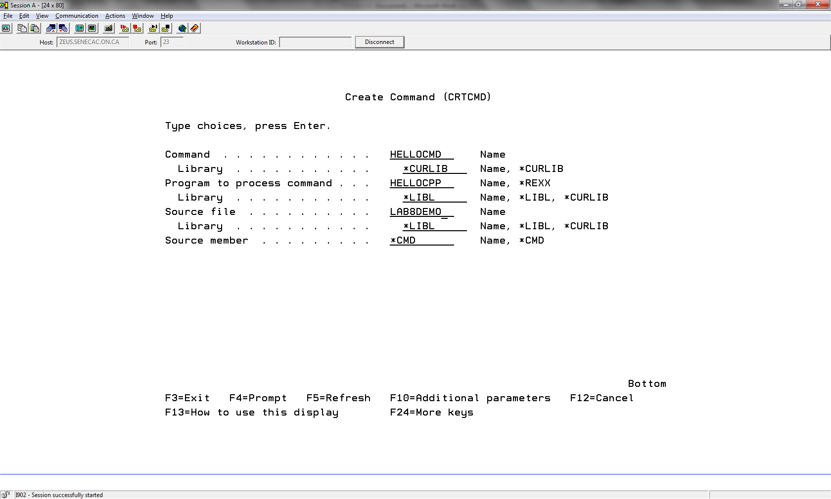

Lab 8 asks you to create a DSPSYSLVL command. Because of a missed lecture, some of the display file code is available to be copied. The second part of Lab 8 asks you to produce an RPGLE program that processes the STUDENTS file. Some of the required display file code for this application is available as well.

Create a source physical file called LAB8 and copy STUDENTHO and SYSLVLDHO from LAB8 in IBC233LIB.

A DSPSIZ(24 80 \*DS3)

A R RECORD1

A 2 3USER

A 2 30'Display System Level'

A 2 70SYSNAME

A 4 28'Version:'

A SYSLVLV 2 O 4 38

A 6 28'Release:'

A SYSLVLR 2 O 6 38

A 8 23'Modification:'

A SYSLVLM 2 O 8 38

A 11 21'F4 - Command Provided By'