**Lab objectives:**

**Create an RPGLE program that determines employee pay and combine it with the externally described printer file that was developed in Lab 9.**

**Run a file override from the command line to have your RPGLE program produce different results**

**Requirements to pass the lab:**

Successfully run the RPGLE Payroll program with and without a file override.

## RPGLE

INPUT

Add the SENECAPAY library to your library list to allow you to pick up externally described fields from the SHIFTRATES and ALLSHIFT files for your RPGLE program.

Use the Show in Table feature to look at the data in the files and the field definitions.

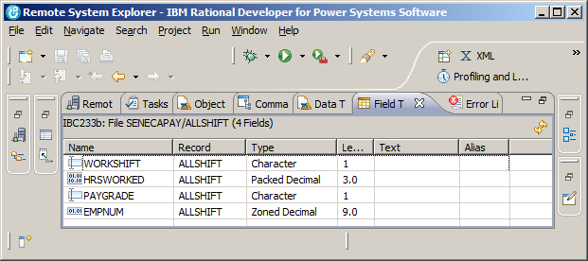

What is the field information for the ShiftRate Table?

Name Record Type Length

DAYRATE ShiftRates Zoned Decimal 5.2

NIGHTRATE ShiftRates Zoned Decimal 5.2

AFTNRATE ShiftRates Zoned Decimal 5.2

**Program**

The program you are coding should produce similar results to an RPGLE program called PayrollPgm.

This program is found in IBC233LIB and that should already be part of your library list if your initial program

is working. The data is found in the SENECAPAY library. You can either run a command to always include this library in your library list every time you sign in, or make an adjustment to your initial program when running the program in Client Access.

Your RDi workspace requires the same choice – make this an activity you have to do every time you start RDi or something that automatically happens so the compile step will be able to find the externally described files in SENECAPAY.

Run the instructor provided program in Client Access.

A screen record from a display file should show:

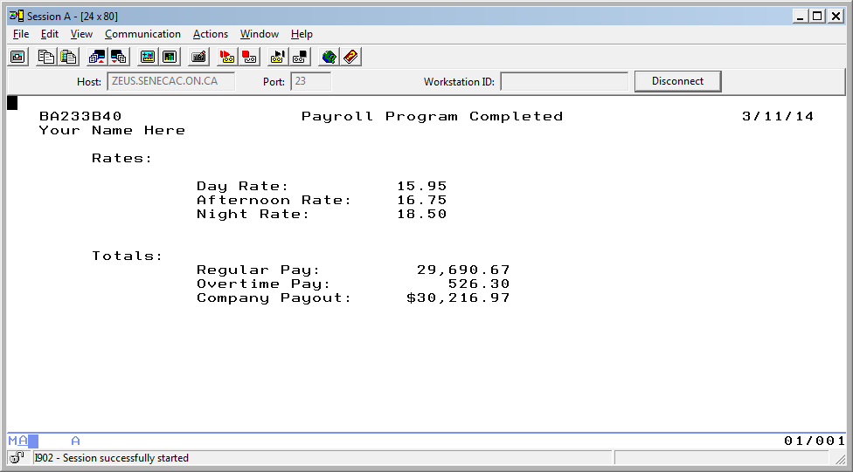

Note that your name in place of “Your Name Here” will identify your work when demonstrating the finished program.

Take a look at the output for the program in your output queue. The numbers will be different, but it should look similar to the following:

**3/11/2014 14:05:51 Weekly Payroll Report Page:0001**

**Name: Your Name**

**Employee Work Pay Hourly Hours Regular Overtime Total**

**Number Shift Grade Rate Worked Pay Pay Pay**

**333-333-333 D 1 17.31 41 692.40 25.97 718.37**

**122-222-222 D 3 15.15 35 530.25 .00 530.25**

**322-222-222 D 2 16.67 40 666.80 .00 666.80**

**...**

**567-567-567 A 3 15.91 39 620.49 .00 620.49**

**Totals: $?????????? $?????? $???????**

Your name will be included on your report.

You have already developed the externally described printer file that will be used by your RPGLE program.

All you need to do is determine which output lines get printed at specific times and how to handle overflow printing; the logic for calculating pay, overtime pay and total pay; and handle reading the records from the file.

Printing:

You have a printer record called Title. When writing this to a report, you will automatically get to a new page. This is useful at the start of the report so it does not print on the same page as an unrelated report and is useful when you want to get to a new page after reaching the overflow line while your report is printing.

**Write Title;** is the RPGLE code you need to use.

What are the other output record names supported by your externally described printer file?

for the column headings: _____________ for the detail line: ______________

for the summary line _____________

In order to handle overflow you need to select an indicator from 01 to 99 and identify it as an overflow indicator

to the program.

FFilename++IPEASF.....L.....A.Device+.**Keywords**+

FPAYRPT O E PRINTER **OFLIND(*IN01)**

This overflow indicator will be automatically turned on for you when you print a detail line on the overflow line. Usually this is line 60 on a 66 line page. This can be reset to a different line number with the OVRPRTF command.

The logic dealing with overflow can appear just before you code to print a detail line.

Basically you need to check the indicator. If it is on, print the Title output record and any other needed heading records and then ensure the indicator is turned off. (The system automatically turns this indicator on and the programmer is required to turn it off.)

Payroll Processing:

The logic to determine the amounts paid for regular pay, overtime pay, total weekly pay for the employee and totals for all employees can be handled in a subroutine. Determine a good time to invoke this subroutine in your main routine and call this subroutine PaySr.

In this subroutine you will be adjusting the HourlyRate (a field initially defined on a display file record and brought into your program at compile time.)

The first adjustment is based on one record that is found in a file called SHIFTRATES.

You should get this record at the start of your program, before you enter the loop that processes all the AllShift records.

Your WorkShift field found in the ALLSHIFT file can be a “D”, “A”, or “N” for Day, Afternoon or Night shift times.

HourlyRate will either be the DayRate, NightRate or AftnRate.

The second adjustment is based on Paygrade from the AllShift file:

Paygrade 1 - 7.3% higher rate than the rate for their shift

2 - 5.4% higher rate than the rate for their shift

3 - 4.5% lower rate than the rate for their shift

After you have determined the HourlyRate, you need to calculate the workers pay based on a 40 hour work week.

Any hours over 40 would have an overtime rate applied which is time and a half to the overtime horus.

Workers working 40 hours or less would only get their rate that you already determined based on shift time and paygrade.

After you have determined the employee pay, appropriate total fields are incremented for all employees.

Definition specifications for calculated totals

Lab 7 asked you to research fields that are work fields. These fields need to be defined and are not part of any externally described files.

Here is a sample Definition Spec, Stand Alone field that is required for the Payroll program:

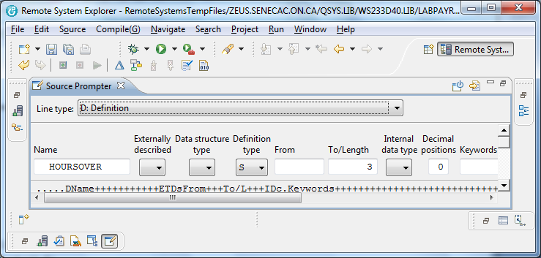

FILES:

Four files need to be declared in your program. Use the display file name CONFIRMPAY.

File Type FT (IOUC) Record Length RL

File Designation FD (PSRTF) Record Address Type RAT (ADFKPDZ)

End of File EF Device (Printer,Disk,Workstn)

File Addition FA Keywords

File Format FF (FE)

Filename FT FD EF FA FF RL RAT Device Keywords

F________________ ___ ___ ___ ___ ___ ____ ___ ________________ ______________________________________

F________________ ___ ___ ___ ___ ___ ____ ___ ________________ ______________________________________

F________________ ___ ___ ___ ___ ___ ____ ___ ________________ ______________________________________

F________________ ___ ___ ___ ___ ___ ____ ___ ________________ ______________________________________

Include the HoursOver field

Name S/U Declaration To/ Data Decimal Keywords

Type From Length Type Pos

D___HOURSOVER__ ___ ____ ___ ___ ___ ___ ____________________

// T H I S C O D E W I L L B E D E V E L O P E D I N C L A S S IF ABSENT – GET NOTES

// M A I N R O U T I N E

/FREE

READ SHIFTRATES

WRITE TITLE

WRITE COLHDG

READ ALLSHIFT

DOW NOT %EOF

EXSR PAYSR

IF *IN01;

WRITE TITLE;

WRITE COLHDG;

*IN01 = *OFF;

ENDIF

WRITE;

READ ALLSHIFT

ENDDO;

TOTEMPAY = TOTREGPAY + TOTOVTPAY;

WRITE TOTALS;

EXFMT RECORD1;

*INLR = *ON;

RETURN;

BEGSR PAYSR;

SELECT;

WHEN WORKSHIFT = ‘D’;

HOUSLYRATES = DAYRATE;

SELECT;

WHEN PAYGRADE = ‘1’;

EVAL(H)

…

// P A Y S R

BEGSR PaySr;

ENDSR;

**Produce the CONFIRMPAY display file**

It reports on the Day, Afternoon and Night rates read from the ShiftRates data file and Totals determined after reading all the AllShift records.

Compile your RPGLE program.

Run your program and check your spooled file output.

If your program is running properly, you are ready for the final phase of this lab.

File Overrides

The AllShift file contains records for day, afternoon and night shift workers.

You can isolate a single shift type of workers in your report without having to make any changes in your RPGLE program. This powerful feature is available to you by creating a view and using the OVRDBF command.

To create a view on ALLSHIFT in the SENECAPAY collection/library you need to run STRSQL at the command line in Client Access.

In your interactive SQL session:

CREATE VIEW DY233D40/NIGHTS AS

SELECT * FROM SENECAPAY/ALLSHIFT

WHERE WORKSHIFT = 'N'

RCDFMT ALLSHIFT

This view only includes night shift workers. You can compare the entire file with the view.

SELECT * FROM SENECAPAY/ALLSHIFT

SELECT * FROM NIGHT

In order to get your RPGLE program to only process night shift workers, at the command line enter the following command:

OVRDBF ALLSHIFT NIGHT

You are overriding all references to the file ALLSHIFT to be directed to the View NIGHT.

To confirm the override is in effect run the following command:

DSPOVR

If you press F3, you will be at a different invocation level and may lose the overrid

Call your program. It should only be processing the night shift workers.

The view object NIGHTS does not show the results in Employee number order.

(not the amounts and data will not be the same for your report)

**11/17/2013 15:52:32 Weekly Payroll Report Page:0001**

**Name: Your Name**

**Employee Work Pay Hourly Hours Regular Overtime Total**

**Number Shift Grade Rate Worked Pay Pay Pay**

**444-444-444 N 1 20.07 40 ????? ?????**

**522-222-222 N 2 19.33 40 ????? ?????**

**143-444-433 N 3 17.58 40 ????? ?????**

**243-343-433 N 3 17.76 40 ????? ?????**

An index can be created to show Employee number order, but we will get all shifts included.

A logical file can be used to produce an object similar to a view and also to create an object similar to an index.

A logical file can also produce an object that can’t be created with SQL. We will produce this object in our next lab. This logical file will only show night shift workers and will also present those records in employee number order.

Authorities

What change needs to be made for the *Public in order for students to build views over SencaPay/AllShift?

