Game Design Document

Fill up the following document

1. Write the title of your project.

# “*Alien-Ventures:the Beggining* ”

1. What is the goal of the game?

To make players feel the experience of adventures

1. Write a brief story of your game.

An Adventurer wents out on a journey and accidently found a portal linking to planet ***‘hsb-001’.***

He has to find a way back to his own planet.on his way,he has to cross

many hurdles,interact with mobs,gather tools,equip himself with

armour and practice parkour for his final stage.

1. Which are the playing characters of this game?

Playing characters are the ones who respond to the user based on the input from the user.

* Cars, monkeys, dinos, wizards, etc., are the playing characters in the game.

|  |  |  |
| --- | --- | --- |
| Number | Character Name | What can this character do? |
| 1 | Zen | The main character |
| 2 | Jim | The supporting character(only for multiplayer game in future) |
| 3 | Crabster | Mob |
| 4 | snailer | Mob |
| 5 |  |  |
| 6 |  |  |
| 7 |  |  |
| 8 |  |  |

1. Which are the Non-Playing Characters of this game?

* Non-Playing characters are the ones that don't have an action or behavior when the user interacts with the game.
* Hurdles, stones, bananas, coins, etc., are non-playing characters in the game.

|  |  |  |
| --- | --- | --- |
| Number | Character Name | What can this character do? |
| 1 | tunnel | Can block the way and is home for many mobs |
| 2 | Ion cubes | Will be useful for the final stage and equipments |
| 3 | stairs | climbing |
| 4 | wood | crafting |
| 5 | Sub-Moth | Vehicle for underwater diving |
| 6 | Titanium scraps | Base metal for crafting tools and more |
| 7 | All 118 Chemical elements(IN LATER VERSIONS) | For crafting different objects to escape from planet |
| 8 |  |  |

Draw your imagination of this game. What does this game look like?

* Draw the game either on your computer or on paper.
* Add images of the game scenes to show each of the playing and non-playing characters at least once.

SUB-MOTH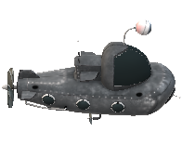

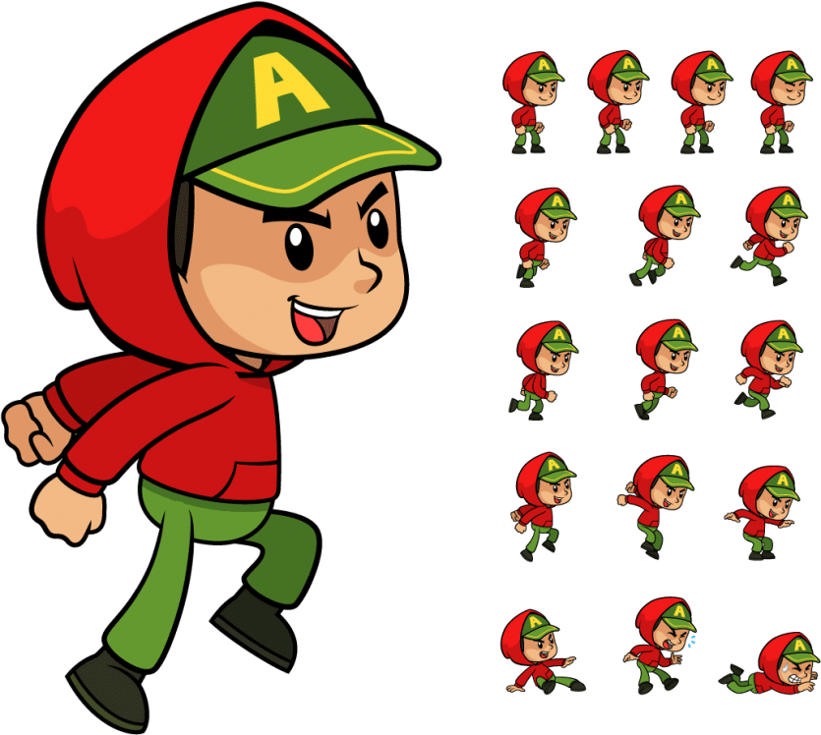

zen

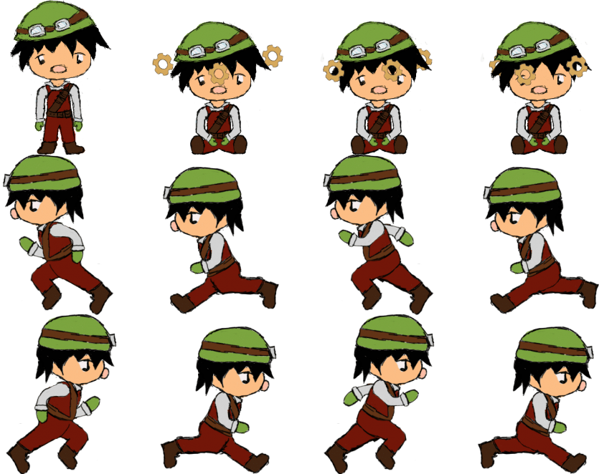

ION CUBE:

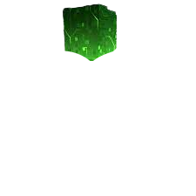

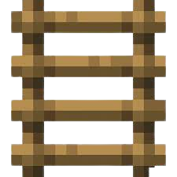

LADDER

TUNNELTITANIUM INGOT

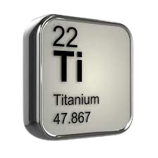

WOOD:

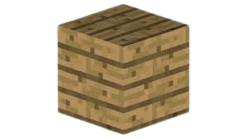

m

How do you plan to make your game engaging?

I will release some more versions of this game on web introducing more mobs and difficulties which will make game engaging.