Support My Drum Machine?
What Tiny-Spice could support my drum machine project?
Could I, for example, trim R or C values live and have the waveforms play on the speaker?
Would I eventually hook this up to my verilog simulator and let that handle any big digital blocks?
Opamps and transistor models are only a few circuits away.

The Point
What is the point of this? It’s never going to be accurate enough to write wav files that will sound anything like the hardware will produce. It’s just solving sudukos. Maybe that’s enough. I could say it’s “educational”.

Damped Oscillator
The first thing to be able to simulate would be the heart of the drum machine: the damped oscillator.
I stole this from a youtube video by lookmumnocomputer which in turn stole this from an old 1978 electronics magazine.
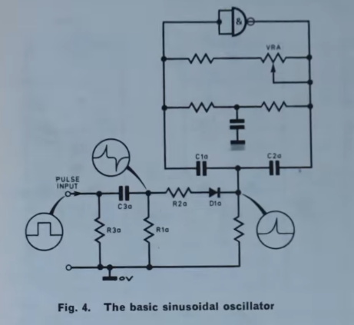
The things that Tiny-Spice v0.8.0 cannot do are:

- Arbitrary PWL sources – for the squarewave input.
- The NAND gate/inverter.
- Write out a WAV file for playback.
Tantalisingly close...

Values
From the same video:
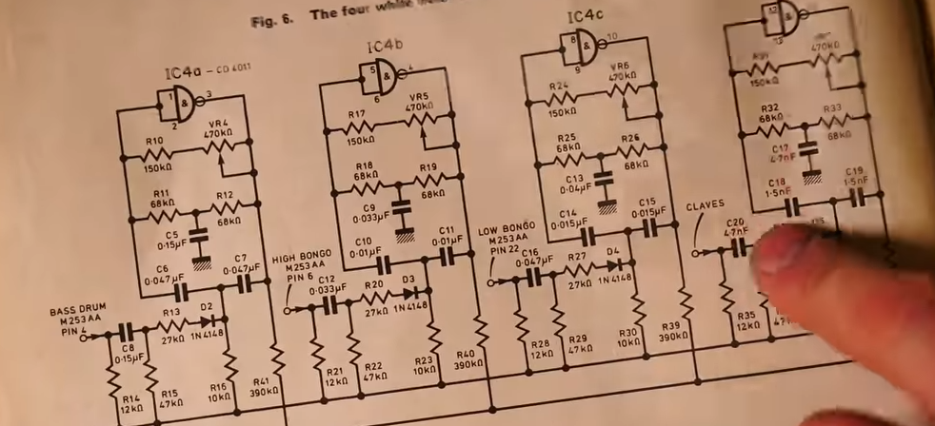
The resistors are the same values for the trigger circuit, but the cap value depends on the drum type. Classic parameterisation opportunity!

Source: Piece-Wise Linear (PWL)
Adding a PWL source would allow me to simulate the bottom part of the circuit. That circuit turns a pulse output from a sequencer into a small trigger pulse.
NGSPICE manual shows this kind of stuff:
PWL ( T1 V1 < T2 V2 T3 V3 T4 V4 ... >) <r = value > < td = value >
Examples:
VCLOCK 7 5 PWL (0 -7 10 NS -7 11 NS -3 17 NS -3 18 NS -7 50 NS -7)
+ r =0 td =15 NS

Each pair of values specifies the value v_i at time t_i. The values at intermediate time intervals are linearly interpolated.
The repeat value:
- -1 or not given, repeat once
- 0 is supposed to repeat forever, but that’s only if you spec a 0 timepoint
- if r matches a time point, repeat from that time point forever
The delay value is td. The entire sequence is delayed by this value.
I’d only need to support, say (a) and (b) and (c). Fuck (d). What about the delay?
I only need a voltage source version.

The Inverter
The circuit in the video above uses a logic inverter. I think it’s essentially using it as an inverting amplifier to get oscillations going.

An Opamp
For my simulator, I can either model a logic gate, or maybe more generally useful for now, model an opamp. And for that, maybe I need to do a voltage controlled voltage source (VCVS) that can take a signed K parameter for the gain?
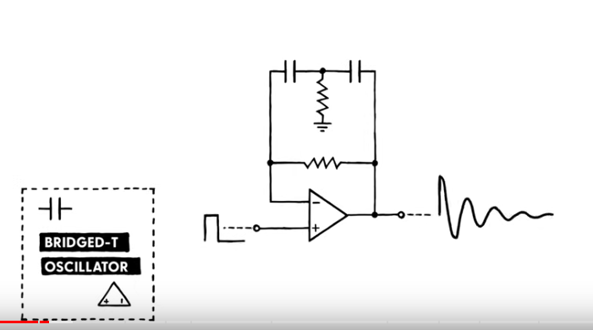

An Opamp Model
Turns out opamp modelling is a rabbit hole. What are the minimum things that an opamp should do for my purposes?
- Transient analysis support
- Gain
Worry about output limiting and frequency shaping as i need it. This means I need to implement VCVS so I’ll implement VCCS too while I’m at it?
https://www.ece.mcgill.ca/~grober4/SPICE/SPICE_Decks/1st_Edition_LTSPICE/chapter2/Chapter%202%20Op%20Amp%20web%20version.html

KiCAD Forum Notes
https://forum.kicad.info/t/universal-opamp-spice-macromodels/19770
Holger:
“Switches are often not a good choice for transient simulation because they produce steps, and the derivative of their response is not continuous. The VSWITCH model (you need PSPICE compatibility enabled by placing
set ngbehavior=ps
into a .spiceinit file in your home directory) has smoothed out corners.
Holger:
The best solution may be to use the simple diode (manual chapt. 12.2.29 SimpleDiodeModel ). This model consists of three regions (on, off, breakdown). Each region is modelled by a resistor. The region boundaries are set by Vfwd and Vrev and are smoothed out by a quadratic smoothing function with range ± ?epsilon. In addition you may set a (smooth) current limit. This model is also available in LTSPICE.

Voltage-Controlled Sources
Implement VCVS (E) and VCCS (G).
- Floating input: ip and in
- Floating output: op on
- A single gain parameter: k
  - allow this to be a bracket expression
The PWL, E & G models were implemented in 0.9.0. There are basic DC unittests for E, G and two flavours of opamps – one using E and one using G.

Kickdrum Circuit Simulation
Here’s the circuit and some waveforms:
Kick Drum implemented as T bridge

* Kickdrum
.subckt kickdrum trig out
C1 fb t 10nF
C2 t out 10nF
R1 t gnd 1k
Rfb out fb 10k
Xoa trig fb out opamp
.ends kickdrum

* opamp
* CMOS book says VCCS converge better
.subckt opamp ip in out
Gitgud out gnd ip in 1000k
Rl out gnd 1
.ends opamp

Vgate gate gnd PWL(0,0, 99us, 0v, 100us,5V, 5ms,5V, 5.01ms, 0V)
Xkd gate out kickdrum

.control
tran 1u 10ms
plot v(gate) v(out)
.endc
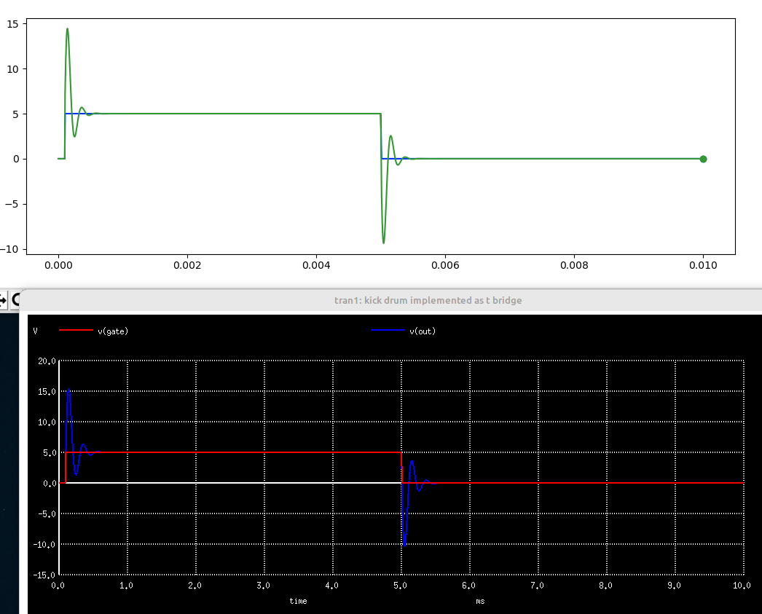

Libraries
The next thing i think i want to do is to reuse the kickdrum circuit and the trigger circuit and combine them.
For this, i think i want to support libraries and maybe “.param” statements. I don’t think i want to do libraries with a .lib statement. But then, i’d be straying from how ngspice does things.

