Tiny Spice
Circuit Simulation
Table of Contents
Constructing the Voltage Node Matrix 3
Example Circuit 3
Current Flow Convention 4
Solver Algorithm 4
Example 5
I1 1 0 3 5
R1 1 2 10 5
R2 2 3 10 5
R3 2 0 5 5
R4 3 0 5 6
Gaussian Reduction 7
Back Substitution 7
Thinking Ahead 7
Newton Raphson 8
The Equations 8
Example 9
Working 9
I1 1 0 3 9
R1 1 0 2 9
R2 1 2 1k 10
D1 2 0 10
Guassian Elimination 11
GMIN 12
The Implementation 12
Modified Nodal Analysis 13
Algorithm 13
References 13
Nonlinear Stuff 14
Linearisation 14
Initial Guesses 14
Implementation 14
Convergence 15
Diode Companion Model 15
Transient Analysis 16
Time-marching: Iteration-based 16
Sinewave Source 17
Initial Results 18
Capacitors 19
Results 19
Cycles 21
Colon 22
Capacitors 23
Tests 23
SPICE2 – diode voltage limiting 24
Precision f32 vs f64 25
SPICE Engine Flowchart 27
Opamp Macromodel Feedback Networks 28
Testing 30
Research 31
Transient? 31
SPICE 31
Original SPICE Thesis 31
Comparison of some simulators 31
SPICE Survey 31
Nonlinear Devices 31
Stamps 32
General 32
Waveform Formats 32

Constructing the Voltage Node Matrix

Example Circuit
Let's go through the steps to build the voltage node matrix for the following circuit:
2

R1
R2
R3
R4
1
3
0
n+
n-
The SPICE for this looks something like:
I1 0 1 3 ; current flows from n+ through to n-
R1 1 2 5
R2 2 3 5
R3 2 0 10
R4 3 0 10

Ngspice gives:
******
** ngspice-26 : Circuit level simulation program
** The U. C. Berkeley CAD Group
** Copyright 1985-1994, Regents of the University of California.
** Please get your ngspice manual from http://ngspice.sourceforge.net/docs.html
** Please file your bug-reports at http://ngspice.sourceforge.net/bugrep.html
** Creation Date: Sat Jun 18 21:22:25 IST 2016
******
Circuit: * build 002 example

Doing analysis at TEMP = 27.000000 and TNOM = 27.000000

No. of Data Rows : 1
v(1) = 3.300000e+01
v(2) = 1.800000e+01
v(3) = 1.200000e+01
ngspice-26 done

Current Flow Convention
Positive current is assumed to flow from the positive node, through the source, to the negative node.
A current source of positive value forces current to flow out of the N+ node, through the source, and into the N- node.

Solver Algorithm
Iterate through each circuit element in the SPICE netlist and update the node equations as we go. This way, I think I can get away without building an adjacency list or anything like that.
- We'll include the ground node so I don't have to special-case the code everywhere.
- Matrices and vectors are 0-indexed, with index 0 being the ground node.
- Negative current flows out of a node.
The basic algorithm is something along the lines of:
- Take a sweep through the circuit and count the nodes. Assume that the node names have been replaced with integer indices starting from 1 (ground is 0, as always).
- Use the node count to size the voltage matrix, and the current vector.
- Go through each element in the circuit and update the matrix and current vectors appropriately.

Example
After counting the nodes, we get 4. Initialise the matrix as so:

I1 1 0 3
This means 3A flowing into node 1, and -3A out of ground.

R1 1 2 10
For this there are two things:
- Firstly, (v1 – v2)/R1 out of node 1
- Then (v2 – v1)/R1 out of node 2

R2 2 3 10
Again:
- Firstly, (v2 – v3)/R2 out of node 2
- Then (v3 – v2)/R2 out of node 3

R3 2 0 5
Then:
- Firstly, (v2 – v0)/R3 out of node 2
- Then (v0 – v2)/R3 out of node 0

I know v0 = 0V, but for the sake of not introducing special cases, roll with it.

R4 3 0 5
Finally:
- Firstly, (v3 – v0)/R4 out of node 3
- Then (v0 – v3)/R4 out of node 0

Gaussian Reduction
This reduces a matrix to its row echelon form, so that back-substitution can be used to solve all the variables one-by-one.
For our example above, we'll first combine the voltage matrix and the current matrix into an augmented matrix.

And now the aim is to convert it to this form:

Then, solve…

Back Substitution
N=3

Loop i = 3 → 1

Thinking Ahead
This is straight-forward for current-sources and resistors. But what happens when the currents become nonlinear? How do I store a function in the matrix? Or are these more likely to go in the current vector? Either way, things'll get messy. Do I store a list of functions that also must be applied to the vector or something?

Newton Raphson

The Equations
Iterate this:
(a)

Forward biased diode:
(b)

Example KCL node equation with a forward-biased diode:
(c)

Matrix solver version
(d)

For Newton-Raphson:
(e)
and
(f)
so:
(g)
That's a really bad example.

Example

R2
R1
1
2
0
n+
n-
The SPICE for this looks something like:
I1 0 1 3 ; current flows from n+ through to n-
R1 1 0 2 ; about 5V on v(1)
R2 1 2 1k
D1 2 0 ; error, but a default model is used

Ngspice gives:
No. of Data Rows : 1
v(1) = 5.989418e+00
v(2) = 6.981910e-01

Working
After counting the nodes, we get 2. Initialise the matrix as so:

I1 1 0 3
This means 3A flowing into node 1

R1 1 0 2
Resistor to ground: (v1 – v0)/R1 out of node 1

R2 1 2 1k
For this there are two things:
- Firstly, (v1 – v2)/R2 out of node 1
- Then (v2 – v1)/R2 out of node 2

D1 2 0
And now the diode:

Guassian Elimination
Want to get a 0.0 in the bottom left-hand corner.

Options are:
- swapping
- multiply a row by a non-zero scalar
- subtracting multiple of another row
I'll stick some numbers in:

Scaling factor: α = 0.001 / 0.501

GMIN
Minimum conductance between nodes in the circuit?
Also, GMIN goes across each PN junction in the design to aid convergence.

The Implementation
How the fook? I can get as far as (a) can I? Nope, can't even represent a function in the ampere vector.
I think I need a sum of equations that know what their derivative is.

Modified Nodal Analysis
Basic KCL doesn't handle voltage sources that well – or at all, really. Modified Nodal Analysis (MNA) help with this.
The basic idea is to solve some branch currents as well as the node voltages. You write:
- an equation for each node not a voltage source, KCL as usual
- and an equation for each voltage source
You end up adding a term for each of the currents flowing through the voltage sources (from p through the source to n).
So for this circuit (taken from MNA2.html below):
q
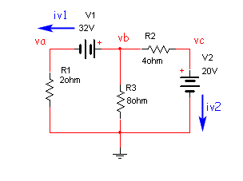
You get this matrix to solve:

Algorithm
To size the matrix, need: number of nodes & number of voltages.
Then can I just throw this at the Guassian Elimination solver?

References
- https://www.swarthmore.edu/NatSci/echeeve1/Ref/mna/MNA2.html

Linear Dependent Sources: E & G
Control voltage with a VCCS and a VCVS. There are 3 nodes (not including ground) and there is one voltage source, so a 4x4 matrix:
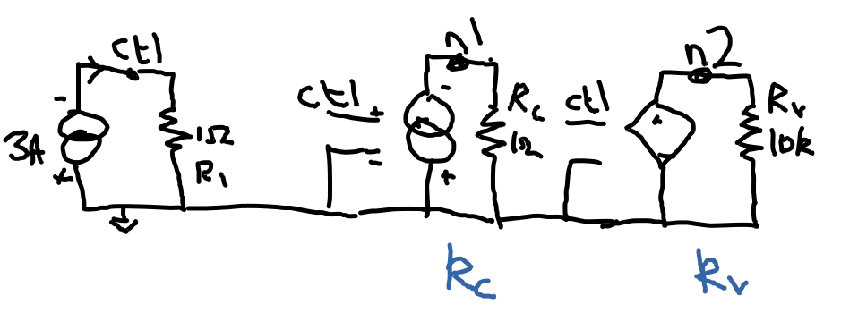
Initially, like this:

Next, stamp the control voltage. Into ctl is 3 A, out of it is -1/R1.

Current source: kc * v(ctl) into n1 where kc has units of A/V. Out of n1 is -1/Rc. Why do I not put kc in the current vector like the 3A went? Cos it has to be multiplied by v(ctl).

I think the VCVS is 2 steps: KCL around n2 and KVL around it too?

(a), (b)
I’m not a fan of how Rv made it into the bottom right. If I’m stamping the V for the VCVS, how would I even find Rv? What if there’s more stuff connected?
What about this instead? Nah, same problem, I need to multiply by kv.

Nonlinear Stuff
So, I was thinking of a datastructure for nonlinear eqns that I'd keep in the matrix and evaluate at each time step. But this isn't the way things are done.

Linearisation
As I noticed, things like resistors and current sources “stamp” the matrix and the RHS in characteristic ways.
For nonlinear devices, linearise the nonlinear devices around an operating point. Then the linearisation is stamped into the system equations, and Gaussian elimination happens, etc.
We go round this loop of linearising and solving until all the unknowns start to settle. Settling is defined with ABSTOL and VNTOL.
This loop is Newton-Raphson, apparently.
http://www.ecircuitcenter.com/SpiceTopics/nonlinear%20Analysis/nonlinear%20Analysis.htm

Initial Guesses
I'm not sure how initial guesses go.

Implementation
- Create a matrix and LHS for all linear devices in the circuit. Store this away as a skeleton matrix/LHS.
- Loop:
  - Copy skeleton matrix to working matrix/LHS.
  - Foreach nonlinear device:
    - Linearise
    - Stamp working matrix/LHS
  - Solve using Gaussian Elimination, etc.
  - Check for convergence
    - Converged?
      - Break
    - Check max iteration count:
      - Under? Go around loop
      - Over? Error out.
- Print results
- Bask in glory

Convergence
Again, from http://www.ecircuitcenter.com/SpiceTopics/nonlinear%20Analysis/nonlinear%20Analysis.htm

By default, RELTOL is set to 0.001 (0.1%).
VNTOL ensures that the limit does not get too small, it's usually 1uV.
ABSTOL does the same thing for currents, and is usually 1pA.
I'd have to check that all the elements of the unknown vector converge.

Diode Companion Model
This:
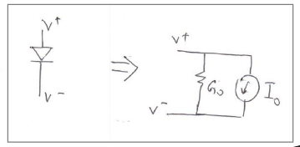

Here's what the diode transfer function looks like:
Diode transfer function. Check out the Amperes on the y-axis.

Transient Analysis
For this to be useful I need:
- time-stepping algorithm
- write waveforms to a file
- a sine-wave source
Then I can add capacitors and inductors, for which I'll need to:
- write a numerical integration thing
- update the DC operating point thing to do the right thing with these

Time-marching: Iteration-based
Used in SPICE2, LVLTIM = 1
Keep track of an internal delta-time (t_delta), which is increased or decreased depending on the Newton-Raphson iteration count. It's kinda keeping track on how difficult Newton-Raphson is getting it finding a solution for us.
- FS (default 0.25) – sets initial t_delta from TSTEP * FS
- FT (default 0.25) – fraction that t_delta is reduced after failure of convergence (iteration count > ITL4)
- RMIN (default 1e-9) – smallest t_delta time step allowed. Causes the dreaded “time step too small” error message.
- RMAX (default 5) – set largest t_delta time step allowed:
t_delta_max = TSTEP * RMAX
- ITL3 (default 6) – lower limit on iteration count.
If Newton-Raphson can converge in fewer trials than set by ITL3, then it's finding it handy. So we'll double t_delta to save some CPU cycles.
- ITL4 (default 20) – upper limit on iteration count.
If Newton-Raphson is hitting this iteration count, then it's in trouble. So reduce the timestep to t_delta*FT and restart the solution attempt. Keep an eye on RMIN too.

Sinewave Source
Independent source. Although it relies on the time.
SPICE for a sinewave source is of the form:
V1 1 0 SIN(VO VA FREQ TD THETA)
From the Ngspice manual:
- VO – Offset
- VA – Amplitude
- FREQ – Frequency
- TD – Delay
- THETA – Damping factor
The ones in bold, I'll implement.
The formula then is:

So I'll need time pumped into whatever I do.
Also, this can be applied to current (I) or voltage(V) sources. How do I abstract this out then? Or is this too simple to bother abstracting?

Initial Results
Simulation of a diode bridge:
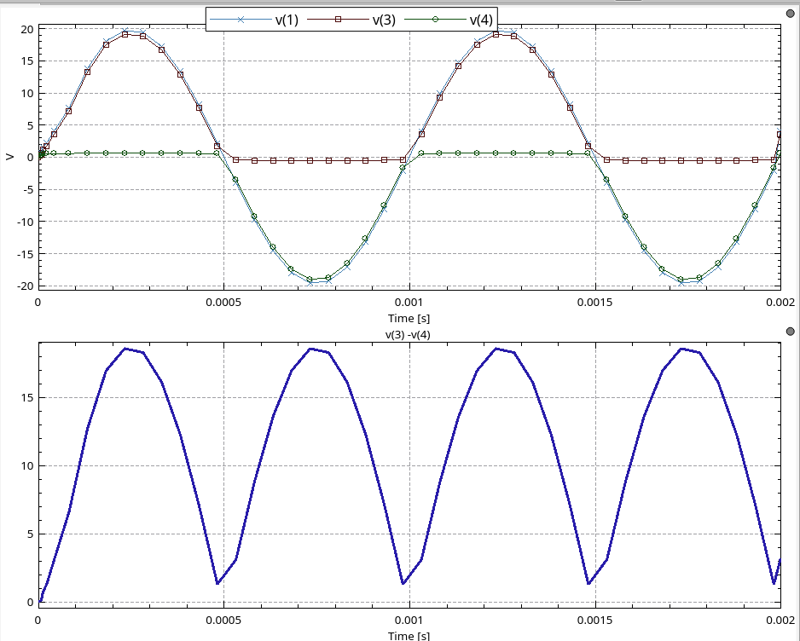
Yeah, this is kinda fucking cool. I've done a transient analysis with an independent source and a fucking nonlinear device! Class!

Capacitors
To introduce capacitors I need to:
- open for dc operating point analysis
- companion model for transient analysis
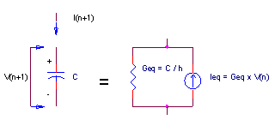
Taken from:
http://www.ecircuitcenter.com/SpiceTopics/Transient%20Analysis/Transient%20Analysis.htm

Results
Check this shit out!
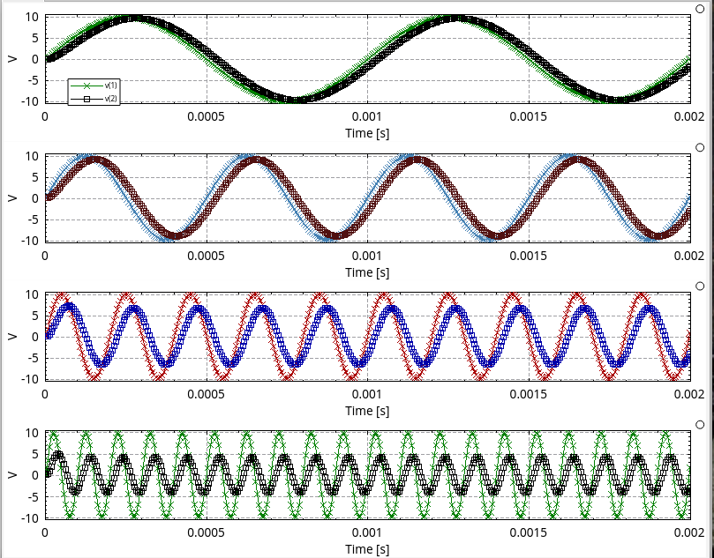
RC Low-Pass Filter. Timestep = 1us
And this!
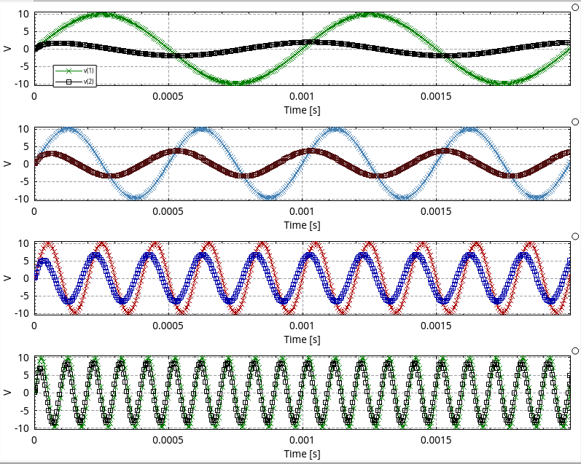
RC High-Pass Filter. Timestep = 1us

Cycles
If the Newton-Raphson thing falls into a loop, then it doesn't seem to matter what the t_delta is changed to. The input voltage is still near 0V, and if the gradients are the same either side, it'll keep falling into the same loop?
I updated the single-diode circuit, and this passes (at least, converges) for the full 720-odd combinations of amplitude, frequency, saturation current and timestep.
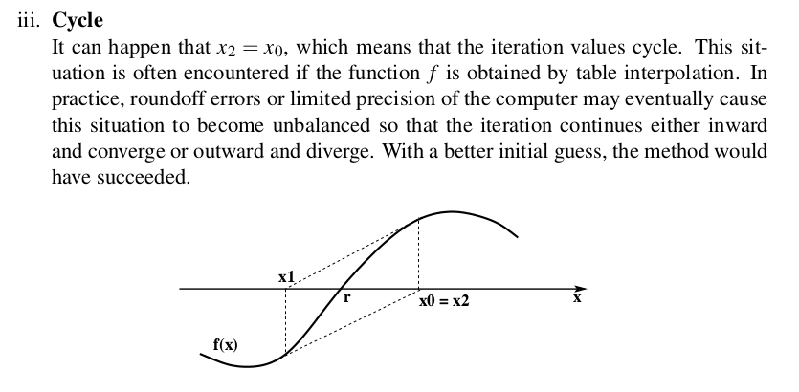
Newton-Raphson cycles from lect_2.pdf
To find cycles? And to fix?
https://stackoverflow.com/questions/24552306/how-to-detect-a-cycle-in-newton-raphson-method-in-c

Colon
Nagel mentions limiting the swing of things to aid convergence.
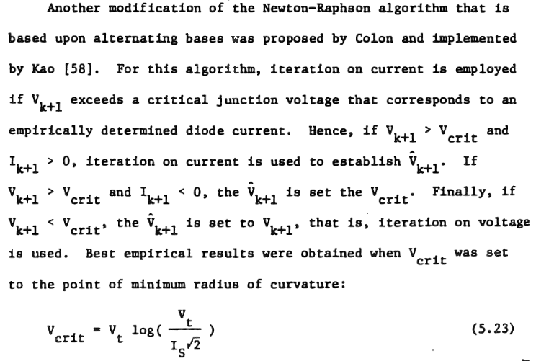
Paragraphs from Nagel.

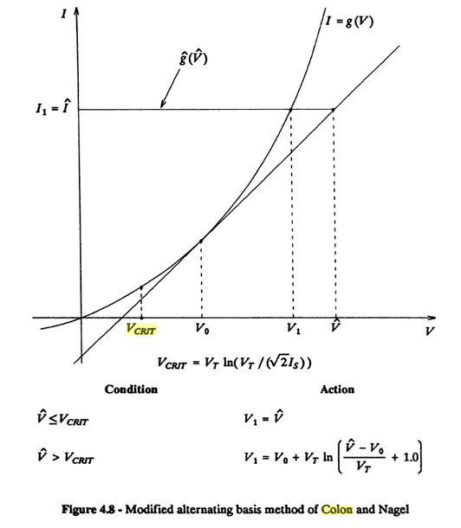
Some things I found on the internet.

So, what makes me think that implementing this will fix my transient analysis? Maybe by limiting the swing in Vd, I'm less likely to hit cycles? Only one thing to do, try it out.
Turns out that Vcrit is near the knee of the diode, so doesn't help. The solver is still finding cycles.

Capacitors
Adding small capacitances across the diodes sometimes helps, or sometimes creates an AC voltage divider. It's not “robusting” the algorithm.

Tests
I'm stuck, so I decided rather than implement a SPICE card reader, I'd try to fix up the tests that I have. The DC diode bridge ones are failing, interestingly…
In one of the equations above, can be negative, which means the natural logarithm can't be found. The natural logarithm of negative numbers is undefined.
So maybe V0 is the last timestep value, not the last solve value?
But this is a DC test that's failing…
What are the things?
- Diode voltage from the previous iteration

- adsf

SPICE2 – diode voltage limiting
Downloaded SPICE2 from this website, it's in FORTRAN.
SUBROUTINE PNJLIM(VNEW,VOLD,VT,VCRIT,ICHECK)
IMPLICIT DOUBLE PRECISION (A-H,O-Z)
C
C THIS ROUTINE LIMITS THE CHANGE-PER-ITERATION OF DEVICE PN-JUNCTION
C VOLTAGES.
C
IF (VNEW.LE.VCRIT) GO TO 30
VLIM=VT+VT
DELV=VNEW-VOLD
IF (DABS(DELV).LE.VLIM) GO TO 30
IF (VOLD.LE.0.0D0) GO TO 20
ARG=1.0D0+DELV/VT
IF (ARG.LE.0.0D0) GO TO 10
VNEW=VOLD+VT*DLOG(ARG)
GO TO 100
10 VNEW=VCRIT
GO TO 100
20 VNEW=VT*DLOG(VNEW/VT)
GO TO 100
30 ICHECK=0
C
C FINISHED
C
100 RETURN
END
It seems to be limiting excursions to 2*VT and doing the Colon/Nagel thing.
Even with this, I'm not converging.

Precision f32 vs f64
It looks like changing the precision to f64 makes everything pass.
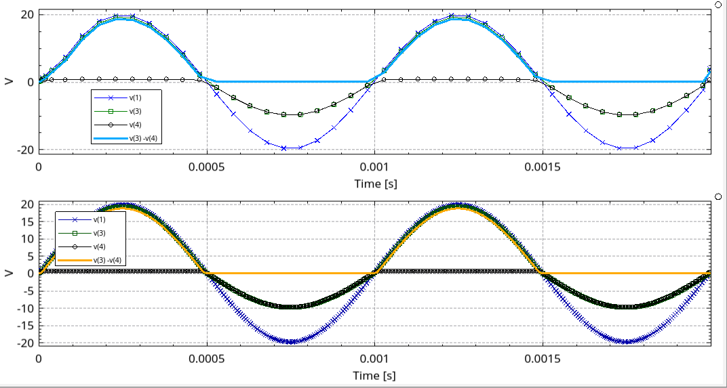
Working diode half-bridge, yesterday.

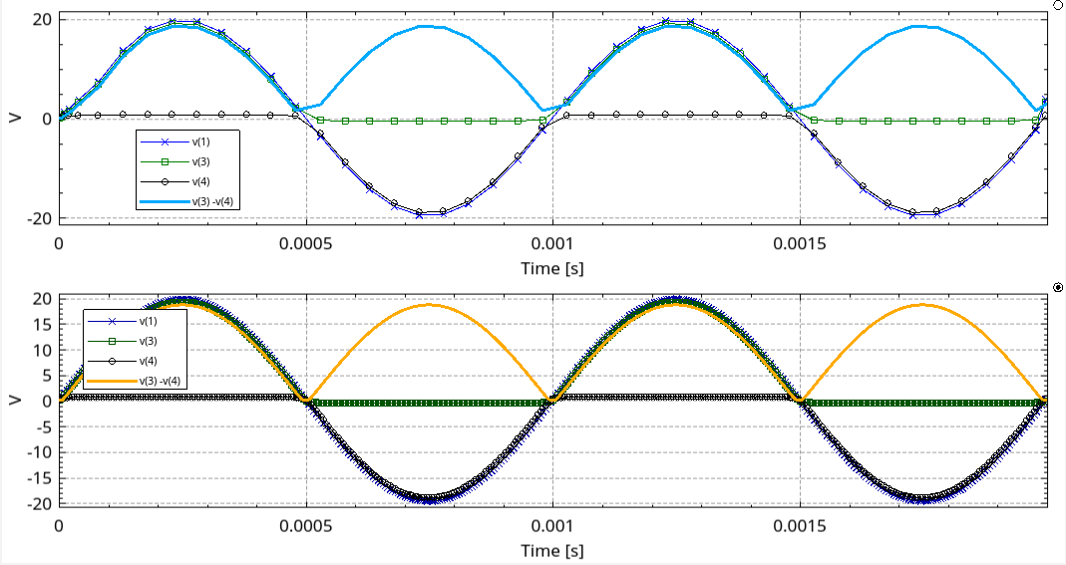
Working diode full-bridge, yesterday.

Running a full loop on the full-bridge:
let timesteps = [10e-6, 5e-6, 2e-6, 1e-6];
let amps = [-2.0, -1.0, -0.5, 0.5, 1.0, 2.0];
let freqs = [3.0e3, 2.5e3, 2.0e3, 1.0e3, 0.5e3, 0.4e3, 0.3e3, 0.2e3, 0.1e3, 0.05e3];
let isats = [1e-9, 1e-12, 1e-13];

Failing List:
kartoffel%

No time-step-too-smalls!!!

SPICE Engine Flowchart
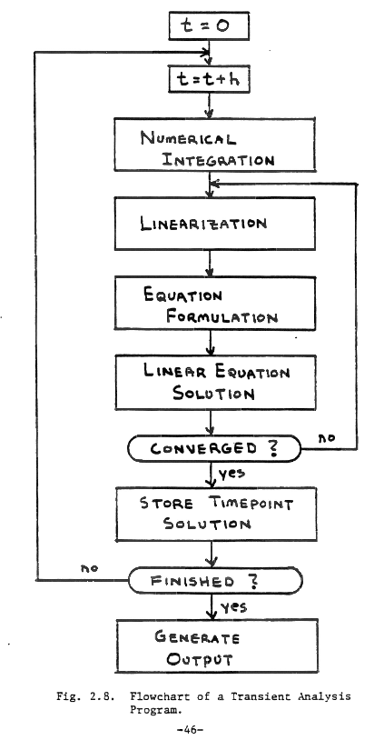
From Nagel's original SPICE paper.

Opamp Macromodel Feedback Networks

Problem
After implementing VCVS (‘E’) and VCCS (‘G’), and trying to build a macromodel for an opamp (git 0247670), the this simulator failed to solve it.

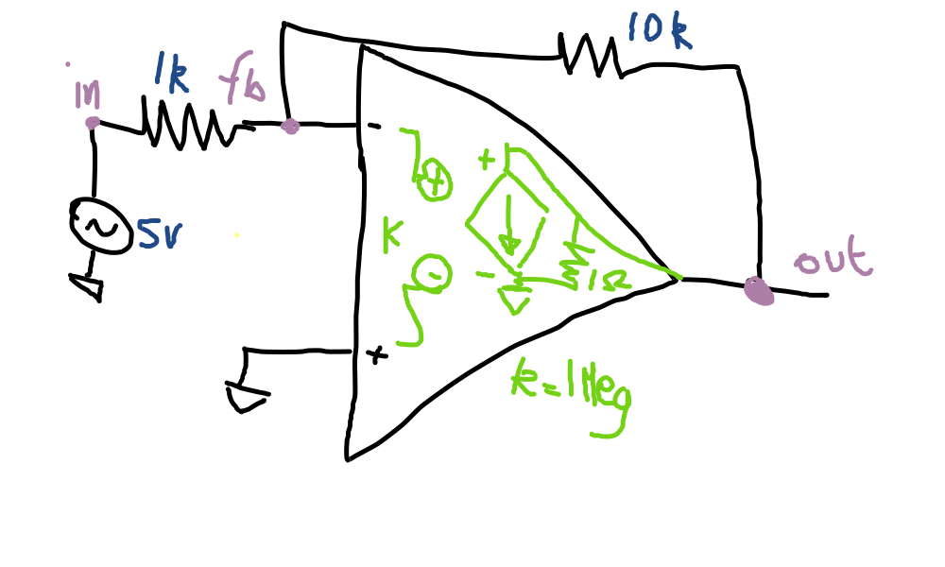
Going for gold, the first sim run was with a 5 V sinewave input. Voltages soon went astronomical financial. It worked fine in NGSPICE. Trying just a DC solve had the same effect. Node voltages wildly diverged.
The first solve has all the “previous values” of the nodes at 0 V. This puts the input to the VCCS of the opamp macromodel at 0 V, so no current at its output. This leaves this network:
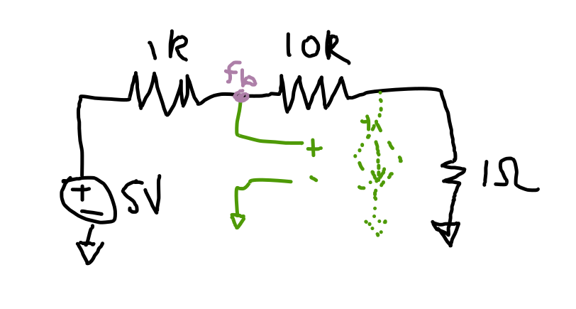
And solving that leaves ‘fb’ somewhere near 10/11 * 5 V = 4.54V.
In the next solve step, the “previous values” put the control voltage to the VCCS sends things stratospheric, it having a large gain factor.
Why does the next step not reign it in? I’ve tried flipping the sign of the gain, but that didn’t work.
Do I need to put something like a GMIN across the inputs?
I did a bit of an internet search and I didn’t find any proof that the dependent sources need source stepping. I could only find mentions of needing source stepping for nonlinear things. A VCCS isn’t nonlinear, right? I’ve only a constant term. So that means I haven’t implemented the operating point algorithm correctly, right?

Fix, I think
It occurred to me I’m doing things wrong. This is a linear problem, I don’t have to look at (and shouldn’t look at) the control voltage at the previous timestep. The gain term ‘k’ has to go into the matrix somewhere so Guassian Elimination can work on it.
The issue is where do I put the things?

Proof

Testing
How do I test my SPICE engine?
At the moment, only trans and op are implemented. Both of these should write datafiles, even though op will have only one data line.
For transient, what are the options?
- check against NGSPICE output
- check against golden vectors
Is there any way of discriminating between runs with different VNTOLs, for example?
There should also be a test that the program doesn't panic.
Should the comparisons be done in the SPICE engine? If not, then the integration tests are going to have to call out to yet another program when the SPICE engine finishes. And ideally this will be something that doesn't need much setup, like Python without matplotlib – not a shell script that won't run on Windows.

Research

Transient?
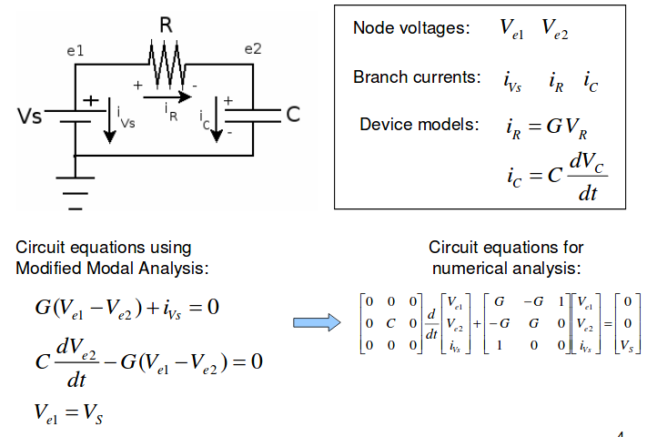
From: http://www.ece.rochester.edu/courses/ECE222/lecture.files/ECE222_Lecture3_spice.pdf page 4.

SPICE
https://embedded.eecs.berkeley.edu/pubs/downloads/spice/spice2.unix.tar.gz

Original SPICE Thesis
https://www2.eecs.berkeley.edu/Pubs/TechRpts/1975/ERL-520.pdf

Comparison of some simulators
http://www.linear.com/solutions/5739

SPICE Survey
http://www.elettrotecnica.unina.it/files/demagistris/didattica/TdC/SPICE_like_simulation.pdf

Nonlinear Devices
http://dev.hypertriton.com/edacious/trunk/doc/lec.pdf via https://github.com/knowm/jspice
http://www.ecircuitcenter.com/SpiceTopics/nonlinear%20Analysis/nonlinear%20Analysis.htm
http://ic.sjtu.edu.cn/ic/msda/wp-content/uploads/sites/7/2013/02/lect08_nonlinear_stamp.pdf
http://www3.imperial.ac.uk/pls/portallive/docs/1/7292572.PDF
https://electronics.stackexchange.com/questions/324485/nonlinear-equation-solvers-in-spice-simulators

Stamps
http://www.ece.iisc.ernet.in/%7Edipanjan/E8_262/E8262-CAD_4+5.pdf
http://users.ecs.soton.ac.uk/mz/CctSim/chap1_4.htm

General
http://www.elect.mrt.ac.lk/EE321_documents/ee321s3.3.pdf

Waveform Formats
http://www.rvq.fr/linux/gawfmt.php

