**4. Getting to Know Plants**

**Topic4_2**

**Experiment-2**

**Aim:** proving that plant stem can transport water and mineral salts solution.

**Equipment:** soft stem, glass, blade, water, red/blue ink.

**Figure:**

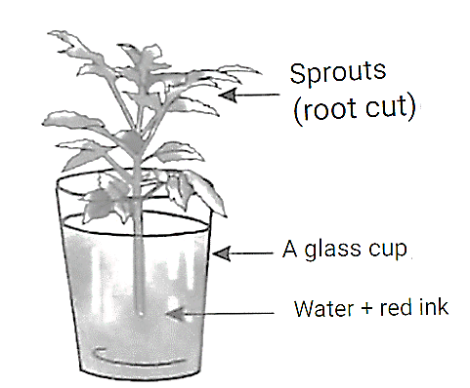

**Procedure:**

* Take $\frac{1}{3}$ (third part) part of water in a glass.
* Add a few drops of red ink to water to make the water red in colour.
* Cut the stem of the plant from the base with a blade and place it in a glass filled with red colour water.
* The next day observe the plant parts.

**Observation:** The stem and branches of the plant become red in colour.

**Conclusion:** Plant stems transport water and mineral salts solution.

**Experiment-4**

**Aim:** Proving that plant leaves remove excess water as vapour through transpiration.

**Equipment:** Potted plant, transparent polythene bag, thread.

**Figure:**

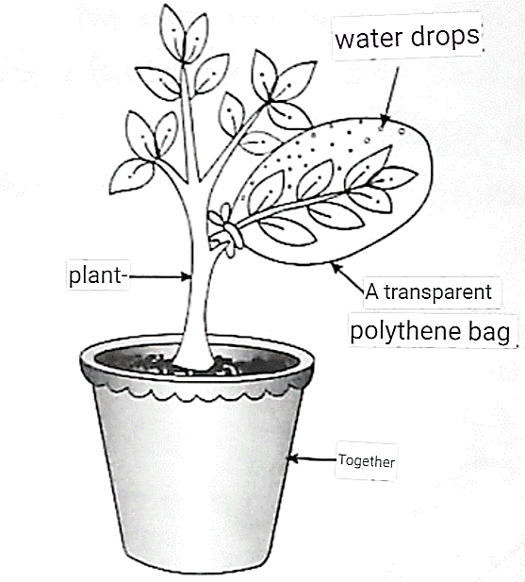

Pot

**Procedure:**

* Take a potted plant.
* Enclose a leafy branch of the plant in a polythene cover and tie up its mouth closed with a thread.
* Now place the plant pot in sunlight.
* After a few hours, observe the inner surface of the covers.

**Observation:** Water droplets are seen inside the polythene bag.

**Conclusion:** Plant leaves release excess water as vapour through transpiration.

**Experiment-5**

**Aim:** To prove that starch is present in the leaf.

**Equipment:** Leaf, beaker, water, spirit, test tube, iodine solution, burner.

**Figure:**

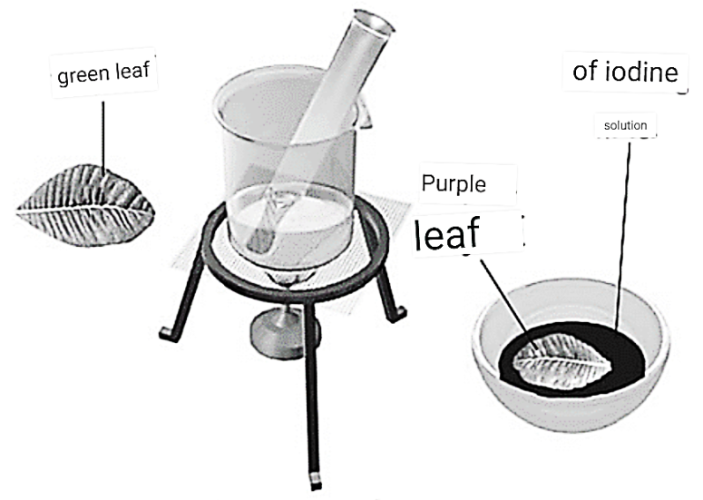

Solution

Of iodin

**Procedure:**

* Pluck a leaf from the plant and place it in a test tube.
* Add the spirit until the leaves are covered.
* Place the test tube in a beaker half filled with water.
* Heat the beaker till all the green colour from the leaf comes out into the spirit in the test tube.
* Take out the leaf carefully and wash it in water.
* Place the leaf on a plate and put a few drops of iodine solution on it. Note down your observation.

**Observation:** Drops of iodine on the leaves turn the leaves dark black/brown.

**Conclusion:** Indicates the presence of starch in the leaf of a plant.

**Topic4_3**

**Experiment-6**

**Aim:** Prove whether or not roots are necessary for healthy plant growth.

**Equipment:** Two pots (filled with soil), two plants, blade, water.

**Figure:**

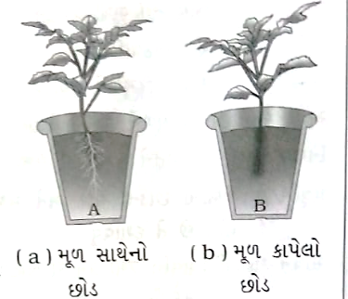

(Change in animation-મૂળ સાથેનો છોડ- Weed with roots, મૂળ કાપેલો છોડ- without roots)

**Procedure:**

* Select two plants of the same kind from the open ground and dig them out with roots.
* Plant one of the two plants with roots in the soil of pot A.
* Cut off the roots from the other plant and plant it in pot B.
* Water them regularly. Observe both plants after a week.

**Observation:** Plants with roots are well-developed, while plants without roots are underdeveloped.

**Conclusion:** Roots are essential for healthy plant growth.

**Experiment-7**

**Aim:** Show how roots hold the plant firmly in the soil.

**Equipment:** Gram, maize, cotton wool, two bowls, water.

**Figure:**

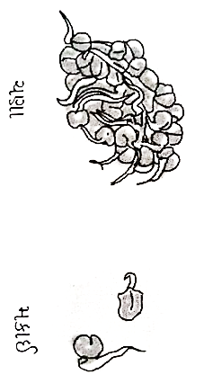

(Change in animation-ચણા-Gram, મકાઈ-Corn)

**Procedure:**

* Take two bowls.
* Place some wet cotton in both.
* Put 3 or 4 seeds of a gram in one bowl and the same number of maize seeds in another bowl.
* Keep the cotton wet by sprinkling water every day, until the sprouts have grown into young plants.
* After a week try to separate both the young plants from the cotton. Note down your observation.

**Observation:** The roots of plants cannot be easily removed from cotton.

**Conclusion:** Roots hold the plant firmly in the soil.