PREDICTIVE MAINTENANCE SYSTEM

Machine Learning Project Report

Submitted By

Harnish Savant
PRN: 25070243032

Dataset: NASA C-MAPSS Turbofan Engine Degradation Simulation (FD001)
April 2026

1. Problem Statement

In modern industrial settings, unplanned equipment failure causes enormous financial and operational damage. Turbofan jet engines, gas turbines, and heavy industrial machinery are critical assets whose failure mid-operation can halt entire production lines. Traditional maintenance strategies fall into two broad categories: reactive maintenance, which waits for failure before acting, and time-based preventive maintenance, which services equipment at fixed calendar intervals regardless of actual condition.
Both approaches carry significant drawbacks. Reactive strategies lead to emergency repair costs and safety risks, while fixed-interval maintenance wastes resources on equipment that does not yet need attention. A smarter alternative is Predictive Maintenance (PdM), which uses real-time sensor data and machine learning to estimate how long a piece of equipment can safely continue operating before it requires service.
The central metric in predictive maintenance is Remaining Useful Life (RUL) — the number of operational cycles remaining before an engine is expected to fail. Accurately predicting RUL allows maintenance teams to plan interventions at the most cost-effective time, reducing both unplanned downtime and unnecessary servicing.
This project addresses the RUL prediction problem using sensor data from the NASA C-MAPSS FD001 dataset, which simulates turbofan engine degradation under controlled conditions. A regression model is trained to accept current sensor readings and predict a numerical RUL estimate, enabling data-driven maintenance decisions.

2. Objectives

The following objectives guided the development of this project:

- Explore and understand the structure and content of the NASA C-MAPSS FD001 dataset through systematic Exploratory Data Analysis (EDA).
- Calculate the Remaining Useful Life (RUL) for each engine in the training set using the run-to-failure structure of the data.
- Apply a RUL cap of 125 cycles to prevent the model from being influenced by early healthy-state rows where degradation patterns are not yet visible.
- Identify and remove low-information features such as sensors and operational settings with zero or near-zero variance.
- Normalize all selected features using MinMax scaling to eliminate scale-based bias across sensors with different measurement units.
- Train six regression models — Linear Regression, K-Nearest Neighbors, Decision Tree, Random Forest, Bagging Regressor, and Gradient Boosting — on the preprocessed training data.
- Evaluate and compare all models using Root Mean Squared Error (RMSE), Mean Absolute Error (MAE), and R-squared (R2) metrics on both training and test sets.
- Select the best-performing model and serialize it along with the scaler for real-world deployment.
- Deploy the final model as a Flask web application that provides real-time RUL predictions with a color-coded health status indicator.

3. Dataset Description

3.1 Source
The dataset used in this project is the NASA C-MAPSS (Commercial Modular Aero-Propulsion System Simulation) Turbofan Engine Degradation Simulation Dataset. It is publicly available through the NASA Prognostics Data Repository maintained by the Prognostics Center of Excellence (PCoE) at NASA Ames Research Center. The dataset was originally published alongside benchmark research in engine health monitoring and has since become a standard benchmark in the predictive maintenance literature.

3.2 Subset Used
This project uses the FD001 subset, which simulates engine degradation under a single operating condition with a single fault mode (High Pressure Compressor degradation). This controlled setup makes FD001 the most accessible entry point for building and validating predictive models without the additional complexity of multi-condition or multi-fault scenarios.

3.3 Files Used

File Name | Description
train_FD001.txt | Time-series sensor data for 100 engines, each recorded from healthy initial state through to failure
test_FD001.txt | Similar sensor readings for 100 test engines, but each sequence is cut off at some point before failure
RUL_FD001.txt | Ground truth RUL values for each test engine at the point of cutoff — used as prediction targets for evaluation
Table 3.1: Dataset files and their descriptions

3.4 Feature Details
Each row in the data files contains 26 columns with no header row. The column structure is described below:

Column Index | Column Name | Description
1 | unit_id | Engine identifier (1 to 100)
2 | cycle | Operating cycle number (increments each engine run)
3–5 | op1, op2, op3 | Three operational setting values characterizing the flight envelope
6–26 | sensor_1 to sensor_21 | Twenty-one sensor measurements including temperatures, pressures, fan speeds, and efficiency ratios
Table 3.2: Column description of the FD001 dataset

3.5 Dataset Size

Dataset | Number of Rows | Number of Columns
Training Data | 20,631 | 26
Test Data | 13,096 | 26
RUL Labels | 100 | 1
Table 3.3: Size summary of all dataset files

3.6 Key Observations
- No missing values were found in either the training or test datasets. All records are complete across all 26 columns.
- The training set covers 100 distinct engines. Engine lifetimes range from approximately 128 cycles to 362 cycles, showing natural variability in degradation rates.
- Several features carry no predictive information because their values remain constant across all observations. These include op2, op3, sensor_1, sensor_5, sensor_6, sensor_10, sensor_16, sensor_18, and sensor_19.
- The remaining sensors show gradual trends that correlate with the degradation process, making them meaningful inputs for RUL prediction.

4. Methodology

The project follows a structured machine learning pipeline from raw data ingestion through to model deployment. The workflow is divided into clearly defined stages as illustrated below.

4.1 Methodology Diagram

Step 1 | Data Collection — Load train_FD001.txt, test_FD001.txt, RUL_FD001.txt into Pandas DataFrames with manually assigned column headers
▼
Step 2 | Exploratory Data Analysis — Check for missing values, examine engine lifetimes, analyze sensor variance, compute RUL correlations, visualize degradation trends
▼
Step 3 | RUL Calculation — Compute RUL = max_cycle(engine) − current_cycle for each row in the training set
▼
Step 4 | RUL Capping — Clip all RUL values to a maximum of 125 cycles to focus model learning on the active degradation phase
▼
Step 5 | Feature Selection — Calculate per-column variance; drop zero-variance or near-constant features that provide no discriminating information
▼
Step 6 | Feature Scaling — Apply MinMaxScaler (fit on training data only) to normalize all remaining features to [0, 1]
▼
Step 7 | Test Data Preparation — Extract the last cycle of each test engine; apply the same fitted scaler; load ground-truth RUL values
▼
Step 8 | Model Training — Train six regression models: Linear Regression, KNN, Decision Tree, Random Forest, Bagging Regressor, Gradient Boosting
▼
Step 9 | Model Evaluation — Measure RMSE, MAE, and R2 on both train and test sets; compare models; select the best performer
▼
Step 10 | Deployment — Serialize the best model and scaler using pickle; build a Flask web app for real-time RUL prediction

4.2 Data Collection
The three FD001 text files were downloaded from the NASA Prognostics Data Repository. Since the files contain no header rows, column names were defined manually: the first two columns represent the engine ID and cycle number, the next three are operational settings (op1, op2, op3), and the remaining twenty-one are sensor readings (sensor_1 through sensor_21). All files were loaded into Pandas DataFrames using whitespace as the delimiter.

4.3 Exploratory Data Analysis
A thorough EDA was performed before any modelling to understand the data structure, distribution characteristics, and predictive potential of each feature. This phase is covered in detail in Section 4.4 below with all supporting visualizations.

4.4 RUL Calculation
Since the training set contains run-to-failure records, the maximum observed cycle number for each engine corresponds to its failure point. The RUL for any given row was computed as the difference between that engine's maximum cycle and the current cycle of that row. At the start of an engine's life, this value is high; it decreases monotonically down to zero at the final cycle before failure.

4.5 RUL Capping
A standard technique in RUL modelling is to cap the target value at a reasonable upper threshold. During the early healthy phase of an engine's operation, the sensor signals do not yet show meaningful degradation patterns, so training on very large RUL values can introduce noise and mislead the model. A cap of 125 cycles was applied: any RUL value greater than 125 was set to 125. This approach keeps the model focused on the portion of the engine's life where sensor signals are genuinely informative.

4.6 Feature Selection
The variance of each feature column was computed across the full training set. Features with zero or near-zero variance (threshold of 0.0001) were identified and removed, as they carry no discriminating information. A total of 10 features were dropped, leaving 16 informative features for model training.

4.7 Feature Scaling
Sensor readings in the FD001 dataset span vastly different numerical ranges. For example, sensor_9 values exceed 9,000 while sensor_15 values hover around 8.4. Without normalization, models that are sensitive to feature magnitude (such as KNN) would be dominated by high-range sensors. MinMaxScaler was applied to transform all remaining features to the [0, 1] range. Critically, the scaler was fitted only on the training data and then applied to both training and test sets, preventing any data leakage from the test split.

4.8 Test Data Preparation
For evaluation, only the last recorded cycle of each test engine was used, since the RUL ground truth in RUL_FD001.txt corresponds to the state of each engine at the point its sequence was cut off. The last-cycle rows were extracted, scaled with the pre-fitted scaler, and paired with the corresponding ground truth RUL values (also clipped at 125 cycles to match the training target distribution).

4.9 Model Training and Evaluation
Six regression models were trained on the processed training data. Each model was then evaluated on both the training set and the test set using RMSE, MAE, and R2. Evaluating on both sets allows us to identify any overfitting — a large gap between training and test performance indicates that a model has memorized the training examples rather than learning generalizable patterns.

4.10 Model Deployment
The best-performing model was saved to disk using Python's pickle module, along with the fitted MinMaxScaler and the list of selected feature names. A Flask web application was developed to load these saved objects and expose a prediction endpoint. The web interface allows users to enter sensor readings directly and receive a real-time RUL estimate with a color-coded health indicator.

5. Exploratory Data Analysis

Before any model was trained, a comprehensive exploratory analysis was conducted to understand the dataset thoroughly. This section presents all key findings from the EDA phase, supported by the actual output charts generated during analysis.

5.1 Missing Values and Data Quality
The very first check performed was for missing or null values. Both the training set (20,631 rows) and test set (13,096 rows) were found to be completely clean with zero missing entries across all 26 columns. This means no imputation strategy was needed and we could proceed directly with the full dataset.
Additionally, all features were confirmed to hold numeric (float64 or int64) data types with no text or categorical columns present. This made the dataset immediately usable for numerical preprocessing without encoding steps.

5.2 Engine Lifetime Distribution
Since the training data contains run-to-failure records, the maximum cycle number observed for each engine represents its total operational lifetime before failure. Figure 5.1 shows the lifetime of each of the 100 training engines as a bar chart.

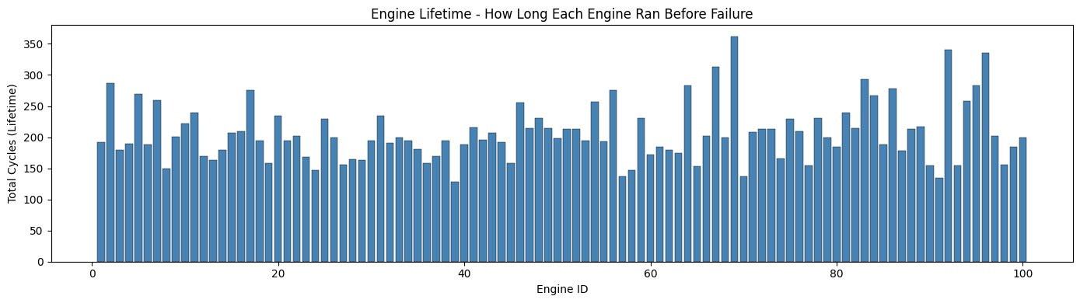
Figure 5.1: Total cycles (lifetime) for each of the 100 training engines before failure
The chart shows considerable variation across engines. Some engines lasted fewer than 150 cycles while others ran beyond 350 cycles. This natural spread reflects realistic engine-to-engine variability rather than any data quality issue. The key observation is that no two engines behave identically, which is why a model must learn general degradation patterns from sensor trends rather than memorizing specific lifetime durations.

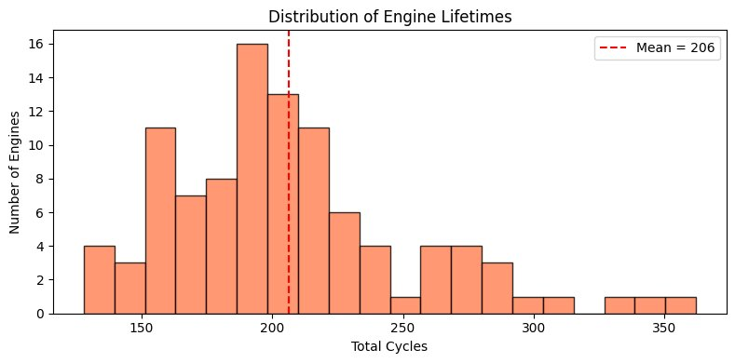
Figure 5.2: Distribution of engine lifetimes — most engines ran between 150 and 250 cycles (mean: 206 cycles)
Figure 5.2 shows the distribution of lifetimes across all 100 engines. The distribution is roughly bell-shaped and centered around a mean of 206 cycles, with a slight right skew due to a small number of engines that lasted significantly longer. This confirms that engine lifetimes are not clustered at one value — the model needs to handle a broad range of target outputs.

5.3 Sensor Variance Analysis
Not all sensors contribute useful information. Some sensors remain completely constant throughout an engine's entire operational life, making them uninformative for any predictive task. Figure 5.3 shows the computed variance for every sensor and operational setting, sorted in ascending order.

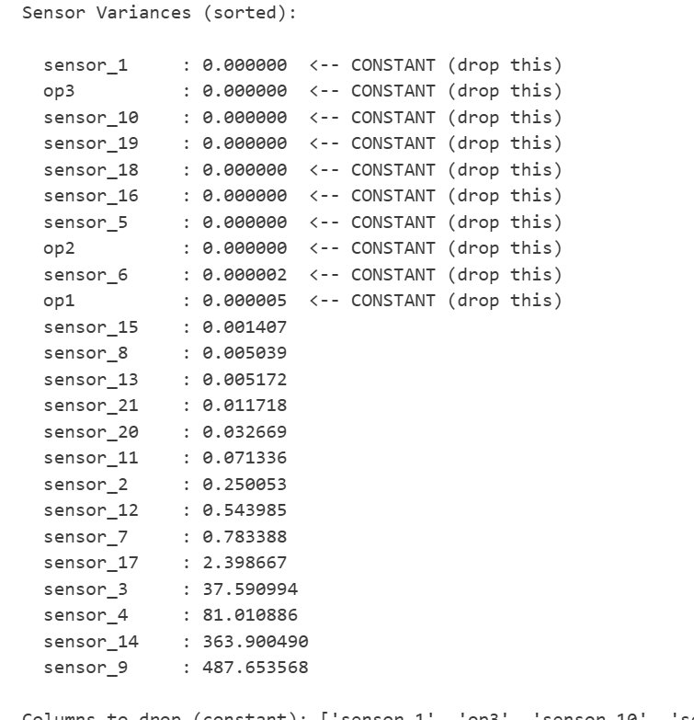
Figure 5.3: Variance of each sensor and operational setting — features with near-zero variance were flagged for removal
From the variance analysis, the following features were identified as constant (variance below 0.0001) and subsequently dropped from the feature set: sensor_1, op3, sensor_10, sensor_19, sensor_18, sensor_16, sensor_5, op2, sensor_6, and op1. This reduced the feature space from 24 input columns to 14 meaningful sensors (sensor_2, sensor_3, sensor_4, sensor_7, sensor_8, sensor_9, sensor_11, sensor_12, sensor_13, sensor_14, sensor_15, sensor_17, sensor_20, and sensor_21).
The remaining sensors span a wide range of variances — sensor_9 and sensor_14 show the highest variance at 487 and 363 respectively, while sensor_15 and sensor_8 have quite low but non-zero variance. All retained sensors were confirmed to carry at least some variation across the dataset, justifying their inclusion as candidate features.

5.4 RUL Distribution
After computing the RUL column (max_cycle minus current_cycle per engine), the distribution of RUL values across all training rows was examined. Figure 5.4 shows this distribution.

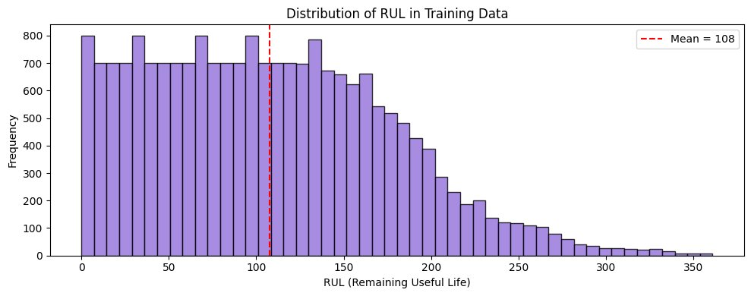
Figure 5.4: Distribution of RUL values across all 20,631 training rows — right-skewed with mean around 108 cycles
The distribution is right-skewed, with a large number of rows having RUL values below 125 and a long tail extending to above 350. This skew exists because engines accumulate far more data points during their degrading phase than during their initial healthy phase — as an engine approaches failure, there are progressively fewer cycles remaining.
The mean RUL across all training rows is approximately 108 cycles. The visible plateau at the left of the distribution between 0 and about 125 reflects the clipping applied: all RUL values above 125 were capped at 125 in the training target. This capping is visible as a spike at 125 cycles in the histogram and is intentional — it prevents the model from training on very large RUL values where sensor signals are not yet degradation-indicative.

5.5 Correlation Analysis — Sensors vs RUL
One of the most important steps in any EDA for a supervised learning task is examining how strongly each feature correlates with the target variable. Figure 5.5 shows the full correlation matrix between all retained sensors and the RUL target.

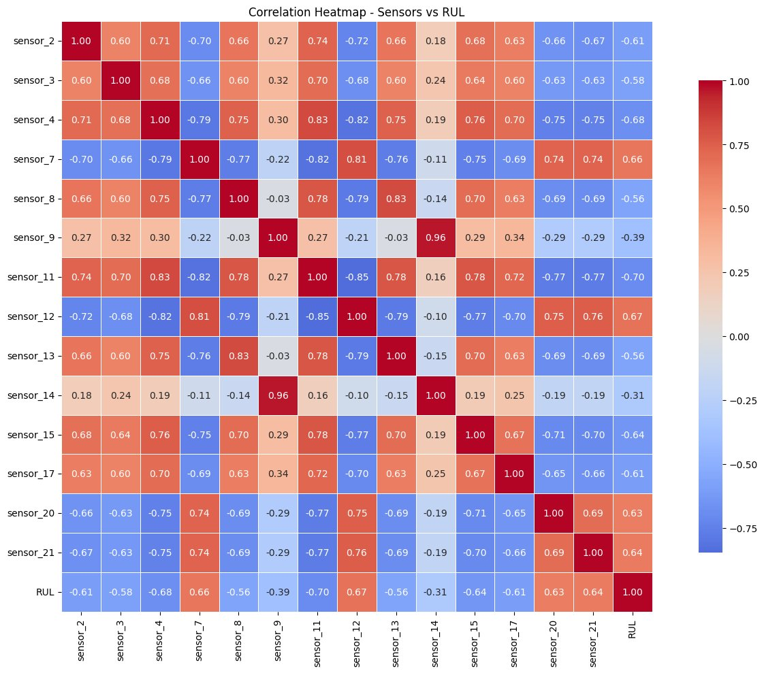
Figure 5.5: Correlation heatmap between all useful sensors and RUL — red indicates positive correlation, blue indicates negative
The heatmap reveals several key patterns. First, the RUL column (bottom row and rightmost column) shows notably negative correlation with most sensors, meaning that as RUL decreases (engine nearing failure), sensor values tend to increase or decrease in a consistent direction. Sensors such as sensor_11, sensor_4, sensor_12, sensor_7, and sensor_15 show the strongest absolute correlation with RUL, which makes them the most predictive individual features.
Second, many sensors are highly correlated with each other (e.g., sensor_4 and sensor_11 show a correlation of 0.83). This multicollinearity means tree-based models may use different subsets of these correlated sensors across different trees, which actually helps ensemble models like Random Forest generalize better.

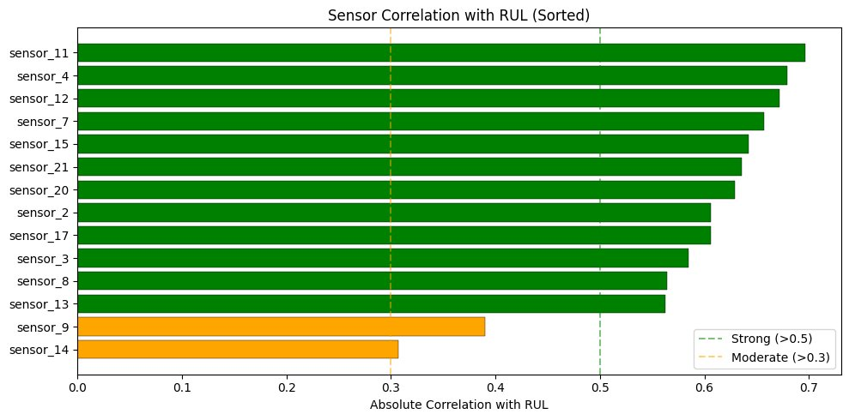
Figure 5.6: Absolute correlation of each sensor with RUL — all but sensor_9 and sensor_14 exceed the 0.5 strong-correlation threshold
Figure 5.6 ranks the sensors by their absolute correlation with RUL. Sensor_11 leads with a correlation of approximately 0.70, followed closely by sensor_4 (0.68), sensor_12 (0.67), sensor_7 (0.66), and sensor_15 (0.64). Twelve of the fourteen retained sensors show strong correlation (above 0.50) with RUL. Only sensor_9 (0.39) and sensor_14 (0.31) show moderate correlation, and even these are above the 0.30 threshold, meaning they still carry some predictive signal.

5.6 Sensor Trends Over Engine Life
To understand how sensors behave as an engine degrades, the top six most correlated sensors were plotted over the operational life of Engine 1. Figure 5.7 shows these time-series plots.

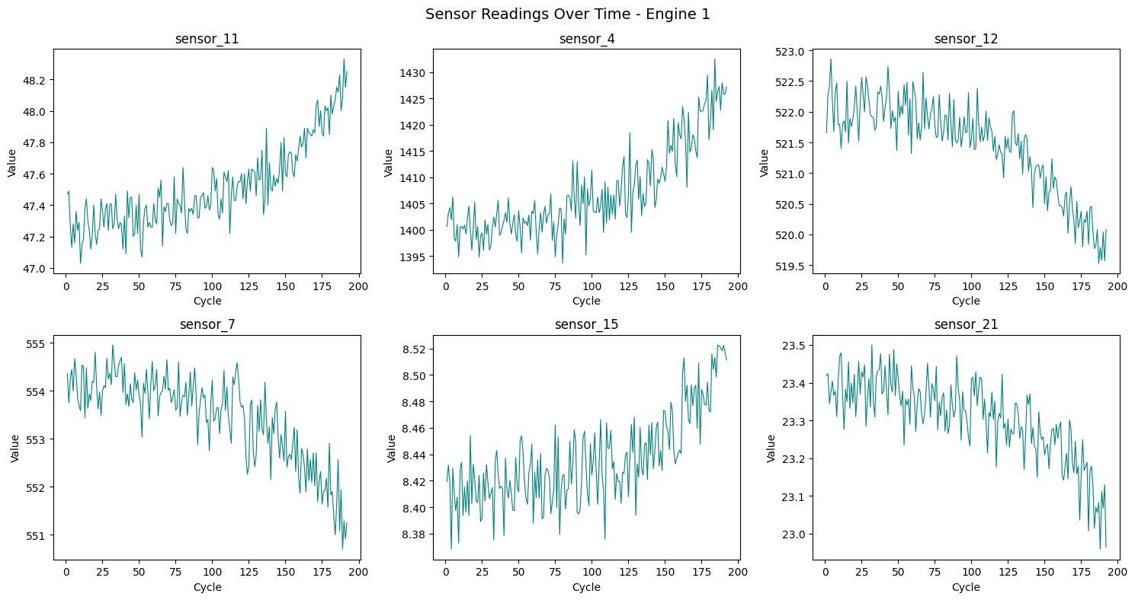
Figure 5.7: Readings of the top 6 sensors over all 192 cycles of Engine 1 — degradation trends are clearly visible
The plots reveal clear and consistent degradation trends. Sensor_11 and sensor_4 show a steady upward drift over the engine's lifetime, while sensor_12, sensor_7, sensor_15, and sensor_21 show a downward trend. These monotonic trends confirm that these sensors are measuring physical quantities that change predictably as engine health degrades — exactly the kind of signal a regression model can learn from.
The noisy oscillation within each trend is typical of real sensor measurements and does not undermine the underlying trend. More sophisticated feature engineering (such as rolling averages or polynomial trend fitting) could smooth these signals further, but even raw sensor values carry enough information for the models to learn from.

5.7 Healthy vs Degraded Sensor Comparison
The final EDA visualization compared sensor value distributions between two states: the healthy phase (rows where RUL > 125, meaning the engine is well within its operational life) and the degraded phase (rows where RUL < 25, meaning the engine is close to failure). If a sensor is genuinely predictive of RUL, its distribution should look visually distinct between these two states.

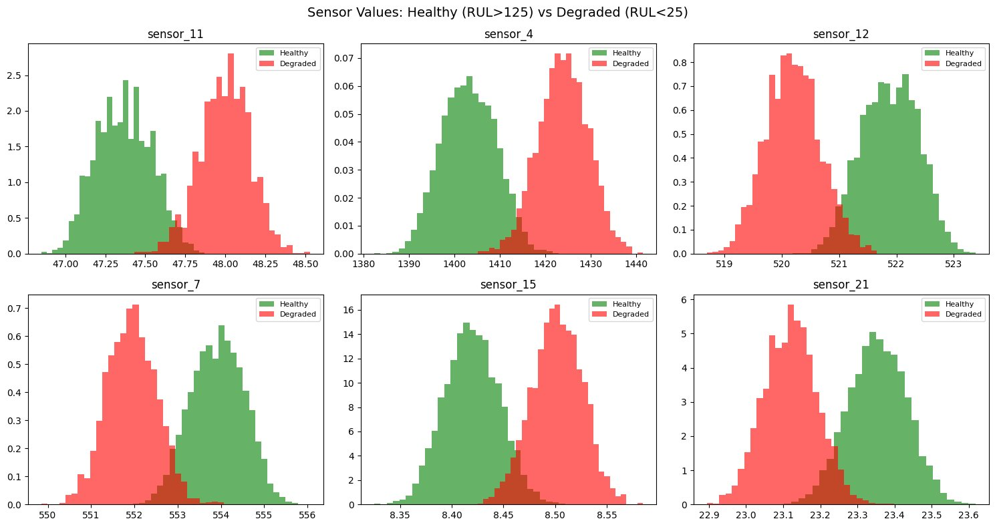
Figure 5.8: Sensor value distributions for healthy engines (RUL > 125, green) vs degraded engines (RUL < 25, red) — clear separation confirms predictive relevance
Figure 5.8 demonstrates a clear and consistent distribution shift for all six top sensors. For sensor_11 and sensor_4, the degraded distribution is shifted to higher values compared to the healthy state. For sensor_12 and sensor_7, the degraded distribution is shifted to lower values. These shifts confirm that the sensors are genuinely responsive to the physical degradation process and that a classifier or regressor can distinguish between healthy and degraded states based on sensor readings alone.
This visual separation also provides practical intuition for the deployment scenario: when a user enters sensor readings into the web application, the model is essentially determining whether those readings resemble a healthy engine or a degraded one, and how far along the degradation progression the engine appears to be.

5.8 EDA Summary
The key findings from the exploratory analysis that directly informed the modelling decisions are summarized below:

- Dataset is complete — no missing values in either training or test sets.
- 100 engines with variable lifetimes (128 to 362 cycles, mean 206) — model must generalize across engines, not memorize specific durations.
- 10 features identified as constant and removed — cleaned feature set contains 14 informative sensors.
- RUL distribution is right-skewed — capping at 125 cycles is justified to focus on the degradation phase.
- 12 of 14 sensors show strong correlation (>0.50) with RUL — feature quality is high and the prediction task is feasible.
- Monotonic degradation trends visible in top sensors — raw sensor readings are sufficient for model training without extensive feature engineering.
- Clear distribution separation between healthy and degraded states — models will have strong signal to differentiate RUL ranges.

6. Techniques and Algorithms Used

6.1 Data Preprocessing
- Computed as max_cycle(engine) − current_cycle for each training row. RUL Calculation
- Applied a cap of 125 cycles to the RUL target to focus model learning on the degradation phase. RUL Capping
- Removed features with variance below 0.0001, eliminating constant-valued sensors. Variance-Based Feature Selection
- Normalized all remaining features to [0, 1] using sklearn's MinMaxScaler, fitted only on training data. MinMax Scaling

6.2 Machine Learning Models

Linear Regression — Baseline model that fits a hyperplane through the feature space. Assumes a purely linear relationship between sensor readings and RUL.

K-Nearest Neighbors (KNN) — Predicts RUL by averaging the targets of the k=5 nearest training samples in the normalized feature space.

Decision Tree Regressor — Partitions the feature space recursively into axis-aligned regions. Configured with max_depth=10 to limit overfitting.

Random Forest Regressor — Ensemble of 100 decision trees (max_depth=10), each trained on a random feature subset and bootstrap sample. Predictions are averaged across all trees, reducing variance significantly.

Bagging Regressor — Trains 50 base estimators (default Decision Trees) on bootstrap samples of the training data. Reduces variance by averaging multiple independent learners.

Gradient Boosting Regressor — Builds 100 shallow trees (max_depth=5) sequentially, each correcting the residual errors of the previous tree using gradient descent. Generally powerful for structured data.

6.3 Evaluation Metrics
- Penalizes large prediction errors heavily due to squaring. Unit is the same as RUL (cycles), making it directly interpretable. Root Mean Squared Error (RMSE)
- Average of absolute prediction errors. Less sensitive to outliers than RMSE; gives the typical prediction error in cycles. Mean Absolute Error (MAE)
- Proportion of variance in RUL explained by the model. A value of 1.0 is a perfect fit; 0.0 means the model performs no better than predicting the mean. R-Squared Score (R2)

6.4 Development Tools
- Python 3 — primary programming language
- Pandas & NumPy — data loading, manipulation, and numerical computation
- Scikit-learn — model training, scaling, and evaluation
- Matplotlib & Seaborn — all EDA visualizations and plots
- Pickle — model and scaler serialization for deployment
- Flask — web framework for the real-time prediction interface
- HTML, CSS, JavaScript — front-end of the prediction web application

7. Model Understanding and Justification

Training multiple models and comparing numbers is only one part of the story. Understanding why each model behaves the way it does — and why one is ultimately better suited than the others — is what separates a good analysis from a great one. This section explains how each model actually thinks about the RUL prediction problem, what its strengths and weaknesses are in this specific context, and what the final model choice tells us about the nature of engine degradation data.

7.1 Why Multiple Models Were Tested
A common mistake in early machine learning projects is to pick one model and optimize it without ever questioning whether a different learning approach might be fundamentally better suited to the problem. Each algorithm makes different assumptions about the structure of the data, and those assumptions either help or hurt depending on how the data actually behaves.
Engine degradation is a complex physical process. Sensor signals do not change proportionally with remaining life — they often follow curved or piecewise trends, and interactions between sensors (e.g., temperature affecting pressure readings) add further non-linearity. Testing a spectrum of models from simple linear to complex ensemble methods allows us to empirically discover which family of assumptions fits this data best, rather than guessing upfront.
The model selection in this project was not based only on numerical accuracy. Generalization ability, stability, and practical deployment suitability were all considered. A model that performs brilliantly on training data but collapses on test data is worse than a model with slightly lower peak accuracy that behaves consistently.

7.2 Model-by-Model Understanding

Linear Regression
Linear Regression works by finding the best straight-line relationship between input features and the target. Mathematically, it minimizes the sum of squared differences between predicted and actual RUL values and fits a single weighted combination of all features to explain the output.
The core assumption here — that RUL changes linearly with sensor values — is unfortunately not realistic for turbofan engines. Degradation tends to accelerate as failure approaches, creating a curved relationship that no straight line can capture. The model tries its best by fitting an average slope across all stages of the engine's life, but it ends up underfitting: too optimistic for late-stage engines and too pessimistic for healthy ones.

Advantages | Limitations
Fast to train, minimal compute | Assumes linear degradation — not realistic
Fully interpretable (feature weights) | Underfits non-linear patterns in sensor data
Good baseline for comparison | Cannot capture sensor interactions
Table 7.1: Linear Regression — Advantages vs Limitations
Verdict for this problem: Not suitable. Engine degradation is inherently non-linear and Linear Regression is structurally unable to capture it.

K-Nearest Neighbors (KNN)
KNN does not build a model at all during training — it simply memorizes the entire dataset. When a prediction is needed, it finds the k=5 most similar training examples (based on Euclidean distance in the feature space) and returns their average RUL as the prediction.
The intuition is appealing: if two engines have almost identical sensor readings right now, they should have similar remaining lives. This reasoning is sound in principle, but breaks down in practice when the feature space has many dimensions. With 14 features, the concept of "nearest neighbor" becomes unreliable — points that appear close in high-dimensional space may actually represent very different physical states. This phenomenon, often called the curse of dimensionality, is the main reason KNN underperforms compared to tree-based methods here.

Advantages | Limitations
No training required (lazy learner) | Unreliable in high-dimensional feature spaces
Naturally captures local non-linear patterns | Slow prediction time on large datasets
No distributional assumptions | Sensitive to irrelevant or noisy features
Table 7.2: KNN — Advantages vs Limitations
Verdict for this problem: Moderate performance. The idea is reasonable but the high-dimensional sensor space hurts distance-based reasoning.

Decision Tree
A Decision Tree learns a set of if-then rules by recursively splitting the training data on the feature that best separates high-RUL from low-RUL instances. The result is a tree structure where each leaf node holds a predicted RUL value for the subset of data that reaches it.
For example, the tree might learn: "If sensor_11 > 47.8 AND sensor_4 > 1420 → RUL is approximately 15 cycles." This kind of rule directly reflects the physical intuition that certain sensor combinations signal late-stage degradation. Decision Trees can capture non-linear patterns and feature interactions, which is why they outperform both Linear Regression and KNN here.
The problem is instability. A single tree is highly sensitive to the specific training examples it sees — a small change in the data can lead to a completely different tree structure. This makes individual trees unreliable and motivates the use of ensemble methods.

Advantages | Limitations
Captures non-linear degradation rules | Highly unstable — small data changes → very different tree
Human-readable decision rules | Prone to overfitting without depth limits
Fast training and prediction | High variance model
Table 7.3: Decision Tree — Advantages vs Limitations
Verdict for this problem: Better than simple models but unreliable on its own. The instability of a single tree is its fundamental weakness here.

Random Forest (Best Model)
Random Forest is the most important model to understand conceptually, because it is the one chosen for deployment. It is an ensemble of decision trees, but with two key sources of randomness introduced to make each tree different from the others.
First, each tree is trained on a different bootstrap sample of the training data (sampling with replacement). Second, at every split in every tree, only a random subset of features is considered as candidates. These two sources of randomness ensure that the 100 trees in the forest are genuinely diverse — they make different mistakes in different parts of the feature space.
When predicting RUL for a new engine, all 100 trees produce their own estimate, and the final prediction is simply the average. Because the trees make uncorrelated errors, their mistakes tend to cancel out when averaged. This is the core of why ensemble learning works: diversity plus averaging kills variance without significantly increasing bias.
For this specific dataset, Random Forest is well-matched for three reasons. The degradation process is non-linear and involves interactions between multiple sensors — trees handle both naturally. The dataset has 14 features and 20,000+ training rows — large enough to build stable trees but not so large that compute becomes a bottleneck. And the run-to-failure structure means there is genuine pattern to learn, not just noise — the forest reliably picks up on the systematic degradation trends visible in the EDA.

Advantages | Limitations
Handles non-linear degradation naturally | Less interpretable than a single tree
Reduces overfitting through averaging 100 trees | Slightly higher computation than simpler models
Robust to noisy sensor readings | Feature importance is approximate, not exact
Handles sensor interactions automatically | Less effective if training data is very small
Table 7.4: Random Forest — Advantages vs Limitations
Verdict for this problem: Best model. The ensemble mechanism directly addresses the two biggest challenges in this dataset — non-linear degradation and noisy sensors — while providing the best generalization to unseen engines.

Bagging Regressor
Bagging (Bootstrap Aggregating) works similarly to Random Forest: it trains multiple base models on different bootstrap samples and averages their predictions. The key difference is that Bagging does not restrict which features each tree can use at each split — the full feature set is available to every tree at every decision point.
This sounds like it should make Bagging more powerful than Random Forest, but it actually causes a problem. Because all trees in the Bagging ensemble have access to the same features, they tend to make similar splits — especially on the most informative sensors like sensor_11 and sensor_4. This means the trees are correlated with each other, and correlated errors do not cancel out when averaged. The result is an ensemble that behaves closer to a single well-trained tree than to a truly diverse forest.
The results confirm this. Bagging achieved a training R2 of 0.9722 (near-perfect) but a test R2 of only 0.7996. That gap — the largest among all models — is the signature of an overfitted ensemble that learned training-specific noise rather than generalizable degradation patterns.

Advantages | Limitations
Reduces variance compared to single tree | Trees are correlated — errors do not cancel well
More stable than single Decision Tree | Prone to overfitting without feature randomness
Simple concept, easy to understand | Inferior to Random Forest on this dataset
Table 7.5: Bagging Regressor — Advantages vs Limitations
Verdict for this problem: Good idea in principle, but the overfitting observed in the results shows that feature randomness (which Random Forest adds) is important for this dataset.

Gradient Boosting
Gradient Boosting takes a fundamentally different approach to ensembling. Rather than building many trees independently and averaging them (as Random Forest and Bagging do), it builds trees sequentially. Each new tree is trained specifically to correct the errors that the previous trees could not fix. The algorithm uses gradient descent to minimize prediction errors step by step.
This sequential error-correction strategy is why Gradient Boosting is often described as focusing on hard cases — the examples where earlier trees struggled get more attention from later trees. This makes it very powerful for capturing subtle, complex patterns in the data.
In this project, Gradient Boosting performed comparably to Random Forest on the test set (RMSE 17.81 vs 17.22), but with a slightly lower R2 and higher MAE. The sequential nature of the algorithm also makes it more sensitive to hyperparameter choices (learning rate, tree depth, number of iterations) and more prone to overfitting if not carefully tuned. For this dataset size and without hyperparameter optimization, Random Forest proved marginally more reliable.

Advantages | Limitations
Learns complex non-linear patterns very well | Sensitive to hyperparameter choices
Focuses learning on difficult predictions | Slower to train than Random Forest
Strong performance on structured data | Can overfit if learning rate is too high
Table 7.6: Gradient Boosting — Advantages vs Limitations
Verdict for this problem: Very powerful and nearly as good as Random Forest here. Would likely match or surpass Random Forest with proper hyperparameter tuning, but at the cost of additional complexity.

7.3 Final Model Justification — Why Random Forest
The selection of Random Forest as the final deployed model was a deliberate, evidence-based decision grounded in both the numerical results and conceptual understanding of the problem. The reasoning can be broken down into four specific arguments:

1. It matches the structure of the problem. Engine degradation is non-linear and involves interactions between multiple sensors. Random Forest — through its tree structure — handles both of these naturally, without requiring the problem to be reformulated or features to be manually engineered.

2. It achieves the best bias-variance balance. The training-to-test gap for Random Forest (RMSE 15.32 → 17.22) is the tightest among the ensemble models. This indicates that the model has found a genuine generalizable pattern in the data, not just memorized the training examples. Bagging's much larger gap (6.95 → 17.94) confirms that without feature randomness, overfitting is a real risk on this dataset.

3. It is stable and consistent. Because predictions are averaged across 100 diverse trees, the output is far more stable than a single Decision Tree. A single noisy sensor reading or a slightly unusual engine will not dramatically alter the prediction — the forest absorbs that variation across its many trees.

4. It is deployment-ready. Random Forest makes predictions in milliseconds, does not require GPU acceleration, and handles the 14-feature input space comfortably. It serializes cleanly with pickle and loads instantly in the Flask application. Gradient Boosting would require tuning for competitive performance; Random Forest delivered strong results out of the box.

The model selection was not based solely on accuracy numbers, but on generalization ability, stability, and real-world applicability. A model that performs consistently on data it has never seen before is more valuable than one that achieves perfect scores only on data it was trained on.

7.4 Comparison Summary

Model | Non-Linear | Overfit Risk | Stability | Test RMSE | Verdict
Linear Regression | No | Low | High | 20.83 | Too simple
KNN | Partial | Medium | Medium | 20.17 | Dimension problem
Decision Tree | Yes | High | Low | 19.50 | Unstable alone
Random Forest | Yes | Low | High | 17.22 | BEST — selected
Bagging | Yes | High | Medium | 17.94 | Overfits here
Gradient Boosting | Yes | Medium | Medium | 17.81 | Strong, needs tuning
Table 7.7: Conceptual comparison of all six models on key criteria for this problem

8. Results and Discussion

8.1 Training Set Performance

Model | Train RMSE | Train MAE | Train R2
Linear Regression | 21.47 | 17.56 | 0.7346
KNN | 16.68 | 11.71 | 0.8397
Decision Tree | 16.65 | 11.60 | 0.8403
Random Forest | 15.32 | 11.11 | 0.8649
Bagging Regressor | 6.95 | 4.96 | 0.9722
Gradient Boosting | 16.23 | 11.72 | 0.8484
Table 8.1: Training set performance across all six models

8.2 Test Set Performance

Model | Test RMSE | Test MAE | Test R2
Linear Regression | 20.83 | 16.57 | 0.7298
KNN | 20.17 | 14.47 | 0.7467
Decision Tree | 19.50 | 14.59 | 0.7631
Random Forest | 17.22 | 12.20 | 0.8154
Bagging Regressor | 17.94 | 12.46 | 0.7996
Gradient Boosting | 17.81 | 12.64 | 0.8026
Table 8.2: Test set performance across all six models — Random Forest achieved the best results

8.3 Discussion
Linear Regression performed the weakest overall, with a test RMSE of 20.83 and R2 of 0.7298. This outcome is expected given that RUL degradation follows a non-linear trajectory — sensor signals do not shift proportionally with remaining life, so a strictly linear model cannot fully capture the underlying pattern.

K-Nearest Neighbors improved slightly over linear regression (test RMSE 20.17). However, KNN is sensitive to the curse of dimensionality — in a 14-feature space, the notion of distance between samples becomes less meaningful, limiting its ability to generalize well.

Decision Tree further improved to a test RMSE of 19.50. While trees can capture non-linear boundaries, a single tree is inherently unstable — small changes in training data can lead to a very different structure. This limits its test performance despite reasonable training fit.

Random Forest achieved the best test performance with an RMSE of 17.22 and R2 of 0.8154. By averaging predictions from 100 independently trained trees (each using a random feature subset), the model reduces the high variance of individual trees while maintaining low bias. This balance between bias and variance led to the strongest generalization.

Bagging Regressor showed a striking discrepancy: training RMSE of only 6.95 (R2 = 0.9722) versus test RMSE of 17.94. This wide gap is a textbook sign of overfitting — the model essentially memorized the training data but failed to generalize the patterns to unseen engines.

Gradient Boosting performed comparably to Random Forest on the test set (RMSE 17.81, R2 0.8026). Its sequential error-correction mechanism is powerful but also more prone to overfitting on smaller datasets. In this case, Random Forest had a marginal but consistent edge.

8.4 Best Model Selection
Random Forest Regressor was selected as the final model for the following reasons:
- Achieved the lowest test RMSE of 17.22 cycles — meaning predictions are on average off by approximately 17 cycles.
- Achieved the highest test R2 of 0.8154 — the model explains over 81% of the variance in engine degradation.
- Training-to-test gap is reasonable (15.32 vs 17.22 RMSE), indicating generalization without severe overfitting.
- Computationally efficient for inference compared to Gradient Boosting, making it suitable for real-time deployment.

8.5 Web Application
The trained Random Forest model was deployed via a Flask web application. Users can input sensor readings for the 14 selected features and receive a real-time RUL prediction. The response is presented with a color-coded health indicator:
- Green (Healthy) — RUL above 60 cycles; the engine is operating normally.
- Orange (Warning) — RUL between 30 and 60 cycles; maintenance should be planned soon.
- Red (Critical) — RUL below 30 cycles; immediate inspection or maintenance is required.

9. Conclusion

This project demonstrated a complete machine learning workflow for predicting the Remaining Useful Life of turbofan engines using the NASA C-MAPSS FD001 dataset. Starting from raw sensor data, the work covered exploratory analysis, feature engineering, model comparison, and real-time deployment — each stage built logically on the previous one.
The Random Forest Regressor emerged as the best-performing model, achieving a test RMSE of 17.22 cycles and an R2 score of 0.8154. This means the model can predict, on average, when an engine will fail within roughly 17 cycles of the true value — a level of precision that is practically useful for maintenance scheduling.
Several important lessons emerged from this work. First, a careful EDA phase is not optional — the variance analysis that identified 10 constant sensors directly improved model quality by removing noise before any learning occurred. Second, the correlation analysis and healthy-vs-degraded comparison gave clear pre-modelling evidence that the prediction task was feasible, which built confidence before committing compute time to model training. Third, the comparison between training and test metrics revealed overfitting in the Bagging Regressor despite its impressive training performance, illustrating why test evaluation is the only meaningful measure of model quality.
Looking beyond this project, several extensions are worth pursuing. Incorporating rolling statistics and trend features (moving averages, standard deviations over recent cycles) would give models richer time-series context. Deep learning architectures — particularly LSTMs — are well-suited to sequential sensor data and could further reduce prediction error. Expanding to the other C-MAPSS subsets (FD002 through FD004) with multiple operating conditions and fault modes would test whether the methodology scales to more complex real-world scenarios.
Ultimately, this project confirmed that sensor-based predictive maintenance is both technically achievable and practically valuable. A well-built RUL prediction system directly translates into reduced downtime, optimized maintenance costs, and improved safety — all meaningful outcomes in industrial operations.

10. References

[1] Saxena, A., Goebel, K., Simon, D., and Eklund, N. (2008). Damage Propagation Modeling for Aircraft Engine Run-to-Failure Simulation. Proceedings of the 1st International Conference on Prognostics and Health Management (PHM08), Denver, CO.
[2] Ramasso, E., and Saxena, A. (2014). Performance Benchmarking and Analysis of Prognostic Methods for CMAPSS Datasets. International Journal of Prognostics and Health Management, Vol. 5, No. 2.
[3] Heimes, F.O. (2008). Recurrent Neural Networks for Remaining Useful Life Estimation. Proceedings of the International Conference on Prognostics and Health Management.
[4] Lim, P., Goh, C.K., and Tan, K.C. (2016). A Time Window Neural Network Based Framework for Remaining Useful Life Estimation. Proceedings of the International Joint Conference on Neural Networks (IJCNN).
[5] Scikit-learn Documentation. Ensemble Methods. Available at: https://scikit-learn.org/stable/modules/ensemble.html
[6] NASA Prognostics Center of Excellence. Turbofan Engine Degradation Simulation Data Set. Available at: https://data.nasa.gov/
[7] Flask Documentation. Flask Web Development. Available at: https://flask.palletsprojects.com/

