GOODS NOT RECEIVED
SEQUENCE DIAGRAM PACK
Preventive, On-Us, Smart POS, Direct Merchant, Acquirer API, Scheme and Non-Response Scenarios

Included scenarios
- 1. Scenario 1: Preventive Resolution - Parcel Left with Neighbour
- 2. Scenario 2: On-Us Merchant Resolution
- 3. Scenario 3: Smart POS / Smart Merchant Evidence
- 4. Scenario 4: Issuer Direct-to-Merchant API Collaboration
- 5. Scenario 5: Issuer-to-Acquirer API Collaboration
- 6. Scenario 6: Formal Scheme Flow through Visa / Network
- 7. Scenario 7: Merchant Does Not Respond to Evidence Request
Control principle: AI organizes and recommends; deterministic policy constrains; authorized humans decide; controlled services execute and audit.

Scenario 1: Preventive Resolution - Parcel Left with Neighbour
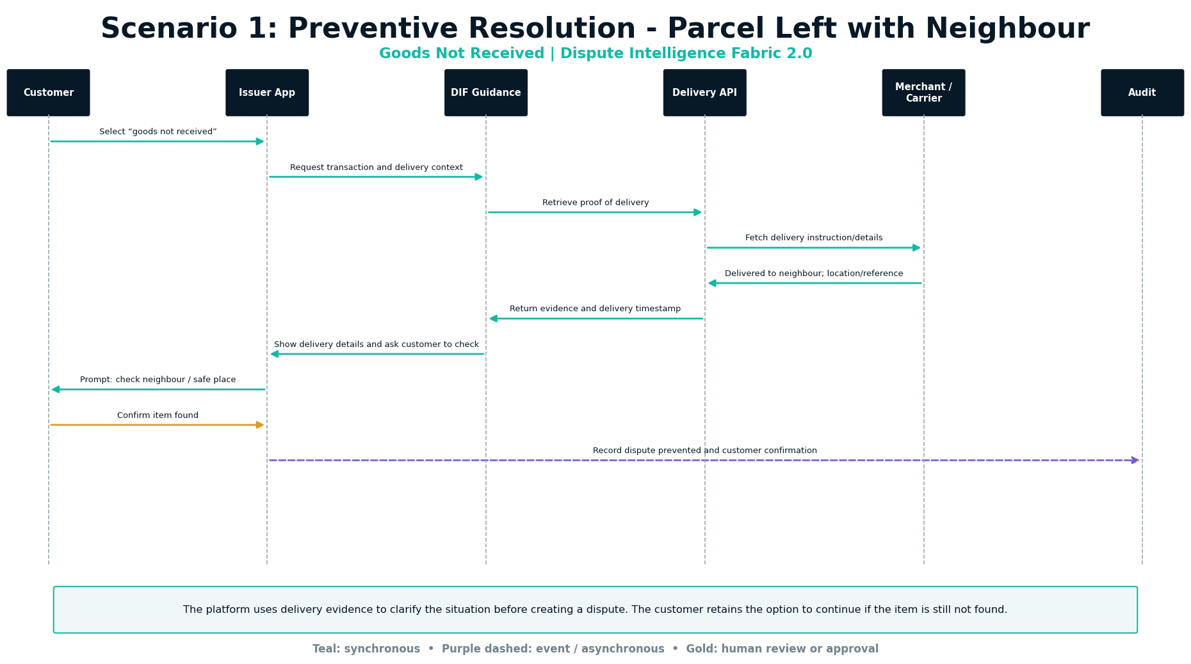

Scenario 2: On-Us Merchant Resolution
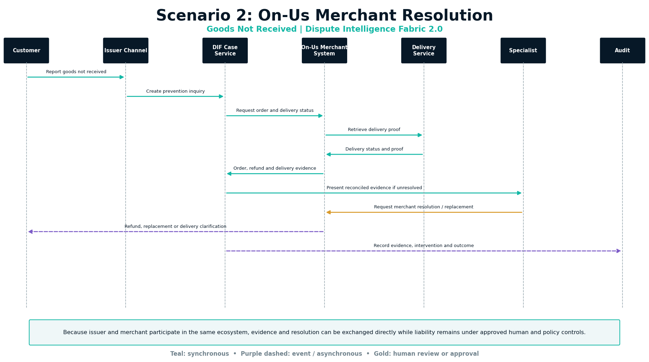

Scenario 3: Smart POS / Smart Merchant Evidence
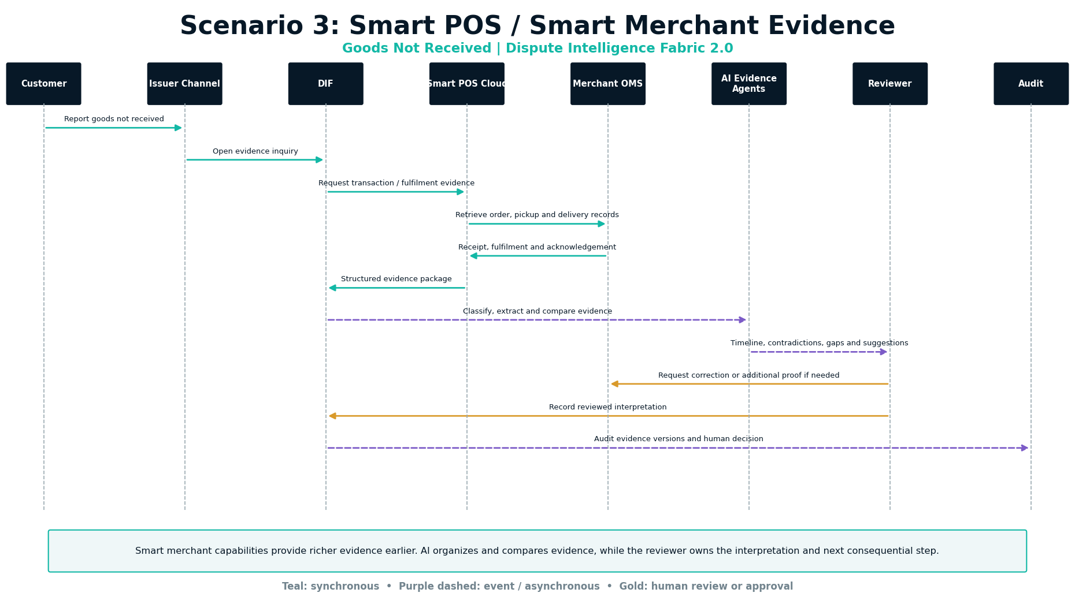

Scenario 4: Issuer Direct-to-Merchant API Collaboration
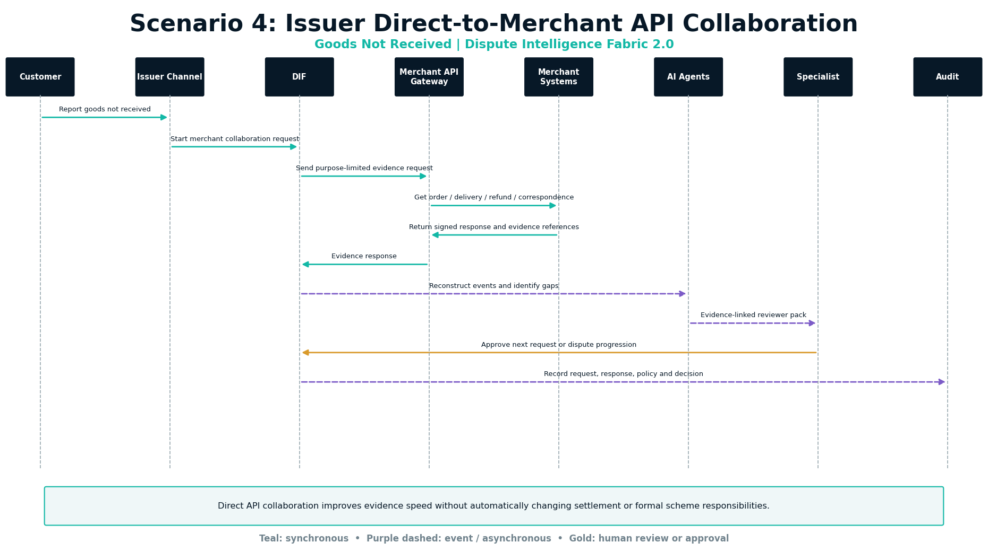

Scenario 5: Issuer-to-Acquirer API Collaboration
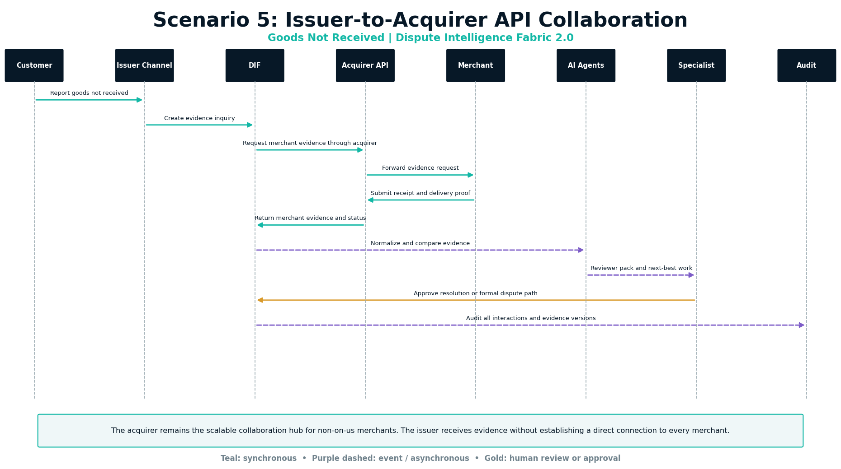

Scenario 6: Formal Scheme Flow through Visa / Network
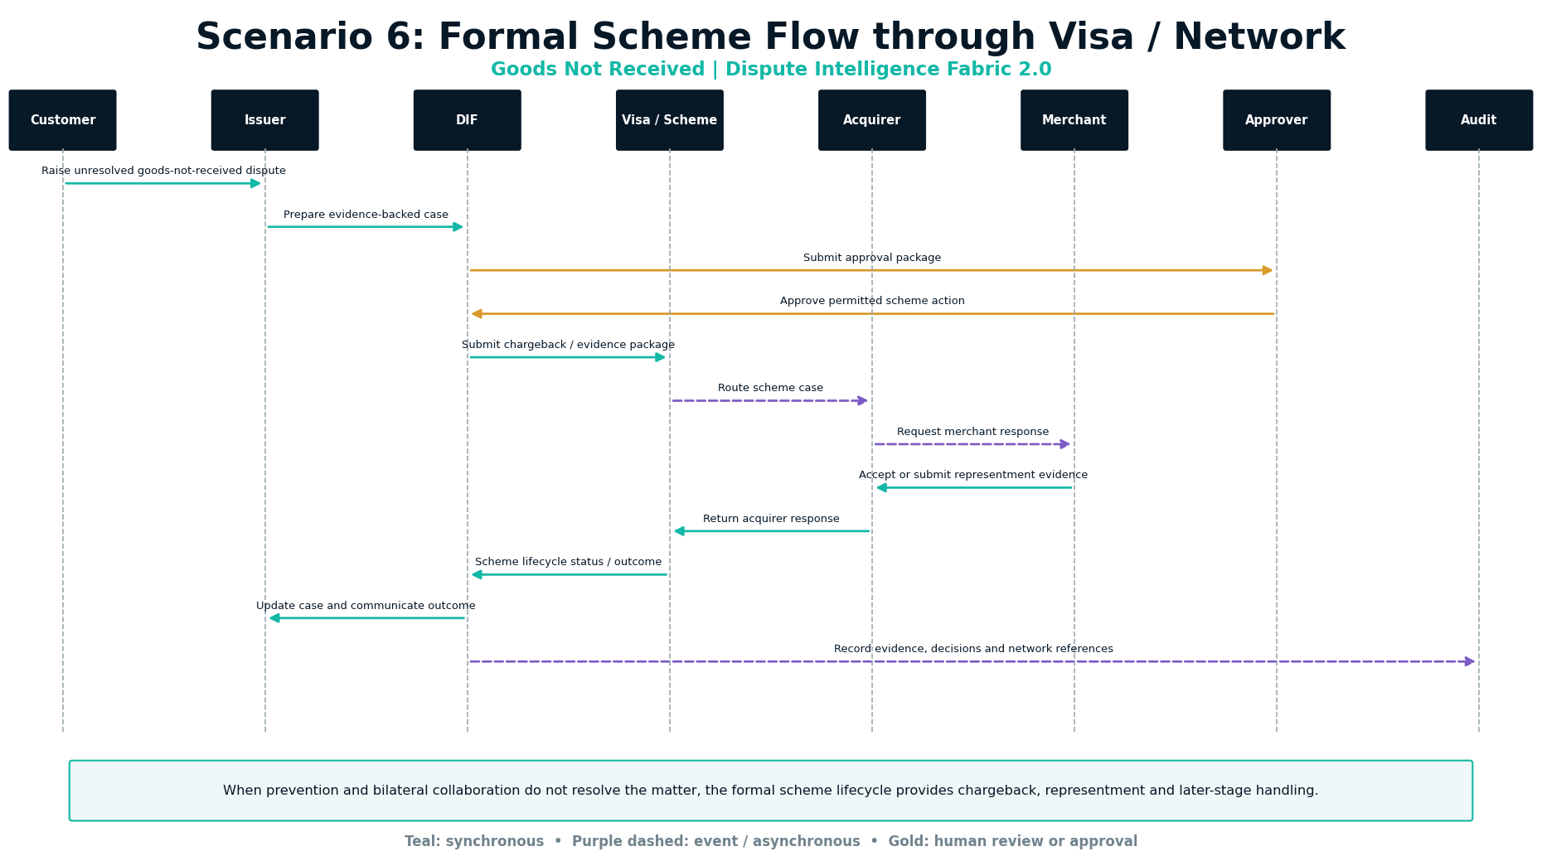

Scenario 7: Merchant Does Not Respond to Evidence Request
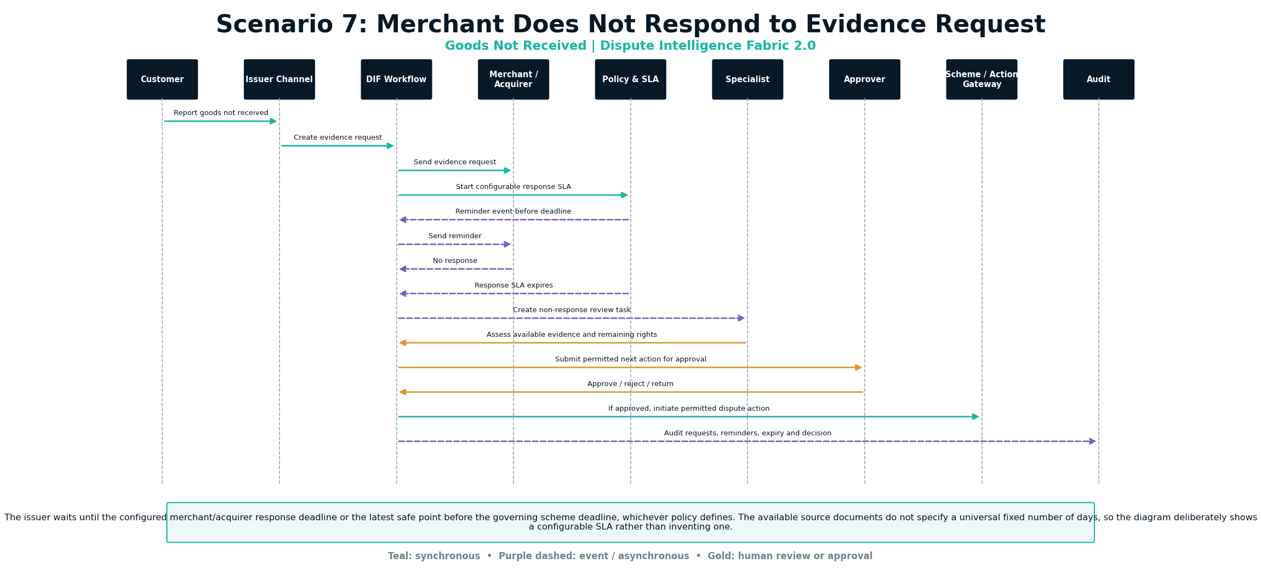

Merchant Non-Response: Waiting and Escalation Logic
The exact waiting period is not universal and is not specified in the available solution documents. It must be configured by institution, channel, merchant/acquirer agreement, market and governing scheme deadlines. The safe design is to calculate a response due date and preserve enough time for review, approval and any permitted scheme action.
- Start the merchant/acquirer response SLA when the evidence request is accepted for delivery.
- Generate one or more reminders according to configured policy.
- Stop waiting at the configured response deadline or the latest safe point before the scheme deadline.
- Create a specialist task when no response is received.
- Proceed using available evidence only after policy and human review.
- Do not auto-assign final liability solely because the merchant did not respond.
- If formal action is permitted, route it through approval and the relevant acquirer/network/action gateway.

Recommended configurable fields
Configuration | Purpose | Control
merchant_response_due_at | Response deadline derived from policy | Must not exceed latest safe scheme-processing point
reminder_schedule | Reminder event offsets | Versioned and auditable
scheme_action_deadline | Latest permitted network action time | Derived from applicable policy/rules
review_buffer | Time reserved for specialist and approval | Configured, monitored and alerted
non_response_disposition | Permitted next steps after no response | Human and policy controlled

