**Lab-1:** Environment Setup for Mobile Application Development

**Name:** *Harnoor Dhindsa*

**Let’s Setup the Environment**

Before installing React, it’s important to ensure your system meets the necessary requirements. Here’s what you need:

**Operating System:**

* Windows 10/11
* macOS 10.10 or later
* Ubuntu 16 or later

**RAM:** 4GB or More

**STORAGE:** 10GB free disk space

**STEP – 1:**

For setting up the environment you need to install the Node.js and NPM(Node Package Manager)

To Download the Node.js visit this website: <https://nodejs.org/en/download/>

Once you install the Installer your Node.js and NPM will be automatically install in your System to confirm them we can do the version check

**STEP – 2:**

To check the version for Node.js open your terminal/CMD and type.

* node -v



And for the NPM type

* npm -v



**STEP – 3:**

Now we have to install the expo app

Open you terminal/CMD again and type.

* npm install expo-cli -global

or

* npm install –global expo-cli

**STEP – 4:**

Now we have to create a Project

To do that we have to Choose the location where you want your Project

You can choose your location by changing the directory

* cd c:\\cprg303-D-Lab-Assignment

Once you change the directory type

* npx create-expo-app “*Name-of-your-project*”

or

* npx create-expo-app@latest “*Name-of-your-project*”

**STEP – 5:**

Once you create you project go to your project through terminal/CMD

* cd “*Name-of-your-project*”

**STEP – 6:**

To open your Project in VS code type

* code .

in your terminal/CMD

**STEP – 7:**

If you want to open the app in your phone you need to download the app called **Expo GO** in your device

IOS: <https://apps.apple.com/us/app/expo-go/id982107779>

ANDROID: <https://play.google.com/store/apps/details?id=host.exp.exponent&hl=en_US>

Once you Install the app go back to your terminal/CMD and type

* npx expo start

or

* npm start

It will generate a QR Code which you have to scan with your mobile’s camera and the app will be open in your phone using Expo Go which you recently install

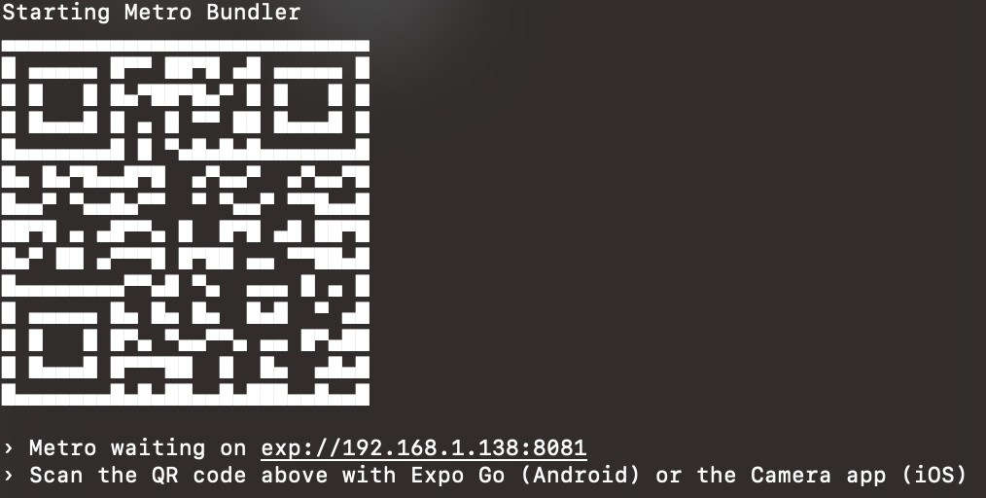

*Example of QR Code which will generate using the commands above*

Once you scan this will be the First look of your App

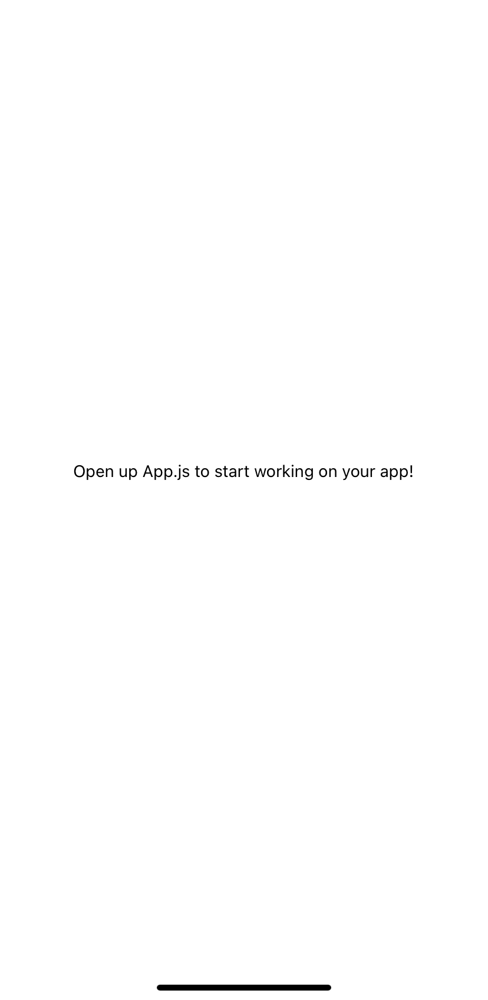

**Troubleshooting**:

While using macOS sometimes ~npm command doesn’t work when you are creating a project so to avoid any error you need to use the ~sudo npm to avoid using the sudo everytime you need to install the Homebrew from the link below

HomeBrew: <https://brew.sh/>

After installing the Homebrew run

* brew install node

in your terminal and restart your mac… your error will be fixed