Benin CPI Analysis Report
Generated on: 2025-10-29 14:17:52

Introduction
This report presents a comprehensive analysis of Consumer Price Index (CPI)
for Benin across multiple sectors including Food, Housing, Restaurant, and Transportation.
The analysis includes model selection, forecasting, and performance evaluation.

Methodology
The analysis employs multiple modeling approaches:
1. Base Model: Simple regression with current values
2. AR Model: Autoregressive model with lagged dependent variable
3. ARX Model: Autoregressive model with exogenous variables
4. LagX Model: Model with lagged exogenous variables
5. AR_LagX Model: Combined AR and lagged exogenous variables
Model selection is performed using backward elimination with a significance level of 0.10.
The best model is chosen based on test RMSE and AIC criteria.

Food CPI Analysis

Data Summary
Period: 2001-01 to 2025-02
Number of observations: 290
Features: Food CPI, FAO Food Price Index, FAO Meat, FAO Dairy Index, FAO Cereals Index, FAO Oils Index, FAO Sugar Index, UCSB CHIRPS Rainfall: avg, Groundnut oil ** ($/mt), Palm oil ($/mt), Palm kernel oil ($/mt), Soybean oil ($/mt), Sunflower oil ($/mt), Maize ($/mt), Sorghum ($/mt), Rice, Thai 5% ($/mt), Rice, Thai 25% ($/mt), Rice, Thai A.1 ($/mt), Rice, Viet Namese 5% ($/mt), Wheat, US SRW ($/mt), Wheat, US HRW ($/mt), Beef ** ($/kg), Chicken ** ($/kg), Lamb ** ($/kg), Sugar, EU ($/kg), Sugar, world ($/kg), EUR/USD, Subsidy_Index, TradeRestriction_Index, Crude oil, average ($/bbl), Crude oil, Brent ($/bbl), Crude oil, WTI ($/bbl)
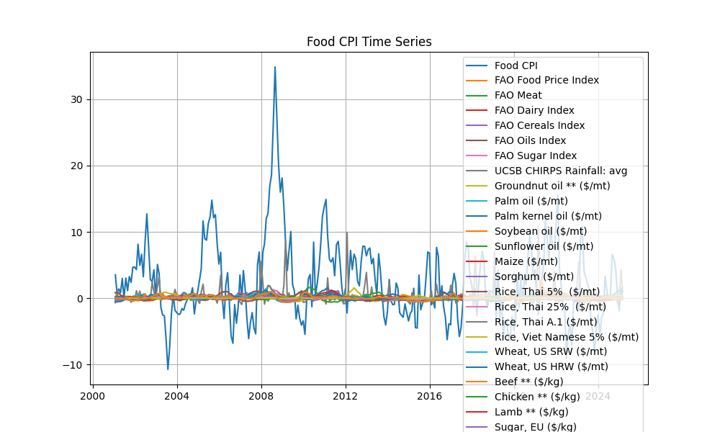
Figure: Time series plot for Food CPI

Housing CPI Analysis

Data Summary
Period: 2000-01 to 2025-02
Number of observations: 302
Features: House CPI, EUR/USD, Crude oil, average ($/bbl), Crude oil, Brent ($/bbl), Crude oil, WTI ($/bbl)
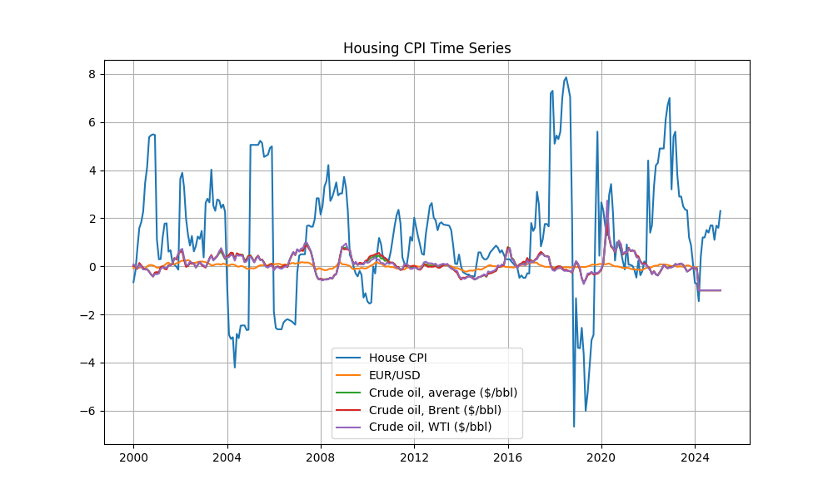
Figure: Time series plot for Housing CPI

Restaurant CPI Analysis

Data Summary
Period: 2001-01 to 2025-06
Number of observations: 294
Features: Restauration CPI, Natural gas, US ($/mmbtu) NGAS_US, Natural gas, Europe ($/mmbtu) NGAS_EUR, Cocoa ($/kg) COCOA, Coffee, Arabica ($/kg) COFFEE_ARABIC, Coffee, Robusta ($/kg) COFFEE_ROBUS, Tea, avg 3 auctions ($/kg) TEA_AVG, Tea, Colombo ($/kg) TEA_COLOMBO, Tea, Kolkata ($/kg) TEA_KOLKATA, Tea, Mombasa ($/kg) TEA_MOMBASA, Coconut oil ($/mt) COCONUT_OIL, Groundnuts ($/mt) GRNUT, Fish meal ($/mt) FISH_MEAL, Groundnut oil **($/mt) GRNUT_OIL, Palm oil ($/mt) PALM_OIL, Palm kernel oil ($/mt) PLMKRNL_OIL, Soybeans ($/mt) SOYBEANS, Soybean oil ($/mt) SOYBEAN_OIL, Soybean meal ($/mt) SOYBEAN_MEAL, Rapeseed oil ($/mt) RAPESEED_OIL, Sunflower oil ($/mt) SUNFLOWER_OIL, Barley ($/mt) BARLEY, Maize ($/mt) MAIZE, Sorghum ($/mt) SORGHUM, Rice, Thai 5% ($/mt) RICE_05, Rice, Thai 25% ($/mt) RICE_25, Rice, Thai A.1 ($/mt) RICE_A1, Rice, Viet Namese 5% ($/mt) RICE_05_VNM, Wheat, US SRW ($/mt) WHEAT_US_SRW, Wheat, US HRW ($/mt) WHEAT_US_HRW, Banana, Europe ($/kg) BANANA_EU, Banana, US ($/kg) BANANA_US, Orange ($/kg) ORANGE, Beef **($/kg) BEEF, Chicken **($/kg) CHICKEN, Lamb **($/kg) LAMB, Shrimps, Mexican ($/kg) SHRIMP_MEX, Sugar, EU ($/kg) SUGAR_EU, Sugar, US ($/kg) SUGAR_US, Sugar, world ($/kg) SUGAR_WLD
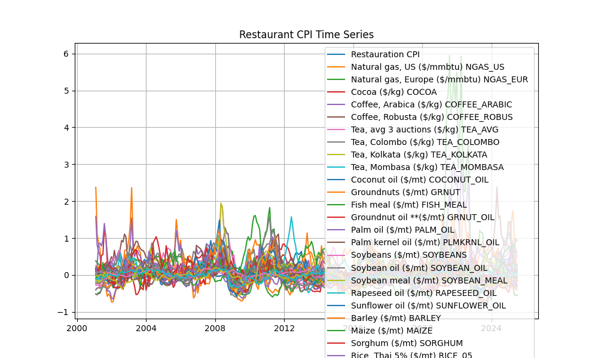
Figure: Time series plot for Restaurant CPI

Transportation CPI Analysis

Data Summary
Period: 2001-01 to 2025-06
Number of observations: 294
Features: transportation CPI, Crude oil, average ($/bbl) CRUDE_PETRO, Crude oil, Brent ($/bbl) CRUDE_BRENT, Crude oil, Dubai ($/bbl) CRUDE_DUBAI, Crude oil, WTI ($/bbl) CRUDE_WTI, Coal, Australian ($/mt) COAL_AUS, Coal, South African **($/mt) COAL_SAFRICA, Natural gas, US ($/mmbtu) NGAS_US, Natural gas, Europe ($/mmbtu) NGAS_EUR, Liquefied natural gas, Japan ($/mmbtu) NGAS_JP
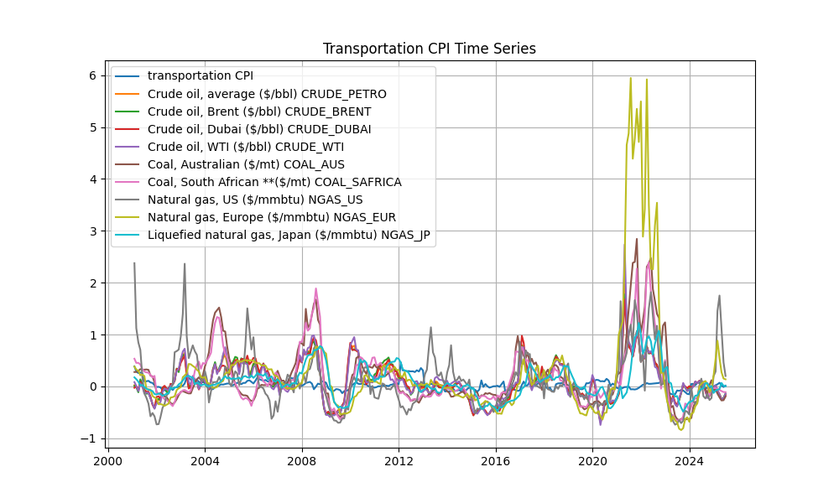
Figure: Time series plot for Transportation CPI

Conclusion
This report presents a comprehensive analysis of CPI trends across different sectors in Benin.
The analysis reveals distinct patterns and trends in each sector, with varying degrees of predictability
and different optimal model specifications for forecasting.

