1. 病人资料（部分栏位）：

|  |  |  |  |  |  |  |  |  |  |  |  |  |  |  |  |  |  |
| --- | --- | --- | --- | --- | --- | --- | --- | --- | --- | --- | --- | --- | --- | --- | --- | --- | --- |
| serial  Number | 性別 | 出生日期 | 吸菸狀況(年月) (1) | 尼古丁成癮度合計(分)(1) | times | 療程(1) | 就診日期(1) | 開藥週數(1) | 目前平均吸煙量(支/天)(1) | 療程(2) | 就診日期(2) | 開藥週數(2) | 目前平均吸煙量(支/天)(2) | 療程(3) | 就診日期(3) | 開藥週數(3) | 目前平均吸煙量(支/天)(3) |
| 1 | 1 | 1966/7/1 | 30 | 7 | 4 | 1 | 105/01/04 | 2 | 20 | 1 | 105/01/18 | 2 | 0 | 1 | 105/02/01 | 2 | 0 |
| 2 | 2 | 1973/2/4 | 20 | 9 | 6 | 1 | 105/01/04 | 2 | 40 | 1 | 105/01/18 | 2 | 10 | 2 | 105/04/18 | 2 | 20 |
| 3 | 1 | 1965/10/2 | 35 | 10 | 1 | 1 | 105/01/04 | 4 | 40 |  |  |  |  |  |  |  |  |
| 4 | 1 | 1957/5/29 | 30 | 7 | 2 | 1 | 105/01/04 | 3 | 20 | 1 | 105/03/29 | 4 | 20 |  |  |  |  |
| 5 | 1 | 1953/9/26 | 40 | 6 | 4 | 1 | 105/01/04 | 2 | 20 | 1 | 105/01/18 | 2 | 0 | 1 | 105/02/01 | 2 | 0 |
| 6 | 1 | 1956/11/29 | 40 | 6 | 4 | 1 | 105/01/05 | 2 | 14 | 1 | 105/01/19 | 2 | 0 | 1 | 105/02/02 | 2 | 0 |
| 7 | 1 | 1967/8/22 | 28 | 5 | 1 | 1 | 105/01/05 | 2 | 20 |  |  |  |  |  |  |  |  |
| 8 | 1 | 1988/5/6 | 13 | 4 | 5 | 1 | 105/01/05 | 2 | 15 | 1 | 105/02/01 | 2 | 2 | 1 | 105/02/15 | 1 | 40 |
| 9 | 1 | 1985/3/10 | 14 | 3 | 2 | 1 | 105/01/05 | 2 | 20 | 1 | 105/01/25 | 3 | 0 |  |  |  |  |
| 10 | 1 | 1955/12/8 | 43 | 7 | 3 | 1 | 105/01/05 | 2 | 20 | 1 | 105/01/18 | 4 | 3 | 1 | 105/02/15 | 2 | 0 |
| 11 | 1 | 1962/1/11 | 15 | 10 | 1 | 1 | 105/01/05 | 2 | 40 |  |  |  |  |  |  |  |  |
| 12 | 2 | 1979/12/26 | 8 | 8 | 4 | 1 | 105/01/05 | 2 | 40 | 1 | 105/01/18 | 2 | 0 | 1 | 105/02/01 | 2 | 0 |
| 13 | 1 | 1961/10/8 | 30 | 3 | 1 | 1 | 105/01/05 | 4 | 40 |  |  |  |  |  |  |  |  |
| 14 | 1 | 1966/8/1 | 20 | 5 | 1 | 1 | 105/01/05 | 4 | 10 |  |  |  |  |  |  |  |  |
| 15 | 1 | 1960/7/25 | 44 | 7 | 1 | 1 | 105/01/08 | 2 | 20 |  |  |  |  |  |  |  |  |
| 16 | 1 | 1950/10/23 | 40 | 6 | 3 | 1 | 105/01/11 | 2 | 10 | 1 | 105/01/25 | 3 | 0 | 1 | 105/02/15 | 3 | 2 |
| 17 | 1 | 1959/3/2 | 40 | 7 | 1 | 1 | 105/01/11 | 2 | 20 |  |  |  |  |  |  |  |  |
| 18 | 1 | 1961/1/19 | 33 | 5 | 3 | 1 | 105/01/11 | 2 | 15 | 1 | 105/01/25 | 3 | 2 | 1 | 105/02/15 | 3 | 0 |
| 19 | 1 | 1954/10/20 | 40 | 7 | 3 | 1 | 105/01/12 | 2 | 40 | 1 | 105/01/25 | 3 | 20 | 1 | 105/02/15 | 3 | 10 |
| 20 | 1 | 1963/1/21 | 35 | 4 | 1 | 1 | 105/01/12 | 2 | 6 |  |  |  |  |  |  |  |  |
| 21 | 1 | 1980/1/30 | 20 | 4 | 4 | 1 | 105/01/12 | 4 | 2 | 1 | 105/02/23 | 4 | 0 | 2 | 105/04/12 | 4 | 0 |
| 22 | 1 | 1962/9/7 | 30 | 8 | 1 | 1 | 105/01/12 | 2 | 20 |  |  |  |  |  |  |  |  |
| 23 | 1 | 1967/7/28 | 30 | 6 | 3 | 1 | 105/01/12 | 4 | 2 | 2 | 105/05/10 | 4 | 10 | 2 | 105/06/14 | 4 | 0 |
| 24 | 1 | 1954/8/3 | 40 | 8 | 5 | 1 | 105/01/12 | 2 | 20 | 1 | 105/01/26 | 4 | 0 | 1 | 105/02/23 | 2 | 0 |
| 25 | 1 | 1985/12/20 | 18 | 9 | 2 | 1 | 105/01/12 | 4 | 40 | 1 | 105/02/26 | 4 | 25 |  |  |  |  |
| 26 | 1 | 1961/10/23 | VPN無記錄 |  | 0 |  |  |  |  |  |  |  |  |  |  |  |  |
| 27 | 1 | 1955/4/15 | 30 | 5 | 2 | 1 | 105/01/15 | 3 | 20 | 1 | 105/02/05 | 4 | 0 |  |  |  |  |
| 28 | 1 | 1964/12/25 | 30 | 7 | 1 | 1 | 105/01/18 | 2 | 10 |  |  |  |  |  |  |  |  |
| 29 | 1 | 1961/4/15 | 40 | 9 | 3 | 1 | 105/01/18 | 2 | 60 | 1 | 105/02/01 | 3 | 0 | 1 | 105/02/22 | 3 | 0 |
| 30 | 1 | 1985/4/9 | 10 | 8 | 1 | 1 | 105/01/18 | 2 | 20 |  |  |  |  |  |  |  |  |
| 31 | 1 | 1964/1/14 | 30 | 6 | 5 | 1 | 105/01/19 | 2 | 40 | 1 | 105/02/01 | 2 | 0 | 1 | 105/02/19 | 4 | 0 |
| 32 | 1 | 1961/10/11 | 40 | 9 | 3 | 1 | 105/01/20 | 2 | 20 | 1 | 105/02/17 | 4 | 40 | 2 | 105/11/03 | 4 | 40 |
| 33 | 1 | 1961/8/14 | 35 | 4 | 2 | 1 | 105/01/26 | 1 | 20 | 1 | 105/02/02 | 2 | 14 |  |  |  |  |
| 34 | 1 | ###### | 3 | 6 | 1 | 1 | 105/02/01 | 2 | 20 |  |  |  |  |  |  |  |  |
| 35 | 1 | 1982/2/12 | 6 | 5 | 1 | 1 | 105/02/01 | 2 | 10 |  |  |  |  |  |  |  |  |
| 36 | 1 | 1975/1/23 | 25 | 6 | 1 | 1 | 105/02/15 | 3 | 30 |  |  |  |  |  |  |  |  |
| 37 | 1 | 1964/9/26 | 35 | 10 | 1 | 1 | 105/02/16 | 2 | 40 |  |  |  |  |  |  |  |  |
| 38 | 1 | 1967/12/16 | 20 | 5 | 1 | 1 | 105/02/16 | 2 | 20 |  |  |  |  |  |  |  |  |
| 39 | 1 | 1952/5/5 | 48 | 8 | 3 | 1 | 105/02/16 | 3 | 10 | 1 | 105/03/07 | 3 | 0 | 1 | 105/03/28 | 2 | 0 |
| 40 | 1 | 1961/2/22 | 20 | 5 | 1 | 1 | 105/02/19 | 1 | 10 |  |  |  |  |  |  |  |  |
| 41 | 1 | 1958/10/21 | 40 | 4 | 1 | 1 | 105/02/22 | 4 | 10 |  |  |  |  |  |  |  |  |
| 42 | 1 | 1932/9/20 | 50 | 5 | 3 | 1 | 105/02/22 | 2 | 20 | 1 | 105/03/07 | 2 | 0 | 1 | 105/03/21 | 4 | 0 |
| 43 | 1 | 1957/1/13 | 40 | 5 | 1 | 1 | 105/02/23 | 4 | 30 |  |  |  |  |  |  |  |  |
| 44 | 1 | 1979/8/3 | 20 | 8 | 1 | 1 | 105/02/24 | 2 | 40 |  |  |  |  |  |  |  |  |
| 45 | 1 | 1971/12/18 | 25 | 6 | 1 | 1 | 105/02/24 | 2 | 30 |  |  |  |  |  |  |  |  |
| 46 | 1 | 1975/5/3 | 20 | 5 | 3 | 1 | 105/02/26 | 1 | 0 | 1 | 105/03/03 | 2 | 0 | 1 | 105/03/16 | 4 | 0 |
| 47 | 1 | 1956/11/23 | 40 | 5 | 3 | 1 | 105/02/26 | 2 | 10 | 1 | 105/03/12 | 2 | 0 | 1 | 105/03/26 | 4 | 0 |
| 48 | 1 | 1962/10/2 | 25 | 1 | 2 | 1 | 105/03/01 | 1 | 10 | 1 | 105/03/08 | 2 | 0 |  |  |  |  |
| 49 | 1 | 1965/2/24 | 30 | 8 | 5 | 1 | 105/03/02 | 3 | 40 | 1 | 105/03/23 | 4 | 0 | 1 | 105/04/20 | 1 | 0 |
| 50 | 1 | 1943/2/26 | 57 | 6 | 2 | 1 | 105/03/07 | 2 | 10 | 1 | 105/03/21 | 3 | 1 |  |  |  |  |
| 51 | 1 | 1971/6/10 | 28 | 8 | 2 | 1 | 105/03/07 | 2 | 40 | 1 | 105/03/21 | 3 | 7 |  |  |  |  |
| 52 | 2 | 1962/8/10 | 20 | 7 | 4 | 1 | 105/03/07 | 2 | 15 | 1 | 105/03/21 | 4 | 3 | 1 | 105/04/18 | 2 | 6 |
| 53 | 1 | 1971/9/9 | 25 | 5 | 1 | 1 | 105/03/07 | 4 | 10 |  |  |  |  |  |  |  |  |
| 54 | 2 | 1970/12/29 | 20 | 7 | 2 | 1 | 105/03/08 | 3 | 20 | 1 | 105/04/11 | 3 | 10 |  |  |  |  |
| 55 | 2 | 1970/10/24 | 29 | 2 | 1 | 1 | 105/03/08 | 2 | 10 |  |  |  |  |  |  |  |  |
| 56 | 1 | 1976/11/13 | 20 | 4 | 1 | 1 | 105/03/08 | 2 | 15 |  |  |  |  |  |  |  |  |
| 57 | 1 | 1962/10/18 | 30 | 5 | 3 | 1 | 105/03/09 | 1 | 10 | 1 | 105/04/28 | 3 | 10 | 1 | 105/05/16 | 4 | 2 |
| 58 | 1 | 1952/9/16 | 40 | 4 | 2 | 1 | 105/03/14 | 2 | 20 | 1 | 105/03/28 | 2 | 0 |  |  |  |  |
| 59 | 1 | 1981/9/14 | 14 | 7 | 2 | 1 | 105/03/14 | 2 | 30 | 1 | 105/03/28 | 3 | 0 |  |  |  |  |
| 60 | 1 | 1978/1/14 | 20 | 10 | 2 | 1 | 105/03/14 | 2 | 30 | 1 | 105/03/28 | 2 | 15 |  |  |  |  |
| 61 | 1 | 1982/8/21 | 9 | 8 | 2 | 1 | 105/03/14 | 2 | 40 | 1 | 105/03/28 | 2 | 20 |  |  |  |  |
| 62 | 1 | 1962/1/28 | 40 | 7 | 1 | 1 | 105/03/15 | 2 | 20 |  |  |  |  |  |  |  |  |
| 63 | 2 | 1961/3/3 | 32 | 8 | 5 | 1 | 105/03/15 | 2 | 20 | 1 | 105/03/29 | 2 | 5 | 1 | 105/04/12 | 2 | 2 |
| 64 | 1 | 1969/9/3 | 30 | 5 | 4 | 1 | 105/03/15 | 2 | 20 | 1 | 105/03/28 | 2 | 7 | 1 | 105/04/12 | 2 | 2 |
| 65 | 1 | 1969/12/13 | 25 | 6 | 3 | 1 | 105/03/16 | 1 | 40 | 1 | 105/04/06 | 4 | 20 | 1 | 105/05/23 | 3 | 20 |
| 66 | 1 | 1952/12/20 | 45 | 7 | 3 | 1 | 105/03/21 | 3 | 20 | 1 | 105/04/11 | 3 | 0 | 1 | 105/05/02 | 2 | 3 |
| 67 | 1 | 1970/6/1 | 29 | 10 | 1 | 1 | 105/03/21 | 3 | 50 |  |  |  |  |  |  |  |  |
| 68 | 1 | 1948/3/2 | 40 | 5 | 4 | 1 | 105/03/22 | 3 | 10 | 1 | 105/04/11 | 2 | 0 | 1 | 105/04/25 | 2 | 0 |
| 69 | 1 | 1987/1/18 | 13 | 3 | 3 | 1 | 105/03/28 | 2 | 15 | 1 | 105/04/11 | 2 | 0 | 1 | 105/04/25 | 2 | 0 |
| 70 | 1 | 1991/12/7 | 8 | 6 | 4 | 1 | 105/03/28 | 2 | 20 | 1 | 105/04/11 | 2 | 10 | 1 | 105/04/25 | 2 | 0 |
| 71 | 1 | 1996/9/16 | 2 | 7 | 3 | 1 | 105/03/28 | 2 | 10 | 1 | 105/04/11 | 2 | 0 | 1 | 105/04/25 | 2 | 0 |
| 72 | 1 | 1962/3/25 | 20 | 6 | 4 | 1 | 105/03/28 | 4 | 20 | 1 | 105/04/25 | 4 | 0 | 2 | 105/05/31 | 4 | 5 |
| 73 | 1 | 1968/10/6 | 無第一療程 |  | 2 | 2 | 105/03/29 | 4 | 30 | 2 | 105/04/26 | 4 | 10 |  |  |  |  |
| 74 | 1 | 1958/10/24 | 30 | 4 | 1 | 1 | 105/03/29 | 2 | 15 |  |  |  |  |  |  |  |  |
| 75 | 2 | 1953/12/1 | 42 | 5 | 1 | 1 | 105/03/29 | 2 | 10 |  |  |  |  |  |  |  |  |
| 76 | 1 | 1976/7/26 | 15 | 5 | 1 | 1 | 105/04/06 | 1 | 15 |  |  |  |  |  |  |  |  |
| 77 | 2 | 1957/8/27 | 34 | 5 | 3 | 1 | 105/04/11 | 2 | 15 | 1 | 105/04/25 | 3 | 3 | 1 | 105/05/16 | 3 | 2 |
| 78 | 1 | 1967/1/5 | 30 | 6 | 1 | 1 | 105/04/11 | 2 | 20 |  |  |  |  |  |  |  |  |
| 79 | 1 | 1949/6/11 | 50 | 8 | 1 | 1 | 105/04/12 | 2 | 30 |  |  |  |  |  |  |  |  |
| 80 | 1 | 1965/6/9 | 20 | 7 | 3 | 1 | 105/04/12 | 2 | 5 | 1 | 105/04/25 | 2 | 0 | 1 | 105/05/09 | 4 | 0 |
| 81 | 1 | 1966/4/30 | 20 | 6 | 2 | 1 | 105/04/16 | 4 | 15 | 1 | 105/05/14 | 4 | 5 |  |  |  |  |
| 82 | 1 | 1977/12/13 | 20 | 7 | 2 | 1 | 105/04/18 | 2 | 20 | 1 | 105/05/02 | 2 | 0 |  |  |  |  |
| 83 | 1 | 1933/12/5 | 60 | 7 | 1 | 1 | 105/04/18 | 2 | 40 |  |  |  |  |  |  |  |  |
| 84 | 1 | 1953/2/28 | 40 | 6 | 4 | 1 | 105/04/18 | 2 | 10 | 1 | 105/05/02 | 2 | 0 | 1 | 105/05/23 | 2 | 3 |
| 85 | 1 | 1960/1/26 | 30 | 9 | 3 | 1 | 105/04/18 | 2 | 60 | 1 | 105/05/02 | 3 | 3 | 1 | 105/05/23 | 3 | 6 |
| 86 | 2 | 1975/3/22 | 22 | 6 | 3 | 1 | 105/04/18 | 2 | 20 | 1 | 105/05/02 | 2 | 10 | 1 | 105/05/16 | 2 | 7 |
| 87 | 2 | 1993/10/18 | 10 | 8 | 2 | 1 | 105/04/19 | 1 | 30 | 1 | 105/04/26 | 1 | 0 |  |  |  |  |
| 88 | 1 | 1942/1/1 | 60 | 10 | 4 | 1 | 105/04/19 | 1 | 30 | 1 | 105/04/26 | 1 | 20 | 1 | 105/05/03 | 2 | 10 |
| 89 | 1 | 1981/4/29 | 18 | 7 | 2 | 1 | 105/04/19 | 2 | 30 | 1 | 105/05/02 | 2 | 0 |  |  |  |  |
| 90 | 1 | 1989/8/17 | 8 | 6 | 1 | 1 | 105/04/19 | 2 | 20 |  |  |  |  |  |  |  |  |
| 91 | 1 | 1949/2/20 | 45 | 5 | 3 | 1 | 105/04/20 | 4 | 15 | 1 | 105/05/18 | 4 | 0 | 1 | 105/08/10 | 4 | 0 |
| 92 | 1 | 1960/7/18 | 30 | 2 | 4 | 1 | 105/04/22 | 2 | 15 | 1 | 105/05/06 | 4 | 3 | 1 | 105/06/03 | 2 | 3 |
| 93 | 1 | 1970/5/2 | 25 | 6 | 2 | 1 | 105/04/25 | 4 | 30 | 1 | 105/07/11 | 4 | 0 |  |  |  |  |
| 94 | 1 | 1973/3/9 | 20 | 8 | 1 | 1 | 105/04/25 | 2 | 30 |  |  |  |  |  |  |  |  |
| 95 | 1 | 1978/11/3 | 22 | 8 | 2 | 1 | 105/04/25 | 2 | 20 | 1 | 105/05/09 | 2 | 0 |  |  |  |  |
| 96 | 2 | 1982/10/1 | 7 | 5 | 1 | 1 | 105/04/26 | 2 | 20 |  |  |  |  |  |  |  |  |
| 97 | 1 | 1958/10/17 | 35 | 9 | 2 | 1 | 105/05/02 | 2 | 40 | 1 | 105/05/16 | 2 | 0 |  |  |  |  |
| 98 | 1 | 1952/9/14 | 40 | 4 | 2 | 1 | 105/05/02 | 2 | 20 | 1 | 105/05/16 | 2 | 0 |  |  |  |  |
| 99 | 1 | 1962/12/14 | 30 | 5 | 3 | 1 | 105/05/02 | 2 | 2 | 1 | 105/05/16 | 2 | 0 | 1 | 105/05/30 | 4 | 0 |
| 100 | 1 | 1937/9/23 | 60 | 4 | 2 | 1 | 105/05/03 | 4 | 20 | 1 | 105/06/06 | 4 | 0 |  |  |  |  |
| 101 | 1 | 1989/6/1 | 2 | 7 | 4 | 1 | 105/05/09 | 2 | 20 | 1 | 105/05/23 | 2 | 2 | 2 | 105/09/19 | 2 | 20 |
| 102 | 2 | 1978/9/22 | 20 | 5 | 1 | 1 | 105/05/11 | 2 | 7 |  |  |  |  |  |  |  |  |
| 103 | 1 | 1962/5/14 | 8 | 7 | 1 | 1 | 105/05/14 | 4 | 30 |  |  |  |  |  |  |  |  |
| 104 | 1 | 1956/10/1 | 41 | 6 | 3 | 1 | 105/05/16 | 2 | 20 | 1 | 105/05/30 | 2 | 4 | 1 | 105/06/13 | 4 | 0 |
| 105 | 1 | 1966/4/10 | 33 | 10 | 2 | 1 | 105/05/16 | 2 | 20 | 1 | 105/05/30 | 2 | 0 |  |  |  |  |
| 106 | 1 | 1960/1/5 | 38 | 8 | 1 | 1 | 105/05/16 | 2 | 20 |  |  |  |  |  |  |  |  |
| 107 | 1 | 1958/6/22 | 35 | 8 | 2 | 1 | 105/05/16 | 2 | 5 | 1 | 105/05/30 | 2 | 0 |  |  |  |  |
| 108 | 1 | 1945/2/16 | 50 | 7 | 3 | 1 | 105/05/16 | 2 | 20 | 1 | 105/05/30 | 2 | 0 | 1 | 105/06/13 | 4 | 0 |
| 109 | 1 | 1956/5/3 | 43年6月 | 8 | 2 | 1 | 105/05/18 | 2 | 25 | 1 | 105/06/06 | 4 | 10 |  |  |  |  |
| 110 | 1 | 1982/12/3 | 15年2月 | 5 | 1 | 1 | 105/05/20 | 2 | 15 |  |  |  |  |  |  |  |  |
| 111 | 1 | 1976/2/4 | 18 | 5 | 3 | 1 | 105/05/24 | 1 | 20 | 1 | 105/05/31 | 2 | 0 | 1 | 105/06/14 | 2 | 0 |
| 112 | 1 | 1989/6/7 | 10 | 5 | 3 | 1 | 105/05/24 | 1 | 15 | 1 | 105/05/31 | 2 | 0 | 1 | 105/06/14 | 2 | 0 |
| 113 | 1 | 1950/11/12 | 50 | 6 | 4 | 1 | 105/05/24 | 2 | 10 | 1 | 105/06/07 | 2 | 0 | 1 | 105/06/21 | 2 | 0 |
| 114 | 1 | 1965/10/1 | 20 | 9 | 2 | 1 | 105/05/24 | 2 | 20 | 1 | 105/06/07 | 2 | 6 |  |  |  |  |
| 115 | 1 | 1986/12/5 | 6 | 7 | 1 | 1 | 105/05/25 | 4 | 15 |  |  |  |  |  |  |  |  |
| 116 | 2 | 1983/5/25 | 10 | 9 | 1 | 1 | 105/05/31 | 2 | 40 |  |  |  |  |  |  |  |  |
| 117 | 1 | 1976/12/14 | 24 | 6 | 4 | 1 | 105/06/06 | 2 | 20 | 1 | 105/06/20 | 2 | 1 | 1 | 105/07/04 | 2 | 0 |
| 118 | 1 | 1960/5/7 | 37 | 10 | 1 | 1 | 105/06/06 | 2 | 40 |  |  |  |  |  |  |  |  |
| 119 | 1 | 1983/7/15 | 20 | 5 | 4 | 1 | 105/06/06 | 2 | 10 | 1 | 105/06/20 | 2 | 10 | 1 | 105/07/04 | 2 | 5 |
| 120 | 1 | 1975/4/29 | 26 | 8 | 2 | 1 | 105/06/07 | 2 | 30 | 1 | 105/06/21 | 2 | 30 |  |  |  |  |
| 121 | 1 | 1964/4/1 | 25 | 1 | 3 | 1 | 105/06/07 | 2 | 20 | 1 | 105/06/21 | 4 | 0 | 1 | 105/08/09 | 2 | 0 |
| 122 | 1 | 1949/1/15 | 30 | 1 | 3 | 1 | 105/06/08 | 2 | 10 | 1 | 105/06/21 | 3 | 0 | 1 | 105/07/11 | 3 | 5 |
| 123 | 1 | 1938/5/22 | 61 | 6 | 1 | 1 | 105/06/10 | 2 | 20 |  |  |  |  |  |  |  |  |
| 124 | 1 | 1955/9/15 | 40 | 8 | 2 | 1 | 105/06/11 | 2 | 20 | 1 | 105/06/25 | 2 | 10 |  |  |  |  |
| 125 | 2 | 1975/5/21 | 20 | 10 | 1 | 1 | 105/06/13 | 4 | 40 |  |  |  |  |  |  |  |  |
| 126 | 2 | 1970/11/1 | 18 | 6 | 1 | 1 | 105/06/13 | 4 | 20 |  |  |  |  |  |  |  |  |
| 127 | 1 | 1943/7/1 | 51 | 6 | 1 | 1 | 105/06/14 | 2 | 15 |  |  |  |  |  |  |  |  |
| 128 | 1 | 1971/4/3 | 25 | 7 | 6 | 1 | 105/06/14 | 2 | 20 | 1 | 105/06/27 | 2 | 0 | 1 | 105/07/11 | 2 | 1 |
| 129 | 1 | 1963/6/26 | 35 | 9 | 1 | 1 | 105/06/17 | 2 | 25 |  |  |  |  |  |  |  |  |
| 130 | 1 | 1960/1/28 | 30 | 9 | 1 | 1 | 105/06/20 | 2 | 40 |  |  |  |  |  |  |  |  |
| 131 | 1 | 1966/8/31 | 30 | 6 | 3 | 1 | 105/06/21 | 2 | 16 | 1 | 105/06/28 | 4 | 10 | 2 | 105/10/01 | 4 | 10 |
| 132 | 1 | 1972/4/24 | 29 | 7 | 1 | 1 | 105/06/21 | 2 | 30 |  |  |  |  |  |  |  |  |
| 133 | 1 | 1958/9/28 | 40 | 10 | 1 | 1 | 105/06/21 | 2 | 40 |  |  |  |  |  |  |  |  |
| 134 | 2 | 1965/3/15 | 30 | 8 | 2 | 1 | 105/06/21 | 2 | 30 | 1 | 105/07/11 | 3 | 0 |  |  |  |  |
| 135 | 1 | 1974/2/17 | 25 | 6 | 2 | 1 | 105/06/22 | 4 | 30 | 1 | 105/07/20 | 4 | 0 |  |  |  |  |
| 136 | 1 | 1959/9/4 | 35 | 7 | 1 | 1 | 105/06/27 | 2 | 20 |  |  |  |  |  |  |  |  |
| 137 | 2 | 1979/7/7 | 22 | 4 | 1 | 1 | 105/06/27 | 2 | 15 |  |  |  |  |  |  |  |  |
| 138 | 1 | 1971/9/30 | 30 | 7 | 1 | 1 | 105/06/27 | 2 | 40 |  |  |  |  |  |  |  |  |
| 139 | 1 | 1946/11/22 | 40 | 5 | 4 | 1 | 105/06/27 | 2 | 10 | 2 | 105/10/24 | 2 | 10 | 2 | 105/11/07 | 3 | 0 |
| 140 | 1 | 1969/11/13 | 25 | 7 | 1 | 1 | 105/06/27 | 4 | 30 |  |  |  |  |  |  |  |  |
| 141 | 1 | 1968/7/1 | 10 | 7 | 1 | 1 | 105/06/28 | 2 | 20 |  |  |  |  |  |  |  |  |
| 142 | 1 | 1989/7/24 | 5 | 4 | 1 | 1 | 105/07/01 | 2 | 4 |  |  |  |  |  |  |  |  |
| 143 | 1 | 1980/3/13 | 12 | 5 | 5 | 1 | 105/07/04 | 2 | 15 | 1 | 105/07/18 | 2 | 10 | 1 | 105/08/15 | 4 | 8 |
| 144 | 1 | 1975/11/24 | 20 | 5 | 4 | 1 | 105/07/04 | 2 | 20 | 1 | 105/07/18 | 2 | 4 | 1 | 105/08/01 | 2 | 2 |
| 145 | 1 | 1982/10/16 | 10 | 7 | 2 | 1 | 105/07/04 | 2 | 20 | 2 | 105/10/03 | 4 | 20 |  |  |  |  |
| 146 | 1 | 1958/12/16 | 40 | 4 | 4 | 1 | 105/07/04 | 2 | 8 | 1 | 105/07/18 | 2 | 0 | 1 | 105/08/01 | 2 | 0 |
| 147 | 1 | 1938/3/10 | 65 | 9 | 1 | 1 | 105/07/06 | 2 | 30 |  |  |  |  |  |  |  |  |
| 148 | 1 | 1959/5/27 | 30 | 7 | 2 | 1 | 105/07/12 | 1 | 15 | 1 | 105/07/19 | 4 | 5 |  |  |  |  |
| 149 | 1 | 1956/3/3 | 40 | 2 | 4 | 1 | 105/07/12 | 2 | 13 | 1 | 105/07/26 | 2 | 7 | 1 | 105/08/09 | 4 | 6 |
| 150 | 1 | 1967/10/14 | 25 | 5 | 2 | 1 | 105/07/14 | 1 | 15 | 1 | 105/07/22 | 3 | 10 |  |  |  |  |
| 151 | 1 | 1963/8/30 | 25 | 6 | 2 | 1 | 105/07/18 | 2 | 15 | 1 | 105/08/01 | 4 | 10 |  |  |  |  |
| 152 | 1 | 1963/10/15 | 20 | 7 | 1 | 1 | 105/07/20 | 2 | 20 |  |  |  |  |  |  |  |  |
| 153 | 1 | 1977/1/17 | 12 | 8 | 2 | 1 | 105/07/20 | 2 | 20 | 1 | 105/08/03 | 2 | 20 |  |  |  |  |
| 154 | 1 | 1973/7/24 | 30 | 6 | 4 | 1 | 105/07/23 | 4 | 25 | 1 | 105/08/22 | 4 | 10 | 2 | 105/09/19 | 4 | 3 |
| 155 | 1 | 1985/12/19 | 20 | 9 | 1 | 1 | 105/07/23 | 2 | 20 |  |  |  |  |  |  |  |  |
| 156 | 1 | 1981/5/18 | 6 | 6 | 1 | 1 | 105/07/25 | 4 | 10 |  |  |  |  |  |  |  |  |
| 157 | 1 | 1953/12/29 | 30 | 6 | 4 | 1 | 105/07/26 | 1 | 20 | 1 | 105/08/02 | 1 | 10 | 1 | 105/08/09 | 2 | 5 |
| 158 | 1 | 1975/10/3 | 25 | 8 | 4 | 1 | 105/08/01 | 2 | 30 | 1 | 105/08/15 | 2 | 0 | 1 | 105/08/29 | 2 | 0 |
| 159 | 1 | 1961/6/7 | 35 | 10 | 1 | 1 | 105/08/01 | 2 | 40 |  |  |  |  |  |  |  |  |
| 160 | 2 | 1957/7/7 | 40 | 7 | 2 | 1 | 105/08/01 | 2 | 10 | 1 | 105/08/15 | 4 | 2 |  |  |  |  |
| 161 | 2 | 1967/4/22 | 25 | 10 | 1 | 1 | 105/08/01 | 2 | 40 |  |  |  |  |  |  |  |  |
| 162 | 2 | 1968/5/11 | 30 | 8 | 6 | 1 | 105/08/02 | 2 | 30 | 1 | 105/09/13 | 4 | 20 | 1 | 105/10/18 | 2 | 0 |
| 163 | 1 | 1948/6/18 | 30 | 6 | 1 | 1 | 105/08/09 | 2 | 15 |  |  |  |  |  |  |  |  |
| 164 | 1 | 1963/11/23 | 20 | 8 | 1 | 1 | 105/08/09 | 4 | 20 |  |  |  |  |  |  |  |  |
| 165 | 1 | 1960/2/12 | 40 | 9 | 1 | 1 | 105/08/09 | 4 | 30 |  |  |  |  |  |  |  |  |
| 166 | 1 | 1949/12/20 | 45 | 9 | 3 | 1 | 105/08/09 | 4 | 40 | 1 | 105/08/30 | 4 | 12 | 2 | 105/10/04 | 4 | 12 |
| 167 | 1 | 1964/2/3 | 35 | 10 | 6 | 1 | 105/08/15 | 2 | 30 | 1 | 105/08/29 | 2 | 0 | 1 | 105/09/12 | 4 | 0 |
| 168 | 1 | 1951/4/4 | 40 | 4 | 1 | 1 | 105/08/15 | 2 | 6 |  |  |  |  |  |  |  |  |
| 169 | 1 | 1951/9/23 | 45 | 7 | 1 | 1 | 105/08/15 | 2 | 20 |  |  |  |  |  |  |  |  |
| 170 | 1 | 1972/1/16 | 25 | 7 | 1 | 1 | 105/08/15 | 2 | 30 |  |  |  |  |  |  |  |  |
| 171 | 2 | 1981/10/14 | 17 | 8 | 3 | 1 | 105/08/16 | 1 | 30 | 1 | 105/08/23 | 2 | 20 | 1 | 105/09/13 | 2 | 10 |
| 172 | 1 | 1962/1/1 | 40 | 7 | 2 | 1 | 105/08/18 | 3 | 15 | 1 | 105/09/08 | 3 | 11 |  |  |  |  |
| 173 | 1 | 1957/8/28 | 30 | 4 | 2 | 1 | 105/08/19 | 2 | 25 | 1 | 105/09/05 | 4 | 14 |  |  |  |  |
| 174 | 1 | 1953/6/26 | 40 | 9 | 2 | 1 | 105/08/20 | 2 | 30 | 1 | 105/09/03 | 2 | 30 |  |  |  |  |
| 175 | 1 | 1951/2/23 | 40 | 8 | 3 | 1 | 105/08/22 | 2 | 40 | 1 | 105/09/05 | 2 | 0 | 1 | 105/09/19 | 4 | 0 |
| 176 | 1 | 1959/6/18 | 30 | 4 | 4 | 1 | 105/08/22 | 2 | 10 | 1 | 105/09/05 | 2 | 3 | 1 | 105/09/19 | 2 | 3 |
| 177 | 1 | 1965/1/24 | 30 | 5 | 3 | 1 | 105/08/22 | 2 | 10 | 1 | 105/09/05 | 4 | 0 | 1 | 105/10/03 | 2 | 0 |
| 178 | 2 | 1956/8/17 | 35 | 3 | 1 | 1 | 105/08/22 | 2 | 20 |  |  |  |  |  |  |  |  |
| 179 | 1 | 1979/3/28 | 無第一療程 |  | 2 | 1 | 105/08/23 | 2 | 20 | 1 | 105/09/05 | 2 | 2 |  |  |  |  |
| 180 | 1 | 1977/4/23 | 18 | 4 | 4 | 1 | 105/08/26 | 2 | 15 | 1 | 105/09/09 | 4 | 0 | 1 | 105/10/05 | 2 | 0 |
| 181 | 1 | 1982/5/20 | 無第一療程 |  | 1 | 1 | 105/08/29 | 2 | 20 |  |  |  |  |  |  |  |  |
| 182 | 1 | 1973/9/6 | 23 | 7 | 3 | 1 | 105/08/29 | 2 | 20 | 1 | 105/09/12 | 3 | 3 | 1 | 105/10/03 | 3 | 2 |
| 183 | 1 | 1947/6/26 | 50 | 7 | 4 | 1 | 105/08/30 | 2 | 10 | 1 | 105/09/12 | 2 | 10 | 1 | 105/09/26 | 1 | 8 |
| 184 | 1 | 1950/6/18 | 50 | 6 | 2 | 1 | 105/09/05 | 2 | 30 | 1 | 105/09/19 | 2 | 0 |  |  |  |  |
| 185 | 1 | 1972/4/27 | 28 | 8 | 6 | 1 | 105/09/05 | 2 | 40 | 1 | 105/09/19 | 4 | 0 | 1 | 105/10/17 | 2 | 0 |
| 186 | 1 | 1976/2/2 | 24 | 3 | 2 | 1 | 105/09/06 | 3 | 20 | 2 | 105/12/27 | 4 | 10 |  |  |  |  |
| 187 | 1 | 1990/7/13 | 10 | 5 | 3 | 1 | 105/09/08 | 2 | 20 | 1 | 105/09/22 | 2 | 4 | 1 | 105/10/03 | 4 | 0 |
| 188 | 1 | 1943/12/9 | 50 | 8 | 1 | 1 | 105/09/12 | 3 | 20 |  |  |  |  |  |  |  |  |
| 189 | 1 | 1971/1/28 | 30 | 6 | 2 | 1 | 105/09/12 | 2 | 30 | 1 | 105/09/26 | 3 | 3 |  |  |  |  |
| 190 | 1 | 1950/6/13 | 40 | 7 | 5 | 1 | 105/09/13 | 2 | 20 | 1 | 105/09/27 | 2 | 0 | 1 | 105/10/11 | 4 | 17 |
| 191 | 1 | 1944/10/22 | 55 | 5 | 2 | 1 | 105/09/13 | 2 | 30 | 1 | 105/09/26 | 4 | 0 |  |  |  |  |
| 192 | 1 | 1956/8/15 | 40 | 6 | 5 | 1 | 105/09/14 | 2 | 40 | 1 | 105/09/27 | 4 | 0 | 1 | 105/10/31 | 2 | 0 |
| 193 | 1 | 1970/3/31 | 30 | 5 | 2 | 1 | 105/09/17 | 2 | 20 | 1 | 105/10/01 | 4 | 0 |  |  |  |  |
| 194 | 1 | 1962/6/14 | 30 | 5 | 1 | 1 | 105/09/26 | 4 | 20 |  |  |  |  |  |  |  |  |
| 195 | 1 | 1958/10/20 | 40 | 3 | 2 | 1 | 105/09/26 | 4 | 10 | 1 | 105/10/24 | 4 | 0 |  |  |  |  |
| 196 | 2 | 1964/9/6 | 15 | 9 | 1 | 1 | 105/09/26 | 4 | 20 |  |  |  |  |  |  |  |  |
| 197 | 1 | 1960/7/30 | 40 | 3 | 3 | 1 | 105/09/26 | 3 | 12 | 1 | 105/10/18 | 3 | 0 | 1 | 105/11/07 | 2 | 0 |
| 198 | 1 | 1973/7/25 | 20 | 8 | 1 | 1 | 105/10/03 | 2 | 20 |  |  |  |  |  |  |  |  |
| 199 | 1 | 1983/7/23 | 10 | 9 | 1 | 1 | 105/10/03 | 2 | 20 |  |  |  |  |  |  |  |  |
| 200 | 1 | 1971/7/13 | 30 | 8 | 2 | 1 | 105/10/12 | 2 | 20 | 1 | 105/10/25 | 3 | 0 |  |  |  |  |
| 201 | 1 | 1949/9/7 | 40 | 6 | 2 | 1 | 105/10/12 | 3 | 20 | 1 | 105/11/07 | 4 | 4 |  |  |  |  |
| 202 | 1 | 1959/11/13 | 35 | 6 | 1 | 1 | 105/10/17 | 2 | 20 |  |  |  |  |  |  |  |  |
| 203 | 1 | 1960/4/28 | 30 | 5 | 4 | 1 | 105/10/17 | 2 | 20 | 1 | 105/10/31 | 2 | 0 | 1 | 105/11/14 | 2 | 0 |
| 204 | 1 | 1944/10/3 | 40 | 6 | 2 | 1 | 105/10/18 | 2 | 20 | 1 | 105/11/01 | 2 | 7 |  |  |  |  |
| 205 | 1 | 1966/8/17 | 30 | 4 | 1 | 1 | 105/10/18 | 2 | 10 |  |  |  |  |  |  |  |  |
| 206 | 1 | 1951/7/15 | 45 | 8 | 3 | 1 | 105/10/18 | 2 | 30 | 1 | 105/10/31 | 2 | 0 | 1 | 105/11/14 | 2 | 0 |
| 207 | 1 | 1964/1/3 | 30 | 2 | 1 | 1 | 105/10/18 | 2 | 20 |  |  |  |  |  |  |  |  |
| 208 | 1 | 1971/12/17 | 30 | 9 | 1 | 1 | 105/10/18 | 2 | 40 |  |  |  |  |  |  |  |  |
| 209 | 1 | 1939/6/25 | 20 | 7 | 4 | 1 | 105/10/19 | 2 | 20 | 1 | 105/11/01 | 2 | 0 | 1 | 105/11/14 | 2 | 2 |
| 210 | 1 | 1953/1/13 | 40 | 5 | 4 | 1 | 105/10/31 | 2 | 30 | 1 | 105/11/14 | 2 | 5 | 1 | 105/11/28 | 2 | 0 |
| 211 | 1 | 1947/8/30 | 45 | 5 | 1 | 1 | 105/11/02 | 2 | 30 |  |  |  |  |  |  |  |  |
| 212 | 1 | 1954/3/9 | 47 | 5 | 4 | 1 | 105/11/05 | 1 | 20 | 1 | 105/11/12 | 2 | 20 | 1 | 105/11/26 | 2 | 0 |
| 213 | 1 | 1960/8/26 | 40 | 8 | 1 | 1 | 105/11/07 | 2 | 20 |  |  |  |  |  |  |  |  |
| 214 | 1 | 1965/10/8 | 30 | 4 | 2 | 1 | 105/11/08 | 2 | 20 | 1 | 105/11/21 | 2 | 7 |  |  |  |  |
| 215 | 1 | 1968/9/22 | 33 | 9 | 3 | 1 | 105/11/10 | 2 | 20 | 1 | 105/12/01 | 4 | 10 | 1 | 105/12/22 | 2 | 5 |
| 216 | 1 | 1973/7/26 | 15 | 4 | 1 | 1 | 105/11/11 | 4 | 10 |  |  |  |  |  |  |  |  |
| 217 | 1 | 1985/10/27 | 13 | 4 | 2 | 1 | 105/11/12 | 2 | 8 | 1 | 105/11/26 | 4 | 0 |  |  |  |  |
| 218 | 1 | 1952/6/30 | 40 | 5 | 1 | 1 | 105/11/15 | 1 | 10 |  |  |  |  |  |  |  |  |
| 219 | 1 | 1968/4/20 | 31 | 9 | 3 | 1 | 105/11/21 | 2 | 40 | 1 | 105/12/05 | 2 | 0 | 1 | 105/12/19 | 2 | 0 |
| 220 | 1 | 1959/5/29 | 30 | 3 | 2 | 1 | 105/11/21 | 2 | 15 | 1 | 105/12/05 | 2 | 2 |  |  |  |  |
| 221 | 1 | 1968/1/24 | 30 | 4 | 1 | 1 | 105/11/26 | 2 | 5 |  |  |  |  |  |  |  |  |
| 222 | 1 | 1992/7/30 | 8 | 5 | 2 | 1 | 105/11/26 | 2 | 10 | 1 | 105/12/10 | 4 | 0 |  |  |  |  |
| 223 | 1 | 1964/1/21 | 34 | 9 | 2 | 1 | 105/11/28 | 1 | 30 | 1 | 105/12/05 | 4 | 0 |  |  |  |  |
| 224 | 1 | 1949/4/23 | 50 | 4 | 1 | 1 | 105/11/28 | 2 | 10 |  |  |  |  |  |  |  |  |
| 225 | 1 | 1961/8/14 | 40 | 10 | 1 | 1 | 105/11/29 | 2 | 20 |  |  |  |  |  |  |  |  |
| 226 | 1 | 1981/2/28 | 16 | 7 | 1 | 1 | 105/11/30 | 2 | 20 |  |  |  |  |  |  |  |  |
| 227 | 2 | 1960/8/24 | 36 | 9 | 2 | 1 | 105/12/05 | 2 | 20 | 1 | 105/12/19 | 2 | 18 |  |  |  |  |
| 228 | 1 | 1971/6/24 | 20 | 8 | 2 | 1 | 105/12/05 | 2 | 20 | 1 | 105/12/19 | 2 | 10 |  |  |  |  |
| 229 | 1 | 1971/11/11 | 25 | 6 | 3 | 1 | 105/12/06 | 1 | 30 | 1 | 105/12/13 | 1 | 10 | 1 | 105/12/20 | 4 | 3 |
| 230 | 1 | 1957/3/7 | 38 | 3 | 2 | 1 | 105/12/06 | 2 | 15 | 1 | 105/12/19 | 2 | 0 |  |  |  |  |
| 231 | 1 | 1960/10/7 | 35 | 5 | 1 | 1 | 105/12/12 | 3 | 40 |  |  |  |  |  |  |  |  |
| 232 | 1 | 1967/8/13 | 28 | 4 | 1 | 1 | 105/12/12 | 3 | 20 |  |  |  |  |  |  |  |  |
| 233 | 2 | 1949/7/4 | 42 | 8 | 1 | 1 | 105/12/13 | 4 | 30 |  |  |  |  |  |  |  |  |
| 234 | 1 | 1969/11/17 | 30 | 2 | 1 | 1 | 105/12/13 | 3 | 10 |  |  |  |  |  |  |  |  |
| 235 | 1 | 1961/1/19 | 38 | 8 | 1 | 1 | 105/12/15 | 3 | 20 |  |  |  |  |  |  |  |  |
| 236 | 2 | 1973/10/21 | 7年6月 | 8 | 1 | 1 | 105/12/19 | 2 | 10 |  |  |  |  |  |  |  |  |
| 237 | 1 | 1972/1/17 | 30 | 7 | 1 | 1 | 105/12/19 | 2 | 50 |  |  |  |  |  |  |  |  |
| 238 | 1 | 1971/11/6 | 25 | 4 | 1 | 1 | 105/12/24 | 2 | 10 |  |  |  |  |  |  |  |  |
| 239 | 1 | 1956/2/11 | 38 | 4 | 1 | 1 | 105/12/26 | 2 | 20 |  |  |  |  |  |  |  |  |
| 240 | 1 | 1958/1/4 | 40 | 7 | 1 | 1 | 105/12/26 | 2 | 12 |  |  |  |  |  |  |  |  |
| 241 | 1 | 1955/7/24 | 40 | 4 | 1 | 1 | 105/12/26 | 2 | 20 |  |  |  |  |  |  |  |  |
| 242 | 1 | 1954/6/14 | 41 | 4 | 1 | 1 | 105/12/26 | 2 | 20 |  |  |  |  |  |  |  |  |
| 243 | 1 | 1967/2/6 | 37 | 10 | 1 | 1 | 105/12/26 | 2 | 20 |  |  |  |  |  |  |  |  |
| 244 | 1 | 1972/8/9 | 15 | 7 | 1 | 1 | 105/12/26 | 4 | 40 |  |  |  |  |  |  |  |  |
| 245 | 1 | 1982/10/28 | 15 | 4 | 1 | 1 | 105/12/27 | 3 | 12 |  |  |  |  |  |  |  |  |
| 246 | 1 | 1968/11/17 | 30 | 9 | 1 | 1 | 105/12/30 | 2 | 40 |  |  |  |  |  |  |  |  |

1. 对病人的戒烟效果进行评估

$$assessment=LasttimeNum/\log\left(e+firstGrade\right)$$

评估的结果由第一次医生给出的烟瘾得分和最后一次调查患者给出的近一周日均吸烟量两个部分决定。

得分越低，戒烟效果越好，例如：

情况一：烟瘾大(firstGrade小)，最后调查日均吸烟少，则assessment结果低

情况二：烟瘾小(firstGrade大)，最后调查日均吸烟若和情况一相近，则assessment比情况一要小(戒烟效果好)

情况三：无论烟瘾大小，若最后调查日均吸烟量为0，则定义为戒烟成功，assessment计算为0。

1. 对assessment画直方图

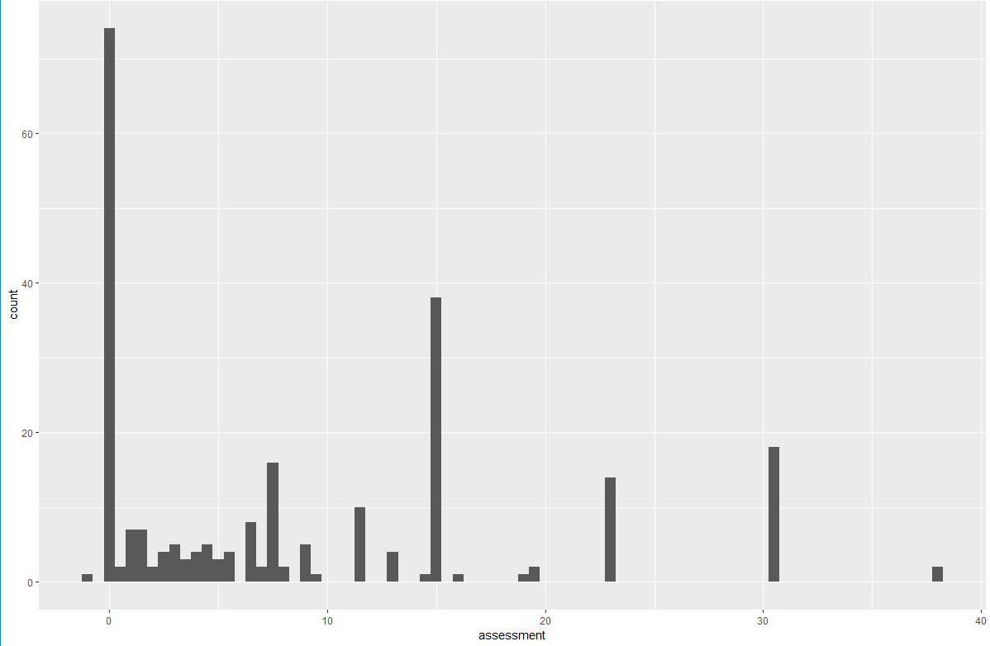

因为蛮多人成功的，以至assessment > 0的长条看不清楚，现把assessment=0暂时去掉：

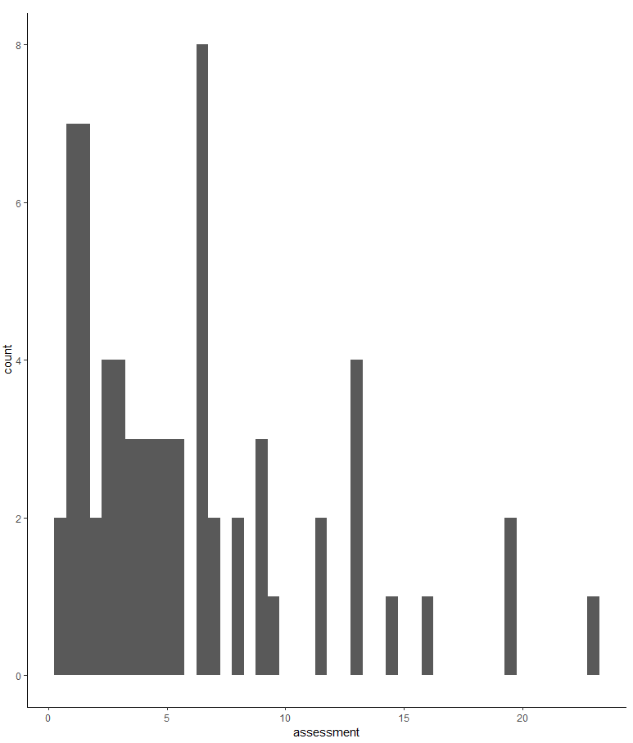

我们根据assessment划分成四类：

把assessment=0单独为一类，记为戒烟成功类A，

assessment在0~5属于第二类，记为戒烟比较成功类B，

assessment在5~10属于第三类，记为戒烟需努力类C

assessment>10属于第四类，记为戒烟效果不好

把assessment和药品类型整合成一张直方图：

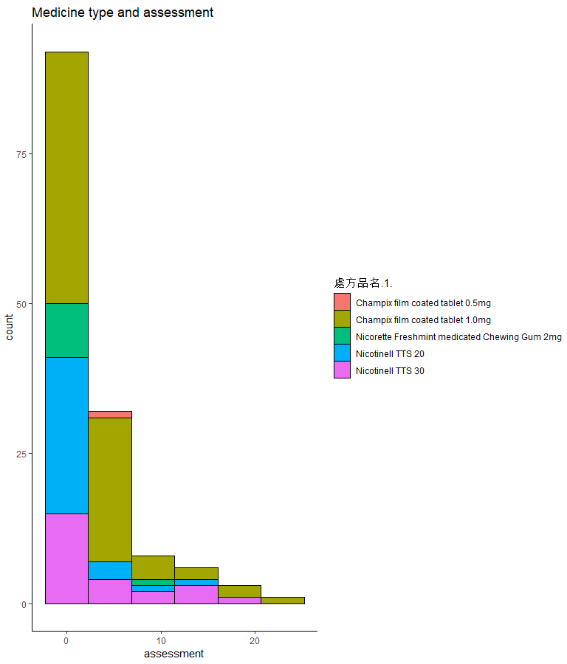

可以注意到，红色和军绿色的药名相同，只是剂量不同，蓝色和紫色也是这样。观察可知，在assessment接近0的患者大部分使用的是Nicotinell药物，且使用Nicotinell的患者中，assessment接近0 的占比最大，不妨按用药来分类看看

Medicine1： Medicine2：

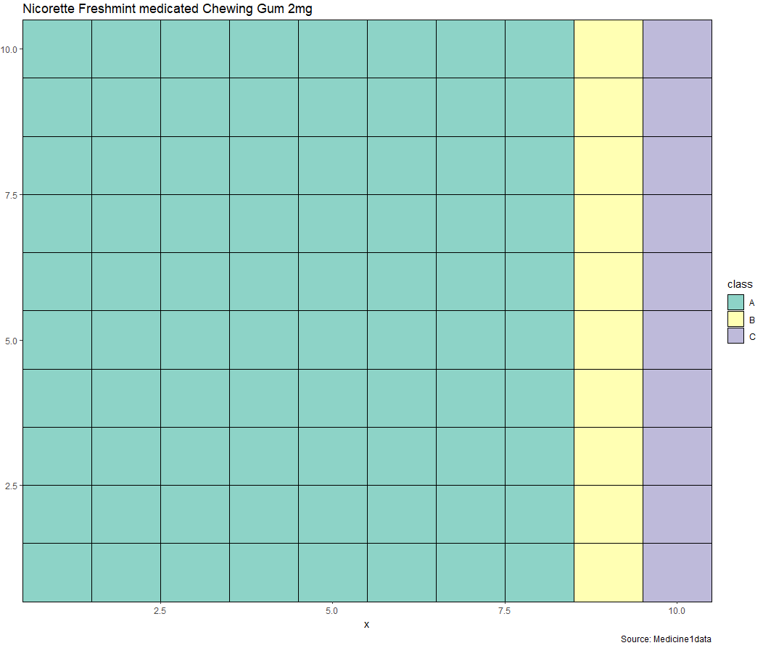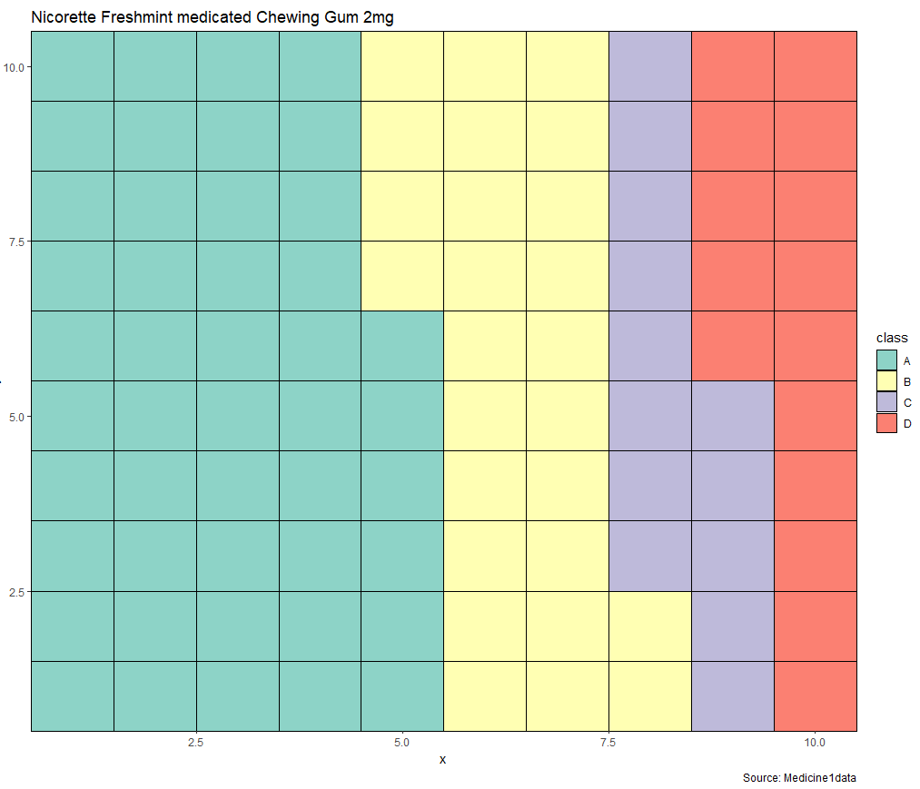

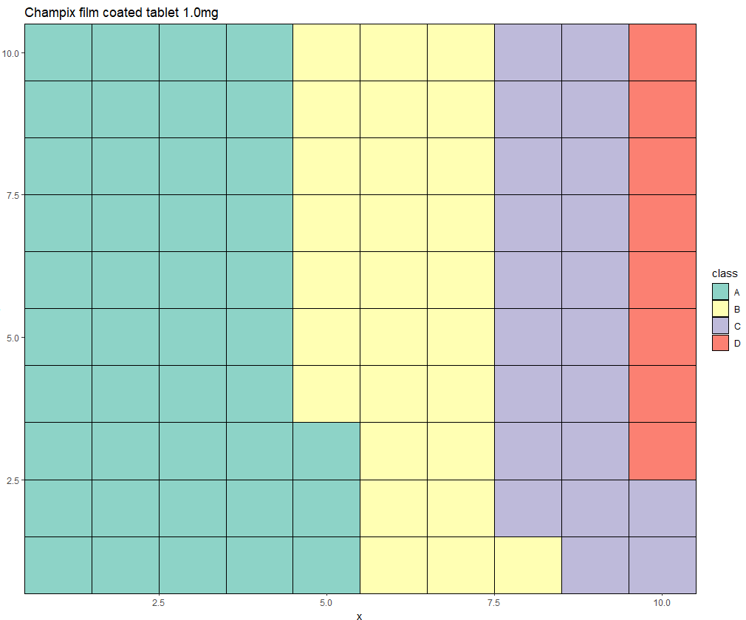

Medicine3