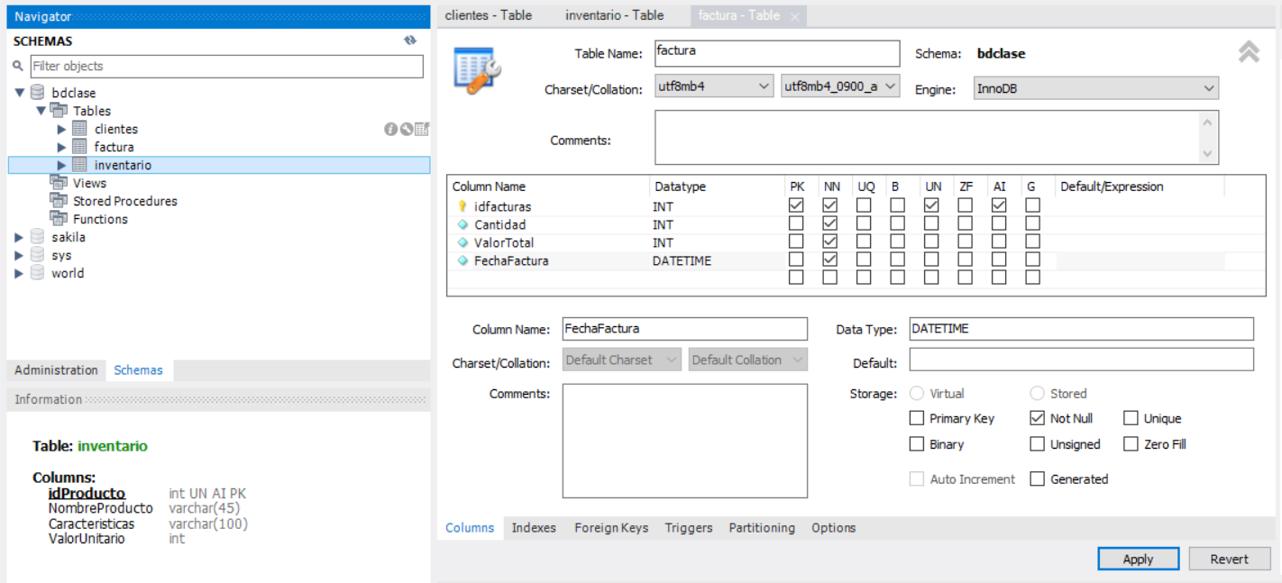

**TABLE: clientes**

CREATE TABLE `bdclase`.`clientes` (

`idCliente` INT UNSIGNED NOT NULL AUTO_INCREMENT,

`Nombre` VARCHAR(45) NOT NULL,

`Telefono` VARCHAR(10) NULL,

`Direccion` VARCHAR(45) NULL,

PRIMARY KEY (`idCliente`));

**TABLE: inventario**

CREATE TABLE `bdclase`.`inventario` (

`idProducto` INT UNSIGNED NOT NULL AUTO_INCREMENT,

`NombreProducto` VARCHAR(45) NOT NULL,

`Caracteristicas` VARCHAR(100) NULL,

`ValorUnitario` INT NOT NULL,

PRIMARY KEY (`idProducto`));

**TABLE: factura**

CREATE TABLE `bdclase`.`facturas` (

`idFacturas` INT UNSIGNED NOT NULL AUTO_INCREMENT,

`Cantidad` INT NOT NULL,

`valor total` INT NOT NULL,

PRIMARY KEY (`idFacturas`));