RETURNSFORM14 WEB HOSTING SERVICES REQUISITION
Project: Sector report data collection process
Date: 19 March 2026
Purpose: This requisition requests approval for web hosting, database, performance, security, and traffic-management upgrades required to support the ReturnsForm14 website used for the sector report data collection process.
Current baseline: The site is currently running on a Render 512 MB instance at approximately USD 7 per month. The requested upgrades are intended to improve speed, capacity, security, and reliability during active data collection and reporting.
Requested upgrade items
Item | Description | Estimated Cost | Billing Basis
Render PostgreSQL database | Upgrade to Render Basic PostgreSQL database with 4 GB capacity and two CPUs for improved database performance. | USD 75 | Per month
Additional Render storage / RAM allocation | Additional storage/RAM allocation as referenced in the project request, priced at approximately USD 0.30 per GB, with a stated estimate of USD 77 for the requested expansion. | USD 77 | As requested / vendor confirmation needed
Cloudflare speed upgrade | Upgrade the current Cloudflare plan/license from approximately USD 1 to USD 15 to improve website speed and delivery performance. | USD 15 | Per month
Cloudflare SSL certificate manager | Add SSL certificate management on Cloudflare to strengthen certificate handling and security coverage. | USD 12 | Per month
Render Pro instance option | Upgrade to a Render Pro instance, stated as USD 20 plus USD 3 service charge. | USD 23 | Per month
Cloudflare load balancing | Add Cloudflare load balancing to help maintain site availability and traffic handling. | USD 35 | Per month

Important pricing note: Some of the vendor amounts above may represent alternative upgrade paths or overlapping services. They have been recorded exactly as requested and should be confirmed with Render and Cloudflare before procurement is finalized.
Justification: The requested upgrades will provide increased compute capacity, stronger database performance, improved page-load speed, better traffic management, and stronger SSL/security support for the sector report data collection website.
Requested action: Approve procurement and reimbursement for the above web hosting and infrastructure services to support uninterrupted operation of the ReturnsForm14 platform.
Prepared by: Joel Harold Onyango
Bill to / approving entity: To be completed by the requesting organization before submission.

Previous spending so far
Note: This separate table records prior and current observed spending/charges already incurred or currently appearing in project billing records.
Date / Period | Source | Description | Amount | Status / Basis
16 March 2026 | Cloudflare | Registrar registration fee for returnsform14.org | USD 8.70 | Previously incurred
17 March 2026 | OpenAI | ChatGPT subscription / tooling charge used for project support | USD 23.20 | Previously incurred
2026-March | Render | returnsform14 web service Starter usage so far ($0.26 + $0.01) | USD 0.27 | Current unbilled charges
2026-March | Render | database_ecommerce Basic-256mb datastore usage so far ($0.22 + $0.01 disk) | USD 0.23 | Current unbilled charges
2026-March | Render | Team users Professional plan (1 member) | USD 19.00 | Current standing charge

Spending-so-far note: Render March entries above were taken from the current unbilled charges export and may increase before invoice close.
Supporting Evidence
The images and billing excerpt below are attached as supporting reference for the requested and already-incurred web hosting expenditure items.
Render database pricing screenshot (captured 17 March 2026):
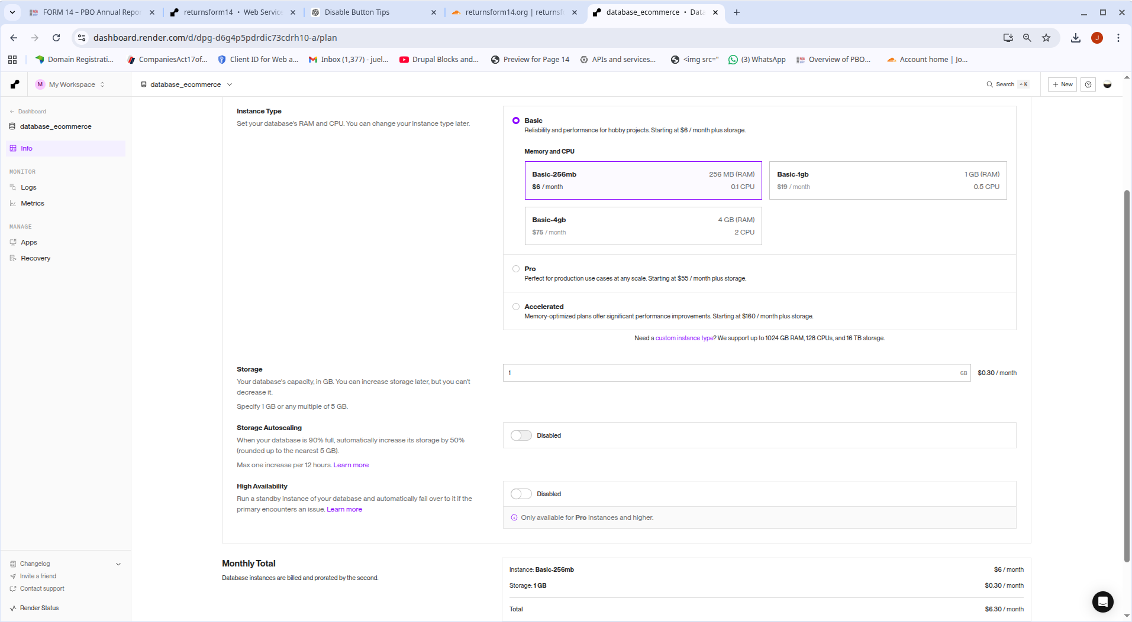
Figure 1: Render pricing screen showing Basic-256mb, Basic-1gb, Basic-4gb and storage pricing.

Excerpt from current Render unbilled charges:
Period | Type | Name | Charge | Usage | Cost
2026-March | Services | returnsform14 | Starter | 27.61 | $0.26
2026-March | Services | returnsform14 | Starter | 1.24 | $0.01
2026-March | Datastores | database_ecommerce | Basic-256mb | 27.7 hours | $0.22
2026-March | Datastores | database_ecommerce | Basic-256mb Disk (1GB) | 27.7 hours | $0.01
2026-March | Team Members | Team users | Professional | 1 member | $19.00
Note: The CSV excerpt above reflects currently unbilled and standing account charges, while the requisition table in this document lists proposed upgrade items requiring approval.
SMS spending: Render Starter web service at approximately $7 per month, Render Basic-256mb database at approximately $6 per month, 1GB disk at approximately $0.30 per month, Render Professional team member charge at $19 per month, proposed Render Standard 2GB upgrade at $25 per month, proposed Render Postgres Basic-4gb at $75 per month, Cloudflare Pro at $25 per month or $240 annually, Advanced Certificate Manager from $10 per month, and Cloudflare Load Balancing from $5 per month.




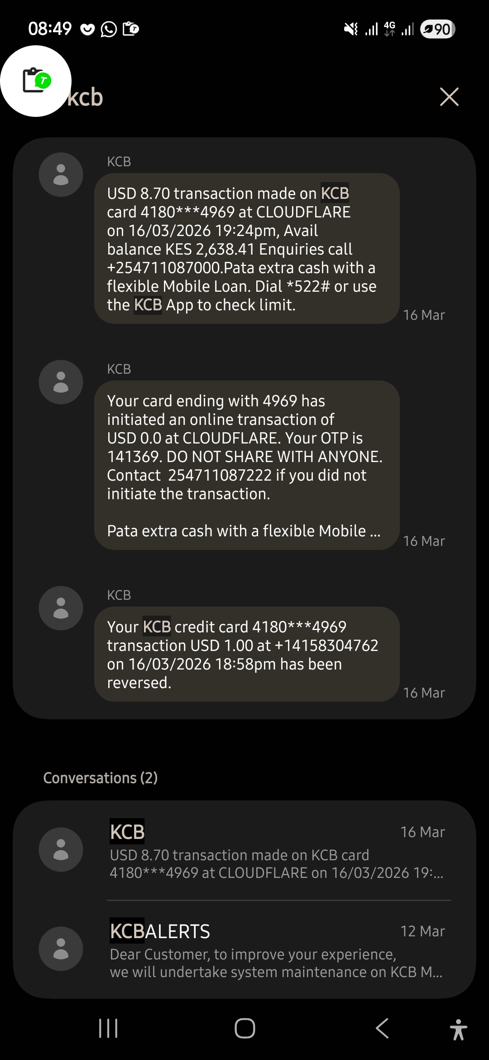

Summary of Amounts to Be Added
Item | USD | KSh | Rate Used
Render PostgreSQL database | USD 75.00 | KES 9,697.50 | 1 USD = 129.30 KES
Additional Render storage / RAM allocation | USD 77.00 | KES 9,956.10 | 1 USD = 129.30 KES
Cloudflare speed upgrade | USD 15.00 | KES 1,939.50 | 1 USD = 129.30 KES
Cloudflare SSL certificate manager | USD 12.00 | KES 1,551.60 | 1 USD = 129.30 KES
Render Pro instance option | USD 23.00 | KES 2,973.90 | 1 USD = 129.30 KES
Total | USD 262.00 | KES 33,876.60 | 1 USD = 129.30 KES

Summary of Amounts Already Spent
Item | USD | KSh | Rate Used
Cloudflare registrar registration fee | USD 8.70 | KES 1,124.91 | 1 USD = 129.30 KES
OpenAI ChatGPT subscription / tooling charge | USD 23.20 | KES 2,999.76 | 1 USD = 129.30 KES
Render web service unbilled usage so far | USD 0.27 | KES 34.91 | 1 USD = 129.30 KES
Render database and disk unbilled usage so far | USD 0.23 | KES 29.74 | 1 USD = 129.30 KES
Render Professional team member standing charge | USD 19.00 | KES 2,456.70 | 1 USD = 129.30 KES
Total | USD 51.40 | KES 6,646.02 | 1 USD = 129.30 KES

