Collaboration Analysis Report
Source workbook: collaboration.xlsx
Unique PBOs analyzed: 1,507

Scope and Method
- The unit of analysis for the main questions is the unique PBO name across the collaboration workbook.
- A PBO is treated as collaborating when at least one of the collaboration-type fields is recorded: information exchange, technical support, funding, or equipment flows.
- Partner-type analysis is deduplicated at PBO level, so the same PBO is counted once per partner type even if it appears in multiple rows or reporting periods.
- Partner labels were standardized into major groups for visuals, while a full raw partner-type table is included later in the report.

Question 1: How Many PBOs Collaborated?
Out of 1,507 unique PBOs in the collaboration workbook, 1,507 had at least one recorded collaboration type. That is 100.00% of all PBOs in this file. 0 PBOs (0.00%) had partner rows but no collaboration type marked.
Status | PBOs | Percentage of all PBOs
Collaborated with at least one partner | 1507 | 100.00%
No collaboration type recorded | 0 | 0.00%
Total PBOs in collaboration workbook | 1507 | 100.00%
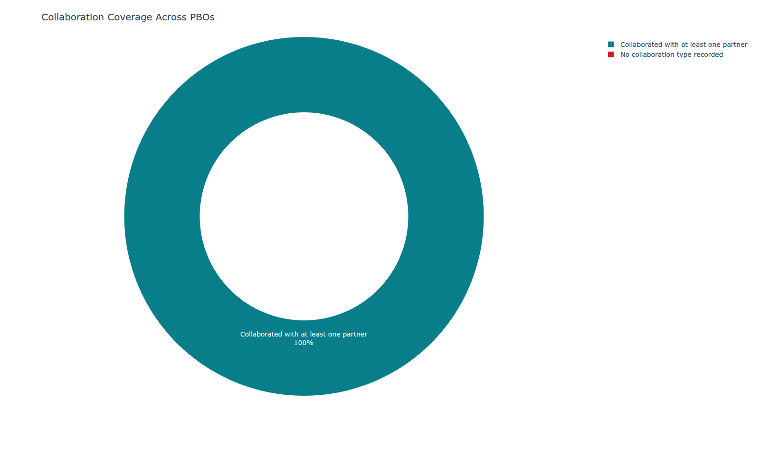
Figure 1. Collaboration coverage across all PBOs.

Which Partners Did Collaborating PBOs Work With?
The most common partner group was PBOs, mentioned by 1,126 collaborating PBOs (74.72%). The table and chart below show the frequency and percentage for each cleaned partner group.
Partner type | Frequency | Percentage of collaborating PBOs
PBOs | 1126 | 74.72%
CBOs | 793 | 52.62%
Government Agencies | 790 | 52.42%
Academic Institutions | 621 | 41.21%
Donor Agencies | 617 | 40.94%
Health Institutions | 556 | 36.89%
Research Institutions | 399 | 26.48%
FBOs / Religious Institutions | 394 | 26.14%
Others | 11 | 0.73%
Corporate | 8 | 0.53%
Missing Partners Type | 3 | 0.20%
Media | 2 | 0.13%
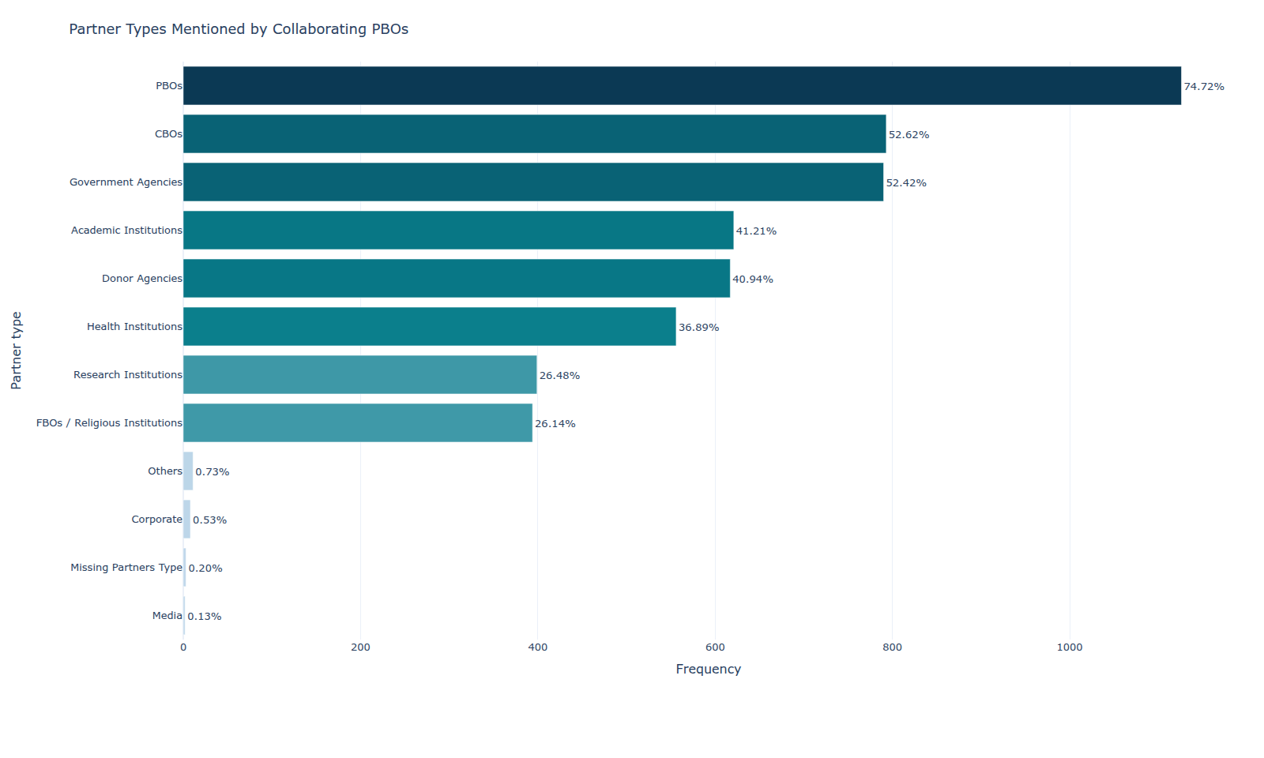
Figure 2. Partner groups mentioned by collaborating PBOs.

Question 2: What Kind of Partnership Was It?
The most common collaboration type was Information exchange, reported by 1,327 collaborating PBOs (88.06%).
Collaboration type | Frequency | Percentage of collaborating PBOs
Information exchange | 1327 | 88.06%
Technical support to partner | 771 | 51.16%
Technical support from partner | 700 | 46.45%
Funding from partner | 553 | 36.70%
Funding to partner | 415 | 27.54%
Equipment to partner | 226 | 15.00%
Equipment from partner | 206 | 13.67%
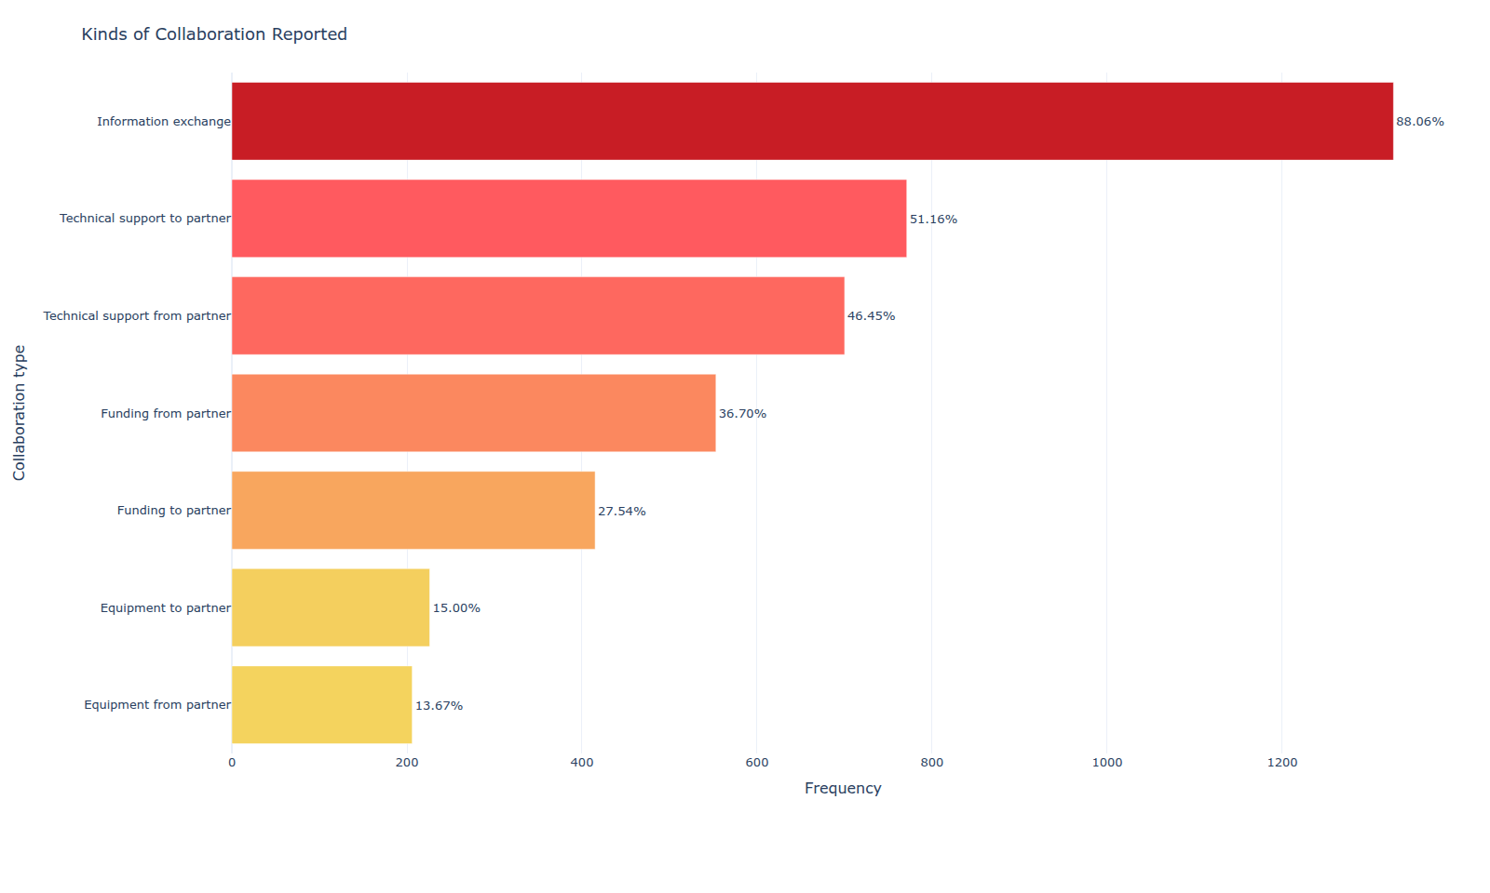
Figure 3. Collaboration types reported by collaborating PBOs.

Partner Type by Collaboration Type
The matrix below shows, for each cleaned partner group, how many unique PBOs reported each collaboration type. The heatmap visual summarizes the same pattern using percentages within each partner type.
Partner type | Partner-type PBOs | Collaboration type | Frequency | Pct within partner type value | Pct within partner type | Pct of collaborating PBOs
PBOs | 1126 | Information exchange | 985 | 87.47779751332149 | 87.48% | 65.36%
PBOs | 1126 | Technical support to partner | 429 | 38.09946714031972 | 38.10% | 28.47%
PBOs | 1126 | Technical support from partner | 403 | 35.790408525754884 | 35.79% | 26.74%
PBOs | 1126 | Funding from partner | 289 | 25.666074600355238 | 25.67% | 19.18%
PBOs | 1126 | Funding to partner | 197 | 17.4955595026643 | 17.50% | 13.07%
PBOs | 1126 | Equipment from partner | 110 | 9.769094138543517 | 9.77% | 7.30%
PBOs | 1126 | Equipment to partner | 87 | 7.726465364120781 | 7.73% | 5.77%
CBOs | 793 | Information exchange | 677 | 85.37200504413619 | 85.37% | 44.92%
CBOs | 793 | Technical support to partner | 341 | 43.00126103404792 | 43.00% | 22.63%
CBOs | 793 | Technical support from partner | 159 | 20.05044136191677 | 20.05% | 10.55%
CBOs | 793 | Funding to partner | 110 | 13.871374527112232 | 13.87% | 7.30%
CBOs | 793 | Equipment to partner | 67 | 8.448928121059268 | 8.45% | 4.45%
CBOs | 793 | Funding from partner | 38 | 4.791929382093317 | 4.79% | 2.52%
CBOs | 793 | Equipment from partner | 20 | 2.5220680958385877 | 2.52% | 1.33%
Government Agencies | 790 | Information exchange | 692 | 87.59493670886076 | 87.59% | 45.92%
Government Agencies | 790 | Technical support to partner | 296 | 37.46835443037975 | 37.47% | 19.64%
Government Agencies | 790 | Technical support from partner | 287 | 36.32911392405063 | 36.33% | 19.04%
Government Agencies | 790 | Funding to partner | 66 | 8.354430379746836 | 8.35% | 4.38%
Government Agencies | 790 | Funding from partner | 63 | 7.974683544303797 | 7.97% | 4.18%
Government Agencies | 790 | Equipment to partner | 39 | 4.936708860759493 | 4.94% | 2.59%
Government Agencies | 790 | Equipment from partner | 33 | 4.177215189873418 | 4.18% | 2.19%
Academic Institutions | 621 | Information exchange | 509 | 81.96457326892109 | 81.96% | 33.78%
Academic Institutions | 621 | Technical support to partner | 194 | 31.239935587761675 | 31.24% | 12.87%
Academic Institutions | 621 | Technical support from partner | 163 | 26.247987117552334 | 26.25% | 10.82%
Academic Institutions | 621 | Funding to partner | 74 | 11.916264090177133 | 11.92% | 4.91%
Academic Institutions | 621 | Funding from partner | 50 | 8.051529790660226 | 8.05% | 3.32%
Academic Institutions | 621 | Equipment to partner | 33 | 5.314009661835748 | 5.31% | 2.19%
Academic Institutions | 621 | Equipment from partner | 17 | 2.737520128824477 | 2.74% | 1.13%
Donor Agencies | 617 | Information exchange | 422 | 68.39546191247973 | 68.40% | 28.00%
Donor Agencies | 617 | Funding from partner | 314 | 50.89141004862236 | 50.89% | 20.84%
Donor Agencies | 617 | Technical support from partner | 208 | 33.71150729335494 | 33.71% | 13.80%
Donor Agencies | 617 | Technical support to partner | 162 | 26.25607779578606 | 26.26% | 10.75%
Donor Agencies | 617 | Funding to partner | 115 | 18.638573743922205 | 18.64% | 7.63%
Donor Agencies | 617 | Equipment from partner | 82 | 13.290113452188008 | 13.29% | 5.44%
Donor Agencies | 617 | Equipment to partner | 36 | 5.834683954619125 | 5.83% | 2.39%
Health Institutions | 556 | Information exchange | 449 | 80.75539568345323 | 80.76% | 29.79%
Health Institutions | 556 | Technical support from partner | 198 | 35.61151079136691 | 35.61% | 13.14%
Health Institutions | 556 | Technical support to partner | 188 | 33.81294964028777 | 33.81% | 12.48%
Health Institutions | 556 | Funding to partner | 53 | 9.532374100719425 | 9.53% | 3.52%
Health Institutions | 556 | Equipment to partner | 49 | 8.81294964028777 | 8.81% | 3.25%
Health Institutions | 556 | Funding from partner | 35 | 6.294964028776978 | 6.29% | 2.32%
Health Institutions | 556 | Equipment from partner | 21 | 3.776978417266187 | 3.78% | 1.39%
Research Institutions | 399 | Information exchange | 336 | 84.21052631578947 | 84.21% | 22.30%
Research Institutions | 399 | Technical support from partner | 129 | 32.33082706766917 | 32.33% | 8.56%
Research Institutions | 399 | Technical support to partner | 121 | 30.32581453634085 | 30.33% | 8.03%
Research Institutions | 399 | Funding from partner | 37 | 9.273182957393484 | 9.27% | 2.46%
Research Institutions | 399 | Funding to partner | 36 | 9.022556390977442 | 9.02% | 2.39%
Research Institutions | 399 | Equipment to partner | 10 | 2.506265664160401 | 2.51% | 0.66%
Research Institutions | 399 | Equipment from partner | 7 | 1.7543859649122806 | 1.75% | 0.46%
FBOs / Religious Institutions | 394 | Information exchange | 336 | 85.27918781725889 | 85.28% | 22.30%
FBOs / Religious Institutions | 394 | Technical support to partner | 142 | 36.04060913705584 | 36.04% | 9.42%
FBOs / Religious Institutions | 394 | Technical support from partner | 85 | 21.573604060913706 | 21.57% | 5.64%
FBOs / Religious Institutions | 394 | Funding to partner | 49 | 12.436548223350254 | 12.44% | 3.25%
FBOs / Religious Institutions | 394 | Funding from partner | 31 | 7.868020304568528 | 7.87% | 2.06%
FBOs / Religious Institutions | 394 | Equipment to partner | 28 | 7.1065989847715745 | 7.11% | 1.86%
FBOs / Religious Institutions | 394 | Equipment from partner | 13 | 3.2994923857868024 | 3.30% | 0.86%
Others | 11 | Information exchange | 6 | 54.54545454545454 | 54.55% | 0.40%
Others | 11 | Technical support from partner | 3 | 27.27272727272727 | 27.27% | 0.20%
Others | 11 | Funding from partner | 2 | 18.181818181818183 | 18.18% | 0.13%
Others | 11 | Equipment to partner | 2 | 18.181818181818183 | 18.18% | 0.13%
Others | 11 | Funding to partner | 1 | 9.090909090909092 | 9.09% | 0.07%
Others | 11 | Equipment from partner | 1 | 9.090909090909092 | 9.09% | 0.07%
Others | 11 | Technical support to partner | 0 | 0.0 | 0.00% | 0.00%
Corporate | 8 | Funding from partner | 4 | 50.0 | 50.00% | 0.27%
Corporate | 8 | Information exchange | 3 | 37.5 | 37.50% | 0.20%
Corporate | 8 | Technical support from partner | 3 | 37.5 | 37.50% | 0.20%
Corporate | 8 | Equipment to partner | 2 | 25.0 | 25.00% | 0.13%
Corporate | 8 | Technical support to partner | 1 | 12.5 | 12.50% | 0.07%
Corporate | 8 | Funding to partner | 0 | 0.0 | 0.00% | 0.00%
Corporate | 8 | Equipment from partner | 0 | 0.0 | 0.00% | 0.00%
Missing Partners Type | 3 | Information exchange | 2 | 66.66666666666666 | 66.67% | 0.13%
Missing Partners Type | 3 | Technical support from partner | 1 | 33.33333333333333 | 33.33% | 0.07%
Missing Partners Type | 3 | Technical support to partner | 0 | 0.0 | 0.00% | 0.00%
Missing Partners Type | 3 | Funding to partner | 0 | 0.0 | 0.00% | 0.00%
Missing Partners Type | 3 | Funding from partner | 0 | 0.0 | 0.00% | 0.00%
Missing Partners Type | 3 | Equipment to partner | 0 | 0.0 | 0.00% | 0.00%
Missing Partners Type | 3 | Equipment from partner | 0 | 0.0 | 0.00% | 0.00%
Media | 2 | Information exchange | 2 | 100.0 | 100.00% | 0.13%
Media | 2 | Technical support to partner | 0 | 0.0 | 0.00% | 0.00%
Media | 2 | Technical support from partner | 0 | 0.0 | 0.00% | 0.00%
Media | 2 | Funding to partner | 0 | 0.0 | 0.00% | 0.00%
Media | 2 | Funding from partner | 0 | 0.0 | 0.00% | 0.00%
Media | 2 | Equipment to partner | 0 | 0.0 | 0.00% | 0.00%
Media | 2 | Equipment from partner | 0 | 0.0 | 0.00% | 0.00%
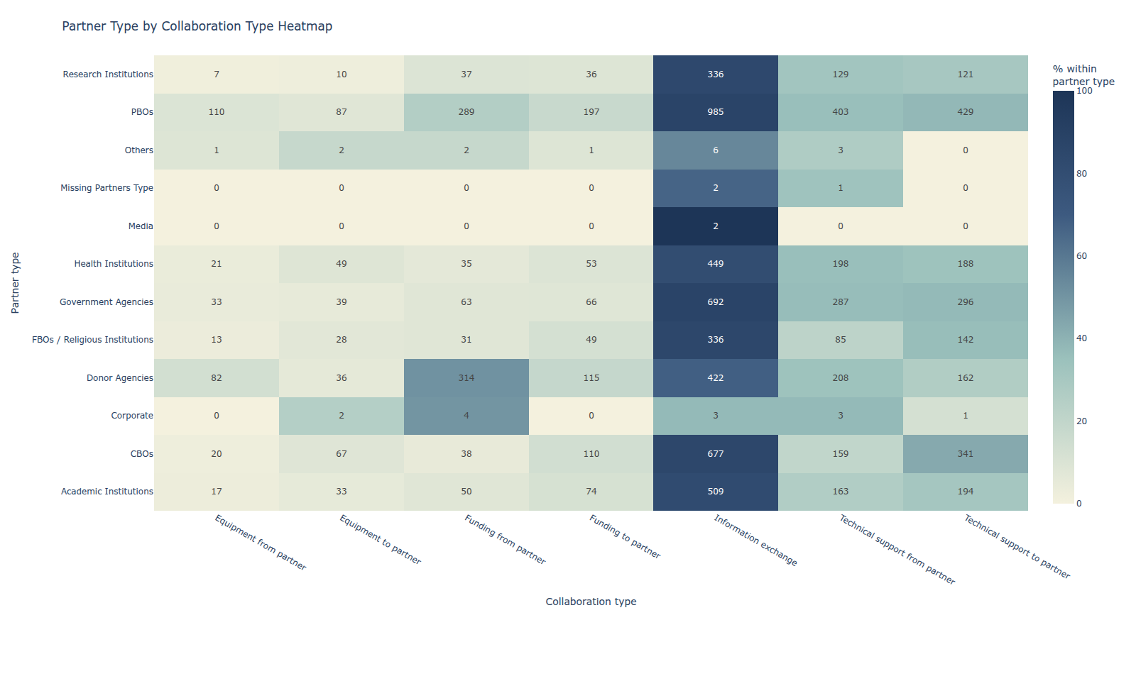
Figure 4. Heatmap of collaboration types within each partner group.

Raw Partner Types Captured in the Workbook
This appendix-style table keeps the original partner-type labels as entered in the source workbook, so one-off labels and specific named partners remain visible for audit and cleaning purposes.
Raw partner type | Frequency | Percentage of collaborating PBOs
PBOS | 1125 | 74.65%
CBOS | 793 | 52.62%
GOVERNMENT AGENCIES | 765 | 50.76%
ACADEMIC INSTITUTIONS | 620 | 41.14%
DONOR AGENCIES | 616 | 40.88%
HEALTH INSTITUTIONS | 556 | 36.89%
RESEARCH INSTITUTIONS | 399 | 26.48%
FBOS | 390 | 25.88%
NATIONAL GOVERNMENT | 28 | 1.86%
COUNTY GOVERNMENT | 2 | 0.13%
CORPORATES | 1 | 0.07%
CORPORATE | 1 | 0.07%
CULTURE | 1 | 0.07%
AGRO DEALERS | 1 | 0.07%
CHURCH INSTITUTIONS | 1 | 0.07%
CONSULTANCY FIRM | 1 | 0.07%
CHURCH | 1 | 0.07%
CARIBOU DIGITAL | 1 | 0.07%
GOOGLE | 1 | 0.07%
GIZ | 1 | 0.07%
FINANCIAL INSTITUTIONS | 1 | 0.07%
FINANCIAL INSTITUTION | 1 | 0.07%
FACEBOOK | 1 | 0.07%
LIMITED COMPANY | 1 | 0.07%
KPSA | 1 | 0.07%
INDIVIDUAL DONATION | 1 | 0.07%
MEDIA | 1 | 0.07%
MEDIA HOUSES | 1 | 0.07%
META | 1 | 0.07%
MINISTRY OF FOREIGN AFFAIRS JAPAN | 1 | 0.07%
NETWORKS ON HIV/AIDS,HEALTH PROMOTION,ABUSE/ADICTION&TRAUMA/PEACE | 1 | 0.07%
NOT INDICATED | 1 | 0.07%
MASTERCARD | 1 | 0.07%
KILIMANJARO BLIN TRUST AFRICA | 1 | 0.07%
OTHERS | 1 | 0.07%
ORPHANS AND WOMEN GROUP | 1 | 0.07%
PRIVATE INDIVIDUALS | 1 | 0.07%
PARENTS OF CHILDREN WITH ASD | 1 | 0.07%
PRIVATE SOOCIAL ENTERPRISES | 1 | 0.07%
RELIGIOUS GROUPS | 1 | 0.07%
RELIGIOUS INSTITUTIONS | 1 | 0.07%
RESEARCH STUDENTS | 1 | 0.07%
SAFARICOM PLC | 1 | 0.07%
SCHOOLS | 1 | 0.07%
SEGAL FAMILY FOUNDATION | 1 | 0.07%
SELF HELP GROUP | 1 | 0.07%
SELF HELP GROUPS | 1 | 0.07%
STTG | 1 | 0.07%
UBER | 1 | 0.07%
WELL WISHERS | 1 | 0.07%

Headline Findings
1,507 out of 1,507 PBOs in the collaboration workbook reported at least one collaboration type, indicating very broad collaboration coverage in this dataset.
PBO-to-PBO collaboration was the most common partner grouping, followed by CBOs and Government Agencies.
Information exchange dominated the collaboration modes overall, while technical support flows were also common in both directions.
Among donor-agency collaborations, funding from partner was recorded by 314 unique PBOs, which is 50.89% within the Donor Agencies partner group.

