PUBLIC BENEFIT ORGANIZATIONS REGULATORY AUTHORITY

MAINTENANCE
GUIDE
A picture book for recording computer maintenance
Follow the screens, run the correct Windows helpers, enter the results, and verify your submitted report. For ICT officers, interns, computer owners and reviewing managers.
YOUR WORKFLOW
Choose computer → collect evidence → fill the maintenance form → sign → submit → view the saved report → request follow-up if needed.

Find the right page
Task | Guide pages
Start a report and identify the computer | 2–3
Download and run scripts; find their output | 4–5
Enter services, sign and submit | 6–9
Find reports, correct them, or raise a complaint | 10–13
All 17 scripts: expected output and destination | 14–18
Start the application (server administrator) | 19
Troubleshooting and completion checklist | 20

Addresses used in this guide
Use the application address supplied by ICT. Add the paths below to that same address. For example, if it is http://localhost:5000, the form is http://localhost:5000/maintenance. “localhost” works only on the computer hosting the app.
Open | Path
Maintenance Form / Computer Register | /maintenance • /assets
Scripts / All Submissions | /scripts • /submissions
Sign In / Help Desk | /login • /helpdesk/

Screenshots show the actual local application with fictional demonstration data. Windows output examples are illustrative, derived from the scripts; they were not collected from a Windows computer. Your results, dates and report IDs will differ.

1 Start with the correct computer
Open Computer Register (/assets). If you have an account, sign in at /login first using the credentials issued by ICT, then return to the register. This records your username when you submit.
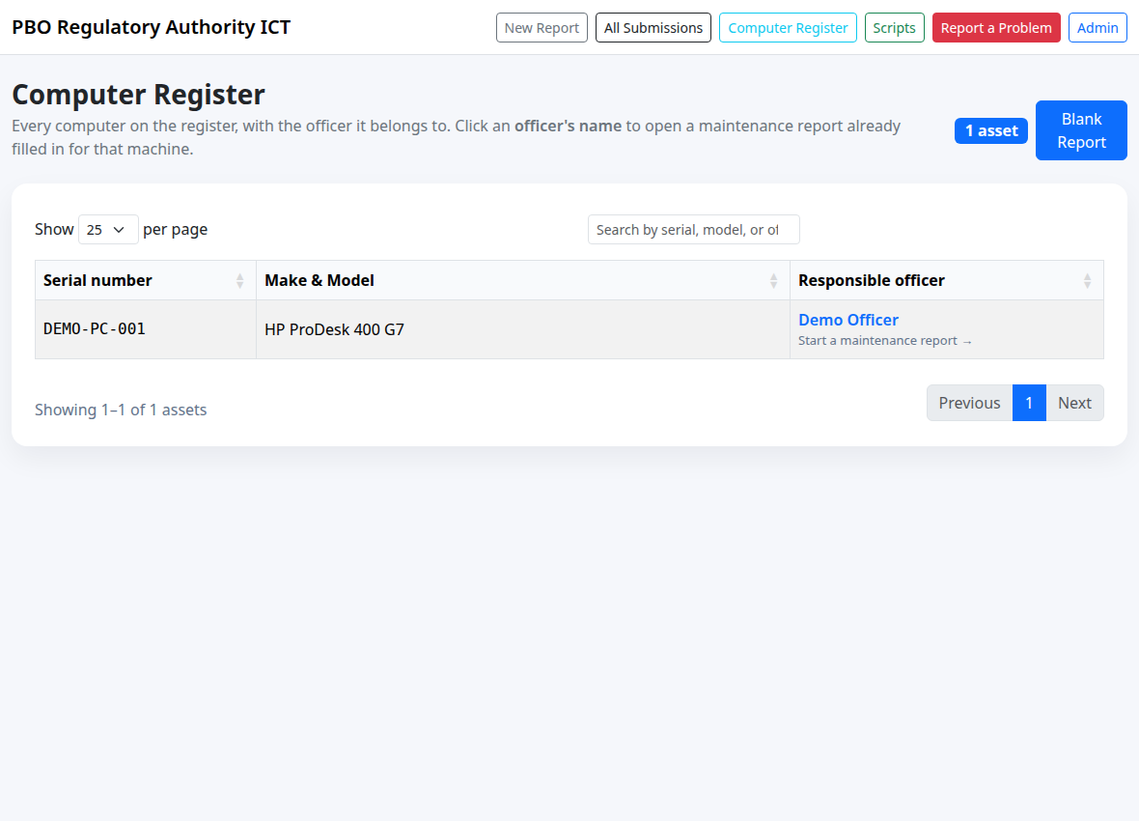
Picture 1. The Computer Register. Use the search box, then click the responsible officer’s name.
1. Search by serial number, make/model or responsible officer. Check that the row describes the machine you are servicing.
2. Click the officer’s name to open a prefilled maintenance form. The serial number, chassis model and officer name are copied from the register.
3. If the machine is not listed, use Blank Report or open /maintenance and enter its details manually.
WHAT TO EXPECT
The prefilled form says “Filled in from the Computer Register.” It does not automatically fill every field. Check the details against the physical computer.
The current application allows maintenance submission and viewing without signing in. Editing needs an ICT manager or administrator; the full admin records table needs an administrator. Signing in may initially open the admin console or help desk, depending on your role.

2 Complete Report Details
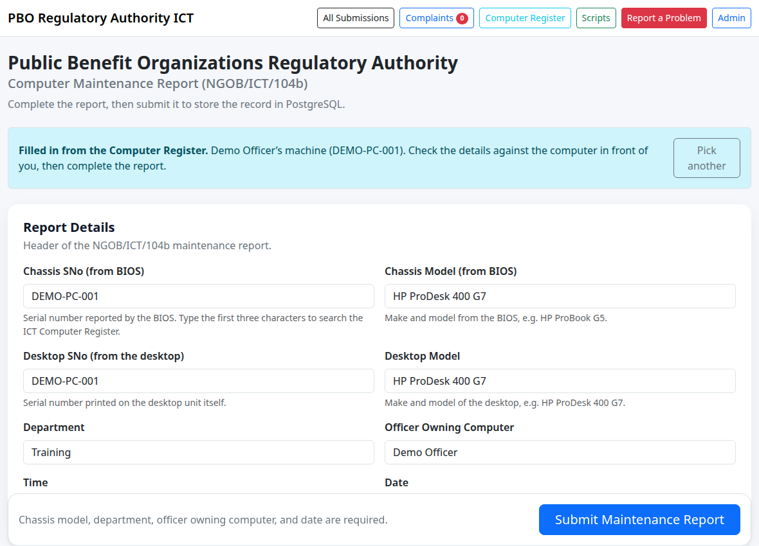
Picture 2. A completed Report Details section. All values shown are demonstration data.
1. Confirm Chassis SNo (from BIOS) and Chassis Model (from BIOS) using the identity scripts on page 14. Enter only the identifier or manufacturer/model, not the full report.
2. Read Desktop SNo from the physical desktop sticker; use the script to cross-check it. Enter Desktop Model for the serviced desktop. For inapplicable desktop fields, leave them blank and explain in field 14.
3. Enter Department, Officer Owning Computer, Time and Date. The required fields are Chassis Model, Department, Officer Owning Computer and Date.
ALTERNATIVE REGISTER LOOKUP
In a blank form, type at least three characters in Chassis SNo, then select the correct suggestion. This fills the chassis model and officer. Verify the selected computer before continuing.
Use the date picker; date presentation follows your browser locale. The stored date format is YYYY-MM-DD. “Chassis Model” is a model such as HP ProDesk 400 G7, not a Windows hostname.

3 Download the matching script
Keep the maintenance form open. Open Scripts (/scripts) in a separate browser tab so that navigating does not discard an unfinished report.
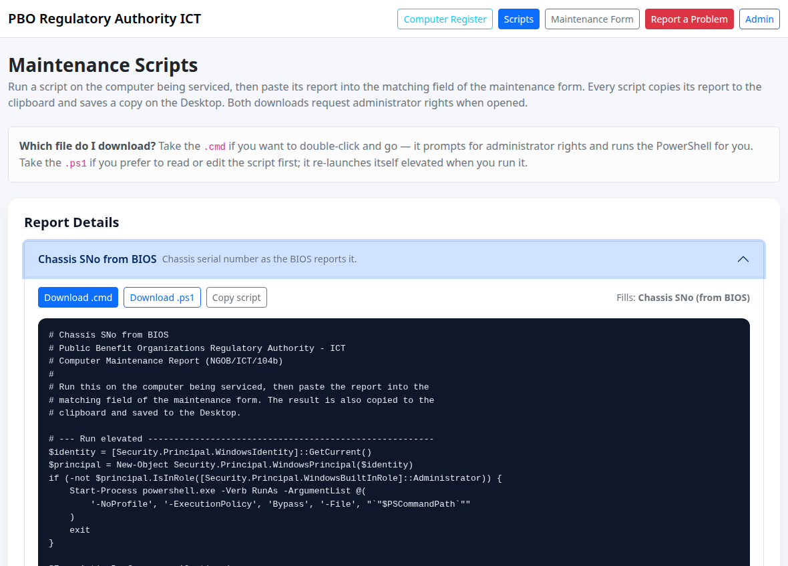
Picture 3. Expand a script. Download buttons appear on the left; “Fills:” identifies the destination field.
1. Select a script under Report Details or Services. Read its title, summary and Fills label.
2. Choose Download .cmd for a double-click launcher, or Download .ps1 to run the PowerShell file yourself. Both versions execute the same helper and request administrator rights.
3. Save it on the Windows computer being serviced. Run one helper at a time, then record its output before running the next.
“Copy script” copies program code. It does not copy findings from your computer. Use the output produced after execution as your maintenance evidence.

4 Run it and find the output

Option A — double-click the .cmd file
1. Open Downloads in Windows File Explorer. Double-click the downloaded file, for example chassis-serial-number.cmd.
2. Respond to the Windows administrator prompt using the authorised credentials for that computer. If you cannot elevate, ask ICT for assistance.
3. Wait for collection to finish. A PowerShell window displays the report and Notepad opens the saved text file.

Option B — run a downloaded .ps1 file
Open Windows PowerShell in the folder containing the download. Run the following, changing the filename for each helper:
powershell.exe -NoProfile -ExecutionPolicy Bypass -File ".\chassis-serial-number.ps1"
The helper relaunches with administrator rights if needed. This command uses a process-specific execution policy; if organisation policy still blocks it, ask ICT to assist.

What successful output looks like
=== Chassis SNo from BIOS ===
Computer: DEMO-WIN-PC Collected: 2026-09-10 10:30
BIOS serial number : DEMO-PC-001
Enclosure serial : DEMO-PC-001
...
Copied to the clipboard.
Saved to C:\Users\<account>\Desktop\Chassis-SNo-from-BIOS.txt
Illustrative excerpt. Extra lines and the Desktop path depend on the computer and account.
Where the result goes | What you do next
PowerShell window | Read the findings and any errors.
Clipboard | Paste with Ctrl+V into the matching form field, following the field rules on pages 14–18.
Desktop .txt file, opened in Notepad | If clipboard copying failed, select and copy the relevant text from Notepad.

The file is saved on the Desktop of the account running the elevated script, which may differ from the signed-in user. Check the displayed “Saved to” path. Rerunning the same helper overwrites that helper’s same-named file; rename or archive it before servicing another machine. The next script also replaces the clipboard.

5 Enter the service findings
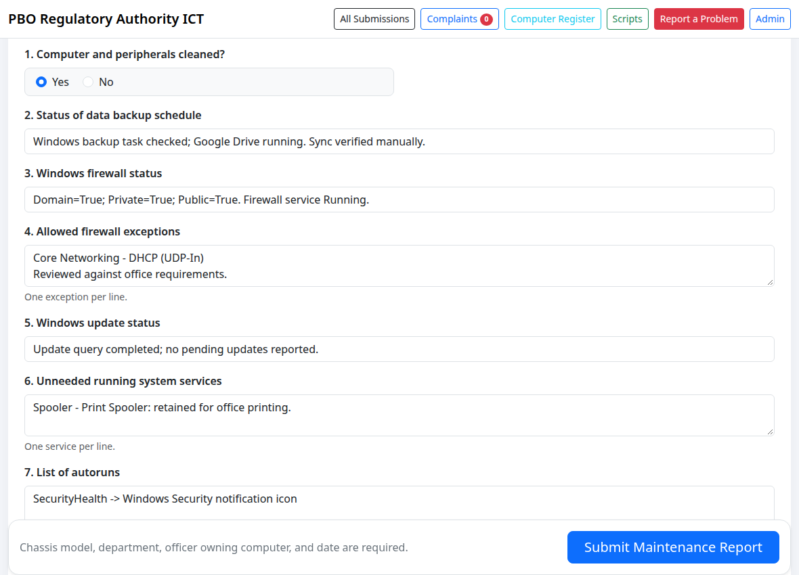
Picture 4. The first service fields. Single-line boxes hold summaries; larger boxes hold lists.
1. For field 1, select Yes only if the computer and peripherals were physically cleaned. Select No if they were not. There is no cleaning script.
2. For fields 2, 3 and 5, type a clear single-line summary of backup, firewall and Windows Update findings. Include failures or unavailable checks.
3. For fields 4, 6, 7 and 8, paste the relevant lists, one entry per line. Review services and installed programs before labelling anything “unneeded”.
COPY FINDINGS, NOT CODE
The form does not import .txt files and there is no script-output upload control. Paste text into the matching field. Keep full local output as evidence; do not put a file path in the form in place of the findings.
Use pages 15–17 for the exact script-to-field mapping. Combine the backup and Google Drive results in field 2; running Google Drive checks does not prove that files have finished syncing. Verify the sync status manually.

6 Finish antivirus, disk and observations
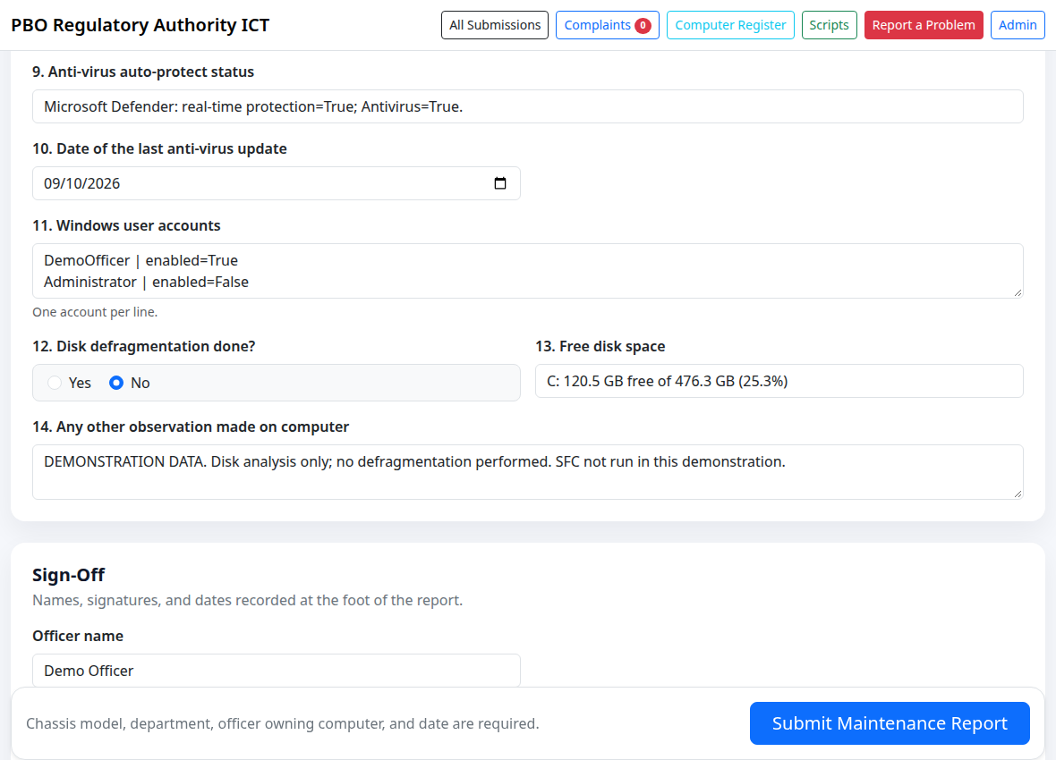
Picture 5. Antivirus, accounts, disk space and observations. The antivirus update is a date field.
1. Run antivirus-status. Summarise protection in field 9, and enter the “Signatures updated” date in field 10 using the date picker.
2. Paste local account findings into field 11. Run disk-defragmentation for analysis and history, then record whether defragmentation was actually done in field 12.
3. Summarise free space in field 13. Use field 14 for detailed additional drives, failures, manual checks, follow-up actions and any SFC findings.
DO NOT CONFUSE ANALYSIS WITH COMPLETION
The disk helper uses Optimize-Volume -Analyze; it does not defragment or optimise the drive. Do not select Yes merely because it ran. If no defragmentation was performed, select No and explain any SSD/not-applicable circumstances in field 14.
Keep field 13 within 60 characters, for example “C: 120.5 GB free of 476.3 GB (25.3%)”. The system-file-check helper runs sfc /scannow and can repair Windows files; use it when appropriate for the maintenance task. Details are on page 18.

7 Sign and submit
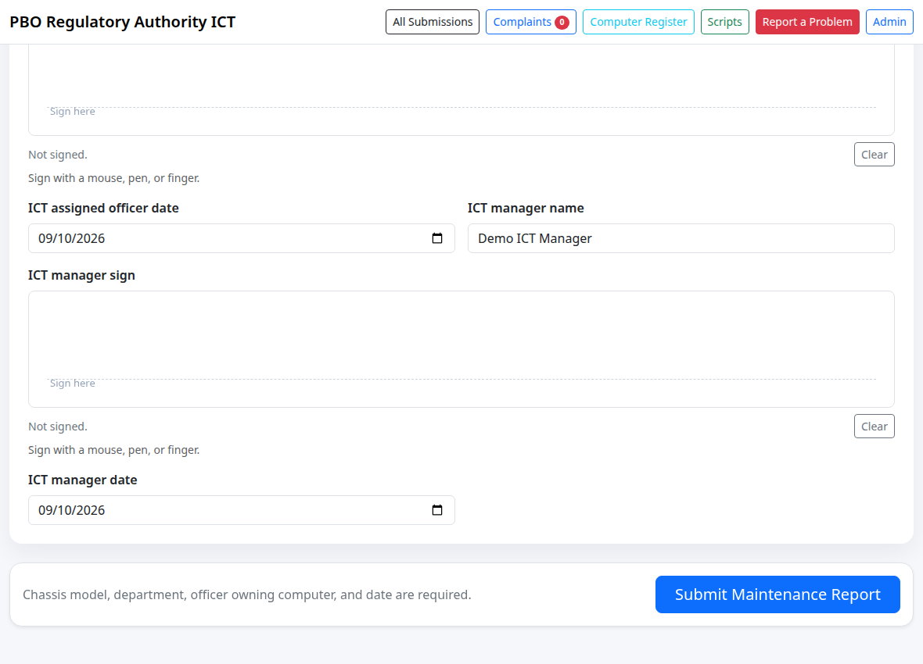
Picture 6. Bottom of Sign-Off and the Submit Maintenance Report button. Demo signatures were deliberately left blank.
1. Complete the three sign-off groups as available: Officer, ICT assigned officer, and ICT manager. Each has a name, a signature pad and a date.
2. Each signer draws their own signature with a mouse, pen or finger. Use Clear to redraw. A typed name is not a drawn signature.
3. Review the computer identity, required fields, all 14 service entries, dates and signatures. Select Submit Maintenance Report once.
EXPECTED RESULT
The next page shows “Computer maintenance report saved.” and a numbered Maintenance Report. If the form stays open, read the error message and correct the highlighted or missing fields.
Unsigned reports are accepted by the application; follow your organisation’s sign-off procedure. There is no separate approval-submission button in this workflow. A manager can add available sign-off details later by editing the report.

8 Verify the saved report
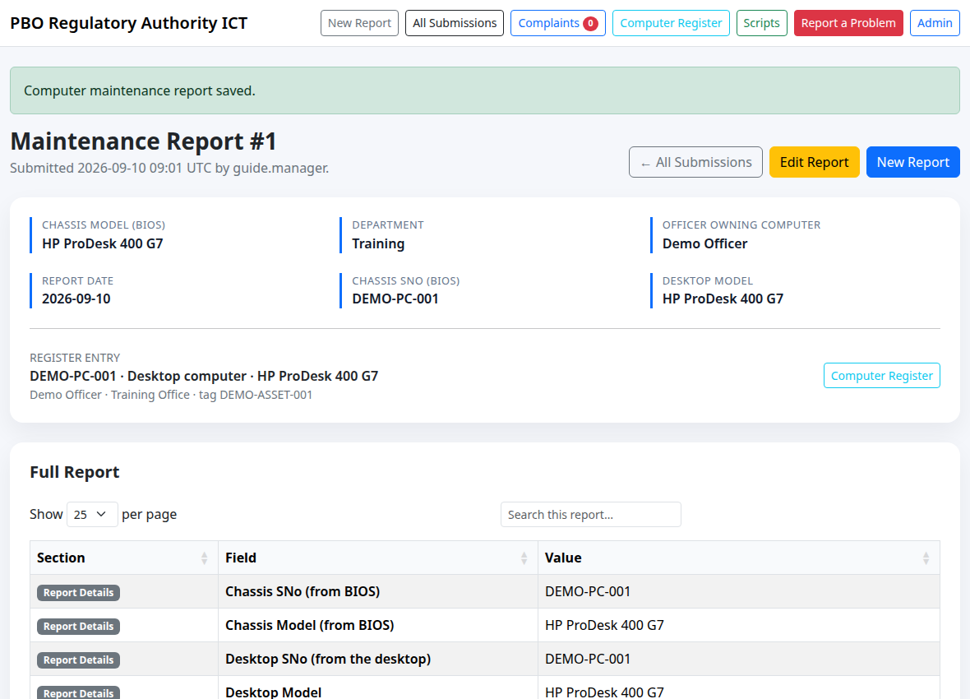
Picture 7. Successful submission: confirmation message, report number, submitter and linked register entry.
1. Check the confirmation and note the report ID. The address becomes /table/<id>, for example /table/1.
2. Verify chassis serial, model, officer, department and report date. If linked, the Register entry should describe the correct computer.
3. Read the Full Report table. Use Search this report to locate a field, or set Show to All to display every field, including Sign-Off.
YOUR RECORD OF SUBMISSION
Keep the report ID and its application URL. The saved report is the confirmation that your information reached the application; a Desktop text file alone is not a submitted maintenance report.
When email is configured, a new maintenance submission is also sent to the configured notification recipients and opted-in account addresses. Delivery is best-effort: missing email does not mean the report failed to save. Submission and edit timestamps on record pages are displayed in UTC.

9 Find and view reports later
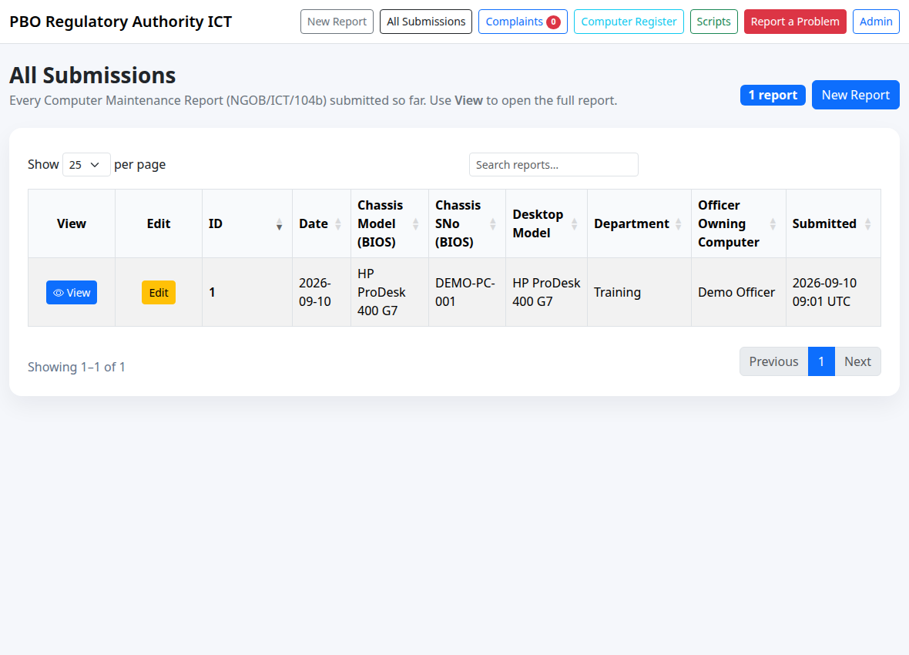
Picture 8. All Submissions shows saved reports. Search, then select View for the desired report.
1. Open All Submissions from the navigation, or go directly to /submissions.
2. Search using the report ID, chassis serial number, officer, department or model. Use the page controls if the list is long.
3. Select View to open the full report at /table/<id>. Select New Report only when starting a different maintenance record.

Where each kind of output belongs
Output | Post / view location
Maintenance checks and script findings | Enter at /maintenance; view at /submissions → View.
Original helper text files | Saved on the serviced computer’s Desktop; not uploaded automatically.
Unresolved fault and supporting excerpt | Submit a separate complaint at /helpdesk/; track it using its reference and tracking link.
Administrator’s full records table | Sign in as administrator, then open /admin/records.

To print a report or save a local PDF, open the full report, clear its search and select Show All, then use the browser’s Print command. Check the preview; this is a browser function, not a dedicated maintenance export button.

10 Correct a submitted report
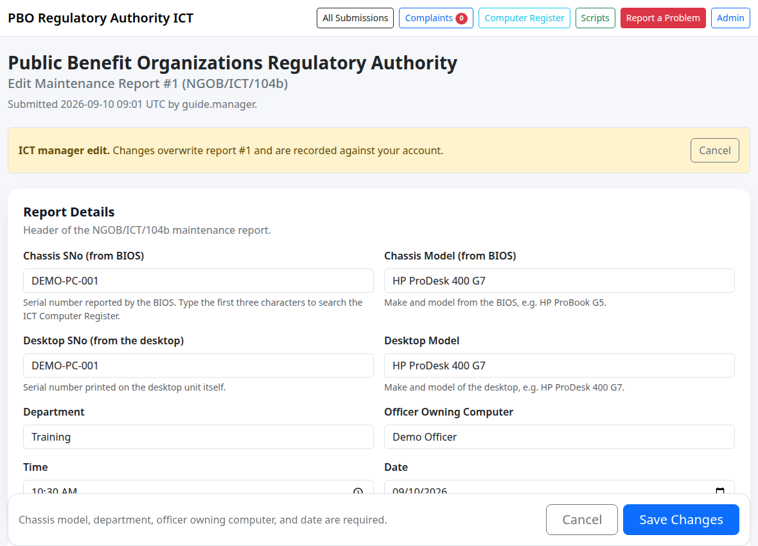
Picture 9. An ICT manager’s edit form. The banner identifies the existing report being changed.
1. Sign in as an ICT manager or administrator. Open the report and select Edit Report, or use Edit in All Submissions.
2. Confirm the report ID in the heading. Correct the needed fields or complete the available sign-off.
3. Scroll to the bottom and select Save Changes. The app returns to the same report and displays an update confirmation and an Edited badge.
EXPECTED RESULT
The existing report is updated in place, with the editor’s username and edit time recorded. It keeps the same report ID. Use Cancel if you do not want to save changes.
If you do not see Edit Report, ask an ICT manager to correct the record, providing the report ID and the exact change required. An ordinary account cannot edit by typing the edit address. Avoid submitting a duplicate report just to fix a typing error.
Changing the selected computer or serial number can change the report’s register link. After saving such a correction, inspect Register entry again. Editing overwrites the current values; the UI does not present a complete history of earlier field values.

11 Post an unresolved problem
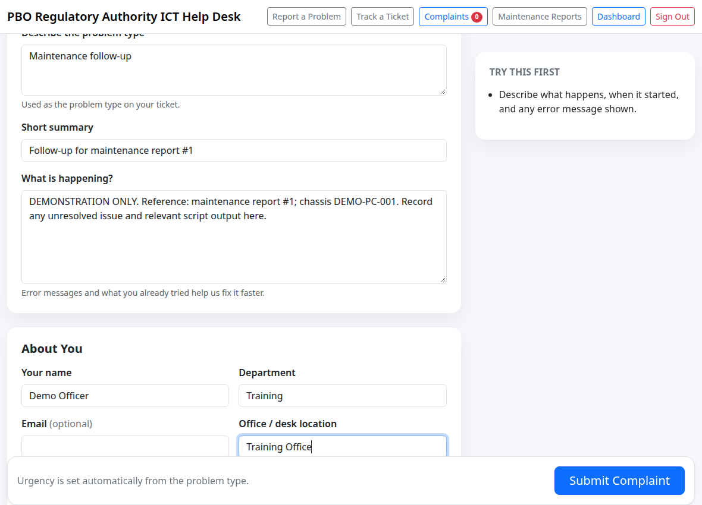
Picture 10. Report a Problem. Include the maintenance report ID, serial number and relevant findings in the complaint.
1. Save the maintenance report first. Open Report a Problem or /helpdesk/ in a separate tab.
2. Choose Problem type and read any self-help guidance. If you choose Other, fill Describe the problem type.
3. Fill Short summary, What is happening?, Your name and Department. Add email, location and the Windows computer name when available.
4. In What is happening?, include the maintenance report ID, chassis serial, symptoms, relevant script-output excerpt and actions already taken. Select Submit Complaint.
The help desk is a separate record within the same application. Submitting maintenance does not automatically create a complaint or link the two records; mention the maintenance report ID yourself. There is no attachment upload on this complaint form.

12 View the complaint and follow up
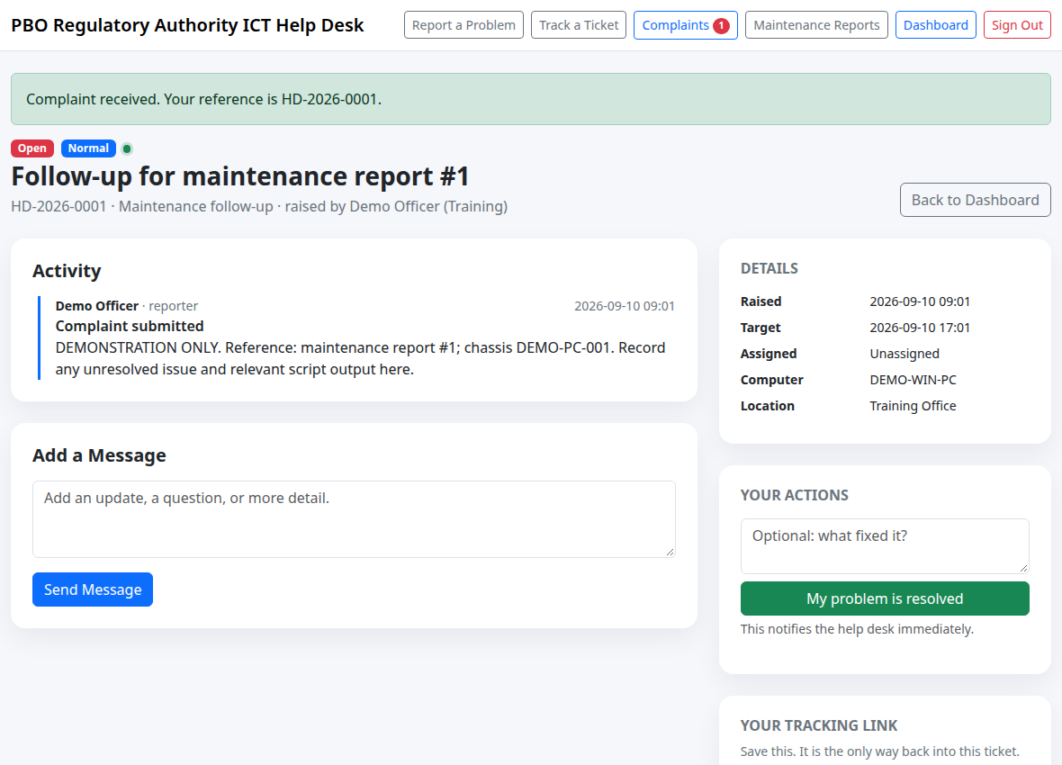
Picture 11. The submitted complaint has its own HD reference, status, tracking information and activity.
1. After Submit Complaint, save the HD reference and the private tracking link/code shown on the ticket page. This ID is different from the maintenance report number.
2. Return through the private link, or open /helpdesk/track and enter the reference and tracking code. Review the status and responses; add a reply if more detail is needed.
3. Signed-in account holders can use Complaints (/helpdesk/complaints). ICT staff work the queue at /helpdesk/staff.
WHO FINISHES THE TASK?
ICT interns and officers can pick, return or transfer their own tasks, reply and mark work resolved. The reporter or an ICT manager/administrator can close the ticket. A manager can also take over another person’s task.
After the fault is addressed, check the result on the computer. Use the ticket controls to confirm resolution or reopen if the issue persists. If the maintenance record also needs correction, ask a manager to edit that maintenance report; ticket updates do not rewrite it.

REFERENCE 1 OF 5

Script reference: computer identity
Illustrative output excerpts; use the values actually collected on the serviced Windows computer. Download each file from /scripts. Choose .cmd or the equivalent .ps1.

Chassis SNo from BIOS
Run: chassis-serial-number.cmd (or .ps1)
Saved on Desktop: Chassis-SNo-from-BIOS.txt
BIOS serial number : DEMO-PC-001
Enclosure serial : DEMO-PC-001
Post to: Chassis SNo (from BIOS). Enter DEMO-PC-001 only. Do not paste BIOS version, headers or UUID into the serial field.

Chassis Model from BIOS
Run: chassis-model.cmd (or .ps1)
Saved on Desktop: Chassis-Model-from-BIOS.txt
Manufacturer : HP
Model : HP ProDesk 400 G7
Post to: Chassis Model (from BIOS). Enter the manufacturer/model once, e.g. HP ProDesk 400 G7. Do not substitute the Windows computer name.

Desktop SNo
Run: desktop-serial-number.cmd (or .ps1)
Saved on Desktop: Desktop-SNo.txt
Identifying number : DEMO-PC-001
Baseboard serial : DEMO-BOARD-01
Post to: Desktop SNo (from the desktop). Cross-check the desktop sticker and enter its serial number. A motherboard serial is not necessarily the desktop serial.

Desktop Model
Run: desktop-model.cmd (or .ps1)
Saved on Desktop: Desktop-Model.txt
Manufacturer : HP
Model : HP ProDesk 400 G7
Memory : 16 GB
Post to: Desktop Model. Enter the desktop make/model only. Put useful memory or OS observations in field 14.

REFERENCE 2 OF 5

Script reference: backup and firewall
Illustrative output excerpts; use the values actually collected on the serviced Windows computer. Download each file from /scripts. Choose .cmd or the equivalent .ps1.

Status of data backup schedule
Run: data-backup-schedule.cmd (or .ps1)
Saved on Desktop: Status-of-data-backup-schedule.txt
File History service: Running (startup Manual)
No scheduled tasks matching 'backup'.
Post to: 2. Status of data backup schedule. Summarise findings in field 2. Verify the actual backup product/schedule manually; the helper’s wbadmin fallback message does not prove that no backup exists.

Google Drive update check
Run: google-drive-update.cmd (or .ps1)
Saved on Desktop: Google-Drive-update-check.txt
Google Drive version <installed version>
Google Drive is running (PID <number>).
Post to: 2. Status of data backup schedule. Append the installed version, process and task findings to field 2. This checks installation/processes; it neither updates Drive nor confirms completed sync. Record missing/default-path results honestly.

Windows firewall status
Run: windows-firewall-status.cmd (or .ps1)
Saved on Desktop: Windows-firewall-status.txt
Domain profile: enabled=True inbound=Block outbound=Allow
Firewall service: Running
Post to: 3. Windows firewall status. Summarise Domain, Private and Public enabled states and service status in field 3. Actual default-action values may differ; this helper does not change firewall settings.

Allowed firewall exceptions
Run: firewall-exceptions.cmd (or .ps1)
Saved on Desktop: Allowed-firewall-exceptions.txt
Enabled inbound allow rules: <count>
Core Networking - DHCP (UDP-In)
Post to: 4. Allowed firewall exceptions. Paste the enabled inbound Allow rule names into field 4, one per line. This output is limited to that rule scope; it is not every firewall rule.

REFERENCE 3 OF 5

Script reference: updates and startup
Illustrative output excerpts; use the values actually collected on the serviced Windows computer. Download each file from /scripts. Choose .cmd or the equivalent .ps1.

Windows update status
Run: windows-update-status.cmd (or .ps1)
Saved on Desktop: Windows-update-status.txt
Windows Update service: Running
<KB ID> Security Update installed <date>
No pending updates.
Post to: 5. Windows update status. Summarise the recent update date and pending-update result in field 5. Record any query error instead of saying up to date. The helper searches but does not install updates.

Unneeded running system services
Run: unneeded-running-services.cmd (or .ps1)
Saved on Desktop: Unneeded-running-system-services.txt
--- Commonly unneeded services that are running ---
Spooler - Print Spooler
Post to: 6. Unneeded running system services. Review the candidate list and all automatic running services. Enter findings in field 6, explaining which are needed. A listed service may be essential, such as printing; nothing is stopped by this helper.

List of autoruns
Run: autoruns.cmd (or .ps1)
Saved on Desktop: List-of-autoruns.txt
--- Registry Run keys ---
SecurityHealth -> <startup command>
Post to: 7. List of autoruns. Paste relevant startup entries into field 7, one per line. The output also includes Startup folders, WMI startup apps and logon/startup tasks. It does not disable them.

Unneeded software installations
Run: unneeded-software.cmd (or .ps1)
Saved on Desktop: Unneeded-software-installations.txt
<Program name> | <version> | installed <date>
Post to: 8. Unneeded software installations. The script lists installed programs, not confirmed unwanted programs. Review with the owner/ICT; put unnecessary items or your review conclusion in field 8. It does not uninstall anything.

REFERENCE 4 OF 5

Script reference: antivirus and storage
Illustrative output excerpts; use the values actually collected on the serviced Windows computer. Download each file from /scripts. Choose .cmd or the equivalent .ps1.

Anti-virus auto-protect status
Run: antivirus-status.cmd (or .ps1)
Saved on Desktop: Anti-virus-auto-protect-status.txt
Real-time protection : True
Antivirus enabled : True
Signatures updated : <date and time>
Post to: 9. Anti-virus auto-protect status. Put the protection summary in field 9. Also enter the signature-update DATE ONLY in field 10. If Defender is unavailable, verify the registered third-party product manually; do not invent a date.

Windows user accounts
Run: windows-user-accounts.cmd (or .ps1)
Saved on Desktop: Windows-user-accounts.txt
DemoOfficer | enabled=True | last logon <time> | ...
DEMO-WIN-PC\DemoAdmin [User]
Post to: 11. Windows user accounts. Paste local accounts and Administrators membership into field 11. It does not list every domain account. If elevation uses another account, HKCU/startup results in other helpers may describe that elevated user.

Free disk space
Run: free-disk-space.cmd (or .ps1)
Saved on Desktop: Free-disk-space.txt
C: 120.5 GB free of 476.3 GB (25.3% free)
Post to: 13. Free disk space. Summarise in field 13 within its 60-character storage limit. Put additional drives in field 14. The helper measures fixed-drive space; it does not delete files.

REFERENCE 5 OF 5

Script reference: disk analysis and SFC
Illustrative output excerpts; use the values actually collected on the serviced Windows computer. Download each file from /scripts. Choose .cmd or the equivalent .ps1.

Disk defragmentation
Run: disk-defragmentation.cmd (or .ps1)
Saved on Desktop: Disk-defragmentation.txt
--- Volume analysis ---
Drive C: media=SSD
ScheduledDefrag [Ready] last run <time> result <code>
Post to: 12. Disk defragmentation done?. Select Yes/No in field 12 based on work actually performed; place analysis/history in field 14. This helper only analyses. Its media label uses physical disk 0, so verify the actual drive type on multi-disk machines.

System file check (SFC)
Run: system-file-check.cmd (or .ps1)
Saved on Desktop: System-file-check-(SFC).txt
--- CORRUPTION / FAILED REPAIR ENTRIES ---
None.
--- FILE REPAIR ENTRIES ---
None.
Post to: 14. Any other observation made on computer. Paste the relevant SFC/CBS findings into field 14. The console shows the main sfc /scannow result; record that too. “None.” only means no matching log entries were extracted, not proof that the scan completed successfully.
SFC CAN PERFORM REPAIRS
Unlike the collection-only helpers, system-file-check runs sfc /scannow. It can take several minutes and can repair protected Windows files. Wait for completion; preserve the console result and record any error or follow-up required.
Manual entries still needed: physical cleaning (field 1), antivirus-update date (field 10, from the antivirus output), actual defragmentation status (field 12), other observations (field 14), department, computer owner, report date/time and all available sign-off details.

Troubleshooting and final check
What you see | What to do
Script blocked or no administrator access | Confirm the download came from your application. Ask ICT to run it with authorised Windows administrator credentials; do not work around organisation policy.
No text appears when pasting | Open the saved Desktop .txt in Notepad and copy the relevant lines. Confirm that you ran the script, rather than only selecting Copy script.
Cannot find the .txt file | Read “Saved to” in PowerShell. Check the Desktop for the account used during elevation, including redirected/OneDrive Desktop paths.
Command missing, access denied, or query failed | Record the failure in the relevant field or field 14. Check the status manually with ICT; do not replace missing evidence with a healthy result.
Report will not submit | Complete chassis model, department, owning officer and date. Correct invalid dates/times; draw signatures on the pads. Check field 13 stays within 60 characters.
Not sure whether a submit succeeded | Search All Submissions for the computer and date before submitting again. Open View and verify the contents to avoid duplicates.
Report has a mistake / no Edit button | Provide the report ID and correction to an ICT manager or administrator.
No notification email | Check that the report appears in All Submissions. Ask the administrator to inspect email configuration and delivery logs if needed.
No register suggestion or wrong match | Type at least three serial characters and select carefully. Use a blank report if unregistered; recheck the saved Register entry.
Tables or download accordions do not respond | Reload with network access; the pages use externally hosted Bootstrap/jQuery/DataTables assets. Preserve unsaved findings first.

Before you finish
- The report describes the correct computer and owner.
- Script findings are in their matching form fields; manual checks and failures are recorded accurately.
- Available sign-off is complete, and the report has saved with a report ID.
- You reopened the report and checked the stored values.
- Any unresolved issue has its own help desk complaint and saved tracking information.

