hhStatistics

Which type of data in statistics
• Population: The complete set of all possible observations in a study. For example, all customers of an e-commerce website.
• Sample: A subset of the population, which is used to make inferences about the population. For example, a random sample of 1,000 customers from the e-commerce website.

Type of Statistics

Descriptive Statistics
Descriptive statistics refers to the methods used to summarize, organize, and describe the main features of a dataset. It provides a way to present large amounts of data in a simpler, more interpretable form by focusing on central tendencies, dispersion, and distribution of data.

Inferential Statistics
Inferential statistics involves making predictions or inferences about a population based on a sample of data drawn from that population. Unlike descriptive statistics, which merely describes the data, inferential statistics allow us to make generalizations, test hypotheses, and draw conclusions beyond the immediate data.

Statistics Topic

Descriptive Inferential
Measures of Central Tendency Probability
Measures of Variability Central Limit Theorem
Measures of Shape Hypothesis Testing
Percentiles Z - Test
Frequency Distribution T – Test
Covariance and Correlation Chi Square Test

Measures of Central Tendency

Mean
np.mean(dataframe["Age"])

Median
np.median(dataframe["Age"])

Mode
stats.mode(dataframe["Age"])

Usage
Measures of central tendency mostly use for data cleaning in data science

Measures of Variability

Range
Range is a statistical measure that represents the difference between the maximum and minimum values in a dataset. It provides a simple indication of how spread out the values in the dataset are. Range=Maximum Value−Minimum Value
Using numpy range = np.ptp(dataframe["Age"])

Usage
The range has various applications in data science and statistical analysis. It is primarily used to understand the spread or dispersion of data within a dataset. Minimum use in machine learning

Mean Absolute Deviation
mad_a = np.sum(np.abs(sec_a-mean))/len(sec_a)
mad_b = np.sum(np.abs(np.subtract(sec_b,mean)))/len(sec_b)
The mean absolute deviation is the average distance between each data point and the mean of the dataset. It give us an idea about the variability in a dataset.
MAD = ∑​∣xi​− x̄∣ / n
x̄ = mean, xi = modules like (2=2, -2=2), ∑= sum, n = no of item
Where Usage use when twice dataset of same mean value
The Mean Absolute Deviation (MAD) is used when you need to understand the spread of your data, i.e., how much the data points differ from the average.

Standard Deviation
The standard deviation is the square root of the variance. Mathematically, for a dataset with values x1,x2,…,xn and a mean x̄, the standard deviation (σ for a population or s for a sample) is calculated as follows:
- Population Standard Deviation:
σ= √∑​(xi​− µ)² / N
- Sample Standard Deviation:
s = √∑​(xi​− µ)² / n – 1
where σ poputation standard deviation, N/n is the size of the population, xi represents each individual value, and µ is the mean of the dataset.
np.std(sec_a)

Variance
Variance is calculated as the average of the squared differences between each data point and the mean of the dataset. Mathematically, for a dataset with values x1,x2,…,xn​ and a mean x̄, the variance (σ² for a population or s² for a sample) is computed as follows:
- Population Variance:
σ² = ∑​(xi​− x̄)² / N
- Sample Variance:
s² = √∑​(xi​− x̄)² / n – 1
where:
- N is the number of observations in the population. / n for sample.
- xi​ represents each individual value., x̄ is the mean of the dataset.
- np.var(sec_a)

Percentage and Percentiles and Quartiles

Percentiles
Percentiles are used in statistics to give you a number that describe the value that a given percent of the values are lower than.

Quartiles

Interquantile Range (IQR) maximum use for machine learning
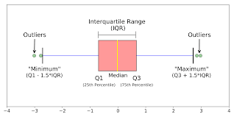

Measures of Shape

Skewness
Skewness is a measure of the asymmetry of the distribution of values in a dataset. It tells us whether the data is skewed to the left (negatively skewed), skewed to the right (positively skewed), or symmetric.
Skewness = ∑​(xi​− x̄)³ / (N – 1). σ³
^{Check the skew}
Dataset[“Age”].skew()
If the output is greater than 0 that is called positive skew chart or positive distribution chart
If the output is less than 0 that is called negative skew chart or negative distribution chart

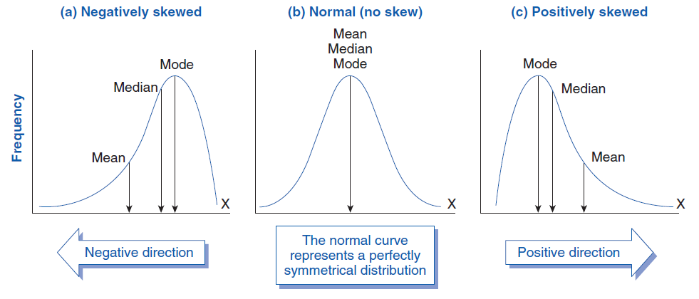

Probability
Probability measure the likelihood or chance of a particular outcome or event occurring. It is typically expressed as a number between 0 and 1, where 0 indicates impossibility (event will not occur) and 1 indicates certainty (event will occur).
P(A)= Number of time A occurs​/Total number of possible outcomes

Random Variables
A random variable is a X that assigns a real number to each outcome in the sample space of a random experiment.
Discrete Random Variable: A random variable that takes on a countable number of distinct values. (Fixed Number like[1,2,3,4,5,6])
Continuous Random Variable: A random variable that can take any value within a given range or interval. (Continuous Number like [1,1.1,1.2,1.3,1.4,1.5,2.3,3.4,4.2,5.3,5.7,6.1] )

Probability Distribution
Probability distribution describe how the probabilities of different outcomes are distributed over the sample space of random variable.
- Discrete Probability Distribution
- Continuous Probability Distribution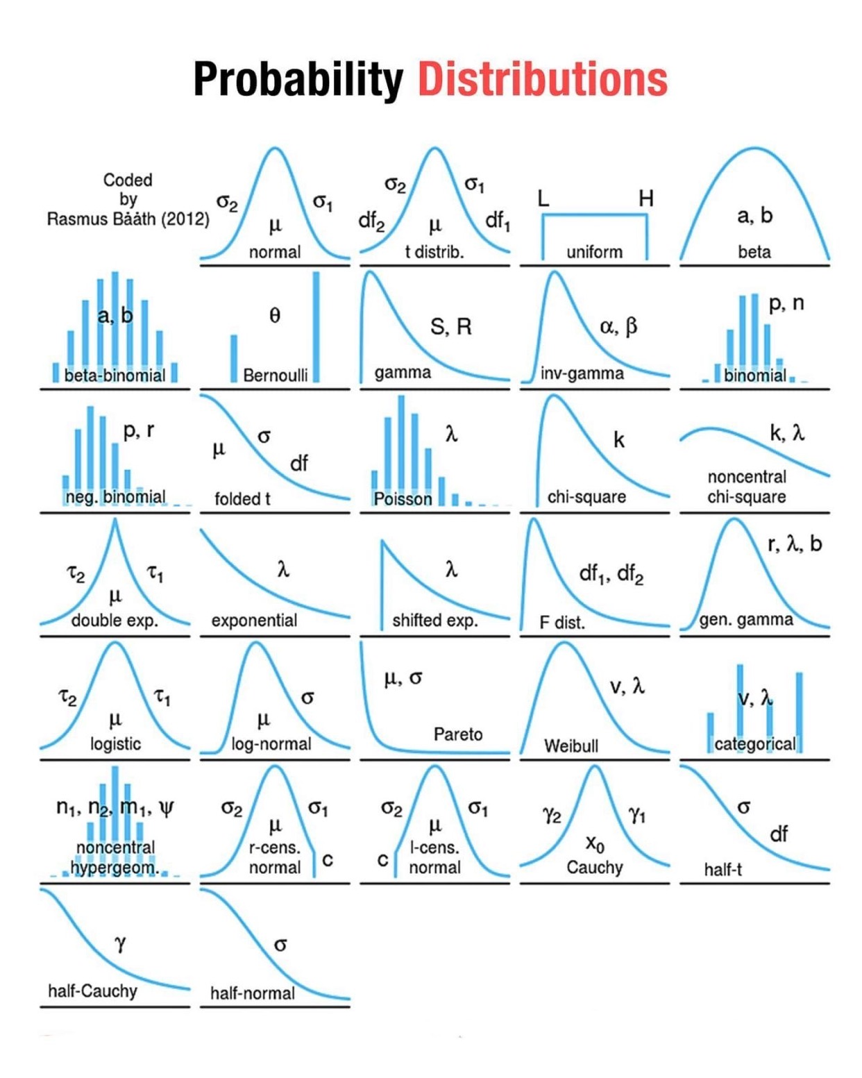

Probability Distribution Functions
A probability distribution is the mathematical function that gives the probabilities of occurrence of different possible outcomes for an experiment.

Probability Distribution Functions – PDF, PMF & CDF
Probability Density Function (PDF) use for Continuous Probability Distribution
Probability Mass Function (PMF) use for Discrete Probability Distribution
Cumulative Density Function (CDF) use for both

Normal Distribution
It known as the Gaussian distribution, is a probability distribution that is symmetric about the mean, showing that data near the mean are more frequent in occurrence than data far from the mean. In graph form, normal distribution will appear as a bell curve.

Standard Normal Distribution
The standard normal distribution, also know as the Z distribution or Z-score, is a specific case of the normal distribution.
Mean(µ) of 0 and a standard deviation (σ) of 1.

Frequency Distribution
Frequency distribution is a summary of how often different values occur in a dataset. It shows the number of times each unique value appears in the dataset.

Covariance and Correlation

Covariance
Covariance signifies the direction of linear relationship between two variables. Be direction we mean if the variables are directly proportional or inversely proportional to each other.
(Increasing the value of one variable might have a positive or negative impace on the value of other variable)
Cov(x,y) = ∑(x_{i -} x̄) * (y_{i –} y⁻) / N
Practically:
dataframe.select_dtypes(["int64"]).cov()

Correlation
Correlation analysis is a method of statistical evaluation used to study the strength of a relationship between two, numerically measured, continuous variables.
Correlation = Cov(x,y) / σx * σy
Where:
Cov is the covariance
σx is the standard deviation of x.
σy is the standard deviation of y.
Practically:
dataframe.select_dtypes(["int64", “float64”]).corr()
Note:
Mostly use correlation instead of covariance and mostly use in machine learning and linear regression of machine learning
Difference between Covariance and Correlation
Only value difference like range
Covariance value range: - ∞ to ∞
Covariance value range: -1 to 1

Central Limit Theorem
The Central limit theorem (CLT) states that when plotting a sample distribution of means the means of the sample will be equal to the population mean and the sample distribution will approach normal distribution with variance equal to standard error.

There are few assumptions behind the CLT:
The sample data must be sampled and selected randomly from the population.
There should not be any multicollinearity in the sampled data which is one sample should not influence the other samples.
The sample size should be no more than 10% of the population. Generally, sample size greater than 30 (n>30) is considered good.

Use of Central Limit Theorem
Central limit theorem are use where not possible to find out population data mean and then use it to find the mean.

Hypothesis Testing
It is a part of statistical analysis, where we test the assumptions made regarding the population parameter. It is generally used when we were compare a single group with an external group and two or more groups with each other.

Terminology used in Hypothesis Testing
Null Hypothesis: Null hypothesis is a statistical theory that suggests there is no statistical significance exists between populations. It is denoted by H0 and read as H-naught.
Alternative Hypothesis: An alternative hypothesis suggests there is a significant different between population parameters. It could be greater or smaller. Basically, it is the contrast of the null hypothesis. It is denoted by Ha and H1.

Hypothesis Testing (Practical)

Step of hypothesis testing:
- State null (H0) and alternative (H1) hypothesis
- Choose level of significance (α)
- Find critical values
- Find test statistic
- Draw your conclusion

State null (H0) and alternative (H1) hypothesis:
H0 most always contain equality (=). H1 always contain difference (≠, <, >).

Choose level of significance (α) (value alpha 1% 5%)
Denoted by alpha or α. It is fixed probability of wrongly rejecting a True Null Hypothesis.
